Securing a better future for all at 16 and beyond – supplementary resources
Background information, data and case studies to the annual lecture for further education and skills 2014

The further education and skills annual lecture is based on a survey Ofsted carried out between September 2013 and April 2014. Inspectors visited 25 local authorities and a range of charities and organisations to explore the effectiveness of local strategies to ensure the sustained participation of all 16–19 year olds.
The lecture also uses evidence from the survey Transforming 16 to 19 education and training: the early implementation of 16 to 19 study programmes. The purpose of this survey was to evaluate how effectively further education and skills providers and schools and academies with sixth forms have implemented the 16 to 19 study programmes introduced in August 2013 and made the best use of the changed funding arrangements for 16–19-year-olds. The fieldwork for this survey was undertaken from September 2013 to April 2014.
The majority of young people successfully progress to education and training at 16.
Proportion of 16-18-year-olds recorded in education and training, by end of 2012 and 2013 (provisional)
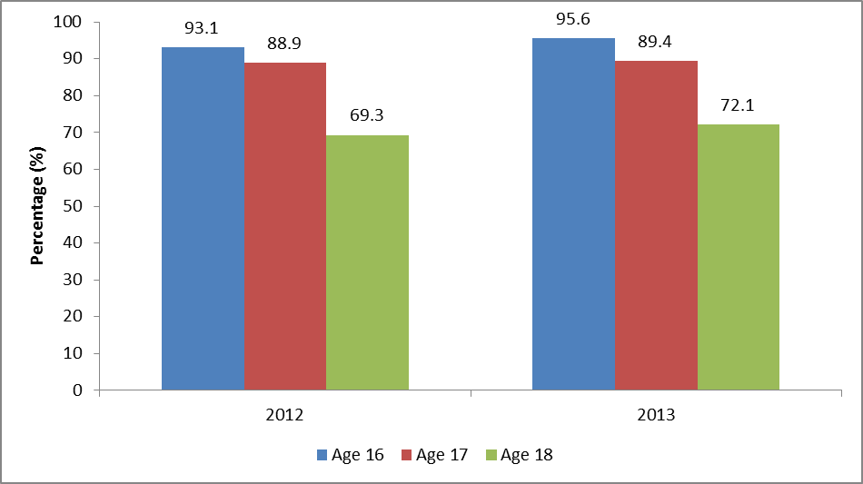
Source: Department for Education: Participation in education, training and employment, age 16 to 18, June 2014; www.gov.uk/government/statistics/participation-in-education-training-and-employment-age-16-to-18.
In March 2014, of the 1.2 million 16–17-year-olds known to local authorities, 90.3% were participating in some form of education or training; an improvement of 1.4 percentage points from last year.
Source: Department for Education: Participation in education and training by local authority; https://www.gov.uk/government/publications/participation-in-education-and-training-by-local-authority.
Only 77% of young people eligible for free schools meals in mainstream schools entered a sustained destination at 16 compared with 88% of those not eligible for free school meals.
Source: Department for Education: Destinations of key stage 4 and key stage 5 pupils: 2011 to 2012, June 2014; www.gov.uk/government/publications/destinations-of-key-stage-4-and-key-stage-5-pupils-2011-to-2012.

However, as the proportion of young people who are not in education, employment or training (NEET) aged 16 to 18 falls, the proportion of young people of the same age group whose activity is unknown is higher than that for young people who are NEET in over half of local authorities.
The proportion of young people who are NEET varies considerably according to regions. The proportion of young people who are in the category ‘situation unknown’ also varies considerably according to region. In each region there are likely to be considerable local variations for both categories.

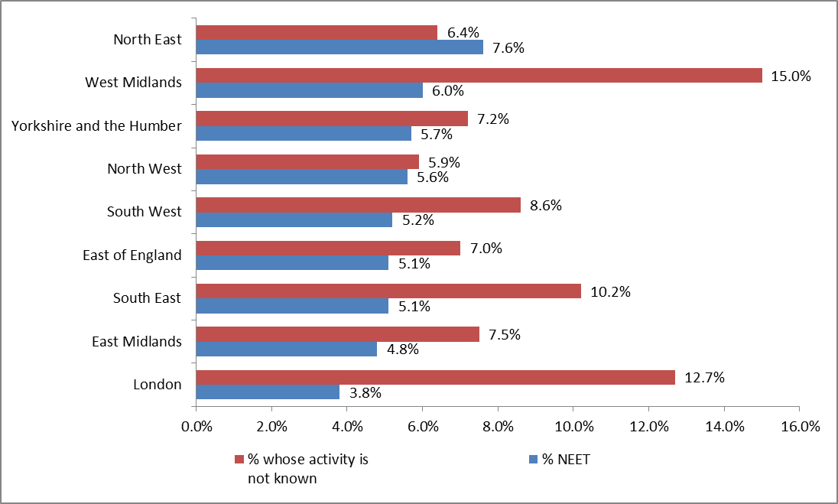
The proportion of 16–18-year-olds who were NEET or where their activity is unknown at the end of 2013, by region
Source: Department for Education: 2013 NEET data by local authority; www.gov.uk/government/publications/neet-data-by-local-authority-2012-16-to-18-year-olds-not-in-education-employment-or-training.

Just one in 40 young people who achieve five or more General Certificates of Secondary Education (GCSEs) at A*–C at school are NEET at age 17. This compares with one in six who obtained fewer GCSEs.
Source: Migration Advisory Committee: Migrants in low-skilled work, July 2014; www.gov.uk/government/publications/migrants-in-low-skilled-work.
At a national level, around 42,000 16–17-year-olds’ activity is unknown. In terms of gender, the percentage of females participating in education or training is greater and this gender gap is wider at aged 17 than at 16.
Source: Department for Education: Participation in education and training by local authority; August 2014; www.gov.uk/government/publications/participation-in-education-and-training-by-local-authority.
A smaller proportion of white 16–17-year-olds is recorded in education and training that any other ethnic group.
Proportion of 16–17-year-olds recorded in education and training by ethnicity, March 2014
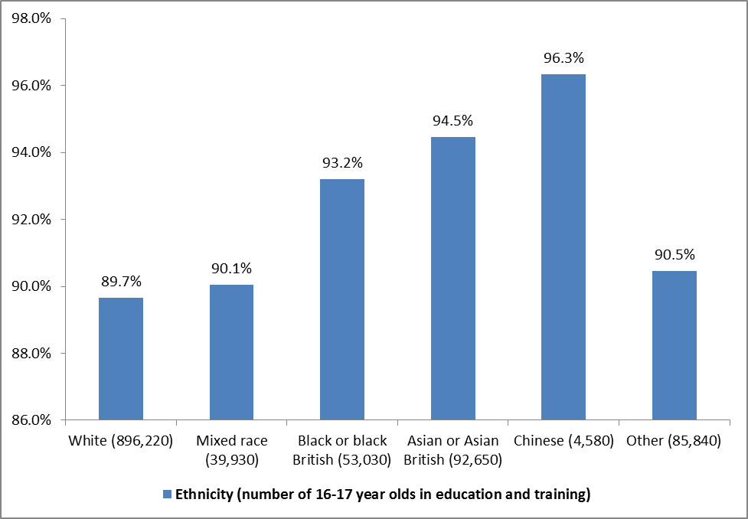
Source: Department for Education: Participation in education and training by local authority; www.gov.uk/government/publications/participation-in-education-and-training-by-local-authority.
Although it has fallen steadily over the last two years, the number of young people aged 16 to 24 who are NEET is still far too high.

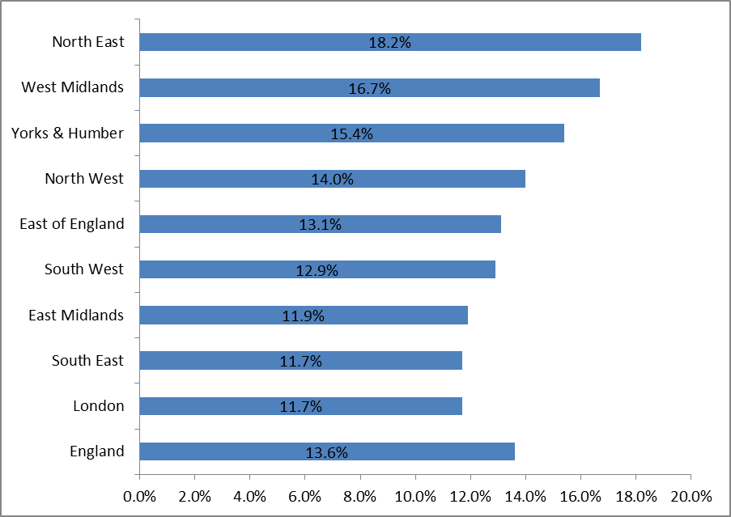
Percentage of 16–24-year-olds who are NEET, by region and gender – quarterly statistics for April to June 2014
Source: Department for Education: NEET statistics quarterly brief: April to June 2014; www.gov.uk/government/statistics/neet-statistics-quarterly-brief-april-to-june-2014.
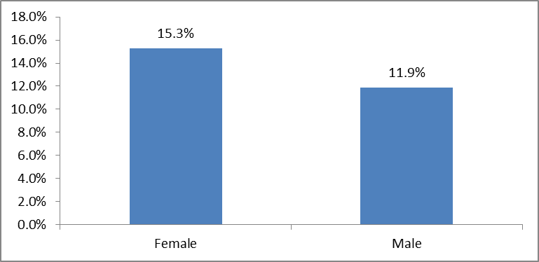
A higher proportion of young women aged 16 to 24 were NEET in April - June 2014 than young men.
Source: Department for Education: NEET statistics quarterly brief: April to June 2014; www.gov.uk/government/statistics/neet-statistics-quarterly-brief-april-to-june-2014.
The UK and four other European countries have a youth unemployment rate that is three or more times greater than the adult rate.
Youth and adult unemployment rates across selected European countries October–December 2013
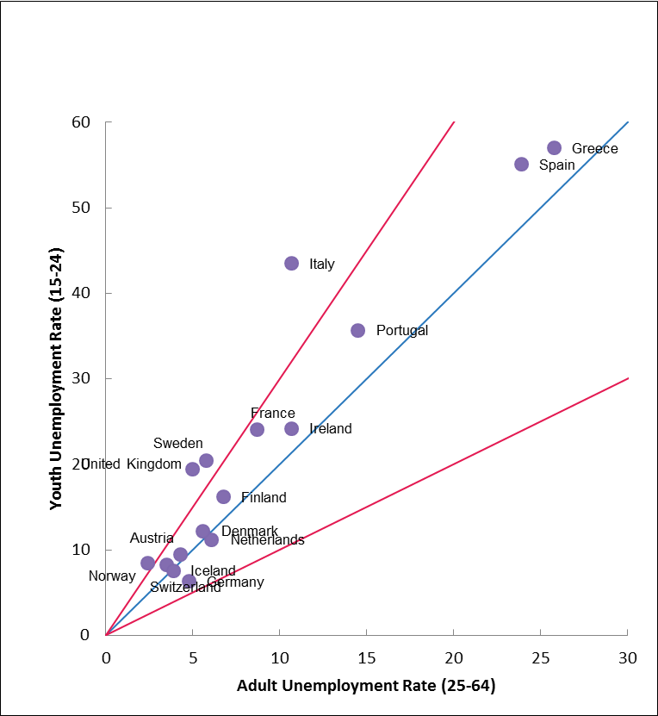
Source: UK Commission for Employment and Skills: Precarious futures? Youth employment in an international context, June 2014; www.gov.uk/government/publications/youth-employment-in-an-international-context.
In May 2014, youth long-term unemployment (six months and over) for 18–24-year-olds is 283,000. This is a fall from last year of 25%, compared with 16% for the 25 and over age group.
Source: Centre for Economic & Social Inclusion: Labour market analysis published in August 2014; www.cesi.org.uk/statistics.

47% of people without qualifications were employed in the period April to June 2013, compared with 87% of graduates.
Source: ONS: Graduates in the UK Labour Market 2013; www.ons.gov.uk/ons/rel/lmac/graduates-in-the-labour-market/2013/rpt---graduates-in-the-uk-labour-market-2013.html.
Employment, unemployment and inactivity rates for people in the UK by the highest level of qualifications they hold, April to June 2013

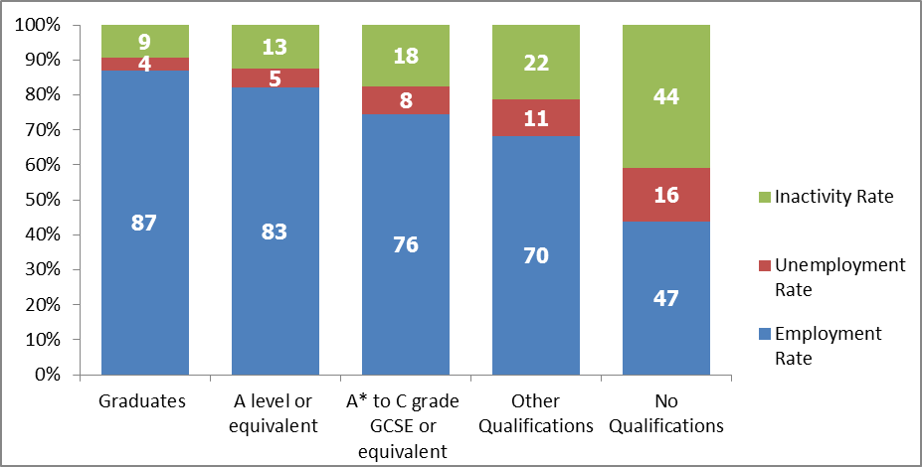
Source: Office for National Statistics: Graduates in the UK Labour Market 2013, labour force survey dataset; www.ons.gov.uk/ons/rel/lmac/graduates-in-the-labour-market/2013/rpt---graduates-in-the-uk-labour-market-2013.html.

