Domestic Green Deal and Energy Company Obligation in Great Britain, Monthly report

Statistical release: Experimental statistics
21 October 2014
© Crown copyright 2014
You may re-use this information (not including logos) free of charge in any format or medium, under the terms of the Open Government Licence.
To view this licence, visit www.nationalarchives.gov.uk/doc/open-government-licence/
or write to the Information Policy Team, The National Archives, Kew, London TW9 4DU,
or email: psi@nationalarchives.gsi.gov.uk.
Any enquiries or comments in relation to this statistical release should be sent to DECC’s Green Deal Statistics Team at the following email address: EnergyEfficiency.Stats@decc.gsi.gov.uk
Contact telephone: 0300 068 5106
This document is also available from our website at https://www.gov.uk/government/collections/green-deal-and-energy-company-obligation-eco-statistics

Contents
Charts 4
Executive summary 5
Introduction 5
Key points 5
Detailed Results 6
All measures installed up to end August 2014 (Table 1 and Table 1a) 6
Green Deal Assessments, by month (Table 2, Chart 1) 6
Green Deal Plans in unique properties, cumulative totals by month (Table 3, Table 3a, Table 3b, Chart 2) 7
Cashback vouchers where payments have been made, by month of installation (Table 4, Table 4a, Chart 3) 8
Green Deal Home Improvement Fund where payments have been made, by month of installation (Table 5, Table 5a) 10
ECO measures installed by obligation, up to the end of August 2014 (Table 6, Table 6a, Chart 4, Chart 5) 10
Measures not captured by administrative data sources 12
ECO brokerage, as at the end of September 2014 (Table 7, Chart 6) 13
Supply chain, as at the end of September 2014 (Table 8, Chart 7) 13
Annex A – Tables 15
Annex B – Background 29
Green Deal 29
Energy Company Obligation 30
Green Deal Cashback 31
Green Deal Home Improvement Fund 31
ECO Brokerage 31
The Supply Chain 32
Annex C – Sources and Methodology 33
National Statistics 33
Further Information and Feedback 34
Next Releases 34

Charts
Chart 1 - Number of Green Deal Assessments lodged, by month 7
Chart 2 - Number of Green Deal Plans in unique properties, cumulative totals at end of each month, and by stages 8
Chart 3 - Number of Cashback vouchers where payments have been made (excluding payments made through the exception process), by month of installation 9
Chart 4 - Provisional cumulative number of ECO measures installed, by obligation, at end of each month 11
Chart 5 - Provisional number of measures installed under ECO, by measure type, by obligation, up to end August 2014 12
Chart 6 – Value of ECO brokerage contracts let, by auction 13
Chart 7 – Development of supply chain (cumulative numbers) at end of each month 14

Executive summary

Introduction
This release presents the latest statistics on the Green Deal (GD) up to the end of September 2014 and the Energy Company Obligation (ECO) up to the end of August 2014.
For more details about the GD/ECO schemes, please see Annex B. More detailed analysis of GD Assessments lodged, Cashback measures installed and provisional measures installed under ECO up to the end of June 2014 are also available in the quarterly statistical release.

Key points
- A provisional 965,000 measures were installed in around 797,000 properties through ECO, Cashback, Green Deal and the Green Deal Home Improvement Fund to the end of August 2014 (the latest month that we have complete data for), up from 941,000 measures to the end of July. The large majority of installed measures (97 per cent) were delivered through ECO. In addition, 105,000 measures eligible under the ECO amendment order have also been installed (see page 11).

- GD Assessments - 356,514 were lodged up to the end of September 2014 (Chart 1), up from 326,883 at end of August. The 29,631 GD Assessments in September was 11 per cent higher than the number in August (26,625).

- Green Deal Plans – 5,736 households had Green Deal Plans in progress at the end of September 2014, 21 per cent more than the 4,737 at the end of August. Of these 5,736 Plans, 1,808 were ‘new’ (quote accepted), another 1,347 were ‘pending’ (Plan signed) and 2,581 were ‘live’ (all measures installed), 45 per cent of all Plans (Chart 2).

- Cashback vouchers - by the end of September 2014, 16,253 had been issued and, of these, 14,490 vouchers had been paid (following installation of 15,427 measures) (Chart 3) through the standard Cashback route. Overall, including additional measures installed through the Cashback exception process (see page 9), around £13.3 million has been paid and the majority have been for boiler replacements.

- Green Deal Home Improvement Fund - by the end of September 2014, there were 21,041 active applications and, of these, 3,235 vouchers had been paid (following installation of 4,413 measures), with a value of £13.6 million. Around half (48 per cent) of these measures have been for solid wall insulation.

- ECO measures - provisional figures show there were 939,863 measures installed under ECO up to the end of August 2014, with 22,131 installed in August. This continues the downward trend in measures installed each month since March 2014, although energy companies have also started delivering measures eligible under the ECO amendment order with around 105,000 additional installations reported between April and August.

- Of all notified ECO measures installed to date, 36 per cent were for cavity wall insulation, 28 per cent were for boiler upgrades and 21 per cent were for loft insulation. All solid wall insulation types accounted for seven per cent (Chart 5).

Detailed Results

This section of the report provides the latest available information on different elements of the Green Deal and ECO. This includes the number of Assessments and Green Deal Plans, Cashback vouchers spent, measures installed through Cashback and ECO, a summary of ECO brokerage and an overview of the supply chain. Data on Green Deal are presented to the end of September 2014 in this release, whilst ECO is presented to the end of August 2014. Aggregate data on all measures installed are also presented to the end of August.

The Green Deal and ECO quarterly statistical release provides a range of analysis and further breakdowns on Assessments lodged, Cashback measures installed and provisional measures installed to the end of June 2014.

All measures installed up to end August 2014 (Table 1 and Table 1a)

A provisional 965,000 measures were installed in around 797,000 properties through ECO, Cashback, Green Deal and the Green Deal Home Improvement Fund to the end of August 2014 (the latest month that we have complete data for), up from 941,000 measures to the end of July (Table 1 and Table 1a). The large majority of installed measures (97 per cent) were delivered through the Energy Company Obligation. The most prevalent measures were cavity wall insulation, boilers and loft insulation. Further detailed results of each of these delivery mechanisms are within the main commentary. This excludes measures installed but not captured by administrative data sources, i.e. using alternative finance (see page 12), and also the 105,000 installed ECO measures eligible under the ECO amendment order.

Green Deal Assessments, by month (Table 2, Chart 1)

The first step in the Green Deal process involves a Green Deal Assessor coming to the home, talking to the owner/occupier about their energy use and seeing if they can benefit from making energy efficiency improvements to their property. This leads to a Green Deal Advice Report (GDAR) being produced for the householder and lodged on a national register. The customer is then able to view the energy efficiency measures which have been recommended and understand the potential costs and savings. For more information on the GD assessment process see here.

At the end of September 2014 there were 356,514 GD Assessments lodged in total (Chart 1). The 29,631 GD Assessments in September was 11 per cent higher than the number in August (26,625), the second highest number recorded in a month to date.

Chart 1 - Number of Green Deal Assessments lodged, by month
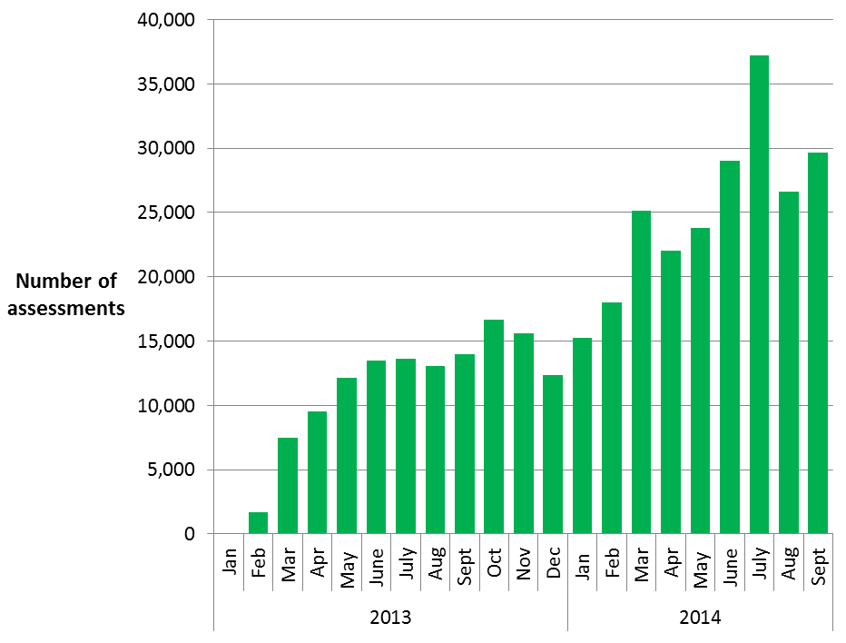

Green Deal Plans in unique properties, cumulative totals by month (Table 3, Table 3a, Table 3b, Chart 2)

Following an Assessment, for householders who choose to take on any of the recommended measures, there are a number of routes to pay for the improvements. Some customers may choose Green Deal finance to pay for part or all of their planned improvements, whilst others may choose to pay for measures out of savings or other sources of finance, and some may be part funded through ECO support.

For those who choose Green Deal finance, there are three stages in the life cycle of a Green Deal Plan. The first stage (a ‘new’ Plan) is after a customer has obtained a quote and confirmed they wish to proceed, the second stage (a ‘pending’ Plan) is when a Plan has been signed by the customer and progress is being made to install measures, whilst the final stage (a ‘live’ Plan) is after the measures have been installed and the energy supplier has all the information required to bill Green Deal charges. For more detail on these stages, please see Annex B.

In total, there were 5,736 Green Deal Plans in the system at the end of September 2014, up from 4,737 at the end of August 2014. This represents continued growth in the number of Green Deal Plans in the system after a period of relatively low activity. Of these 5,736 Plans, 1,808 were ‘new’ (quote accepted), another 1,347 were ‘pending’ (Plan signed) and 2,581 were ‘live’ (all measures installed), 45 per cent of all Plans. As ‘new’ and ‘pending’ Green Deal Plans lead to installation of measures and charges starting to accrue, they will be replaced as ‘live’ Green Deal Plans in future monthly releases. The three reporting stages are presented in Table 3 and Chart 2.
The total number of measures installed using Green Deal finance was 5,638 up to the end of September 2014 (see Table 3a). Photovoltaics accounted for 28 per cent of measures installed, followed by boilers (23 per cent), and solid wall insulation (17 per cent) (see Table 3b).

Chart 2 - Number of Green Deal Plans in unique properties, cumulative totals at end of each month, and by stages
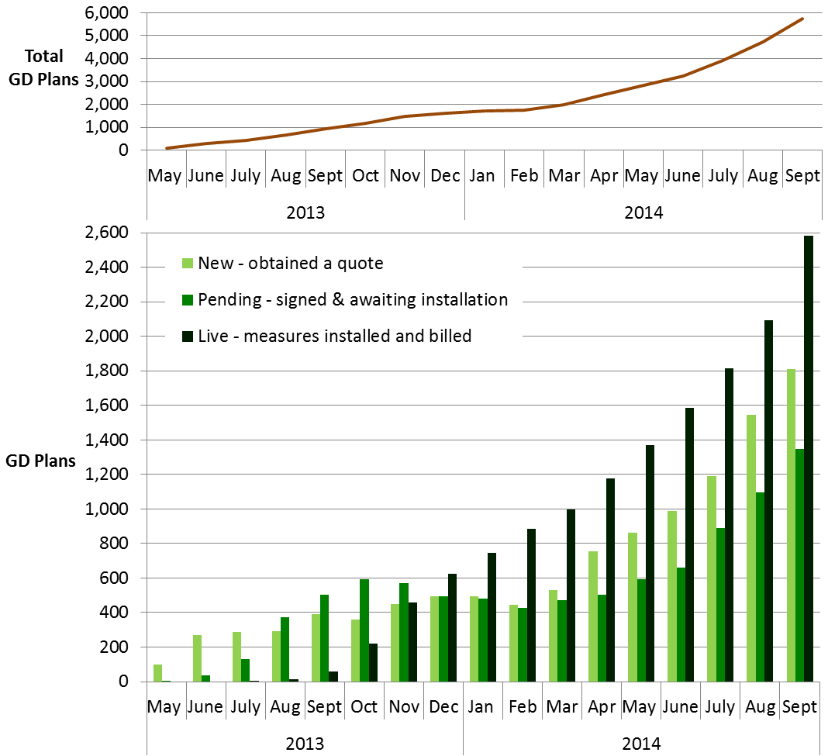

Cashback vouchers where payments have been made, by month of installation (Table 4, Table 4a, Chart 3)

The Cashback scheme was available from January 2013 to June 2014 in England and Wales. It was a financial incentive specifically aimed to encourage domestic customers to get measures installed through the Green Deal process, although it is the customers’ choice whether they decide to take out Green Deal finance or other sources of finance to fund the installation of the measures. The Cashback scheme closed at the end of June 2014 but vouchers will continue to be redeemed and paid until 30 September 2014. Figures will continue to be reflected in statistical releases as measures continue to be installed.

Of the 16,253 vouchers issued at the end of September 2014, 14,490 (89 per cent) had been paid following the installation of 15,427 measures (mainly boilers, solid wall insulation and loft insulation) through the standard Cashback route (Table 4, Table 4a and Chart 3). Additionally, 1,992 applications and payments were made through the Cashback Exception Process, which includes payments for solid wall insulation and warm air heating measures when these measures are not displayed on the EPC. These take the total number of vouchers issued to the end of September 2014 to 18,245 and the total number of payments made to 16,482. Measures installed through the exception process are not included in Table 4a as the appropriate data are not currently available. Overall, measures to the value of around £13.3 million have been paid through the Cashback Scheme, including uplift payments due to the new Cashback measure rates.

Customers only receive payments once Providers have confirmed to the Cashback Administrator that the measures have been installed and a large batch of payments were processed in June 2013, hence the higher number in that month. Subsequently, the number of Cashback vouchers paid each month has decreased from this peak. However, the £2.3m of Cashback vouchers paid for installations in June 2014 was the highest recorded to date, as can be seen in Table 4.

Chart 3 - Number of Cashback vouchers where payments have been made (excluding payments made through the exception process), by month of installation
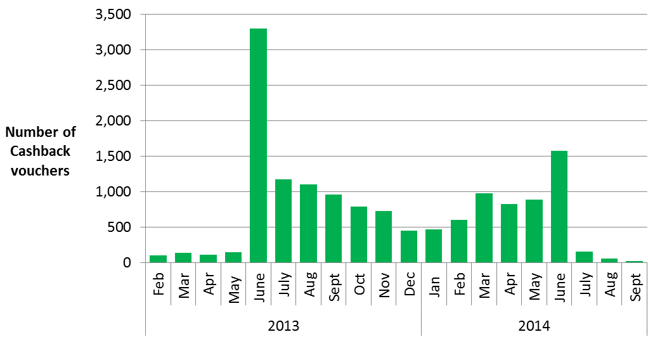
Cashback measures where payments have been made (Table 4a)

Table 4a shows that replacement boilers were the main measure where Cashback payments have been made (80 per cent of all Cashback measures installed), whilst a further 13 per cent were for solid wall insulation, five per cent were for loft insulation and two per cent were for cavity wall insulation. More than one measure can be installed in a property and covered by a single Cashback payment.

Green Deal Home Improvement Fund where payments have been made, by month of installation (Table 5, Table 5a)

The Green Deal Home Improvement Fund (GDHIF) was an incentive scheme open to all householders in England and Wales wanting to improve the energy efficiency of their homes. The scheme allowed householders to choose one or both of two offers available and were eligible to claim up to £7,600. The Green Deal Home Improvement Fund (GDHIF) opened in June 2014 and closed to new applicants at 6:30pm on 24 July 2014.

By the end of September 2014, there were 21,041 Green Deal Home Improvement Fund active applications, with a total budget committed of around £114m. Around half of GDHIF applications were accompanied with a Green Deal Advice Report, with the remainder accompanied with an Energy Performance Certificate. By the end of September, of these active applications, 20,276 vouchers had been issued.

Of these, 3,235 vouchers had been paid (following installation of 4,413 measures) by the end of September, with a value of around £13.6 million. Solid wall insulation was the main measure where GDHIF payments have been made (48 per cent of measures installed) followed by gas boiler installations (26 per cent) and flue gas heat recovery device installations (25 per cent). Of the 3,235 payments made, 1,966 applicants received the Green Deal Advice Report (GDAR) refund (of up to £100 each), and 309 applicants received the Home Buyer Bonus (of up to £500 each).

ECO measures installed by obligation, up to the end of August 2014 (Table 6, Table 6a, Chart 4, Chart 5)

The Energy Company Obligation (ECO) was introduced in January 2013 to reduce energy consumption and support people at greater risk of living in fuel poverty. Information on measures installed under ECO is at a lag of a month compared to other figures presented in this release due to the time taken for information to be reported and verified. Hence, data on measures installed under ECO is presented until the end of August 2014.

All measures installed under ECO are provisional until the end of the obligation period as checks are undertaken. Users should note that, in order to produce the timeliest data possible, estimates in this report include a month of data that has yet to be through initial Ofgem validation checks (i.e. they are as reported by energy suppliers to Ofgem). Revisions to data are routinely included in releases and will be explained if they are large.

Table 6 shows the provisional number of measures installed under ECO and Chart 4 shows the cumulative total number of measures installed and by ECO obligation by month of installation.

Chart 4 - Provisional cumulative number of ECO measures installed, by obligation, at end of each month
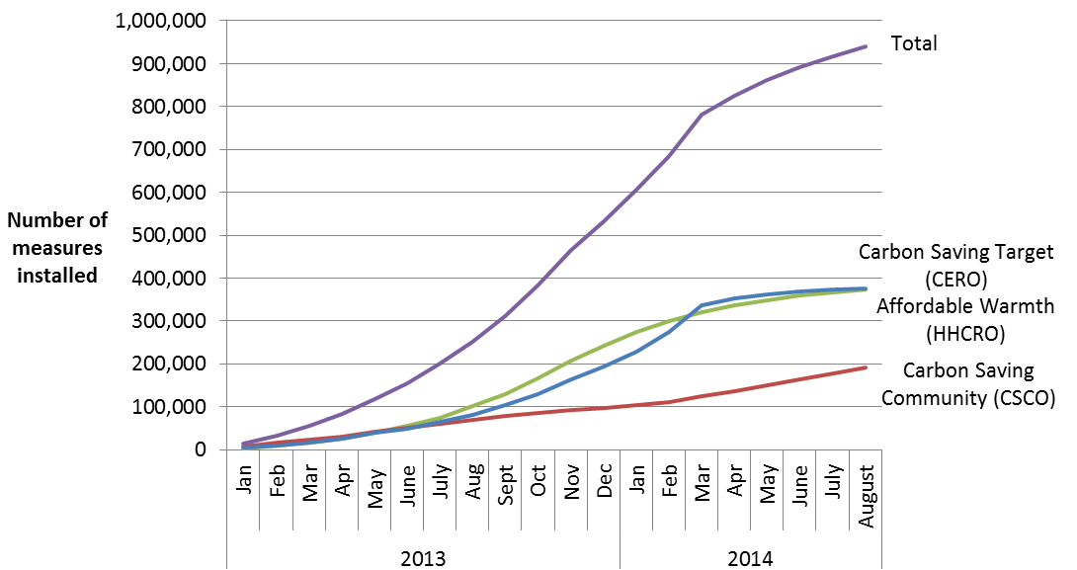

Overall, 939,863 measures had been installed to the end of August 2014, with 22,131 installed in August, which was 14 per cent lower than the 25,714 installed in July. The number of measures installed peaked to date in March (97,809), in part, due to the incentive for energy companies to deliver Carbon Saving Target (CERO) measures by the end of March 2014 in order to benefit from the proposed levelisation which would provide uplift to CERO carbon scoring. Consequently the number of measures installed in months since March 2014 were much lower. However, companies have started delivering measures eligible under the ECO amendment order with around 105,000 installations reported between April and August 2014, of which nearly 22,000 were reported in August. Over half of these (54 per cent) were cavity wall insulation measures and under half (44 per cent) were loft insulation measures. These measures cannot yet be captured through the formal Ofgem reporting process and are not included in the headline statistics nor in the breakdowns below, but will do so in future months.

The split by obligation shows 40 per cent of measures installed under ECO were delivered through the Carbon Saving Target (CERO), 20 per cent delivered were through Carbon Saving Communities (CSCO) and 40 per cent were delivered through Affordable Warmth (HHCRO).

Table 6a and Chart 5 show the provisional number of measures installed under ECO, by measure type and ECO obligation. This shows that the majority of the 939,863 measures installed under ECO were for cavity wall insulation (36 per cent), boiler upgrades (28 per cent) and loft insulation (21 per cent). Overall, 777,194 properties benefitted from one or more ECO measures being installed up to the end of August 2014 (Table 6a).

Chart 5 - Provisional number of measures installed under ECO, by measure type, by obligation, up to end August 2014
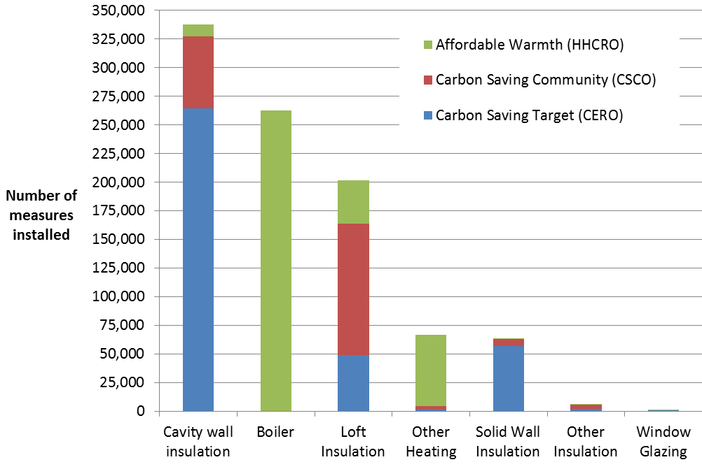
The majority (80 per cent) of the 338,082 cavity wall insulation measures installed were delivered to Hard to Treat cavity wall properties.
Around two thirds (63 per cent) of the 201,571 loft insulation measures installed under ECO up to the end of August 2014 were top ups.

Of the 63,181 solid wall insulation measures installed, the large majority (92 per cent) were External Wall Insulation.

Measures not captured by administrative data sources

The figures in these tables do not include estimates of measures installed following a Green Deal Assessment where the measure was not captured by administrative data sources (i.e. measures installed using alternative finance). Alternative sources of finance may include savings, payment from a landlord, housing association or Local Authority or other type of loan or credit, but would not have received funding from any of our reported routes. Additional work has been undertaken on this which is reported in the quarterly statistical release.

ECO brokerage, as at the end of September 2014 (Table 7, Chart 6)

The ECO Brokerage system operates as a fortnightly anonymous auction where providers can sell ‘lots’ of future measures of ECO Carbon Saving Target, ECO Carbon Saving Communities and ECO Affordable Warmth, to energy companies in return for ECO subsidy. Chart 6 shows that up to the end of September 2014 there have been 44 auctions, with a total value of contracts let worth £418 million. Auctions 25, 32, 33, 34, 36 and 40 saw no contracts let; however auctions 42 and 44 both had over £6m of contracts traded. The levels of brokerage activity in recent months are likely to have been affected by uncertainty around the period, following the announced proposals for a set of changes to ECO.
Chart 6 – Value of ECO brokerage contracts let, by auction
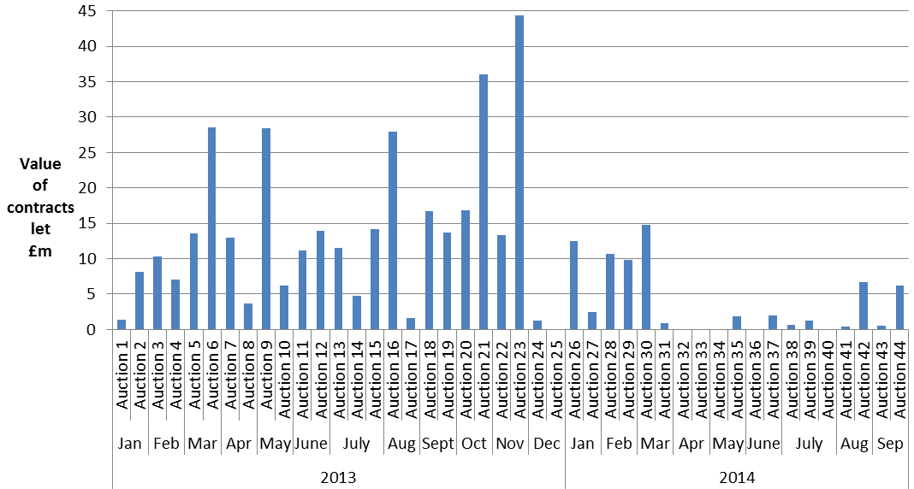

For more detail on the results of each auction, please see ECO Brokerage.

Supply chain, as at the end of September 2014 (Table 8, Chart 7)

The supply chain to support the Green Deal has been developing since October 2012. This includes individual Advisors (who carry out and produce Green Deal Advice Reports) and Assessor organisations (who employ authorised Green Deal Advisors), Green Deal Providers (who quote for and arrange Green Deal Plans with householders and arrange for the measures to be installed), and Installer organisations (who install energy efficiency improvements under the GD finance mechanism). Chart 7 shows the number of organisations and individuals who have been accredited as of the end of each month.

Chart 7 – Development of supply chain (cumulative numbers) at end of each month

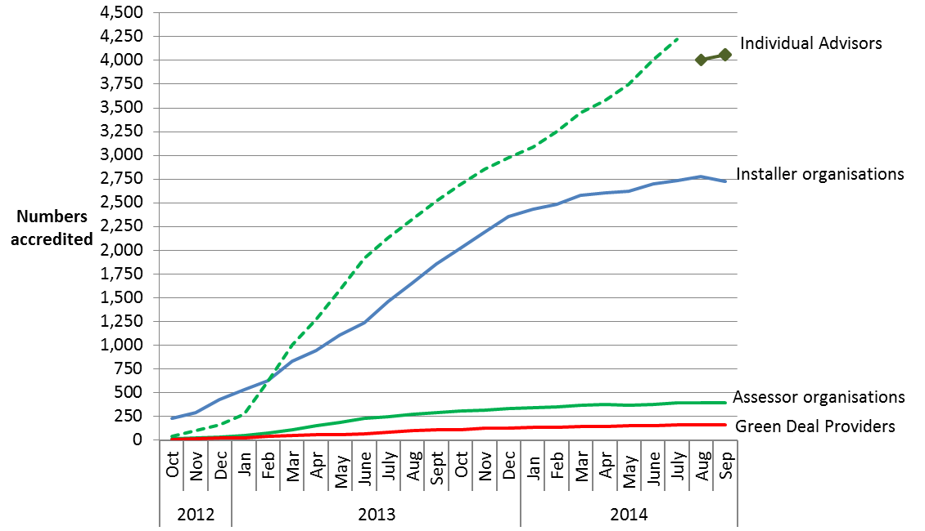

The numbers of accredited GD Assessor organisations and individual Advisors has been increasing steadily as individual Assessors complete their training and are accredited. At the end of September 2014 there were 391 Assessor organisations employing a total of 4,061 Advisors, compared to 286 and 2,517 respectively at the end of September 2013. The measurement of the number of individual Advisors changed in August 2014 following improved data quality checks by the GD ORB. An improved automated deduplication process, implemented in August 2014, is more effective at identifying potential duplicate advisor entries and has therefore reduced the total number of unique individual advisors. The new series of individual Advisors is illustrated in Chart 7 by the dark green line with “” markers and is not directly comparable with the original series (dotted line).

The number of Green Deal Providers has increased to 162 from 107 at the end of September 2013. The number of accredited Installer organisations has increased steadily from 1,853 accredited at the end of September 2013 to 2,729 organisations accredited at the end of September 2014, although the number of installers has decreased slightly since August 2014. These organisations will provide a wide range of different measures and in different geographical locations (see quarterly statistical release for more details).

The Green Deal Oversight and Regulation Body (ORB) produces publically available information on the supply chain, and the latest figures are available by using the search tool on the ORB website. There is also information available on contacts in local areas.

Annex A – Tables
Please note, components may not add up to totals due to rounding.
Table 1: Provisional number of measures installed through ECO, Cashback, using Green Deal finance or Green Deal Home Improvement Fund, by month of installation
 | Delivery mechanism
Installation Month¹ | ECO ² | Cashback ³ |  | Green Deal  Finance Plans |  |  | Green Deal Home Improvement Fund ⁴ | Total number of measures installed ⁵
January 2013 ⁶ | 14,692 | 0 |  | 0 |  |  | 0 | 14,692
February 2013 | 18,872 | 96 |  | 0 |  |  | 0 | 18,968
March 2013 | 21,689 | 136 |  | 0 |  |  | 0 | 21,825
April 2013 | 28,751 | 110 |  | 0 |  |  | 0 | 28,861
May 2013 | 34,117 | 145 |  | 0 |  |  | 0 | 34,262
June 2013 | 36,428 | 3,337 |  | 5 |  |  | 0 | 39,770
July 2013 | 45,897 | 1,266 |  | 7 |  |  | 0 | 47,170
August 2013 | 50,848 | 1,158 |  | 133 |  |  | 0 | 52,139
September 2013 | 58,939 | 1,012 |  | 170 |  |  | 0 | 60,121
October 2013 | 72,431 | 842 |  | 524 |  |  | 0 | 73,797
November 2013 | 82,348 | 787 |  | 465 |  |  | 0 | 83,600
December 2013 | 67,357 | 471 |  | 422 |  |  | 0 | 68,250
January 2014 | 74,511 | 498 |  | 275 |  |  | 0 | 75,284
February 2014 | 76,748 | 676 |  | 308 |  |  | 0 | 77,732
March 2014 | 97,809 | 1,067 |  | 261 |  |  | 0 | 99,137
April 2014 | 42,605 | 941 |  | 380 |  |  | 0 | 43,926
May 2014 | 37,420 | 962 |  | 475 |  |  | 46 | 38,903
June 2014 | 30,556 | 1,688 |  | 378 |  |  | 483 | 33,105
July 2014 | 25,714 | 157 |  | 537 |  |  | 2,584 | 28,992
August 2014 | 22,131 | 60 |  | 568 |  |  | 1,228 | 23,987
Total to date | 939,863 | 15,409 |  | 4,908 |  |  | 4,341 | 964,521
¹ Measures installed in earlier installation months can be notified at a later date under some circumstances.
² Energy companies have also reported the installation of an additional 105,000 measures eligible under the ECO amendment order between April and August 2014, of which nearly 22,000 were reported in August. These are not included in the table.
³ Cashback figures do not include any measures from the Cashback Exception Process.
⁴ The Green Deal Home Improvement Fund was only available from June 2014. The May figure includes a small number of measures installed in February and April 2014.
⁵ Some measures may have been installed through more than one delivery mechanism and there is therefore a small level of double counting.
⁶ Includes some measures installed between October and December 2012.

Table 1a: Provisional number of individual households that have had measures installed through ECO, Cashback, using Green Deal finance or Green Deal Home Improvement Fund, by month of installation
 | Delivery mechanism
Installation Month¹ | ECO ² | Cashback ³ |  | Green Deal  Finance Plans |  | Green Deal Home Improvement Fund ² |  | Total number of individual  households ⁴
January 2013 ⁵ | 13,040 | 0 |  | 0 |  | 0 |  | 13,040
February 2013 | 16,830 | 95 |  | 0 |  | 0 |  | 16,925
March 2013 | 19,249 | 133 |  | 0 |  | 0 |  | 19,382
April 2013 | 25,690 | 109 |  | 0 |  | 0 |  | 25,799
May 2013 | 30,628 | 143 |  | 0 |  | 0 |  | 30,771
June 2013 | 32,842 | 3,302 |  | 0 |  | 0 |  | 36,144
July 2013 | 40,496 | 1,172 |  | 1 |  | 0 |  | 41,669
August 2013 | 42,917 | 1,099 |  | 11 |  | 0 |  | 44,027
September 2013 | 49,562 | 954 |  | 45 |  | 0 |  | 50,561
October 2013 | 59,275 | 787 |  | 162 |  | 0 |  | 60,224
November 2013 | 66,586 | 725 |  | 239 |  | 0 |  | 67,550
December 2013 | 53,637 | 443 |  | 168 |  | 0 |  | 54,248
January 2014 | 60,331 | 465 |  | 120 |  | 0 |  | 60,916
February 2014 | 61,773 | 603 |  | 137 |  | 0 |  | 62,513
March 2014 | 80,265 | 971 |  | 112 |  | 0 |  | 81,348
April 2014 | 33,302 | 822 |  | 183 |  | 0 |  | 34,307
May 2014 | 29,566 | 883 |  | 194 |  | 46 |  | 30,689
June 2014 | 24,051 | 1,569 |  | 215 |  | 459 |  | 26,294
July 2014 | 20,157 | 150 |  | 228 |  | 1,825 |  | 22,360
August 2014 | 16,997 | 51 |  | 277 |  | 850 |  | 18,175
Total to date | 777,194 | 14,476 |  | 2,092 |  | 3,180 |  | 796,942
¹ Measures installed in earlier installation months can be notified at a later date under some circumstances.
² Where a household has measures installed in two or more months, the earliest installation month is recorded.
³ Cashback figures do not include any households that have had measures installed solely through the Cashback Exception Process.
⁴ Some households may have had installations through more than one delivery mechanism and there is therefore a small level of double counting.
⁵ Includes some measures installed between October and December 2012.

Table 2: Number of Green Deal Assessments¹ and cumulative total, by month
 |  | Total in Month |  | Cumulative Total
Month² |  | Green Deal Assessments |  | Green Deal Assessments
January 2013 |  | 74 |  | 74
February 2013 |  | 1,729 |  | 1,803
March 2013 |  | 7,491 |  | 9,294
April 2013 |  | 9,522 |  | 18,816
May 2013 |  | 12,146 |  | 30,962
June 2013 |  | 13,517 |  | 44,479
July 2013 |  | 13,645 |  | 58,124
August 2013 |  | 13,087 |  | 71,211
September 2013 |  | 13,965 |  | 85,176
October 2013 |  | 16,672 |  | 101,848
November 2013 |  | 15,595 |  | 117,443
December 2013 |  | 12,385 |  | 129,828
January 2014 |  | 15,268 |  | 145,096
February 2014 |  | 17,998 |  | 163,094
March 2014 |  | 25,138 |  | 188,232
April 2014 |  | 22,004 |  | 210,236
May 2014 |  | 23,811 |  | 234,047
June 2014 |  | 29,018 |  | 263,065
July 2014 |  | 37,193 |  | 300,258
August 2014 ² |  | 26,625 |  | 326,883
September 2014 |  | 29,631 |  | 356,514
¹ As measured by the number of Green Deal Advice Reports lodged on the central register against unique property.
² The number of Assessments in August 2014 has been revised from 26,626 to 26,625

Table 3: Number of Green Deal Plans^{1,2,3,4} in unique properties, cumulative total by month
Month |  | 'New'¹ Green Deal Plans |  | 'Pending'² Green Deal Plans |  | 'Live'³ Green Deal Plans |  |  |  | 'Total'⁵ Green Deal Plans
May 2013 |  | 98 |  | 2 |  | 0 |  |  |  | 100
June 2013 |  | 270 |  | 36 |  | 0 |  |  |  | 306
July 2013 |  | 286 |  | 132 |  | 1 |  |  |  | 419
August 2013 |  | 293 |  | 372 |  | 12 |  |  |  | 677
September 2013 |  | 392 |  | 505 |  | 57 |  |  |  | 954
October 2013 |  | 360 |  | 594 |  | 219 |  |  |  | 1,173
November 2013 |  | 448 |  | 572 |  | 458 |  |  |  | 1,478
December 2013 |  | 493 |  | 493 |  | 626 |  |  |  | 1,612
January 2014 |  | 494 |  | 481 |  | 746 |  |  |  | 1,721
February 2014 |  | 445 |  | 426 |  | 883 |  |  |  | 1,754
March 2014 |  | 532 |  | 473 |  | 995 |  |  |  | 2,000
April 2014 |  | 756 |  | 505 |  | 1,178 |  |  |  | 2,439
May 2014 |  | 863 |  | 593 |  | 1,372 |  |  |  | 2,828
June 2014 |  | 986 |  | 661 |  | 1,587 |  |  |  | 3,234
July 2014 |  | 1,192 |  | 891 |  | 1,815 |  |  |  | 3,898
August 2014 |  | 1,547 |  | 1,098 |  | 2,092 |  |  |  | 4,737
September 2014 |  | 1,808 |  | 1,347 |  | 2,581 |  |  |  | 5,736
¹ A 'new' Green Deal Plan is after a customer has obtained a quote from a Green Deal Provider and confirmed they wish to proceed. The Green Deal Provider has then successfully requested a Green Deal Plan record prior to signature by the customer.
² A 'pending' Green Deal is when a Green Deal Plan has been signed by the customer, progress is being made to install Green Deal Plan measures (measures are installed during the ‘pending’ stage) and the Plan is being finalised so that charging can start.
³ A 'live' Green Deal Plan is after all the measures have been installed in the property, the information required to disclose the Plan to future bill payers has been attached to the Plan and the energy supplier has all the information required to bill Green Deal charges.
⁴ There are an additional 89 'completed' Green Deal Plans at the end of September 2014. These are when Plans have been paid off in full after all the measures have been installed in the property, and therefore the Plan is no longer active on the system.
⁵ Total Green Deal Plans are the total number of Plan identifiers for unique properties on the Central Charge Database at the end of reporting month.

Table 3a: Number of measures installed using Green Deal finance^{1,2}, and cumulative total³, by month⁴
 | Total in Month |  |  |  |  |  |  | Cumulative Total
Installation Month | Green Deal  Measures |  |  |  |  |  |  | Green Deal Measures
June 2013 | 5 |  |  |  |  |  |  | 5
July 2013 | 7 |  |  |  |  |  |  | 12
August 2013 | 133 |  |  |  |  |  |  | 145
September 2013 | 170 |  |  |  |  |  |  | 315
October 2013 | 524 |  |  |  |  |  |  | 839
November 2013 | 465 |  |  |  |  |  |  | 1,304
December 2013 | 422 |  |  |  |  |  |  | 1,726
January 2014 | 275 |  |  |  |  |  |  | 2,001
February 2014 | 308 |  |  |  |  |  |  | 2,309
March 2014 | 261 |  |  |  |  |  |  | 2,570
April 2014 | 380 |  |  |  |  |  |  | 2,950
May 2014 | 475 |  |  |  |  |  |  | 3,425
June 2014 | 378 |  |  |  |  |  |  | 3,803
July 2014 | 537 |  |  |  |  |  |  | 4,340
August 2014 | 568 |  |  |  |  |  |  | 4,908
September 2014 | 730 |  |  |  |  |  |  | 5,638
¹ As measured by the number of measures installed using Green Deal finance where a Green Deal Plan has gone ‘live’.
² There may be a number of measures which have also been reported under ECO or Cashback.
³ The number of measures installed using Green Deal finance in earlier installation months are subject to revision as Green Deal Plans may become 'live' after the month of installation.
⁴ The number of measures installed using Green Deal finance in any month other than the latest month are not directly comparable with the number of ‘live’ Green Deal Plans for each of those respective months. This is because some measures may have been installed in a month previous to when the corresponding Green Deal Plan went ‘live’.

Table 3b: Number of measures installed using Green Deal finance^{1,2}, up to end of September 2014
Measure Types | Total number of Measures installed using Green Deal finance³ |  | Percentage of Measures
Boiler | 1,299 |  | 23
Condensing bottled LPG boiler | 1 |  | 0
Condensing bulk LPG (not community) boiler | 2 |  | 0
Condensing gas boiler | 687 |  | 12
Condensing gas boiler with flue gas heat recovery | 6 |  | 0
Condensing LPG boiler | 1 |  | 0
Condensing mains gas (not community) boiler | 575 |  | 10
Condensing mains gas (not community) boiler with flue gas heat recovery |  | 16 | 0
Condensing oil (not community) boiler | 10 |  | 0
Condensing oil boiler | 1 |  | 0
Cavity Wall Insulation | 277 |  | 5
Loft Insulation | 533 |  | 9
Loft insulation | 528 |  | 9
Room in roof insulation | 5 |  | 0
Micro-generation | 1,604 |  | 28
Air source heat pump and radiators | 2 |  | 0
Photovoltaics | 1,597 |  | 28
Solar water heating | 4 |  | 0
Wood logs boiler | 1 |  | 0
Other Heating | 373 |  | 7
Fan assisted storage heaters | 2 |  | 0
Heating controls | 321 |  | 6
Hot water cylinder thermostat | 50 |  | 1
Other Insulation | 219 |  | 4
Draught proofing | 68 |  | 1
Flat Roof Insulation | 33 |  | 1
High performance external doors | 2 |  | 0
Hot water cylinder insulation | 116 |  | 2
Under floor insulation | 0 |  | 0
Solid Wall Insulation | 976 |  | 17
Cavity fill and external wall insulation | 2 |  | 0
External wall insulation | 946 |  | 17
Internal wall insulation | 28 |  | 0
Window Glazing | 7 |  | 0
Total | 5,638 |  | 100
¹ As measured by the number of measures installed using Green Deal finance where a Green Deal Plan has gone 'live', or ‘completed’ following being ‘live’.
² There may be a small number of measures which have also been reported under ECO or Cashback.
³ The number of measures installed using Green Deal finance are subject to revision as Green Deal Plans may become 'live' after the month of installation.

Table 4: Number and value of Cashback vouchers paid, and cumulative total, by month, England and Wales only

Vouchers issued ¹ |  | Payments made ²
Installation Month | Number | Number | Value (£) ⁵
February 2013 |  | 95 | 25,750
March 2013 |  | 133 | 35,990
April 2013 |  | 109 | 29,510
May 2013 |  | 143 | 40,192
June 2013 |  | 3,302 | 896,305
July 2013 |  | 1,172 | 330,430
August 2013 |  | 1,099 | 309,646
September 2013 |  | 954 | 265,769
October 2013 ³ |  | 787 | 228,338
November 2013 ³ |  | 725 | 233,746
December 2013 ³ |  | 443 | 141,426
January 2014 |  | 465 | 150,763
February 2014 |  | 603 | 254,863
March 2014 ³ |  | 971 | 476,792
April 2014 ³ |  | 822 | 502,841
May 2014 ³ |  | 883 | 917,351
June 2014 ³ |  | 1,569 | 2,285,780
July 2014 ³ |  | 150 | 65,370
August 2014 ³ |  | 51 | 61,700
September 2014 |  | 14 | 10,950
Sub-total | 16,253 | 14,490 | 7,263,509
Cashback Exception Process ⁴ | 1,992 | 1,992 | 4,418,833
Cashback uplift payments ⁵ |  |  | 1,601,677
Total to date | 18,245 | 16,482 | 13,284,019

¹ Cashback vouchers issued data cannot be broken down to the same level of detail. The 16,253 Cashback vouchers issued up to the end of August 2014 equates to a total budget committed of around £10.6m. This has reduced slightly from the amount reported last month as some of these vouchers have since expired.
² Numbers of Cashback vouchers paid in earlier installation months are subject to revision as Cashback redemptions can be paid later than the month of installation.
³ The numbers of Cashback vouchers paid for measures installed in these months have all been revised. The numbers of Cashback vouchers paid for measures installed in August 2014 has been revised from 35 to 51. This is due to Cashback redemptions being paid in later months.
⁴ The Cashback Exception Process has additionally paid 1,992 vouchers (following 1,992 exception applications), totalling £4.4m for solid wall insulation and warm air heating measures where those recommended measures are not displayed on the EPC. Of the total number of 1,992 exceptions, 305 were additional vouchers issued that were paid in September 2014 with a total value of £1,380,624.
⁵ Vouchers redeemed on or after 13 December 2013 are eligible for higher rates for Cashback. The values reported in the table for Cashback vouchers paid between 13 December and 25 March are for the original Cashback amount.

Table 4a: Number of measures installed with Cashback^{1,2}, up to end of September 2014, England and Wales only

 | Total number of Cashback measures delivered |  |  |  | Percentage of Measures
Boiler |  | 12,311 |  | 80
Gas Boiler |  | 12,240 |  | 79
Oil Boiler |  | 71 |  | 0
Cavity wall insulation |  | 298 |  | 2
Loft Insulation |  | 740 |  | 5
Loft Insulation |  | 730 |  | 5
Room in Roof Insulation |  | 10 |  | 0
Other Heating |  | 12 |  | 0
Electric Storage Heaters |  | 1 |  | 0
Flue Gas Heat Recovery Devices |  | 0 |  | 0
Heating Controls |  | 11 |  | 0
Warm Air Units |  | 0 |  | 0
Waste water heat recovery systems |  | 0 |  | 0
Other Insulation |  | 48 |  | 0
Draught Proofing |  | 12 |  | 0
Flat Roof Insulation |  | 11 |  | 0
Hot Water Cylinder Insulation |  | 6 |  | 0
Passageway Walk-through Doors |  | 9 |  | 0
Under Floor Insulation |  | 10 |  | 0
Solid Wall Insulation |  | 1,978 |  | 13
Window Glazing |  | 40 |  | 0
Double Glazing |  | 40 |  | 0
Secondary Glazing |  | 0 |  | 0
Total number of measures |  | 15,427 |  | 100
¹ More than one measure can be installed with Cashback per unique property.
² This table does not include any measures from the Cashback Exception Process.

Table 5: Number and value of Green Deal Home Improvement Fund vouchers paid, and cumulative total, by month, England and Wales only
 | Active applications ¹ |  | Vouchers issued ² |  |  | Payments made ^{3,4}
 | Number ⁵ |  |  |  |  | Number | Value (£)
Installation Month ⁶
May 2014 ⁷ |  |  |  |  |  | 46 | 141,513
June 2014 |  |  |  |  |  | 459 | 2,486,870
July 2014 |  |  |  |  |  | 1,825 | 7,342,207
August 2014 |  |  |  |  |  | 850 | 3,318,236
September 2014 |  |  |  |  |  | 55 | 273,135
Total to date | 21,041 | 20,276 |  |  |  | 3,235 | 13,561,962
¹ GDHIF active applications include any vouchers issued, pending, or vouchers which have been paid. It excludes any vouchers which have been cancelled, rejected, superseded or claim failed. Vouchers issued are reported against the month in which they were issued. The 21,041 applications up to the end of September 2014 equates to a total budget committed of around £114m.
² There may have been several vouchers issued for a single application where a customer has modified key elements of their application
³ Of the 3,235 payments made, 309 applicants received the Home Buyer Bonus (of up to £500 each)
⁴ Of the 3,235 payments made, 1,966 applicants received the Green Deal Advice Report refund (of up to £100 each)
⁵ Comparable applications and vouchers data are not available by installation month.
⁶ The numbers of GDHIF payments made in early months have been revised. This is due to GDHIF redemptions being paid in later months. Where a household has measures installed in two or more months, the earliest installation month is recorded.
⁷ May figures include a small number of payments where measures were installed in February and April. These refer to applications that ‘transferred’ from the Cashback scheme.

Table 5a: Number of measures installed through Green Deal Home Improvement Fund¹ up to end of September 2014, England and Wales only
Measure Types | Total number of GDHIF measures delivered |  |  | Percentage of Measures
Boiler | 1,141 |  |  | 26
Gas Boiler | 1,141 |  |  | 26
Cavity wall insulation | 15 |  |  | 0
Loft Insulation | 1 |  |  | 0
Room in Roof Insulation | 1 |  |  | 0
Other Heating | 1,115 |  |  | 25
Electric Storage Heaters | 0 |  |  | 0
Flue Gas Heat Recovery Devices |  | 1,115 |  | 25
Warm Air Units | 0 |  |  | 0
Waste water heat recovery systems |  |  | 0 | 0
Other Insulation | 13 |  |  | 0
Flat Roof Insulation | 1 |  |  | 0
Passageway Walk-through Doors |  | 9 |  | 0
Under Floor Insulation | 3 |  |  | 0
Solid Wall Insulation | 2,117 |  |  | 48
Window Glazing | 11 |  |  | 0
Double/Triple Glazing | 10 |  |  | 0
Secondary Glazing | 1 |  |  | 0
Total number of measures | 4,413 |  |  | 100
¹ More than one measure can be installed with Green Deal Home Improvement Fund per unique property.

 | Table 6: Provisional number of ECO measures installed¹, by obligation, by month
 |  | Obligation
 | Installation Month ² | Carbon Saving Target (CERO) | Carbon Savings Community (CSCO) |  | Affordable Warmth (HHCRO) | Total number of ECO measures installed
of which 'Rural'
sub-obligation
 | January 2013¹ | 3,994 | 7,994 | 0 | 2,704 | 14,692
 | February 2013 | 5,310 | 7,467 | 0 | 6,095 | 18,872
 | March 2013 | 6,678 | 7,515 | 1 | 7,496 | 21,689
 | April 2013 | 10,167 | 8,289 | 2 | 10,295 | 28,751
 | May 2013 | 12,293 | 9,607 | 1 | 12,217 | 34,117
 | June 2013 | 10,465 | 9,876 | 8 | 16,087 | 36,428
 | July 2013 | 15,687 | 10,542 | 1 | 19,668 | 45,897
 | August 2013 | 17,195 | 7,682 | 0 | 25,971 | 50,848
 | September 2013 | 21,433 | 8,605 | 14 | 28,901 | 58,939
 | October 2013 | 26,960 | 7,617 | 27 | 37,854 | 72,431
 | November 2013 | 34,671 | 7,260 | 40 | 40,417 | 82,348
 | December 2013 | 29,128 | 4,872 | 57 | 33,357 | 67,357
 | January 2014 | 34,742 | 6,385 | 97 | 33,384 | 74,511
 | February 2014 | 44,529 | 7,474 | 369 | 24,745 | 76,748
 | March 2014 | 63,907 | 12,785 | 217 | 21,117 | 97,809
 | April 2014 | 14,727 | 12,326 | 52 | 15,552 | 42,605
 | May 2014 | 10,183 | 14,432 | 89 | 12,805 | 37,420
 | June 2014 | 6,886 | 13,586 | 109 | 10,084 | 30,556
 | July 2014 | 3,786 | 13,990 | 189 | 7,938 | 25,714
 | August 2014 | 2,551 | 12,684 | 170 | 6,896 | 22,131
 | Total to date ³ | 375,292 | 190,988 | 1,443 | 373,583 | 939,863
 | ¹ Includes some measures installed between October and December 2012
² ECO measures installed in earlier installation months can be notified at a later date under some circumstances. Some notified measures can be reallocated to different ECO obligations and so are subject to change.
³ Energy companies have also reported the installation of an additional 105,000 measures eligible under the ECO amendment order between April and August 2014, of which nearly 22,000 were reported in August. These measures will be reported in future releases.

Table 6a: Provisional number of ECO measures installed¹, by measure type*, by obligation, up to end August 2014

 | Obligation
Measure Types² | Carbon Saving Target (CERO) |  | Carbon Savings Community (CSCO) |  | Affordable Warmth (HHCRO)
 |  |  |  | of which 'Rural'  sub-obligation |  |  | Total number of ECO measures delivered | Percentage of ECO Measures
Boiler | N/A |  | N/A | N/A | 262,963 |  | 262,963 | 28.0
Cavity wall insulation | 264,732 |  | 62,669 | 486 | 10,681 |  | 338,082 | 36.0
Loft Insulation | 49,019 |  | 115,030 | 853 | 37,522 |  | 201,571 | 21.4
Micro-generation | N/A |  | N/A | N/A | 0 |  | 0 | 0.0
Other Heating | 1,695 |  | 2,653 | 0 | 62,307 |  | 66,655 | 7.1
Other Insulation | 2,109 |  | 3,994 | 60 | 99 |  | 6,202 | 0.7
Solid Wall Insulation | 56,971 |  | 6,200 | 44 | 10 |  | 63,181 | 6.7
Window Glazing | 766 |  | 442 | 0 | 1 |  | 1,209 | 0.1
Total number of measures ³ | 375,292 |  | 190,988 | 1,443 | 373,583 |  | 939,863 | 100
Total number of unique properties^{4,5} |  | 317,699 | 171,485 |  | 300,054 |  | 777,194
¹ As reported by energy suppliers to Ofgem in their monthly returns. Excludes any measures which have been rejected by Ofgem or withdrawn by obligated energy suppliers. Please see the accompanying Methodology Note for more details.
² Please see Ofgem’s guidance for suppliers for more details on eligible measures
³ Energy companies have also reported the installation of an additional 105,000 measures eligible under the ECO amendment order between April and August 2014, of which nearly 22,000 were reported in August. These measures will be reported in future releases.
⁴ The addresses where 15 ECO measures were installed are unknown. As it is unknown whether these are unique properties they have been excluded from this total. Also, some ECO measures were installed in properties without recording the full address (e.g. blocks of flats), so there may be slightly more unique properties than recorded here.
⁵ The total number of unique properties by obligation does not equal the total number of unique properties overall, as some properties have measures installed under more than one obligation

*For the full list of measure types, please see Table 6a in Excel here.

Table 7: Number of ECO brokerage auctions¹ and total amount traded, by month
Month |  | Number of auctions |  | Total amount traded
January 2013 |  | 2 |  | £9.5m
February 2013 |  | 2 |  | £17.4m
March 2013 |  | 2 |  | £42.0m
April 2013 |  | 2 |  | £16.6m
May 2013 |  | 2 |  | £34.6m
June 2013 |  | 2 |  | £25.0m
July 2013 |  | 3 |  | £30.5m
August 2013 |  | 2 |  | £29.6m
September 2013 |  | 2 |  | £30.4m
October 2013 |  | 2 |  | £52.9m
November 2013 |  | 2 |  | £57.7m
December 2013 |  | 2 |  | £1.2m
January 2014 |  | 2 |  | £14.9m
February 2014 |  | 2 |  | £20.5m
March 2014 |  | 2 |  | £15.6m
April 2014 |  | 2 |  | £.0m
May 2014 |  | 2 |  | £1.9m
June 2014 |  | 2 |  | £2.0m
July 2014 |  | 3 |  | £1.9m
August 2014 |  | 2 |  | £7.0m
September 2014 |  | 2 |  | £6.8m
Total to date |  | 44 |  | £417.9m
¹ ECO brokerage auctions are scheduled to take place on a fortnightly basis.

Table 8: Number¹ of accredited Assessor organisations, individual Advisors, Green Deal Providers, and Installer organisations, cumulative totals by month

Month² | Assessor organisations | Individual Advisors | Green Deal Providers | Installer organisations
October 2012 | 13 | 40 | 8 | 231
November 2012 | 18 | 100 | 15 | 285
December 2012 | 29 | 159 | 20 | 429
January 2013 | 48 | 270 | 25 | 531
February 2013 | 77 | 618 | 40 | 629
March 2013 | 108 | 1,003 | 48 | 831
April 2013 | 152 | 1,274 | 55 | 942
May 2013 | 182 | 1,582 | 60 | 1,108
June 2013 | 226 | 1,919 | 66 | 1,234
July 2013 | 248 | 2,129 | 79 | 1,457
August 2013 | 269 | 2,332 | 101 | 1,662
September 2013 | 286 | 2,517 | 107 | 1,853
October 2013 | 302 | 2,687 | 112 | 2,020
November 2013 | 314 | 2,855 | 123 | 2,190
December 2013 ³ | 331 | 2,972 | 125 | 2,353
January 2014 | 344 | 3,087 | 130 | 2,432
February 2014 | 352 | 3,254 | 133 | 2,483
March 2014 | 364 | 3,445 | 143 | 2,575
April 2014 | 373 | 3,580 | 143 | 2,601
May 2014 | 369 | 3,747 | 151 | 2,619
June 2014 | 375 | 4,006 | 151 | 2,697
July 2014 | 392 | 4,219 | 156 | 2,735
August 2014 ⁴ | 393 | 4,006 | 161 | 2,774
September 2014 | 391 | 4,061 | 162 | 2,729
¹ Numbers include domestic, both domestic and non-domestic and a small number of non-domestic only participants.
² Months are approximate as they are based on numbers up to the end of the last full week in the month.
³ December reporting period is up to the 23rd December 2013.
⁴ The measurement of the number of individual Advisors changed in August 2014 and is not directly comparable with the number of advisors up to the end of July 2014.

Annex B – Background

Green Deal
The Green Deal (GD) was launched on 28 January 2013 in England and Wales (and on 25 February 2013 in Scotland) with the aim of tackling a number of the key barriers to the take-up of energy efficiency measures.

Customers having Green Deal Assessments undertaken have the choice of how they proceed. They might take the view that their home is sufficiently energy efficient, or that they want to finance work through a Green Deal Plan or that they want to use alternative funding arrangements (e.g. use of savings).

The Green Deal process for households is briefly described below:

Step 1 – Assessment – A Green Deal assessor will come to the home, talk to the owner/occupier about their energy use and see if they can benefit from making energy efficiency improvements to their property.

Step 2 – Recommendations – The assessor will recommend improvements that are appropriate for the property and indicate whether they are expected to pay for themselves through reduced energy bills.

Step 3 – Quotes – Green Deal Providers will discuss with the owner/occupier whether a Green Deal Plan is right for them and quote for the recommended improvements, including the savings estimates, savings period, first year instalments and payment period for each improvement. A number of quotes can be obtained.

Step 4 – Signing a Plan – The customer chooses to proceed with a given provider and package of measures. The owner/occupier needs to obtain the necessary consent to make improvements to the property before they can agree terms with the GD Provider of a Green Deal Plan, at which stage they enter a cooling-off period.

Step 5 – Installation – Once a Green Deal Plan has been agreed, the Provider will arrange for the improvements to be made by a Green Deal Installer. Once the installation has been completed a letter is sent to the Bill Payer and, at this stage, the Green Deal Plan goes ‘live’.

Repayments will be no more than what a typical household should save in energy costs.

It has only been possible for Green Deal Providers to request Plans once commercial agreements between the Green Deal Finance Company and Green Deal Providers have been agreed. It took Green Deal Providers some time to prepare their businesses to bring offers to the market with Green Deal Plans being created from May onwards for the small number of GD Providers who have finalised their offer to date.
For those who choose Green Deal finance, there are three stages in the life cycle of a Green Deal Plan for which reports are generated.

- the first stage (a ‘new’ Green Deal Plan) is after a customer has obtained a quote from a Green Deal Provider and confirmed they wish to proceed. The Green Deal Provider has then successfully requested a Green Deal Plan record prior to signature by the customer. It is possible that more than one Green Deal Plan may be requested for each household.
- the second stage (a ‘pending’ Green Deal Plan) is when a Green Deal Plan has been signed by the customer, progress is being made to install Green Deal Plan measures and the Plan is being finalised so that charging can start.
- the final stage (a ‘live’ Green Deal Plan) is after the measures have been installed in the property, the information required to disclose the Plan to future bill payers has been attached to the Plan and the energy supplier has all the information required to bill Green Deal charges. At this stage the daily charge has been confirmed along with the date from when the charge will be accrued on their electricity bill.

Energy Company Obligation
The Energy Company Obligation (ECO) started on 1 January 2013 (although energy companies have been able to count against their targets measures delivered since 1 October 2012) and runs to 31 March 2015. It broadly takes over from two previous schemes (Carbon Emissions Reduction Target - CERT - and Community Energy Saving Programme - CESP) and focuses on providing energy efficiency measures to low income and vulnerable consumers and those living in 'hard-to-treat' properties.

There are three main ECO obligations – The Carbon Saving Target (CERO); Carbon Saving Communities (CSCO) and Affordable Warmth (HHCRO).

Carbon Saving Target - This covers the installation of measures like solid wall and hard-to-treat cavity wall insulation, which ordinarily can’t be financed solely through the Green Deal.

Carbon Saving Communities Obligation - This provides insulation measures to households in specified areas of low income. It also makes sure that 15 per cent of each supplier’s obligation is used to upgrade more hard-to-reach low-income households in rural areas.

Affordable Warmth Obligation - This provides heating and insulation measures to consumers living in private tenure properties who receive particular means-tested benefits. This obligation supports low-income consumers who are vulnerable to the impact of living in cold homes, including the elderly, disabled and families.

The Government announced proposals for a set of changes to ECO in December 2013. These include: extending through to 2017, with new targets; reducing the ambition of the Carbon Saving Target element; and allowing new measures (loft and standard cavity wall insulation, and district heating) to be eligible under that element. The Government published a consultation on these proposals in March 2014, and intends subject to consultation, that revised regulations will come into force later this year, but with many changes taking effect as from 1 April 2014.

How do the Green Deal and ECO interact?

Following a GD Assessment there will be a range of measures which could improve the energy efficiency of the property. Some of these could be paid for through GD finance, up to the point where the expected annual cost will not exceed what a typical household should save in energy costs. However, depending on the measure or the property, other sources of finance may also be required. ECO funding could be one of these sources, for example for measures such as Solid Wall Insulation and hard-to-treat Cavity Wall insulation.

Green Deal Cashback
The Cashback scheme closed at the end of June 2014. There will be no further applications for the Cashback scheme but vouchers will continue to be redeemed and paid until 30 September 2014.

The Green Deal Cashback Scheme rewarded the first Green Deal customers. It was a first-come, first served offer where householders can claim cash back from Government on energy saving improvements like insulation, front doors, windows and boilers with packages worth over £1,000. It was available for households in England and Wales.

For more information on the separate scheme that operates in Scotland please see the relevant website.

Green Deal Home Improvement Fund
The Green Deal Home Improvement Fund (GDHIF) was an incentive scheme open to all householders in England and Wales wanting to improve the energy efficiency of their homes. The scheme allowed householders to choose one or both of two offers available and they were eligible to claim up to £7,600. Householders could also claim a refund of up to £100 for a Green Deal Advice Report (GDAR). The Green Deal Home Improvement Fund (GDHIF) closed to new applicants at 6:30pm on 24 July 2014. For more information please see the GDHIF website. For more information on the separate scheme that operates in Scotland please see the relevant website. Statistics on this scheme can be found here.

DECC published GDHIF application data on the gov.uk website on a weekly basis until the scheme closed, to assist businesses and households. This weekly series reported the number of applications, vouchers issued and maximum value of vouchers issued. This data was provided from the GDHIF administrator and was therefore provisional.

ECO Brokerage
The ECO Brokerage system operates as a fortnightly anonymous auction where GD Providers can sell ‘lots’ of future measures of ECO Carbon Saving Target, ECO Carbon Saving Communities and ECO Affordable Warmth, to energy companies in return for ECO subsidy.

This market-based mechanism has been introduced to support an open and competitive market for the delivery of the ECO. Brokerage allows a range of Green Deal providers to fairly compete on price to attract ECO support and enables energy suppliers to deliver their obligations at the lowest possible cost, thereby reducing the impact on customer energy bills.

Sellers (GD Providers) can make a competitive offer on brokerage by leveraging additional sources of finance, such as part funding measures through Green Deal Finance, partnerships with local authorities, or driving down costs by economies of scale.

The Supply Chain
To understand more about the organisations and infrastructure underpinning the Green Deal, this report also includes a section summarising the trends in the number of Green Deal Advisors (and Assessor organisations), the number of Green Deal Providers and the number of Green Deal Installer organisations.

Annex C – Sources and Methodology
The estimates in this and future Statistical Release use administrative data generated as part of the Green Deal and Energy Company Obligation processes.
There are seven main sources of information:
- Landmark – who manage the national lodgement of Green Deal Assessments in England and Wales
- Energy Savings Trust (EST) – who manage the national lodgement of Green Deal Assessments in Scotland
- Green Deal Central Charge Database – which manages the recording and administration of Green Deal Plans
- Ofgem – who administer the Energy Company Obligation and collect information from energy companies on measures installed under ECO.
- The Green Deal Oversight and Regulation Body (ORB) – who administer the certification of GD organisations (including assessors, installers and providers)
- Data on ECO brokerage is publically available following each auction.
- Capita – who administer the Green Deal Cashback Scheme and the Green Deal Home Improvement Fund
This report uses data from Landmark and the Energy Savings Trust for numbers of lodged Assessments and on measures installed using Green Deal finance, data from the Central Charge Database on Green Deal Plans, data from the Cashback Scheme Administrator on Cashback vouchers issued and measures installed, data from Ofgem on ECO measures, data from the ORB for the supply chain and the published data on ECO brokerage.

The statistics presented in this report are used by a wide range of organisations. Please see the accompanying methodology note here for more details.

National Statistics
These statistics have been assessed by the UK Statistics Authority against the Code of Practice for Official Statistics. The Statistics Authority published its report on 12 June 2014: http://www.statisticsauthority.gov.uk/assessment/assessment/assessment-reports/index.html. These statistics can be designated as National Statistics subject to DECC implementing a small number of requirements across the range of DECC statistics assessed, relating to further documentation on the needs of users, improving methodology on assumptions, assessing risks to use of admin data, improving clarity and linkages between the range of stats produced and review data release formats. A number of these actions have been addressed and are detailed in the updated methodology note here.

As with any new data collection, there are likely to be some data quality issues to resolve as the process beds in. Therefore data in these monthly releases should be treated as provisional and subject to revision.

Any revisions will be marked in the data tables and for any significant revisions we will provide an explanation of the main reasons.

Further Information and Feedback
Any enquiries or comments in relation to this statistical release should be sent to DECC’s Green Deal Statistics Team at the following email address: EnergyEfficiency.Stats@decc.gsi.gov.uk

Contact telephone: 0300 068 5106

The statistician responsible for this publication is Peter Antoniades.

Further information on energy statistics is available at
https://www.gov.uk/government/organisations/department-of-energy-climate-change/about/statistics

Next Releases
All future publications of this series will be released mid-month to cover the preceding month, with publication dates available on the gov.uk website.

The next monthly publication is planned for publication at 9.30am on 20 November 2014 and will contain the latest available information on the number of Assessments and Green Deal Plans, Cashback and GDHIF vouchers paid, measures installed, a summary of ECO brokerage and an overview of the supply chain.

The next quarterly publication is also planned for publication at 9.30am on 18 December 2014 and will contain more detailed information on activity up to the end of September 2014 including geographic breakdowns of Green Deal Assessments, Green Deal Plans, ECO measures and, for the first time, further breakdowns of statistics on the Green Deal Home Improvement Fund.

© Crown copyright 2014
Department of Energy & Climate Change
3 Whitehall Place
London SW1A 2AW
www.gov.uk/decc

Information on the number of Green Deal Home Improvement Fund (GDHIF) applications, vouchers issued and maximum value of vouchers issued was published on a weekly basis from 17 June until the scheme closed on 24 July. This weekly series reported the number of applications, vouchers issued and maximum value of vouchers issued.
Available if householders bought a home in the 12 months prior to application.
ECO measures installed in earlier installation months can be notified at a later date under some circumstances. Some notified measures can be reallocated to different ECO obligations and so are subject to change.
Boilers are only eligible under HHCRO. A full list of measure type eligibility by obligation is published here: https://www.ofgem.gov.uk/ofgem-publications/83100/copyofecomeasurestable-mar2014url.pdf
Hard to Treat cavity wall properties are also sometimes known as ‘hard-to-fill’. This means that they cannot be insulated using the same methods and/or products as a standard cavity wall.
Where there was at least 60mm of existing loft insulation.
Unlike Advisors in Assessor organisations, individual Installers within an installer organisation do not need to register.
The number of Assessor organisations can decrease due to an organisation’s authorisation being suspended and / or withdrawn, or because they have voluntarily withdrawn (e.g. by not renewing their certification).
The number of advisors is an approximation as there is no single point of entry to the Market for Assessors, Installers or Advisors to provide a unique participant ID
The Plan is a contract between the owner/occupier and the Provider – it sets out the work that will be done and the repayments.
For example, in the case of a Green Deal Plan that is regulated by the Consumer Credit Act 1974, the consumer will have 14 days to withdraw from the part of the Green Deal Plan which provides credit.

