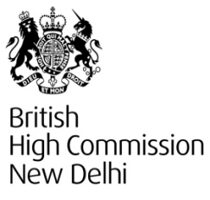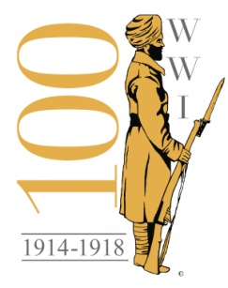
FIRST WORLD WAR CENTENARY COMMEMORATION: RESOURCES FOR MEDIA

- Comprehensive background: https://www.gov.uk/government/topical-events/first-world-war-centenary
- Imperial War Museum (IWM) Commemoration site: http://www.1914.org/
- Digital Postcards: https://www.flickr.com/photos/thedcms/collections/72157644439930043/
- Images of Highclere Castle, War Horse, Blenheim Palace, Cliveden, the Royal Pavilion and The National Museum of the Royal Navy: https://www.dropbox.com/sh/7r00pfyc0pkhaw5/AABGdTvTGN1BCxAuEROqyhHoa
- Images of the British Library and the exhibition Enduring War: Grief, Grit and Humour: http://pressandpolicy.bl.uk/imagelibrary/default.aspx?SubjectID=468&NewsAreaID=3
- Images of Portsmouth’s HMS M33: https://www.dropbox.com/sh/2l5zepdnzwrlu26/AADbOmLRcsWX43yFxp8vpw-5a
- Images of Imperial War Museum (IWM) London’s new First World War Galleries: https://press.iwm.org.uk (Username: First World War; Password: IWM/press)
- Specifically On Brighton: The Royal Pavilion and other buildings in Brighton were used to treat wounded Indian soldiers and a number of special events and exhibitions are taking place as part of WW1 commemorations. A permanent display at the Royal Pavilion provides a fascinating account of how the royal palace was transformed into a military hospital for Indian soldiers who were serving on the Western Front. The story also features in a new exhibition War Stories: Voices for the First World War at Brighton Museum and Art Gallery 12 July 2014 - 1 March 2015 and a display on the seafront, Dr Brighton’s War: Hospitals and Healing in Brighton during WW1 9 July - 31 August.
Further Background:
- http://www.brighton-hove.gov.uk/content/press-release/war-stories-voices-first-world-war
- http://www.visitbrighton.com/first-world-war
- http://www.brighton-hove-rpml.org.uk/WhatsOn/Pages/TheRoyalPavilionEstateandtheFirstWorldWar.aspx
- http://www.brighton-hove-rpml.org.uk/WhatsOn/Pages/DrBrightonsWar9julto31aug2014.aspx
- Press release: http://www.brighton-hove.gov.uk/content/press-release/war-stories-commemorating-centenary-world-war-one-brighton-hove
- More info on the Chattri Memorial service to remember the Indian soldiers who fought in WW1 at the South Downs near Brighton (Sunday 8 June): www.chattri.com; www.black-history.org.uk & www.sikhmuseum.com/brighton
- Images selection: http://www.brighton-hove-rpml.org.uk/HistoryAndCollections/collectionsthemes/pavilionindianhospitalartphotography/Pages/pavilionindianhospitalartphotographs.aspx
- The United Service Institution of India (USI): http://www.usiofindia.org/Projects/View/?pid=72
- UK Punjab Heritage Association: http://news.ukpha.org/
- Details of Exhibition “The Sikhs &WW1”: http://www.empirefaithwar.com/
- Details of Punjab Heritage Association exhibition in the UK “Empire, Faith & War”: https://www.soas.ac.uk/gallery/efw/

