  - : Support for reform
consulatation process
    - In 2006, the Law Commission and the Scottish Law Commission (the Law Commissions) launched the current review of insurance contract law.
    - Consultation has taken place over 7 years, 9 issues papers, 3 consultation papers and several hundred meetings. Set out below are a few key figures demonstrating support for reform from across the insurance market. It covers three areas.
      - Disclosure
      - Insurance warranties
      - Insurers’ remedies for fraudulent claims
Reforming the duty of disclosure
    - In June 2012, the Law Commissions published their third Consultation Paper, “The Business Insured’s Duty of Disclosure and the Law of Warranties”.
    - Consultees were asked whether sections 18 to 20 of the Marine Insurance Act 1906 are in need of reform to clarify the duty of disclosure in business and other non-consumer insurance. Of 45 respondents to this question, 36 (80%) agreed that there is a need for reform (see figure A.1). The detail of the Law Commissions’ proposals was also strongly supported by stakeholders.
Figure A.1: Need for reform of disclosure rules
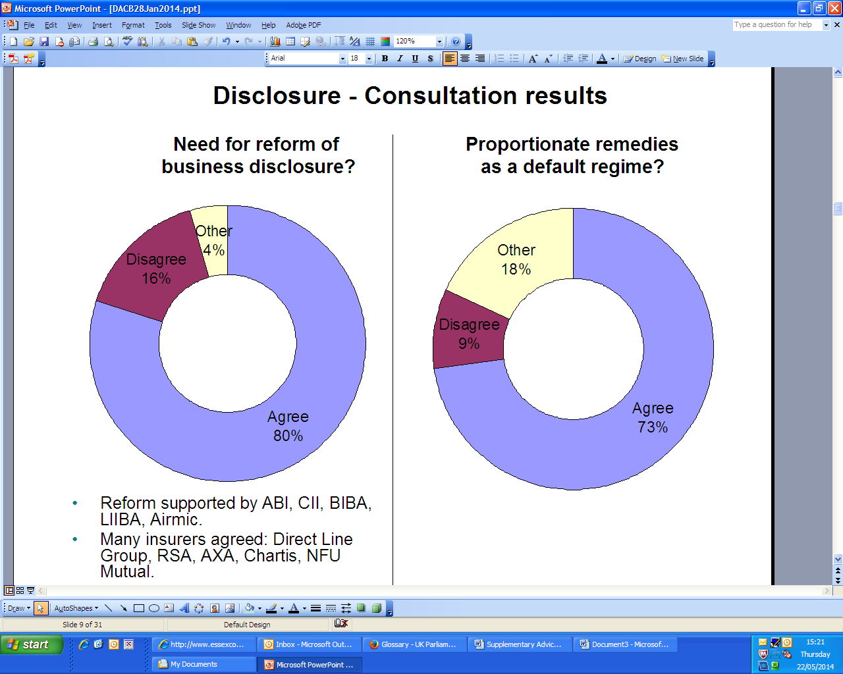

    - The proposals received support from across the insurance market, including insurers, brokers and policyholders, as well as from lawyers, legal academics and members of the judiciary.
    - Notably, reform was supported by the Association of British Insurers (ABI), the Chartered Insurance Institute (CII), the British Insurance Brokers’ Association (BIBA), the London & International Insurance Brokers Association (LIIBA) and Airmic, Group Risk Development (GRiD) and the Investment & Life Assurance Group (ILAG). Many insurers agreed, including Direct Line Group, RSA, AXA, Chartis and NFU Mutual.
    - The ABI commented:
The proposals appear to offer greater clarity for insureds in respect of their duty to disclose and the impact of not disclosing material information. It is in the interests of both insurers and insureds that the duty of disclosure has been complied with, leading to greater certainty that risks are correctly assessed and priced and coverage will be assured.
Reforming the remedies for breach of the duty
    - The Law Commissions also consulted on the regime of remedies that should apply where a policyholder fails in its disclosure duty. The Law Commissions proposed that, where the policyholder’s conduct is not dishonest, proportionate remedies should be the default regime for non-disclosure and misrepresentation in business insurance. Of 44 respondents to this question, 32 (73%) agreed.
    - Only four consultees (9%) disagreed with the proposal, but eight (18%) were classed as “other”. Figure A.2: Proportionate remedies as a default regime in non-consumer insurance.
    - Strong support was received from policyholder groups, brokers and lawyers. Although insurers represented three of the four consultees who disagreed outright with the proposal, a majority of insurers overall supported the reform. The Chartered Insurance Institute commented:
We accept that remedies can be complex in situations where the insurance is bespoke or the risk characteristics are unique, and assessing what the insurer would have done had they been in possession of the information might be difficult. Nevertheless, proposing a range of remedies short of avoidance is the right approach.
Warranties
    - In their 2012 consultation paper, the Law Commissions asked generally whether consultees agreed that there is a need to reform the law of warranties as set out in sections 33 to 34 of the Marine Insurance Act 1906. Of 41 respondents to this question, 36 (88%) agreed. Two consultees (5%) disagreed and three (7%) marked “other”.
Figure A.3: Is there a need to reform the law of warranties?

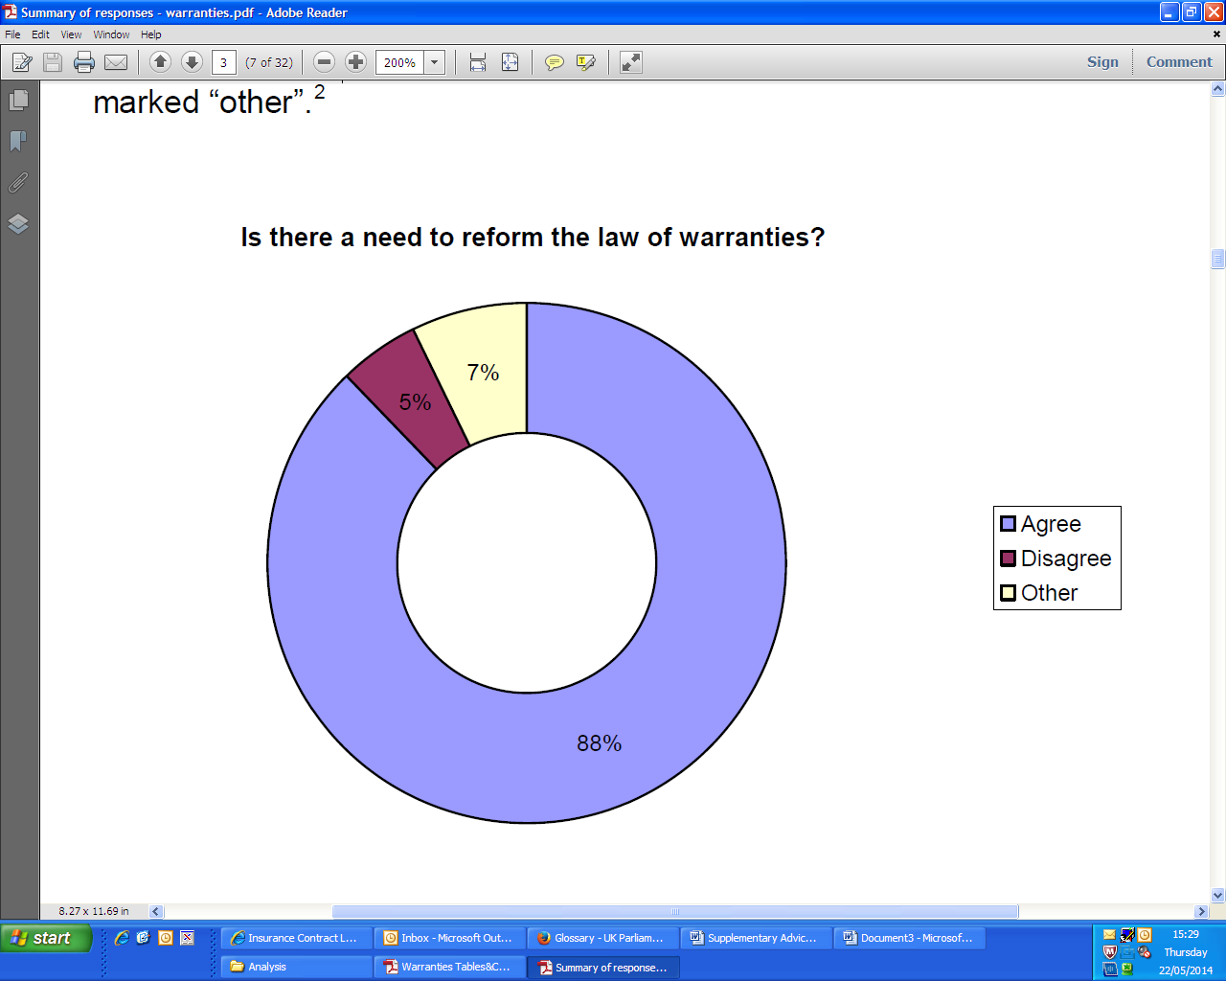
    - RSA’s summarised the views of many consultees:
We consider that the current legal position in relation to warranties is anachronistic, potentially confusing (both within the insurance market and amongst policyholders) and does not reflect what RSA considers to be prudent commercial practice with respect to the commercial arrangements with our customers.
    - Airmic said its members are “overwhelmingly in favour” of reform in this area, and indeed are already looking to make changes in industry practice.
Basis of the contract clauses
    - Consultees were asked whether, in business insurance, a term in a proposal form, contract or accompanying document requiring the policyholder to warrant the accuracy of the answers given, or having the result of converting the answers to warranties by stating that they form the basis of the contract, should be of no effect. Of 41 consultees who answered this question, 32 (78%) agreed with the proposal. Five consultees (12%) disagreed and four (10%) marked “other”.
    - The LMA said:
we would agree that blanket “basis of the contract clauses” in commercial contracts, ie that all representations in the disclosure material be converted to warranties and incorporated into the contract of insurance, should be of no effect.
    - A number of insurers, including AXA and ACE, have already pledged to remove basis of the contract clauses from their policies.
Consequences of a breach of warranty
    - Consultees were asked what the consequences of a breach of warranty should be. Consultees were therefore asked where a warranty is not complied with, the insurer’s liability should be suspended rather than discharged, with liability restored if and when the policyholder remedies the breach (see figure A.4).
    - Of 42 consultees who responded to this question, 33 (79%) agreed with the proposals. Of 38 consultees who commented on the second proposition, 29 (76%) agreed that liability should be restored if the breach is remedied. Only one consultee disagreed. Eight marked “other”.
Figure A.4: Effect of breach of warranty on insurer’s liability
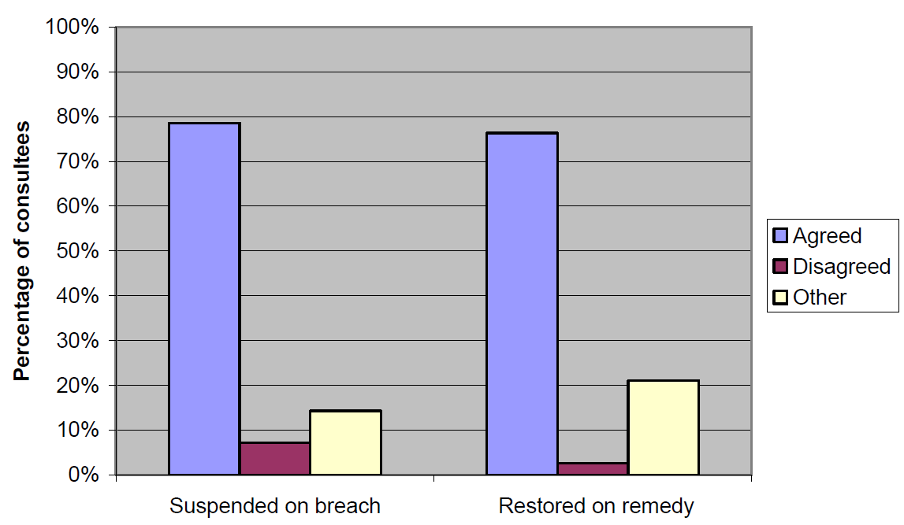
    - RSA said:
We believe that the current legal position whereby a breach of warranty, regardless of rectification, materiality or the absence of any prejudice suffered by an insurer, automatically discharges an insurer from all future liability under a policy, regardless of whether that breach relates to a particular loss or claim event, is overly harsh on policyholders and does not reflect what our commercial customers expect from RSA when they insure with us.
Remedies for fraudulent claims
    - In June 2011, the Law Commissions published their second consultation paper of their review of insurance contract law. They proposed that a policyholder who commits a fraud should:
      - forfeit the whole claim to which the fraud relates;
      - forfeit any claim where the loss arises after the date of the fraud; and
      - be entitled to be paid for any previous valid claim which arose before the fraud took place.
Figure A.5: Insurer’s remedies for fraudulent claims
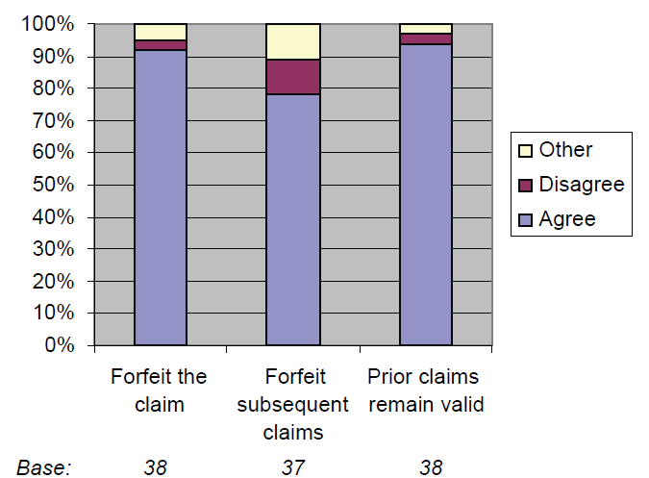
    - The FOS said:
We agree that those who commit fraud should forfeit the whole claim to which the fraud relates and any claim where the loss arises after the date of the fraud – although previous valid claims should be unaffected. This mirrors our current approach to the issue and we welcome the fact that the proposals reflect this.
  - : The Cost of insurance Disputes concerning disclosure and warranties
The cost of disputes over non-Disclosure
    - In 2012, the Law Commissions estimated the cost of insurance disputes over alleged non-disclosure by commercial policyholders before entering a contract. These estimates were based on reported litigation, judicial statistics, a survey of Airmic members and Lord Justice Jackson’s review of the costs of civil litigation. The available evidence is summarised below.
The volume of disputes
    - The duty of disclosure generates considerable litigation. The Law Commissions considered this issue in 2012. They identified 41 reported judgments on the duty of disclosure in a recent 10 year period: 26 High Court judgments and 15 appeals. These form “the tip of the iceberg”. Data from the Judicial Statistics suggests that less than 4% of all litigation commenced in the High Court results in a trial. On this basis, 26 High Court judgments would result from 700 cases where litigation is commenced.
    - The problem mainly involves larger businesses with more than 250 employees, of which there were 6,595 in the UK in 2013. In the AIRMIC survey, 5% of respondents had been involved in litigation on the issue of non-disclosure in the last five years, suggesting around 660 claims in 10 years. This is compatible with the number one might anticipate, based on reported court judgments.
    - There will be an even larger number of disputes which do not involve litigation. In the AIRMIC survey, 31% of participants stated that insurers had raised non-disclosure issues against them in the last five years. Assuming that similar levels of disputes are experienced across all 6.595 large businesses, this suggests something in the region of 4,000 disputes over non-disclosure between large businesses and insurers over 10 years.
    - The reported litigation is therefore “the tip of the iceberg”. The numbers are illustrated figuratively below.
Figure 1: The number of disputes over non-disclosure in commercial insurance over the last 10 years

4,000

Disputes ⁽⁴⁾

600 - 700
Proceedings started ⁽³⁾

15 Appeals ⁽¹⁾

26 High Court judgments ⁽²⁾

The costs of disputes
(1) | 13 cases reported in the Court of Appeal, 2 cases reported in the Court of Session concerning non-disclosure.
(2) | Number of reported High Court cases concerning non-disclosure
(3) | Estimate based upon a 3.7% figure of Queens Bench Division claims proceeding to final judgment. AIRMIC figures suggest that in 10 years 10% of large businesses (>250 employees) litigate over non-disclosure, suggesting that 632 businesses have issued claims.
(4) | Estimate based upon AIRMIC figures that 31% of businesses experience a dispute involving non-disclosure.
    - This level of disputes generates substantial legal costs. This is illustrated by research carried out for Lord Justice Jackson’s review of the costs of civil litigation. The research collected data on the cost of 49 Commercial Court cases where the costs of one part to the dispute were determined by the court. The Law Commissions used these to estimate the cost of a High Court trial, by removing 6 cases which concerned minor pre-trial applications, and 2 cases where insufficient data was presented.
    - Based on the remaining 41 cases, the mean cost for one party was £402,389.41 and the median was £157,200. The high mean reflects a few very expensive cases, including one over £5 million. Clearly, any system in which a single case can add £5 million to total costs is variable and unpredictable. It is thought, however, that it is necessary to include such cases within the average (mean) cost figures as the few very expensive cases contribute so much to the total figures. The costs of an appeal were much less than the costs of a contested trial. In the study, the costs relating to the one appeal were estimated at around £35,000.
    - Based on the Jackson research and on the views of industry experts, the average costs have been estimated as follows:
Costs of non-disclosure disputes in commercial insurance over 10 years
Number of disputes | Average cost per case | Total costs in category (£M)
15 appeals | Additional £35,000 | 0.5
26 High Court judgments | £400,000 | 10.4
624 cases where proceedings were issued (but which did not proceed to trial) | £100,000 | 62.4
6,350 disputes where no proceedings were issued | £25,000 | 158.8
OVERALL COSTS (one party) |  | 232.1
OVERALL COSTS (both parties) |  | 464.2
Average cost per case (both parties) | 116.050

    - On this basis, the average cost across all 4,000 disputes is £116,050. The total overall legal costs associated with disputes over non-disclosure are in the region of £464 million over 10 years, or £46 million a year.
    - As an additional check on this estimate, the Law Commissions looked at the fee income of legal firms dealing with insurance disputes. Based on industry knowledge, they compiled a list of the top 11 firms dealing with insurance coverage disputes. The total turnover of these firms for 2009/10 was £1.7 billion, of which it was estimated that at least 10% is for insurance coverage disputes (an estimated £170 million) and that a quarter of those coverage disputes involve disputes over non-disclosure. This suggests around £42 million spent on solicitors’ fees, but there would be additional costs in barristers’ fees and expert witnesses. This estimate is thought to be consistent with the size of the legal market in this area.
    - In addition to legal fees, policyholders and insurers also incur internal costs in dealing with disputes, both in terms of staff time and in disruption to the business. It is estimated that these additional costs amount to around a quarter of legal fees. This adds £29,000 to the cost of each dispute, and £11.5 million a year to the cost of disputes across the economy as a whole.
    - On the basis of the models, the annual cost of non-disclosure disputes to the UK economy is estimated at £57.5 million.
    - Consideration has been given to whether this estimate should be changed in the light of events since 2012. Although efforts have been made to reduce costs following the Jackson reforms, these are based on the principle of proportionality, and are unlikely to have reduced the cost of large claims over serious insurance disputes. However, given the various uncertainties involved in this calculation, it is preferable to think in terms of a spread of costs. On this basis, the cost of non-disclosure disputes to the UK economy is estimated at around £50 million to £60 million a year.
WARRANTIES
    - In line with the assessment for disclosure, the Law Commissions reviewed the number of cases on warranties since the beginning of 2003 to quantify these factors. They found 28 cases, of which two were Scottish. Seven of these cases were heard by the Court of Appeal and one by the House of Lords. This suggests an even greater rate of cases going to higher courts than for disclosure, around 25%, and again that there are difficulties in applying the law rather than establishing the facts.
    - Using the same methodology as for non-disclosure, it is assumed that 28 reported cases imply that proceedings would have been issued in 700 to 800 disputes.
    - Airmic’s research indicates that 20% of its members have had a claim disputed for breach of warranty within the past three years. Assuming again that breach of warranty primarily affects larger businesses, of which Airmic’s members are typical, approximately 4300 disputes over warranties can be expected in a 10 year period. This is based on a large business population of 6455, of which 6.6% per year will experience an insurance warranty dispute. Thus cases which are litigated to trial represent a small fraction of the number of likely disputes. This is broadly comparable to the level of disputes seen on disclosure.
    - It is believed that the costs of a warranty dispute will be similar to the costs of a disclosure dispute, because their level of factual complexity and legal difficulty are similar. As potential breaches of warranty are often presented together with pre-contractual non-disclosure when a case comes to court, some cost overlap is likely. If this is assumed to occur in 50% of cases, this suggests that the current state of the law may cost around £25m per year. Again, these costs are expected to remain stable over time after allowing for inflation.
    - Adding internal costs amounting to around a quarter of legal fees would add £6.25 million to the cost, making a total £31.25 million.
    - Given the high margin of error, the additional costs of warranty disputes is estimated at between £25 million and £35 million a year.

  - : Specific Impacts
    - This annex contains consideration of any specific impact on statutory equality duties, competition, small firms, human rights and the justice system.
Statutory equality duties
    - Having regard to the guidance on this specific impact test, it is considered that this proposal will have no equality impact. Completion of the screening questions indicated no need for a full equality impact assessment. There will be no impact (adverse or otherwise) on any of the protected characteristics.
Competition
    - Having regard to the filter questions on this specific impact test, it is considered that this proposal will have no negative effect on competition and that a full impact assessment is not required. The filter questions were considered, with the following results.
    - There will be no direct limit on the number or range of suppliers. The proposals concern only the terms on which insurance may be written. Access to the supply side of the insurance market in the UK is controlled by the Prudential Regulation Authority. Other EU insurance regulators also have a role where an insurance undertaking regulated in their jurisdiction exercises passporting rights to open a branch office in the UK. The proposals have no direct effect on these bodies.
    - There will be no indirect restriction on the number or range of suppliers. The proposals represent a default regime which parties can choose to contract out of if they do not consider the proposals to be appropriate for their particular contracts. Indeed, there is no requirement on insurers in the UK to write business under English or Scottish law and an alternative regime may be chosen if more desirable.
    - There is no restriction on the ability to compete. Since insurers will be able to contract out of the proposals, they will be able to offer higher or lower standards of protection to their clients as they see fit.
    - There will be no restriction on suppliers’ incentives to compete vigorously. At present, it is difficult for policyholders to distinguish between insurers who are offering a good product and will not rely on technical legal arguments to escape liability, and those who will. Policyholders therefore tend to buy on price, increasing the likelihood of under-pricing, and consequent market instability. Insurers offering a good quality product remain vulnerable to competitive pressure from others, as long as policyholders do not know how to identify them. Introducing a default regime which meets a basic standard supports insurers who offer a higher quality product. Those who wish to compete on price alone will be able to contract out of the default rules. Purchasers will be able to understand more easily the nature of the product they are buying, while insurers will be able to adopt a wider range of approaches to market positioning more easily than at present.
Small businesses
    - Having regard to the filter questions on this specific impact test, it is considered that this proposal will have no negative effect on small businesses and that a full impact assessment is not required. The filter questions were considered, with the following results.
    - The proposed changes to insurance contracts law will affect small businesses as purchasers of insurance. However, the changes are generally protective of their interests, making it more likely that insurance will respond as expected. The Law Commissions have made enquiries about the need for special protective measures to be taken for small businesses, and included a request for evidence of need in their third consultation paper. No evidence was forthcoming.
    - Independently of the proposals, micro-businesses will still be able to complain to the Financial Ombudsman Service if they feel they have been treated unfairly by their insurer. The Financial Conduct Authority (the FCA) also has power to intervene if consumers (including small businesses) are being treated unfairly by insurers.
    - The proposals will be a default regime for all insurance transactions. Accordingly, they will apply to all types of businesses, rather than any particular group.
    - As the measures are not regulatory ones, there is no need to make alternative provision specifically for small businesses. Insurers are regulated by the FCA. The proposed changes are designed to improve the legal position in favour of small businesses. However, the proposals will function as a default position, all businesses who do not feel the reforms will benefit them will be able to make alternative arrangements.
    - There is no evidence to suggest a greater impact on the operations and performance of small businesses than others as a result of the proposals. Evidence gathered to date suggests that problems on disclosure and warranties in insurance contracts are suffered more severely by large companies than small ones. Insofar as there is an impact on small businesses, it is considered that the overall effect this will be positive.
Justice
    - The main impact on the court system is the possibility of some additional appellate disputes, estimated at no more than 3-4 a year over the next 10 years, In the longer term, there may be a fall in the number of High Court disputes, though most insurance disputes are conducted by some form of alternative dispute resolution, such as arbitration.
Other specific impacts
    - It is not considered that there will be any impacts on rural proofing, the environment, sustainable development or health.

For further information and discussion, see: Summary of responses to Joint Consultation Paper on Post Contract Duties and other Issues: Insurers’ Remedies for Fraudulent Claims (December 2012); and Summaries of responses to Joint Consultation Paper on The Business Insured's Duty of Disclosure and the Law of Warranties: Disclosure (March 2013) and Warranties (March 2013). Available at http://lawcommission.justice.gov.uk/areas/insurance-contract-law.htm and http://www.scotlawcom.gov.uk/law-reform-projects/joint-projects/insurance-law.
Insurance Contract Law: The Business Insured’s Duty of Disclosure and the Law of Warranties, the Law Commission and the Scottish Law Commission, LCCP 204 / SLCDP 155 (June 2012).
The Consumer Insurance (Disclosure and Representations) Act 2012 abolished the duty of disclosure for consumer insurance contracts and replaced it with a duty to take reasonable care not to make misrepresentations.
See the Law Commissions’ Summary of Responses – Disclosure (March 2013) for further information: http://lawcommission.justice.gov.uk/docs/duty-of-disclosure_responses_duty.pdf
Commercial Risk Europe, “Second leading insurer removes basis clauses from UK contracts”, 4 July 2013.
Insurance Contract Law: Post Contract Duties and other Issues (December 2011) Law Commission Consultation Paper No 201; Scottish Law Commission Discussion Paper No 152. http://lawcommission.justice.gov.uk/docs/cp201_ICL_post_contract_duties.pdf. The summary of responses is at http://lawcommission.justice.gov.uk/docs/insurers-remedies-for-fraud_responses.pdf.
Between January 2002 and January 2012.
See Ministry of Justice, Judicial and Court Statistics 2010 (June 2011) p 134. Out of 4,864 claims issued in the Queens Bench Division at the Royal Courts of Justice, 182 went to trial (representing 3.7% of claims issued).
BIS, Business Population Estimates for the UK 2011, Table 1.
Airmic, Non-disclosure of material information – Member Survey (2010).
Jackson LJ, Review of Civil Litigation Costs: Preliminary Report (2011), Appendix 9.
These cases all cost less than £20,000 and clearly did not involve trials.
One case settled for a sum combining both damages and costs and another included the costs of the subsequent appeal which could not be disaggregated from the data.
This turnover information for 2009/10 was obtained from The Lawyer’s online directory of UK firms, http://www.thelawyer.com/directory/uk-firms/.
Airmic, Pre-conference Survey 2013.
BIS, Business Population Estimate for the UK 2012.
This is discussed in the body of the impact assessment.

