UK Standards for Microbiology Investigations

Type SMI Title front cover here <tab+enter>

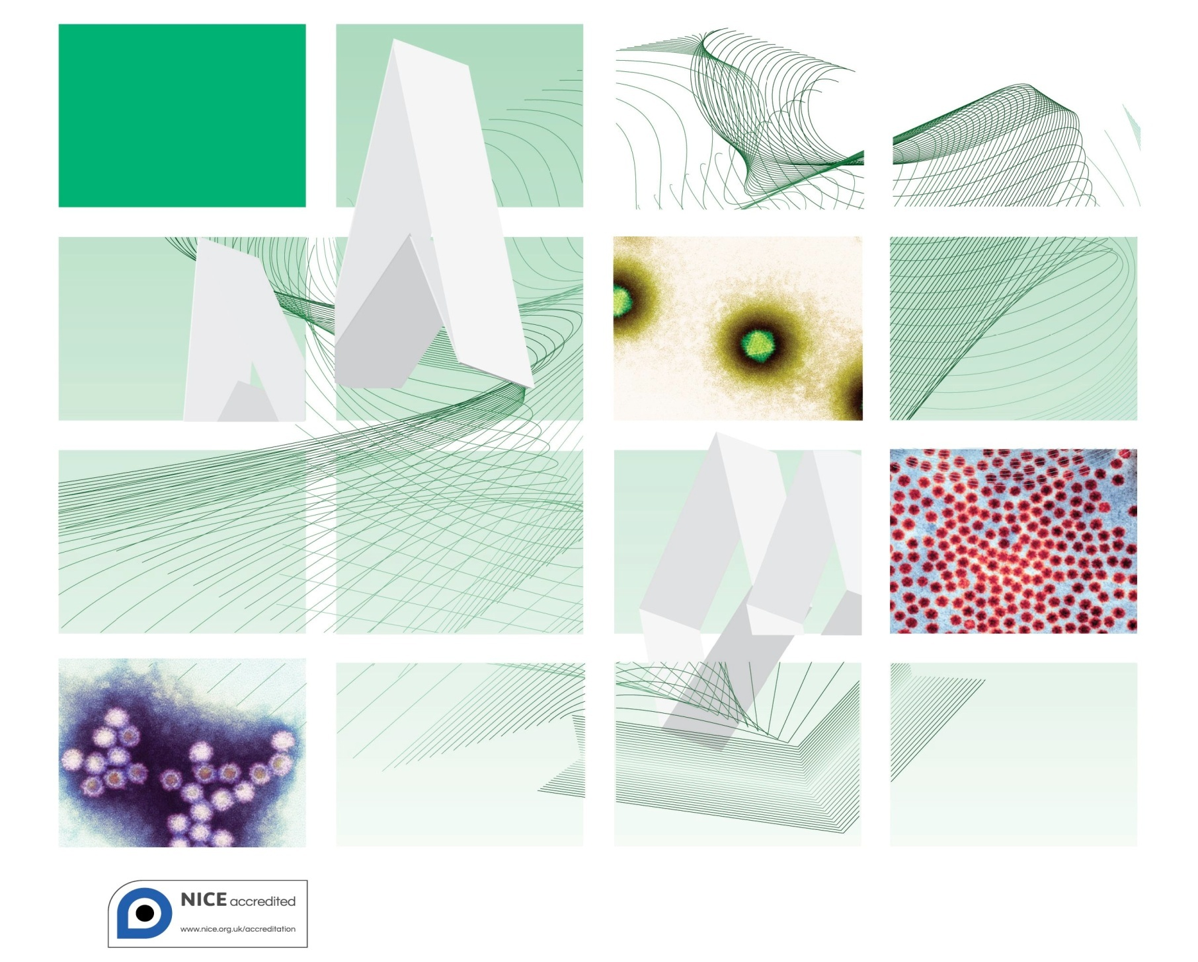

Acknowledgments
UK Standards for Microbiology Investigations (SMIs) are developed under the auspices of Public Health England (PHE) working in partnership with the National Health Service (NHS), Public Health Wales and with the professional organisations whose logos are displayed below and listed on the website http://www.hpa.org.uk/SMI/Partnerships. SMIs are developed, reviewed and revised by various working groups which are overseen by a steering committee (see http://www.hpa.org.uk/SMI/WorkingGroups).
The contributions of many individuals in clinical, specialist and reference laboratories who have provided information and comments during the development of this document are acknowledged. We are grateful to the Medical Editors for editing the medical content.
For further information please contact us at:
Standards Unit
Microbiology Services
Public Health England
61 Colindale Avenue
London NW9 5EQ
E-mail: standards@phe.gov.uk
Website: http://www.hpa.org.uk/SMI
UK Standards for Microbiology Investigations are produced in association with:

Contents
Acknowledgments 2
Contents 3
Amendment Table 4
UK Standards for Microbiology Investigations: Scope and Purpose 5
Scope of Document 8
Introduction 8
Technical Information/Limitations 8
1 Safety Considerations 9
2 Specimen Collection 9
3 Specimen Transport and Storage 9
4 Equipment and Reagents 10
5 Specimen Processing/Procedure 10
6 Quality Assurance 12
7 Limitations 12
8 Reporting Procedure 12
9 Notification to PHE or Equivalent in the Devolved Administrations 13
References 14

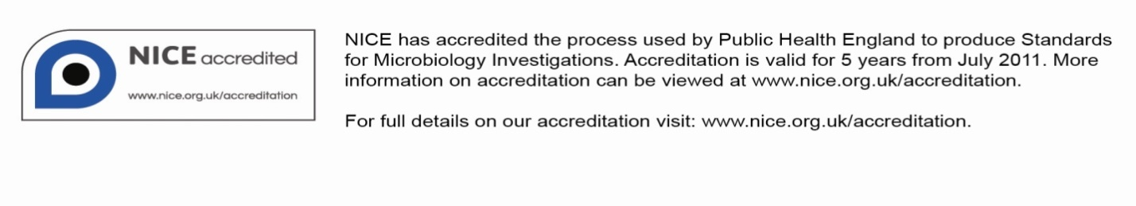
Amendment Table
Each SMI method has an individual record of amendments. The current amendments are listed on this page. The amendment history is available from standards@phe.gov.uk.
New or revised documents should be controlled within the laboratory in accordance with the local quality management system.
Amendment No/Date. | 3/dd.mm.yy <tab+enter>
Issue no. discarded. | #.# <tab+enter>
Insert Issue no. | #.# <tab+enter>
Section(s) involved | Amendment
Whole document. | Document has been transferred to a new template to reflect the Health Protection Agency’s transition to Public Health England.  Front page has been redesigned.  Status page has been renamed as Scope and Purpose and updated as appropriate.  Professional body logos have been reviewed and updated.  Standard safety references have been reviewed and updated.  Scientific content remains unchanged.

Amendment No/Date. | # <tab+enter>/dd.mm.yy <tab+enter>
Issue no. discarded. | #.# <tab+enter>
Insert Issue no. | #.# <tab+enter>
Section(s) involved | Amendment
Whole document. | Document presented in a new format.
References. | Some references updated.
UK Standards for Microbiology Investigations#: Scope and Purpose
Users of SMIs
- SMIs are primarily intended as a general resource for practising professionals operating in the field of laboratory medicine and infection specialties in the UK
- SMIs provide clinicians with information about the available test repertoire and the standard of laboratory services they should expect for the investigation of infection in their patients, as well as providing information that aids the electronic ordering of appropriate tests
- SMIs provide commissioners of healthcare services with the appropriateness and standard of microbiology investigations they should be seeking as part of the clinical and public health care package for their population
Background to SMIs
SMIs comprise a collection of recommended algorithms and procedures covering all stages of the investigative process in microbiology from the pre-analytical (clinical syndrome) stage to the analytical (laboratory testing) and post analytical (result interpretation and reporting) stages.
Syndromic algorithms are supported by more detailed documents containing advice on the investigation of specific diseases and infections. Guidance notes cover the clinical background, differential diagnosis, and appropriate investigation of particular clinical conditions. Quality guidance notes describe laboratory processes which underpin quality, for example assay validation.
Standardisation of the diagnostic process through the application of SMIs helps to assure the equivalence of investigation strategies in different laboratories across the UK and is essential for public health surveillance, research and development activities.
Equal Partnership Working
SMIs are developed in equal partnership with PHE, NHS, Royal College of Pathologists and professional societies.
The list of participating societies may be found at http://www.hpa.org.uk/SMI/Partnerships. Inclusion of a logo in an SMI indicates participation of the society in equal partnership and support for the objectives and process of preparing SMIs. Nominees of professional societies are members of the Steering Committee and Working Groups which develop SMIs. The views of nominees cannot be rigorously representative of the members of their nominating organisations nor the corporate views of their organisations. Nominees act as a conduit for two way reporting and dialogue. Representative views are sought through the consultation process.
SMIs are developed, reviewed and updated through a wide consultation process.
Quality Assurance
NICE has accredited the process used by the SMI Working Groups to produce SMIs. The accreditation is applicable to all guidance produced since October 2009. The process for the development of SMIs is certified to ISO 9001:2008.
SMIs represent a good standard of practice to which all clinical and public health microbiology laboratories in the UK are expected to work. SMIs are NICE accredited and represent neither minimum standards of practice nor the highest level of complex laboratory investigation possible. In using SMIs, laboratories should take account of local requirements and undertake additional investigations where appropriate. SMIs help laboratories to meet accreditation requirements by promoting high quality practices which are auditable. SMIs also provide a reference point for method development.
The performance of SMIs depends on competent staff and appropriate quality reagents and equipment. Laboratories should ensure that all commercial and in-house tests have been validated and shown to be fit for purpose. Laboratories should participate in external quality assessment schemes and undertake relevant internal quality control procedures.
Patient and Public Involvement
The SMI Working Groups are committed to patient and public involvement in the development of SMIs. By involving the public, health professionals, scientists and voluntary organisations the resulting SMI will be robust and meet the needs of the user. An opportunity is given to members of the public to contribute to consultations through our open access website.
Information Governance and Equality
PHE is a Caldicott compliant organisation. It seeks to take every possible precaution to prevent unauthorised disclosure of patient details and to ensure that patient-related records are kept under secure conditions.
The development of SMIs are subject to PHE Equality objectives http://www.hpa.org.uk/webc/HPAwebFile/HPAweb_C/1317133470313. The SMI Working Groups are committed to achieving the equality objectives by effective consultation with members of the public, partners, stakeholders and specialist interest groups.
Legal Statement
Whilst every care has been taken in the preparation of SMIs, PHE and any supporting organisation, shall, to the greatest extent possible under any applicable law, exclude liability for all losses, costs, claims, damages or expenses arising out of or connected with the use of an SMI or any information contained therein. If alterations are made to an SMI, it must be made clear where and by whom such changes have been made.
The evidence base and microbial taxonomy for the SMI is as complete as possible at the time of issue. Any omissions and new material will be considered at the next review. These standards can only be superseded by revisions of the standard, legislative action, or by NICE accredited guidance.
SMIs are Crown copyright which should be acknowledged where appropriate.
Suggested Citation for this Document
Public Health England. (YYYY <tab+enter>). Type SMI Title here <tab+enter>. UK Standards for Microbiology Investigations. V # <tab+enter> Issue #.# <tab+enter>. http://www.hpa.org.uk/SMI/pdf.

Scope of Document
The SMI describes the procedure for carrying out haemadsorption of viruses.
This SMI should be used in conjunction with other SMIs.
Introduction
Many viruses (eg influenza, parainfluenza, measles and mumps virus and some picornaviruses) contain surface glycoproteins known as haemagglutinins (HA). These are capable of binding red blood cells. As these viruses replicate in cell culture, HA molecules appear on the cell surface. If red blood cells of the appropriate species are added to the cell culture tube in which the virus is replicating, they will adhere to the cell sheet – a phenomenon known as haemadsorption¹. The presence of haemadsorbing viruses can therefore be detected several days before a cytopathic effect becomes apparent. Identification can then be confirmed using methods such as haemagglutination inhibition, haemadsorption inhibition, or, most commonly nowadays, immunofluorescence.
This document does not cover the principles of cell culture which can be found in V 39 – Procedure for the Care and Propagation of Cell Cultures for Virus Isolation.
Technical Information/Limitations
N/A
1 Safety Considerations²⁻¹⁸
1.1 Specimen Collection^{2,3}
Hazard labelling according to local policy.
1.2 Specimen Transport and Storage²⁻⁷
Compliance with current postal and courier transportation regulations is essential.
A suitable virus transport system must be used and the specimen should be placed in a sealed plastic bag, separately from the request form.
1.3 Specimen Processing²⁻¹⁸
Laboratory procedures that may give rise to infectious aerosols must be conducted in a class 1 microbiological safety cabinet (MSC).
It is strongly recommended that disposable gloves are worn when inoculating samples or manipulating cell cultures.
2 Specimen Collection
2.1 Type of Specimens
Respiratory specimens.
2.2 Optimal Time of Specimen Collection
Respiratory specimens are the most successful sample type and should be taken as soon as possible after symptoms appear and no later than five days after onset. All specimens should be taken before anti-viral chemotherapy is commenced.
Successful recovery of a virus from clinical specimens depends on the quality of material received for inoculation. Many viruses are susceptible to drying, adverse pH and varying osmotic potential. For this reason, samples should be placed in virus transport medium immediately after they have been taken. Duplicate specimens may be required for the exclusion of other microbial pathogens.
2.3 Correct Specimen Type and Method of Collection
N/A
2.4 Adequate Quantity and Appropriate Number of Specimens
N/A
3 Specimen Transport and Storage^{2,3}
3.1 Time between Specimen Collection and Processing
Specimens should be transported to the laboratory and processed as soon as possible. Specimens that may be delayed should be refrigerated prior to transportation to the laboratory. Samples should be refrigerated at 4°C if there is likely to be a delay in processing. If the delay is likely to exceed 24 hours the sample should be stored at -70°C and thawed prior to processing. Repeated freezing and thawing should be avoided.
3.2 Special Considerations to Minimise Deterioration
N/A
4 Equipment and Reagents
4.1 Equipment
- Sterile pipettes
4.2 Reagents
- Guinea Pig Red blood cells (RBCs) are stored in the buffer in which the cells were received at 2°C to 8°C. Cells expire ten days after they are drawn from the animal and should be discarded in autoclavable waste
- Sterile, 10 times phosphate buffered saline is prepared and is then diluted to one times using sterile, filtered, distilled water. This should then be stored at 2°C to 8°C
- Viral culture maintenance medium with antibiotics
- Positive control virus (parainfluenza virus) in tube of PLC/PRF/5 line which is used instead of Rhesus Monkey Kidney (RMK) cells (RMKs are no longer available in the UK from April 2006 for ethical reasons ) or Madin Darby dog kidney cells (MDCK)
- Negative control in uninoculated tube of current lot of PLC/PRF/5 cells or Madin Darby dog kidney cells (MDCK)
5 Specimen Processing/Procedure^{2,3}
5.1 Test selection
N/A
5.2 Culture and investigation
Preparation of RBCs¹⁹
- Transfer RBCs to 15mL conical centrifuge tube. Centrifuge for five minutes at 500×g. Aspirate supernatant and Buffy coat
- Resuspend RBCs in cold (2°C to 8°C) PBS. Wash in cold PBS until supernatant is clear (two to three times)
- Aspirate PBS after last wash. Measure remaining volume of cells using graduations on centrifuge tube. Add a sufficient amount of PBS to make a 10% cell solution
- Haemadsorption is made using a 0.4% RBCs solution prepared with cell maintenance medium
Haemadsorption¹⁹
- Wear gloves during the procedure and carry it out in a Class I or Class II safety cabinet
- Aspirate maintenance medium from the patient tubes and control tubes to be tested so that the cell monolayer is exposed
- Add 0.2mL of the 0.4% RBC suspension to each tube. Be careful not to cross contaminate the tubes. Positive and negative tubes should be tested last
- Gently tilt the stationary rack from side to side to ensure RBC contact with cell monolayer. Place stationary rack at 4°C for thirty minutes. Tubes should be placed horizontally so that the erythrocyte suspension covers the monolayer of cells
- Invert tubes quickly, following incubation, to dislodge RBCs lying on the cell sheet
- Examine the cell culture tube under light microscope with 4× objective for RBCs that are adherent to the monolayer. All tubes should be read as soon as possible after their removal from the fridge
- Pour off the RBCs. Then wash the cells with PBS and add maintenance medium on those that require further incubation
5.3 Identification
Negative - No haemadsorption of RBCs and no haemagglutination of cells in fluid medium. RBCs float freely in the medium.
Positive - Haemadsorption of RBCs to infected cells or haemagglutination of RBCs in fluid medium. Differentiation of virus type should be carried out by IF.
Picture of haemadsorption of influenza in medium in primary monkey kidney cells
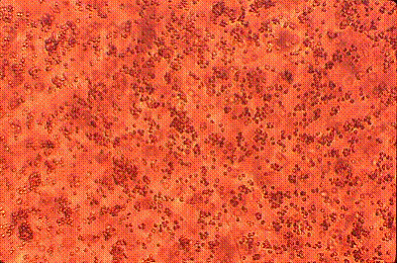
Picture courtesy of Dr Ken Mutton

6 Quality Assurance^{20,21}
See Q 2 – Quality Assurance in the Diagnostic Virology and Serology Laboratory.
6.1 Assessment of preparation
A quality system should be in place to ensure that appropriate internal and external quality assessment and quality control procedures are maintained.
It is essential that laboratories have evidence of adequate validation of methods, equipment and commercial and in-house test procedures demonstrating that they are fit for purpose.
6.2 Internal and external quality assurance
N/A
7 Limitations
Successful isolation of organisms depends on correct specimen collection, transport, storage and processing; the quality and range of cell lines used and the use of correct conditions for culture and the provision of adequate/suitable clinical information.
Only cell lines proven to be susceptible to respiratory viruses should be used and susceptibility should be checked on acquisition and at regular intervals. Cells retrieved from liquid nitrogen storage should be checked for sensitivity before use.
The procedure(s) in these documents aim to describe good microbiological standards for the specimen types specified. Other procedures may be required and professional interpretation by qualified staff is essential. Please note that knowledge of infectious diseases changes constantly and although this SMI is under regular review it may not include emerging pathogens.
The above guidance should be supplemented with local assessments of limitations.
8 Reporting Procedure
8.1 Reports
Negative tubes should be reported as eg “Virus not isolated”.
Positive tubes should be reported as eg “Haemadsorbing virus isolated”.
If further tests are to be carried out, a report should be issued stating further results are pending. As all influenza and parainfluenza viruses haemadsorb confirmation of the patient’s virus type or subtype should be done.
8.2 Reporting Time
The identification of a haemadsorbing virus should be carried out as soon as possible and should usually allow reporting of a positive identified virus culture within the working day on which heamadsorption was first recognised. Where delay in identification is unavoidable a hard copy interim report should be issued stating eg “A haemadsorbing virus has been isolated in cell culture. Identification to follow.” The clinician should be telephoned with this information to allow a discussion of the likely identity of the virus.
9 Notification to PHE^{22,23} or Equivalent in the Devolved Administrations²⁴⁻²⁷
The Health Protection (Notification) regulations 2010 require diagnostic laboratories to notify Public Health England (PHE) when they identify the causative agents that are listed in Schedule 2 of the Regulations. Notifications must be provided in writing, on paper or electronically, within seven days. Urgent cases should be notified orally and as soon as possible, recommended within 24 hours. These should be followed up by written notification within seven days. For the purposes of the Notification Regulations, the recipient of laboratory notifications is the local PHE Health Protection Team. If a case has already been notified by a registered medical practitioner, the diagnostic laboratory is still required to notify the case if they identify any evidence of an infection caused by a notifiable causative agent.
Notification under the Health Protection (Notification) Regulations 2010 does not replace voluntary reporting to PHE. The vast majority of NHS laboratories voluntarily report a wide range of laboratory diagnoses of causative agents to PHE and many PHE Health Protection Teams have agreements with local laboratories for urgent reporting of some infections. This should continue.
Note: The Health Protection Legislation Guidance (2010) includes reporting of HIV & STIs, HCAIs and CJD under ‘Notification Duties of Registered Medical Practitioners’: it is not noted under ‘Notification Duties of Diagnostic Laboratories’.
Other arrangements exist in Scotland^{24,25}, Wales²⁶ and Northern Ireland²⁷.

References
1. Koneman EW, Allen S D, Janda W M, Schreckenberger P C, Winn W J, editors. Color Atlas and Textbook of Diagnostic Microbiology. 5th ed. Philadelphia: Lippincott Williams and Wilkins; 1997. p. 1241
2. European Parliament. UK Standards for Microbiology Investigations (SMIs) use the term "CE marked leak proof container" to describe containers bearing the CE marking used for the collection and transport of clinical specimens. The requirements for specimen containers are given in the EU in vitro Diagnostic Medical Devices Directive (98/79/EC Annex 1 B 2.1) which states: "The design must allow easy handling and, where necessary, reduce as far as possible contamination of, and leakage from, the device during use and, in the case of specimen receptacles, the risk of contamination of the specimen. The manufacturing processes must be appropriate for these purposes".
3. Official Journal of the European Communities. Directive 98/79/EC of the European Parliament and of the Council of 27 October 1998 on in vitro diagnostic medical devices. 7-12-1998. p. 1-37.
4. Health and Safety Executive. Safe use of pneumatic air tube transport systems for pathology specimens. 9/99.
5. Department for transport. Transport of Infectious Substances, 2011 Revision 5. 2011.
6. World Health Organization. Guidance on regulations for the Transport of Infectious Substances 2013-2014. 2012.
7. Home Office. Anti-terrorism, Crime and Security Act. 2001 (as amended).
8. Advisory Committee on Dangerous Pathogens. The Approved List of Biological Agents. Health and Safety Executive. 2013. p. 1-32
9. Advisory Committee on Dangerous Pathogens. Infections at work: Controlling the risks. Her Majesty's Stationery Office. 2003.
10. Advisory Committee on Dangerous Pathogens. Biological agents: Managing the risks in laboratories and healthcare premises. Health and Safety Executive. 2005.
11. Advisory Committee on Dangerous Pathogens. Biological Agents: Managing the Risks in Laboratories and Healthcare Premises. Appendix 1.2 Transport of Infectious Substances - Revision. Health and Safety Executive. 2008.
12. Centers for Disease Control and Prevention. Guidelines for Safe Work Practices in Human and Animal Medical Diagnostic Laboratories. MMWR Surveill Summ 2012;61:1-102.
13. Health and Safety Executive. Control of Substances Hazardous to Health Regulations. The Control of Substances Hazardous to Health Regulations 2002. 5th ed. HSE Books; 2002.
14. Health and Safety Executive. Five Steps to Risk Assessment: A Step by Step Guide to a Safer and Healthier Workplace. HSE Books. 2002.
15. Health and Safety Executive. A Guide to Risk Assessment Requirements: Common Provisions in Health and Safety Law. HSE Books. 2002.
16. Health Services Advisory Committee. Safe Working and the Prevention of Infection in Clinical Laboratories and Similar Facilities. HSE Books. 2003.
17. British Standards Institution (BSI). BS EN12469 - Biotechnology - performance criteria for microbiological safety cabinets. 2000.
18. British Standards Institution (BSI). BS 5726:2005 - Microbiological safety cabinets. Information to be supplied by the purchaser and to the vendor and to the installer, and siting and use of cabinets. Recommendations and guidance. 24-3-2005. p. 1-14
19. Cann AJ, editor. Virus Culture A Practical Approach. Oxford: Oxford University Press; 1999. p. 54-5
20. Snell JJS, Brown DFJ, Roberts C, editors. Quality Assurance Principles and Practice in the Microbiology Laboratory. London: Public Health Laboratory Service; 1999. p. 147-8
21. Clinical Pathology Accreditation (UK) Ltd. Standards for the Medical Laboratory. Clinical Pathology Accreditation (UK) Ltd. Sheffield: 2004. p. 1-56.
22. Public Health England. Laboratory Reporting to Public Health England: A Guide for Diagnostic Laboratories. 2013. p. 1-37
23. Department of Health. Health Protection Legislation (England) Guidance. 2010. p. 1-112.
24. Scottish Government. Public Health (Scotland) Act. 2008 (as amended).
25. Scottish Government. Public Health etc. (Scotland) Act 2008. Implementation of Part 2: Notifiable Diseases, Organisms and Health Risk States. 2009.
26. The Welsh Assembly Government. Health Protection Legislation (Wales) Guidance. 2010.
27. Home Office. Public Health Act (Northern Ireland) 1967 Chapter 36. 1967 (as amended).

Microbiology is used as a generic term to include the two GMC-recognised specialties of Medical Microbiology (which includes Bacteriology, Mycology and Parasitology) and Medical Virology.

