Individual Insolvencies by Region, England and Wales, 2013

Coverage  England and Wales  Release date  10 July 2014  Frequency of release  Annual  Next update  July 2015  Media enquiries  Kathryn Montague  +44 (0)20 7674 6910  Ade Daramy  +44 (0)20 7596 6187  Lead Statistician  John Perrett  statistics@insolvency.gsi.gov.uk  +44 (0)20 7637 6504  Issued by  The Insolvency Service  4 Abbey Orchard Street  London  SW1P 2HT  Website  https://www.gov.uk/government/organisations/insolvency-service  Reference  Ins/Coms/070 | This statistical release provides breakdowns of individual insolvencies in England and Wales, at region, county, unitary authority and local authority levels. It also includes age and gender breakdowns of individual insolvencies at region level. The statistics cover the calendar years 2000 to 2013, including revisions to data from 2000 to 2012 where applicable.  Key facts  - The total insolvency rate decreased in all regions, but the individual voluntary arrangement rate increased.  - The North East continued to have the highest insolvency rates, while London had the lowest.  - Areas with the highest insolvency rates were concentrated in seaside resort areas, parts of the North East, South West and East Midlands.  - The gap between male and female insolvency rates narrowed.  - Insolvency rates among those aged under 35 were higher for women than men.  .
Removal of “Experimental Statistics” designation
Individual Insolvencies by Region was first published in 2009, covering the period 2000-2008. It has been as designated as Experimental Statistics – new Official Statistics which are undergoing evaluation – each year since then.
In 2013, the Insolvency Service consulted users about the usefulness of these statistics and acted on feedback received. The methods used to produce these statistics are stable and so the Insolvency Service has removed the Experimental Statistics designation.
These statistics will be designated as Official Statistics until they have been assessed by the UK Statistics Authority, who will judge whether they meet the quality standards of National Statistics.
Contents
 |  | Page
1 | Definitions | 2
2 | Summary | 3
3 | Total individual insolvencies | 4
4 | Bankruptcies | 8
5 | Debt relief orders | 12
6 | Individual voluntary arrangements | 16
7 | Age and gender analysis | 20
8 | Background notes | 24

1. Definitions
Bankruptcy | A form of debt relief available for anyone who is unable to pay their debts. Assets owned will transfer to a trustee in bankruptcy who will realise them and distribute the proceeds to creditors. Discharge from debts usually takes places 12 months after the bankruptcy order is granted. A trustee may be a licensed insolvency practitioner or may be the official receiver.
Debt relief order (DRO) | A form of debt relief available to those who have a low income, low assets and less than £15,000 of debt. There is no distribution to creditors, and discharge from debts takes place 12 months after the DRO is granted.
Individual voluntary arrangement (IVA) | A voluntary means of repaying creditors some or all of what they are owed. Once approved by 75% or more of the creditors, the arrangement is binding on all. IVAs are supervised by licensed insolvency practitioners.
Rate per 10,000 adults | The number of insolvencies divided by the number of people aged 18 or over, multiplied by 10,000. A rate of 100 insolvencies per 10,000 adults is equivalent to 1% of the adult population.
Total individual insolvencies | The sum of bankruptcies, DROs and IVAs.

2. Summary

- The rate of total individual insolvencies per 10,000 adults in England and Wales followed an increasing trend from 7.2 in 2000 to a peak of 30.9 in 2009; since then the rate has fallen each year to 22.4 in 2013. This pattern has been driven by a number of factors including the rapid increase and subsequent decline in bankruptcies over the same period, the rapid increase in registration of IVAs between 2004 and 2006, and the introduction in 2009 and subsequent increase in the number of DROs.

Regions
- The total insolvency rate per 10,000 adults decreased in all regions of England and Wales between 2012 and 2013. Insolvency rates at regional level have broadly followed the same trend exhibited by England and Wales as a whole since 2000, with some variation in the peak year for the rate, the steepness of the initial increase and the slope of the following decline.
- The bankruptcy rate per 10,000 adults decreased in all regions of England and Wales between 2012 and 2013, in a continuation of a downward trend seen since 2009. The DRO rate per 10,000 adults decreased for the first time since their introduction, in all regions; conversely, the IVA rate per 10,000 adults increased between 2012 and 2013 in all regions, having decreased in the previous two years.
- The North East had the highest total individual insolvency rate in England and Wales in 2013, at 30.6 per 10,000 adults; this region has had the highest rate since 2008. The North East also had the highest rates of bankruptcy and IVA in 2013, but the South West had the highest rate of DRO in 2013. London had the lowest rates for each type of individual insolvency.

Local authorities
- Local authority areas in London and the Home Counties had the lowest rates for each type of individual insolvency in 2013.
- Many of the areas with the highest individual insolvency rate per 10,000 people were in local authorities with seaside resorts – for example Torbay (Torquay), Denbighshire (Rhyl), Blackpool and Scarborough – but this pattern varied by insolvency procedure.
- Other local authorities in England and Wales with higher insolvency rates included parts of the North East, South West and East Midlands.

Age and gender variations
- The individual insolvency rate per 10,000 adults was higher for males (22.6) than for females (22.1) for England and Wales in 2013. The difference has narrowed substantially in recent years, with insolvency rates having decreased more quickly for males than females since 2009. In four regions, the insolvency rate for females was higher than that for males.
- Insolvency rates were highest among the 35-44 age group for both males and females.
- In the 18 to 24 and 25 to 34 age groups, insolvency rates were higher for females than males.

More detailed information on total individual insolvency rates, and those for each of the three insolvency procedures, is provided in the following pages, and in the detailed tables on the Insolvency Service website.

3. Total Individual Insolvencies (including bankruptcies, DROs and IVAs)

- The rate of total individual insolvencies per 10,000 adults in England and Wales fell to 22.4 in 2013 from 24.5 in 2012, having followed a decreasing trend since the peak of 30.9 in 2009, as shown in Figure 1 below.

- The North East had the highest total individual insolvency rate in 2013 at 30.6 per 10,000 adults (8.2 higher than England and Wales), followed by the South West at 26.4 (4.0 higher than England and Wales). London had the lowest rate in 2013 at 13.9 (8.5 lower than England and Wales).

- The rate for most regions has followed a similar decreasing trend since 2009 to that for England and Wales as a whole, as shown in Figure 2 below. Comparing the rate for each region in 2013 with its highest peak since 2000, the East Midlands showed the largest decrease, at 11.4 per 10,000 adults, while London showed the smallest decrease, at 5.7 (compared with a decrease of 8.5 in England and Wales).

- The local authority with the highest total individual insolvency rate in 2013 was Torbay with a rate of 47.2 per 10,000 adult population (in 2012 Torbay also had the highest total individual insolvency rate, at 53.8), the lowest was Isles of Scilly at 5.3 (see Table 1 below; the distribution of local authorities by total individual insolvency rate is given in Figure 4 below). The lowest in 2012 was Harrow at 9.9. In 2013 the highest four insolvency rates were in coastal areas (Torbay, Denbighshire, Blackpool and Scarborough). By comparison seven out of the ten areas with the lowest insolvency rates were in London.

- Local authorities with lower total individual insolvency rates (represented by lighter shades in Figure 3 below) tended to be concentrated around London and the Home Counties, while many of those local authorities with higher individual insolvency rates (represented by darker shades in Figure 3 below) were in the South West, East Midlands and North East regions.

- The total insolvency rate was lower in 2013 than in 2012 in 276 out of 348 local authorities. The largest decrease in the rate was in Isles of Scilly at 15.8 per 10,000 adults (though this represented a decrease from four insolvencies to one); the largest increase was in Rossendale at 7.1 per 10,000 adults.

Figure 1: Total individual insolvencies per 10,000 adult population, England & Wales, 2000 to 2013

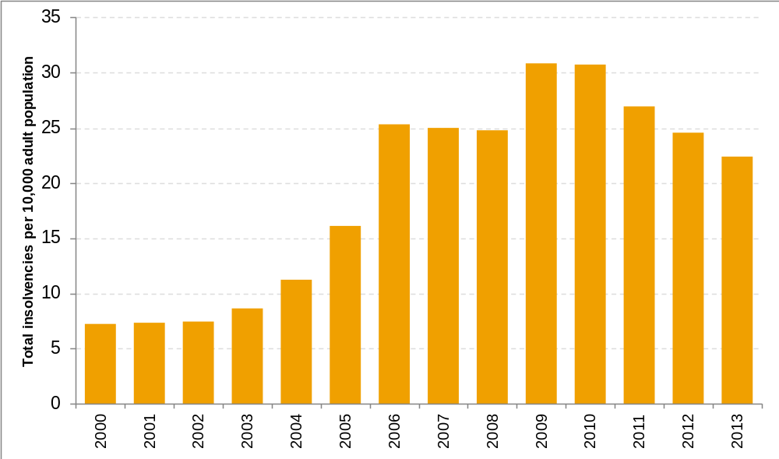

Figure 2: Total individual insolvencies per 10,000 adult population by region, England and Wales, 2011 to 2013

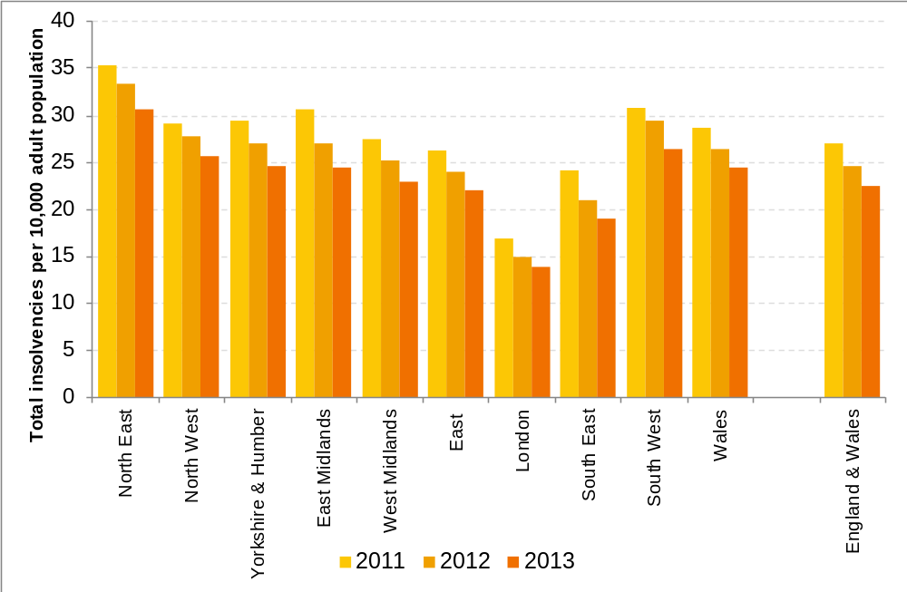
Figure 3: Total individual insolvencies per 10,000 adult population by local authority, England and Wales, 2013
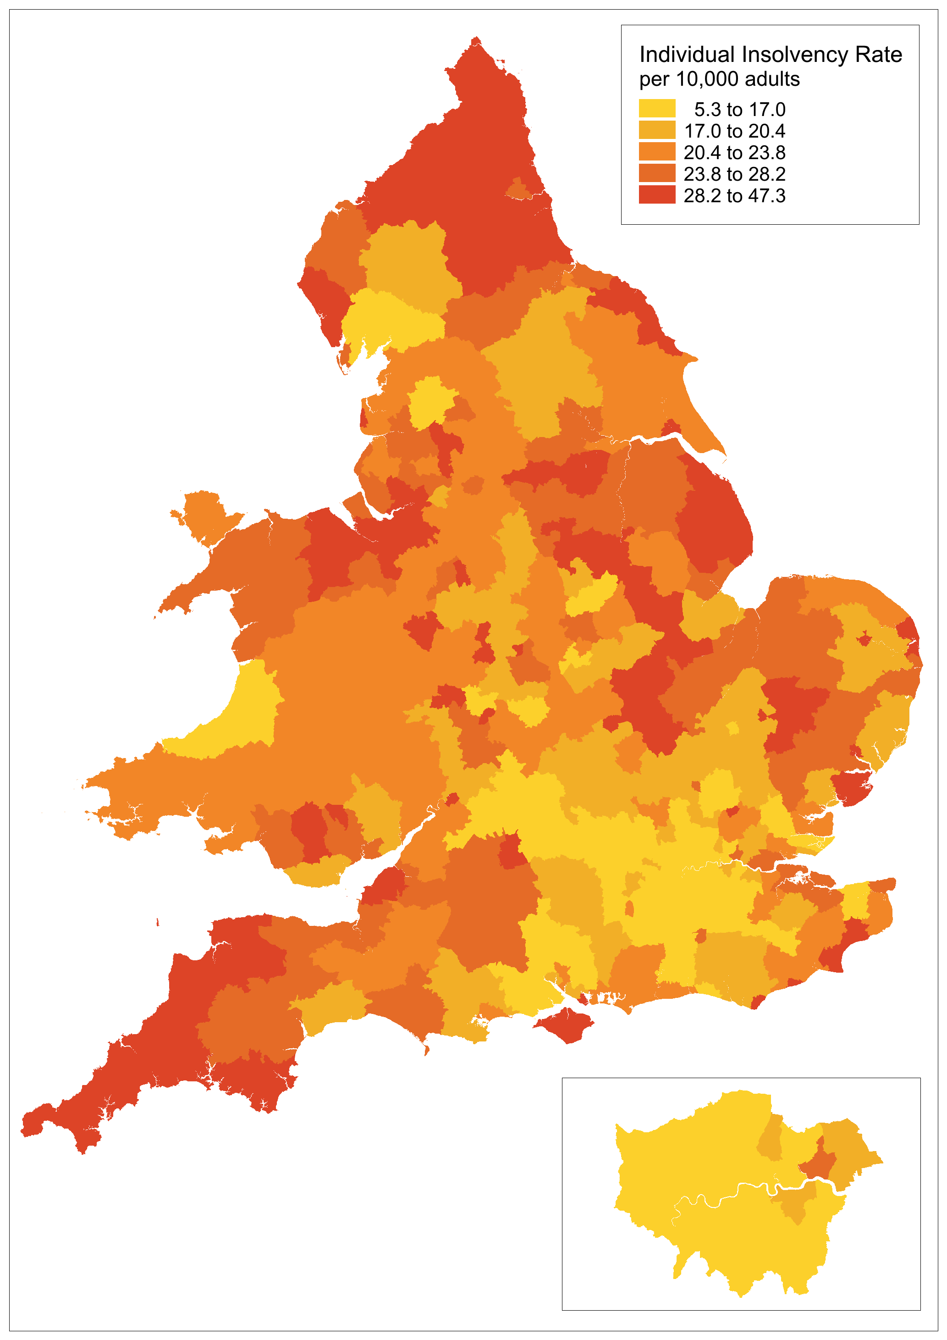

Figure 4: Distribution of total individual insolvency rate by local authority, England and Wales, 2013
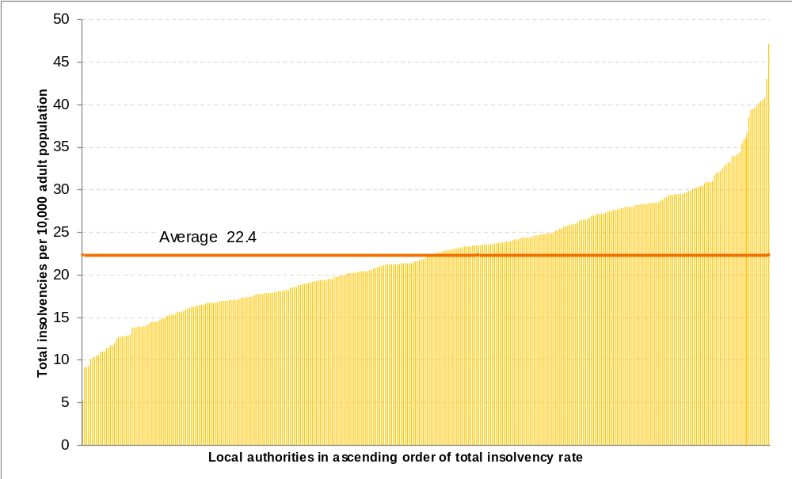

Table 1: Local authorities with the ten highest and lowest individual insolvency rates, England and Wales, 2013

Highest Total Insolvency rates |  |  |  | Lowest Total Insolvency rates
Local authority | Number of new cases | Rate per 10,000 adult population |  | Local authority | Number of new cases | Rate per 10,000 adult population
Torbay | 506 | 47.2 |  | Isles of Scilly | 1 | 5.3
Denbighshire | 323 | 43.0 |  | Wandsworth | 231 | 9.2
Blackpool | 458 | 40.8 |  | Camden | 172 | 9.2
Scarborough | 360 | 40.6 |  | Westminster | 174 | 9.3
Mansfield | 338 | 40.4 |  | Brent | 247 | 10.1
Halton | 393 | 40.2 |  | Barnet | 292 | 10.3
South Kesteven | 430 | 39.8 |  | Epsom and Ewell | 62 | 10.4
Kingston upon Hull, City of | 801 | 39.6 |  | St Albans | 114 | 10.5
Stoke-on-Trent | 770 | 39.5 |  | Harrow | 199 | 10.6
Cannock Chase | 305 | 39.3 |  | Richmond upon Thames | 162 | 10.9

4. Bankruptcies

- The rate of bankruptcies per 10,000 adults in England and Wales fell to 5.4 in 2013 from 7.1 in 2012, having followed a decreasing trend since the peak of 17.2 in 2009, as seen below in Figure 5.

- The North East had the highest bankruptcy rate in 2013 at 7.0 per 10,000 adults (1.6 higher than England and Wales), followed by the East Midlands and South West at 6.1 (0.7 higher than England and Wales). London had the lowest rate in 2013 at 4.0 (1.4 lower than England and Wales).

- The bankruptcy rate for each region has decreased each year since the peak of 2009, as shown in Figure 6 below. Comparing the rate for each region with its peak in 2009, the South West showed the largest decrease, at 15.5 per 10,000 adults, while London showed the smallest decrease, at 7.0 (compared with a decrease of 11.8 in England and Wales).

- The local authority with the highest bankruptcy rate in 2013 was Blackpool at 11.2, followed by Torbay at 11.0; the lowest was Cambridge at 2.1 (see Table 2 below; the distribution of local authorities by bankruptcy rate is given in Figure 8 below).

- Local authorities with lower bankruptcy rates (represented by lighter shades in Figure 7 below) tended to be concentrated around London and the Home Counties, while many of those local authorities with higher bankruptcy rates (represented by darker shades in Figure 7 below) were in the South West, North East and Wales regions, and parts of Gloucestershire, Warwickshire, Northamptonshire and Lincolnshire.

- The bankruptcy rate was lower in 2013 than in 2012 in 310 out of 348 local authorities. The largest decrease in the rate was in Isles of Scilly at 10.5 per 10,000 adults (though this represented a decrease from three bankruptcies to one); the largest increase was in Christchurch at 2.7 per 10,000 adults.

Figure 5: Bankruptcies per 10,000 adult population, England and Wales, 2000 to 2013

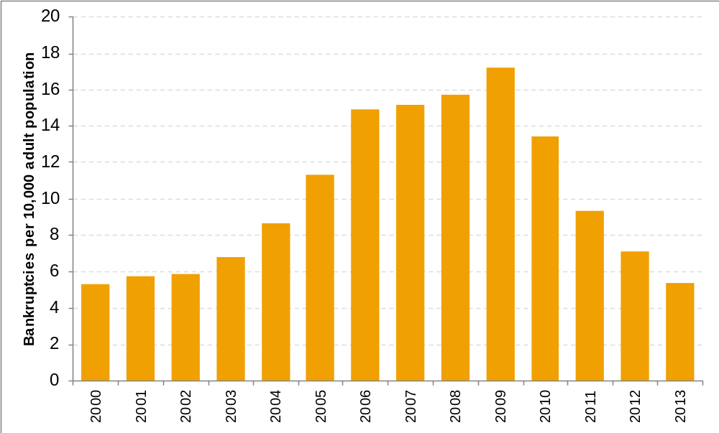

Figure 6: Bankruptcies per 10,000 adult population by region, England and Wales, 2011 to 2013
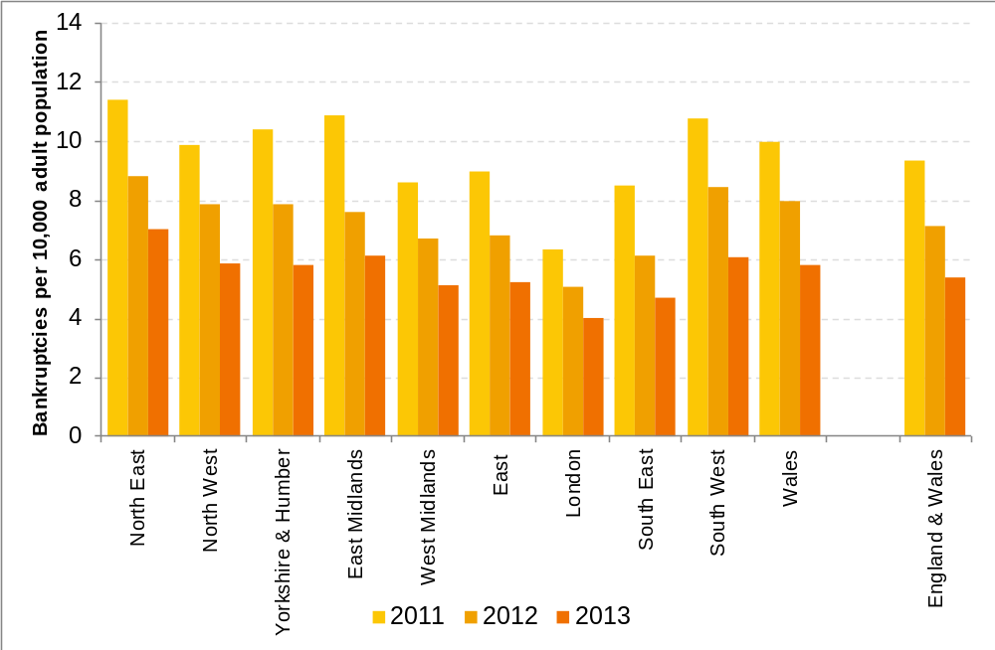
Figure 7: Bankruptcies per 10,000 adult population by local authority, England and Wales, 2013
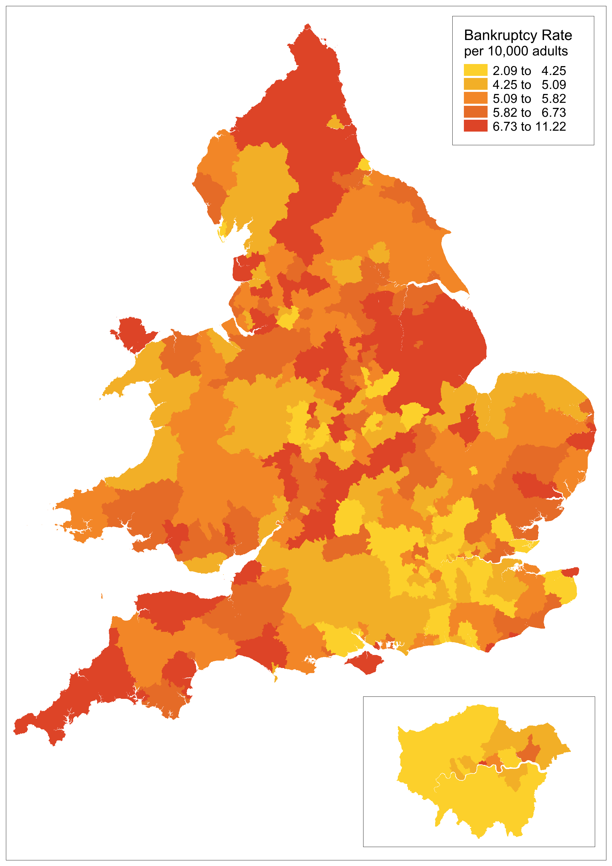

Figure 8: Distribution of bankruptcy rates by local authority, England and Wales, 2013
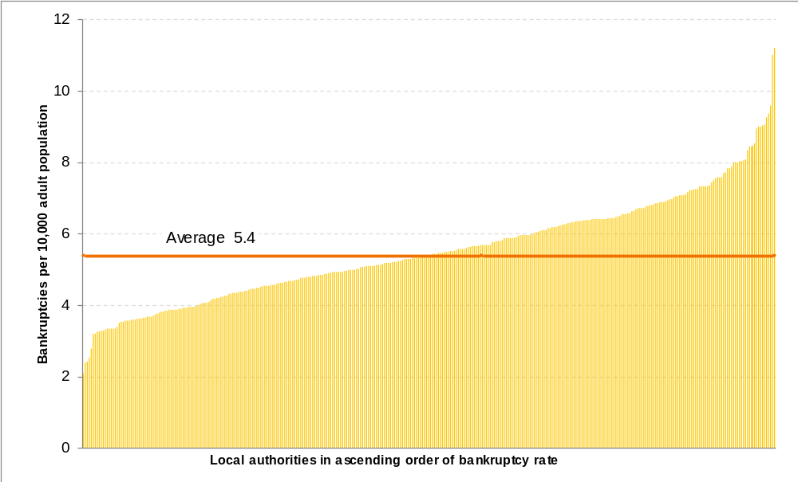

Table 2: Local authorities with the ten highest and lowest bankruptcy rates, England and Wales, 2013

Highest bankruptcy rates |  |  |  | Lowest bankruptcy rates
Local authority | Number of new cases | Rate per 10,000 adult population |  | Local authority | Number of new cases | Rate per 10,000 adult population
Blackpool | 126 | 11.2 |  | Cambridge | 22 | 2.1
Torbay | 118 | 11.0 |  | Wokingham | 29 | 2.4
Corby | 47 | 9.6 |  | Wandsworth | 61 | 2.4
Eastbourne | 76 | 9.4 |  | South Oxfordshire | 27 | 2.5
South Kesteven | 100 | 9.3 |  | Hart | 20 | 2.8
West Lindsey | 66 | 9.1 |  | Welwyn Hatfield | 29 | 3.2
Newark and Sherwood | 84 | 9.0 |  | East Hertfordshire | 35 | 3.2
North Devon | 68 | 9.0 |  | Lambeth | 82 | 3.3
West Somerset | 26 | 9.0 |  | Ealing | 86 | 3.3
Rossendale | 48 | 8.9 |  | Richmond upon Thames | 49 | 3.3

5. Debt Relief Orders (DROs)

- The rate of DROs per 10,000 adults in England and Wales decreased to 6.1 in 2013 from 7.0 in 2012, this is a reverse of the increasing trend seen since their introduction in April 2009, as seen below in Figure 9.

- The South West had the highest DRO rate in 2013 at 9.1 per 10,000 adults (3.0 higher than England and Wales), followed by the North East with 8.5 per 10,000 adults (2.4 higher than England and Wales). London had the lowest rate in 2013 at 3.3 (2.8 lower than England and Wales).

- Previously for DROs the rate for each region, except London, had increased each year since 2009, but the rate fell for all regions between 2012 and 2013 (see Figure 10 below). In 2013 the DRO rate per 10,000 adult population was 6.1, which was 0.9 lower than 2012 and 0.5 lower than 2011. Comparing the rate for each region for 2013 and 2012, the North East showed the largest decrease, at 1.6 per 10,000 adults (compared with a decrease of 0.8 in England and Wales between 2012 and 2013).

- The local authority with the highest DRO rate in 2013 was Scarborough at 23.2, followed by Denbighshire at 22.9; the lowest was the Isles of Scilly at 0.0, followed by Tandridge at 1.2 (see Table 3 below; the distribution of local authorities by DRO rate is given in Figure 12 below). Seven out of the ten local authorities with the highest DRO rates were in coastal areas.

- Local authorities with lower DRO rates (represented by lighter shades in Figure 11 below) tended to be concentrated around London and the Home Counties, parts of the West Midlands and the North West, while many of those local authorities with higher DRO rates (represented by darker shades in Figure 11 below) were in the South West, parts of Wales, the East and the North East.

- The DRO rate was lower in 2013 than in 2012 in 225 out of 348 local authorities. The largest decrease in the rate was in Great Yarmouth at 9.7 per 10,000 adults; the largest increase was in North Somerset at 4.2.

Figure 9: DROs per 10,000 adult population for England and Wales, 2009 to 2013
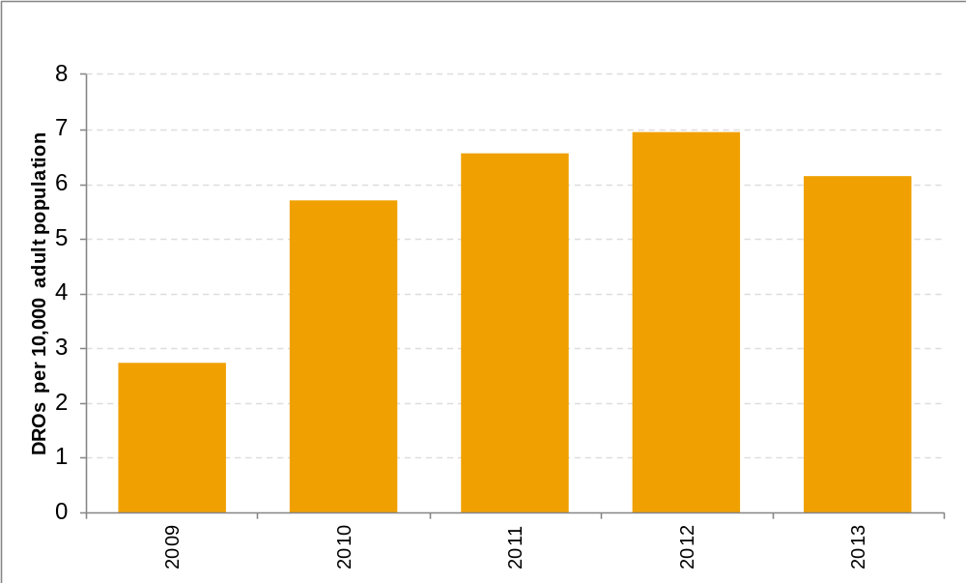

Figure 10: DROs per 10,000 adult population by region, England and Wales, 2011 to 2013
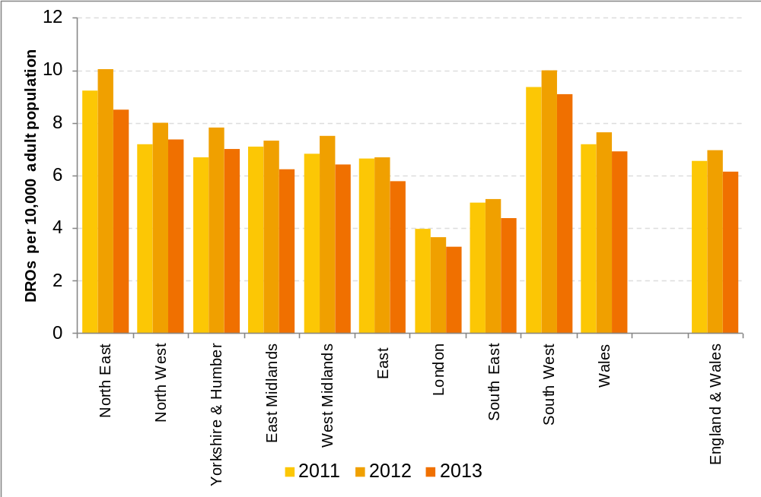

Figure 11: DROs per 10,000 adult population by local authority, England and Wales, 2013
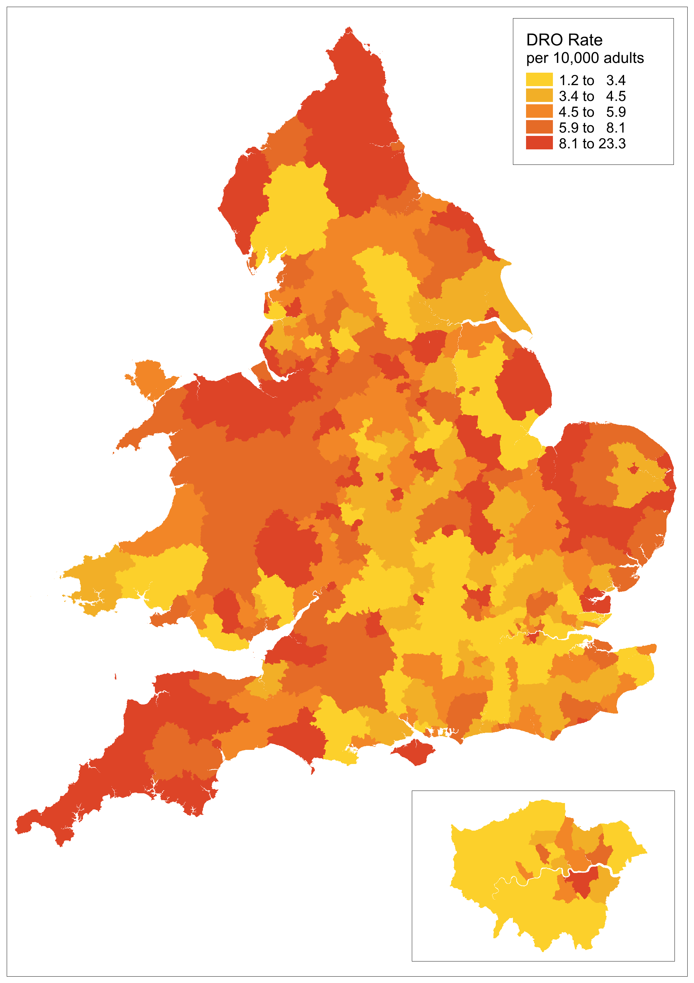
Figure 12: Distribution of DRO rates by local authority, England and Wales, 2013
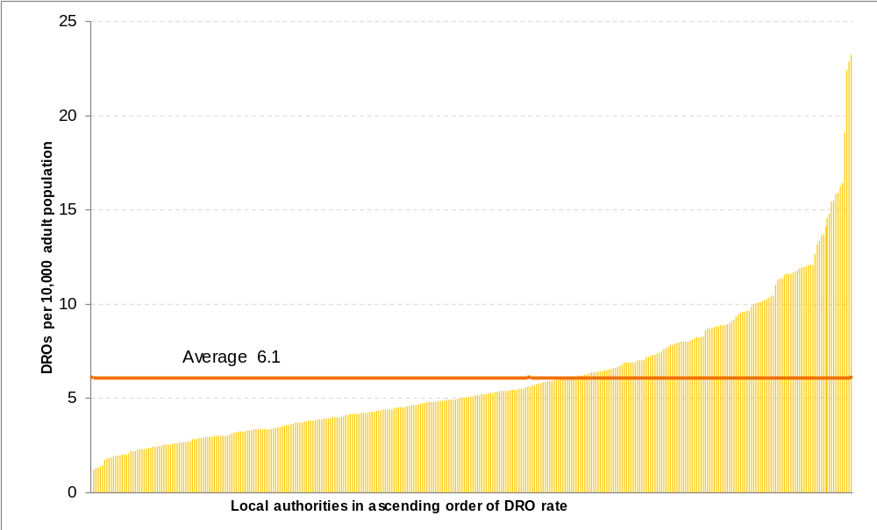

Table 3: Local authorities with the ten highest and lowest DRO rates, England and Wales, 2013
Highest DRO rates |  |  |  | Lowest DRO rates
Local authority | Number of new cases | Rate per 10,000 adult population |  | Local authority | Number of new cases | Rate per 10,000 adult population
Scarborough | 206 | 23.2 |  | Isles of Scilly | 0 | 0.0
Denbighshire | 172 | 22.9 |  | Tandridge | 8 | 1.2
Torbay | 240 | 22.4 |  | Westminster | 25 | 1.3
Kingston upon Hull, City of | 387 | 19.1 |  | Harrow | 25 | 1.3
Copeland | 93 | 16.4 |  | Wycombe | 19 | 1.4
Halton | 159 | 16.3 |  | City of London | 1 | 1.5
South Kesteven | 172 | 15.9 |  | Brent | 43 | 1.8
Stoke-on-Trent | 309 | 15.8 |  | Barnet | 51 | 1.8
Isle of Wight | 175 | 15.5 |  | Merton | 29 | 1.8
Mansfield | 129 | 15.4 |  | Eden | 8 | 1.9

6. Individual Voluntary Arrangements (IVAs)

- The rate of IVAs per 10,000 adults in England and Wales increased to 10.9 in 2013 from 10.5 in 2012, though this is still lower than the rates in 2009, 2010, and 2011, as seen below in Figure 13.

- The North East had the highest IVA rate in 2013 at 15.1 per 10,000 adults (4.2 higher than England and Wales), followed by the North West at 12.3 (1.4 higher than England and Wales). London had the lowest rate in 2013 at 6.6 (4.3 lower than England and Wales).

- The rate for each region has followed a similar trend to that for England and Wales as a whole, reaching a peak in 2010, decreasing in 2011 and 2012, then increasing in 2013; the exception being the South West which has seen a sustained increase (see Figure 14 below). Comparing the rate for each region in 2013 with its peak in 2010, East Midlands showed the largest decrease, at 1.3 per 10,000 adults, while the North East showed an increase, at 0.2 (compared with a decrease of 0.7 in England and Wales).

- The local authority with the highest IVA rate in 2013 was Cannock Chase, at 21.7, the lowest was Isles of Scilly at 0 followed by Camden at 2.5 (see Table 4 below; the distribution of local authorities by IVA rate is given in Figure 16 below).

- Local authorities with lower IVA rates in 2013 (represented by lighter shades in figure 15 below) tended to be concentrated around London, Lancashire, Cumbria and the Home Counties, while many of those local authorities with higher IVA rates (represented by darker shades in figure 15 below) were in the North East, parts of the East Midlands and parts of Merseyside, Nottinghamshire, Kent and South Yorkshire.

- The IVA rate was lower in 2013 than in 2012 in 143 out of 348 local authorities. The largest decrease in the rate was in Daventry at 5.6 per 10,000 adults; the largest increase was in Shepway at 8.6.

Figure 13: IVAs per 10,000 adult population by region, England and Wales, 2000 to 2013

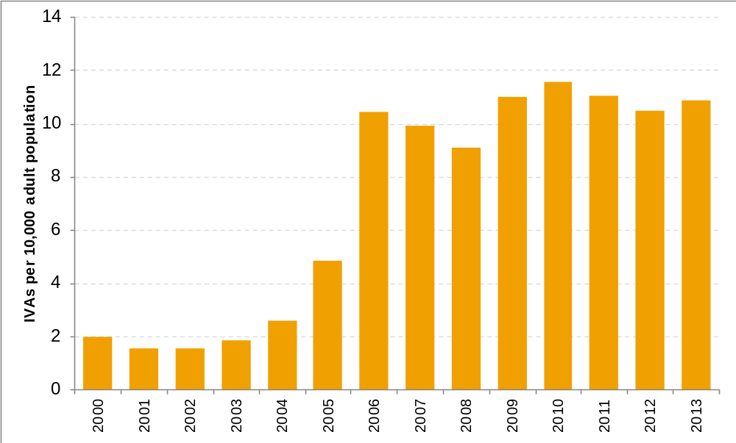

Figure 14: IVAs per 10,000 adult population by region, England and Wales, 2011 to 2013
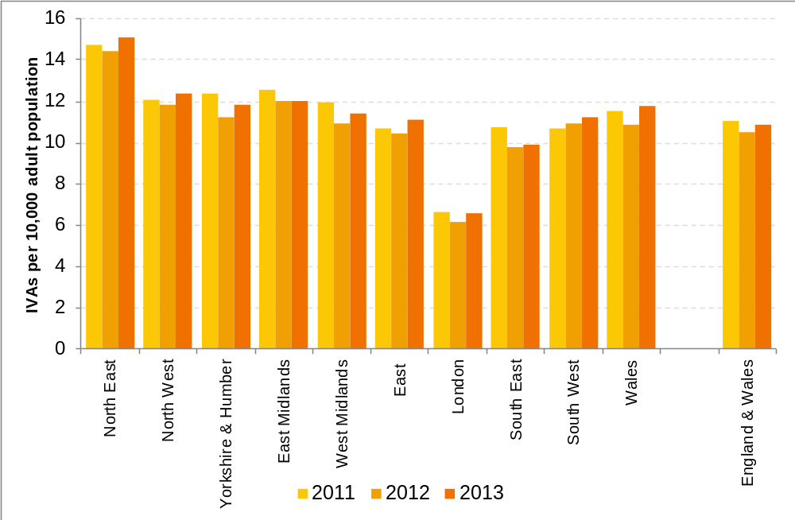

Figure 15: IVAs per 10,000 adult population by local authority, England and Wales, 2013
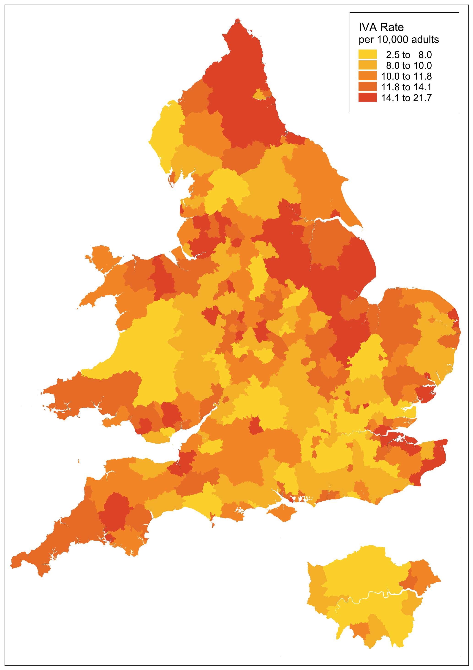
Figure 16: Distribution of IVA rates by local authority, England and Wales, 2013
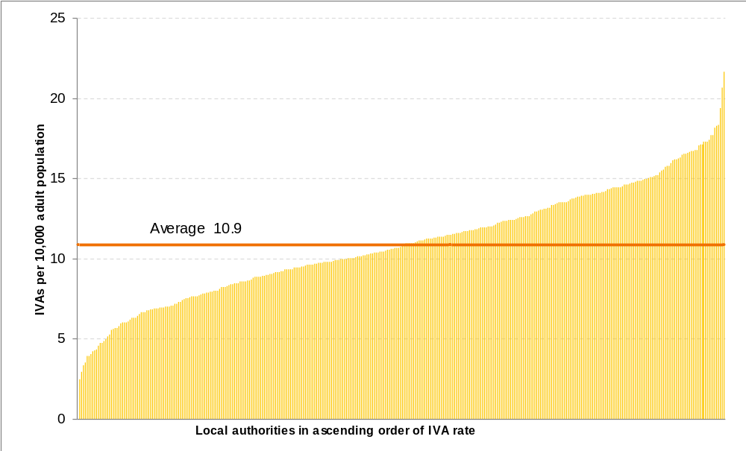

Table 4: Local authorities with the ten highest and lowest IVA rates, England and Wales, 2013
Highest IVA rates |  |  |  | Lowest IVA rates
Local authority | Number of new cases | Rate per 10,000 adult population |  | Local authority | Number of new cases | Rate per 10,000 adult population
Cannock Chase | 168 | 21.7 |  | Isles of Scilly | 0 | 0.0
Hartlepool | 150 | 20.7 |  | Camden | 47 | 2.5
Blaenau Gwent | 108 | 19.4 |  | City of London | 2 | 2.9
Peterborough | 262 | 18.4 |  | Kensington and Chelsea | 43 | 3.4
Mansfield | 153 | 18.3 |  | Westminster | 66 | 3.5
Tamworth | 109 | 18.2 |  | Hammersmith and Fulham | 57 | 3.9
Boston | 93 | 17.7 |  | St Albans | 43 | 4.0
County Durham | 737 | 17.7 |  | Cambridge | 43 | 4.1
Blackpool | 196 | 17.4 |  | Ceredigion | 27 | 4.3
Rossendale | 93 | 17.3 |  | Chiltern | 31 | 4.3

7. Age and Gender Analysis

In England and Wales in 2013:

- Overall males had a higher insolvency rate (22.6) than females (22.1);

- The individual insolvency rate was highest in the 35-44 age group for both males and females (38.1 for males, 36.2 for females and 37.2 in total);

- For the younger age groups, 18-24 and 25-34, the insolvency rate was higher among females than males; the reverse was true for those age groups over 35 (see Figure 17 below). This was also the case for most regions.

- In 6 out of the 10 regions the male insolvency rate was higher than the female insolvency rate. However, as Figure 18 illustrates the difference in insolvency rates between males and females is often very marginal. In the South West and North East – the regions with the highest insolvency rates in 2013 – female insolvency rates were higher than male insolvency rates.

The patterns varied to some extent between different types of insolvency procedure:

- The rates of bankruptcies per 10,000 adults were higher for males than for females across all regions of England and Wales overall, and for all age groups except 18-24.

- The IVA rates per 10,000 adults were higher for females in the age groups 18-24 and 25-34, but lower in the other age bands. IVA rates were higher for males than females in all regions.
- By contrast, the rate of DROs was highest amongst females in all regions of England and Wales, and within regions DRO rates were higher for females than males for all age groups. The DRO rate was highest for the age group 25-34.

The difference between the individual insolvency rate in England and Wales for females and for males has reduced over the last five years, as illustrated in Figure 19 below.

- In 2009, the rate for females was 26.0 per 10,000 adults, 9.5 lower than the rate of 35.5 for males; in 2013, the rate for females was 22.2, 0.4 lower than the rate of 22.6 for males.

- The reduction in the difference can partly be explained by the introduction in 2009 and subsequent increase in the number of DROs, for which, as described above, a higher proportion of individual debtors were female in comparison with IVAs and bankruptcies.

Figure 17: Insolvency rate per 10,000 adult population by insolvency procedure, age group and gender in 2013, England and Wales
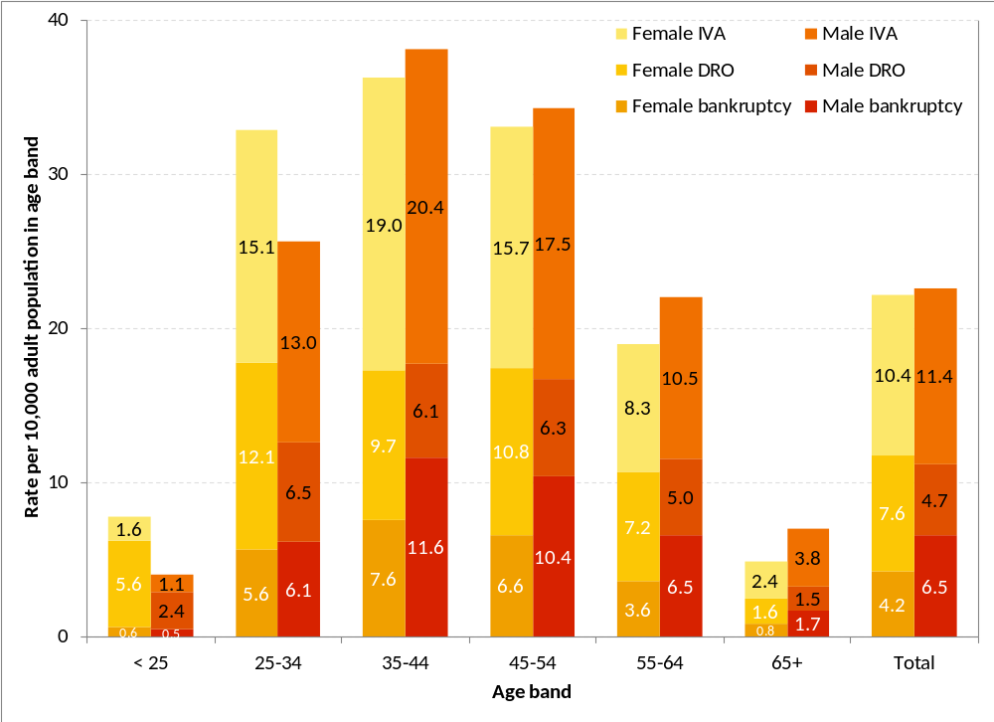

Figure 18: Total individual insolvency rate per 10,000 adult population by region and gender, England and Wales, 2013

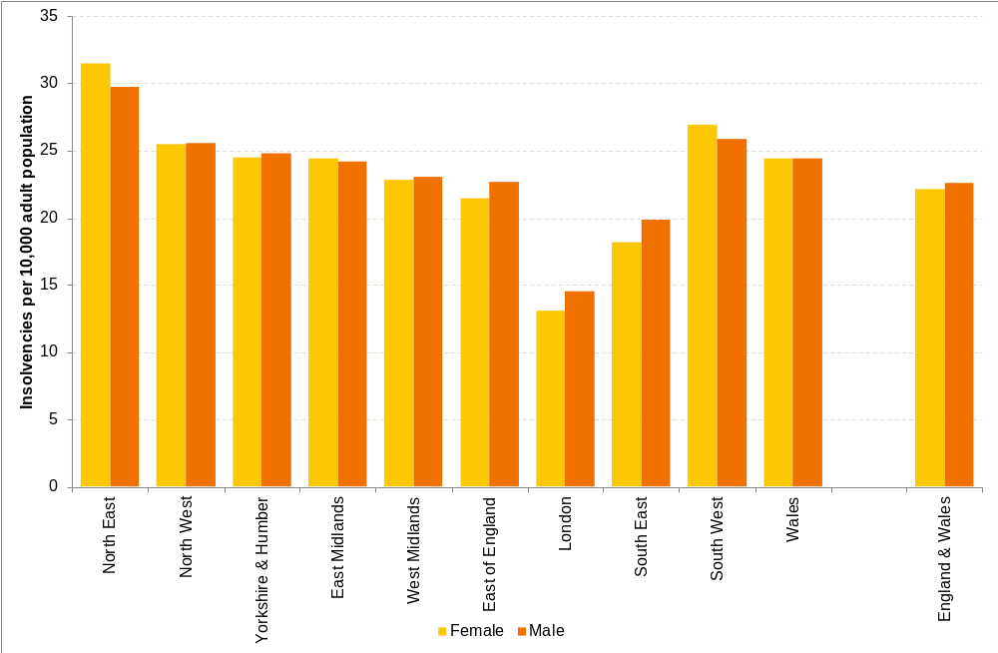

Figure 19: Insolvency rate per 10,000 adult population by insolvency procedure, gender and year, England and Wales, 2008 to 2013
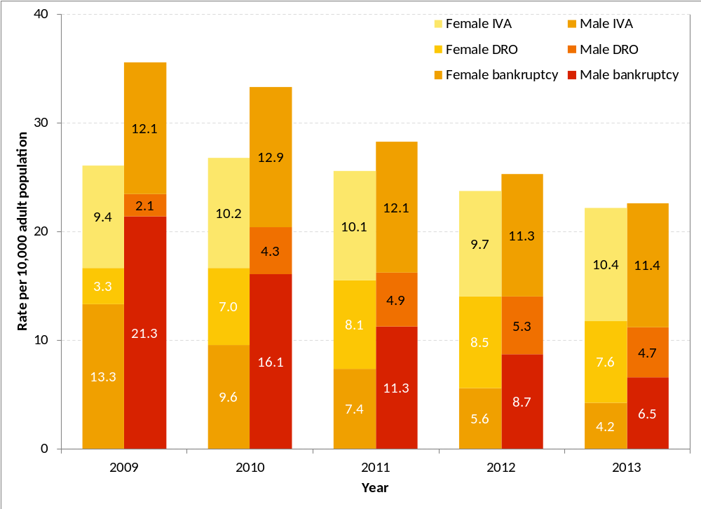

8. Notes to accompany the Individual Insolvency Statistics by Region
For general notes on individual insolvency statistics in England and Wales please see the quarterly Insolvency Statistics publication, which is the definitive source of the number of new cases each year in England and Wales, and the rate per 10,000 adults. The latest publication is at https://www.gov.uk/government/publications/insolvency-statistics-january-to-march-2014.

Data sources and methodology
Details of individual insolvencies are sourced from administrative records held by the Insolvency Service. Extracts from these records, including postcode, date of birth, date of insolvency, and gender, are taken to derive the breakdowns used in this publication.

Postcode data are matched against the National Statistics Postcode Lookup, to determine the region and local authority of each individual. These data are then aggregated to produce counts of insolvencies in each geographical area. The National Statistics Postcode Lookup is derived from data from the Office for National Statistics and Ordnance Survey.
Contains Ordnance Survey data © Crown copyright and database right 2014
Contains Royal Mail data © Crown copyright and database right 2014
Contains National Statistics data © Crown copyright and database right 2014

Geographical boundary definitions are sourced from the Office for National Statistics and are based on Ordnance Survey data.
Contains Ordnance Survey data © Crown copyright and database right 2014
Contains National Statistics data © Crown copyright and database right 2014

Population statistics are sourced from the Office for National Statistics publication Population Estimates for UK, England and Wales, Scotland and Northern Ireland, Mid-2013 (and related statistics for previous years). These statistics are used as the denominator when calculating insolvency rates per 10,000 adult population.

Quality
This section provides information on the quality of the Individual Insolvency Statistics by Region, to enable users to judge whether or not the data are of sufficient quality for their intended use. The section is structured in terms of the six quality dimensions of the European Statistical System.

Relevance (the degree to which the statistical product meets user needs for both coverage and content)
The Insolvency Service has policy responsibility for individual insolvency in England and Wales only; the extent of the coverage of these statistics reflects this.
Individual insolvency figures at national (England and Wales) level are published quarterly by the Insolvency Service as a National Statistics release. The most recent such figures relate to Q1 2014, published on 29 April at https://www.gov.uk/government/publications/insolvency-statistics-january-to-march-2014. The annual statistics in this publication provide breakdowns by region, county, unitary authority and local authority; and by age and gender at region-level.
Users of insolvency statistics include the Insolvency Service itself, which has policy responsibility for insolvency in England and Wales and for the non-devolved areas within Scotland and Northern Ireland; other government departments; parliament; the insolvency profession; debt advice agencies; media organisations; academics; the financial sector; the business community and the general public.
The views of users have been taken into account when making changes to this publication. In August 2013, the Insolvency Service launched a user feedback survey to obtain the views of users on the usefulness of the statistics, and where improvements could be made. The survey closed in October 2013 and was followed by a meeting with users and the publication of a summary of user feedback.

Accuracy and Completeness (including the closeness between an estimated or stated result and the [unknown] true value)

The latest data relate to the calendar year 2013. National-level statistics covering this period were published on 7 February 2014 as part of the quarterly Insolvency Statistics publication – though the Individual Insolvency Statistics by Region is not consistent with the quarterly publication (see Coherence, below).

Accuracy and completeness of geographic data

Individual insolvents have been classified into geographic areas on the basis of the postcode supplied by the individual. As some postcodes supplied are missing or incomplete, or have not matched the National Statistics Postcode Lookup, some individuals have not been matched to geographic areas.

Nationally, this proportion has been decreasing from about 12% in 2000 to less than 1% in 2012 in the case of bankruptcies and decreasing from around 15% in 2000 to less than 1% in 2012 in the case of IVAs. The proportion for DROs is between 0.1% and 0.2%. A postcode quality file is provided as a separate table.

Postcodes are assigned to areas using the centroid of the postcode area. As postcode boundaries are not contiguous with other geographic boundaries, these postcode boundaries could span several geographic boundaries.

It is possible an individual changed place of residence in order to cut costs and attempt to get out of financial difficulty. Where this failed and the individual was declared insolvent, it will be the address at the time of the insolvency which is recorded and used to classify the insolvent's location, where this can be determined. Where more than one address has been provided and the address at the time of insolvency is not known, an address has been chosen at random.

Case numbers for some areas for the years 2000 to 2012 may be higher than previously published. This is due to the use of an updated postcode directory which has enabled some insolvent individuals with a previously unknown geographical location to be assigned to the correct area. The England and Wales totals remain unchanged.

Accuracy and completeness of age and gender data

Some records of individual insolvents have missing or incomplete data for either or both of date of birth and gender. These have been classified as 'unknown’ in the relevant tables, but included in the regional tables if the postcode matched the National Statistics Postcode Lookup. Some individuals have improbable dates of birth (for example 1 January 1900) and have been recoded as ‘unknown’. England and Wales totals and rates are unaffected by this.

Timeliness and Punctuality (Timeliness refers to the elapsed time between publication and the period to which the data refer. Punctuality refers to the time lag between the actual and planned dates of publication.)

The latest data relate to the calendar year 2013. National-level statistics covering this period were published on 7 February 2014 as part of the quarterly Insolvency Statistics publication – though the Individual Insolvency Statistics by Region is not consistent with the quarterly publication (see Coherence, below).

The key statistics in this publication relate to the rate of individual insolvency per 10,000 adult population, which is dependent on population estimates at local authority level for the denominator in this calculation. The Office for National Statistics released Population Estimates for UK, England and Wales, Scotland and Northern Ireland, Mid-2013 on 26 June 2014. The two-week period between these source statistics being released, and publication of these statistics, is the minimum required to ensure outputs can be produced to the required standard.

The date of publication was announced on the National Statistics Publication Hub with a provisional date of July 2014. The final release date of 10 July 2014 was announced on the Hub on 3 June 2014.

Accessibility and Clarity (Accessibility is the ease with which users are able to access the data. It also relates to the format in which the data are available and the availability of supporting information. Clarity refers to the quality and sufficiency of metadata, illustrations and accompanying advice)
The Insolvency Statistics are available free of charge to the end user on the GOV.UK website. They are also linked via the Publication Hub and they meet the standards required under the Code of Practice for Official Statistics and the Insolvency Service’s own website accessibility policy. Related data are available at the same GOV.UK location.
This publication consists of a statistics release, which contains key results and commentary to help interpret the data, and detailed data tables in Excel format.
If you have any queries about the publication or would like it in a different format, please email statistics@insolvency.gsi.gov.uk

Comparability (the degree to which data can be compared over time and domain)
Numbers of individual insolvencies in each geographical area each year, and the underlying population data, are categorised according to administrative boundaries as at December 2012, allowing for comparisons to be made between time periods and between geographical areas.

Coherence (the degree to which data which are derived from different sources or methods, but which refer to the same phenomenon, are similar)
Numbers of new cases presented in these tables are not consistent with the official, headline quarterly National Statistics published as they have been extracted from a live database at a different point in time and on a different basis. The quarterly National Statistics are the definitive source of the number of new cases each year in England and Wales, and the rate per 10,000 adults.



© Crown copyright 2014
You may re-use this document/publication (not including logos) free of charge in any format or medium, under the terms of the Open Government Licence v2.0 and the Ordnance Survey OpenData Licence.

To view the Open Government Licence v2.0 visit http://www.nationalarchives.gov.uk/doc/open-government-licence; or write to the Information Policy Team, The National Archives, Kew, Richmond, Surrey, TW9 3DU; or email: psi@nationalarchives.gsi.gov.uk.

To view the Ordnance Survey OpenData Licence visit http://www.ordnancesurvey.co.uk/docs/licences/os-opendata-licence.pdf. In addition, the following attribution statements must be acknowledged or displayed whenever the owners’ data is used:
Contains Ordnance Survey data © Crown copyright and database right 2014
Contains Royal Mail data © Crown copyright and database right 2014
Contains National Statistics data © Crown copyright and database right 2014

This document/publication is also available on our website at www.gov.uk/insolvency-service.
Any enquiries regarding this document/publication should be sent to us at statistics@insolvencyservice.gsi.gov.uk.

