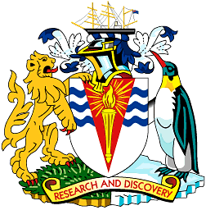
To: Base Commander, Rothera
Base Commander, Halley
Base Commander, King Edward Point
Base Commander, Bird Island
19 June 2014

MID-WINTER MESSAGE: DR PETER HAYES
HM COMMISSIONER FOR THE BRITISH ANTARCTIC TERRITORY AND DIRECTOR, OVERSEAS TERRITORIES, FOREIGN AND COMMONWEALTH OFFICE

As you prepare for the traditional Mid-winter festivities and the official turning of the Antarctic year I want to send you and your teams my sincere thanks for all your hard work and dedication, as well as my best wishes for your celebrations.

It was a real pleasure to spend a few days at Rothera back in January, to see at first hand some of the important scientific work carried out there and meet the people who make it all possible. It was great to be able to thank some of your teams personally for all they do. I left with a strong sense of the real commitment of everyone who works for the British Antarctic Survey to the dual mission of science and presence in the UK’s largest Overseas Territory.

But I know that life on the stations in the middle of an Antarctic winter is a very different proposition to the hustle and bustle of mid-summer and that it offers considerable challenges. Although some of the original hardships of over-wintering have been alleviated by modern comforts, it is still a significant commitment. As your thoughts will turn to family and friends during your celebrations, I can assure you that you and your teams will very much be in ours.

I know that it was a particularly busy summer season, not least with the complex iSTAR project to support, with marine and other research and the running of the stations. I know that the coming season will be equally busy and will see an even greater focus on deep-field activity. Thank you again for all you do to maintain the United Kingdom’s scientific footprint in Antarctica and the wider region.

As you reflect on your achievements and look forward to the return of the sun and the summer season to come I wish you and your teams – and everyone working for BAS - a very enjoyable celebration, as well as a safe, swift and successful conclusion to the winter.

With all best wishes

Dr Peter Hayes
HM Commissioner of the British Antarctic Territory and Director, Overseas Territories, FCO.

