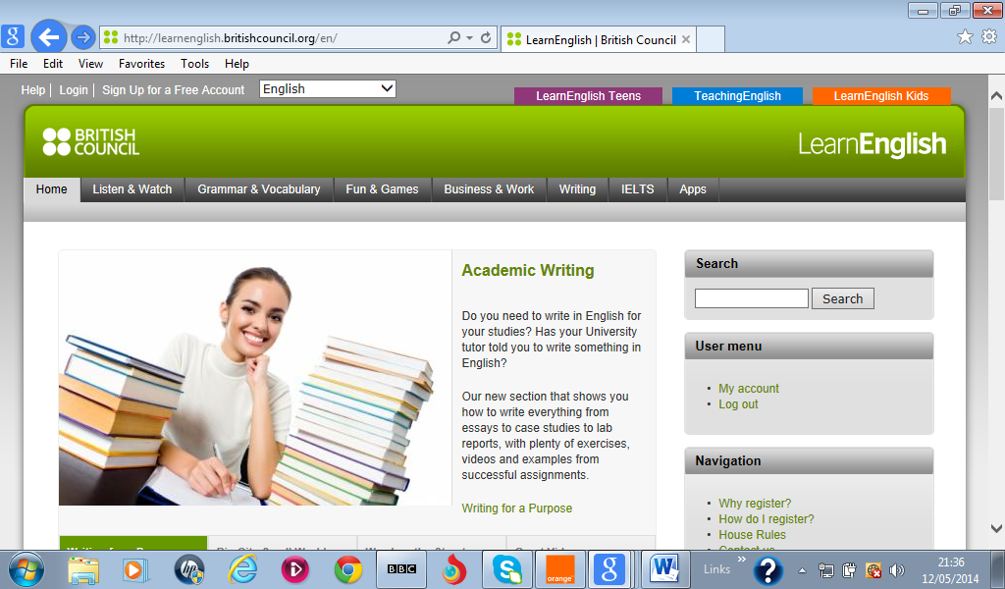
Learn English webquest

Full name ………………………………………… (Parents’) Tel Number……………………….
(Parents’) Email address…………………………………………….
To enter this English Language Week webquest competition, complete your personal details above, then visit Learn English website http://learnenglish.britishcouncil.org/fr/ & find the answers to the 5 questions below. Write your answer for each question in the spaces …………. below. Save this document and send it to English4future@tn.britishcouncil.org by Friday 30th May 2014.

1.Click on Listen & Watch section & Word on the Street  | Watch Stephen and Ashlie in video ‘Animals’ Scene 1.  What’s the name of Ashlie’s dog? Poppy or Mouse?  ………………………………………….
2. Click on the Grammar & Vocabulary section.   | How many minutes do you have to play the game ‘Wordshake’? (Now try the game ☺)  ……………………………………………………….
3. Click on Business & Work section.   | Go to the ‘You’re Hired’ videos. Watch episode 6.  Who gives the best presentation? Daniel or Sarah?  …………………………………………
4. Click on the IELTS section.   | How many questions are there in the ‘ Mock Listening Paper –The Dormitory Tour’ ? 10 or 16?  …………………………………………..
5.Click on the Apps section.  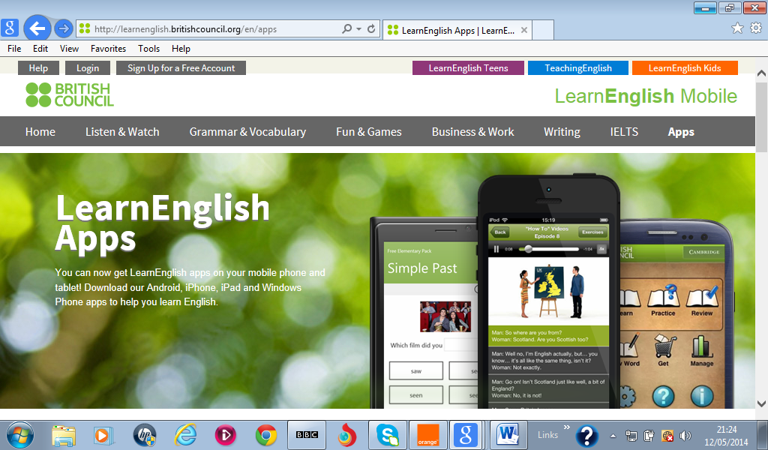 | Which Games Apps combines the fun of football and English?  ……………………………………………..

Good luck!

