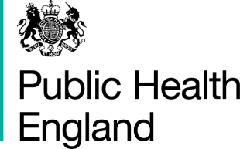

PHE gateway number: 2014-090

Strategic framework to improve the health and wellbeing of gay, bisexual and other men who have sex with men

Opportunity for comment: Feedback form

Name:

Role:

Organisation:

Extensive open consultation has been undertaken to date to inform the development of the Strategic Framework. At this stage we would like to request specific feedback on the below questions. Please return to msm@phe.gov.uk by 9am, Friday 6 June, 2014.

Please keep responses to each question to approx. 200 words

- Are there any major gaps in our analysis of the health and wellbeing of MSM?

- Do the recommendations address the health inequalities we highlight in the document?

- Are there any major recommendations that we have missed?

Any other comments:

