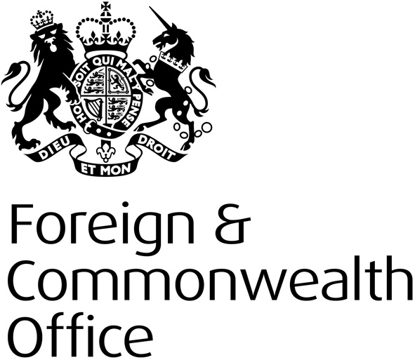

Youth Consultation for the Global Summit to End Sexual Violence in Conflict: London 2014

Age: _____

Gender: _____

Nationality: _____________

Country of residence: ______________

- Do you think sexual violence creates/increases conflict? Why?

- What can you and your peer group do to help change the attitudes and behaviours that underpin sexual violence in conflict¹?

- Why, in your opinion, are children targeted for sexual violence during times of conflict?

- In your view, what are the particular challenges in protecting children and young people from sexual violence?

- What would you like to see local and international governments do to tackle sexual violence in conflict?

- What action needs to be taken to provide better protection for children and young people from sexual violence? Who needs to do this?

- What would justice look like for children and young people who are survivors of sexual violence?

- In your opinion, what forms of support and assistance should be provided by the international community to child and youth survivors of sexual violence?

- What do you think the impact would be of ending sexual violence?

- For the purposes of this consultation, Sexual Violence in Conflict is referred to within the UN General Assembly’s definition: ‘Incidents or patterns […] of sexual violence, that is rape, sexual slavery, forced prostitution, forced pregnancy, enforced sterilization or any other form of sexual violence of comparable gravity against women, men or children.’ (UN Security Council (2012), Conflict-related Sexual Violence: Report of the Secretary-General, A/66/657–S/2012/33, para. 3. Available: www.unhcr.org/refworld/docid/4fbf5b382.html)

