ISCIS On-Line is due to be launched on 27th October 2010.

The look of ISCIS On-Line is very much the same as what you are used to with BANCS On-Line but there are a few subtle changes to bear in mind. Below is a short guide that should help you with the changes. Please contact our Enquiries Team in the usual way should you have any queries.

The login screen and automatic unlock procedures are the same.

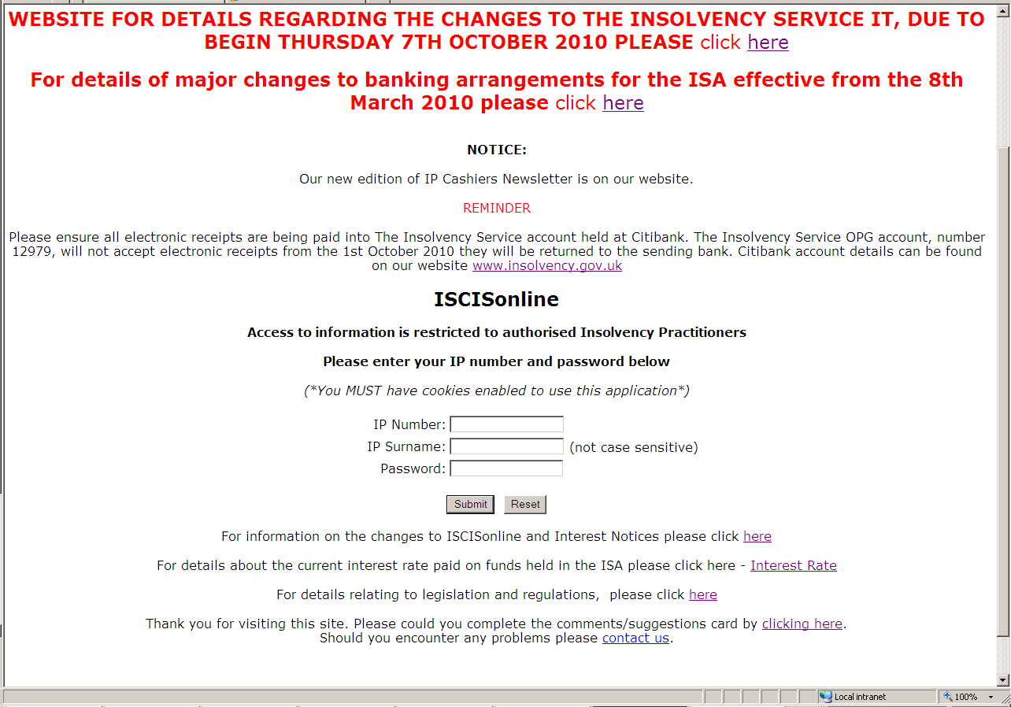

The way you view your cases, print Interest notices (case by case and 6 Monthly), print account statements, check cases held at addresses and check balances also remain unchanged.

There is no change to the way you can manage your password and email address.

All cases on ISCIS will have been assigned a new case id. These will consist of alpha and numeric characters. The insolvency type is defined by:

BKT – Bankruptcy
LQD – Compulsory Liquidation
NCL – Non-Compulsory Liquidation, i.e. Voluntary

When you view your list of cases on ISCIS On-Line you will be able to see your old case id alongside the new.

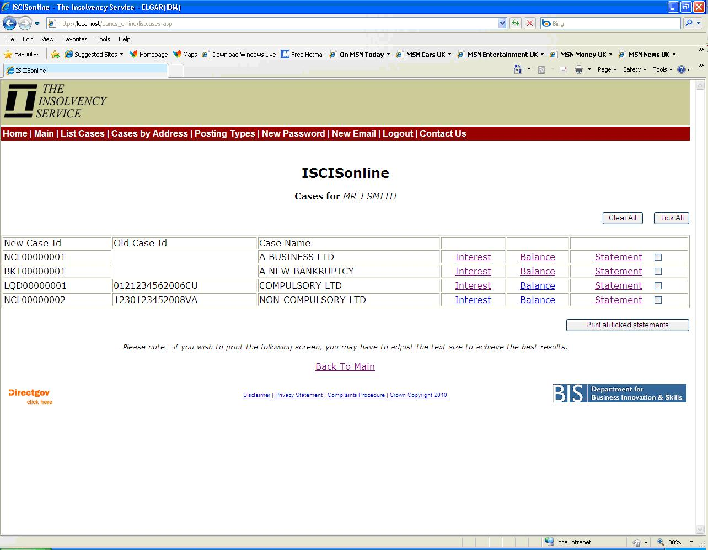

Your old case id can still be used when conducting searches. However you are encouraged to use the new id when searching on ISCIS On-Line. We would also request that you begin using the new id when submitting any correspondence to EAS including requisitions for payment and bank giro credit slips.

When searching by the old case id you must enter the 13 digit account number followed by the alpha character that represents the insolvency type.
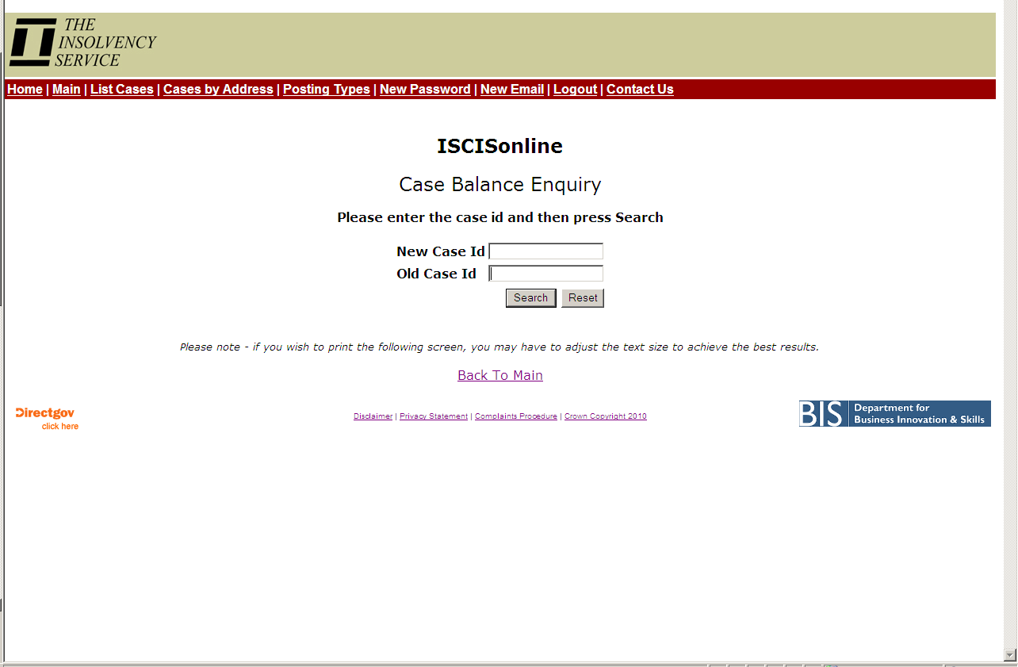

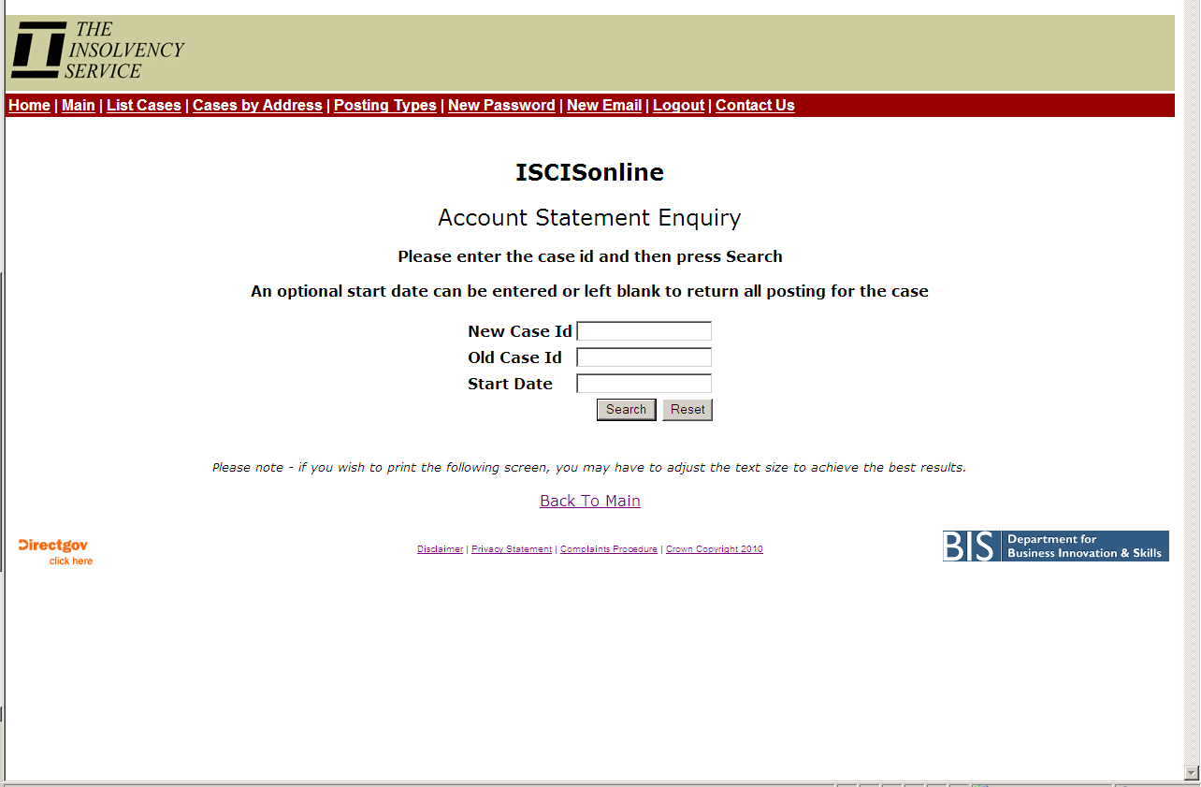

Please remember that ISCIS is a merger of our legacy OR and IP systems. As such when you view a case instead of seeing a single transaction from the OR on handover of the case you will now see all the individual pre handover transactions. Also, there may be posting types that you do not recognise. A full list of posting codes is available by clicking on the ‘Posting Types’ link on any page.

Whether a case is set for earning interest or not can be identified by how the balance is displayed. If the statement/screen shows ‘IB Balance’ then any credit balance on the case is currently eligible to earn interest. If it shows ‘Account Balance’ then it currently is not.



