Survey Standards for Fishing Vessels of 24m and Over
User Guide

Overview

The spreadsheet “Survey Standards for Fishing Vessels of 24m and Over” has been designed to allow owners of fishing vessels to record vital safety information on the Hull and Machinery equipment.
If vessels are not classed, then the MCA, as flag state has to ensure that class rules for hull construction, machinery, electrical and control systems are met in addition to the usual flag state requirements. This is achieved through annual and intermediate surveys, as per the class survey regime, which are chargeable.
MGN 322 Annex 3 para 3 provides guidance on what should be included in annual surveys.
It is the Owners responsibility to ensure that appropriate and verifiable records of all hull and machinery inspections are maintained. If records are not available then attending surveyors may require items to be additionally opened up or presented for survey. When hull or machinery items are being overhauled or maintained then clarification should be sought with the local marine office if surveyor attendance is required. The spreadsheet is a Hull and Machinery Inspection and Survey Record which is intended to assist vessel Owners in demonstrating that maintenance, inspection and surveys have been carried out

It is not a substitute for any other records that are kept. It is merely an electronic recoding system that will help you to produce an annual account for your vessel. All receipts, service records and certificates should be maintained and produced as required by the MCA.

This document gives you a brief guide on how to use the spreadsheet.

Firstly, to get a usable document, when you click on the document link to download the spreadsheet, a box stating “File Download” will appear. You should click on the “Save” option and save the spreadsheet to your own computer. Once this is done, a new box will appear stating “Download Complete”. Click on “Open” and the spreadsheet will appear on the screen ready to use.

Control Panel

The Control Panel is the first screen to be displayed. It looks like this:

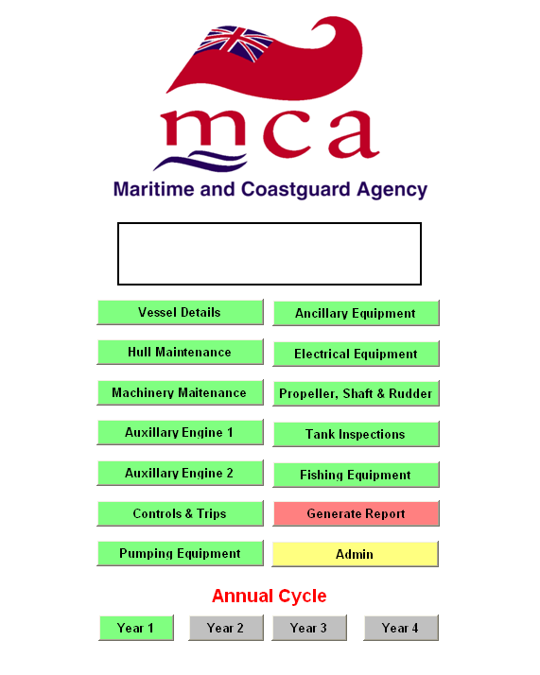

There are a number of options available. When you first start the spreadsheet it is good practice to use the “File>Save As” option from the toolbar at the top of the spreadsheet:

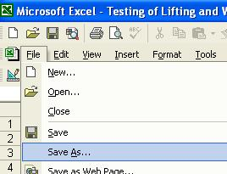

This will allow you to save the spreadsheet using the vessel’s name. If you have several vessels you will need to repeat this for each one.

Once you have saved the spreadsheet under the vessel’s name you can begin recording data. It is good practice to regularly save your work to avoid data loss.

Vessel Details

The first step is to enter the Vessel Details. Here you need to enter the vessel’s name, its Home port, Registered Length, , GT and Year of Build. You should also enter either the RSS Official Number or PLN. You should also enter your contact details. These details will transferred to a report which you can run from this spreadsheet at any time during the survey cycle.

As the survey cycle lasts four years, you should enter the first year in which you are to undertake these inspections.

This date is automatically transferred to the separate record sheets. There is no need to amend the Cycle Start year until a new four year cycle is started. When you click in the Cycle Start Year box, in the bottom right hand corner you will see an option for a drop down box. Click on the relevant year.

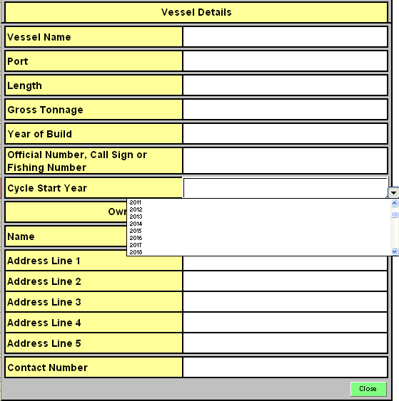

Once these details have been entered, you should click “Close” and this will return you to the Control Panel.

On the control panel, you should click on the relevant Year of the Annual cycle, so in the first instance you should click “Year 1”. There is no need to click Year 1 again. Then, from the Control Panel, you can then click on the relevant Record Sheets you wish to enter. In the top left of each Record sheet, you will see the year when the Survey Cycle began (in this case 2011) and the year of the cycle (Year 1), as shown in the example for Propellers, Shaft Bearings Rudder and Rudder Stock below.

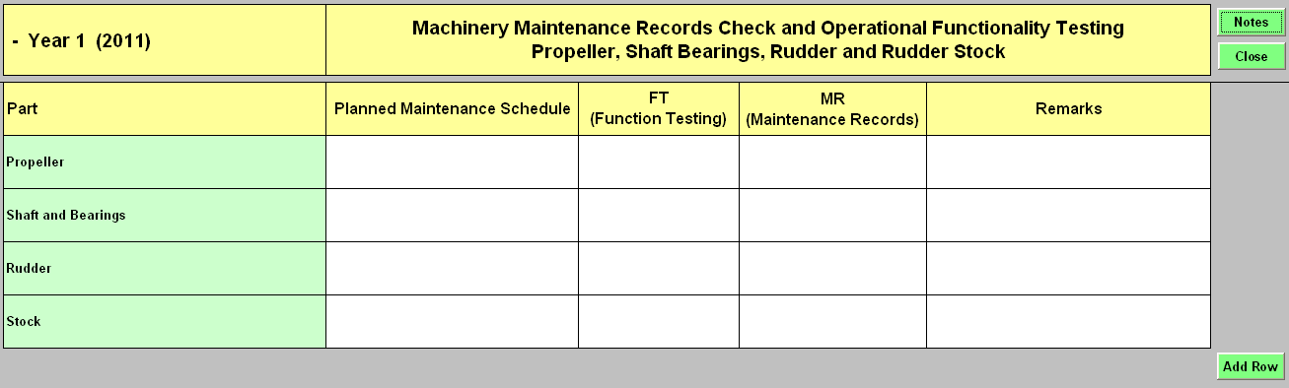

It is not necessary to wait until 1 January to commence a cycle of inspections. Although the document only records years by 2011, 2012, 2013, etc, it will be clear to Surveyors from the details you enter in the other inspection records when the cycle commenced and when the following years also begin.

Once a whole year has passed, you should then click on Year 2 on the control panel. This will then bring up the Record Sheets for the second year, as shown below again showing the year the Survey Cycle began and that you are now recording data for Year 2.

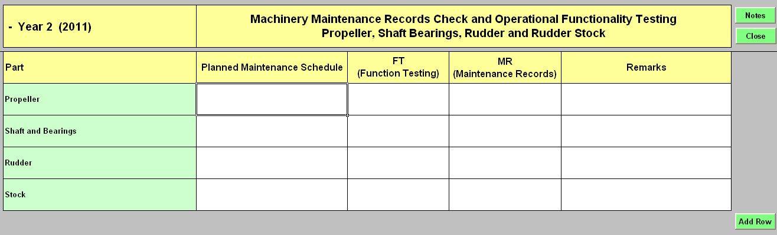

The same process should be undertaken for Years 3 and 4. Provided the document has been saved electronically, the data for previous years will not be lost.

Completion of the Record Sheets

Once the Vessel Details have been completed, the Record Sheets can be completed. The Record Sheets relate to:

- Hull Maintenance
- Machinery Maintenance (Main Engine)
- Auxiliary Engine No.1
- Auxiliary Engine No.2
- Controls and Trips
- Pumping Equipment
- Ancillary Equipment
- Electrical Equipment
- Propeller, Shaft and Rudder
- Tank Inspections
- Fishing Equipment

To enter the relevant Record Sheet, just click on the relevant box.

You will note on the Control Panel there are additional options for “Admin” and “Generate Report”. How to generate a report is explained later on in this guidance. The “Admin” option is purely for MCA purposes.

Basic Principals of the Record Sheets.

You will see that in the top right corner of most record sheets is an option for “Notes”. These Notes will give you guidance on how to undertake the required checks and tests for each of the Record sheets. In the Notes page, you can click “Close” to return to the sheet you are looking to complete.

You can then start completing the Records by clicking on the record sheets you wish to fill in. After each entry, it is recommended you save the document.

Keeping Records for equipment not listed in the Record Sheets.

If you have additional equipment that is not stated in the sheets, you can click “Add row” to make additional lines for recording these checks.

Checks Undertaken and Remarks

Most sheets have an option for “Checks Undertaken” and “Remarks” You can record the checks as set out in the Notes and MGN 322, the date of the checks and in “Remarks” any comments regarding the findings of these checks.

Function Testing, Maintenance Records

Some Record Sheets have entries required for Function Testing and Maintenance Records.

FT stands for Fuction Testing. By clicking in the relevant box, you will get a drop down option for Pass or Fail and you should click on whichever option applies

MR stands for Maintenance Records. By clicking in the relevant box you will get a drop down box with options for “OK” or “X”. OK indicate that records are kept in good order and X means they are not. You should click on the relevant option.

Maintenance Schedules

Several Record Sheets have sections relating to Maintenance schedules and whether they have been done and recorded.

If a maintenance schedule is required then it should be recorded in brief what the schedule is, that it is been done as per recommendations and records are kept in good order. In the “Done” box relating to Maintenance schedules, by clicking in the box you will get a Yes or No option and you should click on the option that indicates whether the maintenance schedule has been kept to. In the “Records” box, by clicking in the relevant box you will get a drop down box with options for “OK” or “X”. OK indicate that records are kept in good order and X means they are not. You should click on the relevant option.

Moving between Record Sheets

When completing separate record sheets, you can move between sheets by clicking close, which in all cases (apart from the Notes sheet, will return you to the Control Panel. Remember to regularly save your data. If you exit the spreadsheet without saving, the data will be lost.

Additional Information

The remaining information required by the sheets is considered to be self explanatory. However, if you are unsure about the information that is required, please contact your local surveyor who will be able to assist you.

Reports

You can generate a report on all your checks at any time during the process. You can do this going to the Control Panel and clicking on “Generate Report”. This will produce a message stating “This will produce a report for the entire cycle period. It will take a while to collate – Proceed” Should you wish to have the report, you should click the Yes option.

Once the report is ready, you will have the option to manually amend the page breaks. Only do this if you are comfortable with doing this. Doing so will not change the data but surveyors will be able to review the data without the page breaks being amended.

You can then print off this report. It is not recommended that you save this report under a different name as this will also change the name of the Spreadsheet. As the report is generated from the data in the spreadsheets, you only need to print the report. Any subsequent changes to the report will be automatically generated by changing the data in the individual sheets.

