

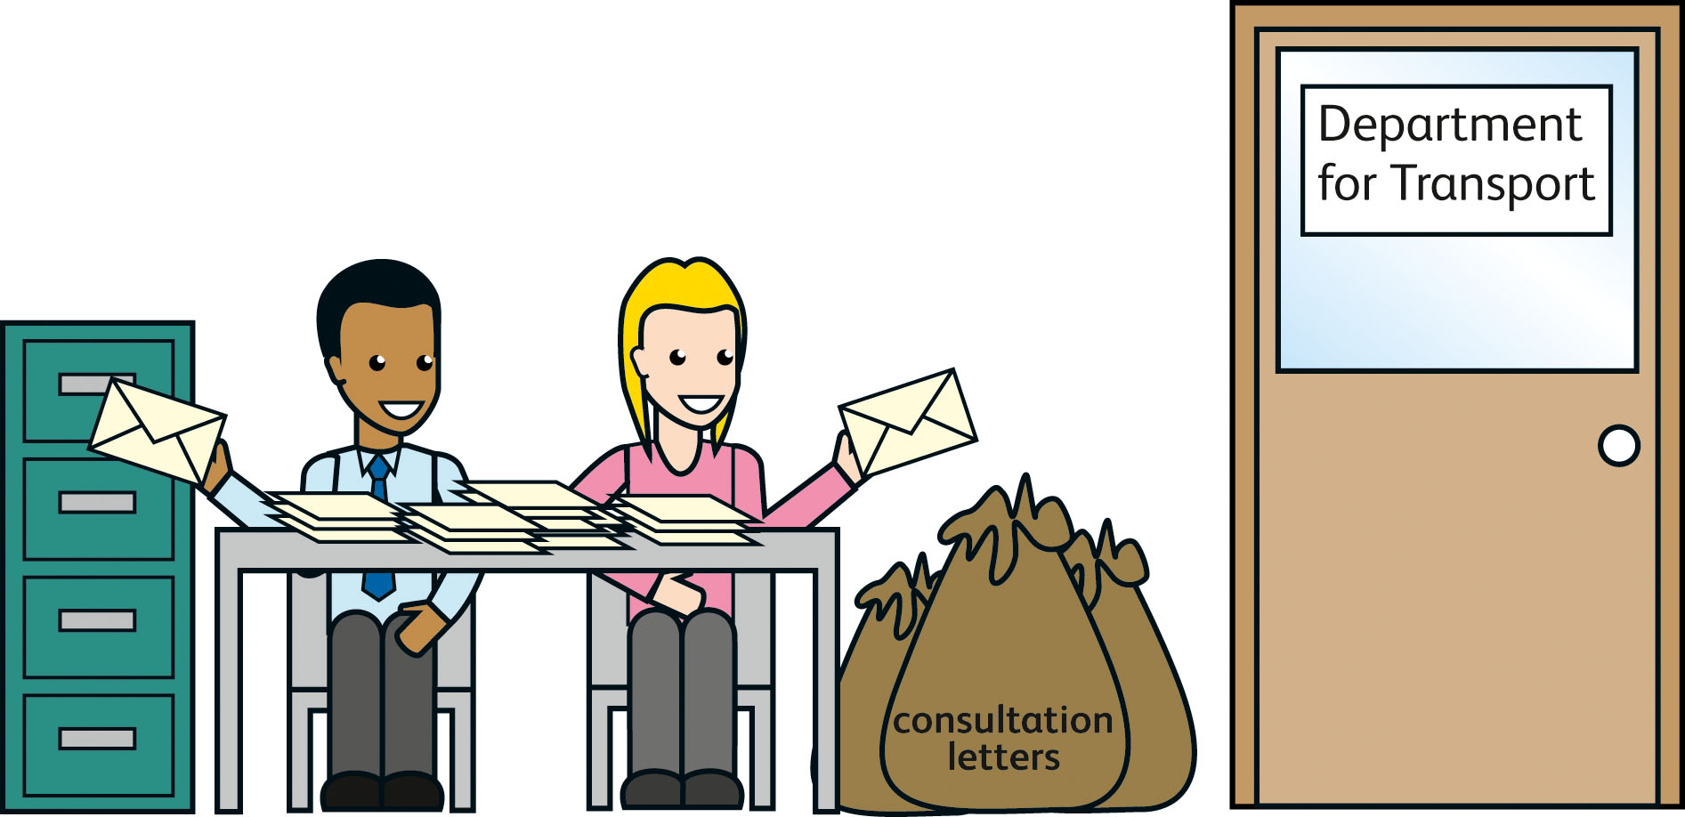
Personal Independence Payment
How it might affect blue parking badges
-------------------------------------------------
Tell us what you think
July 2012

This booklet asks what you think about planned changes to the blue badge scheme when Personal Independence Payment starts in 2013. This is a big booklet and you may not want to read all of it. Instead, look at the list of contents on pages 1 and 2. It shows what is in the booklet. Look down the list to find things you are interested in.
Blue boxes
In this easy-read booklet we sometimes explain what words mean. The first time we mention any of these words it is in bold green writing. Then we write what the words mean in a blue box.
When the words are used later in the booklet, we show them in normal green writing.
Questions
If you have any questions, you can contact
Sally Kendall
Traffic Division
Department for Transport
Great Minister House
33 Horseferry Road
London SW1P 4DR
Email bbes@dft.gsi.gov.uk

© Queen’s Printer and Controller of HMSO 2012
Copyright in the typographical arrangement rests with the Crown.
Contents
Message from the Minister 3
What’s in the booklet – in a few words 5
About changes to benefits 5
About blue badges 6
About the consultation 6
Our ideas 7
Why we are thinking about these changes now 8
What will happen next 8
Telling us what you think 9
How to tell us what you think 9
Freedom of information 10
Who can get a blue badge now 11
Without further assessment 11
With further assessment 12
More about the changes to benefits 14
More about Disability Living Allowance 14
More about Personal Independence Payment 15
How well can the person plan and follow a journey 17
How well can the person move around 17
What this means 18

Ideas for the blue badge scheme 19
Idea 1 – No link with Personal Independence Payment 20
Idea 2 – Automatic right to a blue badge for people
getting the enhanced mobility component 22
Idea 3 – Automatic right to a blue badge for people who
score 8 or more for the ‘moving around’ question 25
If you have a good idea 27
The questions in the consultation 29

Message from the Minister
The government is making a lot of important changes to the benefits system. These include changes to Disability Living Allowance.
Disability Living Allowance
This is money that someone with a disability or a health condition may be able to get to help them pay for the help and support they need.

The changes to Disability Living Allowance will also change the way many working age people get blue badges for free car parking.
Working age people
These are people who are aged between 16 and 64.

Blue badges
Local councils give these to some disabled people to let them park their cars for free and in places where other people cannot park.

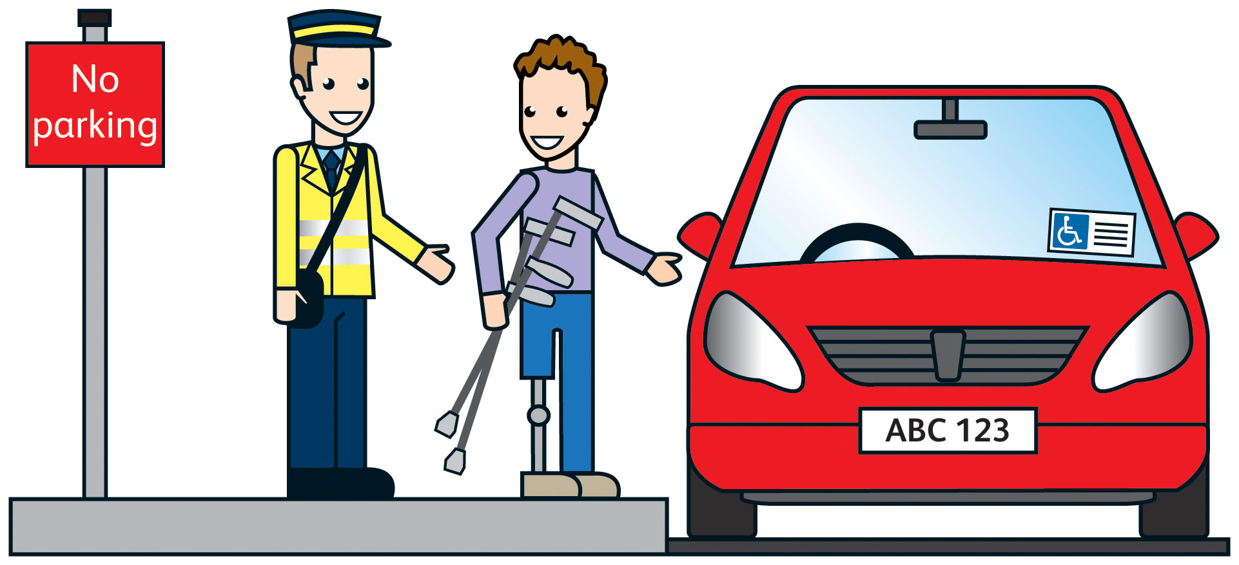
About 3 out of every 10 blue badges go to people who get the highest rate of Disability Living Allowance because they find it very hard to walk and get about.
At the moment, local councils automatically give these people a blue badge. But Disability Living Allowance is changing in 2013, and so the rules about who can get a blue badge need to change too.
I want to make sure blue badges go to the people who need them most. I also want to make sure that people will be able to get blue badges in the future too. To do this I must make some hard decisions.
To make sure I get these decisions right, I am having a consultation.
Consultation or consulting
This is when the government asks people what they think about the government’s plans, and for ideas about the best way to do things.

We already have some good ideas about how to make sure the right people get a blue badge. Our ideas are shown in this booklet.
I want to know what you think about our ideas. I also want to hear from you if you have any ideas of your own. What you tell us will help me decide what should happen next.
 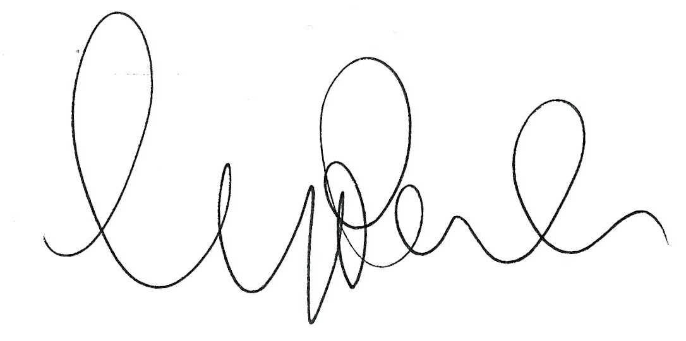
Norman Baker MP,
Minister for Transport
What’s in the booklet – in a few words
About changes to benefits
Disability Living Allowance for working age people will change from April 2013.
Personal Independence Payment will start replacing Disability Living Allowance for working age people from April 2013.
Personal Independence Payment
This is a new benefit to help disabled people live full, active and independent lives. Disabled people who can get the benefit will get money to help them pay the extra costs of being disabled.

At first the change will only affect people who make a new claim. But from October 2013, the Department for Work and Pensions will start asking working age people who already get Disability Living Allowance to make a claim for Personal Independence Payment.
The government has already consulted people about the changes to benefits. You can see all the consultations at www.dwp.gov.uk/pip
The government will be publishing a response to the consultations later this year.
But there are no changes to Disability Living Allowance for children younger than 16, nor for people who are 65 or more on 8 April 2013.
About blue badges
In England, 2½ million people have blue badges that let them park free or in places where other people cannot park their cars. Nearly 7 out of every 10 of these people are over 65.
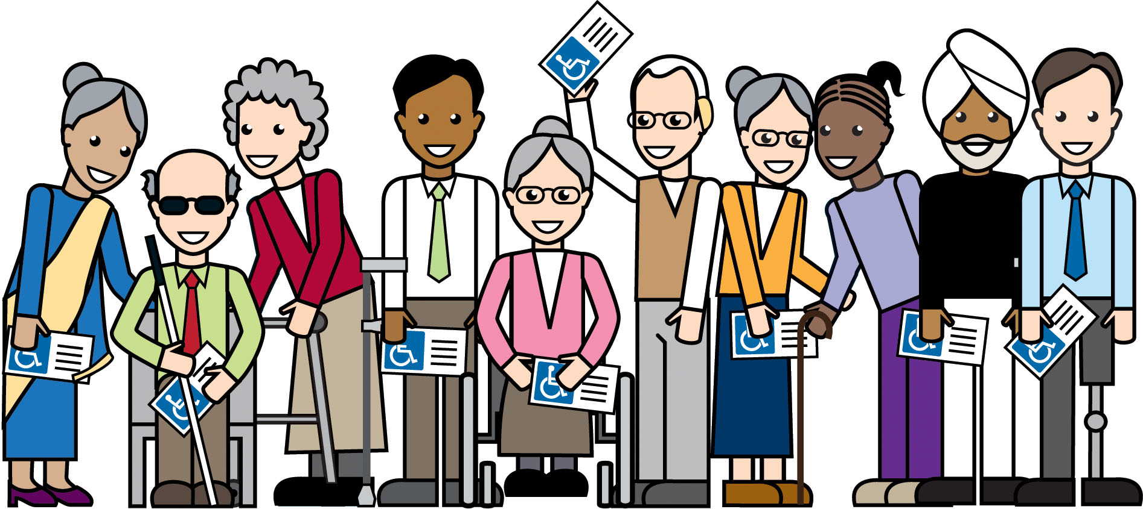
The start of Personal Independence Payment in 2013 means
that we must change the system for those who can automatically
get a blue badge.
The Department for Transport is holding the consultation because
we are in charge of the law that says who can get a blue badge.
About the consultation
This consultation is to find out what people think of our ideas about who can get a blue badge when Personal Independence Payment starts in 2013.
In particular, we would like to hear from disabled people and disability groups. We also want to hear from local councils who are in charge of the blue badge scheme.
Our ideas
We have 3 ideas for a new system to decide who can get a blue badge. But if you have a good idea, please tell us about it.
These are our 3 ideas for the new system.
1 A system where there is no link between the blue badge scheme and the Personal Independence Payment. Everyone would apply for a blue badge in the same way.
2 A system where a person can automatically get a blue badge if they get the enhanced mobility component of Personal Independence Payment.
Enhanced mobility component
This is the highest rate of Personal Independence Payment for people who find it very hard to get about.

3 A system where a person can automatically get a blue badge if they get 8 points or more in the part of the assessment for Personal Independence Payment that looks at how well a person can physically move around. More about the points system is on page 25.
Assessment
This is the method the Department for Work and Pensions will use to work out if a person can get Personal Independence Payment. People will be given points depending on how well they can do everyday things.

Why we are thinking about these changes now
We must start making plans to change the rules about who can automatically get a blue badge because Personal Independence Payment starts soon – from April 2013.
We cannot leave things as they are because working age people will not be able to get Disability Living Allowance when Personal Independence Payment starts.
Local councils, who are in charge of the blue badge scheme, also
need time to make plans for the changes.
What will happen next
When the consultation ends we will look at all the replies we get.
We will take these into account when deciding what will happen next.
Changes to the law about blue badges must be made in time for the start of Personal Independence Payment in April 2013.
Telling us what you think
This consultation is only for people who live in England. People in other parts of the country have their own blue badge schemes.
So if you live in England and want to tell us about any of the things in this booklet, we would like to hear from you. For example, you may want to tell us what you think about our ideas, or you may want to tell us about your own ideas.
You need to tell us what you think by 2 October 2012. This is the date the consultation ends.
How to tell us what you think
Tell us what you think by sending your reply to this address.
Sally Kendall
Traffic Division
Department for Transport
Zone 3/26
Great Minister House
33 Horseferry Road
London SW1P 4DR
For more copies of this booklet, see our website at
www.dft.gov.uk/topics/access/blue-badge
When you reply to the consultation, tell us if your reply is for yourself or for a group. If your reply is for a group, tell us about the people in the group and how you got the ideas from the group.
If you know anyone else who wants to join in this consultation, ask them to contact us. Our address is shown on page 9, or they can email us at bbes@dft.gsi.gov.uk

Freedom of information
The law says that if you reply to this consultation, anyone can ask us to tell them what you and other people said.
If you do not want us to tell other people about what you say, please tell us why. Even then, unless you have a good reason, we may still have to tell people what you said.
Who can get a blue badge now
If a disabled person has a blue badge, they or their driver can park their car where other people cannot. This helps disabled people get to work, to the shops and to other services. That is a good thing, so we want to make sure the blue badge scheme continues.
In England more than 2½ million people have blue badges. Many
say they could not travel without knowing that they can park easily. About 2 out of every 3 blue badges go to people who are over 65.
The law has rules about who can get a blue badge. This section shows a short, easy to read version of the rules. The full rules are in the main consultation booklet. The rules say that people can apply for a blue badge in 2 ways.
• Without further assessment – see below.
• With further assessment – see page 12.
Without further assessment
Without further assessment means that anyone aged more than 2 can automatically get a blue badge if they get certain kinds of benefits or they are blind. One of these benefits is the higher rate mobility component of Disability Living Allowance.
Higher rate mobility component
This is the highest rate of Disability Living Allowance for people who have a disability or illness that affects their body and because of that, it is very hard for them to walk or get about.

Nearly a million people in England are eligible for a blue badge because they get the higher rate mobility component, and about half of these go on to apply for a blue badge.
With further assessment
With further assessment means a person may get a blue badge if they have certain kinds of disabilities. For example
• if an expert says they have a disability which means they cannot walk or it is very hard for them to walk.
• if they have a disability in both arms and find it very hard to use parking meters.
• if a young child needs bulky medical equipment that must be kept near a vehicle at all times.
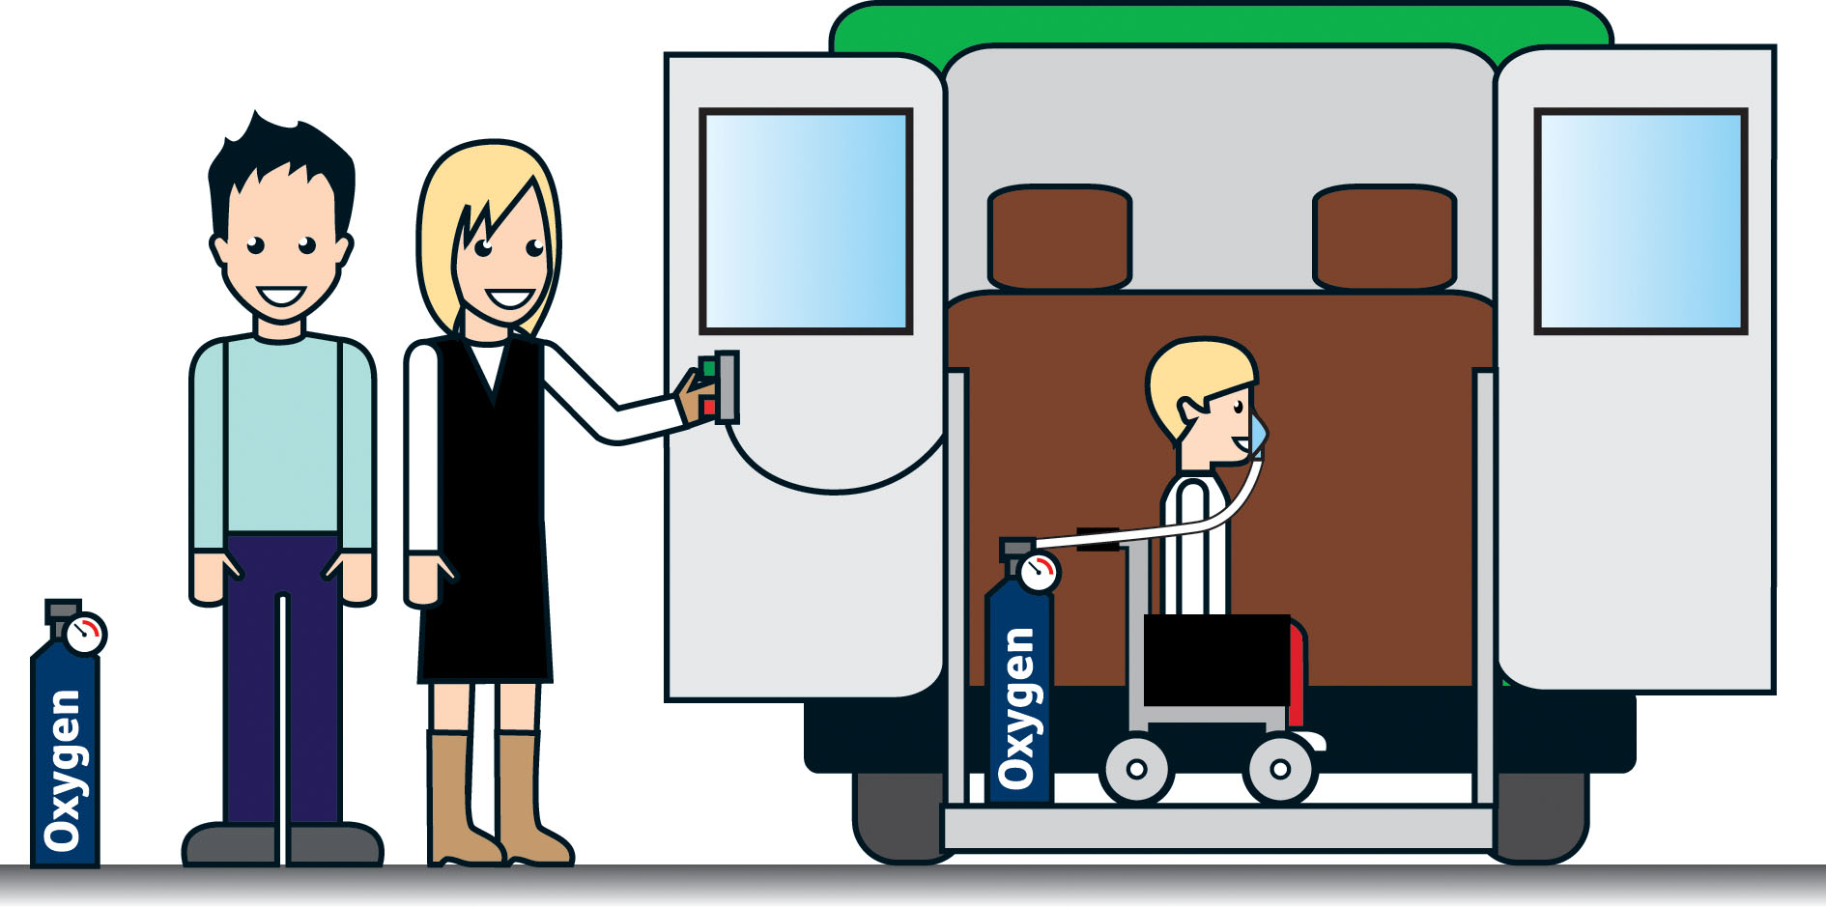
More than 1½ million people in England get a blue badge under these rules.
The decision about whether or not a person can get a blue badge is made by the local council. People who apply for a blue badge may have to see a person who is specially trained to work out how far they can walk.
People with a mental illness or a learning disability may get a blue badge if their illness or disability means they cannot walk or they find it very hard to walk.
Consultation question 1
What should local councils take into account when deciding if a person should get a blue badge?
a Should people get a blue badge if they have a mental illness or a learning disability, but they can walk? Please give your reasons.
b Should blue badges be for people who cannot walk or find it very hard to walk? Please give your reasons.
c Should some people automatically get a blue badge if they get certain kinds of benefit or if they are blind? Or should everyone have to apply for a blue badge in the same way?
More about the changes to benefits
Disability Living Allowance is changing from April next year. But the changes will only affect working age people. There are no changes
to Disability Living Allowance for children who are younger than 16,
nor for people who are 65 or over on 8 April 2013.
A new benefit called Personal Independence Payment will start replacing Disability Living Allowance for working age people from April 2013.
At first the change will only affect people who make a new claim. But from October 2013, the Department for Work and Pensions will start asking working age people who already get Disability Living Allowance to make a claim for Personal Independence Payment.
The government has consulted people about the changes to Disability Living Allowance and the new Personal Independence Payment. These consultations are finished now, but you can still read them, for information only, at www.dwp.gov.uk/pip
More about Disability Living Allowance
Disability Living Allowance is for people who need extra support to live with their disability or illness.
Some people get the highest rate of Disability Living Allowance because they have a disability or illness that affects their body and because of that, it is very hard for them to walk or get about. This extra high rate is called the higher rate mobility component.
People who get the higher rate mobility component can automatically get a blue badge so that they can park free or in places where other people cannot park their cars.
More about Personal Independence Payment
Personal Independence Payment is a new benefit to help disabled people live independently by paying the extra costs of being disabled.

Personal Independence Payment will start to replace Disability Living Allowance for working age people from April 2013.
When someone claims Personal Independence Payment, they must have an assessment. The assessment includes 2 activities about how well a person can get out and about. These decide if the person can get the mobility component.
Mobility component
This is the amount of Personal Independence Payment that is paid to help people get out and about. It is paid at 2 rates.
• A low rate for people who find it hard to get out and about.
This is called the standard mobility component.
• A high rate for people who find it very hard to get out and about. This is called the enhanced mobility component.

The 2 activities for the mobility component ask
1 How well can the person plan and follow a journey.
2 How well can the person move around.
There is more about these activities on page 17.
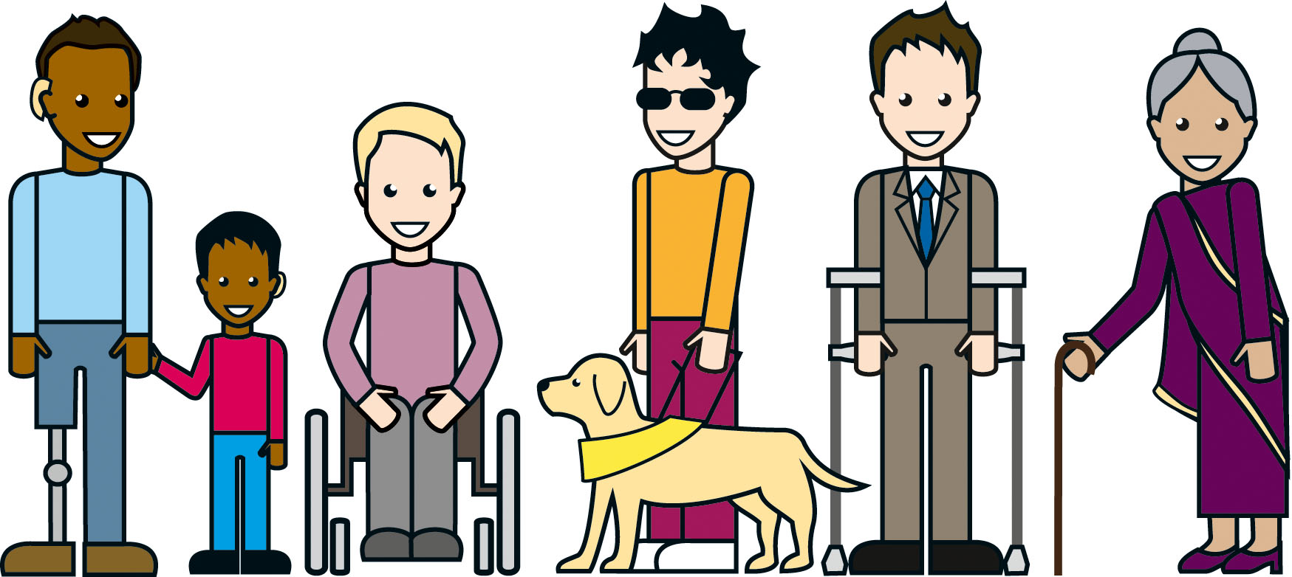
The Department for Work and Pensions will give
• fewer points if the person can get out and about more easily.
• more points if the person finds it hard to get out and about.
If, when added together, the Department for Work and Pensions gives the person
• 7 or fewer points, they do not get any mobility component.
• between 8 and 11 points, they get the standard mobility component
• 12 or more points, they get the enhanced mobility component.
Page 17 talks about what the Department for Work and Pensions looks for when they give points for each of the 2 activities.
How well can the person plan and follow a journey
For this activity, the Department for Work and Pensions is looking at how well the person can work out a journey to a place they do not know well, and then make that journey. For example.
• If the person has no trouble doing this, they will get no points.
• If the person gets very upset when travelling and needs another person to go with them, they might get 4 points.
• If the person cannot work out a journey and travel alone, they might get 15 points.
How well can the person move around
For this question, the Department for Work and Pensions is looking at whether the person has a disability or illness, and how much this affects how well they can move around. For example.
• If the person can walk 200 metres, they will get no points.
• If the person cannot walk more than 50 metres, they might get
8 points.
• If the person cannot walk at all, they might get 12 points.
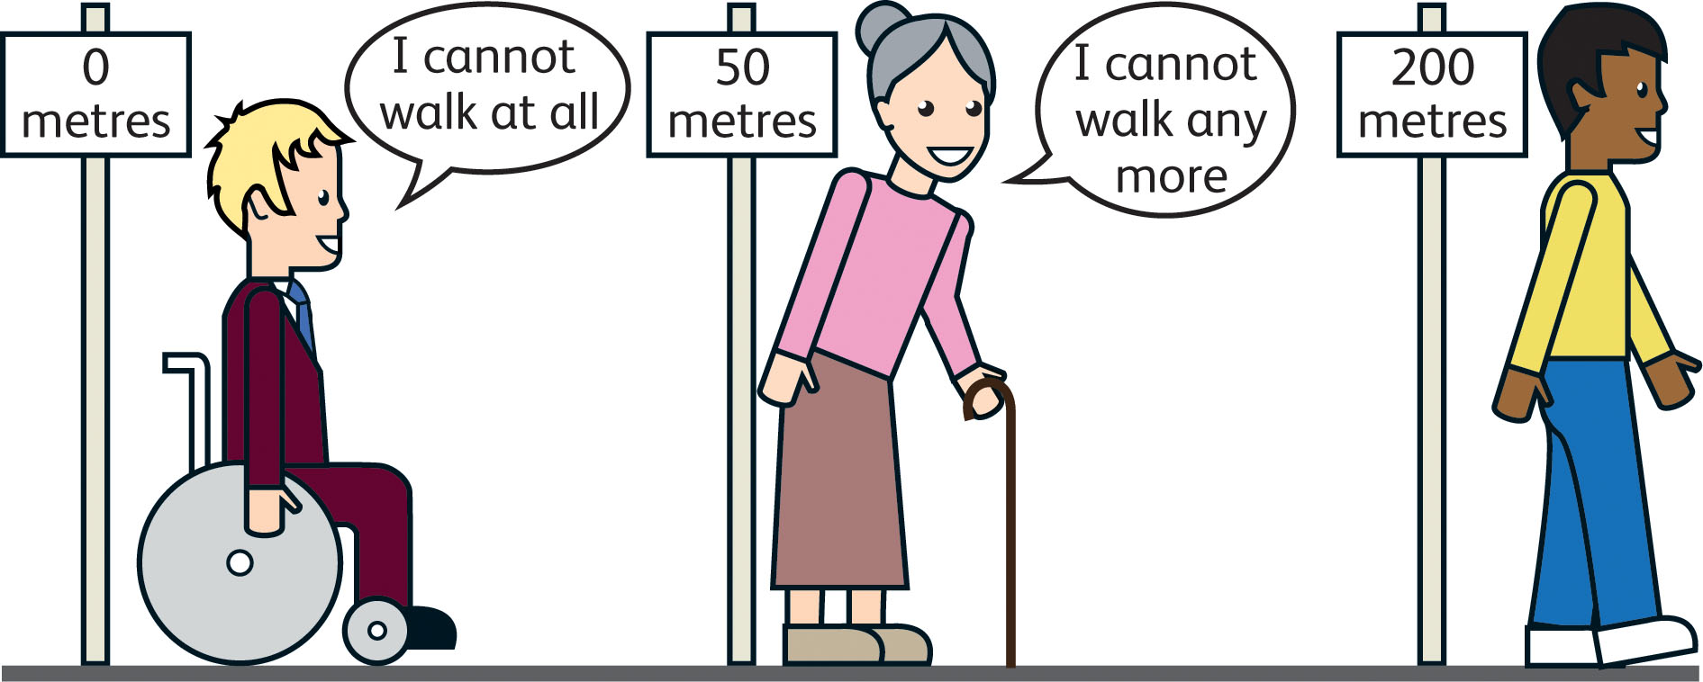
What this means
This means that a person could get the enhanced mobility component of Personal Independence Payment if a mental health condition or a learning disability stops them from working out a journey and travelling alone.
This is very different to the rules for the higher rate mobility component of Disability Living Allowance. Those rules say that a person must have a disability or illness that affects their body before they can get the higher rate mobility component.
Because this is such a big change, we want you to tell us what you think of our ideas for who can get a blue badge when Personal Independence Payment starts. Also, if you have a good idea of your own, please tell us about it.
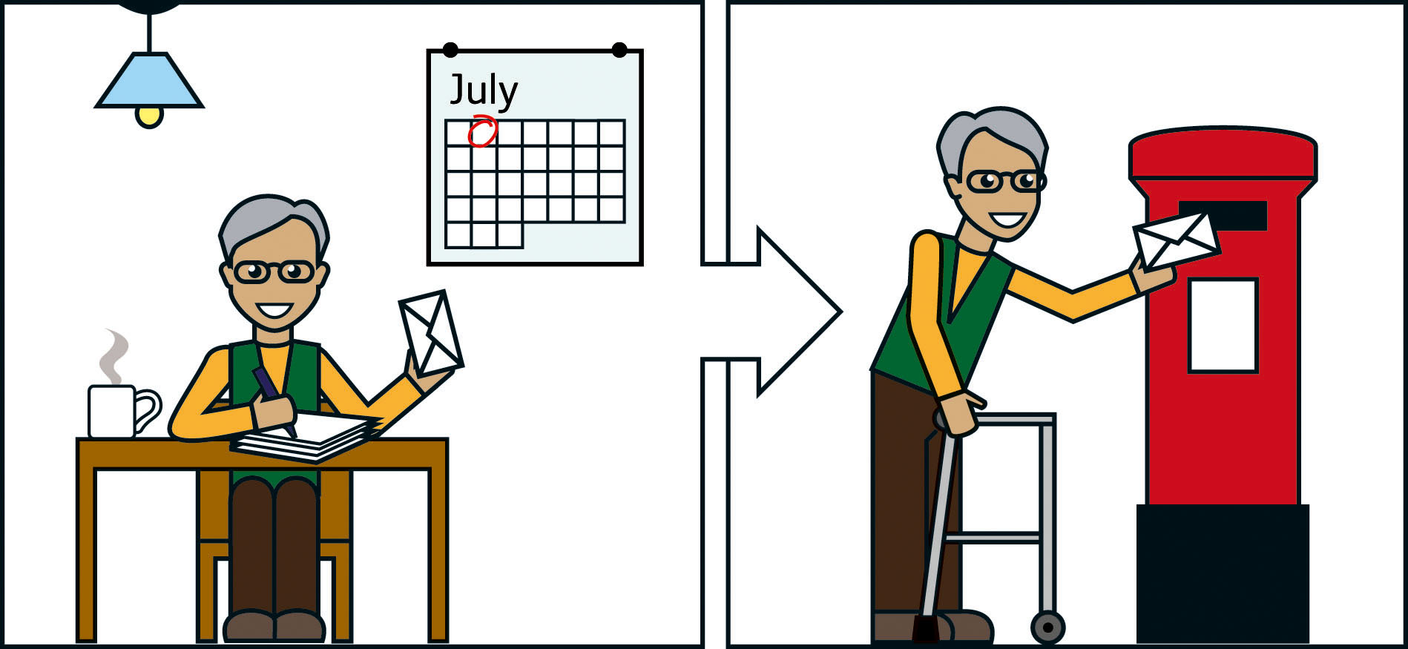
The rest of this booklet is about our 3 ideas for the changes we must make to the blue badge scheme.
Ideas for the blue badge scheme
The blue badge scheme must change when Personal Independence Payment starts next year. This is because working age people will not be able to get Disability Living Allowance when Personal Independence Payment starts. This is explained on pages 12 to 18.
This part shows our 3 ideas for dealing with the changes. There may be other ideas for the changes, but these are the ideas we are thinking about most.
But our ideas will not affect people younger than 16, those aged 65 or over, or people who became disabled while they were working in the army, navy or airforce.
We would like to hear what you think about our 3 ideas. If you have an idea for a system that could work well, we would like to hear about that too.
We have worked out what each of our 3 ideas might cost. These are shown later in this part. We worked out the costs by looking at the
• cost to process applications for blue badges.
• cost to decide if the person should have a blue badge.
• cost of making the blue badges.
• cost to local councils in lost parking charges.
We would like to know if you think we have missed anything out. See Consultation question 6 on page 28.
Idea 1
No link with Personal Independence Payment
As the law is now, everyone who gets the higher rate mobility component of Disability Living Allowance can automatically get a blue badge.
If we do not change the law, this rule will not apply to working age people who get the enhanced mobility component of Personal Independence Payment. So if we use this idea, from April 2013, working age people who received the enhanced mobility component would have to
• apply for a blue badge in the same way as everybody else.
• be assessed on their ability to walk or whether they have a disability in both arms.
This would mean local councils would have to make a decision on every application for a blue badge.
It would also mean that some people must have 2 assessments,
1 to get Personal Independence Payment and another to get a
blue badge.
We believe that this idea would lead to fewer people having a blue badge. As a result there would be lower costs for local councils compared to what the blue badge scheme costs now.
We have worked out that, by 2015, this idea would save local councils between £5 million and £25 million each year.
Consultation question 2
What do you think about our first idea – no automatic right to a blue badge for people who get the enhanced mobility component of Personal Independence Payment?
a Should everyone aged between 16 and 64 have to apply to their local council if they want a blue badge? Please give your reasons.
b If we use this idea, which groups of people do you think will be most affected by the change? Do you think they would still get a blue badge from their local council?
c If we use this idea, how many people do you think will be affected by the change?
d Do you think children younger than 16 and people aged over 65 should also have to apply direct to their local council for a blue badge? Please give your reasons.
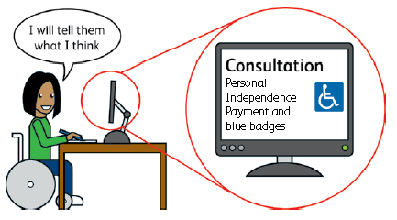
Idea 2
Automatic right to a blue badge for people getting the enhanced mobility component
As we explained on pages 15 to 18, the assessment for Personal Independence Payment includes 2 activities about how well a person can get out and about. These are
• How well can the person plan and follow a journey.
• How well can the person move around.
The assessment of these 2 activities decides if the person can get the mobility component. And if the Department for Work and Pensions gives someone 12 points or more for these 2 activities, the person will get the enhanced mobility component.
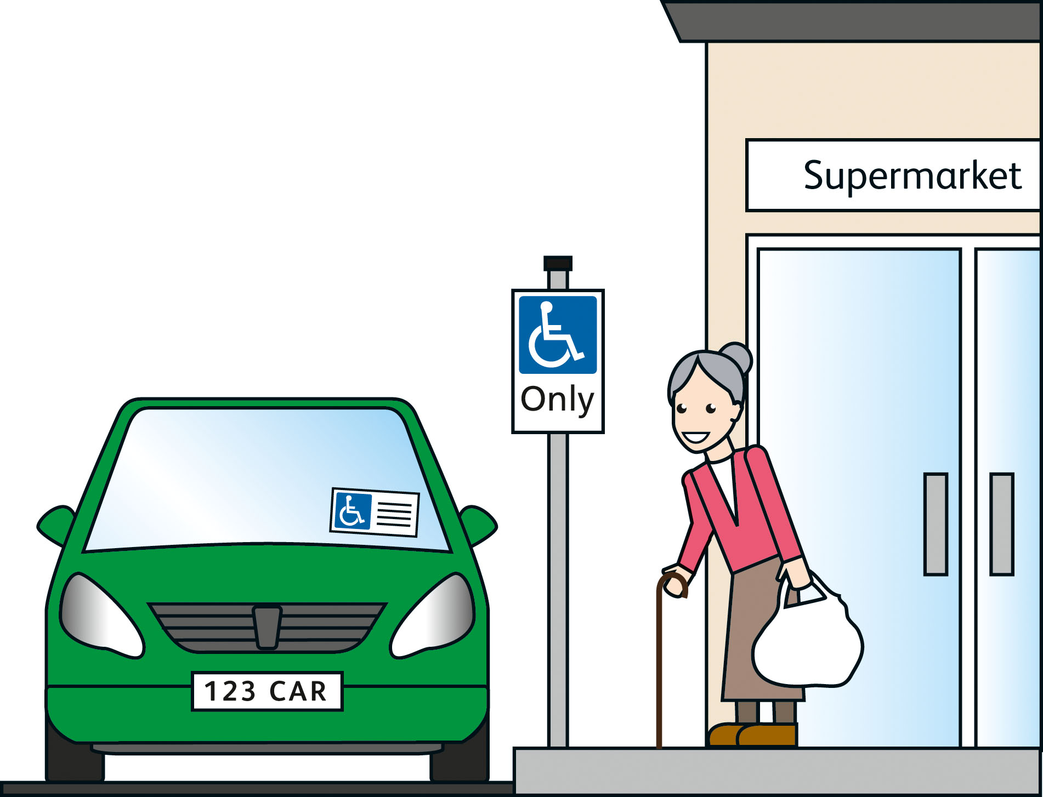
So a person could get the enhanced mobility component even if their only illness or disability is a mental health condition or a learning disability. And that means people who can easily walk could get a
blue badge.
The result would be
• a big increase in the number of people who get blue badges.
• more people with blue badges looking for parking spaces.
• a worse system for people who cannot walk or find it hard to walk.
For this idea, we believe it is important to think about the aims of the blue badge scheme. We know that it would help many disabled people if they could park where other people cannot, but there is a limit on the number of parking spaces in our cities and towns.
We also need to make sure that the right people can get blue badges into the future.
We believe that this idea would lead to more people having a blue badge. As a result there would be higher costs for local councils compared to what the blue badge scheme costs now.
We have worked out that, by 2015, this idea would cost local councils between £15 million and £25 million more each year.
Consultation question 3
What do you think about our second idea – for people to have an automatic right to a blue badge if they get the enhanced mobility component of Personal Independence Payment?
a Should everyone who gets the enhanced mobility component be able to get a blue badge? Please give your reasons.
b If we use this idea, which groups of people do you think will be most affected by being able to get a blue badge automatically?
c If we use this idea, how many people do you think will be affected by the change?
d How do you think this idea might affect people who already have a blue badge, local councils and the future of the blue badge scheme?
e People with blue badges can get some special offers? For example, cheaper parking in car parks and cheap travel on buses and trains. How do you think this idea would affect these special offers?
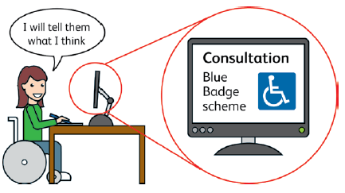
Idea 3
Automatic right to a blue badge for people who score 8 or more for the ‘moving around’ question
This idea is the closest to how things are now.
As we explained on page 17, the assessment for Personal Independence Payment includes an activity about how well the person can move around.
For this question, the Department for Work and Pensions looks at whether the person has a disability or illness, and how much this affects how well they can physically move around. The person gets more points the harder it is for them to move around. For example.
• People who can walk 200 metres get no points.
• People who cannot walk more than 200 metres might get 4 points.
• People who cannot walk more than 50 metres might get 8 points.
• People who cannot walk at all might get 12 points.
Our idea is to change the law so that a person can automatically get a blue badge if they get 8 points or more. This would help keep blue badges just for people who cannot walk or find it very hard to walk far.
But some people would lose out. For example, people with a mental health condition who get a blue badge because they get the higher rate mobility component of Disability Living Allowance would not automatically get a blue badge if they can walk more than 50 metres.
But people who lose out could still apply to their local council for a blue badge in the same way as other people.
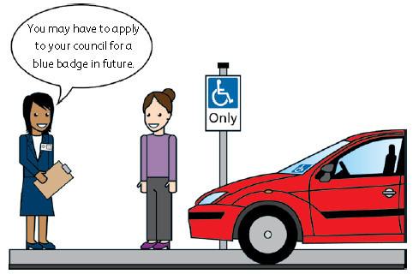
We believe that this idea would mean that about the same number of people could get a blue badge. As a result this idea would cost local councils about the same as the blue badge scheme costs now.
This is the idea we like the best. This is because
• it is the idea that is most like the blue badge scheme as it is now.
• this idea will mean fewer changes.
But we will think about this again after we hear what people tell us as part of this consultation.
Consultation question 4
What do you think about our third idea – for people to have an automatic right to a blue badge if they get 8 or more points for how well they can move around?
a Should people who get 8 or more points for how well they can move around have an automatic right to a blue badge? Please give your reasons.
b If we use this idea, which groups of people do you think will be most affected by the change? Do you think they would still get a blue badge from their local council?
c If we use this idea, how many people do you think will be affected by the change?
If you have a good idea
We think that our ideas show the 3 best ways for changing the blue badge scheme when Personal Independence Payment replaces Disability Living Allowance for working age people in 2013.
But we would like to hear your ideas too. For example.
• Ideas for another system that might work well.
• Ideas that might make it easier to make the changes.
• Ideas that might save money so that the blue badge scheme can continue into the future.
But remember, things cannot stay as they are because of the changes to Disability Living Allowance.
Consultation question 5
Do you have any good ideas for changes to the blue badge scheme?
a How would your idea affect the rules for getting a blue badge? And how would your idea affect people who already have a blue badge, the local council’s costs and the way the blue badge scheme works?
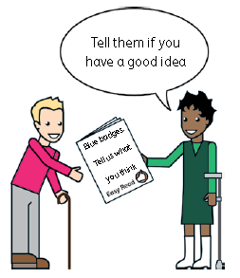
Consultation question 6
a For each of our 3 ideas we said what we think the costs or savings might be. What do you think about these?
b For each of our 3 ideas we said whether the number of blue badges will go up, go down or stay the same. Do you think these are right?
c Do you have any information you can send us to help us work out which idea is best?
The questions in the consultation
There are 6 questions. You do not have to answer them all. If you
need more room to write your answers, use a separate sheet of paper. Page 9 shows where you should send your answers.
Question 1
What should local councils take into account when deciding if a person should get a blue badge?
a Should people get a blue badge if they have a mental illness or a learning disability, but they can walk? Please give your reasons.
b Should blue badges be for people who cannot walk or find it very hard to walk? Please give your reasons.
c Should some people automatically get a blue badge if they get certain kinds of benefit or if they are blind? Or should everyone have to apply for a blue badge in the same way?

…………………………………………………………………………………….
…………………………………………………………………………………….
…………………………………………………………………………………….
…………………………………………………………………………………….
…………………………………………………………………………………….
…………………………………………………………………………………….
Question 2
What do you think about our first idea – no automatic right to a blue badge for people who get the enhanced mobility component of Personal Independence Payment?
a Should everyone aged between 16 and 64 have to apply to their local council if they want a blue badge? Please give your reasons.
b If we use this idea, which groups of people do you think will be most affected by the change? Do you think they would still get a blue badge from their local council?
c If we use this idea, how many people do you think will be affected by the change?
d Do you think children younger than 16 and people aged over 65 should also have to apply direct to their local council for a blue badge? Please give your reasons.

…………………………………………………………………………………….
…………………………………………………………………………………….
…………………………………………………………………………………….
…………………………………………………………………………………….
…………………………………………………………………………………….
…………………………………………………………………………………….

Question 3
What do you think about our second idea – for people to have an automatic right to a blue badge if they get the enhanced mobility component of Personal Independence Payment?
a Should everyone who gets the enhanced mobility component be able to get a blue badge? Please give your reasons.
b If we use this idea, which groups of people do you think will be most affected by being able to get a blue badge automatically?
c If we use this idea, how many people do you think will be affected by the change?
d How do you think this idea might affect people who already have a blue badge, local councils and the future of the blue badge scheme?
e People with blue badges can get some special offers? For example, cheaper parking in car parks and cheap travel on buses and trains. How do you think this idea would affect these special offers?

…………………………………………………………………………………….
…………………………………………………………………………………….
…………………………………………………………………………………….
…………………………………………………………………………………….
…………………………………………………………………………………….
Question 4
What do you think about our third idea – for people to have an automatic right to a blue badge if they get 8 or more points for how well they can move around?
a Should people who get 8 or more points for how well they can move around have an automatic right to a blue badge? Please give your reasons.
b If we use this idea, which groups of people do you think will be most affected by the change? Do you think they would still get a blue badge from their local council?
c If we use this idea, how many people do you think will be affected by the change?

…………………………………………………………………………………….
…………………………………………………………………………………….
…………………………………………………………………………………….
…………………………………………………………………………………….
…………………………………………………………………………………….
…………………………………………………………………………………….
Question 5
Do you have any good ideas for changes to the blue badge scheme?
a How would your idea affect the rules for getting a blue badge? And how would your idea affect people who already have a blue badge, the local council’s costs and the way the blue badge scheme works?

…………………………………………………………………………………….
…………………………………………………………………………………….
…………………………………………………………………………………….
…………………………………………………………………………………….
Question 6
a For each of our 3 ideas we said what we think the costs or savings might be. What do you think about these?
b For each of our 3 ideas we said whether the number of blue badges will go up, go down or stay the same. Do you think these are right?
c Do you have any information you can send us to help us work out which idea is best?

…………………………………………………………………………………….
…………………………………………………………………………………….
…………………………………………………………………………………….
…………………………………………………………………………………….
…………………………………………………………………………………….
How to contact us
Email bbes@dft.gsi.gov.uk

Letters Sally Kendall
Traffic Division
Department for Transport
Great Minister House
33 Horseferry Road
London SW1P 4DR

