Sponsored Museums: Performance Indicators 2012/13
Statistical Release
November 2013

Sponsored Museums: Performance Indicators is an Official Statistic and has been produced to the standards set out in the Code of Practice for Official Statistics

Contents

Chapter 1: Introduction 4
Chapter 2: Visits to DCMS’ Sponsored Museums 2012/13 5
Key findings: 5
Total visits to sponsored museums: 6
Child visits: 7
Overseas visits: 8
Website visits: 8
Annex A: Background note 9

- Introduction

Released: 14 November 2013

Period covered: April 2012 – March 2013, referred to as 2012/13 throughout

Geographic coverage: Sponsored Museums in England

Next release: October 2014

The Department for Culture, Media and Sport (DCMS) sponsors 16 National Museums which provide free entry to their permanent collections. These museums are:
- British Museum
- Geffrye Museum
- Horniman Museum
- Imperial War Museum
- National gallery
- National Maritime Museum
- National Museums Liverpool
- Science Museum Group
- National Portrait Gallery
- Natural History Museum
- Royal Armories
- Sir John Soane’s Museum
- Tate Galleries
- Tyne and Wear Museums
- Victoria and Albert Museum
- Wallace Collection

The data are collected by the museums through sample surveys, with the exception of the information on educational visits and total visits, which are based on actual counts.

Guidance notes explaining how the data should be collected are available below.
https://www.gov.uk/government/publications/sponsored-museums-performance-indicators-2012-13

The most recent performance indicator data available is for 2012/13
https://www.gov.uk/government/collections/performance-indicators

- Visits to DCMS’ Sponsored Museums 2012/13

Key findings:
The figure for total visits to Sponsored Museums is one of DCMS’ Performance Indicators. Visits and other information produced in this report at the individual museums level are also used as Performance Indicators by the museums themselves.

- There were 47 million visits to the Department’s 16 sponsored museums in 2012/13. This was an increase of 2 per cent from 2011/12 (46 million),.

- There were 9 million visits to the sponsored museums by children aged 15 and under in 2012/13, a decrease of 3 per cent since 2011/12^{1,}.

- 44 per cent of all visits were made by overseas visitors. There were 21 million visits from overseas visitors in 2012/13. This was an increase of 4 per cent since 2011/12¹ (20 million overseas visits).

- There were 109 million unique visits to the websites of sponsored museums in 2012/13.

Total visits to sponsored museums:

Total visits to all sponsored museums combined increased by 2.2 per cent from 45.9 million to 46.9 million over this period.^{1,}

Figure 1 shows the number of visits to DCMS’ sponsored museums in 2011/12 and 2012/13

Figure 1: Total visits by museum 2011/12 to 2012/13
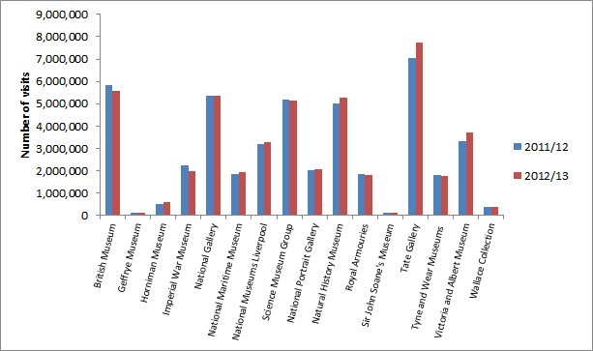
Note: The figure presented for the Royal Armouries in 2011/12 has been revised from that previously published.

Accompanying excel tables showing individual museum visit figures since 2008/09 are available.

Child visits:

There were 8.9 million visits by children aged 15 and under in 2012/13. This was a decrease of 3.1 per cent since 2011/12 (9.2 million) ^{6,}. Figure 3 shows the number of visits made by children to sponsored museums.

Figure 3: The number of visits to sponsored museums by children aged 15 and under by museum visited, 2011/12 to 2012/13,

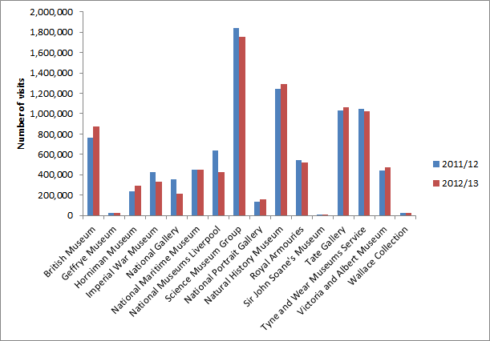
Note: The figures presented for the Royal Armouries and the British Museum in 2011/12 have been revised from that previously published.

Accompanying excel tables showing total child visit figures since 2008/09 are available.

Overseas visits:

There were 20.7 million visits to sponsored museums in 2012/13 by overseas visitors. These visits accounted for 44.1 per cent of all visits, a similar proportion to 2011/12 (43.4%). Overseas visits to the 16 sponsored museums have increased by 4.0 per cent since 2011/12 (19.9 million)^{8,}

Figure 5: Percentage of overseas and UK visits to the 16 DCMS sponsored museums in 2011/12 and 2012/13
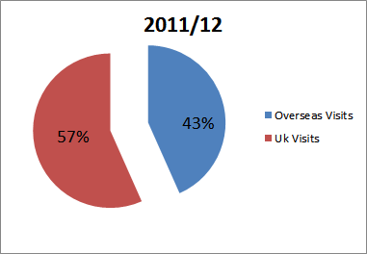
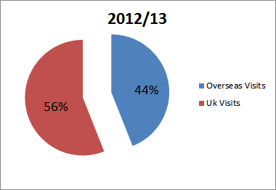

Accompanying excel tables showing the total number of overseas visits to sponsored museums since 2008/09 are available.

Website visits:

In 2012/13 there were a total of 109.4 million unique visits to the websites of the DCMS’ sponsored museums.

However, due to changes in the software used to measure website visits by many of the museums at several points over time, these figures are not directly comparable between years.

Accompanying tables showing the total number of unique visits to the websites of the DCMS’ sponsored museums since 2008/09 are available.

Annex A: Background note

- Sponsored Museums: Performance Indicators is an Official Statistic and has been produced to the standards set out in the Code of Practice for Official Statistics. Official Statistics undergo regular quality assurance reviews to ensure they meet customer needs and are produced free from any political interference. For more information, see http://www.statisticsauthority.gov.uk/assessment/code-of-practice/code-of-practice-for-official-statistics.pdf.

- This release of this publication was delayed by two weeks to 14/11/2013 due to data issues identified during quality assurance.

- Sponsored Museums Performance Indicator publications previously included data on adult visits by NS-SEC group, ethnicity and whether visitors considered themselves to have a long term illness, disability or infirmity.

Previous publications also included data on:

- The number of instances of children participating in outreach activities outside the gallery
- The number of instances of adults aged 16 and over participating in organised activities at the museum/gallery
- The number of instances of adults aged 16 and over participating in outreach activities outside the museum/gallery.
Following consultation with the sponsored Museums and Galleries, the data outlined above were no longer collected from 2012/13 onwards to reduce the burden of data collection on the Museums and Galleries. If you have a continued user need for these data, please contact enquiries@culture.gov.uk

- Due to data issues identified during processing, data on income generated through admissions, trading and fundraising as well as the number of instances of children under 16 participating in on-site organised activities have been omitted from this report and accompanying tables. They will be made available at a later date, once these issues have been resolved. Please contact enquiries@culture.gov.uk for further information.

- This report has been produced by Paul Maley and Sam Tuckett.

- The responsible statistician for this release is Sam Tuckett. For enquiries on this release, please contact Sam Tuckett on 0207 211 2382.

- Next Release: Sponsored Museums: Performance Indicators is an annual publication. The next release is scheduled for October 2014

- For general enquiries telephone: 0207 211 6200
Department for Culture Media and Sport
100 Parliament Street
London
SW1A 2BQ
enquiries@culture.gov.uk
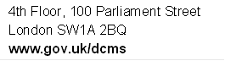

In 2012/13 Royal Armouries White Tower visit figures measured using a clicker on the door, were included for the first time. For the purpose of this comparison, the child, overseas and total visit figures for 2011/12 has been recalculated using this new methodology to enable a percentage change to be given between the two years on a comparable basis. The 2012/13 child, overseas and total visit figures are therefore not comparable to data prior to the revised 2011/12 figures presented in the data tables.
Using a clicker on the door to measure White Tower visitor figures increased total recorded visit figures by approximately 1.4 million, child visit figures by approximately 0.4 million and overseas visit figures by approximately 1.2 million.
This percentage has been updated from what was initially published on 14th November as the number of child visits to the British Museum in 2011/12 has been revised.
Using a clicker on the door to measure White Tower visitor figures increased total recorded visit figures by approximately 1.4 million, child visit figures by approximately 0.4 million and overseas visit figures by approximately 1.2 million.
The 2011/12 figure for Royal Armouries presented on this chart has been recalculated using White Tower figures collected using a clicker on the door to make it comparable to the 2012/13 figure.
This percentage has been updated from what was initially published on 14th November as the number of child visits to the British Museum in 2011/12 has been revised.
In 2012/13 Royal Armouries White Tower visit figures measured using a clicker on the door were included for the first time. For the purpose of this comparison, the child visit figure for 2011/12 has been recalculated using this new methodology to enable a percentage change to be given between the two years on a comparable basis. The 2012/13 figure is therefore not comparable to data prior to the revised 2011/12 figure presented in the data tables.
The 2011/12 figure for Royal Armouries presented on this chart has been recalculated using White Tower figures collected using a clicker on the door to make it comparable to the 2012/13 figure.
Using a clicker on the door to measure White Tower visitor figures increased total recorded visit figures by approximately 1.4 million, child visit figures by approximately 0.4 million and overseas visit figures by approximately 1.2 million.
In 2012/13 Royal Armouries White Tower visit figures measured using a clicker on the door were included for the first time. For the purpose of this comparison, the overseas visit figure for 2011/12 has been recalculated using this new methodology to enable a percentage change to be given between the two years on a comparable basis. The 2012/13 figure is therefore not comparable to data prior to the revised 2011/12 figure presented in the data tables.
Using a clicker on the door to measure White Tower visitor figures increased total recorded visit figures by approximately 1.4 million, child visit figures by approximately 0.4 million and overseas visit figures by approximately 1.2 million.
The 2011/12 figure for Royal Armouries used in calculating the aggregate percentage on this chart has been recalculated using White Tower figures collected using a clicker on the door to make it comparable to the 2012/13 figure.

