2nd Central European Healthcare Event



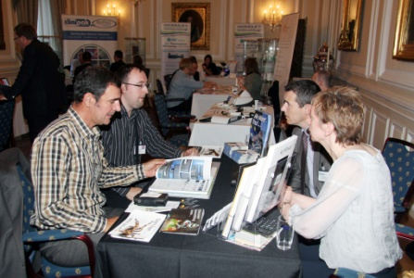

©Science Photo Library/Getty Images

British Ambassador’s Residence Vienna, Austria 4th-5th February 2014

©Science Photo Library

**The Registrations Process**

**Participation/OMIS Fee:**

**Cost (plus VAT):** ~~£1020~~ **£510**

**All delegates will be eligible for a 50% OMIS discount.** An OMIS (Overseas Market Introduction Service) fee is the amount charged for each delegate to accompany the mission and covers the organisation of all programme activity, meals and a networking event listed in the main programme.

Companies which are SME’s and first time exporters also have the possibility to apply for a £ 200 grant on travelling cost.

Successful applications will be notified and will then need to pay the participation fee, collected via the local UKTI International Trade Team. The cost of travel to/from Vienna, freight and hotel accommodation are NOT included. (a registration form will be sent to capture more specific details e.g. for hotel booking and other essential information).

**Cost includes the following:**

* Rental of the exhibition premises
* Marketing and promotion of the event
* Design and production of PDF brochure with companies given one full page profile
* Mailshot of catalogue to named targeted contacts
* Follow up calls and email chasers
* Online advertising on designated event pages
* Targeting of contacts in 10 CEE countries
* Participation in seminars
* Tabletop exhibition stand
* Refreshments throughout the two days
* Evening reception hosted by UK Ambassador to Austria

**Selection of UK participating companies:**

All Expressions of Interest will be examined by the UKTI staff in each of the participating countries, to determine whether or not suitable visitors can be recruited to attend the event. Their decisions will be based on:

* Whether they can match the UK companies’ expertise with the requirements of their selected buyers/delegates in their respective markets.
* The information that has been provided in the Expression-of-Interest (EoI) form.
* Background information on website provided.
* Ensuring that there is good spread of UK companies from across all areas of healthcare.

**Marketing:**

Prior to the event UKTI will produce an event brochure with company profiles and representatives’ names (participants are requested to supply 100 word-company description, company details and company logo). The brochure will be mailed to all business contacts in the CEE countries prior to the event to alert them to your visit to Vienna and will aid in the recruitment of visitors to the event.

Any questions relating to this event should be sent to Verena Wasenegger at the British Embassy in Vienna:

**Verena Wasenegger –Trade Officer**

🖃 verena.wasenegger@fco.gov.uk 🕿 0043 1 71613 6253