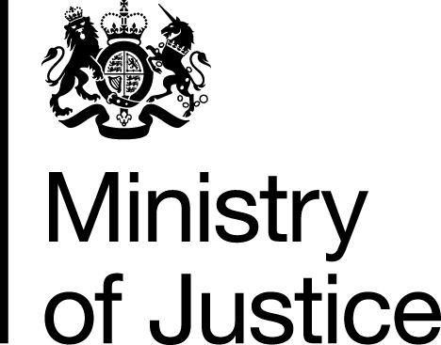 |  |  | www.gov.uk
 | FOI: 86837 |  | December 2013

Freedom of Information Request
You asked for the following information from the Ministry of Justice (MoJ):

“my solicitor has requested I contact the Legal Aid Agency to gain a list of firms and or charities that provide Legal Aid in the South West area and was wondering if you could help? I've check the GOV website but it doesn't provide me with welfare benefits law firms.”

Your request has been handled under the Freedom of Information Act 2000 (FOIA).

I can confirm that the department holds information that you have requested, and I am please to provide this to you:

Welfare Benefits work under Legal Aid is being delivered in the South West area by Civil Legal Advice (CLA).

You can access Civil Legal Advice via www.gov.uk/civil-legal-advice or by calling 0845 345 4 345 or by visiting the Legal Adviser Finder tool on the Gov.UK website by clicking on the following link: http://find-legal-advice.justice.gov.uk/

