Government
Cloud
Strategy

A sub strategy of the Government ICT Strategy
March 2011

Table of contents

Introduction 2
Government’s vision for G-Cloud 5
Strategy 8
How we will make these changes 8
Delivery and implementation 15
Appendix 20
The G-Cloud Strategy alignment with other strategy themes 20

Introduction
Cloud computing has brought about a step change in the economics and sustainability of Information and Communication Technology (ICT) enabled service provision. Government is committed to the adoption of cloud computing and delivering computing resources to users as needed (an on-demand delivery model). By exploiting innovations in cloud computing we will transform the public sector ICT estate into one that is agile, cost effective and environmentally sustainable.

Martha Lane Fox’s Digital by Default Agenda puts ICT at the heart of public services. The implementation of cloud computing and on-demand delivery models is central to meeting these challenges.

Public sector ICT infrastructure has grown over several decades to meet the needs of its users. This approach has resulted in increasingly costly infrastructure proliferation, which has hindered government’s ability to modernise and fully exploit recent ICT developments. The current ICT estate makes it difficult to:
- achieve large, cross government economies of scale
- deliver ICT systems that are flexible and responsive to demand in order to support government policies and strategies
- take advantage of new technologies in order to deliver faster business benefits and reduce costs
- meet environmental and sustainability targets
- procure in a way that encourages a dynamic and responsive supplier marketplace and supports emerging suppliers.

Government cloud is not a single, government owned, entity; it is an ongoing and iterative programme of work which will enable the use of a range of cloud services, and changes in the way we procure and operate ICT, throughout the public sector. The vision is for government to robustly adopt a public cloud first policy, though this will not be possible in every case and there will also be a requirement for a private G cloud.

The government will push ahead with its agenda for data centre, network, software and asset consolidation and the shift towards cloud computing. It will mandate the reuse of proven, common application solutions and policies. These solutions must balance the need to be open, accessible and usable with the growing cyber-security threat and the need to handle sensitive information with due care.

Cloud computing features
Cloud computing represents a radical change in the way that organisations use and pay for ICT. Instead of hosting applications and data on an individual desktop computer, everything is hosted in the “cloud” – a collection of computers and servers accessed via the internet or a private network.

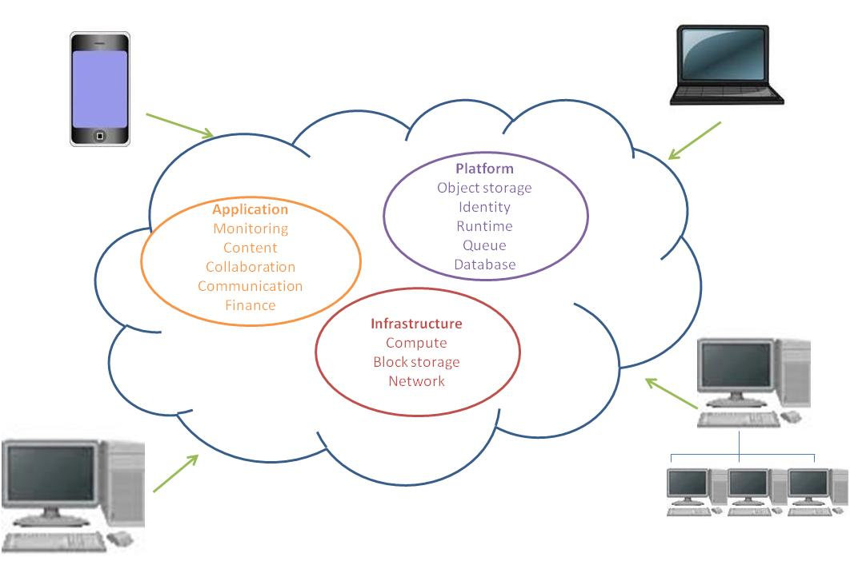
Figure 1: Infrastructure, Platform and Applications can all reside in the cloud and be accessed from a range of devices and locations.

Cloud based technologies have enabled a vibrant market place of software solutions, many based on open standards; these have changed the ICT landscape from one of bespoke online systems to one including many interoperable commodity solutions too. In turn, this engenders changes in behaviour throughout organisations – rather than commissioning bespoke systems, organisations now often have the choice to deploy a best-fit one, off the shelf at a fraction of the cost. Resources such as computing power, storage, applications and services are used only when needed and paid for only when used.

The US National Institute of Standards and Technology’s (NIST) definition of cloud computing is the most widely adopted one, and has been adopted for G-Cloud; it states that:

“Cloud computing is a model for enabling convenient, on-demand network access to a shared pool of configurable computing resources (e.g. networks, servers, storage, applications, and services) that can be rapidly provisioned and released with minimal management effort or cloud provider interaction.”

Cloud computing can be deployed through primarily four different models - private, public, hybrid and community. The primary differences between these models are in scope and access. For private cloud the infrastructure is managed and operated solely for an organisation; for public cloud the infrastructure is owned by a cloud provider and accessible to the general public or a large industry group; for hybrid cloud some resources are managed in-house and others are provided externally; and for community cloud the infrastructure is most likely shared and managed by several organisations.

Government’s vision for G-Cloud
Government will use multi-tenanted services, shared and managed by several organisations. Shared resources, infrastructure, software and information will be provided to a range of end user devices, e.g. laptops, smart phones etc, as a utility – on a pay by use basis, via a network connection – in many cases the internet; this will be supported by new delivery and supply models. It will be dynamically scalable, agile, and easy to move in and out of the service. G-Cloud is not a single entity; it is an ongoing and iterative programme of work which will enable, the use of a range of cloud services, and changes in the way we procure and operate ICT, throughout the public sector.

By adopting cloud computing, the government will be able to more easily exploit and share commodity ICT products and services. This enables the move from high-cost customised ICT applications and solutions to low cost, standard, interchangeable services where quality and cost is driven by the market. It means changing the culture of government to adopt and adapt to the solutions the market provides and not creating unnecessary bespoke approaches.

The vision is for government to robustly adopt a public cloud solution first policy, though this will not be possible in every case. Simply buying cloud technology will not, in itself, save the most money. The greatest value will be gained by Government changing the way we buy and operate our ICT.

Cloud computing is a way to access and use ICT services in a flexible and agile fashion, buying only the services needed when they are needed – we should do it once, do it well and then re-use, re-use, re-use. In achieving this we face challenges in procurement, transition and operational arrangements. In adopting this vision, the government must ensure that the cloud service still provides an acceptable level of
security risk mitigation and allows government organisations to demonstrate they are meeting their legal and statutory obligations as far as information is concerned.

Cloud computing will be enabled via the creation of a Government Application Store. This will take the form of an online portal, and will provide an open marketplace displaying services that will be able to be procured, used, reviewed and reused across the public sector.

The goal for the Government Application Store (Appstore) will be to:
- provide an open, visible, commoditised and cost transparent marketplace, that is the first point of call for any public sector ICT requirement
- create a shop window where all the relevant public sector ICT services can be found encouraging innovation, competition and new suppliers
- exploit pan-public sector purchasing
- enable the IA and security community to have access to information related to the assurance and accreditation status of the service
- be a key enabler for collaborative procurement, including:
  - driving up supplier performance by providing an open feedback mechanism
  - facilitating re-use of a service to drive efficiency and cost savings.

The Government Application Store will be the market place in which public sector organisations can purchase trusted services (and in some instances trial services) from a variety of sources. Overall the Government Application Store will aim to deliver sophisticated capability, diverse services and will allow users to easily find, review, compare, purchase, commission, decommission and switch services.

Government’s use of cloud computing technologies for its ICT requirements moves ICT service provision from a costly dedicated development that is often duplicated many times over, to taking the best fit the market has to offer that balances functionality, service levels and cost. This works most effectively where a mature market exists for a given service so that the business can adapt to utilise the commodity solution quickly and easily.

The benefits for government
Since the emergence of modern ICT solutions, government has defined and purchased custom solutions to meet its needs. In the future, rather than over specifying requirements government will make greater use of commodity solutions that best fit its needs This moves government from attempting to be the architect of bespoke digital solutions to a consumer of widely available and constantly improving mass-market products.

Underpinning the government’s approach will be the optimisation of our data centre infrastructure, which traditionally has been hugely inefficient. Maximising utilisation will allow rationalisation and consolidation of the data centre estate and lead to significant cost, accommodation and energy savings.

For government the benefits will be:

- Many more common commodity solutions – a range of the best industry ICT services and solutions available off the shelf so the government, its agencies and related bodies can use what they need when they need it and not create duplicate services that cannot be shared.
- Flexibility and Freedom – the ability, if required, for departments and organisations to change service provider easily without lengthy procurement and implementation cycles, no ‘lock-ins’ to long contracts and the freedom to quickly adopt better value and more up to date solutions.
- Ready and Easy to Use – complete solutions that are already assured for security, performance and service management. Ready access to ‘hybrid cloud’ solutions that allow the cost efficiencies of the ‘public’ cloud to be used alongside more secure / dedicated private cloud solutions based on a consolidated data centre and service estate;
- Low cost – Services that are paid for on a usage basis, driven by strong competition on price and quality. Transparent costs along with quality and scope-of-service metrics for simpler comparison and control;
- Competitive Marketplace – a range of service providers constantly improving the quality and value of the solutions they offer, from small SME organisations providing niche products to large scale hosting and computer server capacity.

The benefits for suppliers
The development of the marketplace must be beneficial to small, medium and emerging suppliers as well as government if it is to thrive and improve the range and quality of services available. The move from custom to commodity solutions for suppliers means:

- Open Marketplace –always available for government customers, current service usage, cost and performance is transparent along with upcoming opportunities. Contract performance and comparative performance indicators are published. As government customers are not ‘locked-in’ to long-term service contracts, suppliers are free to offer new, better quality and value solutions to government clients at any time
- Simple and Fair Procurement – simplified commodity purchasing, through the use of systems, such as dynamic purchasing systems currently used for other utilities, removes the need for long, expensive procurement processes. This creates a level playing field for suppliers, both major and emerging providers, especially SMEs will be able to offer solutions that can be easily and quickly adopted by government
- Freedom to Innovate – service suppliers are free to innovate, to offer new solutions and improvements to services at any time, rather than being held to deliver often out-dated and inappropriate custom specifications and requirements set through the procurement process.

Strategy

How we will make these changes
The move from customised ICT solutions to the use of a commodity marketplace of ready-to-use services requires a change in approach from both government as a buyer and user, and from providers.

A strategic shift will be required from government to adopt this new approach with new skills and new working arrangements. The G-Cloud Programme will concentrate on delivering the strategic themes and establishing government’s on-going capability to exploit and manage cloud commodity services. It is an iterative process, not all of the answers are known, but in line with the best current ICT services, revision to approach and solutions will be undertaken quickly and often.

Furthermore, the G-Cloud programme will provide the common management structure and assure standards and approach across key clusters of services, known as government commodity services. The commodity services will be managed by the most appropriate organisational body that maintains the skills and market relationships as a ‘centre of excellence’ in any given service area. The managers of the commodity services, under simplified central governance, will form a federated management structure across the ICT service landscape for government.

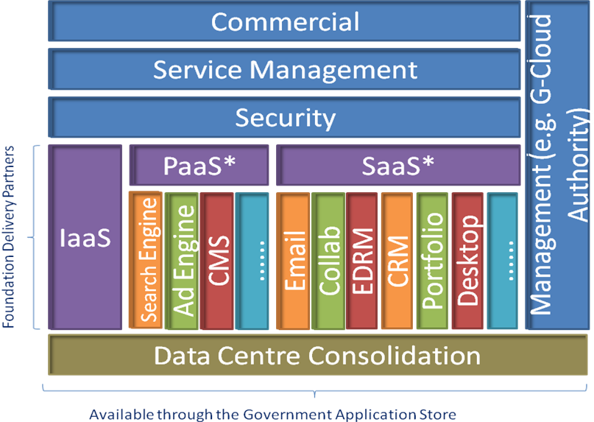
* Common/generic aspects across specific commodity services

This federated model of delivery ensures:
- a common strategy and approach to commodity services identification and commissioning;
- consistent overarching approach and standards to the formation, adoption and management of commodity ICT services;
- a simple inclusive governance approach; and
- devolved management and responsibility to centres of excellence.
The G-Cloud Programme will establish the government’s G-Cloud Authority through aligning tightly with the Public Services Network Authority, and exploring opportunities to integrate with the PSN Authority as soon as is practicable. The G-Cloud Authority will manage the long-term adoption and assurance of commodity services and cloud take-up by government, and will provide any on-going strategic and accreditation management across the commodity services. The G-Cloud Authority will also be able act as a government-wide entity for commodity commissioning and direction of procurement as required.

Rationalise existing provision
Today, public sector ICT is characterised by high levels of duplication, silos of infrastructure, fragmented and often inappropriate provision and low levels of server utilisation. It is estimated that in some cases, infrastructure utilisation is less than 10%. In adopting the principles of commodity and cloud based services, the existing services must be rationalised and aligned with commodity services. Key to driving out the benefits will be the rationalisation of data centres to significantly reduce costs while increasing resilience and capability.

While the public cloud will offer substantial cost savings and increased flexibility for many ICT services and service users, data and privacy restrictions currently prevent some services from being hosted or provided through such means. In these cases, a range of cloud service models can be used to provide the necessary security assurance to hold and process personal or restricted data. Such private clouds can be purchased as part of a hybrid model or government may be able reuse its existing assets to create its own hybrid cloud services.

The G-Cloud programme will:
- review and identify strategies consistent with establishing the commodity services, that consolidate and rationalise the existing ICT provision across government bodies
- evaluate the commercial approach for current ICT service provision to move to commodity / cloud pricing principles early in order to encourage supplier-led rationalisation

- consolidate government-owned and (major) supplier-owned data centres as part of the Data Centre Consolidation plan as the first stage to establishing hybrid cloud capability
- publish and maintain an up-to-date list of existing re-usable assets and services from which public sector organisations can identify and select services
- ensure procurement and renewal of ICT services is reviewed and assured through the G-Cloud commissioning approach and
- identify and promote the adoption of the available rationalised services, focused on those that form part of G-Cloud commodity services.

Reducing bureaucracy, cost and management overheads
One of the main benefits of moving from custom applications and bespoke services to a commodity cloud is reduced bureaucracy, cost and management overheads. A key aim of the G-Cloud programme must be to provide organisations with processes that are as friction free as possible to use.

The enactment of European procurement law often inhibits the adoption of innovative solutions and steers procurement into traditional bespoke responses to customer mandated requirements on solutions and service management. For a commodity market to flourish, the G-Cloud programme must change the adoption model, addressing the key barriers including legislation and current contracts, and encouraging new behaviours and products.

The G-Cloud programme will therefore:
- implement a governance and commercial model which enables the mandating and control of ICT procurement, working closely with the Major Projects Authority, through a central G-Cloud Authority commissioning process (including infrastructure, common and utility applications and ICT services) across the public sector
- quickly implement a tactical Application Store for Government based upon commodity components. This will display services that will be able to be used, reviewed and reused across the public sector
- investigate, trial and agree alternative procurement strategies more appropriate to commodity and cloud procurement, such as
  - dynamic purchasing systems, that allow any supplier who meets the criteria for the provision of the commodity service or solution to be included within the framework
  - central frameworks for commodity services such a Infrastructure as a Service (IaaS), Platform as a Service (PaaS) and Software as a Service (SaaS) where they will dramatically reduce infrastructure costs by enabling public sector organisations’ adoption of standard G-Cloud Infrastructure as a Service

  - re-define the ICT procurement and commercial model to move away from the current model of large bundled ICT procurements which have historically taken in excess of two years to complete (and which contain fixed terms and performance levels for ten years) to a more sustainable and affordability driven model required to successfully deliver the G-Cloud (this will include extensive engagement in defining the role of the retained ICT function of the future).

Government commodity services
For government and its related public bodies to realise the benefit of cloud commodity services, a greater level of understanding and awareness of the services and how to exploit, procure and operate them must be embedded across the IA, Information Management and ICT communities. This will be embodied by the ‘Cloud First’ initiative (as pioneered in the US government Cloud Strategy) which will not only provide an introduction and education to cloud ICT services, but also support and guidance for purchasing and operating cloud based commodity services.

The G-Cloud Programme will seek cross-government support for the introduction of new controls that will mandate that wherever ICT commodity services exist they must be used for service renewals.

The G-Cloud programme will therefore:
- engage widely across public sector organisations and launch the ‘Cloud First’ initiative
- establish clear, consistent metrics for performance and cost
- develop and manage the transition plans, business change plan and communications plan / brand and marketing plan
- mobilise and manage the transition projects required to deliver, for example, the Application Store for Government, the G-Cloud Services and Infrastructure and Data Centre Consolidation.

The initial commodity services will be established through a Foundation Delivery Partner (FDP) programme. FDPs build on the existing rationalised government services and emerging change programmes to establish key commodity services, while working through the approaches and models required for a wholesale migration to commodity cloud services.

The G-Cloud programme has established six initial federated commodity services with FDPs already in place:

Government Commodity Services | Foundation Delivery Partner
Collaboration (SaaS) | Department for Education
Infrastructure as a Service and Platform as a Service (IaaS and PaaS) | Home Office
Email (SaaS) | Warwickshire County Council
Customer Relationship Management (SaaS) | British Council (Learning partnership only)
Web Hosting and online Content Management Systems (IaaS and PaaS) | Government Digital Service, Department of Health, HMRC and others
Public Cloud Services | Ordnance Survey
Enterprise Resource Planning (ERP) | Government Digital Service (GDS)

These initial FDPs are existing services that work with the G-Cloud programme to trial and develop the new approaches required to establish the G-Cloud. They may not be appropriate services for the long-term, and the G-Cloud Authority may, through its review and management of the landscape and commissioning process, redefine these commodity services.

As new commodity services are identified and commissioned from the G-Cloud Authority, a Foundation Delivery Partner within the public sector will be identified to develop and manage the commodity marketplace working alongside the G-Cloud Authority. This approach allows utilisation of key skills across government and prevents the G-Cloud Authority from becoming too large and inflexible.

Define and manage the landscape
The government ICT landscape is broad and widely varied. While adoption of cloud based services and commodity approaches to ICT service provision will improve quality and reduce costs, not all ICT services are mature enough to sustain a vibrant marketplace and existing services will shift and consolidate over time.
The G-Cloud programme must develop a broad landscape based on the ICT service usage and demand to establish a commissioning and adoption roadmap. The Cloud commissioning function will act as the gatekeeper for ICT service provision to:
- provide ICT service strategic planning – monitoring and assessing the maturity and state of ICT service commodity markets and identifying opportunities for government to introduce new cloud / commodity services
- maintain the landscape of current provision, including trends and consolidation
- maintain the standards for technology (IaaS), security, service and commercial management based on accepted industry standards
- define the policies for the G-Cloud and develop the high level design and architecture (including development of the service catalogue, information assurance model and a service management model)
- commission the introduction of new commodity services to meet a new commodity area or consolidated service and de-commission commodity services where the market has changed or the provision is obsolete.

Transparent service information
Transparency and comparison are critical elements to establishing a vibrant market between suppliers. Today, the bespoke approach from government for the procurement of its ICT services means that very few services can be directly compared on price, scope or quality. This has a number of effects - service arrangements cannot be easily shared as the services procured are different, the value of the service cannot be easily determined, and suppliers cannot easily gauge their own performance except against the specific contract which stifles innovation and improvement.
The G-Cloud programme will:
- be responsible for establishing and trialling the definition of standard service metrics (by commodity services and across the landscape if appropriate);
- establish the collection and collation process to be adopted within commodity services for service metrics and
- publish in a comparable form, service metrics spanning the performance, quality and price of services.

Appropriate information assurance
The strategy holds to the principle that information risk owners will remain accountable for the risks to the information for which that department is an owner or custodian. The only asset organisations might own is the information in the service and the associated Information Assurance (IA) and reputational risks. Asset valuation and aggregation is being considered from various perspectives. If legal and regulatory requirements and information risks require specific knowledge of how a service operates, this must still be gained to the appropriate level. Cloud service providers may be required to state under which legal and regulatory frameworks the information is being held at any given moment.

For the efficient use of cloud services across the public sector, and a more pragmatic application of IA at the scale needed, there are a number of core services for which it is more beneficial to provide them once or co-ordinated their provision, e.g. Identity Assurance and Management, and Situational Awareness.

The scale and pace at which services are offered and then changed will pose a challenge when ensuring that the status of relevant aspects of the service are always known. The IA Governance arrangements are being established to ensure the ability to carry out most of the assurance and accreditation work is done once, carried out well and then re-used, re-used, re-used.

Common Service Management
Transparency and comparison are critical elements to establishing a vibrant market between suppliers. Today, the bespoke approach from government for the procurement of its ICT services means that very few services can be directly compared on price, scope or quality. This has a number of effects - service arrangements cannot be easily shared as the services procured are different, the value of the service cannot be easily determined, and suppliers cannot easily gauge their own performance except against the specific contract which stifles innovation and improvement.

The G-Cloud programme will:
- be responsible for establishing and trialling the definition of standard service metrics (by commodity services and across the landscape if appropriate);
- establish the collection and collation process to be adopted within commodity services for service metrics and
- publish in a comparable form, service metrics spanning the performance, quality and price of services.

Delivery and implementation
The G-Cloud programme is responsible to the CIO Delivery Board for the successful adoption of cloud computing and commodity ICT by government. The Programme is governed via a Delivery Board, supported by key working groups and boards for the different elements of the programme.

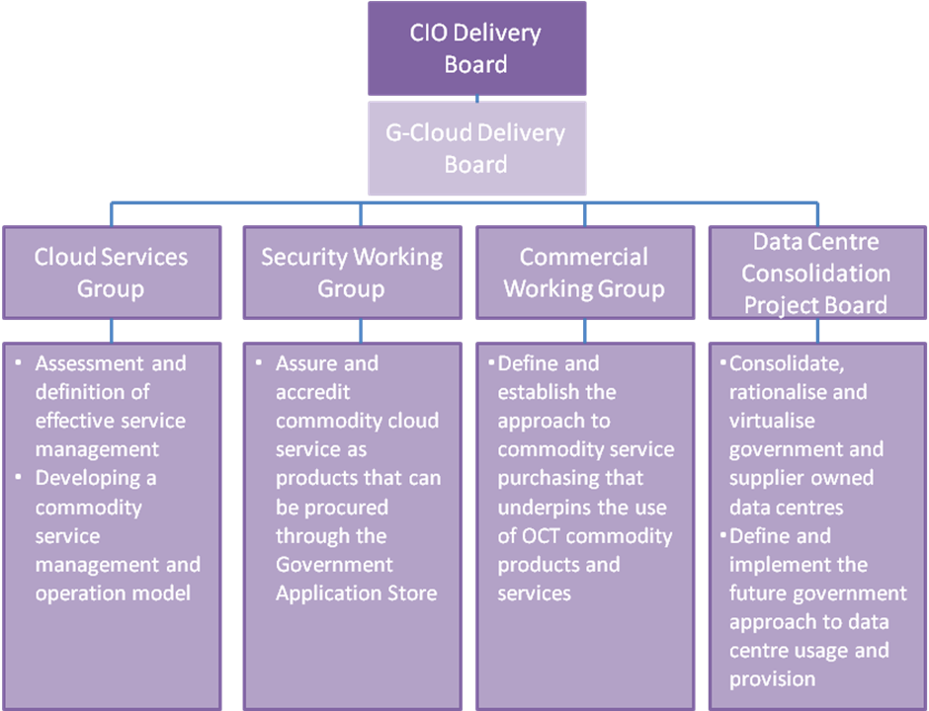

The G-Cloud Delivery Board will govern the programme, setting the overall direction, including the determination and ratification of the Programme’s business objectives, future vision, business case, and the sequencing strategy for delivering the components of the G-Cloud solution, including the Government Apps Store and Data Centre Consolidation.

The initial delivery focus will be on the CIO Delivery Board departments but will then extend to other central Government departments and onto local authorities and wider public services.

The G-Cloud Delivery Board and its working groups will ensure their strategies and plans are aligned with the other infrastructure strands of the Government ICT Strategy.

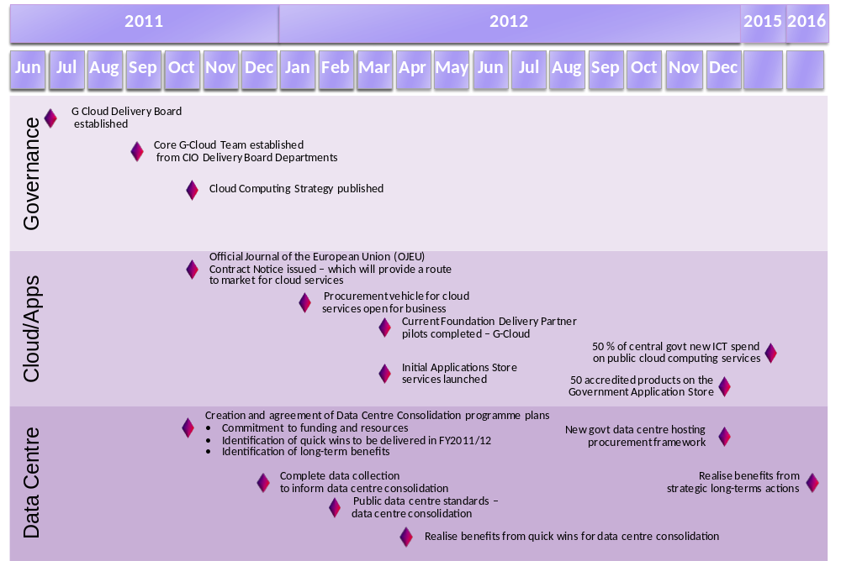

Savings
The projected central government savings for shifting to cloud computing technologies, re-use of services and applications through the Application Store and consolidation and increased utilisation of the data centre estate are as follows:

Savings by Year in £mil
 | 2011-12 | 2012-13 | 2013-14 | 2014-15
G-Cloud & Application Store | - | 20 | 40 | 120
Data Centre Consolidation | - | 20 | 60 | 80

Measuring success
A set of metrics have been established for the government cloud programme. These will demonstrate transparently how the impact and successful implementation will be measured.

Key Measures
Cloud | Cost per full time employee per commodity service  % of central government departments’ new ICT spend on public cloud computing services  Unique departmental systems closed and service moved to a cloud service
Government Application Store | The number of accredited products on the Government Application Store  The number of services departments have adopted from Government Application Store  Number of applications reused by different organisations
Data Centre Consolidation | Number of data centres and associated hosting services  Cost per server  Percentage of servers virtualised  Utilisation of servers

Managing risks and issues
Risk/issue | How we will manage risk
Capability  This strategy will have an impact on retained IT function and the types of knowledge and skills and experience government requires. If we don't define the roles and capabilities to ensure that we can support the business service then we will not achieve the strategic intent and VFM as articulated in the Government ICT strategy. | Work with other ICT strands that are also looking at strategies for dealing with this (e.g. G-Cloud, IT Capability) to identify good practice and guidance across a range of delivery/supply models.
Creating the market  The procurement does not attract and engage with a sufficiently diverse range of suppliers & customers and/or the emerging market is monopolised by large suppliers. | Ensure procurement is sufficiently flexible to attract these suppliers.  A dynamic or easy to re-run procurement is required.
Alignment  A lack of alignment with other cross government strategy strands will lead to divergence, poor interoperability, duplication and confusion. | The governance mechanisms already in place via the CIO delivery board need to be exploited. Furthermore the G-Cloud programme will work with other elements of the ICT strategy to establish an integrated infrastructure governance authority.
End to end service  If we don't recognise and deliver the right operating model we won't deliver the business benefits required by the Government ICT Strategy and will risk increasing overheads to manage services. | Inform the G-Cloud governance debate to ensure required outcomes are implicit in an agreed new service management model;  Work with senior stakeholders to support the required business organisation changes that will be required.
IA and Security  A perceived need for hundreds of public sector organisations to control of all aspects of a service will lead to less use of cloud computing.  The risk ownership and management model for cloud computing can be seen as confusing. This may lead to an erosion in the take up of cloud computing or a lack of trust in how the public sector will use cloud computing. | The use of trusted organisations to carry out the appropriate level of assurance in the service on behalf of the rest of the public sector will allow both the suppliers and consumers of services to understand the risks and counter measures. The organisation owning the information placed in a service will be responsible for the information risks. Pan government assurance and accreditation will assist information risk owners in mitigating their risks.
Culture Change  The culture required to shift to embrace the use of commodity services will require a significant change in the way people work across the ICT functions of government. Should this not be addressed it will impede successful uptake of the G-Cloud principles and approach. | The foundation delivery partners ensure that engagement is being driven from within public sector organisations. The programme is reliant on distributed delivery as such, a broad range of organisations are driving the plans and solutions’ that are being developed. The Cloud programme will also establish a specific communication and engagement work stream.

Appendix

The G-Cloud Strategy alignment with other strategy themes
ICT Strategy theme | Government Cloud Strategy Alignment with theme
Green | A reduction in our data centre estate will lead to significant power savings.  Adoption of government CIO Council’s Green Delivery Unit best practice in procurement and lifecycles
SMEs | We are committed to remove the barriers that have previously impeded SMEs, with a procurement process designed to be simple and inexpensive for suppliers to compete.
Open Source | The appstore will provide a platform from which open source services will be able available.
Open Standards | Strategy will use open standards.
Transparency | Transparency and comparison are critical elements to establishing a vibrant market between suppliers.
Over capacity in data centres | This programme is directly addressing this problem.
Streamline procurement | The app store and associated procurement vehicle is simple and easy to use. Enabling quicker, simplified procurement for ICT services.
Presumption against large projects | Services can be procured individually, on a utility basis.
Public sector productivity and efficiency | Giving public sector employees access to services based on common standards enables  - streamlined workforce change  - sharing of applications and cross governmental working  - reduced departmental training and support for employees transferring between departments
Increased standardisation | Give departments a choice of services, built on common standards that are proven for use in government and can be procured easily  Creates a vibrant and competitive market of reusable services based on government standards  Suppliers test once for government and use many times, reducing costs and price
Greater engagement with departments | The foundation delivery partners ensure that engagement is being driven from within public sector organisations. The programme is reliant on distributed delivery as such, a broad range of organisations are driving the plans and solutions’ that are being developed.
Stimulating economic growth | Create a dynamic and more competitive marketplace, and enable a wide range of SMEs to easily offer services to government.
End to oligopoly of large suppliers | Giving business to suppliers of any size that can offer a good service at a good price and a competitive market that will drive down cost.
Deliver economies of scale | Re-use of services across departments reduces cost and burden of accreditiation.
Responsive public services | Giving public sector employees more flexibility to buy, use and change their ICT, should enable them to better service the public’s needs.
legacy applications have acted as barriers to the rapid introduction of new policies” | The use of virtualisation technology can assist with the immediate problem. The ability to provision quickly via the app store will assist in the short, medium and long term.
Avoid lengthy vendor lock in | Simplified procurement processes will increase ability to move from one vendor to another.  Utility based model for services.
Reuse, sharing and scalability across organisational boundaries | Appstore is a common platform created across departmental boundaries enables reuse and sharing  A common platform enables consumption of services from external bodies by multiple departments (and conversely)
Rationalise diverse property estate | Make it easier for departments to merge/demerge/restructure and relocate  Enable more people to work from outside the office, freeing up office space
Empower public sector reform | Enable government ICT to be used more effectively at lower cost  Simplifying use of services that are not entirely delivered by the public sector, and enabling better integration with 3rd parties both in public, private and 3rd sectors.
Cloud & Apps | We are enabling government to exploit commodity ICT products and services and the consumption of cloud-based services

© Crown Copyright 2011
Publication date: October 2011

You may re-use this information (excluding logos) free of charge in any format or medium, under the terms of the Open Government Licence. To view this licence, visit http://www.nationalarchives.gov.uk/doc/open-government-licence/ or e-mail: psi@nationalarchives.gsi.gov.uk.

Where we have identified any third party copyright information you will need to obtain permission from the copyright holders concerned.

Any enquiries regarding this document should be sent to us through the Cabinet Office website, where the document is also published.
Cabinet Office, 70 Whitehall, London SW1A 1AS

www.cabinetoffice.gov.uk

