National Enforcement Priorities – Outcomes Dashboards

A project for the Welsh Regulators’ Forum

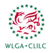 | 
 | 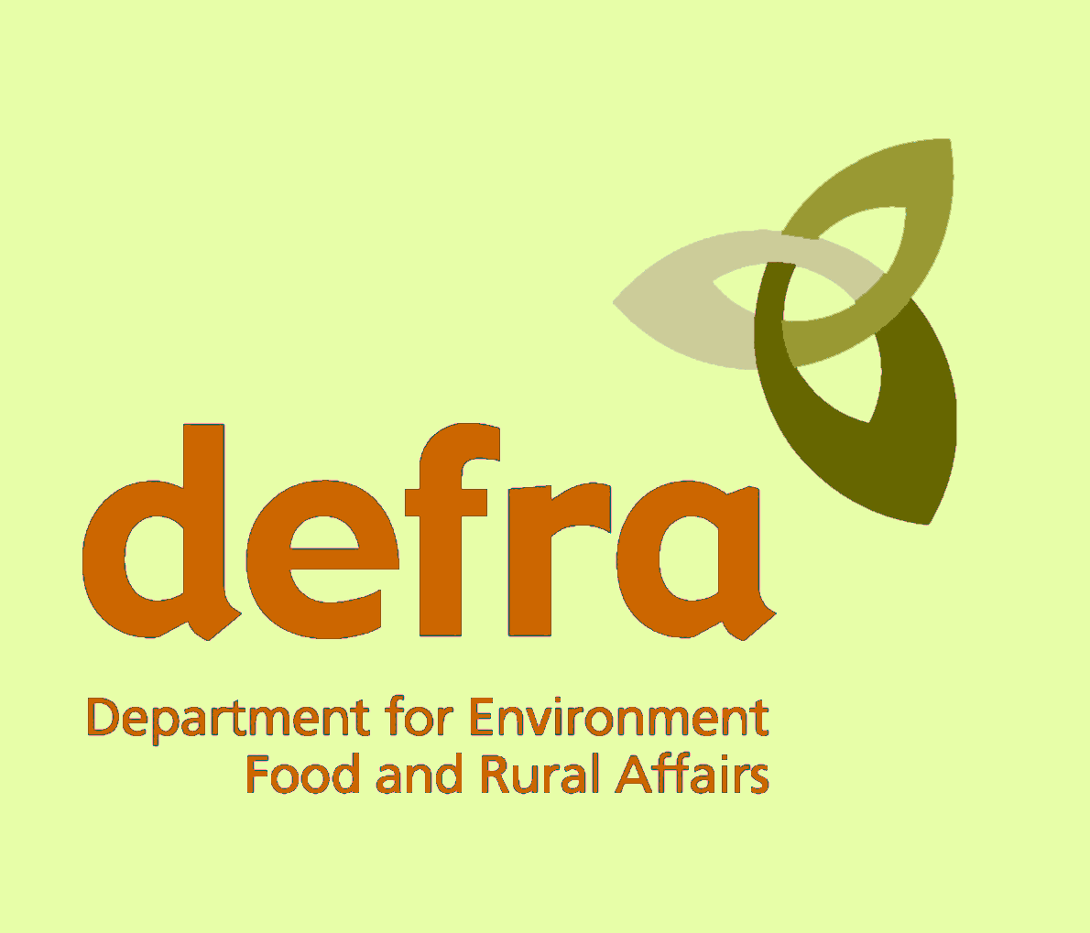
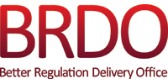 | 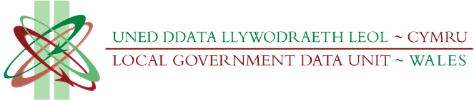
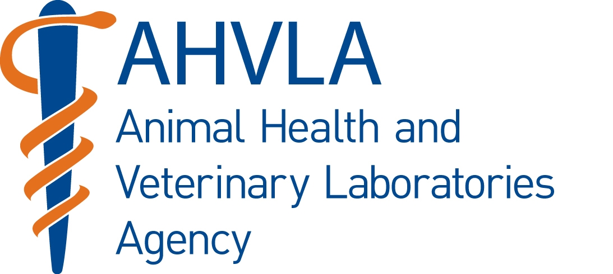 | 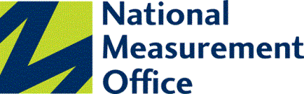
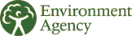 | 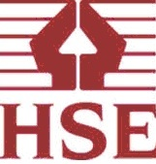

General Statistics – Blaenau Gwent

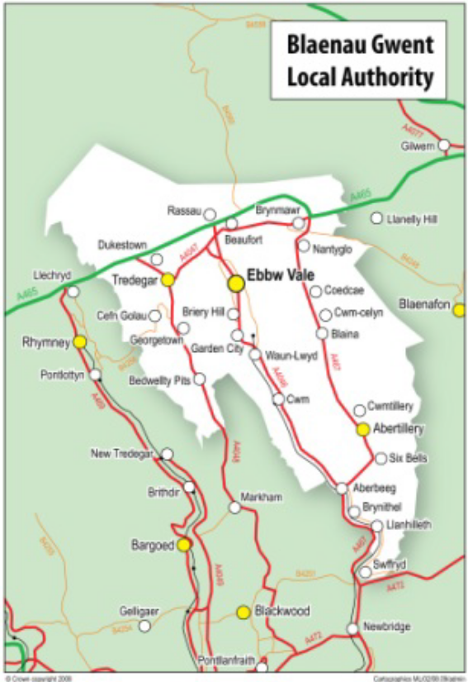

Population = 69,800 (ranked 20th 2011 Census)

Area = 109 km² (ranked 22nd)

Population density = 640 people/km²

Number of businesses = 3,045 (2011 http://www.statswales.wales.gov.uk/TableViewer/tableView.aspx?ReportId=35099)

Business turnover (number of new businesses registered per year)?

NEP1: "Protecting individuals from harm and promoting health improvement"
Activities: Alcohol licensing, restricting underage sales, nutrition claims, housing safety standards, health and safety, product safety surveillance & testing, taxi licensing, gambling licensing, partnership work on local health and wellbeing strategies
Input measures | Output measures
- Estimate of all houses in multiple occupation HMOs in local authority area: (https://statswales.wales.gov.uk/Catalogue/Housing/Hazards-and-Licences/HousesInMultipleOccupation-by-Area) | - The percentage of high risk businesses that were liable to a programmed inspection or alternative inspection activity that were inspected/subject to alternate enforcement activity for health and safety (NSI PPN/001 (iv)) (http://www.infobasecymru.net/IAS/dataviews/tabular?viewId=118&geoId=1&subsetId=)  - The percentage of new businesses identified which were subject to a risk assessment visit or returned a self-assessment questionnaire during the year for health and safety (NSI PPN/008 (iv)) (http://www.infobasecymru.net/IAS/dataviews/tabular?viewId=118&geoId=1&subsetId=  - Total number of Premises Licences + Club Premises Certificates + Personal Licences: (http://www.homeoffice.gov.uk/publications/science-research-statistics/research-statistics/home-office-science/alcohol-lnr-licens-1112-supptab)  - Known houses in multiple occupation HMOs in local authority area: (https://statswales.wales.gov.uk/Catalogue/Housing/Hazards-and-Licences/HousesInMultipleOccupation-by-Area)  - Total number of category 1 and 2 hazards identified by hazard type, dwelling and category : (https://statswales.wales.gov.uk/Catalogue/Housing/Hazards-and-Licences/Category1And2Hazards-by-HazardType-Dwelling-Category)
Impact measures | Outcomes
- Rates of fatal injury per 100,000 all industries (employees)  - Rates of fatal injury per 100,000 all industries (self employed)  http://www.hse.gov.uk/statistics/tables/index.htm#riddor (“histrate”)  - Number of HMOs and non-HMOs where all category 1 hazards have been resolved as a result of local authority action: (https://statswales.wales.gov.uk/Catalogue/Housing/Hazards-and-Licences/AssessmentsAndResolvedHazards-by-Area-Assessment-Dwelling)  - Health status, age standardised SF-36 (higher score means better health):  Physical component summary score:  Mental component summary score:  (http://wales.gov.uk/topics/statistics/headlines/health2012/1209191/?lang=en) | National Enforcement Priority:  - "Protecting individuals from harm and promoting health improvement"  Programme for Government themes:  - “21st Century Healthcare”  - “Welsh Homes (Improving Quality)”  - “Safer Communities for All (Reducing the level of crime and fear of crime / Reducing the harm associated with drug and alcohol misuse / Improving safety in communities)”  HSE Wales outcome:  - “To protect people’s health and safety by ensuring risks in the changing workplace are properly controlled”  Blaenau Gwent Council’s Selected Broad Outcome:  - “Improved quality & length of life, with fairer outcomes for all”

NEP2: "Ensuring the safety and quality of the food chain to minimise risk to human and animal health"
Activities: Approval of food manufacturing, hygiene of food and feeding stuff businesses, checking food claims, sampling & analysis work, food fraud, farmed animal health and welfare, animal health movements and identification
Input measures | Output measures
- FTEs food standards/hygiene/animal feed (FSA indicator)  - Total number of establishments as at 31st March 20xx, by food hygiene rating (FSA indicator)  - Total number of establishments (including unrated) as at 31st March 20xx, by food standards rating (FSA indicator)  - Total number of establishments (including unrated) as at 31st March 20xx, by animal feed rating (FSA indicator)  - FTEs animal health and welfare (Animal Health and Welfare Framework)  - Total number of risk assessed premises for animal health and welfare as at 31st March 20xx indicating numbers in each risk category (Animal Health and Welfare Framework)  (data on the national animal health and welfare databases viz. Animal Movement Licensing System (AMLS) and the Animal health and Welfare Management and Enforcement System (AMES) | Food Hygiene measures:  - % of unrated premises for food hygiene as at 31st March 20xx (FSA indicator)  - % of high risk inspections undertaken during the year for food hygiene (FSA indicator)  Food Standards measures:  - % of high risk inspections undertaken during the year for food standards (FSA indicator)  - The percentage of significant breaches that were rectified by intervention during the year for Trading Standards (feeding stuffs not food) (FSA indicator) (PPN/007i) (http://www.infobasecymru.net/IAS/dataviews/tabular?viewId=118&geoId=1&subsetId=)  - The percentage of significant breaches that were rectified by intervention during the year for Trading Standards (FSA indicator) (CSI PPN/007ii) (http://www.infobasecymru.net/IAS/dataviews/tabular?viewId=118&geoId=1&subsetId=)  - The percentage of significant breaches that were rectified by intervention during the year for Animal Health (feeding stuffs not food) (FSA indicator) (PPN/007ii) (http://www.infobasecymru.net/IAS/dataviews/tabular?viewId=118&geoId=1&subsetId=)  Animal health and welfare measures:  - The percentage of high risk businesses that were liable to programmed inspection that were inspected, for animal health and welfare. (NSI PPN/001iii) (http://www.infobasecymru.net/IAS/dataviews/tabular?viewId=118&geoId=1&subsetId=)  - The percentage new businesses assessed for animal health and welfare (PPN/008iii) (http://www.infobasecymru.net/IAS/dataviews/tabular?viewId=118&geoId=1&subsetId=)  - The percentage of significant breaches that were rectified by intervention during the year for animal health and welfare (PPN/007ii) (http://www.infobasecymru.net/IAS/dataviews/tabular?viewId=118&geoId=1&subsetId=)  - Total no. of inspections of vehicles, by location (WT22, Section1, Welfare of Animals in Transport)  - Total no. of vehicles inspected by location where welfare infringements were found, (WT22, Section 2 Welfare of Animals in Transport)  - The number of animal movement notifications received from livestock keepers and entered on AMLS in accordance with the Welsh Government’s Priority Action Plan  - Total number of activities entered on AMES in accordance with the Welsh Government’s Priority Action Plan
Impact measures | Outcomes
- Total % of broadly compliant premises (excluding unrated and outside) (FSA indicator)  - Using the AMES national database to identify the percentage of premises inspected (‘activities’ on the database) that were found to be compliant | National enforcement Priority:  - “Ensuring the safety and quality of the food chain to minimise risk to human and animal health”  Programme for Government themes:  - “21st Century Healthcare (preventing poor health and reducing health inequalities)”  FSA Wales outcomes:  - “Food produced or sold in the UK is safe to eat”  - “ Enforcement is effective, consistent, risk-based and proportionate and is focussed on improving public health”  AHVLA outcomes:  - “To help safeguard animal health and welfare and public health, protect the economy and enhance food security through research, surveillance and inspection”  - “Meet the objective of ‘Delivering and enforcing standards, of the Animal Health and Welfare Strategy for Great Britain and the Implementation Plan for Wales’”  - “To support the Animal Health and Welfare Framework for England and Wales and helps meet the UK’s obligations under E.C. legislation”  Blaenau Gwent Council’s Selected Broad Outcome:  - “Improved quality & length of life, with fairer outcomes for all”

NEP3: "Promoting a fair and just trading environment for citizens and business"
Activities: Regulating consumer credit and loan sharks, dealing with unfair trading practices, including doorstep crime, scams and rogue trading, inspecting weights and measures equipment, hallmarking, empowering consumers through education, and supporting business through advice
Input measures | Output measures
- FTEs fair trading/product safety (no data)  - Number of full time equivalents (FTE) of staff engaged in Weights and Measures work (NMO section 70 indicator) www.nmo.gov.uk | - % of new businesses identified which were subject to a risk assessment visit or returned a self-assessment questionnaire during the year for trading standards (NSI PPN/008i) (http://www.infobasecymru.net/IAS/dataviews/tabular?viewId=118&geoId=1&subsetId=)  - % of significant breaches that were rectified by intervention from trading standards (PPN/007(i) (http://www.infobasecymru.net/IAS/metadata/view/indicatorinstance?pid=1107&id=14317&norefer=true)  - Submission of statutory return to NMO (section 70, Weights & Measures Act 1985) (www.nmo.gov.uk)
Impact measures | Outcomes
Number of consumer complaints logged by Citizens Advice consumer service (Consumer Direct) https://www.cdb.consumerdirect.gov.uk/cdcreportapp/pexpired.aspx  - No. of Trader complaint – criminal breach  - No. of Trader complaint – civil breach  (PUB09 - Caller Local Authority & Case Type - v1.1)  - % of visited businesses that were weights and measures compliant (NMO section 70 indicator) www.nmo.gov.uk | National enforcement Priority:  - “Promoting a fair and just trading environment for citizens and business”  Programme for Government theme:  - “Growth and Sustainable Jobs / Supporting the Economy and Business”  - “Safer Communities for All (Reducing the level of crime and fear of crime / Improving safety in communities)”  NMO outcome:  - “Promote competition and fair trading by providing a modern legal measurement regime “  Blaenau Gwent Council’s Selected Broad Outcomes:  - Businesses in the local economy are supported to thrive

NEP4: "Improving the local environment to positively influence quality of life and promote sustainability"
Activities: Regulating local environmental quality through LAQM, improving the local environment to positively influence quality of life and promote sustainability, waste minimisation, managing flood risks and other emerging threats from climate change, air quality management, monitoring environmental claims on products, tackling anti-social behaviour through underage sales enforcement
Inputs | Outputs
- Clearance costs of fly tipping (https://statswales.wales.gov.uk/Catalogue/Environment-and-Countryside/Fly-tipping/ClearanceCostsOfFlyTipping-by-LocalAuthority)  - Recorded fly-tipping incidents by local authority (https://statswales.wales.gov.uk/Catalogue/Environment-and-Countryside/Fly-tipping/RecordedFlyTippingIncidents-by-LocalAuthority) | - (Total) number of fly tipping enforcement actions (https://statswales.wales.gov.uk/Catalogue/Environment-and-Countryside/Fly-tipping/NumberOfFlyTippingEnforcementActions-by-Type)
Impacts | Outcomes
- The cleanliness index of Wales by local authority and year (https://statswales.wales.gov.uk/Catalogue/Environment-and-Countryside/State-of-the-Environment/Our-Local-Environment/TheCleanlinessIndexOfWales-by-LocalAuthority-Year) | National enforcement Priority:  - "Improving the local environment to positively influence quality of life and promote sustainability"  Programme for Government themes:  - “Environment and Sustainability (Living within Environmental Limits and Acting on Climate Change / Creating Sustainable Places for People)”  Blaenau Gwent Council’s Selected Broad Outcomes:  - Enhancing the quality and enjoyment of the natural environment  - Contribution to climate change mitigation  - Public amenities & spaces are clean, high quality and accessible

Blaenau Gwent Council’s Outcome Agreement with the Welsh Assembly Government 2010-13
* Those marked with an asterisk apply to regulatory services
Theme | Outcome | Collaborative partners | Headline results
Improved quality and length of life, with fairer outcomes for all | Improved quality & length of life, with fairer outcomes for all* | Aneurin Bevan Health Board’ Linc  Cymru and housing association/  Registered social landlords/ third  sector | Increased provision of community care,  telecare and direct payments. Reduced use of residential care and delayed transfers of care
Good social care allows people a better quality of life | People are protected from harm and abuse | SEWIC – includes 10 authorities | Increase the number of foster carers  Reduced foster placements out of county
A strong and prosperous economy helps to reduce poverty | Businesses in the local economy are supported to thrive* | United Welsh Housing/ Ebbw Vale &  District Development Trust/ Private  property owners and landlords/  Businesses/ Third sector | Ebbw Vale and Abertillery town centres  Regenerated. 27 existing businesses expand. 28 business startups supported
Children and young people grow up as active citizens and achieve the highest possible standards of  wellbeing | Have a comprehensive range of  education and learning opportunities | Caerphilly CBC/ Torfaen CBC / Coleg Gwent/Business Resource Centre/ Communities 1st/Parc Brynbach/ Careers Wales Gwent/ Job Centre Plus | Integration of primary and secondary  education, and of children with SEN into  mainstream education. Increased range of educational opportunities for all pupils
People have the education and skills to live prosperous, fulfilled lives | People participate in learning  opportunities and employment | RCT CBC / Merthyr CBC / Statutory  agencies and the third sector/  Careers Wales Gwent/ BG employers | 7% reduction in No. of people who are NEET. Pupils leaving school with no qualifications reduced from 3% to 0.5%.
Communities are vibrant and safe, with access to good housing and sustainable transport | Public amenities & spaces are clean, high quality and accessible* | Groundworks/ Prescoed Prison /  Future Jobs Fund/ Probation Service | Improved street cleanliness. Faster response to fly-tipping and more  Prosecutions
Wales is an energy efficient, low carbon and low waste society | Contribution to climate change  Mitigation* | Registered social landlords/ Private  sector housing/ Energy companies | Reduced fuel poverty. 3% annual reduction in carbon emissions from public buildings.
The environment is protected and sustainable | Enhancing the quality and enjoyment of the natural environment* | BG Biodiversity Partnership(15  orgs) / Greater Gwent Biodiversity Action Group/ Communities First / Gwent Wildlife Trust | Increased number of protected areas /  nature reserves within BG. Increased volunteer involvement
Our language, culture and heritage thrives | Participation in sports and active recreation increases | Communities First  University of Wales Newport | School pupils taking part in sport &  recreation >=30 times per year increased from 3.6 to 10%. Increased community play facilities
Public services are efficient and provide value for money | More efficient and effective  procurement | Caerphilly CBC  Torfaen CBC | Shared waste management facilities to  save ≈£1.25 million

Taken from the Prospectus for local authority outcome agreements
http://wales.gov.uk/topics/localgovernment/partnership/outcomeagree/sumoutagree/;jsessionid=20CD6DC7D167789E41FBD042145D42CD?lang=en

