Report title
maximum of 65 characters

Subtitle goes here (if required)

Publication date goes here (month YYYY)
DWP research report no. XXX or DWP ad hoc research report no. XXX
A report of research carried out by XXX on behalf of the Department for Work and Pensions.
Crown copyright 20XX.

You may re-use this information (not including logos) free of charge in any format or
medium, under the terms of the Open Government Licence. To view this licence, visit
http://www.nationalarchives.gov.uk/doc/open-government-licence/ or write to the
Information Policy Team, The National Archives, Kew, London TW9 4DU, or email
psi@nationalarchives.gov.uk.

This document/publication is also available on our website at:
https://www.gov.uk/government/organisations/department-for-work-pensions/about/research#research-and-analysis-publications

If you would like to know more about DWP research, email socialresearch@dwp.gov.uk

First published Month 20XX.

ISBN XXX-X-XXXX-XXXX-X

Views expressed in this report are not necessarily those of the Department for Work
and Pensions or any other government department.

Voluntary statement of compliance with the Code of Practice for Statistics
[If your research relies heavily on the use of statistics, consider including a voluntary statement explaining how the research complies with the 3 pillars of the UK Statistics Authority Code of Practice for Statistics. If your research doesn’t rely heavily on statistics, you may still consider how these pillars have been addressed.
Read the DWP research report guidance for more information on what to include in this section.]

The Code of Practice for Statistics (the Code) is built around 3 main concepts, or pillars, trustworthiness, quality and value:
- trustworthiness – is about having confidence in the people and organisations that publish statistics
- quality – is about using data and methods that produce assured statistics
- value – is about publishing statistics that support society’s needs for information
The following explains how we have applied the pillars of the Code in a proportionate way.

Trustworthiness

Quality

Value

Executive summary
[Read the DWP research report guidance for more information on what to include in this section.]

Contents
[Right-click contents list to update contents field.]
Accessible information 6
Using Word styles 6
About styles 6
PDF format 6
Basic practical tips 7
Alternative text for graphics 7
To add alternative text in Word 7
Check your document is accessible 8
Remove hidden data and personal information 8
Other writing guidance 9
Help us improve this template 9
Heading level 1 10
Heading level 2 10
Heading level 3 10

Accessible information
Everything we publish on GOV.UK must be accessible and comply with accessibility regulations. This guidance explains how to make your document accessible for publication online. It also includes some basic practical tips and links to other writing guidance.

Using Word styles

About styles
Use the Word styles that come with this template – especially for headings. The Style list is part of the Home tab in the Word ribbon. Choose the appropriate option from this list instead of changing the size and appearance of the text separately through the Format menu.
Click the arrow at the bottom right of the styles window to bring up a full list of styles available in the document.

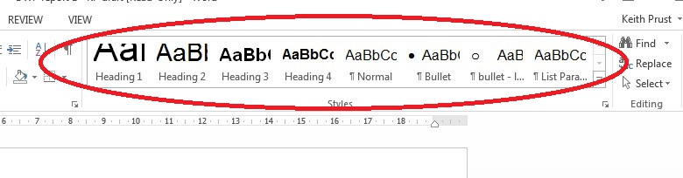
Heading styles let you create a table of contents automatically. Other styles help you produce a consistent layout.

PDF format
If your report is converted to PDF format, the heading level information is preserved. This makes the PDF more accessible for most screen reader users.

Basic practical tips

Alternative text for graphics
If you use a graphic to provide information you must provide the same information in a format that is accessible to blind and visually impaired people. Graphics include logos, photographs, graphs and charts.
Explain the main information conveyed by the graphic in the report text. There is no need to include alternative text (sometimes called ‘alt text’) if the information it conveys is explained in the report text, or if the image is decorative (e.g. a logo). If alternative text is necessary (i.e. it is not feasible to describe the content of the image in the body text), then briefly describe the content of the image to make sense as though there’s no image on the page; for example, write the alternative text as “the health minister tweeted…”, instead of “an image of a tweet by the health minister”.
Alternative text is read by screen readers and displays as hover text in some browsers. When a Word document is converted to PDF format, the alternative text is converted as well.

To add alternative text in Word
- Select the graphic
- Right click
- Select Format Object, Format Picture, Format Chart Area, or other (the words change depending on the type of graphic)
- Select Alt Text
- In the Description box, enter an explanation of the graphic (always fill in this box)
- If you are entering a long description, also use the title box to provide a brief summary (unless you have a complex chart or table, just enter text in just the Description box; when you have complex content to describe, then filling in the Title field is useful so reading the full description is not necessary unless desired)
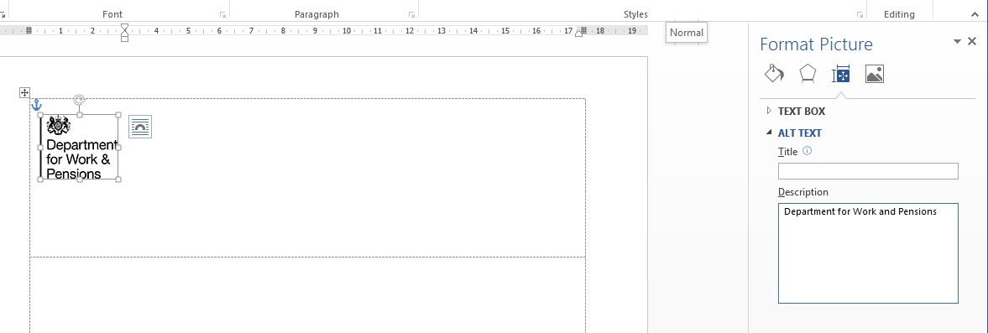

- Read more about adding alternative text.

Check your document is accessible
In Word, and other Microsoft Office applications, you can check if your document is accessible.
Check that your document is saved in the latest version of Word. If the header includes the words [Compatibility mode] then it isn’t using the latest version.
To save to the latest version of Word:
- Select the File tab then Save As
- Choose the folder you want to save the document in
- Use the drop-down list under File Type and choose the top option: ‘Word Document’
- Select Save
To check accessibility:
- Select the File tab
- Select the Check for Issues box, then Check Accessibility
- A new pane will appear to the right of the document giving you errors and warnings about the document’s accessibility
- Select each of the Inspection Results in the top window and the Additional Information box below will tell you why that issue needs to be fixed (how it can affect accessibility) and a step-by-step guide to fixing it

- Read more about checking the accessibility of word documents.

Remove hidden data and personal information
Microsoft Office documents can have hidden data or personal information that you do not want to share with others or be published online. These include:
- comments and revisions marks from track changes
- the name of the document’s author, who last saved it and the date it was created
- text that is formatted as ‘hidden’
Use the Document Inspector to find and remove hidden data and personal information in Word documents. You might want to save a copy of your document before using the Document Inspector as it’s not always possible to restore the data that the Document Inspector removes.
To remove hidden data and personal information:
- Select the File tab
- Select the Check for Issues box, then Inspect Document
- In the Document Inspector dialog box, select the check boxes to choose the types of hidden content that you want to be inspected
- Select Inspect
- Review the results of the inspection in the Document Inspector dialog box
- Select Remove All next to the inspection results for the types of hidden content that you want to remove from your document

- Read more about removing hidden data and personal information.

Other writing guidance
See the DWP research report guidance.

Help us improve this template
If you have any comments on how we could improve this template, email
accessible.formats@dwp.gov.uk.

Heading level 1
Chapter intro style (if required). This style of text introduces a main section or chapter for use in a large document. Use it to give a summary level of description of what the section contains. It allows the busy reader to get a taste of what will be covered. It should not simply be the first paragraph of the section, and does not have to be used.

Heading level 2

Heading level 3
‘Normal’ text style. This style represents the bulk of the document at 12pt. Chapter title, Heading 1 and Heading 2 styles are to be used to break the document into logical sections and subdivisions.
Styles are accessible from the toolbar, or by choosing the ‘Format’ menu, and then ‘Styles and formatting’.
- Bullet style
- Bullet level 2

