Greening Government: ICT Annual Report

Reducing carbon. Reducing cost.

June 2012

Contents
Contents 2
Foreword 3
1 Introduction 4
2 Key Highlights 4
3 Key Challenges 6
4 Progress on Green ICT Commitments 8
5 Maturity Model Assessment 10
6 Roadmap Assessment 11
7 Case Studies 14
8 Forward Look 16

Foreword
The Green Agenda sits at the very heart of Government and using Information and Communications Technology (ICT) to support this agenda is one of the key challenges of the Government ICT Strategy. ICT runs some of the biggest operations across Government and is therefore a major consumer of energy and natural resources. ICT also offers the opportunity to create greener business processes overall and transform organisations. With costs continually rising and our dependence on ICT increasing, the need for us to adopt smarter, greener working practices, and to procure and operate shared services while eliminating ICT duplication and waste, becomes ever more important.
Against this backdrop the Government must continue to deliver quality public services while upholding its Greening Government Commitments, responsibly managing the impact of its ICT on the environment and enabling a low-carbon, energy-efficient estate.
The publication of the new Greening Government: ICT Strategy in October 2011 heralded our commitment towards the Green Agenda and the implementation of the Government ICT Strategy. This ambitious, yet practical strategy endorsed by the Chief Information Officer (CIO) Delivery Board, signalled the renewed vigour we have taken in Greening the Government ICT estate.
This report presents a summary of the progress made by the HMG CIO Council Green ICT Delivery Unit (GDU) during 2011/12. The report highlights the collective achievements and also the challenges faced in taking forward the Greening Government: ICT Strategy and enabling the achievement of the wider Greening Government Commitments.
We are committed to championing and delivering this Agenda. The journey towards our Green ICT vision has begun and we have made significant progress already. We will now build on this solid foundation and through strong governance deliver on our Green ICT Commitments.

Jennifer Rigby
Chair of the Green ICT Delivery Unit
CIO Department of Energy and Climate Change

John Taylor
SRO for Green ICT
CIO Ministry of Defence

1 Introduction
The Green ICT Delivery Unit (GDU)
A forum of Government and wider Green ICT and sustainability leads. Its primary function is to lead the development of the UK Greening Government: ICT Strategy and drive forward its implementation.

At a high-level, renewed focus, prioritisation and leadership has ensured that very good progress has been made on implementing the Greening Government: ICT Strategy and its first set of commitments. Although 2011 forms the Government baseline year from which all progress will be charted going forward, significant progress has already been made in the six months since publication of this strategy. There are many excellent case studies of how individual departments and agencies are adopting Green ICT principles and practices, some of which are included at section 7.

2 Key Highlights

Greening Government: ICT Strategy
The GDU published the Greening Government: ICT Strategy in October 2011, a key pillar and sub-strategy of the over-arching Government ICT Strategy. The Strategy ensures that Government is fully committed to reducing waste, creating a coherent ICT infrastructure while increasing share and re-use, through the embedding and enabling of Green ICT principles and practices throughout the ICT life-cycle.
Published alongside the Greening Government: ICT Strategy were four implementation resource documents: Green ICT Maturity Model, to assess the level of green ICT maturity and progress being made; Green ICT Roadmap, containing fourteen (14) Key Target Outcomes (KTO); Green ICT Workbook, featuring Green ICT best practice actions to adopt and embed within an organisation; and Green ICT Case-Studies, highlighting successful Green ICT initiatives across the public sector.
The Strategy contained nine (9) Green ICT Commitments through which the delivery and implementation of strategy is being fulfilled. Five (5) strategy implementation sub-working groups have been formed to take forward the actions of the nine (9) Green ICT Commitments.

“Embedding and adopting Green ICT principles and practices are fundamental to achieving a low carbon, cost-effective ICT Estate. Their championship and delivery by the GDU is propelling us forward significantly with this agenda”
Andy Nelson Government CIO

Implementing the Strategy
The Greening Government: ICT Vision
A cost-effective and energy efficient ICT estate which is fully exploited, with reduced environmental impacts to enable new and sustainable ways of working for the public ..sector
Since publication of the strategy and resource documentation, all Government Departments have reported that the Greening Government: ICT Strategy is being adopted, actioned and championed by their department. The role and leadership of the CIO has been crucial to ensuring this adoption along with the active support of their GDU members.

Maturity Assessment
The Green ICT Maturity Assessment gives a measure of how well Government departments are adopting Green ICT standards and principles into their processes and practices. Twelve (12) Government Departments completed the maturity assessment, including three of the largest departments (The Department for Work and Pensions, Her Majesty’s Revenue and Customs and The Ministry of Defence) which between them account for the largest proportion of ICT energy usage across Government. They achieved a level of Green ICT Maturity of 2.6 compared with the average across all departments of 2.4. Overall four (4) departments are already at or above the target for an average level of maturity of 3.

Roadmap Assessment
Twelve (12) Government Departments completed the Green ICT Roadmap. Six (6) departments reported achievement of five (5) or more of the fourteen Key Target Outcomes (KTOs) on the Roadmap, with eight (8) departments already reporting work in progress towards achieving the target of ten (10) or more by 2015. An estimated 232,000 tCO₂ emissions has been saved with an estimated cost saving across government of £1.262m over twelve (12) months to end March 2012 from adopting and embedding Greener ICT practices and principles.

Green ICT Metrics
Three (3) Green ICT Metrics and Milestones were incorporated into the Government ICT Strategy Implementation Plan (SIP) These metrics gave a measure of the Government Data Centre Power Usage Effectiveness (PUE) level (indicating the proportion of the overall energy taken by a data centre that is required to cool it), energy consumption cost and volume of tCO₂ of its data centres.
Across ten (10) Government Departments submitting returns, the average PUE for data centres was estimated at 1.87. Government expects to move to a PUE of 1.5 or better as data centres are rationalised. Those departments with high PUE values, greater than 1.5 are already working to put in place key data centre energy saving programmes to reduce power for cooling and thereby the PUE. The total energy consumed by the data centres used by these departments is estimated to emit some 101,000 tCO₂ at a cost to the Government of £17.5m.
Six (6) Government Departments (including the three largest) reported 100% adoption, in their existing contracts for ICT services, of Government Buying Standards (GBS) for sustainable purchase of ICT assets, where these exist, for the type of ICT asset being purchased.

Data Centres
The Government is committed to rationalising the number of data centres across its estate. In the short term the Government ICT Strategy Hosting Consolidation work stream is identifying and taking tactical opportunities for consolidating and sharing existing data centre and hosting services, predominantly within departments at this stage, thereby realising energy, cost and carbon emission savings. In parallel it is developing data centre standards as part of a new government Hosting procurement framework which is due to be in place by end Dec 2012.
In support of this work, departments are asked to endorse the EU Code of Conduct for Energy Efficient Data Centres and adopt its best practices to reduce PUE, energy consumption and costs for all their data centres.

Partnerships
The GDU has members of academia and representatives of the wider public sector as part of its membership. Also recognising the need for greater industry alignment, innovation and engagement, the GDU is engaged with suppliers and the Small and Medium Enterprises (SME) community through the Intellect Green Government Group. The GDU will seek to build on these partnerships and alliances over the coming years. Finally, in order to ensure coherence across Government, the GDU has forged strong links with a number of other Government ICT Strategy work streams, namely those for End User Devices, Procurement, Cloud, Hosting and Capability.

3 Key Challenges
There have been unprecedented levels of engagement across Government to ensure adoption of the Greening Government: ICT Strategy, however, there are still some challenges which we are working to overcome.

Capability and Resourcing
Departments have contributed their Green ICT specialists to the GDU and its working groups to collaborate on behalf of the whole of Government. Equally within Departments, members of the ICT community and others are taking actions to implement the Greening Government: ICT Strategy and meet the commitments therein. The capability and capacity that is available to do this as well as the availability of ICT funding will influence the speed at which Departments can reduce the overall impact of their ICT on the environment. Government is continuing to grow a pool of expertise and experience in tackling Green ICT issues within government and in the Public Sector. More widely the GDU will seek to build on its work with and support for the British Computer Society (BCS) Specialist Groups for Data Centres and Green ICT and its development of training and education, materials and opportunities for the UK ICT professional community, underpinned by continuing work to embed Green ICT within the Skills for the Information Age (SFIA) professional development framework.

Greenhouse Gas (GHG) Protocol ICT Supplement
The GDU recognises the significant work that is being done by the Global e-Sustainability Initiative (GeSI), the World Resources Institute (WRI), the World Business Council for Sustainable Development (WBCSD) and the Carbon Trust with the ICT industry in developing the ICT Sector Guidance for the Greenhouse Gas (GHG) Protocol Product Accounting and Reporting Standard, to provide common approaches and guidance for calculating carbon emissions across the lifecycle of ICT assets and services. The GDU will seek appropriate government-wide adoption of the final guidance alongside other industry and public sector best practices in order to fulfil its commitment to report on operational ICT energy consumption.

G-Cloud Services
Government is committed to the adoption of cloud computing and delivering computing resources to users as needed, through an on demand, commodity-based delivery model. The G-Cloud is an iterative programme of work to achieve this which will deliver fundamental changes in the way the public sector procures and operates ICT. From a green perspective, however, we need to be aware of the inherent new challenges and ensure that Green ICT standards, for example, the EU Code of Conduct for Data Centres are adopted and work to ensure transparency of energy costs by suppliers going forward.

4 Progress on Green ICT Commitments
 |  | Commitment |  | Progress
1 |  | Government to reach Level 3 (practiced and moving forward) of Green ICT Maturity Assessment Model. |  | Adoption of the Maturity Model has been good. 12 Government Departments have now completed the Maturity Model Assessment, with an average overall maturity of 2.4.
2 |  | Government to adopt at least ten (10) of the fourteen (14) Key Target Outcomes set out in the Roadmap for improving its Green ICT practices. |  | 12 Government Departments have now completed the Roadmap assessment, with eight (8) Departments reporting work in progress to achieve 10 Key Target Outcomes.
3 |  | Government to report on operational ICT energy consumption using agreed standards for products and services. |  | Government participated in the GHG Protocol ICT supplement review which took place from Oct 11 to Apr 12. The output guidance is now being assessed by Government Departments with the view to establish programmes of work to baseline and estimate the operational ICT energy consumption.
4 |  | The Government will work with suppliers and technology industry groups to encourage green practices. |  | The Government Procurement Service (GPS) in collaboration with Department for Environment, Food and Rural Affairs (DEFRA) has developed and continues to develop a suite of ICT environmental standards. These standards are now actively being adopted by Government Departments (see metrics). The Government is working in partnership with Intellect and Universities and Higher Education organisations to promote innovation in Green ICT.
5 |  | Government will operate a greener ICT lifecycle, purchasing and using less ICT by appropriate sharing and re-use. |  | The GDU established a Share and Re-use Working group to demonstrate the stewardship of re-use and recycle of excess and surplus electronics across government. The group is actively involved with “ASK ICT” (Asset and Services Knowledgebase) a database comprising details of all government ICT equipment, systems and services and their availability for reuse.
6 |  | Government to adopt the EU Code of Conduct (CoC) for energy efficient data centres. |  | Committing to the standard will enable Government to reduce the PUE of its data centres. Currently, three UK Public Sector bodies have Data Centres registered as Participants under the EU CoC for energy efficient data centres. The following European Codes of Conduct for ICT links shows Endorsers and Participants published as at 16 May 2012: List of Endorsers , List of Participants.
7 | All redundant ICT to be recycled in whole or component parts or materials, or donated to charities and voluntary organisations as part of the Big Society. Reductions in line with the Government Waste Strategy and Hierarchy. |  | Government Procurement Service has a framework for disposal of ICT equipment with the third sector. This framework allows public sector organisations to donate, recycle or sell equipment to offset costs and generate revenue.  Refurbished assets are also made available to the ‘Go ON UK’ project which aims to enable the most disadvantaged groups to have online access at affordable prices to help bridge the digital divide.  Some Government Departments are now actively accounting for their recycled, disposed and redeployed ICT in their Annual Reports.
8 | The Government will use ICT to make its processes more effective and efficient and promote new ways of working. |  | Government Departments are actively adopting video conferencing and collaboration tools to drive down the cost of business travel and paper use to their department. One example is the tele-presence system at a number of key MOD locations, so far resulting in a saving of 761 return journeys, 112,062 miles and 27.2 tCO₂ since it became operational in Feb 2012.
9 | The Government will seek to improve public service provision to: achieve reductions in greenhouse gas emissions, energy use, waste, travel, paper/print, office space and procurement; increase agility and capability; support business outcomes; and support a UK green economy. |  | In collaboration with the Digital by Default agenda, this commitment is being achieved as more and more traditional services are moving on line. Notable examples include the Government Digital Service (GDS) reducing back office paper waste for the Office of the Public Guardian services (eg Power of Attorney) by migrating to an online service and leading to a reduction in processing times from 12 weeks to 4 weeks too. Also the Environment Agency Flood Alerts Service using social media to notify facebook and twitter users of flooding risks and possible dangers.

5 Maturity Model Assessment
Demonstrating progress with embedding Green ICT principles and best practices in ICT processes and working practices, twelve (12) Government Departments provided an assessment. Although this report covered Central Government Departments, five (5) arms-length bodies also provided returns. These will be included in a future report.
In summary, the charts below indicate the highest levels of Maturity are seen around Operations including Energy Optimisation and Disposals with lower levels of Maturity found around Investment Decisions, Solution Design and Enabling Customer Services. This is countered by Government Departments recording their desire to achieve improvements in these areas.
The number of departments at each stage for sub-categories
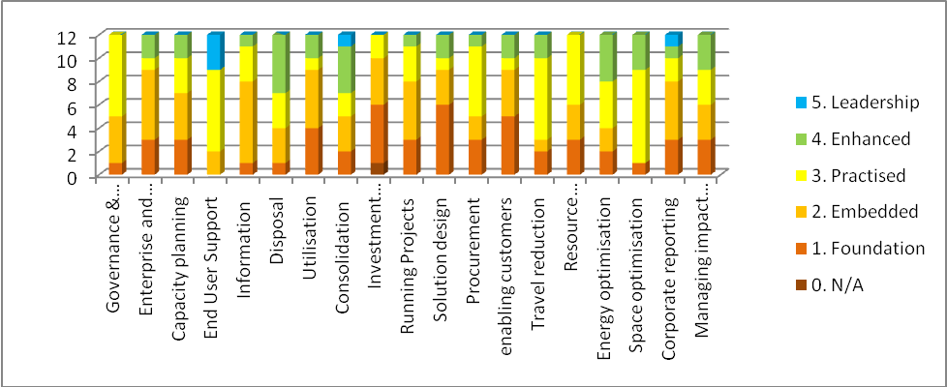
The number of departments already at LEVEL 3 or above for each sub-category
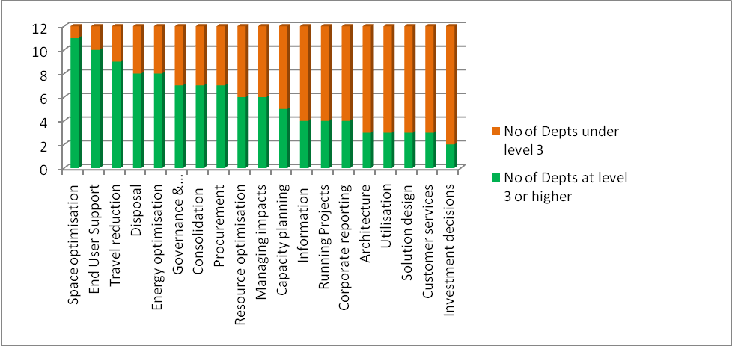

The levels of ambition
Percentage of Departments who have achieved LEVEL 3 or above and percentage desiring to do so.

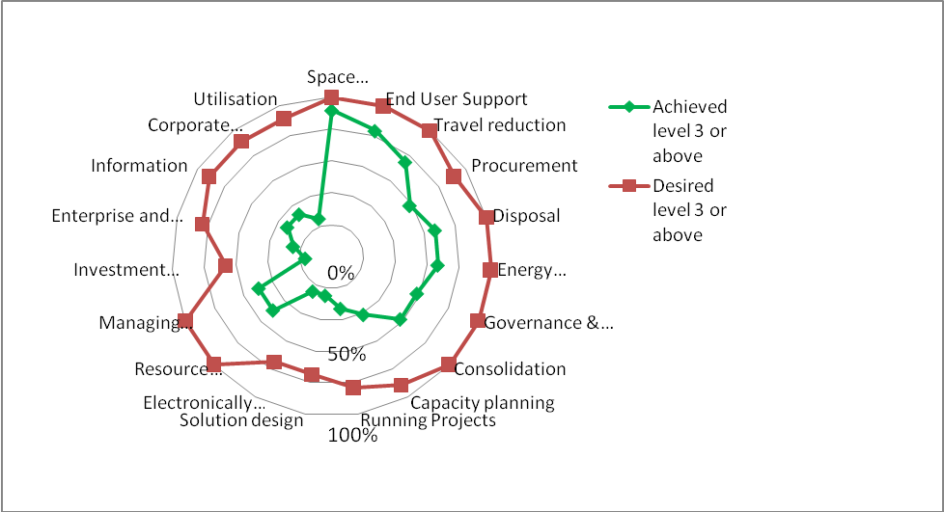

6 Roadmap Assessment
Twelve (12) Government Departments provided assessments demonstrating their achievement of Key Target Outcomes (KTO) through the utilisation of best practices from the Green ICT Workbook. Although this report covered Central Government Departments, fourteen (14) arms-length bodies also provided assessments. These will be included in a future report.
In summary, returns show good levels of achievement around end user and networks, with more to be done in tackling the Back-office ICT services, Supply Chain and Exploitation opportunities. Overall, six (6) Government Departments have already achieved five (5) or more KTOs and eight (8) Government Departments have work in progress to reach the target of 10 KTOs or more.
Roadmap assessments - Demonstrating Adoption of best Green ICT practices and principles
12 returns from 23 departments, 14 returns from other bodies
Key Target Outcome (KTO) | CPS | DCLG | DECC | Defra | DfID | DoH | DWP | FCO | HMRC | HO | MOD | MoJ
KTO1. Use of Green ICT standards in procurement | 4 | 4 | 6 | 5 | 5 | 6 | 5 | 3 | 5 | 4 | 4 | 4
KTO2. Replace for business utility not refresh | 3 | 6 | 6 | 5 | 6 | 6 | 3 | 3 | 4 | 4 | 5 | 4
KTO3. Power consumption minimised for end user access devices. | 4 | 6 | 6 | 5 | 5 | 4 | 5 | 3 | 5 | 4 | 4 | 4
KTO4. Minimise end user access devices | 4 | 4 | 4 | 5 | 5 | 4 | 5 | 2 | 4 | 4 | 4 | 4
KTO5. Minimise and consolidate print | 5 | 6 | 4 | 5 | 4 | 5 | 5 | 3 | 5 | 5 | 3 | 4
KTO6. Rationalise networks | 4 | 6 | 2 | 4 | 3 | 4 | 3 | 2 | 4 | 4 | 6 | 4
KTO7. Tackle supply chain | 3 | 4 | 2 | 5 | 3 | 4 | 4 | 3 | 4 | 3 | 3 | 3
KTO8. Share services and systems | 3 | 4 | 4 | 4 | 4 | 4 | 5 | 3 | 5 | 4 | 4 | 4
KTO9. Virtualise and consolidate hosting arrangements | 4 | 4 | 3 | 4 | 5 | 4 | 5 | 3 | 5 | 4 | 3 | 4
KTO10. EU Data Centre Code of Conduct endorser status | 4 | 3 | 2 | 4 | 3 | N/A | 5 | 3 | 4 | 3 | 1 | 3
KTO11. Server rooms are run energy efficiently | 4 | 5 | 4 | 2 | 4 | 4 | 4 | 3 | 4 | 3 | 4 | 4
KTO12. Storage capacity minimised | 4 | 6 | 4 | 2 | 5 | 4 | 3 | 4 | 5 | 4 | 4 | 2
KTO13. Minimise need for disposal and land-fill | 5 | 6 | 2 | 6 | 6 | 6 | 5 | 3 | 5 | 5 | 5 | 3
KTO14. Reduce business travel | 4 | 4 | 5 | 4 | 6 | 5 | 5 | 4 | 5 | 4 | 4 | 4
1 – Not started 4 – In progress
2 - Under Review 5 – Achieved
3 – Planned 6 - Embedded

For each Key Target Outcome percentage of Departments at each level of achievement
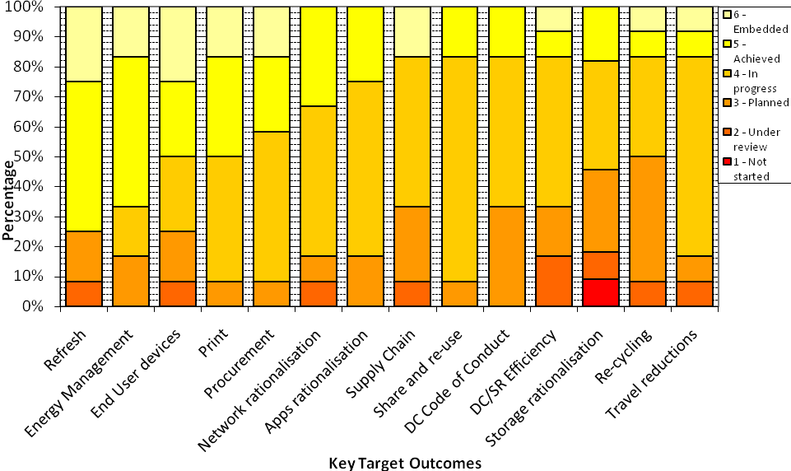
In total six (6) departments have achieved five (5) or more KTOs

Number of Departments working towards each target outcome
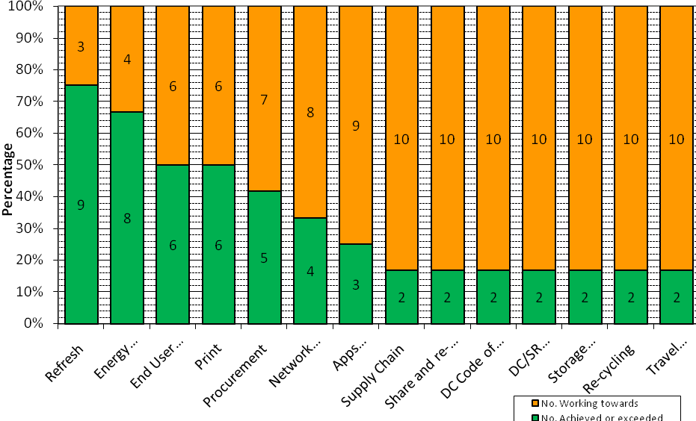

7 Case Studies

Ministry of Justice - Technology Transformation reduces CO₂ output by 3,500 tonnes
The Ministry of Justice (MoJ) is exploiting ICT to transform the justice system by supporting digital working and speeding up the flow of information. MoJ is enabling this change by delivering new technology for courts with reduced hardware and energy needs. In the last year over 3,500 tCO₂ has been saved by replacing old desktop computers and their screens. Over 1200 servers have been replaced with a more efficient virtual architecture and new storage technology has been introduced with lower costs and environmental impacts.

Department for Work and Pensions - Desktop PC Replacement to save about 5,400 tCO₂ per year
In January 2012 the Department for Work and Pensions (DWP) signed a new contract to replace the desktop computers used by its staff. The current DWP desktops have been in place for six years and are overdue a refresh as the desktop is being used beyond its original design intent. Rather than replace the estate with updated personal computers the decision has been taken to redesign the desktop to use a thin client architecture where a graphical interface terminal with little processing ability relies on a server for all of its processing.
Thin clients have a number of technical benefits including: increased service flexibility, improved data security and lower total cost of ownership than traditional PCs as they have a longer refresh cycle (7-10 years). The longer refresh cycle helps to increase the sustainability of the desktop. Additionally thin clients use much less electricity than traditional desktop computers with an associated reduction in CO₂ emissions and departmental energy costs. This reduction is partially offset by higher server and network power requirements; however it is anticipated that DWP will save approximately 5,400 tCO₂ per year as a result of this transformation.

Department for Communities and Local Government - Printer Rationalisation reduces paper usage by 0.5 tonnes a year
In October 2010, an audit of printer, fax machines, scanners and photocopiers at Department for Communities and Local Government’s headquarters, Eland House, highlighted a diverse ICT estate with a large number of underutilised devices. Following the audit DCLG decided to look for a more cost effective and green alternative to its printer estate. The Department has now successfully introduced 50 Multi Functional Devices (MFDs) which will replace around 300 traditional printers. This is expected to lead to paper usage being reduced by 0.5 tonnes per year.

Department for Energy and Climate Change - Improved Cooling and Power Management reduces some energy consumption by over 70%

As the department with lead responsibility for sustainability, Department for Energy and Climate Change (DECC) is committed to reducing its greenhouse gas footprint and running its estates and operations as sustainably as possible. DECC is a comparatively small department - its carbon footprint in 2010/11 was 999 tCO₂ and energy spend was just over £200,000.
A key project last year was the installation of a new chiller designed to cool the DECC server rooms all year round. This allows the department to switch off much larger main chillers for longer periods of time, until they are required to cool the air in the building during office hours in the summer. The chiller cost around £90,000 and DECC expects this to pay back in about five years, saving 94 tCO₂ per year.
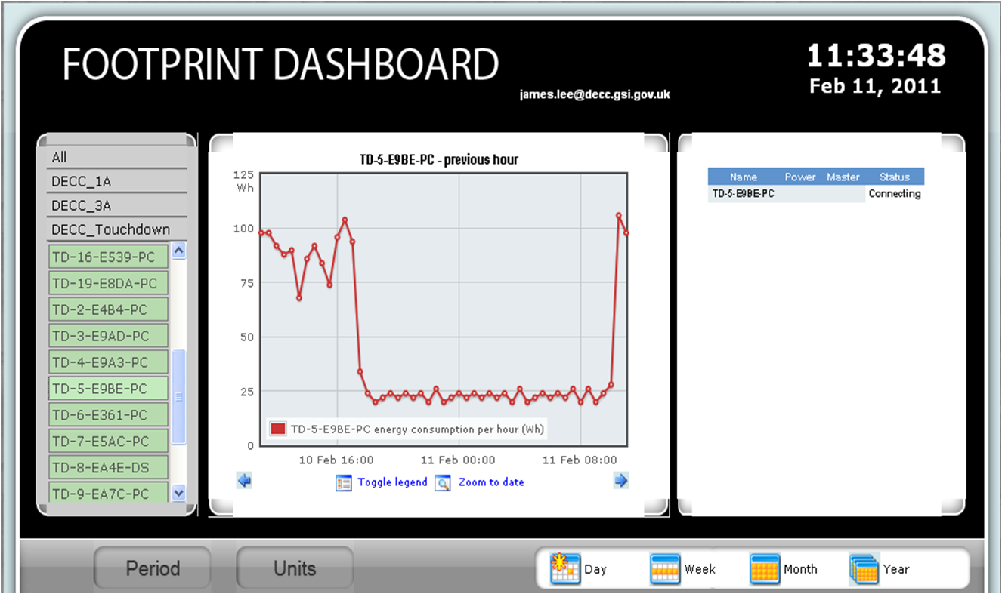
Between September and December 2011 DECC piloted the use of ‘intelligent’ power strips which contain meters to monitor energy usage and switch off ICT equipment when not needed. Equipment (desktops, laptops and printers) was either scheduled to switch off at 9pm or when the power used fell below a certain threshold. Initial findings from this pilot, suggest that the use of scheduling and thresholds reduced the out-of-hours energy consumption of ICT equipment by over 70%.

Her Majesty’s Revenue & Customs - Improving Transparency of ICT Carbon Costs reduces CO₂ emissions and energy bills by over 10%
Her Majesty’s Revenue and Customs (HMRC) operates one of the largest and most complex ICT estates in Government. Operating and running a large ICT estate comes at both an economic and environmental price as ICT is a major user of energy and natural resources. HMRC must address the demands of their technology on scarce resources and rising energy costs.
To support this and the Government drive for greater efficiency and transparency, HMRC has developed a unique Green ICT Model based on the principles of carbon and cost accounting. The Green ICT Model allowed HMRC to measure the carbon footprint of its ICT operations and profile the energy consumption of its ICT estate for the first time. This radical approach means HMRC can measure the effect of new green ICT initiatives and best practices on its carbon footprint and report on energy cost reductions.

Visibility of Green ICT metrics gives Business and Finance Directors a view of the ICT energy cost spend by their departments. This transparency has led to a positive behaviour change, where senior management have driven a campaign to switch off ICT equipment when not in use and request that surplus ICT is decommissioned. Due to these initiatives HMRC has reduced both its CO₂ emissions and energy bills since August 2010 by over 10% (10,500 tCO₂ and £1.9m saved).

8 Forward Look
It is vital we build on the solid progress made so far and continue to deliver on our Green ICT Commitments. The Green ICT Maturity Model, Roadmap and Workbook of best practice have given us an excellent start and a strong platform to build on.
ICT plays a fundamental role in the UK Green Agenda. However, it is not just about delivering energy-efficient ICT, but also about how Green ICT is an enabler for greener and more sustainable government business operation. This means exploring the opportunities for smarter working and smarter technologies; moving to on-line services where possible; exploiting collaborative tools; making better use of mobile technologies and much more.
The GDU will be at the centre of our future plans and its strong leadership and governance will enable, support and help develop the champions of the future. It is imperative that we continue to build this group with the right people and skills to realise our Green Agenda commitments and future goals.
There are many challenges ahead, but this agenda cannot be delivered without behaviour and culture change. The Government’s Green Agenda is a shared responsibility and, in order to succeed, all government departments, citizens and employees need to increase their awareness of their personal and organisational impacts on the environment and embrace the necessary change. Government Departments must take the initiative in aligning and embedding green objectives within their core business objectives.
Successful implementation of the Green Agenda is more likely to be realised through stakeholder engagement and strong partnership with suppliers, the wider Green ICT industry and Academia. Greening government and the government ICT estate is an important strand of the Greening Government: ICT Strategy. The Government has a key role to play in improving performance against green targets and in the way it procures and delivers greener services. The GDU will continue to collaborate and align closely with other work streams of the Government ICT Strategy to ensure that Green ICT principles and practices are intrinsically embedded into core ICT delivery areas.
We will continue to review and refresh the direction of the Greening Government: ICT Strategy. This should look to deepen relationships with the wider public sector, developing stronger links with bodies like the HMG Chief Technology Officer (CTO) Council, the Local Government CIO Council and learning from the wider public sector too. Our goal is to see greater transparency of carbon emissions and the costs linked to them – via the use of modelling guidance such as the GHG protocol. Our aspiration is to eventually baseline all Government ICT emissions with carbon/financial statements published annually.

http://www.cabinetoffice.gov.uk/sites/default/files/resources/greening-government-ict-strategy.pdf
For Green ICT Maturity levels, see section 5
Tonnes of carbon dioxide
http://www.intellectuk.org/

