Greening Government: ICT Annual Report

Reducing carbon. Reducing cost

July 2013

1 Contents
1 Contents 2
2 Foreword 3
3 Introduction 3
4 Key highlights 3
5 Key challenges 7
6 Maturity model assessment 1
7 Roadmap assessment 3
8 Assessments of the operational energy use of IT 3
9 Case studies 3
10 Forward look 3

2 Foreword
Last year we published the first Greening Government Information and Communications Technology (ICT) annual report showing progress made since the Greening Government ICT strategy was published. 2012 was the first time that central government departments assessed their own maturity of how green their technology services are and we published a summary of those results. This year the process is more embedded in departments and as a result we have seen an increase in the information we have about green IT in government and an increase in the maturity of departments. It is a testament to the work by Chief Information Officers (CIOs) and information technology (IT) staff in government that some departments have reached the target maturity level of Level 3 two years in advance of the target.
Of course we are keen to be greener, not only to save on emissions, water and waste, but also to save money wherever possible. Having green IT is more efficient, efficiency leads to cost savings and yet again this year departments are able to attribute savings to the work government has done to make its IT greener.
Green IT can also play its part in reforming the civil service and introducing more modern ways of working like web conferencing and using remote collaboration tools. Departments have told us they are doing this and saving on travel costs and emissions related to travel.
Government IT is on a journey of rapid change including the use of better, cheaper, commodity and cloud-based services. Green is still hugely important as part of this journey and we appreciate the opportunity to demonstrate the progress made over the last year in this report.
Jennifer Rigby Chair of the Green ICT Delivery Unit
John Taylor SRO for Green ICT
CIO Ministry of Defence

3 Introduction
The annual report on green IT for this year contains a lot of new information and builds on the measurements first published in last year’s report. Departments have reported on progress against the government green IT maturity model and roadmap, and adoption of standards like the EU Code of Conduct for Energy Efficient Data Centres. We can also show how government is innovating to be greener and to use better ways of working. Some of the many excellent case studies detailing how individual organisations are adopting green IT principles and practices are also included to tell the story of green IT in government.

4 Key highlights

Implementing the strategy
Over the past year we have made significant progress in implementing the Greening Government ICT strategy. Not only have the roadmap and maturity model been adopted across government departments, but these departments now have plans in place to reach level 3 of the model, the government target is to meet level 3 by 2015. The average green IT maturity score for departments is now 2.9 compared to 2.4 last year.
The Green ICT Delivery Unit (GDU)
A forum of government and wider public sector green IT sustainability leads. It’s primary function is to lead the development of the Greening Government ICT Strategy and drive forward its implementation.

Progress has been made in measuring our technology related energy usage and in signing up to the EU Code of Conduct. The Green ICT Delivery Unit (GDU) continues to drive efficiencies and is looking to modernise ways of working using technology to reduce travel, improve collaboration and find better ways to reuse and recycle IT equipment.
Data centres
With the increase in the use of online services for government transactions, data centres are a key focus of the GDU and government’s green IT strategy. Four government departments have endorsed the EU’s Code of Conduct for Data Centres over the past year and a number of other organisations are progressing towards this goal. In addition a number of data centres used by suppliers to government are now registered as participants under the Code.

Defra is currently working to design guidance for buyers on effective practice for procuring energy efficient data centre services and ensuring sustainability has a high profile in contract management for the increasing number of cloud hosting services being used. The guidance has been discussed with Intellect, the UK industry body
representing both larger industry players and hundreds of smaller companies, and this is being coordinated with input from other government stakeholders. There have also been discussions with the European Commission via its EU wide Green Public Procurement process.

Recycling and reducing waste
IT Recycling
The GPS agreement was used to dispose of 66,448 items, of which 33,514 were resold, generating £405,881.68. A further 8738 items were able to be donated, further reducing the items sent for disposal.
Recycling of IT is key to achieving efficiencies and being greener. The Government Procurement Service (GPS) offers organisations a method for recycling IT assets. The service agreement has been used by at least 33 bodies including schools, councils, agencies and government departments.
Currently work is underway in the GPS to refresh the service agreement to increase the financial benefits. This will focus on money raised from the recovery and sale of components plus that of rare and valuable raw materials, and the sustainability benefits, for example, reducing waste sent to landfill or for incineration.

Public service delivery
In the last year the Government Digital Service published the Government Digital Strategy. This was followed by the publication of individual digital strategies by government departments. These strategies are fundamental to shifting government’s approach to interacting with citizens and businesses. The shift will need to be supported by the right technologies and systems to make the most efficient use of hardware and power. Digital by default also reduces the environmental impact of physical and paper based processes by using technology to create more cost effective, efficient and user-centred online services.

The move to digital by default is crucial as shown by the shift to online in HMRC which has seen more than 80 per cent of HMRC’s tax returns submitted via the internet. These online submissions have resulted in a big paper saving alongside cutting the carbon emissions by 760 tonnes. The use of different channels like SMS for alerts, have also played their part in reducing paper. Streamlining processes has also improved sustainability and efficiency, HMRC now send one Tax Credits award notice to joint households, for example, whereas previously each person in a household would have received a separate letter.

Exploiting collaborative tools
Departments continue to maintain effective working whilst reducing business travel by conducting their business via video, web and teleconferencing. The Home Office extended to all staff members its departmental contract for teleconferencing facilities (this was previously only available to a small number of staff). MOD increased its use of videoconferencing and teleconferencing as part of its travel budget cuts and efficiencies. Peer-to-peer instant messaging is now available and a peer-to-peer webcam trial is underway. These tools and other methods of remote working were used to help reduce travel by government employees during the Olympic games.

The Public Services Network (PSN) continues to drive sustainable savings and efficiencies by removing duplicate network connections, providing simpler procurement and greater competition, and allowing public sector employees to work in more flexible, collaborative ways. PSN creates a common network of networks and a more open and competitive telecommunications marketplace for the UK public sector. It provides assured networks, based on industry standards, over which government can safely share services, including many G-Cloud services, to collaborate in new ways, substantially reducing the cost of communication services across UK Government and enabling new, joined-up and shared public services.

Partnership
This year we have worked closely with colleagues in academia and are grateful to the Joint Information Systems Committee (JISC) for sharing use of its tools to record the use of energy from operating ICT. We have also discussed our plans and sought and received feedback from Industry through Intellect events. Colleagues in local government and the National Health Service (NHS) sit on the GDU and share knowledge about green IT which helps others learn effective practices.
5 Key challenges

Governance and skills
The governance of technology across government is currently being reviewed to ensure it enables teams building digital services and supporting technology to interact effectively.

Going forward as part of this, the green IT agenda will develop a clear link to the cross-government discussions coordinated by the Government Digital Service. The outcomes of this review will also support our aim to broaden skills and capability across the civil service. While this work is primarily focused on IT, we will also explore the linkages to broader sustainability activity in government.

Green data reporting

Over the last year GDU member departments have delivered significant improvements in reporting and success measures. In particular qualitative tools such as the green IT maturity assessment have proved successful by introducing a consistency of approach and a common vocabulary.

More widely, it remains a challenge to ensure open and consistent reporting of green IT data across departments and commercial frameworks. Often departments have contracts in place which predate reporting requirements. Elsewhere a lack of consistency in methodologies (as seen in the use of different footprinting approaches) across government may result in gaps in our understanding.

As government drives efficiencies with the introduction of flexible contracts (for example, through the government CloudStore) and shifts towards new service platforms the challenge is to deliver consistent, simple and relevant environmental reporting for IT. Moving forward the GDU metrics group will seek to improve reporting regimes by developing common standards, methodologies and reporting tools, drawing on our experience to date and developments elsewhere. We will work with colleagues across government and the private sector to better understand how to measure the environmental impact of new services.

Sustainable procurement
It remains a challenge to get a good balance between the social, economic and environmental implications when the public sector procures what it needs.

One of the main issues has been establishing fair and useful measures of environmental impacts and potential whole life costs, without adding barriers or being discriminatory. This will aid buyers in making better purchasing decisions and deliver savings for the tax-payer, and should encourage the market to be transparent, improve environmental risk and performance management, and increase opportunities for all suppliers.

The Government Procurement Service and Defra have further developed ways of incorporating standards into the procurement process and supporting buyers. For example, the G-Cloud ii procurement aligned suppliers to the Greening Government ICT Strategy commitments by supporting best practices such as the EU Code of Conduct for data centre operations (EU CoC) in call-off contracts with customers. The approach has been to identify standards and benchmarks that shine a light on good sustainability performance and provide opportunities, not barriers or ways to exclude. We have seen a significant growth in opportunities for all suppliers, and in particular SMEs, to gain access to public sector opportunities, notably with initiatives such as G-Cloud.

6 Maturity model assessment
Maturity model target
Seven departments have already met or exceeded the 2015 target of level 3 of the maturity model.
Fifteen departments completed the maturity assessment this year, an increase of three from last year. The following graphics are therefore based on percentages rather than counts of departments.
The overall position shows, for government departments:
- an average 2.9 level of maturity up from 2.4 last year
- an average level of ambition at 3.8 this year up from 3.5 last year

Figure 1 - Level of ambition and achievement by category
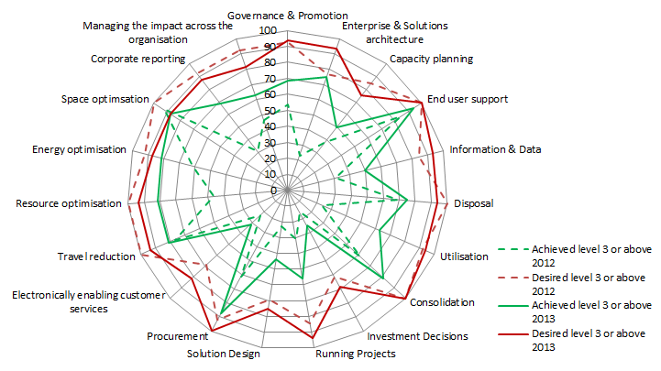

Figure 2 below shows the proportion of departments achieving level 3 or higher for each category. This is useful for illustrating which categories of IT service are most mature and the areas where departments face more challenge.

Figure 2 - Percentage of departments achieving Level 3 maturity by end 2013
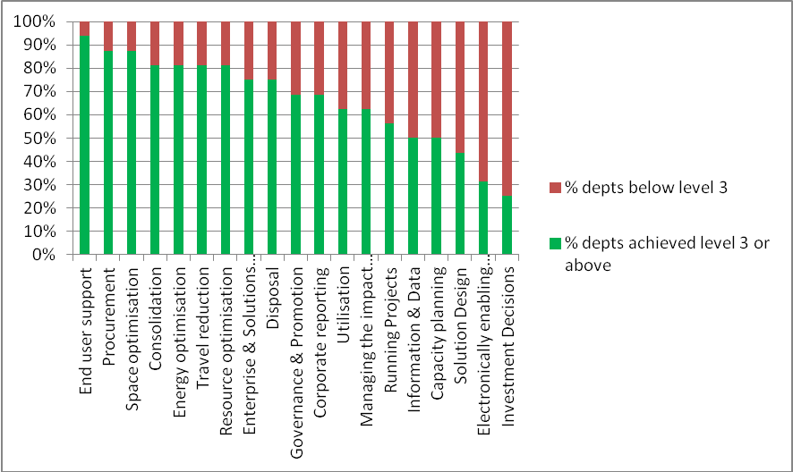

7 Roadmap assessment
Sixteen Government Departments provided assessments – 4 more than last year- demonstrating their achievement of Key Target Outcomes (KTO) through the utilisation of best practices from the Green ICT Workbook.
Returns show good levels of achievement around printing, procurement, energy management and recycling, with more to be done in tackling the back office IT services i.e. storage, data centres and networks. Some departments have moved back to planning activities for some of their KTOs as they switch their focus to achieve the target of meeting 10 out of 14 by April 2015. Overall, two Government Departments have already achieved the target of 10 or more KTOs with twelve other Government Departments having work in progress to reach this target.
The following figures show:
Figure 3. the results of the roadmap assessments, these demonstrate adoption of green IT practices and principles in organisations
Figure 4. the number of departments achieving each KTO i.e. reaching stage five (achieved) or six (embedded) by the end of March 2013
Figure 4 shows at a glance the areas where departments have fully implemented green practices and achieved their target outcomes, it is an indicator of more than just maturity as it shows evidence of full implementation. It also shows the areas still to be implemented which helps the GDU to focus work moving forward on these areas that will be more beneficial to departments.

Figure 3 - Roadmap assessments – progress on adoption of green IT practices and principles
Key Target Outcome (KTO) | BIS  (new) | CO  (new) | DCLG | DCMS  (new) | DfE  (new) | DECC | Defra | DfID | DoH | DWP | FCO | HMRC | HMT  (new) | HO | MOD | MoJ
KTO1. Use of Green ICT standards in procurement | 5 | 5 | 4  ↔ | 2 | 5 | 6  ↔ | 5  ↔ | 5  ↔ | 6  ↔ | 5  ↔ | 4↑ | 6↑ | 6 | 5↑ | 4  ↔ | 4  ↔
KTO2. Replace for business utility not refresh | 5 | 5 | 6  ↔ | 1 | 5 | 6↔ | 5  ↔ | 6↔ | 6↔ | 3↔ | 3  ↔ | 4  ↔ | 6 | 4↔ | 4↓ | 4  ↔
KTO3. Power consumption minimised for end user access devices. | 4 | 5 | 6  ↔ | 4 | 5 | 6↔ | 5  ↔ | 5↔ | 4↔ | 5↔ | 5↑ | 4↓ | 6 | 4↔ | 4↔ | 4  ↔
KTO4. Minimise end user access devices | 4 | 5 | 5  ↔ | 1 | 5 | 4↔ | 4↓ | 4↓ | 4↔ | 5↔ | 3↑ | 6↑ | 6 | 5↑ | 4↔ | 4  ↔
KTO5. Minimise and consolidate print | 5 | 5 | 6  ↔ | 4 | 5 | 6↑ | 5  ↔ | 5↑ | 5↔ | 5↔ | 2↓ | 6↑ | 6 | 4↓ | 4↑ | 4  ↔
KTO6. Rationalise networks | 4 | 6 | 4  ↔ | 4 | 4 | 4↑ | 4  ↔ | 3↔ | N/A | 3↔ | 2  ↔ | 4  ↔ | 4 | 3↓ | 4↓ | 4  ↔
KTO7. Tackle supply chain | N/A | 5 | 5  ↔ | 1 | 4 | 3↑ | 5  ↔ | 4↑ | 4↔ | 4↔ | 4  ↔ | 5↑ | 5 | 4↑ | 2↓ | 4↑
KTO8. Share services and systems | 4 | 5 | 4  ↔ | N/A | 4 | 6↑ | 4  ↔ | 4↔ | N/A | 5↔ | 3  ↔ | 6↑ | 5 | 4↔ | 4↔ | 4  ↔
KTO9. Virtualise and consolidate hosting arrangements | 4 | 4 | 4  ↔ | 5 | 4 | 3↔ | 4  ↔ | 6↑ | 4↔ | 5↔ | 3  ↔ | 6↑ | 6 | 4↔ | 3↔ | 4  ↔
KTO10. EU Data Centre Code of Conduct endorser status | N/A | N/A | 4  ↔ | N/A | 3 | 6↑ | 5↑ | 3↔ | N/A | 5↔ | 3  ↔ | 5↑ | N/A | 4↑ | 4↑ | 4↑
KTO11. Server rooms are run energy efficiently | N/A | N/A | 5  ↔ | N/A | 4 | 4↔ | 4↑ | 3↓ | N/A | 4↔ | 3  ↔ | 6↑ | N/A | 3↔ | 4↔ | 4  ↔
KTO12. Storage capacity minimised | 5 | 4 | 6  ↔ | 4 | 4 | 4↔ | 4↑ | 3↓ | 4↔ | 3↔ | 4  ↔ | 6↑ | 5 | 3↓ | 3↓ | 2  ↔
KTO13. Minimise need for disposal and land-fill | N/A | 5 | 6  ↔ | 4 | 3 | 5↑ | 6  ↔ | 6↔ | 6↔ | 5↔ | 3  ↔ | 6↑ | 5 | 4↓ | 4↓ | 3  ↔
KTO14. Reduce business travel | 4 | 4 | 4  ↔ | N/A | 4 | 5↔ | 5↑ | 5↓ | 5↔ | 5↔ | 5↑ | 5  ↔ | 5 | 4↔ | 4↔ | 4  ↔

Arrows indicate change on previous year. No arrow indicates first return
1 – Not started 2 - Under Review 3 – Planned 4 – In progress 5 – Achieved 6 – Embedded
Figure 4 - Percentage of departments achieving each Key Target Outcome as at end March 2013
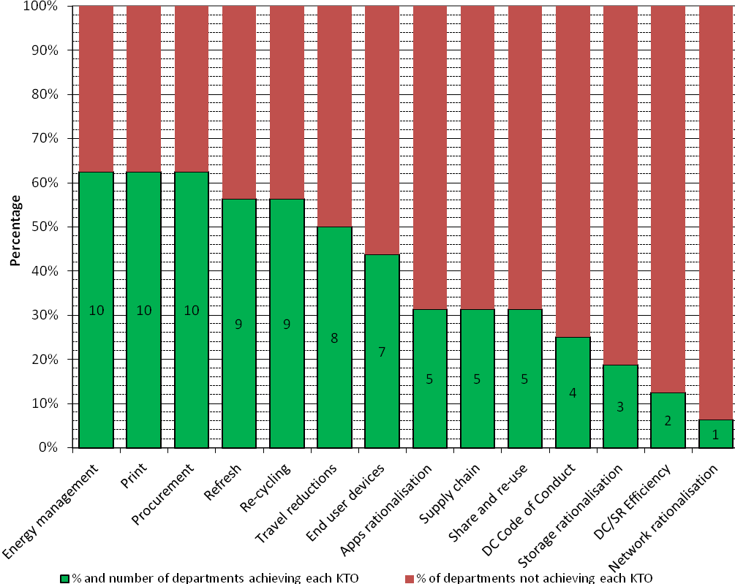

8 Assessments of the operational energy use of IT
Fifteen organisations provided returns showing their operational energy usage for IT. This is the measurement of the energy needed to run the equipment. The GDU worked with the Joint Information Systems Committee for Higher Education (JISC) in developing its footprinting tool for use by government. This was used by ten organisations, with five others using their own tools.

Measuring IT energy use for central government is a substantial undertaking with a number of challenges. These include: the use of different methodologies, complexity of the supply chain and new ways of providing services including cloud which all have an impact on understanding the full picture and on the consistency of the data provided.
This is the first assessment at this level of detail of energy usage by government IT and our aim is to develop further the ways to collect and report this data to improve its accuracy and comparability. The figures, despite some of the shortcomings described above, give a sense of scale and show that servers and their supporting infrastructure consume the most energy which reinforces the need for further work on the energy efficiency of data centres and supports the GDU’s focus on this area.
As the following table shows, ten organisations have provided complete returns with asset counts and energy consumption figures for all types of deployed assets.

Figure 5 – Completeness of departmental returns

The following figure provides an assessment of the returns. These figures indicate the scale of the footprint by type of ICT asset. Although incomplete in some areas, the inclusion of the staffing figures provides an initial baseline against which to chart progress for those departments making consistent returns in future years and enables some relative comparisons year on year as the size of government changes.

Figure 6 - How much energy does government IT use

Category | Energy Use (kWh/y) | % | Energy Cost (£/y) | CO2 emissions (kg/y) | Staff covered per category | Average kWh/y staff | Average £/ staff | Average kg CO2/ staff
Servers | 276,554,199 | 42.6% | 33,186,504 | 151,280,678 | 464,495 | 595 | 71 | 326
End User IT | 145,402,517 | 22.4% | 17,448,302 | 79,538,085 | 464,495 | 313 | 38 | 171
Telephony | 106,341,205 | 16.4% | 12,760,945 | 58,170,766 | 309,324 | 344 | 41 | 188
Networks | 69,839,997 | 10.8% | 8,380,800 | 38,203,875 | 323,495 | 216 | 26 | 118
Imaging | 42,305,123 | 6.5% | 5,076,615 | 23,141,748 | 464,495 | 91 | 11 | 50
AV | 8,170,255 | 1.3% | 980,431 | 4,469,293 | 309,324 | 26 | 3 | 14
TOTAL | 648,613,295 | 100% | 77,833,595 | 354,804,445 | N/A | 1586 | 190 | 867

9 Case studies
Department for International Development - Server rationalisation and air miles tracker
The Department for International Development has carried out a project to drastically reduce the number of servers in its infrastructure. The UK server estate has reduced from 304 to 95 and the overseas server estate has reduced from 298 to 78. Also new laptops are currently being rolled out which use 50% less power and new PCs which use 60% less power. Based on peak usage for the office in Scotland, there has been a 45% reduction in electricity usage in patch rooms and an estimated £30,000 in cost savings.
Over 60% of the Department for International Development’s carbon footprint is air travel. Reducing international air miles is a major challenge due to the nature of the business. This year the environmental operations team and IT team introduced a new air miles tracker system which will improve the monitoring and management of air miles flown. Heads of Department can view departmental air miles online and individuals can monitor their own carbon footprint.

The Department for Education - Thin client
The Department for Education has put in a thin-client infrastructure to support its Arm’s Length Bodies Reform Programme which saw numerous non departmental public bodies merge with the Department for Education and become executive agencies. Over a period of less than six months it went from four main sites to twelve and doubled in size to close to 4000 staff.
To support this change, the department consolidated its back office and moved away from desktop computers as the default. This means that all offices now run a ‘hot-desking’ ratio of seven or eight to ten and every desk has a low power, easy to support, thin client device with a usable life of seven to eight years compared with three to four for the standard desktop. This was done without creating any new data centres so that just two are still maintained. The result of this is dramatically slashed energy consumption at the desktop. While this is somewhat off-set by additional equipment in the data centres, overall consumption for desktop services is only slightly more to support the new department and agencies than when it was half the size.
Home Office - Carbon Trust Standard & Data Centre efficiencies
In December 2012 the Home Office was awarded the Carbon Trust Standard for measuring, managing and reducing its carbon footprint. This means that the department is in line with international best practice and has been certified by the Trust for real carbon reduction and a commitment to continuing reductions.
In March 2013 the Home Office was given Endorser status of the EU Data Centre Code of Conduct. The main data centres hosting Home Office services are constantly being reviewed for efficiency opportunities. Some recent examples include:
- Installation of advanced water cooling infrastructure for direct rack cooling connected to adiabatic condensers on the roof. These will save approximately 428 tonnes of CO₂ equivalent annually
- Installation of more efficient UPSs which improved efficiency from 89% to 95.8% saving around 90KW, with annual savings of approximately 243 tonnes of CO₂ equivalent
- Variable Air Conditioning (AC) Temperatures introduced, raised from 21⁰C to max 24⁰C to reduce power usage of chillers

10 Forward look
Departments have shown this year that they have built on the early progress after the publication of the Greening Government ICT Strategy to continue to deliver on the commitments given in the strategy.
A key theme in the strategy and the work of the GDU is that our objectives are not just about delivering energy efficient IT, but also about how technology and green IT is an enabler for more efficient and more sustainable government overall. Over the next year, the GDU will be focusing on ways to bring together the work on the digital agenda in government with our aim to green government using technology.
Using less is the most efficient way to save energy, we can do this by avoiding duplication and by simplifying how we use technology in government . The government technology strategy will drive this through effective use of cloud services, PSN as well as shared services. We will be working closely with colleagues from across a wide spectrum of government involved with these types of services and also those working on procurement and environmental standards.
We will also be working more closely towards the Civil Service Reform agenda to help implement more modern and flexible ways of working that improve collaboration and deliver green benefits and cost savings. Another focus which will continue and develop is the need to strengthen our use of energy efficient data centres and associated standards. Related to this is building on the methodology, standards and tools used for the first time this year to calculate the energy consumed from our operational use of IT. Having transparency and understanding of the impact of IT both in terms of energy usage and cost has been, and continues to be, a key goal for the GDU. This way departments can focus their efforts on areas of heavy usage and measure the results of any changes made to demonstrate greater efficiencies.
Progressing on the journey towards more maturity in green IT in government means working in partnership with other key initiatives to drive services online, procure technology in better ways and modernise the way the public sector works. We recognise we will achieve more in partnership by combining business and sustainability goals and by understanding the impacts of technology. Looking forward the GDU will build on the opportunities to work in partnership both with departments, the wider public sector and key government initiatives to continue to deliver and broaden the benefits from green IT.

http://iet.jrc.ec.europa.eu/energyefficiency/ict-codes-conduct/data-centres-energy-efficiency
The European equivalent of the UK’s Government Buying Standards, which identify sustainability requirements for public procuring authorities.
https://www.gov.uk/government/publications/greening-government-commitments
http://www.jisc.ac.uk/
http://iet.jrc.ec.europa.eu/energyefficiency/ict-codes-conduct/data-centres-energy-efficiency
https://www.gov.uk/government/publications/greening-government-ict-strategy
https://www.gov.uk/government/publications/greening-government-ict-strategy

