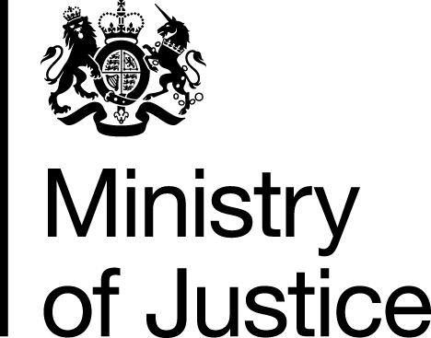 |  |  | www.gov.uk
 | FOI/86003 |  | October 2013

Freedom of Information Request

Following our response to FOI/84918, you asked for the following information from the Ministry of Justice (MoJ):

‘I wondered if it would be possible to get the most recent figure for domestic violence certificates issued. I have the data up until July 2013, so wondered if August & September is available yet?’

Your request has been handled under the Freedom of Information Act 2000 (FOIA).

I can confirm that the department holds information that you have asked for, and I am pleased to provide this to you. The volumes of domestic violence certificates issued in August and September this year were 947 and 912 respectively.

