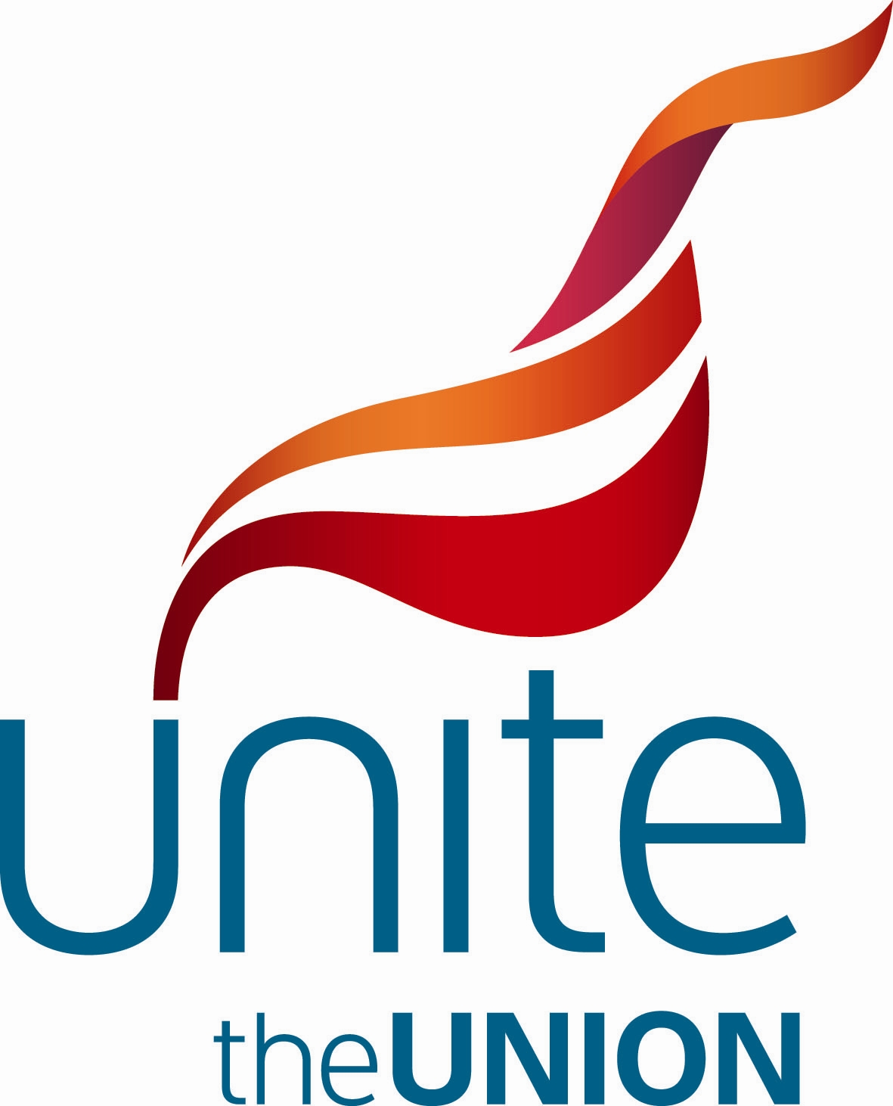

Low Pay Commission Consultation on the NMW
Unite Evidence – September 2012

Summary of the Main Recommendations

- Adult Rate - A rise above projected average earnings in 2013 that brings the adult rate to a minimum of £6.39 and as near to £8.38 as possible in October 2013.

- Development Rate, 16 – 17 Year Olds Rate and Apprentice Minimum Wage Rate - These rates should increase by more than the adult rate in real terms to help close the gap between them and the adult rate.

- Fair Piece Rate - Unite would like to recommend the removal of the fair piece rate option from the hotel sector because it can be argued that hotel room cleaning work does not constitute “output work” under NMW regulation 5 (1999).

- Bogus Self Employment in London Hotels - Unite recommends that the LPC focus on the bogus self employed issue that is becoming increasingly prevalent in employment agencies that are supplying labour to the hotel sector.

- Enforcement for Vulnerable Workers - Unite recommends that the exemption for domestic workers who are said to live as part of the family should be abolished. Unite calls for a clarification in the law that employers may be prosecuted for not paying the NMW whether their workers have legal contracts or not.

- Agricultural Wages Board – Unite would like the LPC to recommend that the Government reverses its decision to abolish the Agricultural Wages Board.

- Compliance and Enforcement - Unite recommends that the Government commits to making real terms increases in current funding for monitoring and enforcement of the NMW.

- Accommodation Offset – Unite would support an increase that does not exceed the rise in the adult national minimum wage.

- Universal Credit - Unite is sceptical that the new universal credit will provide the same level of support for the lowest paid, which means a decent rise in all NMW rates is needed even more.

- Raising of the Personal Tax Allowance - Unite does not believe it would be justified to use the raising of the personal tax allowance as a reason for reducing the rise across the NMW rates.

- Auto Enrolment in Pension Schemes - Unite believes that the employer’s contribution for those minimum wage workers is affordable and should not impact negatively on this year’s rise to the NMW rates.

- Equalities and Disproportionate Impact - Unite is deeply concerned that the impact of cuts, tax credit and benefit changes is falling disproportionately on the incomes of women and disabled people, and the poorest individuals and families, in particular, making the role of the minimum wage even more important.

Introduction

This evidence is submitted by Unite the Union. Unite is the UK’s largest trade union with 1.5 million members across the private and public sectors. The union’s members work in a range of industries including manufacturing, financial services, print, media, construction, transport, local government, food, agriculture, education, health and not for profit sectors.

Unite is pleased to submit evidence to the Low Pay Commission (LPC) on its further review of the National Minimum Wage (NMW). Unite considers the NMW to be one of the most important successes of the former Labour Government. Its introduction and subsequent increases have not had any adverse effects on the labour market, whilst it has benefited millions of low paid workers.

The last rise in the adult rate of 1.8% was welcome. However, the 1.8% increase looks like it will fail to keep pace with inflation, which is forecast by City economists to be 2.4% in October 2012. This difference will see low paid workers’ spending power reduced, which will ultimately have a negative effect on the economy.

Unite would ultimately like the NMW rate to apply as a flat rate from age 16 upwards on a ‘rate for the job’ basis and believes that the LPC needs to be bold in setting a NMW rate for 2012 that will have a significant impact on the working poor and start to tackle income inequality in this country at a time when it is needed more than ever.

The Role of the Low Pay Commission

The LPC has been crucial in successfully co-ordinating the range of views that are shared by the different social partners and has made recommendations that have benefited millions of the most exploited workers. Unite would like to put on record its support for the work that has been done by the LPC and looks forward to being a part of this productive process again.
Level and Impact of the National Minimum Wage

The Economy

Gross Domestic Product (GDP)

Gross Domestic Product (GDP) decreased by 0.5% in the second quarter of 2012, following a decrease of 0.3% in the first quarter of 2012, which means the UK is back in recession.
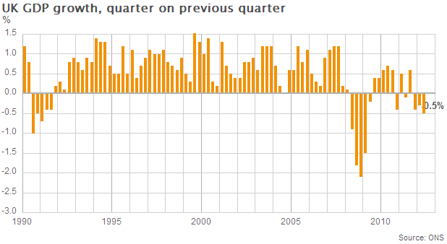
The International Monetary Fund (IMF) has downgraded its forecast for UK growth this year to 0.2%, compared with a previous forecast of 0.8%. The IMF said in its latest World Economic Outlook that GDP across the UK will increase by 1.4% in 2013, a 0.6% cut from its previous 2% forecast.

The Treasury’s independent average forecasts made in the last 3 months for GDP are -0.2% for 2012 and 1.3% in 2013.

Unite understands that all employers will be nervous about the state of the economy given the continuing problems we face in the UK and the Eurozone. However, growth is forecast to return in 2013, so it would be wrong to be overly cautious and risk hitting hardest the lowest paid.
Inflation

In the year to July 2012 the all items retail price index (RPI) rose by 3.2%. Many essentials have been rising at a far higher rate than RPI inflation, which can be seen below.

Food & Drinks Expenditure - Beef up 10.5%, processed fruit up 9.8%, soft drinks up 6.5%, pork up 5.8%, coffee & other hot drinks up 4.0%, processed vegetables up 3.9%, fresh fish up 3.9%.

Travel Expenditure - Fares & other travel costs up 6.8%, bus & coach fares up 5.3%.

Energy Expenditure - Gas up 15.7%, fuel and light up 10.5%, electricity up 8.0%, coal and solid fuels up 4.3%.
Housing, Clothing & Footwear Expenditure - Postage up 23.3%, clothing & footwear 7.4%, household goods up 4.4%.

The Treasury’s independent forecasts for inflation suggest that RPI inflation will remain above CPI inflation and will be around 2.3% in 2013.

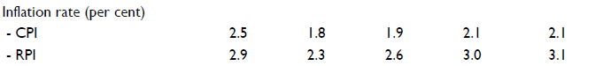

One thing we can be sure of is that it’s the lowest paid who are suffering more than anyone else and they need the LPC to set a NMW rate that will help them during these testing times.

Impact on Employment

Low Paying Sectors Employment

There has been previous concern about the NMW decreasing levels of employment within the UK’s low paying sectors (Retail, Hospitality, Social Work, Cleaning, Textiles, Agriculture, Security and Hairdressing). However, since the introduction of the NMW this has not proven to be the case. In fact, employment in the lower paying sectors within the UK has increased by 995,000 or 15.1%. In the last year employment in the low paying sectors has increased by 211,000 or 2.9%.

Low Paying Sectors | June  1999 | June  2011 | June  2012 | Change Since  June 1999 | Change Since  June 2011
Retail | 2,607,000 | 2,756,000 | 2,856,000 | +249,000 / +9.6% | +100,000 / +3.6%
Hospitality | 1,654,000 | 1,843,000 | 1,962,000 | +308,000 / +18.6% | +119,000 / +6.5%
Social Work  & Residential Care | 1,179,000 | 1,609,000 | 1,571,000 | +392,000 / +33.2% | -38,000 / -2.4%
Cleaning  (Services to buildings) | 528,000 | 630,000 | 638,000 | +110,000 / +20.8% | +8,000 / +1.3%
Textiles | 143,000 | 55,000 | 59,000 | -84,000 / -58.7% | +4,000 / +7.3%
Agriculture | 260,000 | 184,000 | 201,000 | -59,000 / -22.7% | +17,000 / +9.2%
Security | 132,000 | 182,000 | 184,000 | +52,000 / +39.4% | +2,000 / +1.1%
Hairdressing | 79,000 | 107,000 | 106,000 | +27,000 / +34.2% | -1,000 / -0.9%
All low-pay sectors | 6,582,000 | 7,366,000 | 7,577,000 | +995,000 / +15.1% | +211,000 / +2.9%

Unite believes that the evidence continues to show that a NMW in the UK has had a positive effect in the last year on employment levels.

Impact on Profitability

Employers are obviously concerned that the NMW reduces their levels of profit. With this said, Unite believes that it is only right that when a company is making profits, that this success should be shared with their employees, especially at a time, when despite the recent difficulties being experienced, UK corporations are making profits of £79.8 billion in Q1 2012.

Retail Sector

The Deloitte 2012 Global Powers of Retailing ranked 15 UK retailing companies within the top 250 companies in the world, of which Tesco was the highest UK retailer in 3rd place. Tesco made a staggering £3.8bn record profit before tax to the year end February 2012, which was 5.3% higher than the year before. So Unite would not accept that further increases in the NMW are beyond a company of Tesco’s stature, for instance.

Beyond the big companies it is difficult to assess what effect the NMW would have had on the profitability of smaller companies, but we do know that within food retailing in the UK, it is increasingly controlled by a small number of multinational corporations. In the UK we now buy 97.7% of our groceries in supermarkets and 77% from just four supermarket chains – Tesco (30.2%), Asda (17.9%), Sainsburys (16.6%) and Morrisons (12.3%).

So it is obvious that within the food retail market in the UK there has been consolidation by the major supermarkets which now dominate the market. It is this consolidation that is adversely affecting small retailers far more than any additional costs associated with the NMW.

Out of the top 50 employers in the retail sector in the UK, 45 reported a profit in their latest accounts.
Company name | Primary UK SIC (2007) code | Latest accounts date | Latest Operating Revenue (Turnover)  th GBP  Last avail. yr | Profit (Loss) before Tax  th GBP  Last avail. yr | Latest No of Employees  Last avail. yr
TESCO PLC | 47110 | 29/02/2012 | 64,539,000 | 3,835,000 | 406,088
TESCO STORES LIMITED | 47110 | 28/02/2011 | 40,149,000 | 2,243,000 | 261,313
ASDA STORES LIMITED | 47190 | 31/12/2010 | 20,535,000 | 492,000 | 172,548
SAINSBURY'S SUPERMARKETS LTD | 47110 | 31/03/2012 | 22,288,000 | 1,114,000 | 151,300
WM MORRISON SUPERMARKETS P L C | 47110 | 31/01/2012 | 17,663,000 | 947,000 | 131,207
J SAINSBURY PLC | 47110 | 31/03/2012 | 22,294,000 | 799,000 | 101,900
JOHN LEWIS PLC | 47190 | 31/01/2012 | 7,758,600 | 188,100 | 78,700
JOHN LEWIS PARTNERSHIP PLC | 47190 | 31/01/2012 | 7,758,600 | 188,600 | 78,700
MARKS AND SPENCER P.L.C. | 47190 | 31/03/2011 | 9,740,300 | 780,600 | 78,169
SAFEWAY STORES LIMITED | 47110 | 31/01/2011 | 8,877,000 | 473,000 | 64,017
SAFEWAY LIMITED | 47110 | 31/01/2012 | 9,471,000 | 549,000 | 62,702
MARKS AND SPENCER GROUP P.L.C. | 47190 | 31/03/2012 | 9,934,300 | 658,000 | 57,054
WAITROSE LIMITED | 47110 | 31/01/2012 | 5,072,300 | 148,100 | 48,400
NEXT RETAIL LIMITED | 47710 | 31/01/2012 | 3,348,150 | 464,840 | 43,469
DIXONS RETAIL PLC | 47540 | 30/04/2011 | 8,341,800 | -224,100 | 39,733
NEXT PLC | 47190 | 31/01/2012 | 3,441,100 | 579,500 | 32,163
ARGOS LIMITED | 47599 | 28/02/2011 | 4,012,064 | 157,867 | 32,060
B & Q PLC | 47599 | 31/01/2012 | 3,710,400 | 203,300 | 31,184
DEBENHAMS PLC | 47190 | 31/08/2011 | 2,209,800 | 160,300 | 30,624
DEBENHAMS RETAIL PLC | 47710 | 31/08/2011 | 2,027,900 | 214,000 | 27,543
HOME RETAIL GROUP PLC | 47190 | 29/02/2012 | 5,582,800 | 104,100 | 25,816
PRIMARK STORES LIMITED | 47710 | 30/09/2011 | 2,096,422 | 168,062 | 25,575
ICELAND FOODS GROUP LIMITED | 47110 | 31/03/2012 | 2,613,663 | 147,512 | 23,986
ICELAND FOODS LIMITED | 47110 | 31/03/2012 | 2,552,823 | 173,932 | 23,371
WILKINSON HARDWARE STORES,LIMITED | 47520 | 31/01/2011 | 1,559,384 | 60,824 | 23,063
NEW LOOK RETAIL GROUP LIMITED | 47710 | 31/03/2012 | 1,447,500 | -54,500 | 22,605
DSG RETAIL LIMITED | 47540 | 30/04/2011 | 3,858,000 | 18,400 | 22,452
TRAVIS PERKINS PLC | 47789 | 31/12/2011 | 4,779,100 | 269,600 | 21,423
ARCADIA GROUP BRANDS LIMITED | 47710 | 31/08/2011 | 1,543,408 | 166,033 | 20,994
NEW LOOK RETAILERS LIMITED | 47710 | 31/03/2011 | 1,215,251 | 96,474 | 20,081
HOMEBASE LIMITED | 47520 | 28/02/2011 | 1,457,093 | 62,094 | 17,472
LLOYDS PHARMACY LIMITED | 47730 | 31/12/2010 | 1,758,529 | 104,699 | 17,309
WH SMITH PLC | 47620 | 31/08/2011 | 1,273,000 | 93,000 | 16,273
MATALAN RETAIL LTD. | 47710 | 29/02/2012 | 1,117,500 | 9,900 | 15,858
TJX UK | 47710 | 31/01/2011 | 1,264,884 | 92,036 | 15,066
HMV GROUP PLC | 47789 | 30/04/2011 | 1,150,200 | 2,600 | 13,617
BHS LIMITED | 47190 | 31/08/2011 | 740,313 | -76,056 | 12,401
MARTIN MCCOLL RETAIL GROUP LIMITED | 47260 | 30/11/2011 | 804,766 | 4,267 | 12,013
C. & J. CLARK INTERNATIONAL LIMITED | 47721 | 31/01/2011 | 775,200 | 74,900 | 11,396
BOOTS UK LIMITED | 47730 | 31/03/2011 | 6,372,000 | 220,000 | 11,356
RIVER ISLAND CLOTHING CO. LIMITED | 47710 | 31/12/2010 | 720,328 | 110,794 | 10,722
JD SPORTS FASHION PLC | 47640 | 31/01/2012 | 1,059,523 | 67,442 | 10,626
SPORTS DIRECT INTERNATIONAL PLC | 47640 | 30/04/2011 | 1,599,237 | 118,789 | 10,319
THE GAME GROUP PLC | 47789 | 31/01/2011 | 1,625,034 | 23,105 | 10,218
POUNDLAND LIMITED | 47190 | 31/03/2012 | 780,147 | 32,026 | 10,020
LIDL LIMITED | 47110 | 28/02/2011 | 183,179 | 24 | 9,859
ALLDAYS PLC | 47290 | 31/10/2001 | 524,882 | -7,323 | 9,630
COMET GROUP LIMITED | 47540 | 30/04/2011 | 1,478,201 | -39,555 | 9,010
B & M RETAIL LIMITED | 47190 | 31/12/2011 | 712,572 | 51,702 | 8,864
PSTORES REALISATIONS LIMITED | 47710 | 31/03/2010 | 526,653 | 39,358 | 8,638

Hospitality Sector

According to the latest HotStats Hotel Confidence Monitor by TRI Hospitality Consulting levels of optimism for Q3 2012 have dropped compared to Q2 2012 with 70.8% of general managers in London and 54.1% of provincial general managers less optimistic than they were three months ago.

In London, 41.7% of general managers are expecting a year-on-year increase in room occupancy in Q3 2012, with the increase in demand positively affecting average room rate and RevPAR performance, with 79.4% and 79.1% of general managers expecting an increase or no change in Q3 2012, respectively.

However, in the provinces, expectations are lower with a year-on-year increase or no change expected in Q3 2012 for average room rate (61.9%) and RevPAR (48%).

This quarter’s gross operating profit (IBFC) expectations are higher in London than in the provinces, with 58.3% of general managers in London expecting an increase. In contrast, 57.7% of provincial general managers are expecting a decrease in profit.
As for the restaurant part of the hospitality sector, the UK eating-out market is expected to be worth £52bn in 2012, a rise of 3% from last year according to Allegra's Strategies report ‘Eating Out in the UK, 2012’.

According to Allegra's report, the informal eating out market is being driven by consumers dining out more frequently as well as continued expansion and price inflation. Long-term growth prospects remain positive with increased spend, supported by a drop in inflation, forecasting the sector to grow to £65bn by 2017 at a compound annual growth rate (CGAR) of 4.9%.

Out of the top 50 employers in the hospitality sector in the UK, 33 reported a profit. Although this is not as impressive as the retail sector’s performance, it is clear that the majority of the top 50 hospitality employers in the UK are profitable.
Company name | Primary UK SIC (2007) code | Latest accounts date | Latest Operating Revenue (Turnover)  th GBP  Last avail. yr | Profit (Loss) before Tax  th GBP  Last avail. yr | Latest No of Employees  Last avail. yr
COMPASS CONTRACT SERVICES (U.K.) LIMITED | 56210 | 30/09/2011 | 1,685,210 | -14,155 | 52,230
MITCHELLS & BUTLERS PLC | 56302 | 30/09/2011 | 1,796,000 | 132,000 | 40,728
MCDONALD'S RESTAURANTS LIMITED | 56102 | 31/12/2010 | 1,184,462 | 157,211 | 39,296
MITCHELLS & BUTLERS RETAIL LIMITED | 56302 | 30/09/2011 | 1,533,000 | 75,000 | 34,007
SSP GROUP LIMITED | 56103 | 30/09/2011 | 1,721,000 | -42,200 | 29,551
WHITBREAD GROUP PLC | 55100 | 28/02/2011 | 1,599,600 | 268,300 | 27,923
ISS FACILITY SERVICES LIMITED | 56102 | 31/12/2010 | 522,052 | 22,991 | 26,964
GREENE KING PLC | 56302 | 30/04/2011 | 1,042,700 | 116,800 | 20,218
SPIRIT PUB COMPANY PLC | 56302 | 31/08/2011 | 734,400 | -206,600 | 16,929
ISS MEDICLEAN LIMITED | 56290 | 31/12/2010 | 310,689 | 18,191 | 13,911
PIZZA HUT (U.K.) LIMITED | 56101 | 30/11/2011 | 330,959 | -24,178 | 13,670
J D WETHERSPOON PLC | 56302 | 31/07/2011 | 1,072,014 | 61,392 | 13,011
MARSTON'S PLC | 56302 | 30/09/2011 | 682,200 | 80,800 | 12,733
BOURNE LEISURE HOLDINGS LIMITED | 55300 | 31/12/2010 | 802,730 | 93,414 | 11,126
ARAMARK LIMITED | 56290 | 30/09/2011 | 341,447 | 16,502 | 10,983
GREENE KING RETAILING LIMITED | 56302 | 30/04/2011 | 563,000 | -33,000 | 10,979
MILLENNIUM & COPTHORNE HOTELS PLC | 55100 | 31/12/2011 | 820,500 | 193,300 | 10,912
THE RESTAURANT GROUP PLC | 56302 | 31/12/2011 | 487,114 | 48,608 | 10,572
WESTBURY STREET LIMITED | 56290 | 31/12/2011 | 406,141 | 6,509 | 9,638
SELECT SERVICE PARTNER UK LIMITED | 56103 | 30/09/2011 | 548,082 | 4,769 | 9,482
MARRIOTT HOTELS LIMITED | 55100 | 31/12/2011 | 171,688 | 1,176 | 9,367
PIZZAEXPRESS (RESTAURANTS) LIMITED | 56101 | 30/06/2011 | 322,490 | 58,641 | 8,854
STARBUCKS COFFEE COMPANY (UK) LIMITED | 56101 | 30/09/2011 | 397,716 | -32,854 | 8,763
INTERCONTINENTAL HOTELS GROUP PLC | 55100 | 31/12/2011 | 1,138,000 | 342,000 | 7,956
THE RESTAURANT GROUP (UK) LIMITED | 56101 | 31/12/2010 | 356,167 | 49,629 | 7,624
NANDO'S CHICKENLAND LIMITED | 56101 | 28/02/2011 | 317,356 | 31,496 | 7,351
TRAGUS GROUP LIMITED | 56101 | 31/05/2011 | 277,428 | -14,351 | 7,127
TRAGUS BIDCO LIMITED | 56101 | 31/05/2011 | 277,428 | -3,159 | 7,126
ELIOR UK PLC | 56210 | 30/09/2011 | 195,645 | 3,204 | 6,775
KENTUCKY FRIED CHICKEN (GREAT BRITAIN) LIMITED | 56101 | 30/11/2010 | 371,215 | 38,389 | 6,753
BAXTERSTOREY LIMITED | 56290 | 31/12/2011 | 252,031 | 17,222 | 5,456
ASK RESTAURANTS LIMITED | 56101 | 30/06/2011 | 193,348 | 16,997 | 4,981
LRG HOLDINGS LIMITED | 55100 | 31/12/2010 | 319,234 | 2,065 | 4,297
MACDONALD HOTELS LIMITED | 55100 | 31/03/2011 | 196,643 | -5,264 | 4,107
THE LAUREL PUB COMPANY LIMITED | 56101 | 28/02/2007 | 186,821 | -12,610 | 4,049
INITIAL CATERING SERVICES LIMITED | 56210 | 31/12/2010 | 68,453 | 3,620 | 4,034
DE VERE VILLAGE TRADING NO 1 LIMITED | 55100 | 31/12/2010 | 146,066 | 117,150 | 3,973
ORCHID PUBS & DINING LIMITED | 56101 | 31/12/2010 | 128,677 | -12,306 | 3,863
MITCHELLS & BUTLERS RETAIL (NO 2) LIMITED | 56302 | 30/09/2011 | 181,842 | 74,609 | 3,839
BUTLINS SKYLINE LIMITED | 55300 | 31/12/2010 | 184,599 | 17,184 | 3,574
BARRACUDA PUB GROUP LIMITED | 56302 | 30/09/2010 | 153,553 | -18,611 | 3,533
ARAMARK IRELAND HOLDINGS LIMITED | 56210 | 30/09/2010 | 159,852 | 1,792 | 3,526
ENDELL GROUP HOLDINGS LIMITED | 55100 | 31/12/2010 | 335,100 | -102,400 | 3,445
TRAVELODGE HOTELS LIMITED | 55100 | 31/12/2010 | 331,700 | 14,600 | 3,395
LINDLEY CATERING HOLDINGS LIMITED | 56210 | 31/05/2011 | 44,505 | -1,460 | 3,245
JARVIS HOTELS LTD. | 55100 | 31/03/2010 | 119,135 | -15,635 | 3,198
KAYTERM LIMITED | 55100 | 31/03/2010 | 119,135 | -23,791 | 3,198
TOWN AND CITY PUB GROUP LIMITED | 56302 | 30/09/2011 | 92,546 | -4,261 | 3,151
DPGS LIMITED | 56101 | 31/03/2011 | 37,180 | 14 | 3,136
NERO HOLDINGS LIMITED | 56102 | 31/05/2011 | 158,042 | 16,803 | 3,015

Closing the Gender, Ethnic Minorities and Workers with Disabilities Pay Gap

Unite is pleased that the LPC has been asked to report on the effect that the NMW has had on gender, ethnic minorities and workers with disabilities.

Gender

The NMW has become a vital tool in trying to reduce the gender pay gap due to the high concentration of women in low paid jobs and particularly those women in part time jobs. Over the lifetime of the NMW the gender pay gap has been reduced from 16.4% in 1999 to 9.2% in 2011. This cannot all be attributed to the NMW, but there is no doubt that the NMW has been a positive influence in helping to close the gender pay gap.

Hourly earnings excluding overtime

Year | Men | Women | Pay Gap
1999 | 9.07 | 7.58 | 16.4%
2011 | 13.11 | 11.91 | 9.2%
Source: ONS - Annual Survey of Hours and Earnings

Despite the significant potential impact of the NMW on the gender pay gap, the reality is that we are years away from a position of parity between the genders.

Therefore Unite believes that a rise in the NMW will have a beneficial impact in addressing the gender pay gap.

Ethnic Minorities

Bangladeshis and Pakistanis have the highest likelihood of low pay. Almost half of all Bangladeshi and Pakistani employees earn less than £7 per hour. This is a much higher proportion than that for any other ethnic group.
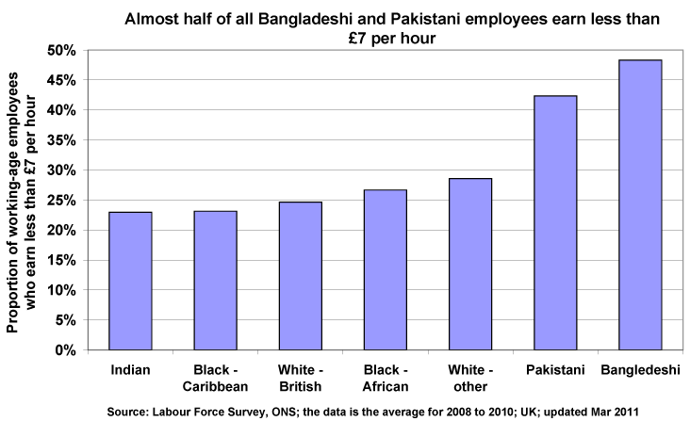
The end result of all this is that some minority ethnic groups still have equivalent incomes that are well below those of the rest of the population. Those from Bangladeshi and Pakistani households have a median equivalent income of only £238 per week, compared to the national median of £404. Nearly half are below the official poverty line.

So clearly the NMW has a key role to play in tackling social exclusion with a high proportion of ethnic minority workers in the low paying sectors of the economy.

Therefore Unite believes that a rise in the NMW would help in trying to tackle the ethnic pay gap.

Workers with Disabilities

Although the employment-rate gap between disabled and non-disabled people has decreased from around 36.2% in 2002 to around 28.7% in 2011, disabled people remain far less likely to be in employment. In 2011, the employment rate of disabled people was 48.8%, compared with 77.5% of non-disabled people.
This situation is not helped when the Government is currently in the process of closing half of Remploy’s 54 factories, which provides employment opportunities for disabled people.

The Government claims that Remploy costs the taxpayer £25,000 a year per person, but trade unions say the figure is more like £7,000 when profits and training placements are taken out. In contrast, a disabled person on full-time benefits costs around £19,000 a year.

Unfortunately the NMW alone cannot provide more employment opportunities for disabled people but a decent increase will help the thousands of disabled workers who are in employment.

Setting a Bold Target for the Adult Rate

Recent studies on minimum pay levels including from the Mayor of London’s office with the ‘London Living Wage’ and from the Joseph Rowntree Foundation have added evidence to the need for bolder minimum wage rates to be set.

The ‘London Living Wage’, is an independently calculated (GLA Economics) minimum income that determines an “adequate level of warmth and shelter, a healthy palatable diet, social integration and avoidance of chronic stress for earners and their dependents.” This equates to £8.30 per hour, which will be £2.11 per hour or 34.1% above the NMW rate for adults of £6.19 as of the 1st of October 2012. In addition the new London Living Wage rates for 2012 will be announced in November.

London mayor Boris Johnson has insisted that employers in the capital would not be putting jobs or the economy at risk by increasing low earners salaries. Johnson said: “Paying the London Living Wage is not only morally right - with the potential to massively reduce child poverty in London - but also it makes good business sense. What may appear to a company to be an unaffordable cost in a highly competitive market is more appropriately viewed as a sound investment decision. I believe that paying decent wages reduces staff turnover and produces a more motivated and productive workforce. As in previous years, this report takes a systematic approach to identifying what is a Living Wage in London. It shows how a wage earner paid less than about £7.25 an hour will be living in poverty, even after benefits and tax credits are taken into account. This means that in London an hourly wage rate of 22 per cent above the National Minimum Wage (NMW) rate of £5.93 is necessary just to take the wage earner above the poverty level.

However, this provides no margin to meet the kind of day-to-day challenges which those of us who are better off can take in our stride. As before, a margin of 15 per cent has therefore been added to the poverty threshold wage. The result is a London Living Wage of £8.30 per hour - an increase of 5.7 per cent on last year's figure and a 24 per cent increase in the six years since its introduction (at £6.70).”

A report from the influential Joseph Rowntree Foundation offers one of the most meaningful reports on poverty and income for some time. “A minimum income standard for the UK in 2012” discovered that according to members of the public, a single person in the UK today needs to earn £8.38 an hour to afford a basic but acceptable standard of living. £8.38 per hour, is £2.19 per hour or 35.4% above the £6.19 NMW as of the 1st of October 2012.

Unite’s policy for the NMW is a living wage.

To this end Unite asks the LPC recommends a rise above the Office for Budget Responsibility’s forecast for average earnings in 2013 of 3.1% that brings the adult rate to a minimum of £6.39 and as near to £8.38 as possible in October 2013.

Young People, Apprentices and Interns

Young People in the Labour Market

Clearly the current labour market statistics do not make comfortable reading. The unemployment rate for 16 to 24 year olds was 21.5% in the three months to June 2012, down 0.3% from the three months to March 2012.

There were 1.01 million unemployed 16 to 24 year olds in the three months to June 2012, down 4,000 from the three months to March 2012. The number of unemployed 16 to 17 year olds decreased by 3,000 on the quarter to reach 203,000 and the number of unemployed 18 to 24 year olds decreased by 1,000 on the quarter to reach 809,000.

Excluding people in full-time education, there were 723,000 unemployed 16 to 24 year olds in the three months to June 2012, up 15,000 from the three months to March 2012. The unemployment rate for 16 to 24 year olds not in full-time education was 20.3% of the economically active population, up 0.1% from the three months to March 2012.

However, despite these poor labour market statistics for young people, Unite does not think there is any evidence that the NMW has had a negative impact on youth employment. Unite believes the fall in youth employment over the period of the NMW is in large part due to more young people staying on in full-time education, rather than the NMW and the slow growth and now double dip recession, which has not helped to improve young peoples employment opportunities.

Young People and Pay

Unite’s young members tell us that pay is the number one determining factor in why they choose to initially go for or stay in a job. Unite would ultimately like the NMW to apply as a flat rate from age 16 upwards on a ‘rate for the job basis.’ Unite believes that the principle of equal remuneration for work of equal value is an important one.
Previous research by the Employer’s Forum on Age (EFA) has attempted to address some of the common objections and showed that equalising the development NMW rate with the adult NMW rate would not have detrimental effects. Some of the EFA’s members including Mark’s and Spencer’s and B&Q removed their age bands a number of years ago.

Unite believes that a removal of the development rate would have minimal negative impacts on employment for 18 to 20 year olds and that any positive impacts would more than offset any negative impacts.

Where Unite is organised, part of our bargaining strategy is for the abolition of youth rates where they apply. In those areas where Unite has abolished youth rates by negotiation there is no evidence that this has led to a decrease in young people employed. This is largely because many companies are prepared to abolish youth rates in recognition that doing so aids recruitment, retention, motivation and productivity.

Unite believes that the UK should move towards a position where workers are not discriminated against on the basis of age, but are paid the rate for the job.

Apprentice Rate of the National Minimum Wage

Unite is pleased to see the exemption that stops apprentices from receiving the NMW has been removed. By bringing apprentices under the scope of NMW legislation, hopefully by being under the NMW enforcement regime, it will go some way to exposing and ultimately stopping the exploitation that has seen some apprentices being paid as little as £1.54 an hour. It was clear that some employers were using the exemption as a loop hole to pay low wages, which impacts adversely on take up and completions and at the same time was reinforcing the gender pay gap, with low pay particularly affecting female apprentices.

Unite believes that apprentices should be paid at least the National Minimum Wage for their work as this is the national baseline wage for all workers in the UK regardless of their skill level, age or legal status, below which no worker should fall.

In terms of the impact of the introduction of the Apprentice rate of the National Minimum Wage on the provision, take-up, and completion of apprenticeship opportunities.

Unite is pleased to see the total volume of Apprenticeship framework achievements in 2010/11 was 200,300. This was an increase of 16.8% compared to 2009/10. Of these there were:

- 131,700 Intermediate Level Apprenticeship framework achievements, a 17.8% increase on 2009/10;
- 67,500 Advanced Level Apprenticeship framework achievements, a 13.6% increase on 2009/10;
- 1,000 Higher Apprenticeship framework achievements, up from 200 in 2009/10;
- Learners aged under 19 achieved 83,300 Apprenticeship frameworks, a 14.1% increase on 2009/10;
- Learners aged 19–24 achieved 77,000 Apprenticeship frameworks, a 20% increase on 2009/10;
- Learners aged 25 and over achieved 39,900 Apprenticeship frameworks, a 16.6% increase on 2009/10.

Unite hopes that these are genuine apprenticeships which contain proper training programs.

Unite does not believe it would be accurate to attribute the dramatic increase in apprenticeships down to the new apprentice rate of the National Minimum Wage but clearly it could have had a positive affect.

However, many employers pay apprentices more then the Apprentice rate of the National Minimum Wage anyway. Unite members in construction, local authorities, graphical trades, manufacturing and engineering receive minimum rates of pay that are above the NMW for their age from day one.

One example from the construction industry can be seen below:-
Agreement | Details | Minimum | Maximum | Progression | Hours
Plumbing (England & Wales) JIB | Apprentice | £5.61 ph | £11.20 ph | 1st year of training £5.61 ph  2nd year £6.43 ph  3rd year £7.26 ph  3rd year with NVQ Level 2 £8.83 ph  4th year £8.94 ph  4th year with NVQ Level 2 £10.15 ph  4th year with NVQ Level 3 £11.20 ph | 37.5
Source: Labour Research Department

In general Unite believes that the Development Rate, 16 – 17 Year Olds Rate and Apprentice Minimum Wage Rate should increase by more then the Adult Rate in real terms, to help close the gap between them and the Adult Rate.

Simplification of National Minimum Wage Regulations

Fair Piece Rates

Unite has highlighted examples of agencies who are abusing the fair piece rate by underpaying the NMW in the hotel industry to the LPC before. Unite unfortunately has to report that the situation has not improved in the past year, based on our experiences.

Clearly the hotel industry has been trying to avoid their financial responsibility by employing agencies and contract cleaning companies for room cleaning services, which were previously directly employed. The hotel industry must not simply be allowed to transfer the blame to agencies and contract cleaning companies.

Many of the piece rates for cleaning rooms in the hotel industry have been set at unattainable levels, which make it impossible for workers to achieve the NMW. One way to stop this would be to remove the fair piece rate option from the hotel sector because it can be argued that hotel room cleaning work does not constitute “output work” under NMW regulation 5 (1999).

Therefore Unite would like to recommend the removal of the fair piece rate option from the hotel sector because it can be argued that hotel room cleaning work does not constitute “output work” under NMW regulation 5 (1999).

Bogus Self Employment in London Hotels

The situation in London Hotels and the employment standards in force have been described by union leaders as “the race to the bottom”. This situation has been fed by widespread out-sourcing to employment agencies. This means that every time a client hotel puts up for renewal an out-sourcing contract puts wages and terms and conditions under pressure. The possibility of reputational damage to brands and hotels is minimised by the ability of client hotels to "blame the agency" if breaches of employment law like underpayment of the NMW or irregular workers are found working in hotels.
The Central London Hotel Workers branch of Unite, are now seeing evidence of bogus self employments rise across the industry. A typical situation would be as follows:

- agency recruits migrant workers either legally or via student visa or via precarious workers;
- worker would be given one or two weeks training as an employee;
- the worker would then be told how to become “self employed” and would carry on working but with a different status;
- students would be rotated so the 20 hours per week limit would not be breached;
- problems with the client would be met by the worker being moved to a different employer;
- with no employment rights, no complaints will be made about underpayment of the NWM for instance.

Unite recommends that the LPC focus on the bogus self employed issue that is becoming increasingly prevalent in employment agencies that are supplying labour to the hotel sector.

Enforcement for Vulnerable Workers

The ‘Domestic Workers Visa’ prevents domestic workers from changing employer. As most domestic workers only ever challenge NMW abuses at the point they leave their employer to work for someone else. The implications of this are that the NMW would not really be enforceable in private households, which leaves domestic workers with poverty pay.

Unite does not believe that any worker should be exempt from basic employment rights. Unite believes that employers should face penalties for paying below the NMW whether their workers are documented or not. Unite’s experience is of employers capitalising on the fear and insecurity of these workers and often only becoming interested in their status if a worker complains.

The maintenance of the NMW is dependent on all workers, irrespective of their employment status, to be paid no less than the NMW level. The current position encourages employers to recruit migrant workers (documented or otherwise) precisely because they are able to get away with paying significantly less than the NMW. This has had a downward (deflationary) pressure on the wages of indigenous workers at the lower end of earnings in the economy. This is clearly an unintended gap in the enforcement of the NMW and employment rights per se.

It is unacceptable that an employer who commercially benefits from paying low wages to an undocumented worker on the basis of illegality of contract, can escape subsequent penalties based on the same illegal contract to which they were (as employers) party. Clearly, undocumented workers will not make a complaint if they believe that the involvement of the authorities may lead to their detention and deportation, so enforcement in this case cannot rely on individual complaints by workers.

In practice, this means that each case is being treated separately and each individual is being required to prove they are covered by the NMW before their particular circumstances can be looked at, which is time consuming and creating additional barriers to these workers receiving the NMW they are entitled to. As a minimum Unite would like to see a situation whereby a trade union can make a representative action on behalf of a group of workers to an employment tribunal and that in such instances HMRC enforcement officers should have access to such workers if they are detained.

Unite recommends that the exemption for domestic workers who are said to live as part of the family should be abolished. Unite calls for a clarification in the law that employers may be prosecuted for not paying the NMW whether their workers have legal contracts or not.

Abolition of the Agricultural Wages Board (AWB)

Opponents of the AWB argue that the legislation is unnecessary now that there is a NMW. This entirely misses the point of the AWB. Whilst it is true that Grade 1 rates are 4p an hour more than the NMW (from 1st October 2012), only 20% of workers covered by the AWB are on the Grade 1 £6.23. 80% of the 154,000 workers covered directly by the AWB are on Grades 2-6 at rates from £6.52 an hour to £8.81 an hour.

Opponents of the AWB also conveniently forget that the Agricultural Wages Order also covers grading arrangements; skills and qualifications; overtime; training costs; apprenticeships; allowances and grants; holidays and other leave; sick pay and much more besides. Most significantly, the Agricultural Wages Act also regulates the provision of tied housing, which 30% of farm workers live in, protecting workers from punitive rent rises and eviction from their homes. All this protection would be lost with abolition.

The call for abolition has been driven by the NFU, and we believe that this is down to their horticultural industry members. This part of agriculture is under pressure from the supermarkets to supply fruit and vegetables at ever tighter margins, and the industry is seeking to cut their costs at the expense of workers. Unite has asked the NFU how wage rates would be set for grades 2-6 if abolition goes ahead, and how the industry would attract the 60,000 new entrants over the next ten years which Lantra, the Sector Skills Council for agriculture, says are necessary just to stand still. There has been no response from the NFU and it is clear that they have given no thought to how wages would be negotiated or set post-abolition.

We have argued that industrial action would be inevitable as the union fought to maintain and improve pay and conditions. For the first time since 1923 agricultural strikes are a real possibility.

Therefore Unite would like the LPC to recommend that the Government reverses its decision to abolish the Agricultural Wages Board.

Compliance and Enforcement

Unite would firstly like to congratulate HM Revenue & Customs (HMRC) enforcement team. Since the NMW introduction in 1999 more than £42 million in NMW arrears for over 163,000 workers has been identified. In 2010/11, HMRC issued 1,126 notices of underpayment and identified just over £3.8m in arrears owed to almost 23,000 workers (an increase of 4,000 on the previous year).

Unite believes that this success clearly warrants increased funding for NMW enforcement, especially when you consider that in the coming year there could be an extra 100,000 new apprentices and potentially 100,000 plus agricultural workers, if the abolition of the Agricultural Wages Boardgoes ahead.

Therefore Unite recommends that the Government commits to making real terms increases in current funding for monitoring and enforcement of the NMW.

Accommodation Offset

In principle Unite is opposed to charges for accommodation being deducted from the NMW. Having workers accommodated on site is to the employers’ benefit and therefore the employer should be fully responsible for the cost.

However, Unite is aware that ill-thought through deregulation without effective enforcement guidelines could lead to further exploitation. Therefore, Unite believes that the Low Pay Commission (LPC) should continue to keep the accommodation offset under serious review.

In its original recommendation (June 1998) the Low Pay Commission (LPC) recommended that accommodation should be the only benefit in kind to count towards the national minimum wage. This recommendation was designed to be a protective measure. By recommending an accommodation offset, the LPC intended to discourage employers from recouping the National Minimum Wage paid to a worker by levying excessive accommodation charges. When recommending the level for the accommodation offset, the Low Pay Commission did not seek to reflect the actual cost to the employer or the actual value of renting accommodation for the worker. Allowing a market rate would not have recognised the advantages to the employer of providing accommodation.

In recent years the accommodation offset has risen in line with increases in the adult national minimum wage. Unite would support an increase that does not exceed the rise in the adult national minimum wage.

Other Factors Influencing the NMW

Universal Credit

According to the Child Poverty Action Group the following benefits will be abolished and replaced by universal credit:

• income support;
• income-based jobseeker’s allowance;
• income-related employment and support allowance;
• housing benefit;
• child tax credit and working tax credit;
• budgeting loans and crisis loan alignment payments – to be replaced by payments on account (an advance of universal credit) in cases of need.

Council tax benefit, crisis loans for other needs and community care grants are also being abolished – responsibility for an equivalent will be passed to local authorities or devolved governments. Disability living allowance for adults of working age is being abolished and replaced by personal independence payment (PIP) – see separate factsheet.

Unite is sceptical that the new universal credit will provide the same level of support for the lowest paid, which means a decent rise in all NMW rates is needed even more.

Raising of the Personal Tax Allowance

According to research by Institute for Fiscal Studies, raising the personal tax allowance to £10,000 by 2015-16 is unlikely to benefit many of the lowest paid workers because one third of all adults earn too little to pay any income tax.
Distributional impact of increasing personal allowance to £10,000, by income decile group
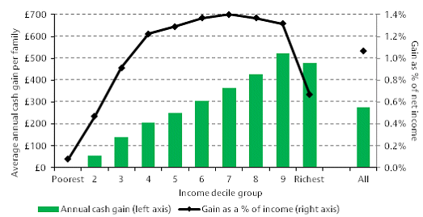
Even as a percentage of their income, it is higher earners who benefit most.

Unite do not believe it would be justified to use the raising of the personal tax allowance as a reason for reducing the rise across the NMW rates.

Auto Enrolment in Pension Schemes

Unite welcomes the introduction of statutory auto enrolment in pension schemes, although believes the 1% statutory employer contribution should have been set higher.

Unite believes that due to the lowest paid workers greater need to spend and the low statutory employer contribution that many low paid workers will choose to opt-out. In addition, many low paid workers on 3 month contracts will miss out due to the 3 month qualifying period.

For those minimum wage workers who qualify and do not opt out and work a 35 hour week they can expect a 1% employer contribution of around £113 per year, which is £2.17 a week, or 43p for each working day.

Unite believes that the employer’s contribution for those minimum wage workers is affordable and should not impact negatively on this years rise to the NMW rates.

Equalities and Disproportionate Impact

Unite is deeply concerned that the impact of cuts, tax credit and benefit changes is falling disproportionately on the incomes of women and disabled people, and the poorest individuals and families, in particular, making the role of the minimum wage even more important.

Diana Holland 17th September 2012
Assistant General Secretary
Unite the Union

For clarifications and more information please contact:
John Neal
Researcher
Unite the Union
128 Theobald's Road, Holborn, London, WC1X 8TN
Tel: +44 (0)207 611 2633
Fax: +44 (0)207 611 2746
Email: John.Neal@unitetheunion.org
Internet: www.unitetheunion.org.uk

IDS Pay Report 1102, August 2012 - Page 14.
www.ons.gov.uk/ons/dcp171778_271962.pdf
www.guardian.co.uk/business/2012/jul/16/imf-slashes-uk-economic-growth-forecast
www.hm-treasury.gov.uk/d/201208forcomp.pdf
www.ons.gov.uk/ons/dcp171778_275060.pdf
www.ons.gov.uk/ons/publications/re-reference-tables.html?edition=tcm%3A77-223807
www.hm-treasury.gov.uk/d/201208forcomp.pdf
JOBS03: Employee jobs by industry (last updated September 2012) (Excel sheet 1056Kb)
www.ons.gov.uk/ons/dcp171778_268511.pdf
www.deloitte.com/assets/DcomGlobal/Local%20Assets/Documents/Consumer%20Business/dtt_CBT_GPRetailing2012.pdf
FAME
Kantar Worldpanel
FAME
HotStats Confidence Monitor Q3 2012
www.caterersearch.com/Articles/10/08/2012/344928/UK-informal-eating-out-market-to-reach-16352b-this.htm
FAME
ONS – Annual Survey of Hours and Earnings
www.poverty.org.uk/55/index.shtml
http://sticerd.lse.ac.uk/dps/case/cr/CASEreport60_summary.pdf
www.poverty.org.uk/55/index.shtml
www.london.gov.uk/sites/default/files/living-wage-2011.pdf
www.livingwage.org.uk/blog/2012-london-living-wage-announcement-november
www.london.gov.uk/sites/default/files/living-wage-2011.pdf
www.jrf.org.uk/sites/files/jrf/minimum-income-standards-2012-full.pdf
//budgetresponsibility.independent.gov.uk/wordpress/docs/March-2012-EFO1.pdf
wwww.ons.gov.uk/ons/dcp171778_273802.pdf
Employers Forum on Age – ‘Equalising the NMW.’ Page 1-4, 2008.
www.tuc.org.uk/extras/apprenticepay.pdf
www.thedataservice.org.uk
www.bis.gov.uk/assets/biscore/employment-matters/docs/n/11-280-national-minimum-wage-annual-report-2011.pdf
www.cpag.org.uk/sites/default/files/CPAG_universalcredit_factsheet_July12.pdf
www.ifs.org.uk/publications/6045

