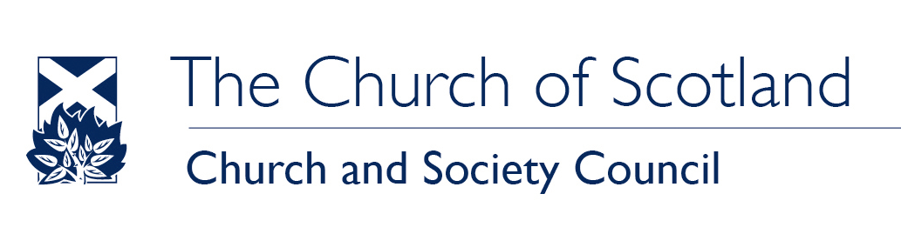

Official Response

SUBJECT: Consultation on the National Minimum Wage

REQUESTED BY: Low Pay Commission

REFERENCE: OR-2012/14

DATE: 13 September 2012

SUBMITTED BY: Chloe Clemmons, Scottish Churches Parliamentary Officer, chloe@actsparl.org

The Church of Scotland is a member of the Scottish Living Wage Campaign. We are committed to justice and the eradication of poverty in every community in Scotland. We believe that raising the level of the National Minimum Wage towards the level of the Living Wage would be a significant step towards this goal and urge you to put forward proposals to this effect in your report.
We believe that there is a responsibility on employers as well as the State to ensure that people in employment are not also in poverty. The Church of Scotland has therefore instructed all Church of Scotland agencies and congregations to implement the Living Wage with all possible speed and in all cases by 2015 or have a plan in place by then with an agreed deadline. The Church has further urged congregations to make payment of the Living Wage a criterion in awarding goods and services over the value of £100,000 in any year.

We would be pleased to provide further information on our work.

For further information on the Campaign see: http://povertyalliance.org.uk/slw-home.asp
For further information on what the Church of Scotland agreed see the Church and Society Council Report to the General Assembly: http://www.churchofscotland.org.uk/__data/assets/pdf_file/0009/9648/03_CHURC.pdf

