


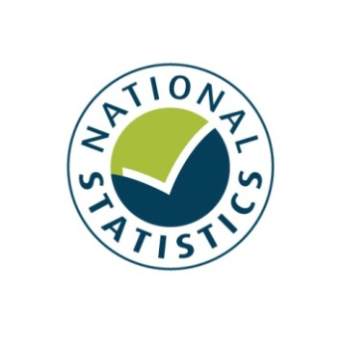


Taking Part 2013/14 Quarter 1
Statistical Release
September 2013

Taking Part is a National Statistic and has been produced to the standards set out in the Code of Practice for Official Statistics

The United Kingdom Statistics Authority has designated these statistics as National Statistics, in accordance with the Statistics and Registration Service Act 2007 and signifying compliance with the Code of Practice for Official Statistics.
Designation can be broadly interpreted to mean that the statistics:
• meet identified user needs;
• are well explained and readily accessible;
• are produced according to sound methods; and
• are managed impartially and objectively in the public interest.

Once statistics have been designated as National Statistics it is a statutory requirement that the Code of Practice shall continue to be observed. See the UK Statistical Authority assessment

Contents

Key findings 4
Introduction 8
Chapter 1: The 2012 Olympic and Paralympic Games 10
Chapter 2: Heritage 16
Chapter 3: Museums and galleries 20
Chapter 4: Libraries 24
Chapter 5: Arts 27
Chapter 6: Archives 31
Chapter 7: Volunteering and charitable giving 33
Chapter 8: Equalities 38
Annex A: Background note 42
Annex B: Key terms and definitions 45
Annex C: Sector definitions 47

Key findings

Taking Part is a household survey in England. It looks at participation in the cultural sectors. This report presents the latest headline estimates for the year July 2012 to June 2013. The survey has run for eight years and is used widely by policy officials, academics and charities to measure participation in the cultural sectors. Please note the time period reported in this release now includes the period when the UK hosted the 2012 Olympic and Paralympic Games, which might have had an effect on participation in some sectors.

2012 Olympic and Paralympic Games

    - Over the year, July 2012 – June 2013, 22 per cent of respondents who had taken part in sport or recreational activity answered that the UK winning the bid to host the 2012 Olympics had motivated them to do more of these activities, an increase from 8 per cent in 2005/06. Most of this increase has been since 2011/12.

    - 8 per cent of respondents who had taken part in cultural activities felt that the UK winning the bid to host the 2012 Olympics had motivated them to take part in more cultural activities. 10 per cent of those who had volunteered felt it motivated them to do more voluntary work.

    - 92 per cent of adults intended to follow or followed the London 2012 Olympic or Paralympic Games, for example by watching on television at home.

    - 19 per cent of adults got actively involved, or intended to get actively involved¹ in the Games. For example, by attending a ticketed Olympic or Paralympic event.

    - Over three quarters (78%) of adults were slightly or strongly supportive of the UK hosting the 2012 Olympic and Paralympic Games. Attitudes have fluctuated since 2005/06 (71% slightly or strongly supportive), with a low in 2007/08 of 60 per cent. Increases in overall support since 2011/12 have been driven by a substantial increase in those strongly supportive of the Games.

Culture

- Nearly three quarters (72%) of adults visited a heritage site in the last year. This represents a significant increase of 3 percentage points since the survey began in 2005/06 but a significant decrease since 2011/12 (74%).

- Over July 2012 – June 2013, the majority of adults (53%) had visited a museum or gallery in the last year. This was higher than in any survey year between 2005/06 and 2011/12.

- The proportion of adults who had visited a museum or gallery in the 12 months prior to being interviewed has significantly increased since 2005/06 (from 42% to 53%). This has been an upward trend since 2008/09.

- 36 per cent of adults had used a library in the 12 months prior to being interviewed, a significant decrease from 48 per cent in 2005/06 and 39 per cent in 2011/12.

- 78 per cent of adults had attended or participated in the arts in the previous year, a significant increase since 2005/06 (76%) and 2010/11 (76%). In June 2012 – July 2013, art engagement was at a similar rate to 2011/12 (78%) but higher than any other previous survey year from 2005/06 onwards. The upward trend has only been present recently, prior to 2011/12 art engagement had been fairly stable.

Volunteering and charitable giving

- The proportion of adults who had volunteered in the last 12 months was 25 per cent, a small but significant increase from 24 per cent in 2005/06. 9 per cent of all adults had volunteered in a DCMS sector (Arts, Museums or Galleries, Heritage, Libraries, Archives, Sport). This was a significant increase from 7 per cent in 2005/06 and 2011/12.

- There has been a significant increase in the proportion of adults aged 16-24 years (up from 25% to 31%) and women (25% to 28%) who had volunteered in the last 12 months compared to 2005/06.

- 16 per cent of 16-24 year olds said the UK hosting the 2012 Olympic and Paralympic Games has motivated them to do more voluntary work.

- 90 per cent of adults had donated money (including donations into a collection box) in the last 12 months and 31 per cent of adults had donated to a DCMS sector. These were both at a similar level to 2010/11.

Digital engagement

- 30 per cent of adults had visited a museum or gallery website in the year ending June 2013, a substantial increase since data collection began in 2005/06 when the figure was 16 per cent.

- Since 2005/06, the proportion of people who have visited heritage websites significantly increased from 18 per cent to 30 per cent.

- In the year ending June 2013, 16 per cent of adults had visited a library website in the 12 months prior to being interviewed, a significant increase from 9 per cent in 2005/06.

Equalities

- Women had higher participation rates than men in the 12 months prior to being interviewed for these measures:
  - 42 per cent had visited a library compared to 30 per cent for men.
  - 28 per cent had taken part in voluntary work compared to 22 per cent for men.
  - 81 per cent had engaged with the arts compared to 75 per cent for men.

- Respondents from BME (Black and minority ethnic) groups had higher participation rates than those from the white group in the 12 months prior to being interviewed for these measures:
  - 46 per cent had visited a library compared to 35 per cent of those from the white group.
  - 84 per cent were supportive of the UK hosting the 2012 Olympic and Paralympic Games compared to 77 per cent of those from the white group.

- Disabled people (including those with a long term limiting illness) had lower participation rates in some sectors than non-disabled people. In the 12 months prior to being interviewed:
  - 48 per cent had visited a museum or gallery compared to 55 per cent for non-disabled people.
  - 38 per cent had digitally engaged with a DCMS sector compared to 44 per cent for non-disabled people.
  - 69 per cent had visited a heritage site compared to 74 per cent for non-disabled people.
  - 73 per cent had engaged with the arts compared to 81 per cent for non-disabled people.

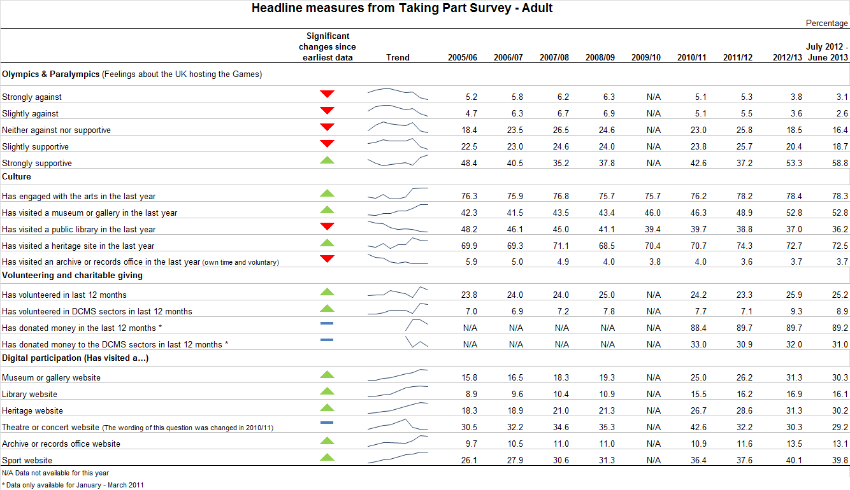
Introduction

This report
Taking Part is a household survey in England. It looks at participation in the cultural sector. This report presents the latest headline estimates for the year up to and including June 2013. The survey has run for nine years and was commissioned by the Department for Culture, Media and Sport (DCMS) in partnership with Arts Council England, English Heritage, and Sport England. The statistics are used widely by policy officials, academics, the private sector and charities to measure participation in the cultural sectors.

Taking Part is the key evidence base for DCMS, providing reliable national estimates of participation and supporting the Department’s aim of improving the quality of life for everyone, by providing people with the chance to get involved in a variety of cultural and sporting opportunities. The survey also aims to inform the DCMS Structural Reform Priorities and Business Plan through the provision of data for DCMS input and impact indicators. See the latest DCMS indicators.

This report presents headline findings for the main cultural estimates along with updates on data which are used to measure the influence of London hosting the 2012 Olympic and Paralympic Games. Data are also used to measure volunteering and charitable giving policy objectives. Where analysis has been extended to look at digital engagement within the DCMS sectors (heritage, museums and galleries, libraries, archives, arts, volunteering and charitable giving), this is presented alongside the relevant sector figures.

Government policies which might have had an impact on participation figures have been outlined at the beginning of relevant chapters throughout the report. This does not indicate that these policies have directly caused the change in participation, simply that they might be a factor. Where observations are made over time, the latest data are compared with the earliest available data (typically 2005/06) unless otherwise stated. Key terms and definitions are provided in Annex B and C of this release.

The latest results presented in this report are based on interviews conducted between July 2012 and June 2013. The total sample size for this period is 10,140. When differences are stated, statistical significance tests have been run at the 95% level. All differences and changes reported are statistically significant at the 95% confidence level unless otherwise stated. This means the probability that any given difference happened by chance is low (at most 1 in 20).

See below for additional resources relating to this release
Spreadsheets and documents accompanying this release

Forthcoming releases and events
The next adult release, scheduled for December 2013, will present the quarter 2 estimates for year 9 (October 2012 – September 2013) for adults.

Future adult releases will follow a similar schedule, being released at the end of March, June, September and December ahead of quarterly reporting on the input and impact indicators that are produced by all Departments.

In addition, topic specific analysis will be published throughout the year, looking in depth at particular areas of the survey. Previous reports have covered Big Society and sport participation (published in the annex of the 2011/12 technical report) The third and most recent report on the 2012 Olympic and Paralympic Games was published 13th December 2012

The most recent Taking Part User Event was held on 28th November 2012. See here for details of the Taking Part User Event and materials from previous events

If you would like further information on these releases or the Taking Part survey, please contact the Taking Part team on TakingPart@culture.gsi.gov.uk. Additional contact details are contained within Annex A.

- The 2012 Olympic and Paralympic Games

This chapter relates to the UK hosting the 2012 Olympic and Paralympic Games. It includes analysis on the extent to which people in England supported hosting the Games; how people got involved or intended to get involved in the Games and whether the Games motivated people to participate in voluntary work, cultural activities or sport.

The latest survey results are from interviews conducted between July 2012 and June 2013 so now include the period when the UK hosted the 2012 Olympic and Paralympic Games between July and September 2012. Further analysis looking at participation rates during the quarter when the 2012 Games were held was carried out as part of the London 2012 Meta-evaluation and published at the end of July 2013.

Government policy, which may have influenced the statistics presented, is described below:
The Government has a policy to make the most of the 2012 Olympic and Paralympic Games; to deliver a legacy over the next ten years, across the five themes of sport and healthy living, growth and the economy, communities and volunteering, regeneration of East London and Paralympic legacy. This includes encouraging more people to take part in sport and volunteering. The Government is using the success of Games-related volunteering to increase the rate of volunteering, including through initiatives such as ‘Join in’, which is funded by the Office for Civil Society to promote sport related volunteering. It is promoting cultural engagement following the Cultural Olympiad, which attracted around 20 million people to events across the UK.

Legacy planning had been part of the planning for the Games from the bid stage onwards. The Government and the Mayor of London have recently (July 2013) published an update report ‘inspired by 2012’ setting out progress against legacy plans. Also published in July 2013 was an independent meta-evaluation of the Games’ legacy benefits, commissioned by the DCMS and produced by a consortium led by Grant Thornton.

Key findings

    - Over the year, July 2012 – June 2013, 22 per cent of respondents who had taken part in sport or recreational activity answered that the UK winning the bid to host the 2012 Olympics had motivated them to do more of these activities, an increase from 8 per cent in 2005/06. Most of this increase has been since 2011/12.

    - 8 per cent of respondents who had taken part in cultural activities felt that the UK winning the bid to host the 2012 Olympics had motivated them to take part in more cultural activities. 10 per cent of those who had volunteered felt it motivated them to do more voluntary work.

    - 92 per cent of adults intended to follow or followed the London 2012 Olympic or Paralympic Games, for example by watching on television at home.

    - 19 per cent of adults got actively involved, or intended to get actively involved¹ in the Games. For example, by attending a ticketed Olympic or Paralympic event.

    - Over three quarters (78%) of adults were slightly or strongly supportive of the UK hosting the 2012 Olympic and Paralympic Games. Attitudes have fluctuated since 2005/06 (71% slightly or strongly supportive), with a low in 2007/08 of 60 per cent. Increases in overall support since 2011/12 have been driven by a substantial increase in those strongly supportive of the Games.

The 2012 Olympic and Paralympic Games

Since 2011/12, the Taking Part survey has asked questions on adults’ intention to get involved or their actual involvement in the Games. In the year ending June 2013, 91.7 per cent of adults intended to follow or followed the London 2012 Olympic or Paralympic Games in some way. Of all survey respondents in the 12 months to June 2013, people followed or intended to follow the Games in the following ways:
- Watching on TV at home (89.1% up from 81.4% in 2011/12)
- Reading an on or offline newspaper (38.1% up from 32.1% in 2011/12)
- Listening to the radio at home (16.2%, a similar level to 2011/12)
- Watching or listening on the internet at home (15.5% up from 13.2% in 2011/12)
- Watching live events on a public big screen (11.1% down from 12.4% in 2011/12)

Additionally from July 2011, adults were asked whether they intended to, or actually did actively follow or get involved in the London 2012 Olympic or Paralympic Games.
In the year ending June 2013, 18.7 per cent of adults said they did actively follow or get involved, a significant decrease from 24.4 per cent in 2011/12. The following ways were reported:
- Attending a ticketed Olympic or Paralympic event (10.3%, up from 7.9% in 2011/12)
- Attending a free Olympic or Paralympic event (5.9%, down from 8.7% in 2011/12)
- Taking part in a Games related community event or activity, e.g. street party or local Inspire Mark project (3.5%, a similar level to 2011/12)
- Taking part in a Games related cultural event or activity (1.6%, a similar level to 2011/12)
- Fewer than 1 per cent followed or intended to follow by: Volunteering during the Games, taking part in a Games related sport or physical activity, using new or improved sports facilities linked to the Games or gaining Games related employment or training.

Motivation to participate more

In July 2012 – June 2013, 22.5 per cent of respondents who had taken part in sport or recreational activity answered that the UK winning the bid to host the 2012 Olympics had motivated them to do more of these activities. This was a significant increase from 7.7 per cent in 2005/06 and higher than any year since then. This increase has largely emerged since 2011/12 when the rate was 7.3 per cent.

Figure 1.1: Proportion of respondents who were motivated to do more sport or recreational physical activity as a result of the UK winning the bid to host the 2012 Olympic and Paralympic Games, 2005/06 to July 2012-June 2013
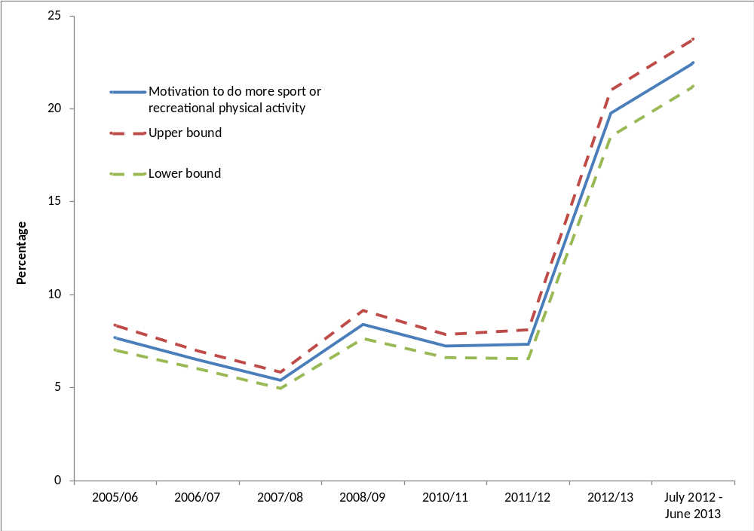
Notes
(1) Confidence intervals range between +/-0.4 and +/-1.3 from 2005/06 onwards.
(2) This question was not asked in 2009/10.
(3) The upper and lower bounds show the 95% confidence interval.

8.0 per cent of respondents who had taken part in cultural activities felt that the UK winning the bid to host the 2012 Olympics had motivated them to take part in more cultural activities. 9.9 per cent of those who had volunteered felt it motivated them to do more voluntary work. These were both significantly higher than in 2010/11 when the figures were 4.0 per cent and 6.6 per cent respectively.

Support for the UK hosting the 2012 Olympic and Paralympic Games

Attitudes towards the UK hosting the Games have fluctuated over the period since 2005/06. Recent increases in overall support since 2011/12 (from 37.2% to 58.8%) have been driven by a substantial increase in those strongly supportive of the Games.
- The rate of people who were either slightly or strongly supportive in the year ending June 2013 (77.6%) was the highest of any survey year.
- The proportion of those who were strongly supportive increased significantly from 48.4 per cent in 2005/06 to 58.8 per cent in the latest results. Strong support for hosting the Games is now at the highest level reported in any survey year.
- The proportion of respondents who were slightly supportive significantly decreased from 2005/06 (22.5%) to 2012/13 (18.7%).
- The proportion who were neither against nor supportive of the Games was significantly lower in the year ending June 2013 (16.4%) than in 2005/06 (18.4%). The latest data also represents a decrease from 25.8 per cent in 2011/12.
- The proportion that were slightly against (2.6%) and strongly against (3.1%) has decreased since 2005/06 and 2011/12 (Figure 1.2).

London won the bid to host the Olympic and Paralympic games on the 6th July 2005. The Games were staged in July, August and September of 2012. These figures represent increasingly strong support for the Games since they were staged.

Figure 1.2: Adults’ opinions about the UK hosting the 2012 Olympic Games, 2005/06 to July 2012 – June 2013
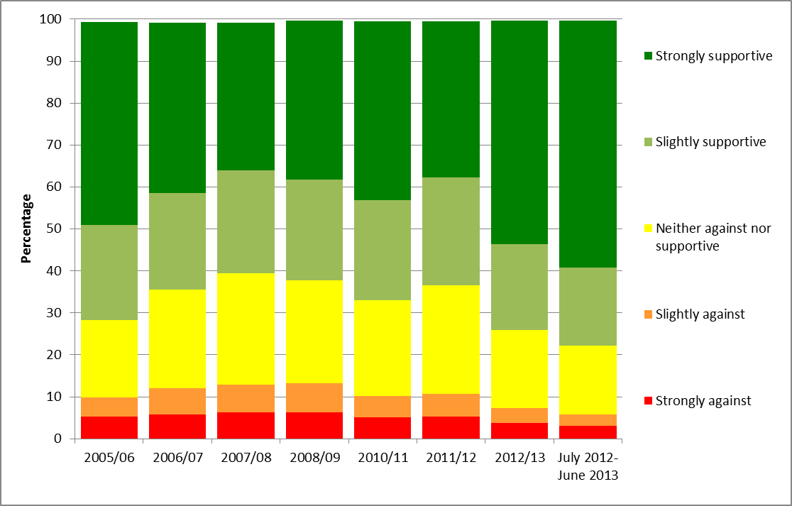
Notes
(1) Confidence intervals range between +/-0.4 and +/-1.3 from 2005/06 onwards.
(2) This question was not asked in 2009/10.

The increase in support has been seen across almost all respondent demographic groups. Some of the largest increases in support since 2010/11 have been amongst:
- Those aged 65-74 from (61.7% to 77.0%)
- Those aged 75+ (from 57.9% to 76.8%)
- Women (from 63.7% to 78.6%)
- Disabled people (from 61.6% to 75.4%)
For all adults the rate who were supportive increased from 66.7 per cent to 77.8 per cent over this time period.

More modest, but still significant increases in support have been among:
- Black or Minority Ethnic adults (from 77.6% to 83.7%), although support was already higher than the average for all adults.
- Those aged 16-24 (from 69.2% to 76.1%)
- Men (from 69.9% to 76.9%)

By region

For the first time since 2010/11, there have been significant increases in support for the Games from 2010/11 to the year ending June 2013 across all English regions.

The levels of support within London, where the majority of the Games were held, varied. Looking at the survey period between July 2005 and June 2013, 75.9 per cent of respondents in Wandsworth (one of the most supportive London boroughs) were supportive of the Games, compared to 57.4 per cent of respondents in Kingston upon Thames (one of the least supportive London borough). (Figure 1.3)

Figure 1.3: Proportion of adults who were slightly or strongly supportive of the UK hosting the 2012 Olympic Games by London borough, July 2005 to June 2013
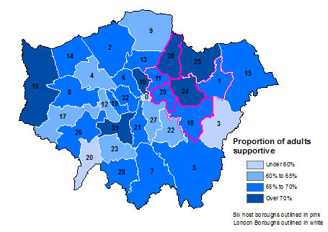
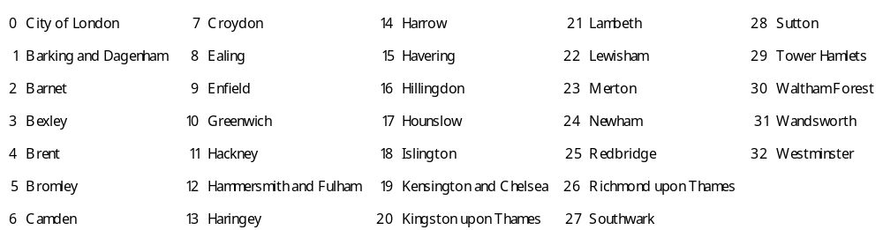

Notes
- Results for the City of London are indicative due to a small sample size.
- Sample sizes vary by London Borough (excluding City of London) from 198 to 796.
- The six host boroughs are Barking and Dagenham, Greenwich, Hackney, Newham, Tower Hamlets and Waltham Forest.

Further detail on this section can be found in the accompanying spreadsheets to this release

- Heritage

The Taking Part survey measures adult participation in heritage by whether respondents visited a heritage site in the 12 months prior to interview, as well as the frequency with which heritage sites were visited. Details on the ways that people digitally engage with heritage are given at the end of this chapter. Digital engagement with the heritage sector includes visiting a heritage website to take a virtual tour of a historical site, learn about history or the historic environment, or discuss history or the historic environment on a forum.

English Heritage also published two reports in 2011 which build on the Taking Part survey to explore participation within the Heritage sector in more detail.
- The Visiting the Past report analyses the factors which affect people's likelihood of visiting three kinds of historic sites:
- Historic parks and gardens
- Historic places of worship
- Monuments, castles and ruins
It examines the effects of the demographic characteristics of visitors (e.g. age), other activities and social circumstances on the probability of visiting these sites. The findings are based on a statistical analysis of the visiting patterns of over 25,000 people surveyed in Taking Part.
- The Mapping Leisure report uses visualisation techniques to create a series of pictures of Taking Part data, allowing the landscape of cultural and sporting participation in England to be visually explored. The pictures visualise the participation levels, demographics, and connections, of over 100 cultural and sporting activities (including heritage). The report interprets the pictures and discusses the questions they raise.

Government policy, which might have influenced the statistics presented, is described below:
DCMS is committed to ensuring that the historic environment of England is properly protected and conserved, so that present and future generations can enjoy the benefits of engaging with our heritage. Through the bodies it funds, DCMS seeks to promote understanding and access to the historic environment, allowing people to appreciate the heritage assets around them.

DCMS funds English Heritage, the Government’s statutory advisor on the historic environment. The Department also provides funding and support to a number of other bodies, including the National Heritage Memorial Fund and the Churches Conservation Trust. Over the life of this Parliament, DCMS will invest over £700 million in heritage, with a further £1.6 billion being invested through the Heritage Lottery Fund.

Of course many other public, private and voluntary organisations fund and support heritage in this country. DCMS works with a range of partner organisations to highlight the benefits heritage brings to the nation and to inspire greater engagement.

Further details of the department’s role in relation to heritage are available on our website.

Key findings

- Nearly three quarters (72%) of adults visited a heritage site in the last year. This represents a significant increase of 3 percentage points since the survey began in 2005/06 but a significant decrease since 2011/12 (74%).

- 31 per cent of adults reported visiting a heritage site less than once a month but at least three or four times a year, a significant increase since 2005/06, following a continuous upward trend from then to the current period.

- There have been significant increases since 2005/06 in the proportion of people who had visited a heritage site over the previous year across many of the socio-demographic groups.

Heritage attendance

The latest results show that 72.5 per cent of adults visited a heritage site in the 12 months prior to interview. This was a significant increase from 69.9 per cent in 2005/06 but a statistically significant decrease since 2011/12 (74.3%). The proportion of adults visiting a heritage site was stable between 2005/06 and 2010/11, but became significantly greater than the first year’s results for the first time in 2011/12. The latest results remain greater than 2005/06 and 2010/11 but are significantly lower than in 2011/12.

Figure 2.1: Proportion of adults who had attended a heritage site in the last 12 months, 2005/06 to July 2012 – June 2013
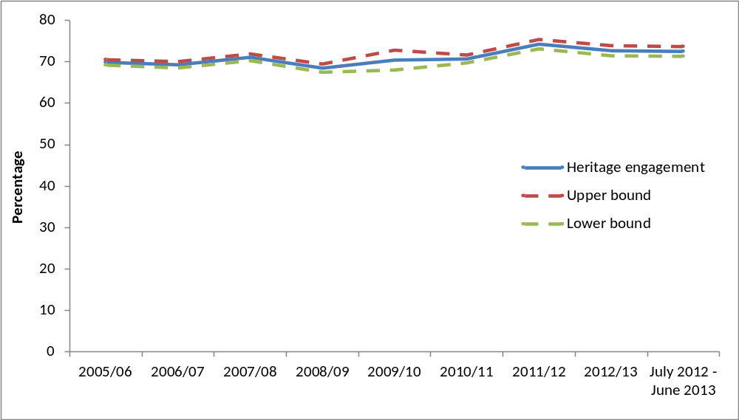
Notes
- Confidence intervals range between +/-0.7 and +/-2.4 from 2005/06 onwards.
- The upper and lower bounds show the 95% confidence interval.

There was an increase in the rate of adults who visited a heritage site less often than once a month but at least three or four times a year (30.7%, an increase of 4.2 percentage points from 2005/06). This represented a gradual upward trend since 2005/06 to the current period.

Socio-demographic groups which experienced large significant increases between 2005/06 and July 2012 – June 2013 were:
- Of a religion other than Christianity (an increase of 8.1 percentage points to 57.8%)
- 65-74 year olds (an increase of 7.9 percentage points to 77.8%)
- Black or ethnic minority groups (an increase of 6.8 percentage points to 57.4%)

Those who had visited a heritage site in the 12 months prior to interview who lived in the “most deprived” index of multiple deprivation group, underwent a significant increase of 15.9 percentage points to 55.6 per cent in the year ending June 2013 since 2009/10 when data using this classification were first collected. There were also significant increases for adults in the “wealthy achievers”, “moderate means” and “hard pressed” ACORN classifications.

There have been significant increases since 2005/06 amongst those who lived in the
- North East (5.7 percentage points to 74.8%)
- Yorkshire and the Humber (6.5 percentage points to 74.8%)
- West Midlands (4.7 percentage points to 70.5%).
- East Midlands (5.1 percentage points to 76.9%)
The above increases first became significantly different from 2005/06 from 2011/12 onwards. Prior to this, trends were relatively stable.

There were significant increases for adults in both urban (70.7%) and rural (80.2%) areas in the year ending June 2013 compared to 2005/06 (68.0% and 77.4% respectively). However compared to 2011/12 there was a significant decrease in the rate for adults living in urban areas (72.9% in 2011/12). The rate remained similar for rural areas compared to 2011/12 (80.4%).

Digital engagement

Since 2005/06, the proportion of people visiting heritage websites significantly increased from 18.3 per cent to 30.2 per cent. The proportion of adults visiting heritage websites has gradually increased year on year but was only first significantly greater than in 2005/06 in 2010/11, after which it has continued to rise to 2011/12 and has remained relatively stable since. Data were not collected in 2009/10.

The Taking Part survey added new questions on heritage websites from July 2011. From July 2012 to June 2013, of people who visited a heritage website:
- Nearly three in five respondents used a heritage website to plan how to get to a historic site (59.9%).
- Almost half used a heritage website to learn about history or the historic environment (48.9%),
- Just under a quarter used a heritage website to buy tickets to visit a historic site (24.7%).
- 17.1 per cent of adults had visited a heritage website to take a virtual tour of a historical site.
- 2.1 per cent of adults who visited a heritage website used it to discuss history or visits to the historic environment on a forum.

Further detail on this section can be found in the accompanying spreadsheets to this release

- Museums and galleries

This chapter examines museum and gallery attendance in the last 12 months, by a range of area-level and socio-demographic breakdowns. Details on the ways that people digitally engage with museums and galleries are also given. Digital engagement with museums and galleries is defined as using websites to look at items from a collection, find out about a particular subject, take a virtual tour of a museum or gallery or to view or download an event or exhibition.

The Department also publishes monthly museum and gallery visits figures. To note, these figures are from the perspective of individual museum and galleries, therefore one person may visit a number of museum and galleries and be counted more than once by different institutions. Data also include overseas visitors. Taking Part is a household survey in England and measures participation from the view point of the individual. Despite these differences the overall trend has been similar, showing an upward trend since 2005/06.

Until 2011/12, Arts Council England also published data on the number of museum visits from those sites participating in the Renaissance in the Regions programme. This was a quarterly return and the figures are not entirely comparable with those published in the Taking Part survey. One person may visit a number of participating museums and be counted more than once by different institutions under the Renaissance in the Regions programme. The figures will also include overseas visitors, which the Taking Part survey does not. Despite these differences, a broadly similar trend is shown in these data as in the Taking Part survey.

Government policy, which may have influenced the statistics presented, is described below:
DCMS directly sponsors 15 museums and galleries, of which 13 were founded by Act of Parliament and are defined as “National Museums”. All DCMS sponsored institutions receive Grant-in-Aid funding from DCMS. Details of how much funding individual museums will receive are published in an annual report. Providing free admission (since 2001) to the permanent collections remains a condition of the national museums and galleries’ Grant-in-Aid funding. DCMS’ stewardship of sponsored museums is at arm’s length.

DCMS also sponsors the Arts Council England, the national body which supports museums and galleries in England. It distributes both direct government funding and funds from the National Lottery, as well as providing advice and guidance, and running programmes to raise standards in museums and galleries. Its main programmes include:
- running the Renaissance programme, which provides funding and support to regional museums.
- running 2 schemes which help regional museums to improve and develop:
  - the Accreditation Scheme, which allows museums to receive official accreditation if they meet a set of standards covering everything from collection management to visitor experience
  - the Designation Scheme, which identifies and recognises collections of national or international importance in regional museums

DCMS and the Wolfson Foundation fund the DCMS/Wolfson Museums and Galleries Improvement Fund, which supports projects in English museums and galleries that improve the quality of displays, and collection interpretation; public spaces; and access and facilities for disabled visitors.

Key findings

- Over July 2012 – June 2013, the majority of adults (53%) had visited a museum or gallery in the last year. This was higher than in any survey year between 2005/06 and 2011/12.

- The proportion of adults who had visited a museum or gallery in the 12 months prior to being interviewed has significantly increased since 2005/06 (from 42% to 53%). This has been an upward trend since 2008/09.

- 32 per cent of adults said they had visited museums or galleries 1-2 times a year, a significant increase from 26 per cent in 2005/06 and 30 per cent in 2011/12. 17 per cent had visited 3-4 times a year, a significant increase from 13 per cent in 2005/06 and 15 per cent in 2011/12. 4 per cent of respondents had visited a museum or gallery at least once a month and 1 per cent went at least once a week.

Overall attendance at museums and galleries

In the period spanning July 2012 to June 2013, 52.8 per cent of adults visited a museum or gallery, an increase in attendance from 2005/06 (42.3%). This remained at the highest proportion recorded since the survey began in 2005/06, as shown in Figure 3.1. The vast majority of visits were made in people’s own free time (97.6%), with a small percentage attending for paid work or for academic study (2.6% and 2.7% respectively).

People who live in rural areas were just as likely as people in urban areas to have visited a museum or gallery in the last year, however there were variations by region.

In July 2012 to June 2013:
- 58.0 per cent of Londoners had visited a museum or gallery in the last 12 months. In the West Midlands only 46.3 per cent had done so.
- Attendance rates in the other regions of England varied between 50.7 per cent and 54.3 per cent.
- Since 2005/06, the proportion of people visiting museums or galleries increased significantly in all regions of England.

Figure 3.1: Proportion of adults who had visited a museum or gallery in the last year, 2005/06 to July 2012 – June 2013
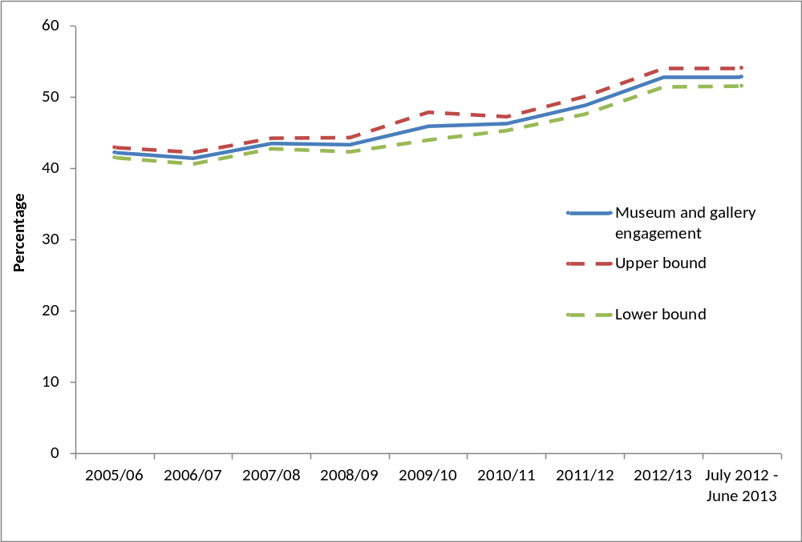
Notes
- Confidence intervals range between +/-0.7 and +/-1.9 from 2005/06 onwards.
- The upper and lower bounds show the 95% confidence interval.

There were differences in attendance rates of museums and galleries in the last year for adults in different ACORN groups. For example those categorised as Wealthy Achievers (60.5%) had significantly higher attendance rates than those categorised as moderate means (46.3%) or hard pressed (39.3%). Likewise those in the Urban Prosperity category (67.7%) also had significantly higher attendance rates than those of moderate means and the hard pressed, as shown in Figure 3.2. There has been a significant increase in attendance rates amongst all ACORN groups since 2005/06.

Over three in five adults (61.4%) in the upper socio-economic group visited a museum or gallery in the last year compared to 39.9 per cent in the lower group. Over half of working adults had attended (57.8%) compared to 45.4 per cent of adults not working. All groups (both upper and lower socio-economic and both working and not working) have seen a significant increase in the proportion visiting a museum or gallery in the last year compared to 2011/12.

Compared to 2011/12, the proportion who visited a museum or gallery in the 12 months prior to being interviewed in the year ending June 2013 increased amongst most demographic groups, the only exceptions being:
- 16-24 and 25-44 year olds
- Those in social or private sector rented housing
- Respondents from black and minority ethnic (BME) groups
- Those of no religion or of a religion other than Christianity

Figure 3.2: Proportion of adults who had visited a museum or gallery in the last year, by ACORN group, July 2012 – June 2013.
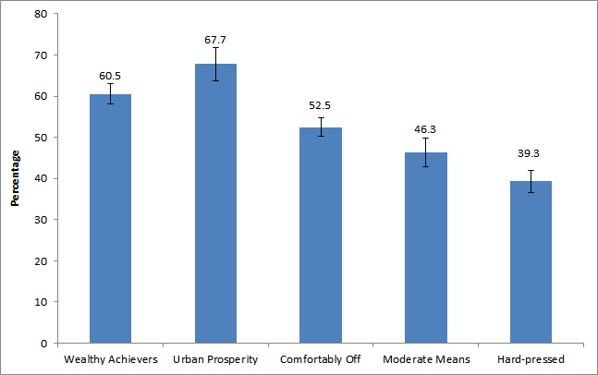
Notes
- Confidence intervals range between +/-2.3 and +/-4.0.
- Categories where confidence intervals overlap cannot be reliably compared.

Digital engagement

30.3 per cent of adults had visited a museum or gallery website in the year ending June 2013, the highest reported level since data collection began in 2005/06 when the figure was 15.8 per cent. There has been a gradual upward trend in digital engagement with museum and galleries since the data were first collected in 2005/06. However this has only been large enough to be significant from 2010/11.

Between 2005/06 and the year ending June 2013, of those who had visited a museum or gallery website, there was
- A significant increase in the proportions of adults visiting a museum or gallery website to find out about or order tickets for an exhibition or event (from 47.9% to 62.1%).
- A significant decrease in the proportion of adults who had visited a museum or gallery website to look at items from a collection (from 33.7% to 19.9%).

The Taking Part survey added new questions on museum and gallery websites from July 2011. In the year ending June 2013, of those who had visited a museum or gallery website, 44.4 per cent had done so to find out about a particular subject, 16.5 per cent of adults had taken a virtual tour of a museum or gallery and 12.6 per cent had viewed or downloaded an event or exhibition. The values above are not significantly different from the corresponding figures in 2011/12.

Further detail on this section can be found in the accompanying spreadsheets to this release
- Libraries

This chapter examines library participation as measured by attendance in the last 12 months, by a range of area-level and socio-demographic breakdowns. Details on the ways that people digitally engage with library services are also given. Digital engagement with libraries is defined as completing a transaction (e.g. reserving or renewing items or paying a fine), searching and viewing online information or making an enquiry.

Government policy, which might have influenced the statistics presented, is described below:
Individual public library services are delivered by 151 library authorities in England, and they have a statutory duty under the Public Libraries & Museums Act 1964 to provide a comprehensive and efficient library service, set in the context of local need, specifically of those who live, work and study in the local area. Central Government core funding for public libraries is paid through the local government settlement, administered by the Department for Communities and Local Government (CLG). Local authorities decide how to allocate funding to public libraries in the light of their statutory duties and local priorities, and in 2011-12 authorities in England invested £820m in their public library services.

The 1964 Act imposes a duty on the Secretary of State for Culture, Media and Sport to oversee and promote the public library service and to secure discharge of the statutory duties of local authorities as well as providing certain powers to take action where a local authority is in breach of its own duty.

The Government is responsible for national library policy and works closely with the development agency for libraries, Arts Council England. Further information about the Arts Council’s support for public libraries is available on their website.

Key findings

- 36 per cent of adults had used a library in the 12 months prior to being interviewed, a significant decrease from 48 per cent in 2005/06 and 39 per cent in 2011/12.

- Since 2005/06, the proportion of adults using a public library has declined in all regions.

Library attendance

In the year ending June 2013, 36.2 per cent of adults reported using a library service in the last 12 months, a significant decrease from 48.2 per cent in 2005/06, and 38.8 per cent in 2011/12 (Figure 4.1).

Figure 4.1: Proportion of adults who had attended a library by gender, 2005/06 to July 2012 – June 2013
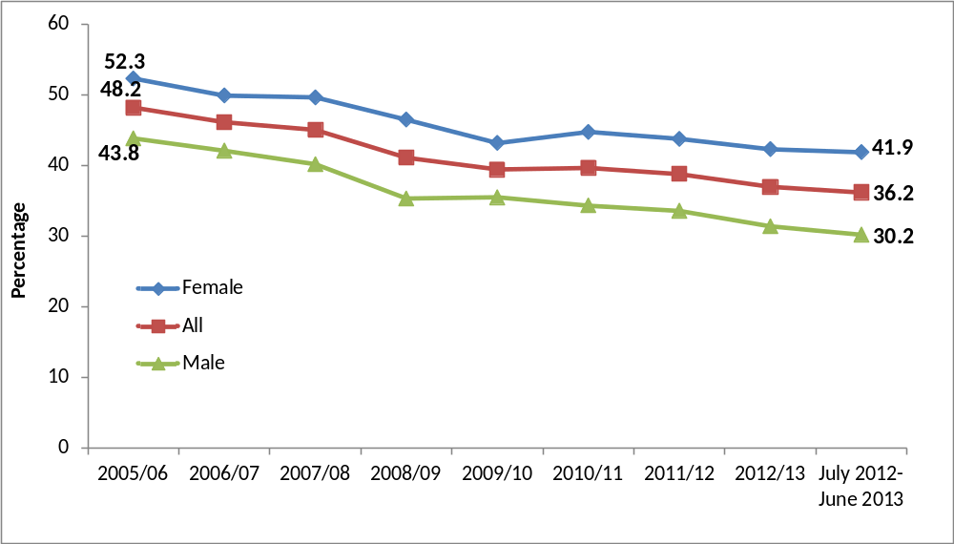
Notes
- Confidence intervals range between +/-0.7 and +/-2.5 from 2005/06 onwards.

As figure 4.1 shows, library usage has remained consistently higher amongst women than men, although usage has dropped significantly amongst both groups since 2005/06, from 52.3 per cent to 41.9 per cent for women and 43.8 per cent to 30.2 per cent for men.

Between 2005/06 and 2012/13, the proportion of people using a public library declined in all regions and in both urban and rural areas.

Compared to 2005/06 there has been a decline in library usage amongst all age groups. Compared to 2011/12 there were significant decreases in the proportion of respondents who visited a library in the 12 months prior to interview amongst:
- 45-64 year olds and 75+ year olds
- Male respondents
- The upper socio-economic group
- Those who were in work
- Home owners
- Those from the white group
- Those who were not religious
- Those who did not have a long standing illness or limiting disability.

In 2012/13, the following patterns of library attendance were observed:

- Women (41.9%) had a higher rate of library attendance than men (30.2%).
- Adults in upper socio-economic groups (38.3%) had a higher rate of library attendance than people in lower socio-economic groups (33.3%).
- Adults who were not working (39.5%) had higher rates of library attendance than those who were working (34.0%).
- Adults from black and minority ethnic (BME) groups (46.1%) had higher rates of library attendance then adults from the white group (34.9%).

Digital engagement

In the year ending June 2013, 16.1 per cent of adults had visited a library website in the 12 months prior to being interviewed, a significant increase from 8.9 per cent in 2005/06.

Of those who had visited a library website:
- 74.9 per cent had searched and viewed online information or made an enquiry
- 40.9 per cent had completed a transaction e.g. reserved or renewed items or paid a fine, a significant increase from 28.1 per cent in 2006/07.

Further detail on this section can be found in the accompanying spreadsheets to this release.

- Arts

Taking Part asks respondents whether they have attended or participated in a range of arts activities. These two forms of activity (attendance and participation) are combined to provide the overall measure of arts engagement. Examples of arts engagement include painting (participation) or attending a theatre (attendance). Details on the ways that people digitally engage with the arts are also given. Digital engagement with the arts is defined as viewing or downloading part or all of a performance or exhibition, discussing the arts or sharing art that others have created, uploading or sharing art that you have created yourself or finding out how to take part or improve your creative skills.

Government policy, which might have influenced the statistics presented, is described below:
The Department is committed to enhancing access to the arts, increasing the number of those who both take part in and attend arts events. The Department funds Arts Council England, an arm’s length body independent of Ministers, to champion and support the arts in England. Over the life of this Parliament, DCMS will invest around £1.8 billion in the arts, via the Arts Council, with a further £1 billion being invested in the arts through the National Lottery.

The Arts Council’s ten-year strategy, Achieving Great Art for Everyone, contains ambitious goals to see more people involved in arts in their communities and enriched and inspired by arts experiences.

Of course many other public, private and voluntary organisations make up the funding landscape that supports the arts in this country. DCMS and Arts Council England works with a range of such partner organisations to advocate for the arts, to highlight the benefits the arts bring to the nation, and to inspire greater participation.

Key findings

- 78 per cent of adults had attended or participated in the arts in the previous year, a significant increase since 2005/06 (76%) and 2010/11 (76%). In June 2012 – July 2013, art engagement was at a similar rate to 2011/12 (78%) but higher than any other previous survey year from 2005/06 onwards. The upward trend has only been present recently, prior to 2011/12 art engagement had been fairly stable.

- Arts engagement in urban areas in the year ending June 2013 (78%) was at a similar level to 2011/12 (78%) but had increased to a higher rate than in any other survey year since data collection began in 2005/06. It also represented a significant increase from 75 per cent in 2005/06. Those living in rural areas had a higher participation rate than those in urban areas (81% compared to 78%).

- Adults aged 65-74 and 75+ have seen a significant increase in engagement since 2005/06 (from 71% to 80% for 65-74 year olds and from 58% to 62% for aged 75 and over). However, adults aged 75 and over still had significantly lower arts engagement rates compared to other age groups.

Arts engagement

The latest results show 78.3 per cent of adults had engaged in the arts in the last year, a significant increase since 2005/06 (76.3%) and 2010/11 (76.2%). It was however a similar rate to 2011/12 (78.2%).

Women (81.2%) had higher arts engagement rates than men (75.2%) between July 2012 and June 2013. There has been a significant increase in women’s engagement with the arts since 2005/06, but for men, their level of engagement has remained similar over this period. Arts engagement rates for both men and women had been stable until 2010/11, after which the trend for women has increased.

Figure 5.1: Proportion of adults who had attended or participated in the arts, by gender, 2005/06 to July 2012 – June 2013
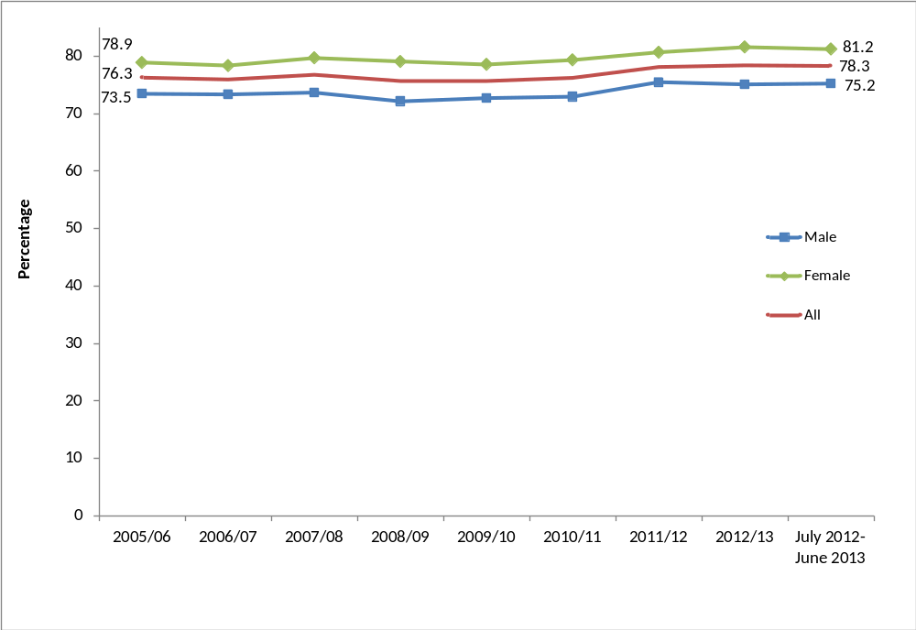
Notes
(1) Confidence intervals range between +/-0.9 and +/-3.1 from 2005/06 onwards.

In the year ending June 2013:
- 64.3 per cent of adults had engaged with the arts three or more times in the previous 12 months, a significant increase from 62.5 per cent in 2005/06 and from 61.2 in 2010/11.
- 7.8 per cent of adults had engaged only once in the previous 12 months, a significant increase from 7.2 per cent in 2005/06.
- 21.7 per cent of adults had not engaged with the arts at all in the previous 12 months, a significant decrease from 23.8 per cent in 2005/06 and 23.9 per cent in 2010/11.

Figure 5.2 shows that the proportion of adults who had engaged with the arts in the previous 12 months by frequency. There has been an upwards trend of those engaging at least once in the last 12 months, but there have been no discernible trends for other frequencies of engagement over the time period.

Figure 5.2: Indexed arts engagement, by frequency of attendance, 2005/06 to July 2012 – June 2013
Indexed, 2005/06 = 100
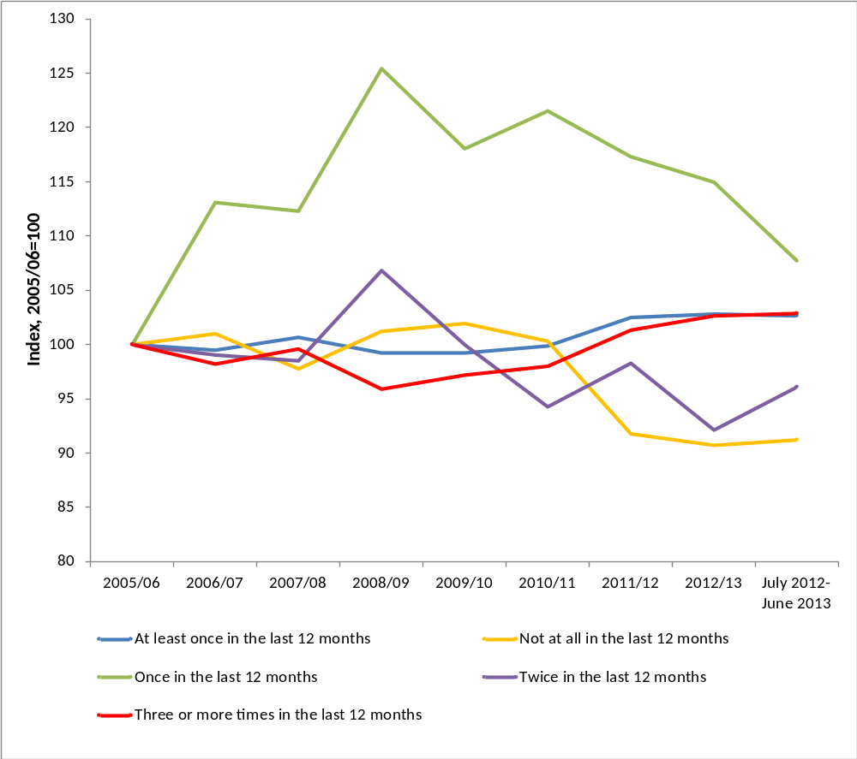

Since 2005/06 there have been significant increases for adults engaging with the arts in:
- The North East (from 70.2% to 74.6%)
- The North West (from 71.5% to 76.5%)
- The East Midlands (from 75.8% to 81.4%)

There were increases in arts engagement for adults living in urban areas (from 74.9% to 77.6%) during this period. Arts engagement tended to be higher amongst people who lived in less deprived neighbourhoods based on the index of multiple deprivation (IMD). Over the 10 IMD groups, engagement rates were lowest (64.4%) in the most deprived group, gradually increasing to 82.9 per cent in the least deprived group. This pattern has been broadly similar since data on IMD groups were first collected in 2009/10.

In the year to June 2013, the following patterns of arts engagement were observed amongst demographic groups:
- Adults aged 75 and over had lower arts engagement rates (62.0%) than the other age groups. Although the 65-74 and 75+ age groups have both seen a significant increase in engagement since 2005/06 (from 70.7% to 80.3% for 65-74 year olds, from 57.7% to 62.0% for age 75 and over), engagement rates for the younger age groups have remained steady during that period.
- Arts engagement was higher amongst adults from the white group (79.2%) than adults from black and minority ethnic (BME) groups (71.0%).
- Adults with no long-standing illness or disability had a higher arts engagement rate (80.6%) than people with a long-standing illness or disability (73.4%). Both groups have seen a significant increase since 2005/06.

These patterns are consistent with previous years.

Digital engagement

In the year ending June 2013, 29.2 per cent of adults had visited a theatre or concert website, no significant change from 2005/06 when the rate was 30.5 per cent but a significant decrease from 2010/11 (42.6%) and 2011/12 (32.2%). However the wording of this question changed slightly in July 2011 which coincides with a decline in the proportion visiting these types of sites.

Of those who had visited a theatre or concert website, 49.0 per cent of adults had bought tickets for an arts performance or exhibition, a significant increase from 43.2 per cent in 2006/07, but a significant decrease from 67.7 per cent in 2010/11 and 54.7 per cent in 2011/12.

The Taking Part survey added new questions about arts websites from July 2011. Between July 2012 and June 2013, for those who had visited an arts website, 71.0 per cent did so to find out more about an artist, performer or event and 23.9 per cent did so to view or download part or all of a performance or exhibition, a significant increase from 2011/12 (20.7%). 8.8 per cent of adults visited an arts website to find out how to take part or improve their creative skills, a similar proportion to 2011/12 which was the first full year of data collection.

Further detail on this section can be found in the accompanying spreadsheets to this release

- Archives

This chapter examines attendance at archives in the 12 months prior to interview by a range of area-level and socio-demographic breakdowns. Details on the way that people digitally engage with archives are also given. Digital engagement with archives is defined as completing a transaction, viewing digitised documents online or searching a catalogue.

Key findings

- The proportion of adults who had visited an archive (in their own time or for voluntary work) was 4 per cent, a significant decrease from the 2005/06 level (6%).

- Using the wider measure, which includes paid work visits and visits for academic study, the proportion of adults who attended in the last year has remained steady since 2008/09 (5%) when the data were first collected and was 5 per cent in the period from July 2012 to June 2013.

- In the same period, half of adults who visited an archive (52%) did so just once in the last 12 months.

- The 65-74 year old age band had the highest proportion of archive visits in the last 12 months (7%) whilst visits amongst 16 to 24 year olds (2%) were significantly lower than people aged 45-64 and 65-74.

Overall participation in archives

In the latest period, 3.7 per cent of adults had visited an archive in the last year in their own time or as part of voluntary work. This was significantly lower than in 2005/06 (5.9%). Using the wider measure, including paid work visits and academic study visits, the proportion in the latest period increased to 4.6 per cent of all adults. The trend over time, shown in Figure 6.1 below, was a downward one.

Three quarters of all archive visits (75.6%) were in visitors own time, followed by 15.5 per cent visiting for paid work, and 7.3 per cent for academic study.

There have been significant decreases in archive attendance rates since 2005/06 in all regions apart from Yorkshire and The Humber and the East Midlands where rates have remained steady.

Figure 6.1: Percentage of adults who had visited an archive or records office, 2005/06 to July 2012 – June 2013
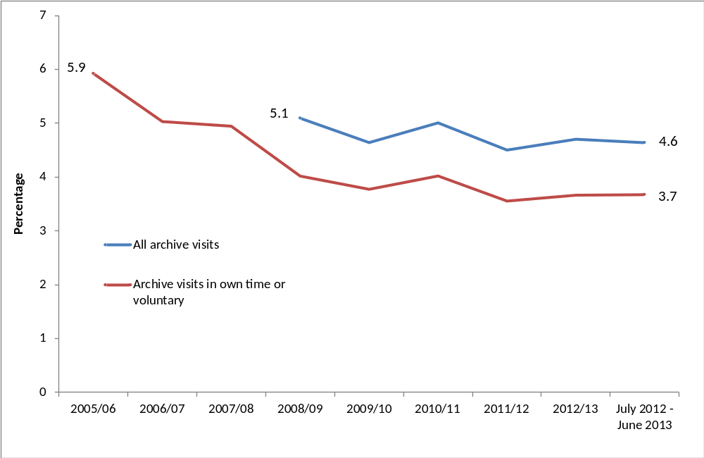
Notes
- Confidence intervals range between +/-0.3 and +/-0.8 from 2005/06 onwards.
- Some archive questions were not asked prior to the 2008/09 survey.

There has been little variation between different demographic groups (apart from age), although adults from upper socio-economic groups had a significantly higher attendance rate (4.5%) than those in lower socio-economic groups (3.0%).

The 65-74 year old age band had the significantly highest proportion of archive visits in the last 12 months (6.6 per cent of people this age) whilst visits amongst 16 to 24 year olds (1.7% of people this age) were significantly lower than people aged 45-64 and 65-74.

Digital engagement

A higher proportion of adults visited an archive or records office online than in person. In July 2012 – June 2013, 13.1 per cent of adults had visited an archive or records office website in the last 12 months, a significant increase from 9.7 per cent in 2005/06. Of those who had visited an archive or records office website, 65.6 per cent had done so to view digitised documents, 33.2 per cent of adults had searched a catalogue, a fifth (20.1%) of adults had found information out about the archive (e.g. opening hours) and 18.0 per cent had completed a transaction, for example, to purchase records.

Further detail on this section can be found in the accompanying spreadsheets to this release

- Volunteering and charitable giving
Taking Part asks whether respondents have participated in voluntary work in the last 12 months and whether this relates to any of the DCMS sectors (sport, art, heritage, museum and galleries, libraries and archives). The survey also includes a range of questions on social capital and cohesion, as well as charitable donations and whether these relate to DCMS sectors.

Government policy, which might have influenced the statistics presented, is described below:
The Government has a policy to encourage charitable giving across society as a whole, to make it easier to give and provide better support to organisations that facilitate giving, whether through digital technology or simplification of the tax system.

For example:
- To encourage giving through the £100 million Catalyst match funding programme which helps cultural organisations diversify their income streams
- tax incentives aimed at boosting legacy giving to cultural bodies and other charities
- The first tax incentive policy to encourage lifetime giving of works of art to public collections through the Cultural Gifts Scheme.

Key findings

- The proportion of adults who had volunteered in the last 12 months was 25 per cent, a small but significant increase from 24 per cent in 2005/06. 9 per cent of all adults had volunteered in a DCMS sector (Arts, Museums or Galleries, Heritage, Libraries, Archives, Sport). This was a significant increase from 7 per cent in 2005/06 and 2011/12.

- There has been a significant increase in the proportion of adults aged 16-24 years (up from 25% to 31%) and women (25% to 28%) who had volunteered in the last 12 months compared to 2005/06.

- 16 per cent of 16-24 year olds said the UK hosting the 2012 Olympic and Paralympic Games has motivated them to do more voluntary work.

- 90 per cent of adults had donated money (including donations into a collection box) in the last 12 months and 31 per cent of adults had donated to a DCMS sector. These were both at a similar level to 2010/11.

Volunteering

A quarter of adults (25.2%) reported that they had taken part in voluntary activities in the last 12 months. This was significantly higher than in 2005/06, when the figure was 23.8 per cent as depicted in figure 7.1. The proportion of all adults that had volunteered in a DCMS sector was 8.9 per cent, a significant increase of 1.9 percentage points since 2005/06 when the rate was 7.0 per cent.

Figure 7.1: Percentage of adults who had volunteered in the last 12 months, 2005/06 to July 2012 – June 2013
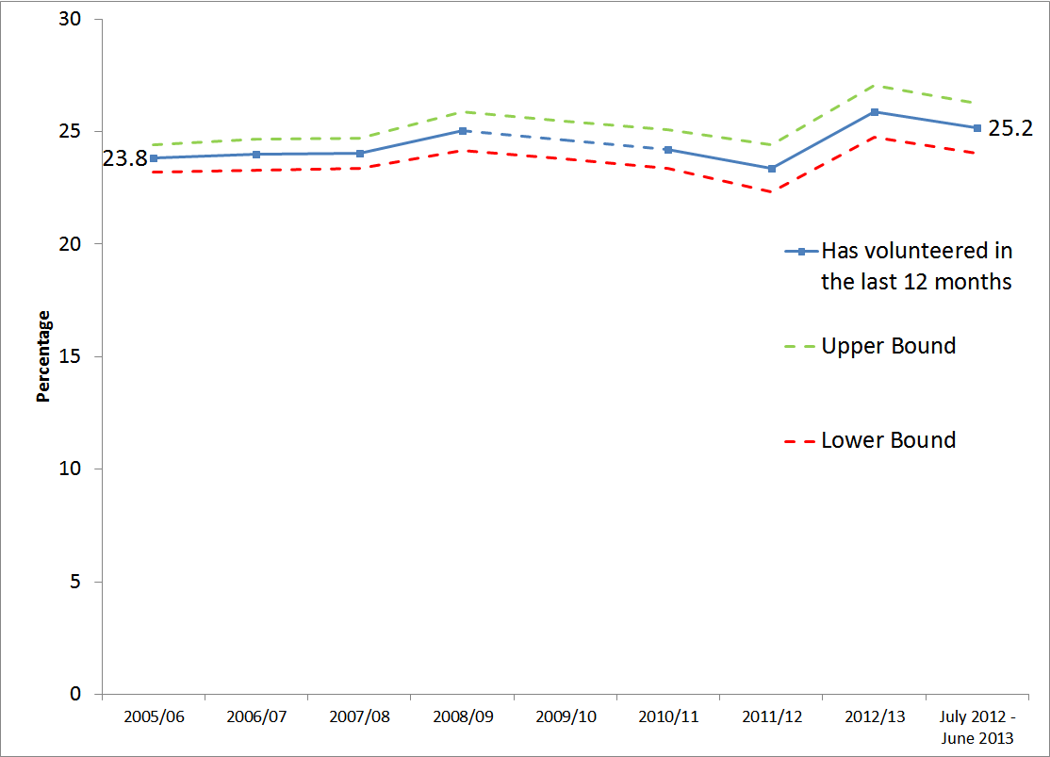
Notes
- Confidence intervals range between +/-0.6 and +/-1.1 from 2005/06 onwards.
- No data are available for 2009/10
- The upper and lower bounds show the 95% confidence interval.

There was a significant increase in the proportion of respondents who did voluntary work connected to the arts or sports sectors between 2005/06 and the latest reporting period, from 6.3 per cent to 9.5 per cent in arts and 19.2 per cent to 22.1 per cent in sports.

In July 2012 to June 2013, there was a significant difference in the proportion of males and females who had volunteered in the sports sector in the 12 months prior to being interviewed. Over double the proportion of men volunteered in sport compared to females (32.1% compared to 14.5%). This has been the case since 2010/11. In all other DCMS sectors there was no significant difference in the proportion of males and females volunteering.

There has also been a significant increase in the proportion of:

- adults aged 16-24 years who had volunteered in the last 12 months compared to 2005/06 (up from 24.7% to 31.0%). There was no significant change for other age groups over this time period. The increase for 16-24 year olds may be linked to 16.1 per cent of 16-24 year olds saying that the UK hosting the 2012 Olympics has motivated them to do more voluntary work, significantly higher than the rate amongst 65-74 year olds (6.8%) and those aged over 75 (3.2%).
- women who had volunteered in the last 12 months compared to 2005/06 (up from 24.7% to 27.8%). A greater proportion of women volunteered compared to men in July 2012 to June 2013 (27.8% compared to 22.4% respectively).
- those not working – up from 23.8 per cent in 2005/06 to 25.7 per cent in July 2012 to June 2013.
- adults with a disability or long term illness (from 23.5% in 2005/06 to 25.5% in 2012/13).

There was a significant increase in the proportion of respondents from urban areas who had volunteered in the last 12 months, from 22.1 per cent in 2005/06 to 24.0 per cent in the year ending June 2013. However the rate of urban respondents volunteering was significantly lower than the rate for rural respondents (30.2%) over this time period. There were also significant increases in the proportions of respondents from the North West and Yorkshire and the Humber who had volunteered in the last 12 months, compared to 2005/06 (from 19.0% to 23.1% for North West and from 18.8% to 23.2% for Yorkshire and the Humber).

Adults who had participated in a DCMS sector had higher volunteering rates within that sector than adults who had not participated, with the exception of the library and arts sectors where the figures were too small to report. For example, of adults who had participated in sport, 31.5 per cent of them had volunteered in sport, compared with just 10.4 per cent of those who had not taken part in sport.

Respondents who volunteered in the museums sector, on average did so for 10 hours and 31 minutes during the four weeks prior to being interviewed. For those who volunteered in the arts sector, the average time spent doing so in this period was 10 hours, 28 minutes. The corresponding average volunteering times in sport and heritage sectors were 9 hours and 45 minutes and 8 hours and 6 minutes respectively in the four weeks prior to interview. Respondents who volunteered in the library sector on average did so for 3 hours 59 minutes.

Charitable giving

Taking Part asks whether respondents had donated money in the last 12 months and whether this was to a DCMS sector.

In July 2012 - June 2013, 89.2 per cent of adults had donated money (including any donations into a collection box) in the last 12 months. 31.0 per cent of all adults had donated to at least one of the DCMS sectors. Of all those who had donated, 15.3 per cent of adults had donated to the museums and galleries sector in the last 12 months, 15.0 per cent to heritage, 6.8 per cent to the arts, 6.2 per cent to sport and 0.8 per cent to libraries. These are similar proportions to when the question was first asked in 2010/11 as shown by figure 7.2, with the exception of charitable giving to sport, for which the rate fell by 1.3 percentage points.

Figure 7.2: Percentage of adults who had donated money in the last 12 months, 2005/06 to July 2012 – June 2013
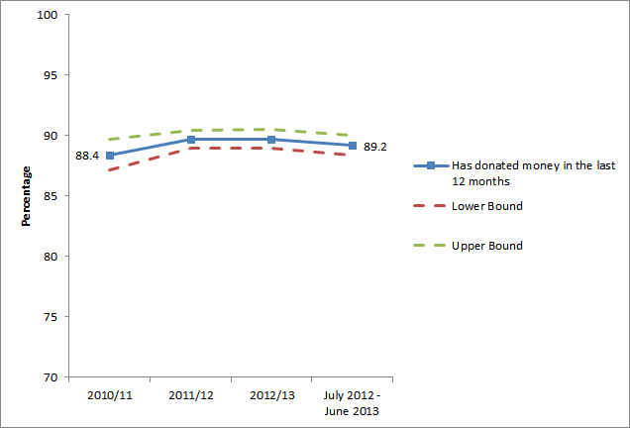
Notes
- Confidence intervals range between +/-0.8 and +/-1.3 from 2005/06 onwards.
- No data are available prior to 2010/11
- The upper and lower bounds show the 95% confidence interval.

36.0 per cent of adults donated money less often than once a week but at least once a month, a significant increase from 32.8 per cent in 2010/11. A further 33.9 per cent donated less often than once a month but at least three or four times a year. There was a significant decrease amongst those who gave only once in the last 12 months from 2005/06 (9.5%) to 2012/13 (7.8%).

Charitable giving to the DCMS sectors significantly increased between 2010/11 and July 2012 to June 2013 in the West Midlands (from 22.8% to 30.2%). However Charitable giving to the DCMS sectors significantly decreased between 2010/11 and July 2012 to June 2013 in the
- North East (from 35.0% to 22.2%)
- South East (from 39.7% to 31.8%)

Over four in five (83.3%) of respondents said they intended to give the same to DCMS sectors in the next 12 months, a significant increase from 2010/11 when the rate was 76.8 per cent. Of those who said they intended to give more to DCMS sectors in the next 12 months (4.9%), 13.9 per cent gave the reason because “they need the money” and nearly a third (30.8%) said it was because “they have more money / I can afford to give more”. However, of those who said they intended to give less to DCMS sectors in the next 12 months (7.6%), 42.0 per cent said this was because they “have less money / can’t afford to give”.

Overall civic participation

Taking Part asks a series of questions on sport and cultural facilities in the respondent’s local area.

Over a quarter of adults (24.1%) had taken action to try to get something done about sport and cultural facilities in their area, or did not need to take such action. The most common action that had been taken was to contact the council, with 12.3 per cent of adults having done so. A further 4.9 per cent of adults had contacted their local councillor or MP.

40.1 per cent of adults had been involved in groups, clubs or organisations in the last 12 months. Of those adults, the most popular type of group was sport/exercise groups (49.4%) followed by hobbies/social clubs (37.7%), which had both remained at a similar level to 2010/11. Also amongst the adults that had been involved in these groups or clubs in the last 12 months, there was a significant decrease in those that had taken part in Groups for children or young people (from 12.5 % to 9.0%), those who had gone to local community or neighbourhood groups (from 13.8% to 11.1%) and those who had attended religious groups (from 14.1% to 11.1%).

Further detail on this section can be found in the accompanying spreadsheets to this release

- Equalities

This chapter explores the variation in engagement rates in the arts, heritage, museums and galleries, libraries, archives and volunteering and charitable giving between different demographic groups. It looks at differences by age, gender, ethnicity and disability, over the period July 2012 to June 2013.

There were considerable variations in engagement levels for these equalities groups across most activities. However, it should be noted that these differences may be linked to factors other than the equality characteristic itself. This is particularly likely to be the case with charitable giving, which is strongly related to an individual’s level of income, which may explain why certain groups are more or less likely to give money to charity.

A range of barriers (external, intra-personal, and inter-personal) are likely to be at the root of these differences.

Key findings

- Women had higher participation rates than men in the 12 months prior to being interviewed for these measures:
  - 42 per cent had visited a library compared to 30 per cent for men.
  - 28 per cent had taken part in voluntary work compared to 22 per cent for men.
  - 81 per cent had engaged with the arts compared to 75 per cent for men.

- Respondents from BME (Black and minority ethnic) groups had higher participation rates than those from the white group in the 12 months prior to being interviewed for these measures:
  - 46 per cent had visited a library compared to 35 per cent of those from the white group.
  - 84 per cent were supportive of the UK hosting the 2012 Olympic and Paralympic Games compared to 77 per cent of those from the white group.

- Disabled people (including those with a long term limiting illness) had lower participation rates in some sectors than non-disabled people. In the 12 months prior to being interviewed:
  - 48 per cent had visited a museum or gallery compared to 55 per cent for non-disabled people.
  - 38 per cent had digitally engaged with a DCMS sector compared to 44 per cent for non-disabled people.
  - 69 per cent had visited a heritage site compared to 74 per cent for non-disabled people.
  - 73 per cent had engaged with the arts compared to 81 per cent for non-disabled people.

Age

There were considerable variations in engagement rates between different age groups. In general, engagement rates decreased with age for many activities. The oldest age group (those aged 75 and over) were less likely to have participated in the following activities than other age groups. In the 12 months prior to being interviewed:

- Museums and galleries: 35.4 per cent of those aged 75 or over had visited a museum or gallery, compared with the other age groups where the rate varied between 45.4 per cent for 16-24 year olds and 57.1 per cent for those aged 45-64 years.
- Volunteering: 19.7 per cent of those aged 75 or over had volunteered compared to the other age groups where the rate varied between 22.8 per cent for 25-44 year olds and 31.0 per cent for 16-24 year olds.
- Arts: 62.0 per cent of those aged 75 or over engaged with the arts compared to the other age groups where rates varied between 79.3 per cent for 45-64 year olds and 81.0 per cent for 16-24 year olds.
- Digital participation: only 12.6 per cent of those aged 75 or over digitally engaged with the DCMS sectors, compared with the other age groups where the rate varied between 34.1 per cent for 65-74 year olds and 49.2 per cent for 25-44 year olds.

These findings are consistent with existing evidence. For example, the report “Social Exclusion of Older People” (based on the English Longitudinal Study of Ageing) highlighted cultural exclusion as one of the key domains of exclusion for older people.

There are likely to be a number of physical barriers to participation for older people (especially where engagement requires more physical activity). However, through analysis, it is difficult to distinguish between real medical barriers from perceived physical problems.

Gender

Women had higher levels of library attendance (41.9% compared to 30.2% for men), engagement with the arts (81.2% compared to 75.2% for men) and were more likely to have volunteered (27.8% compared to 22.4% for men). For other sectors measured by
Taking Part there was no significant difference between men and women. (Figure 8.1)

Figure 8.1: Proportion of adults who had attended or participated in activities by gender, July 2012 – June 2013.
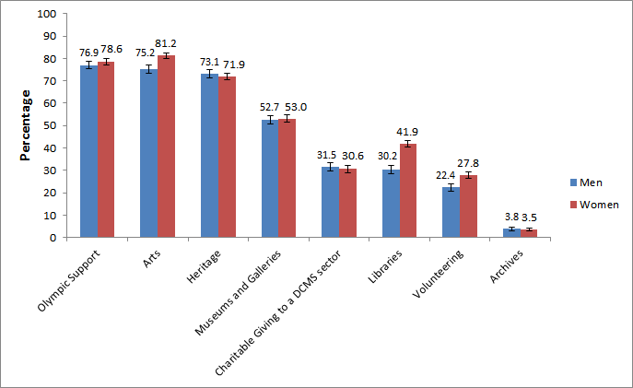
Notes
- Confidence intervals range between +/- 0.6 and +/- 1.9
- Categories where confidence intervals overlap cannot be reliably compared.

Ethnicity

Participation rates in a number of activities were lower for those from black and minority ethnic (BME) groups than for respondents from the white group. In the 12 months prior to being interviewed, adults from BME groups compared with the white group were less likely to: have visited a heritage site (57.4% compared to 74.4%), have engaged with the arts (71.0% compared to 79.2%) or have made a charitable donation to a DCMS sector (21.1% compared to 32.3%). (Figure 8.2)

However, respondents from BME groups were more likely to have used libraries compared with those from the white group (46.1% compared to 34.9%) and to have been supportive of the UK hosting the 2012 Olympic and Paralympic Games compared to the white group (83.7% compared with 77.1%).

A higher proportion of BME support for the UK hosting the Games may be due to location – a higher percentage of adults from BME groups live in London, where the majority of the Games were staged and where support for the Games was higher. There was also a higher rate for adults from BME groups who said they had been motivated to do more voluntary work as a result of the UK winning the bid to host the Games (21.3% compared to 5.6% for adults from the white group).

BME groups have shown increases since 2005/06 in museum and gallery attendance (from 35.4% to 45.6%) and attendance at heritage sites (from 50.7% to 57.4%). However there has also been a decrease in library attendance over this period (from 57.5% to 46.1%).

Figure 8.2: Proportion of adults who had attended or participated in activities by ethnicity, July 2012 – June 2013.
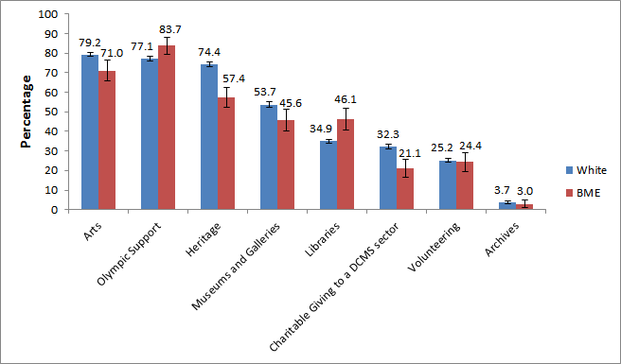
Notes
- Confidence intervals range between +/- 0.5 and +/- 5.6
- Categories where confidence intervals overlap cannot be reliably compared.

Disability

Disabled people (including those with a long term limiting illness) had significantly lower levels of engagement for the following compared with non-disabled people:

- In the year ending June 2013, support for the UK hosting the 2012 Olympic and Paralympic Games was 75.4 per cent compared to 78.9 per cent for non-disabled people.
- Visiting a heritage site: 69.0 per cent visited compared to 74.0 per cent for non-disabled people.
- Visiting a museum or art gallery: 48.0 per cent attended compared to 55.0 per cent for non-disabled people.
- Engagement with the arts: 73.4 per cent engaged compared to 80.6 per cent for non-disabled people.
- Digital engagement with the DCMS sectors: 37.6 per cent digitally engaged compared to 44.5 per cent for non-disabled people.

Evidence on potential barriers to leisure activities (such as a lack of transport to venues, costs and little choice in the use of free time) is available from the Life Opportunities Survey. These barriers may have had an impact on engagement rates for disabled adults.

Annex A: Background note

- The Taking Part survey is commissioned by the Department for Culture, Media and Sport (DCMS) and its partner arm’s length bodies (ALBs). For 2011 to 2015 these are Arts Council England, English Heritage and Sport England.

- Taking Part is a National Statistic and as such has been produced to the high professional standards set out in the Code of Practice for Official Statistics. National Statistics undergo regular quality assurance reviews to ensure they meet customer needs and are produced free from any political interference. See the statistics authority code of practice for more information.

The United Kingdom Statistics Authority has designated these statistics as National Statistics, in accordance with the Statistics and Registration Service Act 2007 and signifying compliance with the Code of Practice for Official Statistics.
Designation can be broadly interpreted to mean that the statistics:
• meet identified user needs;
• are well explained and readily accessible;
• are produced according to sound methods; and
• are managed impartially and objectively in the public interest.

Once statistics have been designated as National Statistics it is a statutory requirement that the Code of Practice shall continue to be observed. See the UK Statistical Authority assessment for more information.

- Stringent quality assurance procedures have been adopted for this statistical release. All data and analysis has been checked and verified by two different members of the team and TNS-BMRB to ensure the highest level of quality.

Guidance on the quality that is expected of Taking Part statistical releases is provided in a quality indicators document. These quality indicators outline how statistics from the Taking Part survey match up to the six dimensions of quality defined by the European Statistical System (ESS). These are: relevance, accuracy, timeliness, accessibility, comparability and coherence.

- Methodology update
TNS-BMRB has introduced a modification to the way in which the dataset is weighted. Previously, both the fresh and re-interview samples were calibrated to gender, age and region population totals before being combined together. However, following (planned) analysis of re-interview data, TNS BMRB concluded that calibration alone was insufficient to compensate for the attrition observed between the first and second interviews. A model has now been developed which determines the probability of being re-interviewed, given data from the first interview. The findings from this model have been incorporated into the weighting process as an extra step before calibration to gender, age and region population totals. The new weighting process is expected to produce more accurate estimates but, for some variables, there may be a small discontinuity in the time series at the point of switching method (the start of the 2013/14 financial year). Data using the new method is added to the annual dataset a quarter at a time so any effect will build over 2013/14. We will provide further details at the end of the survey year.

- The latest results presented here are based on interviews issued between July 2012 and June 2013. The total sample size for this period is 10,140.

- The survey measures participation by adults (aged 16 and over) and children (5-10 and 11-15) living in private households in England. No geographical restriction is placed on where the activity or event occurred. Further information on data for Scotland, Wales and Northern Ireland can be found in question 2 of the “Taking Part: Guidance Note”

- The median adult sample interview length for the 2012/13 survey was 44 minutes 2 seconds (mean 46 minutes 52 seconds). The median survey length for the 5-10 year old child interview was 12 minutes 56 seconds (mean 13 minutes 4 seconds) and for 11-15 year olds it was 22 minutes 1 second (mean 24 minutes 2 seconds).

- Participation in these activities must be for the purpose of recreation or leisure, including voluntary work. It excludes involvement in activities where the prime motivation is paid work or academic studies. The exceptions to this are attendance at historic environment sites which includes visits made for academic study. Paid work visits and academic study visits are also included in one of the archive attendance measures.

- The range has been calculated using a 95% confidence interval. This means, had the sample been conducted 100 times, creating 100 confidence intervals, then 95 of these intervals would contain the true value. All estimates have been rounded to one decimal place. An overall design factor of 1.312 has been applied to the adult dataset for the period July 2012 to June 2013. Individual adult design factors have been calculated for each sector in this period, ranging from 0.929 to 1.717

- Statistical significance tests have been run at the 95% level. A significant increase at the 95% level means that there is less than 5% (1 in 20) chance that the difference observed within the sampled respondents was not also observed in the English population as a whole.

- Some figures may have been revised from previous releases, in which case the figures in this release supersede those from previous statistical releases. For more detailed information on the DCMS revisions policy and how revisions are handled for the Taking Part Survey, please see the DCMS statement of compliance

- The data are weighted to ensure the representativeness of the Taking Part sample. There are two types of weighting: i) to compensate for unequal probabilities of selection; and ii) to adjust for differential non-response. Weighting is based on mid-2009 population estimates from the Office for National Statistics.

- For more information see the Taking Part Survey webpages, including previous publications.

Versions of the questionnaires from all years of the survey are available.

- As published in the last statistical release and on our consultation pages in March, sport participation data are no longer analysed or reported on by DCMS or in the Taking Part publications. Sport participation data are reported on by Sport England in the Active People Survey.

- The fieldwork for the survey is being conducted by TNS-BMRB. For more information, see http://www.tns-bmrb.co.uk

- We can also provide documents to meet the specific requirements of people with disabilities. Please call 020 7211 6000 or email takingpart@culture.gsi.gov.uk

- This report has been produced by Tom Knight, Sam Tuckett and Penny Allen (DCMS). Acknowledgement goes to colleagues within the DCMS, partner ALBs and TNS-BMRB for their assistance with the production and quality assurance of this release.

- The responsible statistician for this release is Tom Knight. For enquiries on this release, please contact Tom Knight on 0207 211 6021 or Penny Allen on 0207 211 6106 or Sam Tuckett on 0207 211 2382.

- For general enquiries telephone: 0207 211 6200
Department for Culture Media and Sport
4th floor
100 Parliament Street
London
SW1A 2BQ
enquiries@culture.gov.uk
Annex B: Key terms and definitions

Term | Definition
2013/14 Q1 | This is the time period covering July 2012-June 2013. It is also referred to as the year or 12 months to June 2013.
ACORN classification | A classification of residential neighbourhoods is a geo-demographic information system categorising some United Kingdom postcodes into various types based upon census data and other information such as lifestyle surveys.
Actively get involved in the Olympics | This covers  - Attending a free Olympic or Paralympic event (e.g. marathon, cycling, road racing)  - Attending a ticketed Olympic or Paralympic event  - Taking part in a Games related sports or physical activity (e.g. AdiZone, Gold Challenge, Cadbury’s Spots V Stripes)  - Using a new or improved sports facility linked to the 2012 Games (e.g. Inspire-marked)  - Games related employment or training  - Taking part in a Games related cultural event or activity (e.g. Cultural Olympiad, London 2012 Festival)  - Volunteering during the Games (e.g. as a Gamesmaker, London Ambassador or for Cadbury’s Spots V Stripes)  Taking part in a Games related community event or activity (e.g. street party or local Inspire Mark project)
Archives | Archives are collections of documents that have been created by families, individuals, businesses or organisations and have been specially chosen to be kept permanently. Further information is available in Annex C.
Arts | A list of arts that the respondent may have participated or attended is available in Annex C: Sector definitions.
Attendance | This refers to the respondent going to a place, for example, attending a library or a heritage site.
Civic participation | Actions include, contact a local radio station, TV station or paper; talk to / written to a sporting or cultural facility, contact the council, contact a local councillor or MP, join a local group or attend a neighbourhood forum, attend a protest meeting or joined a campaign group, or help organise a petition.
Confidence interval | This provides a range in which there is a specific probability that the true value will lie within. For the Taking Part survey, 95% confidence intervals are used which means, had the sampling been conducted 100 times, creating 100 confidence intervals, then 95 of these intervals would contain the true value.
DCMS sectors | The DCMS sectors are the culture, arts, sport, volunteering and charitable giving sectors.
Digital participation | This refers to visiting websites for a number of reasons. These are outlined in Annex C: Sector definitions.
Digitally engage | This refers to the respondent engaging with the DCMS sectors via the internet.

Term | Definition
Engagement | This refers to either attending and/or participating in the sport, culture or arts sector. For example, if the respondent attended an art gallery (attendance) or gave a dance performance (participation).
Following the Olympics | This covers watching the Olympics on TV at home, listening to the radio at home, watching or listening on the internet at home, reading the newspaper online or offline or watching live events on a public big screen.
Historic environment | A list of all historic environments is available in Annex C: Sector definitions.
Index of Multiple Deprivation (IMD) decile group | The Index of Multiple Deprivation is a composite index which measures neighbourhood deprivation across seven domains (for example housing and income deprivation). The IMD decile group splits neighbourhoods into ten groups according to the level of deprivation (eg 10% most deprived neighbourhoods).
Participation | This refers to the respondent actively taking part in the activity. For example heritage participation could refer to visiting a monument such as a castle, fort or ruin, whilst participating in the arts may refer to painting.
Public library service | A list of valid uses of a public library is available in Annex C: Sector definitions.
Significant increase/decrease | A significant increase/decrease at the 95% level means that there is less than a 5% (1 in 20) chance that the difference observed within the sampled respondents is not representative of the English population as a whole.
Socio-demographic groups | Categorising the respondents by different social classes such as age, gender, employment status, housing tenure, ethnicity, religion, disability/illness status and National Statistics Socio-Economic Classes (NS-SEC)
Taking Part Survey | A survey commissioned by the Department for Culture, Media and Sport (DCMS) in partnership with the Arts Council England, English Heritage and Sport England, looking at engagement and non-engagement in culture, leisure and sport. Further information is available on the Taking Part Web pages
Volunteering | Offering one’s time for free. This could be organising or helping to run an event, campaigning, conservation, raising money, providing transport or driving, taking part in a sponsored event, coaching, tuition or mentoring for no expense.

Annex C: Sector definitions

The following annex presents the various definitions for adult participation in DCMS sectors.

Libraries
The respondent is asked if they have used a public library service. If the respondent is unsure what is in scope, the interviewer has the following definition to refer to.
“Use of a public library can include:
- A visit to a public library building or mobile library to make use of library services (including to print/use electronic resources or to take part in an event such as a reading group or author visit)
- The use of on-line library resources or services remotely (i.e. used a computer outside the library to view the website, catalogue or databases)
- Access, and receipt, of the library service by email, telephone, fax or letter
- Receipt of an outreach service such as home delivery or library events outside a library building
Use of other libraries and archive services is excluded.”

Museum, gallery or archive
The respondent is asked if they have attended a museum, gallery or archive. If the respondent is unsure what is in scope, the interviewer has the following definition to refer to.
“Archives are documents that have been created by families, individuals, businesses or organisations and have been specially chosen to keep permanently. They can be written papers such as letters or diaries, maps, photographs or film or sound recordings. Archives are historical documents but do not have to be very old. Places that keep archives are usually called a record office or archive centre.
Registering a birth, death or marriage happens at a registry office, not at an archive centre/record office.”

Arts
The respondent is asked if they have participated in a given list of arts activities, or attended a given list of arts events. Eligible activities and events are as follows.
Participation:
- Dance – ballet or other dance (for fitness and not for fitness)
- Singing – live performance or rehearsal/practice (not karaoke)
- Musical instrument – live performance, rehearsal/practice or played for own pleasure
- Written music
- Theatre – live performance or rehearsal/practice (e.g. play or drama)
- Opera/musical theatre – live performance or rehearsal/practice
- Carnival (e.g. as a musician, dancer or costume maker)
- Street arts (art in everyday surroundings like parks, streets, shopping centre)
- Circus skills (not animals) – learnt or practised
- Visual art – (e.g. painting, drawing, printmaking or sculpture)
- Photography – (as an artistic activity, not family or holiday ‘snaps’)
- Film or video – making as an artistic activity (not family or holidays)
- Digital art – producing original digital artwork or animation with a computer
- Craft – any craft activity (e.g. textiles, wood, metal work, pottery, calligraphy etc)
- Creative writing – original literature (e.g. stories, poems or plays)
- Book club – being a member of one

Attendance:
- Visual art exhibition (e.g. paintings, photography or sculpture)
- Craft exhibition (not crafts market)
- Event which included video or digital art
- Event connected with books or writing
- Street arts (art in everyday surroundings like parks, streets or shopping centre)
- Public art display or installation (an art work such as sculpture that is outdoors or in a public place)
- Circus (not animals)
- Carnival
- Culturally specific festival (e.g. Mela, Baisakhi, Navratri)
- Theatre (e.g. play, drama, pantomime)
- Opera/musical theatre
- Live music performance (e.g. classical, jazz or other live music event but not karaoke)
- Live dance event (e.g. ballet, African People’s dance, South Asian, Chinese, contemporary or other live dance)

Historic environment
The respondent is asked if they have visited the following list of historic environment sites.

- A city or town with historic character
- A historic building open to the public
- A historic park, garden or landscape open to the public
- A place connected with industrial history or historic transport system
- A historic place of worship attended as a visitor
- A monument such as a castle, fort or ruin
- A site of archaeological interest
- A site connected with sports heritage

Digital Participation
Digital Participation includes visiting websites for at least one of the following reasons:

- Museum or gallery website – To look at items from a collection.
- Museum or gallery website – To find out about a particular subject.
- Museum or gallery website – To take a virtual tour of a museum or gallery
- Museum or gallery website – To view or download an event or exhibition
- Library website – To complete a transaction (e.g. reserve or renew items, pay a fine).
- Library website – To search and view online information or make an enquiry.
- Heritage website – To take a virtual tour of a historical site.
- Heritage website – To learn about history or the historic environment
- Heritage website – To discuss history or visits to the historic environment on a forum
- Arts Website – To view or download part or all of a performance or exhibition
- Arts Website – To discuss the arts or share art that others have created
- Arts Website – To upload or share art that you have created yourself
- Arts Website – To find out how to take part or improve your creative skills
- Archive or records office website – To complete a transaction.
- Archive or records office website – To view digitized documents online.
- Archive or records office website – To search a catalogue.

Volunteering
The respondent is asked about any voluntary work they have done, including:

- Raising or handling money / taking part in sponsored events
- Leading a group
- Being a member of a committee
- Organising or helping to run an activity or event
- Visiting people
- Befriending / mentoring people
- Coaching or tuition
- Giving advice/ information/ counselling
- Secretarial, administrative or clerical work
- Providing transport or driving
- Representing – e.g. addressing meetings, leading a delegation
- Campaigning – e.g. lobbying, canvassing, letter writing
- Conservation/restoration
- Officiating – e.g. judging, umpiring or refereeing
- Other practical help - e.g. helping out a school, religious group, with shopping/refreshments
- Work in a charity shop

The respondent is also asked whether this activity was connected to any of the following areas:

- Arts
- Museum or gallery
- Heritage
- Libraries
- Archives
- Sport
- Any other sector

4th Floor, 100 Parliament Street
London SW1A 2BQ
www.gov.uk/dcms
4th Floor, 100 Parliament Street
London SW1A 2BQ
www.gov.uk/dcms
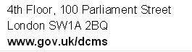

The full list of ways to follow the Games are available in Annex B.
The measurement of sport participation for adults is available in Sport England’s Active People Survey at http://www.sportengland.org/research/about-our-research/active-people-survey/.
Statistical significance tests are applied to all estimates to determine the likelihood that any apparent differences are due to real change, and not due to chance. This is an inherent limitation to using surveys to represent a wider population, in this case all adults in England, compared to carrying out a census, i.e. interviewing all adults in England, which would be prohibitively resource intensive.
DCMS’ input and impact indicators provide information on the delivery and progress towards the Department’s stated outcomes. They reflect the quality and effectiveness of the programmes and priorities set out in our business plan.
The full list of ways to follow the Games are available in Annex B.
Inspire Mark projects are projects that have been inspired by the Games with the aim of doing something special in local communities and are part of the London 2012 Inspire programme of projects. See the above link for more information.
A significant decrease at the 95% level means that there is less than a 5% (1 in 20) chance that the difference observed within the sampled respondents is not representative of the English population as a whole.
A significant increase at the 95% level means that there is less than a 5% (1 in 20) chance that the difference observed within the sampled respondents is not representative of the English population as a whole.
A classification of residential neighbourhoods is a geo-demographic information system categorising some United Kingdom postcodes into various types based upon census data and other information such as lifestyle surveys.
In July 2011, this statement became part of a response list. From July 2005 - June 2011, it was asked as a single question. For this reason, this estimate cannot be compared with previous year’s estimates.
Percentages will not total to 100% as some people may have visited a museum or gallery for more than one reason. Visits to museum and galleries for voluntary work have also not been included.
A significant decrease at the 95% level means that there is less than a 5% (1 in 20) chance that the difference observed within the sampled respondents is not representative of the English population as a whole.
Definitions of socio-economic groups and their classifications are available at http://www.ons.gov.uk/ons/guide-method/classifications/current-standard-classifications/soc2010/soc2010-volume-3-ns-sec--rebased-on-soc2010--user-manual/index.html
A significant decrease at the 95% level means that there is less than a 5% (1 in 20) chance that the difference observed within the sampled respondents is not representative of the English population as a whole.
A significant increase at the 95% level means that there is less than a 5% (1 in 20) chance that the difference observed within the sampled respondents is not representative of the English population as a whole.
An index measures change over time from a chosen starting point. It is expressed as a per cent of a base value, which always equals 100. In this example we are comparing each year’s figures with 2005/06. The values for 2005/06 equal 100 since this is the base year. An index of 110 in a subsequent year means that there has been a 10 per cent increase since 2005/06, whilst an index of 90 signifies a 10 per cent decrease since 2005/06.
Prior to July 2011 the question asked whether the respondent had visited “Theatre/ concert websites or other websites about art”. Since July 2011 the question was changed to ask whether they had visited “Arts websites (including music, theatre, dance, visual arts and literature)”. This may have had an impact on responses and therefore caution should be taken when comparing proportions before and after July 2011.
A significant decrease at the 95% level means that there is less than a 5% (1 in 20) chance that the difference observed within the sampled respondents is not representative of the English population as a whole.
Percentages will not total to 100% as some people may have visited an archive for more than one reason.
A significant increase at the 95% level means that there is less than a 5% (1 in 20) chance that the difference observed within the sampled respondents is not representative of the English population as a whole.
Actions include, contact a local radio station, TV station or paper; talk to / written to a sporting or cultural facility, contact the council, contact a local councillor or MP, join a local group or attend a neighbourhood forum, attend a protest meeting or joined a campaign group, or help organise a petition.
www.culture.gov.uk/images/research/TP_Barriersrreport.pdf
http://www.sportscotland.org.uk/ChannelNavigation/Resources/TopicNavigation/Collections/Research/Older+people+sport+and+physical+activity.htm
http://odi.dwp.gov.uk/docs/res/los/leisure.pdf
Design factors are calculated to correct for imperfect sample design. For example, Taking Part uses a clustered sample, rather than a random sample and this may affect the results for particular demographic groups – design factors are used to correct for this bias.

