19 September 2013
STATISTICAL RELEASE: EXPERIMENTAL STATISTICS
Domestic Green Deal and Energy Company Obligation in Great Britain, Quarterly report: January – June 2013
Introduction
This is the second detailed Green Deal (GD) and Energy Company Obligation (ECO) statistical release. This provides a range of further analysis and geographical breakdowns showing the latest picture of GD Assessments, Cashback, ECO and Supply Chain activity for the period January to June 2013 and estimates of the carbon and energy savings achieved through measures installed.

The most up to data information on the GD and ECO can be found in the monthly statistical releases – available here. Future quarterly releases will also provide more detailed breakdowns on GD Plans.

Key points (for January to June 2013)
Of the 44,479 Green Deal Assessments in Great Britain completed:

- Around a sixth (16 per cent) of GD Assessments were in the South East (7,056), the highest in any region. Five per cent of GD Assessments were in Wales (2,085) and three per cent were in Scotland (1,302).

Of the 43,177 Green Deal Assessments in England and Wales completed:

- The majority (88 per cent) of properties getting a GD Assessment had an energy efficiency band rating of D or lower, suggesting that GD Assessments are generally happening in properties which could benefit from energy efficiency measures. This compares to 85 per cent of the overall domestic building stock in England (Chart 1).

- There were 125,378 improvements recommended in Green Deal Assessments (around 2.9 improvements per assessment). The most common measures recommended were to upgrade the existing boiler with the same fuel and install loft insulation. These each accounted for 13 per cent of all measures and were each recommended in just over a third of all GD Assessments. All solid wall insulation types accounted for 11 per cent of all measures, cavity wall insulation 10 per cent of all measures and Photovoltaics (solar PV) 9 per cent of all measures.

- Around three quarters (77 per cent) of GD Assessments were in owner-occupied properties (33,126), with the remainder split equally between the private rented sector and the social rented sector. This compares to 65 per cent of the housing stock in England and Wales being owner occupied (Chart 3).

Of the provisional 149,681 measures installed under ECO:

- Around a fifth (19 per cent) of ECO measures were in the North West (28,395), the highest in any region. 10 per cent of ECO measures were installed in Scotland (14,616) and five per cent were in Wales (7,923).

Carbon and energy saving

- The estimated lifetime carbon savings of measures installed under ECO (excluding Affordable Warmth) and Cashback was 1.61 MtCO2 with estimated lifetime energy savings of 7,835 GWh.

Contents

Detailed Results Pages 3-14

Green Deal Assessments Pages 3-8

Cashback measures installed Page 8

Measures installed under ECO Pages 8-10

ECO brokerage Page 10

Estimated carbon and energy savings Pages 10-11

The Supply Chain Pages 11-14

Annex A Main Tables Pages 15-23

Annex B Background Pages 24-25

Annex C Sources and Methodology Pages 26-28

Charts
Chart 1 Percentage of GD Assessments lodged, by energy efficiency band
Chart 2 Percentage of GD Assessments lodged, by property type
Chart 3 Percentage of GD Assessments lodged, by tenure

Maps
Map 1 Number of Green Deal Assessments lodged by Local Authority
Map 2 Provisional number of ECO measures installed by Local Authority
Map 3 Number of Assessor organisations operating per Local Authority
Map 4 Number of Installers operating per Local Authority
Detailed Results
This section of the report provides detailed information on different elements of the Green Deal, including a geographic breakdown of where GD Assessments took place and the characteristics of these properties. This report also provides, for the first time, geographic breakdowns on measure installed through Cashback and ECO as well as estimates of the carbon savings achieved through these measures.
Where the report refers to table numbers in brackets, these are the tables included in Annex A and separately in Excel here.

Green Deal Assessments, completed up to 30th June 2013
The Green Deal launched on 28 January 2013 in England and Wales and on 25 February in Scotland. ECO started on 1 January 2013 for Great Britain.

The first step in the Green Deal process involves a Green Deal Assessor coming to the home, talking to the owner/occupier about their energy use and seeing if they can benefit from making energy efficiency improvements to their property.

The main output from this process is that a Green Deal Advice Report (using information from an Energy Performance Certificate and Occupancy Assessment) will be produced and will be lodged on a national register. The householder is then able to view the energy efficiency measures which have been recommended and understand the potential costs and savings.

For more information on the GD assessment process see here or go to Annex B.

Geographic location (Tables 1, 1a, 1b, Map 1)

GD Assessments have been taking place in properties throughout Great Britain. Table 1 presents the regional breakdown of GD Assessments lodged up to 30th June. Tables 1a and 1b present the number of GD Assessments that took place in each Local Authority (LA) (Table 1a) and Parliamentary Constituency (Table 1b).

Around a sixth (16 per cent) of GD Assessments were in the South East (7,056), the highest in any region; this is broadly comparable with the 16 per cent of dwelling stock in 2011 in England as reported by the Department of Communities and Local Government. 14 per cent were in both the North West (6,230) and the West Midlands (6,126), compared to 14 per cent and 10 per cent of dwellings in England. Five per cent of GD Assessments were in Wales (2,085) and three per cent were in Scotland (1,302).

Map 1 shows the number of Green Deal Assessments lodged by Local Authority in England and Wales. The large majority of Local Authorities in England and Wales had at least 10 GD Assessments, showing that GD Assessments were spread across the country.
Map 1 – Number of Green Deal Assessments lodged by Local Authority up to 30th June 2013
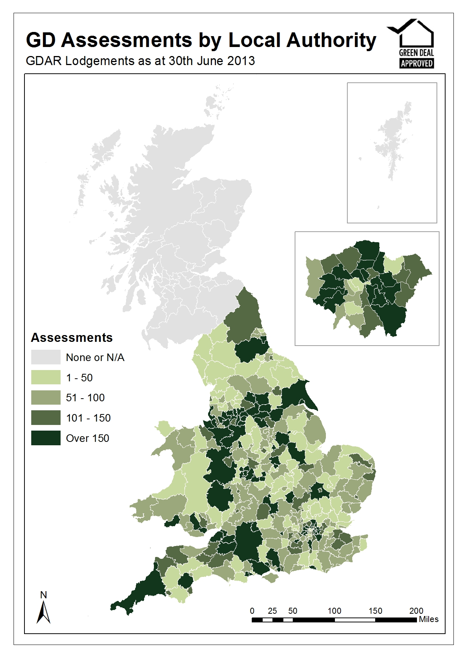
Energy Efficiency Rating (EER) Bands (Table 2, Chart 1)

The energy efficiency rating is presented in an A-G banding system for an Energy Performance Certificate, where Band A rating represents low energy costs (i.e. the most efficient band) and Band G rating represents high energy costs (i.e. the least efficient band).

Chart 1 compares properties that have had Green Deal assessments (coloured blocks) against the energy efficiency rating bands of properties in England in 2011 reported in the English Housing Survey (blocks with black outline).

A slightly higher proportion of Green Deal assessed properties were in the lower energy efficiency bands compared to all properties in England. 88 per cent of properties getting a GD Assessment had an energy efficiency band rating of D or lower, compared with 85 per cent of all properties in England.

Chart 1 – Percentage of GD Assessments lodged, up to 30th June 2013, by Energy Efficiency Band compared with Energy Efficiency Band ratings of all properties in England in 2011.

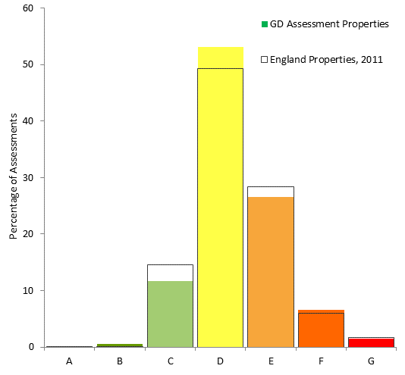

Property Type (Table 3, Chart 2)

Chart 2 shows that 79 per cent of GD Assessments were in houses (34,278), 11 per cent were in flats (4,698), seven per cent were in bungalows (3,161) and two per cent were in maisonettes (1,040). The housing stock in England (as reported in the English Housing Survey 2011-12) shows that 71 per cent of property types were houses, 20 per cent were flats and/or maisonettes (purpose built flat or converted flat), and nine per cent were bungalows.

Chart 2 - Percentage of Green Deal Assessments and England and Wales properties by property type, up to 30th June 2013

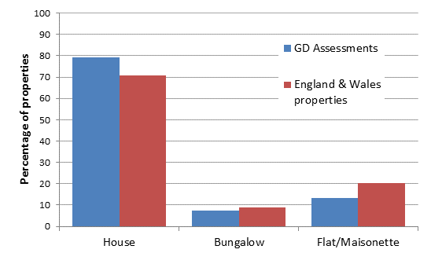

Built Form (Table 4)

The four main types of build are detached, semi-detached, end-terrace and mid-terrace. 35 per cent of GD Assessments (15,179) were semi-detached, followed by 29 per cent which were mid-terrace (12,662), 21 per cent were detached (8,882) and 15 per cent were end-terrace (6,454).

Tenure (Table 5, Chart 3)

Around three quarters (77 per cent) of GD Assessments were in owner-occupied properties (33,126), 12 per cent were in the social rented sector (5,084) and the remaining 11 per cent were in the private rented sector (4,641). In comparison, according to dwelling stock figures released by Department for Communities and Local Government in England and the Welsh Government for Wales there were 65 per cent owner-occupied, 17 per cent social rented sector and 17 per cent private rented sector properties. This suggests that a higher proportion of GD Assessments were in owner-occupied properties than would be expected from the distribution of the housing stock.

Chart 3 – Percentage of Green Deal Assessments and England and Wales properties by tenure, up to 30th June 2013

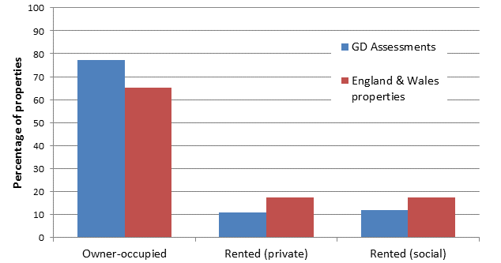

On or off the Mains Gas Grid (Table 6)

In 2011 it was estimated 3.1 million households do not have mains-gas supply in England and Wales. This is around 14 per cent of all properties in England and Wales, and this is similar to the 11 per cent of properties which had a GD assessment and were off the mains-gas grid.

Recommended measures (Tables 7, 7a, 7b)

There were 125,378 improvements recommended in Green Deal Advice Reports, on average around 2.9 recommended measures per GD Assessment. In 35 per cent of Assessments (15,113) one measure was recommended, in 20 per cent of Assessments (8,690) a package of two measures were recommended, in 12 per cent of Assessments (5,348) a package of three measures were recommended, and in 32 per cent of Assessments (14,024), packages of four or more measures were recommended (Table 7b).

The most common measures recommended were to upgrade the existing boiler with the same fuel and install loft insulation. These each accounted for 13 per cent of all measures each and each were recommended in just over a third of all GD assessments (Table 7a).

Cavity wall insulation was the third most common recommendation (10 per cent of all measures recommended). Photovoltaics (solar PV) were the most recommended micro-generation measure, accounting for 9 per cent of recommendations and recommended in around a quarter of all GD assessments. Floor insulation (9 per cent of all measures recommended) and heating controls for wet central heating systems (8 per cent) were other commonly recommended measures. All solid wall insulation types accounted for 11 per cent of all measures recommended.

Cashback measures installed, up to 30th June 2013

The Cashback scheme in England and Wales has been available since January 2013. It is a financial incentive aimed to encourage domestic customers to get measures installed through the Green Deal process, although it is the customers’ choice whether they decide to take out Green Deal finance or other sources of finance to fund the installation of the measures. Cashback vouchers can only be paid after the installation of measures. There were 3,449 Cashback vouchers paid up to 30th June 2013.
Geographic location of cashback vouchers where payments have been made, up to 30th June (Tables 8, 8a and 8b)
Table 8 presents the regional breakdown of cashback vouchers paid up 30th June. Tables 8a and 8b present the number of Cashback vouchers that have been paid in each LA and Parliamentary Constituency in England and Wales up to 30th June.

A quarter of cashback vouchers have been paid in the North West. This is greater than the proportion of GD Assessments that took place in the North West (see Table 1). The regions with the next highest proportions were the South East (15 per cent of all cashback vouchers paid) and the West Midlands (12 per cent).

Measures installed under ECO, up to 30th June 2013
The overall Energy Company Obligation (ECO) period runs until 31 March 2015. All measures installed under ECO are provisional until the end of the obligation period as checks are undertaken. Initial validation checks are undertaken by Ofgem in the month following receipt of data and longer-term audits are done over the obligation period (e.g. to verify the installation of the measures and the quality of installations and to ensure compliance with the ECO guidelines). Users should note that, in order to produce the most timely data possible, estimates in this report include a month of data that has yet to be through initial Ofgem validation checks (i.e. as reported by energy suppliers to Ofgem). Revisions to data are routinely included in releases and will be explained if they are significant.
Geographic location of provisional measures installed under ECO, up to 30th June (Tables 9, 9a and 9b, Map 2)
Tables 9, 9a and 9b present the number of provisional measures installed under ECO, broken down by obligation, in each region (Table 9), LA (Table 9a) and Parliamentary Constituency (Table 9b) up to 30th June.

Around a fifth (19 per cent) of ECO measures were in the North West (28,395), the highest in any region. The regions with the next highest proportions were the West Midlands (14 per cent) and Yorkshire and the Humber (10 per cent) 10 per cent of ECO measures were installed in Scotland (14,616) and five per cent were in Wales (7,923).
Map 2 – Provisional number of ECO measures installed by Local Authority
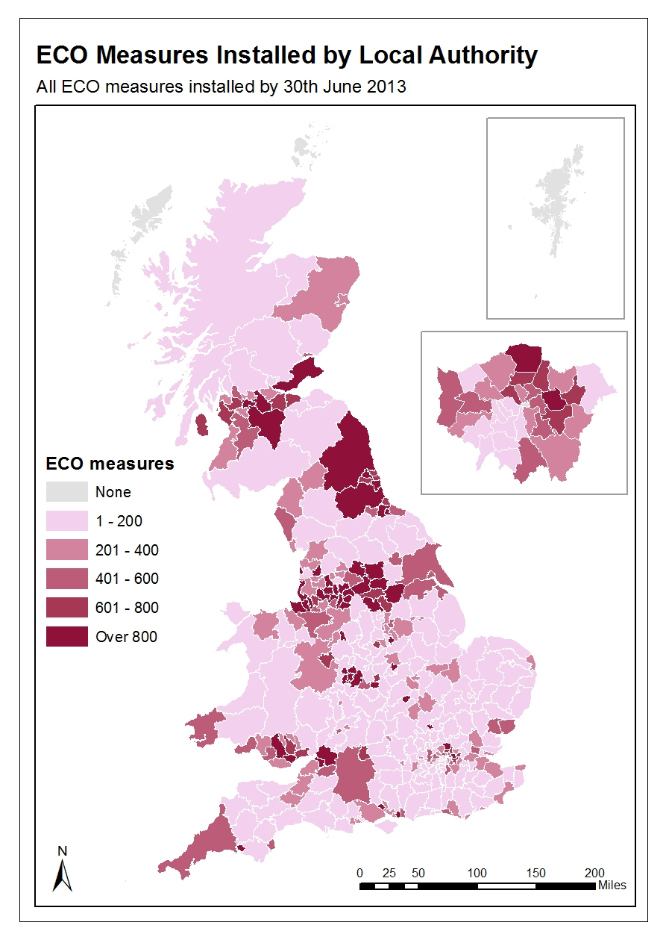

Up to 30th June 2013, 134,133 unique properties had benefitted from having at least one ECO measure installed (Table 9). By ECO obligation, 50,833 properties had Affordable Warmth (HHCRO) measures installed, 45,678 properties had Carbon Saving Community measures installed, and 37,944 unique properties had Carbon Savings Target measures installed.
Fuel type of property of provisional measures installed under ECO, up to 30th June (Table 10)
Table 10 presents the number of provisional measures installed under ECO up to 30th June, broken down by the main fuel type of the property and obligation. This shows that 96 per cent of all ECO measures were installed in gas-fuelled properties, with 3 per cent installed in those fuelled by electricity and 1 per cent installed in those fuelled by other fuels. This varies slightly by obligation, with more electricity-fuelled properties benefitting from measures installed under the Carbon Saving Obligation (6 per cent) than under Affordable Warmth (1 per cent).

Gas is the main source of heating in 84 per cent of households in England. This suggests that a higher proportion of measures installed under ECO were in gas-fuelled properties that would be expected from the housing stock.

ECO Brokerage

The ECO Brokerage system operates as a fortnightly anonymous auction where providers can sell ‘lots’ of future measures of ECO Carbon Saving Obligation, ECO Carbon Saving Communities and ECO Affordable Warmth, to energy companies in return for ECO subsidy.

ECO Brokerage clearing prices by ECO obligation by auction, up to 31st July (Table 11)

Table 11 presents the clearing prices of all lots sold through ECO brokerage from auctions taking place up to the end of July. This shows that the average price paid for lots is decreasing for all three obligations.

Estimated carbon and energy savings for measures installed through Cashback and ECO, up to 30th June
The Final Stage Impact Assessment for the Green Deal and Energy Company Obligation reported that both policies would lead to significant carbon and energy savings. This section estimates the carbon and energy savings derived from measures installed through these policy areas.
Estimated carbon and energy savings relating to measures installed through Cashback and ECO, up to 30th June (Table 12)

Table 12 presents the combined estimated impact of measures installed through Cashback or under ECO (through the Carbon Saving Obligation and Carbon Saving Communities Obligation, but not Affordable Warmth) up to the end of June 2013. This is because carbon reductions are not the stated aim of this policy and difficulties in accurately estimating their carbon impact. This obligation of ECO is anticipated to lead to a net reduction in carbon. However, this depends on reductions in the traded sector emissions out-weighing any increase in non-traded sector emissions.
The estimated lifetime carbon savings of these measures is 1.61 MtCO2 with estimated lifetime energy savings of 7,835 GWh.
For Cashback measures, the net estimated carbon savings has been calculated from the difference between that in the original EPC (pre-installation of measures) and the new EPC (post installation of measures). For ECO only measures, the estimated lifetime carbon savings has been revised to account for estimated levels of comfort taking, which better represent our understanding of the assumed net impact of the installed measures.
This table will, in the future, try to account for the estimated carbon and energy savings of self-financed measures and measures installed through GD or combinations of GD and other delivery mechanisms. Furthermore, there has been no consideration of the estimated carbon or energy savings impact of Affordable Warmth measures.
More information on the methodology used is included here
The Supply Chain
To understand more about the organisations and infrastructure underpinning the Green Deal, this report also includes a section on geographical coverage of the number of Assessor organisations and Green Deal Installer organisations.
Supply chain operational coverage, as at 28th July (Table 13, Maps 3 and 4)
The supply chain to support the Green Deal has been developing since October 2012. This includes individual Advisors (who carry out and produce Green Deal Advice Reports) and Assessor organisations (who employ authorised Green Deal Advisors), Green Deal Providers (who quote for and arrange Green Deal Plans with customers), and Installer organisations (who install energy efficiency improvements under the GD finance mechanism).
The Green Deal Oversight and Regulation Body (ORB) produces publically available information on the supply chain, and the latest figures are available by using the search tool on the ORB website. There is also information available on contacts in local areas.
These organisations operate in different geographical locations and provide a wide variety of offers to consumers. Table 13 and Maps 3 and 4 show the self-reported operational coverage of Green Deal Providers, Assessor organisations and Installers by Local Authority. These figures are based on information submitted onto the ORB consumer search tool by a number of these participating organisations. 18 of the 79 (23 per cent) Green Deal Providers, 150 of the 277 (54 per cent) Assessor organisations and 664 of the 1,616 (41 per cent) Installers had submitted their information as at 28th July 2013.
These figures and maps provide an indication of where these organisations are expecting to operate. However, businesses are flexible and may travel further to other areas as the market develops. Table 13 and Maps 3 and 4 indicate that there is good coverage of where these organisations are expecting to operate across all Local Authorities in Great Britain.
There is some variation in the level of coverage in different administrative areas, with generally fewer Green Deal Providers, Assessor Organisations and installers in Scotland and Wales compared to England. LAs in the North West have the most complete coverage of the GD supply chain out of all regions in Great Britain.
Overall, all LAs are covered by at least three Green Deal Providers, 15 Assessor Organisations and 58 installers.
Map 3 – Number of Assessor organisations operating per Local Authority
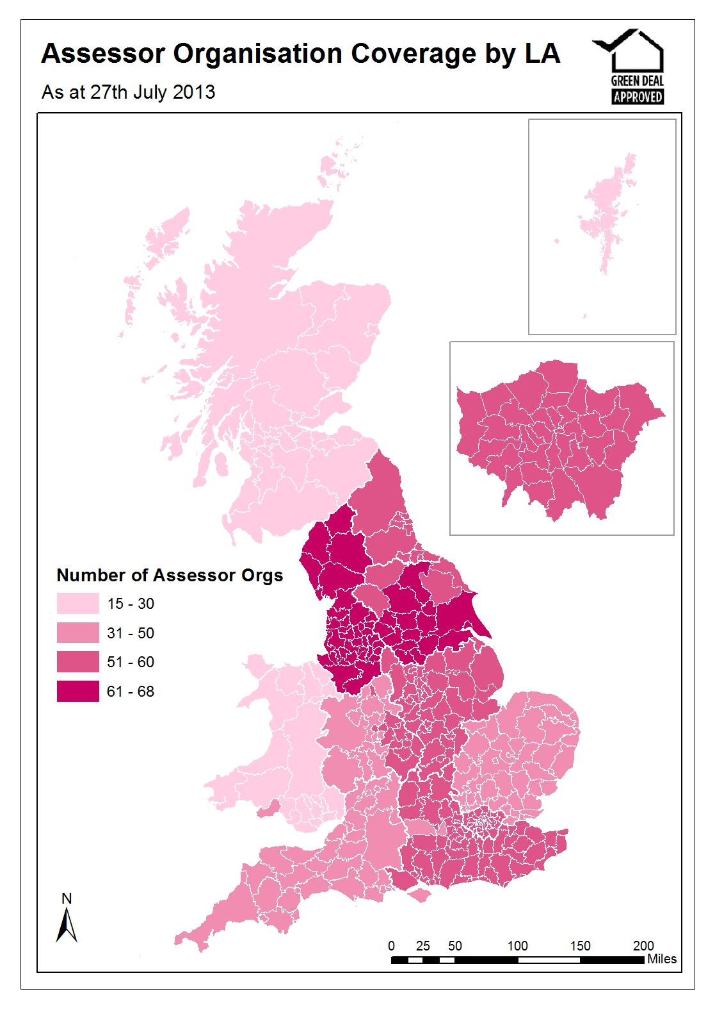
Map 4 – Number of Installers operating per Local Authority
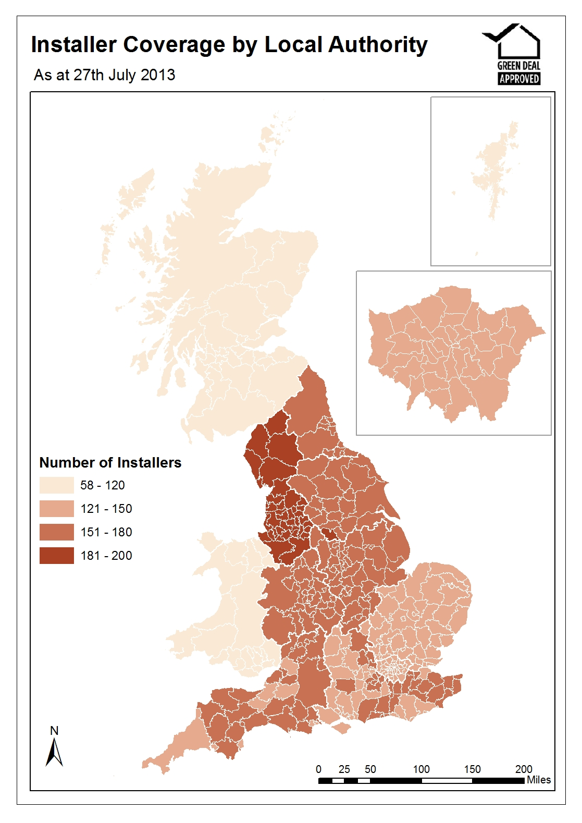

Annex A – Main Tables

Table 1: Number of Green Deal Assessments lodged by region, up to 30th June 2013

Area names |  |  |  | Green Deal Assessments |  | Percentage of Assessments
Great Britain |  |  |  | 44,479 | 100
England |  |  |  | 41,092 | 92
North East |  |  |  | 1,178 | 3
North West |  |  |  | 6,230 | 14
Yorkshire and The Humber |  |  |  | 4,444 | 10
East Midlands |  |  |  | 3,068 | 7
West Midlands |  |  |  | 6,126 | 14
East |  |  |  | 3,005 | 7
London |  |  |  | 5,947 | 13
South East |  |  |  | 7,056 | 16
South West |  |  |  | 4,038 | 9
Wales |  |  |  | 2,085 | 5
Scotland |  |  |  | 1,302 | 3

Table 1a: Number of Green Deal Assessments lodged by administrative area, up to 30th June 2013 (Table available in Excel here).

Table 1b: Number of Green Deal Assessments lodged by Parliamentary Constituency, up to 30th June 2013, England and Wales (Table available in Excel here).

Table 2: Number of Green Deal Assessments by Energy Efficiency Band, up to 30th June 2013, England and Wales

Energy Efficiency Band |  | Green Deal Assessments | Percentage of Assessments
A |  | 11 | 0
B |  | 218 | 1
C |  | 5,064 | 12
D |  | 22,907 | 53
E |  | 11,479 | 27
F |  | 2,848 | 7
G |  | 650 | 2
Total |  | 43,177 | 100

Table 3: Number of Green Deal Assessments by Property Type up to 30th June 2013, England and Wales

Property Type |  | Green Deal Assessments | Percentage of Assessments
House |  | 34,278 | 79
Bungalow |  | 3,161 | 7
Flat |  | 4,698 | 11
Maisonette |  | 1,040 | 2
Total |  | 43,177 | 100

Table 4: Number of Green Deal Assessments by Built Form, up to 30th June 2013, England and Wales

Built Form |  | Green Deal Assessments | Percentage of Assessments
Detached |  | 8,882 | 21
Semi-Detached |  | 15,179 | 35
End-Terrace |  | 6,454 | 15
Mid-Terrace |  | 12,662 | 29
Total |  | 43,177 | 100

Table 5: Number of Green Deal Assessments by tenure, up to 30th June 2013, England and Wales

Tenure |  | Green Deal Assessments | Valid Percentage of Assessments¹
Owner-occupied |  | 33,126 | 77
Rented (private) |  | 4,641 | 11
Rented (social) |  | 5,084 | 12
Unknown |  | 326 | -
Total |  | 43,177 | 100

¹ Percentage of Assessments is calculated only for those Assessments where tenure is known.

Table 6: Number of Green Deal Assessments by whether property is on or off the Mains Gas Grid, up to 30th June 2013, England and Wales

Properties by whether on or off Mains Gas Grid |  | Green Deal Assessments | Percentage of Assessments
Off Gas |  | 4,783 | 11
On Gas |  | 38,394 | 89
Total |  | 43,177 | 100

Table 7: Number of improvements recommended in Green Deal Assessments by measure type (grouped), up to 30th June 2013, England and Wales

Measure Types |  | Number of improvements recommended ¹ | Percentage of improvements recommended
Boiler |  | 18,466 | 15
Cavity Wall Insulation |  | 12,615 | 10
Loft Insulation |  | 16,787 | 13
Micro-generation |  | 19,017 | 15
Other Heating |  | 13,241 | 11
Other Insulation |  | 26,199 | 21
Solid Wall Insulation |  | 13,532 | 11
Window Glazing |  | 5,521 | 4
Total |  | 125,378 | 100

¹ More than one improvement can be recommended per Assessment. On average, there are around three improvements recommended per Assessment.

Table 7a: Number of improvements by measures recommended in Green Deal Assessments, up to 30th June 2013, England and Wales

Measure Type by Measures | Number of improvements recommended¹ | Percentage of improvements recommended
Boiler | 18,466 | 15
Change heating to gas condensing boiler (fuel switch) | 795 | 1
Change heating to gas condensing boiler (fuel switch), and flue gas heat recovery | 53 | 0
Change heating to gas condensing boiler (no fuel switch) | 304 | 0
Change heating to gas condensing boiler (no fuel switch), and flue gas heat recovery | 10 | 0
Condensing oil boiler | 319 | 0
Upgrade boiler, same fuel | 16,440 | 13
Upgrade boiler, same fuel, and flue gas heat recovery | 545 | 0
Cavity wall insulation | 12,615 | 10
Loft Insulation | 16,787 | 13
Loft Insulation | 15,817 | 13
Room-in-roof insulation | 970 | 1
Micro-generation | 19,017 | 15
Air source heat pump with radiators | 281 | 0
Air source heat pump with underfloor heating | 35 | 0
Biomass wood logs boiler | 130 | 0
Biomass wood pellets room heater with boiler | 47 | 0
Ground source heat pump with radiators | 74 | 0
Ground source heat pump with underfloor heating | 14 | 0
Micro-CHP | 42 | 0
Photovoltaics | 11,343 | 9
Solar water heating | 6,438 | 5
Wind turbine (on mast) | 40 | 0
Wind turbine (roof mounted) | 573 | 0
Other Heating | 13,241 | 11
Cylinder thermostat | 1,817 | 1
Heating controls for warm air system | 174 | 0
Heating controls for wet central heating system | 10,223 | 8
New or replacement storage heaters | 640 | 1
Replacement warm-air unit | 73 | 0
Waste water heat recovery | 314 | 0
Other Insulation | 26,199 | 21
Draughtproofing | 5,854 | 5
Flat roof insulation | 1,331 | 1
Floor insulation | 10,937 | 9
Hot water cylinder insulation | 3,506 | 3
Insulated doors | 4,571 | 4
Solid Wall Insulation | 13,532 | 11
External insulation with cavity wall insulation | 648 | 1
Solid wall insulation (pre 1967 England & Wales, pre 1965 Scotland) | 9,246 | 7
Solid wall insulation (from 1967 E&W, from 1965 Scotland) | 3,638 | 3
Window Glazing | 5,521 | 4
Double glazing | 4,933 | 4
Secondary glazing | 472 | 0
Triple glazing | 116 | 0
Total | 125,378 | 100

¹ More than one measure can be recommended per Assessment. On average, there are around three recommendations per Assessment.
² There were two GD assessments that did not recommend any improvements

Table 7b: Number of improvements recommended per Green Deal Assessment, up to 30th June 2013, England and Wales

Number of improvements recommended¹ |  | Number of Green Deal Assessments | Percentage of Green Deal Assessments
0 |  | 2 | 0
1 |  | 15,113 | 35
2 |  | 8,690 | 20
3 |  | 5,348 | 12
4 or more |  | 14,024 | 32
Total |  | 43,177 | 100

¹ Two Green Deal Assessments did not recommend any measures

Table 8: Number of Cashback vouchers paid by region, up to 30th June 2013, England and Wales

Area names |  |  |  | Total number of Cashback vouchers paid | Valid percentage of Cashback vouchers paid¹
England and Wales |  |  |  | 3,449 | 100
England |  |  |  | 3,093 | 93
North East |  |  |  | 118 | 4
North West |  |  |  | 824 | 25
Yorkshire and The Humber |  |  |  | 335 | 10
East Midlands |  |  |  | 294 | 9
West Midlands |  |  |  | 402 | 12
East |  |  |  | 107 | 3
London |  |  |  | 200 | 6
South East |  |  |  | 502 | 15
South West |  |  |  | 311 | 9
Wales |  |  |  | 219 | 7
Unknown |  |  |  | 137 | -

¹ Percentage of Cashback vouchers paid is calculated only for those vouchers where the location is known.

Table 8a: Number of Cashback vouchers paid by administrative area, up to 30th June 2013, England and Wales (Table available in Excel here).

Table 8b: Number of Cashback vouchers paid by Parliamentary Constituency, up to 30th June 2013, England and Wales (Table available in Excel here).

Table 9: Provisional number of ECO measures by ECO obligation by region and total number of unique properties benefitting from ECO, up to 30th June 2013

 |  |  | Obligation
Area names |  |  | Carbon Saving Target (CSO) | Carbon Savings Community³ (CSCO) | Affordable Warmth (HHCRO) | Total number of ECO measures delivered | Valid percentage of ECO measures delivered¹
Great Britain |  |  | 46,059 | 49,530 | 54,092 | 149,681 | 100
England |  |  | 38,931 | 44,045 | 44,089 | 127,065 | 85
North East |  |  | 3,616 | 4,291 | 4,310 | 12,217 | 8
North West |  |  | 6,908 | 11,039 | 10,448 | 28,395 | 19
Yorkshire and The Humber |  |  | 3,265 | 5,207 | 5,885 | 14,357 | 10
East Midlands |  |  | 2,827 | 3,739 | 4,078 | 10,644 | 7
West Midlands |  |  | 3,531 | 8,021 | 8,708 | 20,260 | 14
East |  |  | 4,087 | 1,451 | 2,043 | 7,581 | 5
London |  |  | 3,528 | 5,700 | 2,669 | 11,897 | 8
South East |  |  | 5,745 | 2,219 | 3,677 | 11,641 | 8
South West |  |  | 5,424 | 2,378 | 2,271 | 10,073 | 7
Wales |  |  | 1,826 | 2,269 | 3,828 | 7,923 | 5
Scotland |  |  | 5,282 | 3,216 | 6,118 | 14,616 | 10
Unknown |  |  | 20 | 0 | 57 | 77 | -
Total number of unique properties² |  |  | 37,944 | 45,678 | 50,833 | 134,133

¹ Percentage of ECO measures delivered is calculated only for those ECO measures where the location is known.
² The number of unique properties by ECO sub-obligation does not tally to the total number of unique properties (134,133) as a property can have a number of different measures installed under different ECO obligations.

Table 9a: Provisional number of ECO measures by ECO obligation by administrative area, up to 30th June 2013 (Table available in Excel here).

Table 9b: Provisional number of ECO measures by ECO obligation by Parliamentary Constituency, up to 30th June 2013 (Table available in Excel here).
Table 10: Provisional number of ECO measures by main fuel type of property and ECO obligation, up to 30th June 2013
 |  |  | Obligation |  |  |  | Total number of ECO measures delivered ¹
Fuel Type | Carbon Saving Target (CSO) |  | Carbon Savings Community (CSCO) |  | Affordable Warmth (HHCRO)
 | Number | Percentage | Number | Percentage | Number | Percentage | Number | Percentage
Gas | 42,625 | 93 | 48,250 | 97 | 52,543 | 98 | 143,418 | 96
Electric | 2,801 | 6 | 994 | 2 | 769 | 1 | 4,564 | 3
Other ² | 158 | 0 | 201 | 0 | 230 | 0 | 589 | 0
Oil | 314 | 1 | 34 | 0 | 240 | 0 | 588 | 0
Coal | 77 | 0 | 46 | 0 | 29 | 0 | 152 | 0
Unknown | 84 | - | 5 | - | 281 | - | 370 | -
Total | 45,975 | 100 | 49,525 | 100 | 53,811 | 100 | 149,681 | 100

¹ Percentage of ECO measures delivered is calculated only for those ECO measures where the location is known.
² "Other" fuel type includes District Heating Systems, Liquefied Petroleum Gas and renewables.

Table 11: ECO Brokerage Auction clearing prices¹ by ECO obligation by auction, up to end of July 2013
Auction | Clearing price for Carbon Saving Obligations (CSO) | Clearing price for Carbon Saving Communities (CSCO) | Clearing price for Affordable Warmth (HHCRO)
 | £ per tonne | £ per tonne | £ per £ notional bill saving
Auction 1 | £100.40 | Nothing sold | £0.22
Auction 2 | £103.13 | Nothing sold | £0.21 - £0.24
Auction 3 | £120.00 | £60.00 | £0.23 - £0.24
Auction 4 | £120.00 | £35.57 - £65.37 | £0.22 - £0.24
Auction 5 | £115.10 - £125.10 | Nothing sold | £0.20 - £0.24
Auction 6 | £122.83 | Nothing sold | £0.23 - £0.24
Auction 7 | £102.60 - £120.00 | £42.00 - £55.00 | £0.22 - £0.24
Auction 8 | £119.00 - £120.00 | £50.00 - £55.00 | Nothing sold
Auction 9 | £100.00 - £120.10 | £50.00 - £52.00 | £0.21
Auction 10 | £112.00 | £50.00 - £52.00 | £0.19 - £0.21
Auction 11 | £99.00 - £104.00 | £50.00 | £0.17 - £0.19
Auction 12 | £96.00 - £99.00 | £45.00 | £0.15 - £0.16
Auction 13 | £94.56 | no lots submitted | £0.12 - £0.15
Auction 14 | Nothing sold | £45.00 - £50.00 | £0.14
Auction 15 | £85.00 | £44.00 - £50.00 | £0.13 - £0.15

¹ Clearing prices are either presented as a single figure (where only one trade has taken place or where multiple trades have taken place at the same price) or as a range (where two or more trades have taken place at different prices).
Table 12: Estimated carbon and energy savings relating to measures installed through Cashback and ECO, up to 30th June 2013
Measure type | Estimated lifetime carbon saving (MtCO2) |  |  | Estimated lifetime energy saving (GWh)
 | Non-traded² | Traded | Total
Boiler ³ | 0.00 | 0.00 | 0.00 | 19
Cavity Wall Insulation | 0.98 | 0.07 | 1.05 | 5,044
Loft Insulation | 0.41 | 0.01 | 0.42 | 2,126
Micro-generation | 0.00 | 0.00 | 0.00 | 0
Other Heating | 0.00 | 0.00 | 0.00 | 0
Other Insulation ³ | 0.00 | 0.00 | 0.00 | 4
Solid Wall Insulation | 0.12 | 0.02 | 0.14 | 642
Window Glazing | 0.00 | 0.00 | 0.00 | 0
Total ⁴ | 1.51 | 0.10 | 1.61 | 7,835
¹ Does not include any estimated savings through Affordable Warmth. Please see the Methodology Note for more details
² Carbon emissions are divided into the traded - those covered by the EU Emission Trading Scheme (ETS) - and non-traded sectors
³ There is a small level of estimated carbon saving attributable to ‘boilers’ and ‘other insulation’. However, when rounded to two decimal points this appears as zero.
⁴ These estimated carbon savings have not been incorporated into DECC’s recent Updated Energy Projections (UEPs) published on 16th September 2013, which instead is consistent with energy and carbon saving projections as specified in June 2012’s Green Deal and ECO Final Impact Assessment.

Table 13: Number of accredited Assessor organisations, Green Deal Providers, and Installer organisations reporting where they would operate, by Lower Tier Local Authority, as of 28th July 2013 (Table available in Excel here).

Annex B – Background

Green Deal

The Green Deal (GD) was launched on 28 January 2013 in England and Wales (and on 25 February in Scotland) and will tackle a number of the key barriers to the take-up of energy efficiency measures.

Customers having Green Deal Assessments undertaken have the choice of how they proceed. They might take the view that their home is sufficiently energy efficient, or that they want to finance work through a Green Deal Plan or that they want to use alternative funding arrangements (e.g. use of savings).
The Green Deal process for households is briefly described below:

Step 1 – Assessment – A Green Deal assessor will come to the home, talk to the owner/occupier about their energy use and see if they can benefit from making energy efficiency improvements to their property.

Step 2 - Recommendations – The assessor will recommend improvements that are appropriate for the property and indicate whether they are expected to pay for themselves through reduced energy bills.

Step 3 – Quotes – Green Deal Providers will discuss with the owner/occupier whether a Green Deal Plan is right for them and quote for the recommended improvements, including the savings estimates, savings period, first year instalments and payment period for each improvement. A number of quotes can be obtained.

Step 4 – Signing a Plan – The customer chooses to proceed with a given provider and package of measures. The owner/occupier needs to obtain the necessary consent to make improvements to the property before they can agree terms with the GD Provider of a Green Deal Plan, at which stage they enter a cooling-off period.

Step 5 – Installation – Once a Green Deal Plan has been agreed, the Provider will arrange for the improvements to be made by a Green Deal Installer. Once the installation has been completed a letter is sent to the Bill Payer and, at this stage, the Green Deal Plan goes ‘live’.

Repayments will be no more than what a typical household should save in energy costs.

Energy Company Obligation

The Energy Company Obligation (ECO) started on 1 January 2013 (although energy companies have been able to count against their targets measures delivered since 1 October 2012) and runs to 31 March 2015. It broadly takes over from two previous schemes (Carbon Emissions Reduction Target - CERT - and Community Energy Saving Programme - CESP) and focuses on providing energy efficiency measures to low income and vulnerable consumers and those living in 'hard-to-treat' properties. While ECO is not a financial target, DECC’s Impact Assessment estimated costs at around £1.3 billion a year.

There are three main ECO obligations – The Carbon Saving Obligation (CSO); Carbon Saving Communities (CSCO) and Affordable Warmth (HHCRO). The ECO Carbon Saving Obligation is estimated to be worth around £760 million per year. The Carbon Saving Community Obligation and ECO Affordable Warmth will together provide support worth around an estimated £540 million per year to low-income households and areas.

Carbon Saving Obligation - This covers the installation of measures like solid wall and hard-to-treat cavity wall insulation, which ordinarily can’t be financed solely through the Green Deal.

Carbon Saving Communities Obligation - This provides insulation measures to households in specified areas of low income. It also makes sure that 15 per cent of each supplier’s obligation is used to upgrade more hard-to-reach low-income households in rural areas.

Affordable Warmth Obligation - This provides heating and insulation measures to consumers living in private tenure properties who receive particular means-tested benefits. This obligation supports low-income consumers who are vulnerable to the impact of living in cold homes, including the elderly, disabled and families.

How do the Green Deal and ECO interact?

Following a GD Assessment there will be a range of measures which could improve the energy efficiency of the property. Some of these could be paid for through GD finance, up to the point where the expected annual cost will not exceed what a typical household should save in energy costs. However, depending on the measure or the property, other sources of finance may also be required. ECO funding could be one of these sources, for example for measures such as Solid Wall Insulation and hard-to-treat Cavity Wall insulation.

Green Deal Cashback

The Green Deal Cashback Scheme rewards the first Green Deal customers. It is a first-come, first served offer where householders can claim cash back from Government on energy saving improvements like insulation, front doors, windows and boilers with packages worth over £1000. It is available for households in England and Wales. For more information on Cashback please see the Cashback website. For more information on the separate scheme that operates in Scotland please see the relevant website.

ECO Brokerage

The ECO Brokerage system operates as a fortnightly anonymous auction where GD Providers can sell ‘lots’ of future measures of ECO Carbon Saving Obligation, ECO Carbon Saving Communities and ECO Affordable Warmth, to energy companies in return for ECO subsidy.

This market-based mechanism has been introduced to support an open and competitive market for the delivery of the ECO. Brokerage allows a range of Green Deal providers to fairly compete on price to attract ECO support and enables energy suppliers to deliver their obligations at the lowest possible cost, thereby reducing the impact on customer energy bills.

Sellers (GD Providers) can make a competitive offer on brokerage by leveraging additional sources of finance, such as part funding measures through Green Deal Finance, partnerships with local authorities, or driving down costs by economies of scale.

Annex C – Sources and Methodology

Data Sources
The estimates in this and future Statistical Release use administrative data generated as part of the Green Deal and Energy Company Obligation processes.
There are seven main sources of information:
- Landmark – who manage the national lodgement of Green Deal Assessments in England and Wales
- Energy Savings Trust (EST) – who manage the national lodgement of Green Deal Assessments in Scotland
- Green Deal Central Charge Database – which manages the recording and administration of Green Deal Plans
- Ofgem – who administer the Energy Company Obligation and collect information from energy companies on measures installed under ECO.
- The Green Deal Oversight and Regulation Body (ORB) – who administer the certification of GD organisations (including assessors, installers and providers)
- Data on ECO brokerage is publically available following each auction.
- Capita – who administer the Green Deal Cashback Scheme

This report uses data from Landmark and the Energy Savings Trust for numbers of lodged Assessments, and data from the ORB for the supply chain.

Property Characteristics

Information relating to the characteristics of properties getting GD Assessments is taken from the Energy Performance Certificate relating to the GD Assessment. Properties can be built in a large variety of configurations. A basic division is between free-standing or single-family houses and various types of attached or multi-user dwellings. Both sorts may vary greatly in scale and amount of accommodation provided. Many variations are purely matters of style rather than spatial arrangement or scale.

All property types have a built form. The four main types of build are detached, semi-detached, end-terrace and mid-terrace. Mid-terrace has external walls on two opposite sides; end-terrace has three external walls.

Energy Efficiency Rating

The Energy Efficiency Rating (EER) is presented in an A-G banding system for an Energy Performance Certificate, where Band A rating represents low energy costs (i.e. the most efficient band) and Band G rating represents high energy costs (the least efficient band).

The EER bands based on SAP are:

- Band A (92 plus)
- Band B (81-91)
- Band C (69-90)
- Band D (55-68)
- Band E (39-54)
- Band F (21-38)
- Band G (1-20)

Experimental Statistics

These estimates are released as Experimental Statistics which means they are official statistics undergoing an evaluation process prior to being assessed as National Statistics later in 2013. They are published in order to involve users and stakeholders in their development, and as a means to build in quality assurance during development.
More information on the methodology is included here.
As with any new data collection, there are likely to be some data quality issues to resolve as the process beds in. Therefore data in the monthly reports should be treated as provisional and subject to revision.
Any revisions will be marked in the data tables and for any significant revisions we will provide an explanation of the main reasons.

Further Information and Feedback

Any enquiries or comments in relation to this statistical release should be sent to DECC’s Green Deal Statistics Team at the following email address:
EnergyEfficiency.Stats@decc.gsi.gov.uk

Contact telephone: 0300 068 5202

The statistician responsible for this publication is Matt Walker.

Further information on energy statistics is available at https://www.gov.uk/government/organisations/department-of-energy-climate-change/about/statistics

Next Releases

The next quarterly publication is planned for publication at 9.30am on 19 December 2013 and will contain more detailed information on activity up to the end of September, including geographic breakdowns of Green Deal Assessments and ECO measures and estimates of self-financed measures.

Issued by:
Department of Energy & Climate Change
3 Whitehall Place
London SW1A 2AW
www.gov.uk/decc

Press Enquiries: 0300 068 5219
Out of hours: 020 7215 3505
General Enquiries: 0300 060 4000

At the time of publication DECC did not have record level information on GD Assessments which had taken place in Scotland. As record level information was not available for this publication, geographic breakdowns by Scottish Authority for the 1,302 Assessments which took place up to 30th June are not included in Map 1.
Live tables on dwelling stock 2012 (Table 109) , Department of Communities and Local Government https://www.gov.uk/government/uploads/system/uploads/attachment_data/file/192180/LiveTable109_FINAL_VERSION.xls
Record level GD Assessment information is not available for Scotland at present, but will be included in future releases.
English Housing Survey, Headline Report 2011-12, Annex Table 7 https://www.gov.uk/government/publications/english-housing-survey-2011-to-2012-household-report
The equivalent split is not available for Welsh properties, which make up around 6 per cent of the housing stock in England and Wales.
DCLG, English Housing Survey, Headline Report 2011-12, Annex Table 1.4 https://www.gov.uk/government/uploads/system/uploads/attachment_data/file/211224/Chapter_1_Tables__Figures_and_Annex_Tables.xls
All property types have a built form.
DCLG, English Housing Survey 2011 to 2012 , Household report, Table 1.1, https://www.gov.uk/government/publications/english-housing-survey-2011-to-2012-household-report
Welsh Government, Dwelling stock estimates, 2011-12 , Table 1 http://wales.gov.uk/docs/statistics/2013/130425-dwelling-stock-estimates-2011-12-en.pdf
DCLG, English Housing Survey 2011 to 2012, Homes report, Table 2.3 https://www.gov.uk/government/publications/english-housing-survey-2011-homes-report
These figures only present breakdowns for England and Wales. A separate Cashback scheme operates in Scotland (see website).
The number of unique properties by ECO obligation does not tally to the total number of unique properties (134,133) as a property can have a number of different measures installed under different ECO obligations.
Table 23, Fuel poverty statistics 2011, https://www.gov.uk/government/publications/fuel-poverty-2011-detailed-tables
Individual Installers within an installer organisation do not need to register.
GD accredited organisations are able to provide their operational coverage information onto the ORB consumer search tool on a voluntary basis. Some organisations have waited until they are ready to delivery GD services before providing their details. Separate entries have been submitted for each individual sub-division of an organisation which has its own certification ID.
This information is taken from the 28th July 2013 as there are lags resulting from the time it takes for organisations to provide their information. Earlier information provided may not be representative of delivery of services in the first half of 2013.
The Plan is a contract between the owner/occupier and the Provider – it sets out the work that will be done and the repayments.
For example, in the case of a Green Deal Plan that is regulated by the Consumer Credit Act 1974, the consumer will have 14 days to withdraw from the part of the Green Deal Plan which provides credit.
This is both the EPC and Occupancy Assessment which make up a Green Deal Advice report. This quarterly report is based on data extracts from Landmark up to the end of April 2013.
Information on the Standard Assessment Procedure can be found here https://www.gov.uk/standard-assessment-procedure

