Distinguished Speakers

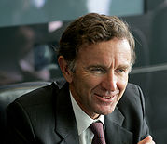
Lord Stephen Green
Minister of State for Trade and Investment, UK

Lord Green is a Conservative member of the House of Lords. After a seven year term at the Ministry of Overseas Development in the 1970s, Lord Green took leave of the civil service to embark on a corporate career with management consultants McKinsey & Co Inc. He went on to become group chief executive and group chairman of Hongkong and Shanghai Banking Corporation.

In his current role, Lord Green sees promotion of trade and industry as a key priority and spearheads various projects to achieve that goal. A trustee of the British Museum, he is also an honorary trustee of Peking University.

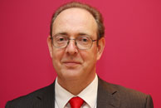
Sir James Bevan KCMG CMG,
British High Commissioner to India

Sir James Bevan joined Foreign & Commonwealth Office (FCO) in 1982; he worked in the Department responsible for West Europe and North East/North Africa. Between 1984-1986 he served as Second Secretary (Press, Political, Aid) at Kinshasa and First Secretary (Political) in Brussels during 1986 – 1990. He then joined EU Department of FCO as Head of EU Enlargement between 1991-93. He was posted in Paris (1993) and Washington (1994-1998) and held the positions of First Secretary (Political-Military) and First Secretary (Political) respectively.

Between 1998 – 2006, Sir James held various positions in FCO that included Head of Africa Department, Head of EU Department, Director Of Balkans and Gibraltar and Director of Africa. Sir James was Visiting Fellow for Centre for International Affairs at Harvard between 2006-07. During 2007 – 2011 Sir James held the position of Chief Operating Officer (Director-General for Corporate Affairs) at FCO, London. He has been the British High Commissioner to India since November 2011.
Sir James was educated at the University of Sussex where he studied Social Anthropology.

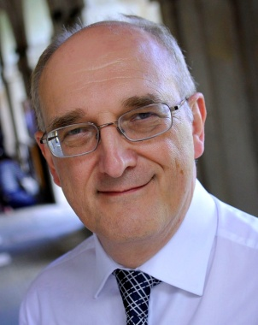
Professor Sir Leszek Borysiewicz
Vice-Chancellor, University of Cambridge

Professor Borysiewicz was installed as the 345th Vice-Chancellor of the University of Cambridge on 1 October 2010. The Vice-Chancellor is the principal academic and administrative officer of the University.

Sir Leszek was previously Chief Executive of the UK’s Medical Research Council (2007-10). From 2001 to 2007 he was at Imperial College London, as Principal of the Faculty of Medicine and later as Deputy Rector, responsible for the overall academic and scientific direction of the institution. He led the development of inter-disciplinary research between engineering, physical sciences and biomedicine.

In 1988 he was a Lecturer in Medicine at Cambridge. He went on to be Professor of Medicine at the University of Wales in Cardiff, where he led a research team that carried out pioneering work on vaccines. In particular, his unit in Cardiff conducted clinical trials for a therapeutic vaccine for human papillomavirus (a cause of cervical cancer) – the first in Europe. He was knighted in 2001 for services to medical research and education.

He was a founding Fellow of the Academy of Medical Sciences in 1996 and a member of its Council from 1997 until 2002; and he became a Fellow of the Royal Society in 2008.

Abanti Sankaranarayanan,
Managing Director, Diageo India

Ms Sankaranarayanan was appointed Managing Director of Diageo India in July 2012 with the mandate to lead the India business’ ambitious growth plans.
Abanti joined Diageo in June 2010 as the Marketing and Innovation Director responsible for brand building of global favourites like Johnnie Walker, Smirnoff, VAT 69 and Cîroc; and within a short time she became known for her brand marketing expertise, as well as her leadership abilities.
Prior to Diageo, Abanti served as a member of the Tata Administrative Service (TAS) cadre since 1992, in a career with the Tata Group, where she where held several key Marketing roles on some of the best known consumer brands of the Tata Group in India, UK and the US. Her remit of brands in Tata included Taj Hotels (India & US), Himalayan Natural Mineral Water, Tetley (UK) and Tata Tea.
Abanti has is an Economics Graduate from St. Stephen’s College, Delhi and an MBA from Indian Institute of Management (IIM), Ahmedabad.

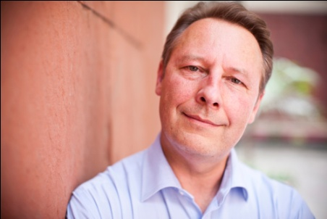
Rob Lynes
Director British Council, India

Rob Lynes took up the post of Director India for the British Council in January 2011. His previous posts include Deputy Director Global Operations and Regional Director for the Middle East. He has been with the British Council since 1994 and has also worked in Poland and Saudi Arabia. Rob holds an MA in applied linguistics. Before joining the British Council Rob worked as a linguist for a number of years in Berlin and was Director of a large language institute in Hungary.

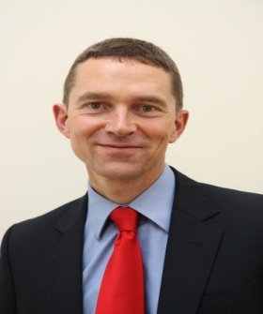
Andrew Mitchell CMG
Director, Prosperity, Foreign and Commonwealth Office (FCO)

Andrew Mitchell took up his appointment as Director, Prosperity in October 2012. Andrew is a career diplomat who was until last summer the FCO Director for the 2012 Olympics, Paralympics and GREAT Campaign. Before that he was the British Ambassador to Sweden. He was in charge of the FCO’s largest ICT-enabled change programme, the Future Firecrest Programme (2002-2007). Andrew has also had postings in Kathmandu (1999-2002) and Bonn (1993-1996).

The Prosperity Directorate is responsible for developing and delivering FCO policy on issues which contribute to the UK’s prosperity, including trade policy, climate change and energy, and global financial and economic stability, as well as other international economic policy issues. The Directorate works closely with the UK Prime Minister’s office and Treasury on G8/G20 issues and leads within HMG on policy towards OECD. Andrew joined the British Diplomatic Service in 1991.

