Driving the Future Today
A strategy for ultra low emission
vehicles in the UK

Summary

September 2013
The Office for Low Emission Vehicles (OLEV) is a cross Government, industry-endorsed, team combining policy
and funding streams to simplify policy development and delivery for ultra low emission vehicles. OLEV currently
comprises people and funding from the Departments for Transport (DfT), Business, Innovation and Skills (BIS), and
Energy and Climate Change (DECC). The core purpose is to support the early market for electric and other ultra low
emission vehicles (ULEVs). OLEV is based in DfT and this document is published by the Department for Transport.

The Department for Transport has actively considered the needs of blind and partially sighted people in accessing
this document. The text will be made available in full on the Department’s website. The text may be freely
downloaded and translated by individuals or organisations for conversion into other accessible formats. If you have
other needs in this regard please contact the Department.

Office for Low Emission Vehicles
Great Minster House
33 Horseferry Road
London SW1P 4DR
Telephone 0300 330 3000
Website www.gov.uk/olev
General email enquiries olev.enquiries@olev.gsi.gov.uk

© Crown copyright 2013, except where otherwise stated

Copyright in the typographical arrangement rests with the Crown.
You may re-use this information (not including logos or third-party material) free of charge in any format or medium,
under the terms of the Open Government Licence v2.0. To view this licence, visit http://www.nationalarchives.gov.
uk/doc/open-government-licence/version/2 or write to the Information Policy Team, The National Archives,
Kew, London TW9 4DU, or e-mail: psi@nationalarchives.gsi.gov.uk.

Where we have identified any third-party copyright information you will need to obtain permission from the copyright
holders concerned.

Cover images:
Left: New Nissan LEAF plug-in electric car produced in Sunderland, UK; Centre: Drayson Racing Technologies’
204.2mph electric car; Right: Jaguar XJ-e plug-in electric hybrid.
(Sources: Nissan; Drayson Racing Technologies; Jaguar Land Rover.)

1. This document summarises the key points from ‘Driving the Future Today’ the Government’s strategy for ultra low emission vehicles in the UK published in September 2013. The full document is available for download at www.gov.uk/olev.
Introduction
2. We have begun a period of change in the way we power our motor vehicles, a period which will provide hugely significant opportunities for the UK to grow its economy, improve our environment and deliver people the independence and mobility they want.
3. The UK Government is committed to grasping this opportunity. Our vision is that by 2050 almost every car and van in the UK will be an ultra low emission vehicle (ULEV), with the UK at the forefront of their design, development and manufacture, making us one of the most attractive locations for ULEV-related inward investment in the world.
Context – the inevitable transition
Figure 1 – The downward trend in global emissions targets around the world, which is driving innovation from vehicle manufacturers
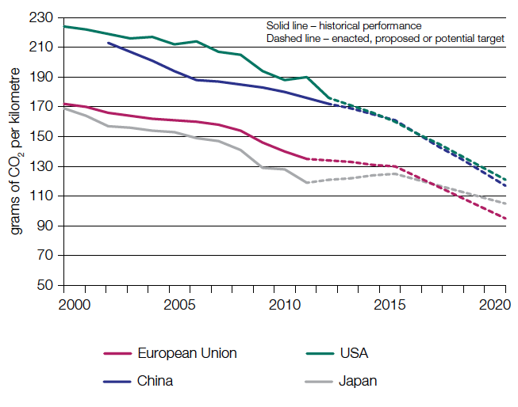
Data source: The International Council on Clean Transportation (ICCT)

4. Around the world, governments are looking to simultaneously reduce their reliance on foreign energy imports, to clean the air in their towns and cities, and to reduce carbon emissions from their societies. There are now vehicle emission targets in place in the major trading blocks around the world. These are driving a revolution in the development of ULEV technologies. Increasing global urbanisation will only hasten this change.
Figure 2 – Global vehicle penetration
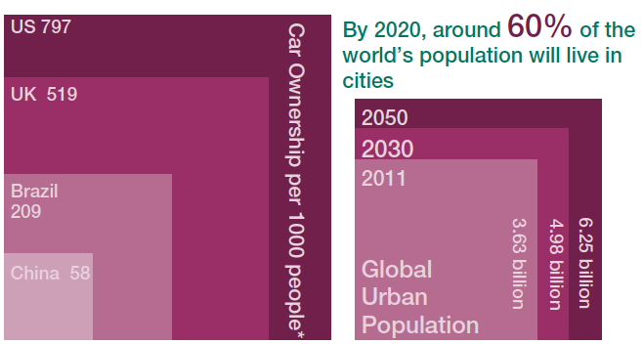
* Brazil data 2008, all others 2010
Data source: World Bank and UN

Figure 3 – The contribution of road transport to the UK’s domestic transport greenhouse gas emissions in 2011
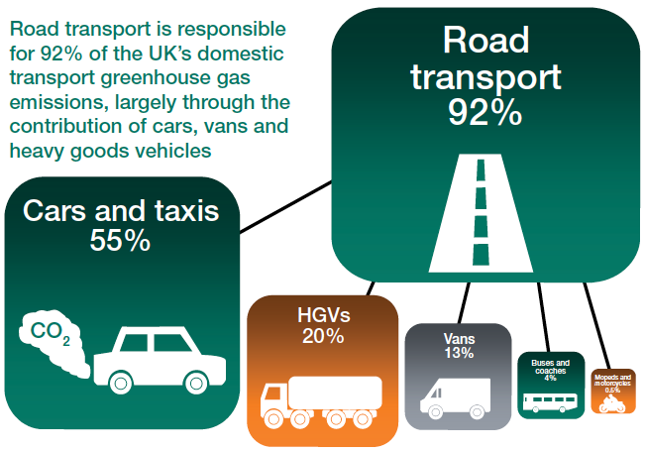
Data source: National Atmospheric Emissions Inventory (NAEI)

5. Efficient transport is vital to the UK’s economic wellbeing and road transport remains the dominant transport mode in the UK. However, traffic and new road capacity can bring with them concerns over air quality and noise. Increasing use of ultra low emission vehicles therefore has a very important role to play in supporting mobility while reducing the carbon and air quality impact of road transport. That is why we announced, in our Action for Roads paper, a funding commitment of over £500 million of new capital investment between 2015 and 2020 to continue to establish the UK as a premier market for ULEVs.
Figure 4 – The impacts of air pollution
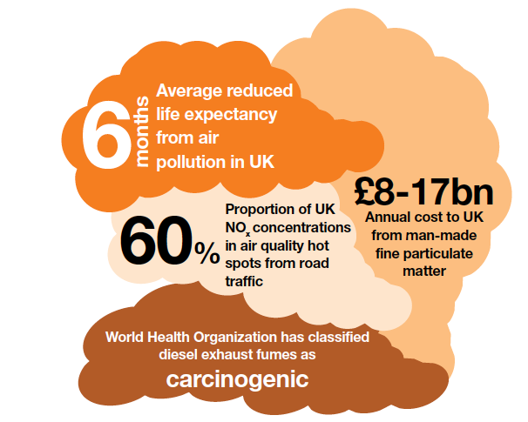

6. This is a once in a lifetime technology change. It offers huge opportunities for the UK automotive sector and supply chain. We already have a growing automotive sector with key skills and world leading foundations in the technologies required for this transition. The challenge is to maintain this momentum, grow a flourishing domestic market for the new vehicles and attract manufacturers and suppliers to site research, development and production facilities in the UK.
Source: Nissan
7. We recognise that industry needs a long-term and stable framework in order to invest and grow. That is why Government and industry published a strategy for growth and sustainability in the UK automotive sector in July 2013. This set a clear path for the research, development and commercialisation of the next generation of low carbon technologies – supported by the creation of a £1 billion Advanced Propulsion Centre, funded by Government and industry.
Figure 5– The move to lower CO2 emitting new cars in the UK
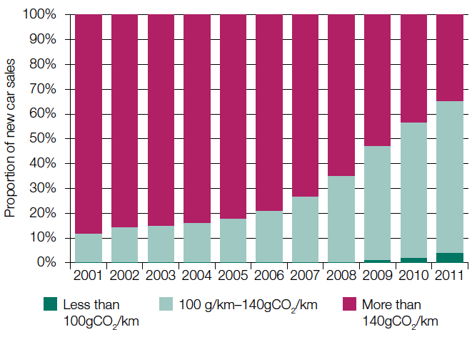
Source: DfT/ DVLA

8. We are committed to supporting the development of a flourishing market for ULEVs in the UK. This will not be easy, there are challenges in helping to bring technologies to market that are affordable, accepted by consumers and have infrastructure in place to enable them to be used to their full potential. A mass market shift to ULEVs will also bring challenges and opportunities for the energy sector, which will need to be prepared for and managed.
ULEV technologies
9. It is not Government’s role to identify and support specific technologies at this early stage. Ultimately, the mass market transition to ULEVs will happen through industry developing and bringing products to market and consumers deciding which products they wish to buy. The emerging consensus in the automotive industry is that a portfolio of solutions will be required to decarbonise road transport.

Figure 6 – The technology road map for cars and vans
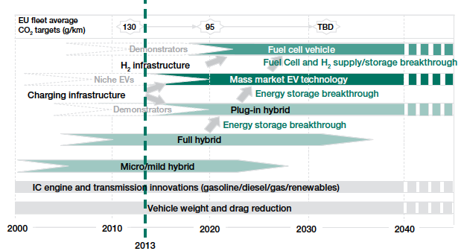
Source: NAIGT

Figure 7 – The technology portfolio for cars and vans
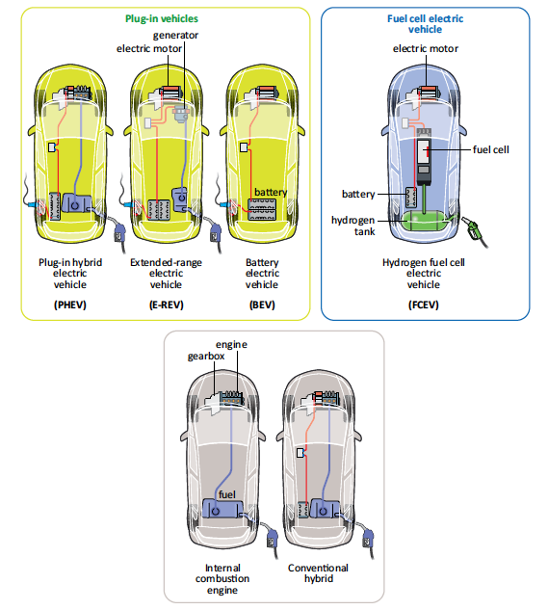

10. The internal combustion engine will continue to play a role in road transport for many years, with improvements in fuel efficiency and increased hybridisation providing incremental improvements in CO2 emissions. As emissions targets become tighter and technologies continue to develop we expect that ULEVs, including plug-in vehicles and hydrogen fuel cell electric vehicles, will take an increasing share of the market for cars and vans. Sustainable biofuels have a role to play in delivering decarbonisation and could play a key role in sectors such as aviation and freight where there are few alternatives to liquid fuel and electrification is far more challenging. There is consensus that electrification will be at the core of the longer term decarbonisation of cars and vans.
11. The Government’s strategy focuses mainly on cars and vans as they present the biggest opportunity for the early adoption of ULEVs. We are, however, also keen to encourage the adoption of ULEV technologies in other vehicle sectors from heavy duty vehicles and buses to powered two wheelers and other small vehicles.
Progress to 2013
12. The emergence of ULEVs as a real option for consumers and businesses, and as an opportunity for the associated supply chain, has begun, and we are taking practical steps to put the UK at the forefront of this global market. We have funded the Office for Low Emission Vehicles (OLEV) to co-ordinate Government’s support. Initially this was with a provision for £400 million funding to 2015, focused on the following areas.
Helping to support the purchase of ULEVs
13. We launched the Plug-in Car Grant and the Plug-in Van Grant to help reduce the cost differential between ULEVs and conventional vehicles. Sales momentum is now beginning to build and we expect this to continue as new vehicles enter the market and costs continue to fall, providing a more diverse choice for consumers at different price points.
14. We are also providing incentives for ULEVs through the tax system. The Government recognises the importance of stability in taxes as the market for these vehicles develops. We have committed to involving industry and wider partners in the process for subsequent development of the tax regime.
15. Fleet sector purchasing decisions can have a crucial role in helping to accelerate ULEV sales. That is why we have been working with the Energy Savings Trust to provide independent advice to fleets through the Plugged-in Fleets Initiative.
Figure 8 – OLEV relationships
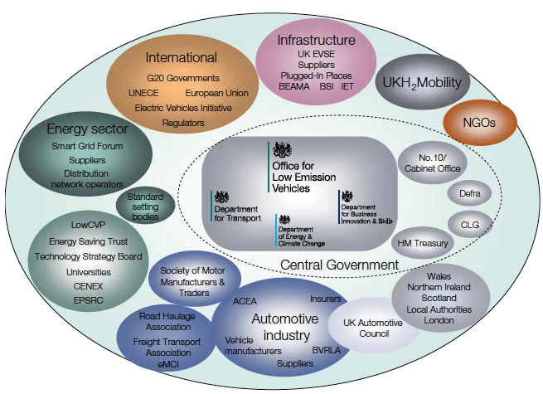

Facilitating the provision of recharging infrastructure
16. Making the Connection (2011) set out the Government’s initial vision for recharging infrastructure in the UK and the steps that it, and other industry players needed to take to make it a reality. This would take the form of recharging provision where consumers would use it most, primarily at homes and workplaces, with some provision of public recharging infrastructure where needed.
17. To this end, the OLEV programme implemented the Plugged-In Places (PIP) scheme, which made available up to £30 million in matched funding to eight regional schemes. This programme accelerated the roll-out of recharging infrastructure in the UK, and has delivered over 5,500 chargepoints in the PIP areas up to the end of June 2013. It has also provided important lessons to inform future roll-out, which we are sharing through a PIP lessons learnt document, published alongside this strategy.
Figure 9 – Plugged-in Places chargepoint numbers
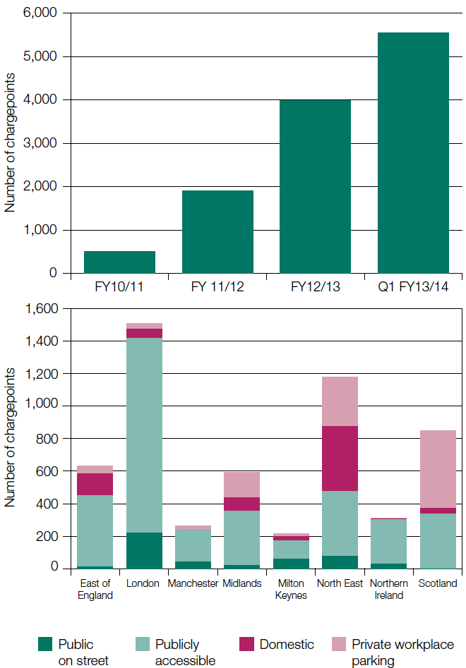

18. The real success of the PIPs has been in providing the platform for private sector organisations to enter the market and together create a strong and steadily growing infrastructure market. We estimate that non-PIP organisations have delivered more than 5,000 additional chargepoints to the end of June 2013.
Figure 10 – The UK’s emerging rapid charger network
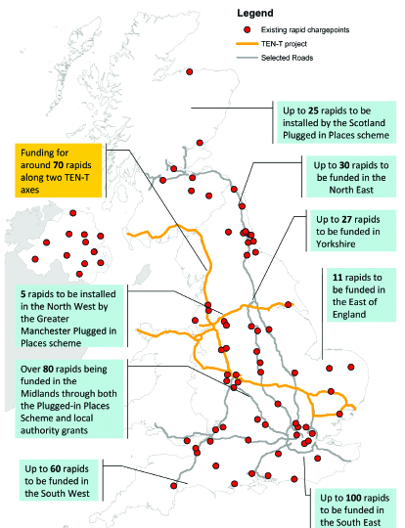

Preparing for hydrogen fuel cell electric vehicles in the UK
19. The Government has consistently supported the development of hydrogen fuel cell vehicles alongside the roll-out of plug-in vehicles as part of its technologically neutral approach. Both technologies are likely to have an important role to play in our future mobility.
20. That is why we are actively working with companies in the ground-breaking UKH2Mobility project to develop a business case for the roll-out of hydrogen fuel cell electric vehicles (and the associated hydrogen refuelling infrastructure) in the UK from 2015.

Figure 11 – Hydrogen refuelling station (HRS) deployment
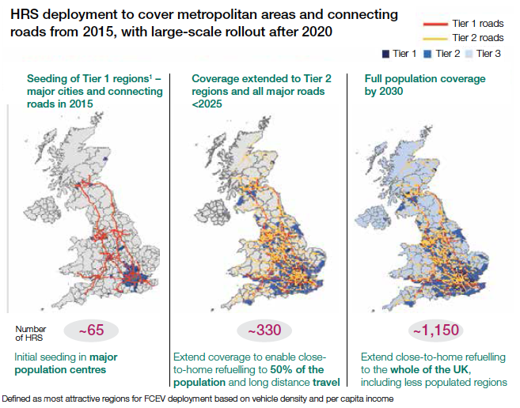
Source: UKH2Mobility, February 2013

Encouraging and investing in research and development
21. The Government is funding an £82 million programme of research and development to support the new generation of ultra low emission vehicles and to help build the skills and knowledge in the UK.
Figure 12 – Automotive Council strategic technology themes
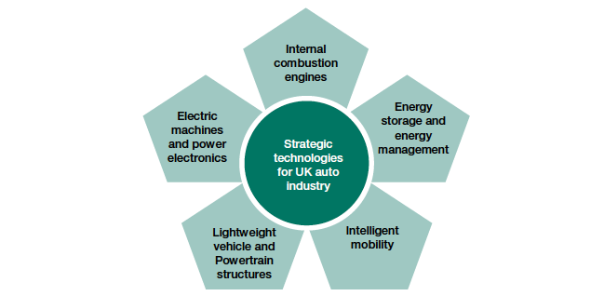
Source: Automotive Council/BIS

22. This funding is focused on identifying and supporting emerging technologies that the UK can exploit and lead on globally. This includes innovations in electric machines and power electronics; energy storage and energy management; lightweight vehicles and powertrains; as well as improvements to the internal combustion engine. It specifically targets areas where commercial funding has not been readily available, or where the cost of full commercialisation of new technologies has been too high, so that we can build value in the supply chain and create opportunities for the UK.
Lowering emissions from other vehicles
23. Government is also working intensively with other sectors to lower emissions from other types of vehicle.
24. We have provided support through the Green Bus Fund to encourage bus operators and local authorities to switch to low and ultra low emission buses. This £87 million fund has delivered more than 1200 new low carbon buses in England, with nearly 350 in London and 275 in Manchester. Many of these buses are being assembled in the UK. In recent years we have also seen the introduction of hydrogen fuel cell electric buses in London.
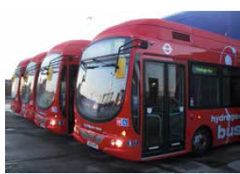
Source: Transport for London
25. We are also working with industry in the Low Carbon HGV Technology Task Force. This includes proposals for a technology accreditation scheme to give operators information on the cost saving benefits of individual technologies as well as the development of a strategy for switching larger freight vehicles to gas engines. This builds upon the work already underway through the OLEV co-funded Low Carbon Truck and Infrastructure Trial, which aims to demonstrate low carbon technologies and provide confidence to the freight industry.
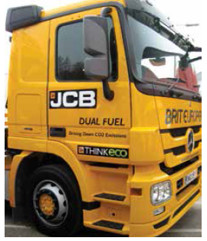
Source: DfT
ULEVs and the energy sector
26. The mass adoption of ULEVs will have significant implications for the energy sector at both a local and a national level. As the number of plug-in vehicles on our roads increases, so will the demand for electricity, placing additional pressures on the electricity system.
27. However, ULEVs can also help to balance the demand for electricity at peak periods and support the efficient use of energy by consumers. This will be facilitated by the introduction of intelligent power supply networks (smart grids) and the roll out of electricity smart meters across all domestic properties in the UK by 2020.
28. The majority of plug-in vehicle owners will charge their vehicles at home, at night time, during the off-peak period. This is not only most convenient for drivers, but also maximises the environmental and economic benefits of plug-in vehicles by using cheaper, lower carbon night-time electricity generation.
29. To help people charge at home as easily as possible, the Government is ensuring that smart metering in Great Britain includes the functionality to support charging of plug-in vehicles. This will allow recharging to happen when it is cheapest for consumers and the energy system (subject to appropriate technology in the chargepoint or plug-in vehicle).
30. Plug-in vehicles could also act as distributed energy storage during periods when renewable (or nuclear) electricity generation exceeds demand. This could happen during the life of the vehicle or as a potential end-of-life use for batteries. There may even be the potential for these vehicles to be used as an energy store, to power the house or feed electricity back to the grid at peak periods.
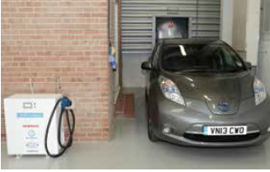
Source: Zero Carbon Futures
Lessons learnt
31. Much has been learnt since we first launched the £400 million programme of policy measures in the UK. This comes from the evidence and feedback from industry, consumer organisations, academia and the wider research community as well as from Government’s own experience with the Plugged-In Places scheme and the Plug-in grants. Some of the headline findings include:
• Most people have little, if any, knowledge of ULEVs. Insufficient or inaccurate information can put off potential buyers.
• High upfront costs are a key barrier. The Plug-in Car Grant was considered an important factor in the purchase decision of 85% of ULEV purchasers.
• ULEVs can provide clear benefits for many fleets and there is an appetite among fleets to embrace the technology, if it can be done cost effectively. Over 60% of the initial Plugged-in Fleets Initiative participants have gone on to procure a plug-in vehicle or are planning to do so.
• Once they have driven an ULEV, people’s preconceptions are often contradicted and their response to the car’s characteristics in terms of smoothness, quietness and acceleration is overwhelmingly positive.
• As previous studies have shown, most charging continues to occur at home and overnight, with some charging at the workplace.
• The provision of an accurate source of chargepoint information is important for convincing existing owners and potential purchasers that their charging needs can be met.

Figure 13 – The Ultra Low Carbon Vehicle Demonstrator programme
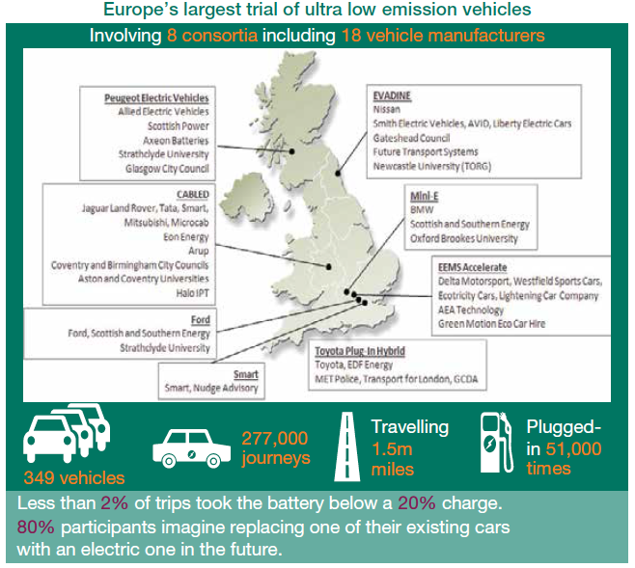

32. Overall, the evidence suggests that the Government’s existing policies are broadly the right ones. Industry experience suggests that the adoption of new technology will take time. One of Government’s key roles is to maintain a consistent policy framework that targets the barriers to adoption and hastens the normalisation of ULEV technology.
The way forward
Strategic approach
The vision
33. The Government’s overall vision for ultra low emission vehicles in the UK is ambitious, but realistic and for the long term. We want to see:
• buoyant domestic fleet and private markets for ULEVs with every new car an ULEV from 2040 and an effectively decarbonised fleet by 2050 to meet our Carbon Plan targets;
• a network of supporting infrastructure that ensures ULEVs are an attractive customer proposition;
• world class skills and facilities for the development and manufacture of ULEV technologies, exporting vehicles globally;
• a smarter electricity grid that maximises the benefits to vehicle owners and the electricity system from the shift to ULEVs; and
• all of the above combining to make the UK the best place in Europe for the automotive sector and associated ULEV industries to invest.
Overarching principles
34. In delivering this vision for the ULEV sector in the UK, Government’s activities will be consistent with the following overarching principles:
a. Focusing on inward investment and the supply chain – The Government will continue to pursue the wider prize of securing the maximum possible benefits to the UK economy from the mass market adoption of ULEVs. This means focusing on enabling the UK supply chain to become pre-eminent in low carbon technologies.
b. Technological neutrality – The Government will not seek to ‘pick winners’ in terms of emerging technologies at this early stage. Instead we will support activities that are backed by industry consensus, allowing the market to ultimately determine which technologies win through. We will generally specify the bulk of our policies in output rather than technology terms.
c. Working with the EU on ambitious but realistic regulation – The Government will work to agree regulations that are ambitious, consistent with our statutory carbon budgets and target for 2050, and which encourage innovation but which are also realistic, deliverable and neither penalise the ordinary motorist nor overburden industry.
d. Addressing market failure – Government can speed the transition to ULEVs by addressing areas where the market alone might not deliver the best outcomes in the shortest possible timescale. The ‘chicken and egg’ problem of ULEV uptake and the provision of refuelling infrastructure is a good example of this.
e. Consistent communications – The Government will engage early, openly and proactively with industry on all aspects of the developing ULEV sector, and we will support clear and consistent communications with consumers.
Key commitments
Long term investment
35. The UK is seen as one of the most open automotive markets in Europe, which is both a strength and a weakness. Because many UK manufacturers are foreign-owned with a global choice of manufacturing and development sites, the UK has to be particularly attractive to stimulate investments in advanced technologies.
36. The Government recognises this. In July 2013, it set out its long-term ambition for roads including a significant funding commitment of over £500 million from 2015 until 2020 to continue to support the growing market for ULEVs. This, combined with the existing £400 million support to 2015 and the recent advanced propulsion centre announcement, constitutes one of the longest and most comprehensive packages of support for ULEVs anywhere in the world.
Support to 2020 – call for evidence
37. This unprecedented funding commitment represents a significant opportunity for the UK. Government is therefore proposing an immediate period of dialogue with industry and other stakeholders to help shape the £500 million package of support for ULEVs in the 2015-2020 period.
• We will launch a call for evidence later this year to inform the development of this package of support, including consumer incentives. This will consider the balance of support between workstreams and plot the path to Government’s exit from subsidy.
Delivering the vision
38. Government will take forward the ULEV agenda in the immediate term through a number of practical actions and commitments in five workstreams. These activities are aimed at normalising the technology, addressing current barriers to adoption (such as price, the infrastructure ‘offer’, and the availability of accurate consumer information), preparing the ground for increased adoption and new technologies (such as hydrogen), stimulating the UK supply chain to make the most of the coming industrial opportunities, and working to ensure that regulatory structures are consistent with the UK’s strategic aims.
39. The full list of commitments is in the Annex, with highlights detailed below.
Workstream 1 – Supporting the early market
• To provide certainty for investors and consumers the existing plug-in vehicle grants will remain unchanged to May 2015, and consumer incentives will remain in place beyond this date.
• We will work with a consortium of major ULEV manufacturers to explore the case for a national consumer communications campaign. Subject to agreement from all those involved, during 2014 we will launch a platform for providing robust and authoritative consumer information on ULEVs, supported by awareness raising activity.
• We will update the Government Buying Standard for Transport by summer 2014 to encourage higher ULEV uptake in the public sector. In addition, we will work to remove unintended administrative barriers to public sector purchase of ULEVs.
Workstream 2 – Shaping the required infrastructure
• We will continue to provide a national package of up to £37 million through to May 2015 to support the installation of chargepoints in homes, residential streets, railway station and public sector car parks and rapid chargepoints to facilitate longer journeys, inviting a second round of bids from train operators, local authorities and the wider public sector by 31 October 2013.
• Subject to further work in Phase 2 of UKH2Mobility, we will explore the options for Government grant funding to support industry’s investments in the initial network of around 65 hydrogen refuelling stations estimated to be required to support the introduction of hydrogen fuel cell electric vehicles in the UK – by May 2014.
Workstream 3 – Securing the right regulatory and fiscal measures
• We will maintain a strong, clear and lasting set of tax incentives for ULEVs until at least 2020. We will involve industry and wider partners in the process for subsequent development of the tax regime – ongoing.
• OLEV will work with HMRC to clarify the tax position for ULEVs and publish this as a factsheet on the OLEV website by May 2014. This will enable fleet managers to better understand the likely costs of ULEVs for their fleets.
• We will work with industry and international partners to support ambitious but realistic and cost effective emissions targets in EU regulations for new vehicles beyond 2020 and to deliver UK ambitions on the Commission’s Clean Power for Transport proposals.
Workstream 4 – Investing in UK automotive capability
• We will continue to work through the Automotive Council to identify specific activities to develop and strengthen the UK ULEV supply chain and, by December 2013, will discuss with industry how best to target ULEV R&D funding out to 2020.
• OLEV will continue to co-ordinate ULEV R&D and supply chain activity across Government, with industry and with the Technology Strategy Board to maximise economic benefits for the UK. This will include working with all stakeholders to ensure appropriate alignment of activities at the Advanced Propulsion Centre and the Energy Storage Centre with other ULEV programmes to maximise benefits for the UK from the move to ULEVs.
• We will offer a prize of up to £10 million to develop long-life battery technology for the next generation of electric vehicles. We will work with NESTA (the UKWs centre of excellence for challenge prizes) and the Technology Strategy Board to develop the competition scope and criteria. The specific challenge to be met and the competition guidelines will be unveiled later in 2013.
Workstream 5 – Preparing the energy sector
• We will continue to require the national rollout of smart meters into homes by 2020. We will ensure that this new technology acts as a platform which can support plug-in vehicle charging.
Conclusion
Figure 14 – Projected ULEV car sales as proportion of all car sales (2011-20)
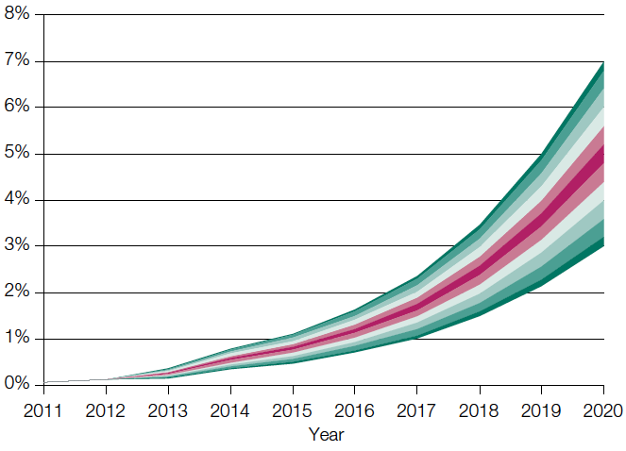
Source: Department for Transport modelling

40. The move to ultra low emission vehicles is inevitable. There are hugely significant benefits for the UK from this transition in terms of energy security, air quality and carbon reduction. Most significantly, the transition also represents a once in a lifetime industrial opportunity for the UK automotive sector if it successfully positions itself in the vanguard of this new technology – delivering jobs and growth for decades to come.
41. The UK Government is wholly committed to this agenda, and recognises that it will take time. The Government’s strategy document sets out why this policy is so important and the comprehensive and compelling set of commitments that the Government is already making to make its vision a reality as fast as possible.
Annex: Full list of commitments
Support to 2020 – call for evidence
We will make provision for over £500 million from 2015 until 2020 to support the growing market for ultra low emission vehicles.
We will launch a call for evidence later in 2013 to inform the development of this package of support, including consumer incentives. This will consider the balance of support between the following workstreams and plot the path to Government’s exit from subsidy.
Workstream 1 – Supporting the early market
a) To provide certainty for investors and consumers the existing plug-in vehicle grants will remain unchanged to May 2015 and consumer incentives will remain in place beyond this date.
b) We will ensure that the guidelines for the Plug-in Grants include appropriate technology neutral performance criteria so as not to exclude emerging technologies like FCEVs – by May 2014.
c) We will simplify the registration of hydrogen FCEVs when they become commercially available from 2015 by removing the requirement for vehicles using hydrogen fuel to be issued with a Vehicle Special Order.
d) We will review the opportunities available to promote uptake of low emission HGV technologies by May 2014, in particular considering the use of incentives that could improve the business case for operators.
e) We will work with a consortium of major ULEV manufacturers to explore the case for a national consumer communications campaign. Subject to agreement from all those involved, during 2014 we will launch a platform for providing robust and authoritative consumer information on ULEVs, supported by awareness raising activity.
f) We will provide funding to the Energy Saving Trust (EST) to continue the Plugged-in Fleets Initiative through to March 2014, helping 100 fleets to identify where plug-in vehicles can support their business needs.
g) We will update the Government Buying Standard for Transport by summer 2014 to encourage higher ULEV uptake in the public sector. In addition, we will work to remove unintended administrative barriers to public sector purchase of ULEVs.
h) We will develop a procurement specification for ULEVs by February 2014 as a basis for future mass public sector procurement exercises, bringing down the cost per vehicle of ULEVs for public sector organisations.
Workstream 2 – Shaping the required infrastructure
a) We will continue to provide a national package of up to £37 million through to May 2015 to support the installation of chargepoints in homes, residential streets, railway station and public sector car parks and rapid chargepoints to facilitate longer journeys, inviting a second round of bids from train operators, local authorities and the wider public sector by 31 October 2013.
b) We will continue to support the creation of a single definitive database of all publicly accessible charging infrastructure. We will build on the existing National Chargepoint Registry (NCR) and work with industry during 2013 and 2014 to develop it to allow greater flexibility and functionality.
c) We will work with the recharging industry and network operators to take account of driver needs when installing infrastructure, developing best practice guidance on signage and information on chargepoint functionality – by summer 2014.
d) We will work with industry, standardisation bodies and global partners to get the best deal for plug-in vehicle drivers on the move to standardise charging infrastructure (including plugs and connectors) – ongoing.
e) We will work with local authorities to ensure that parking regulations for ULEVs are fit for purpose and plug-in vehicle drivers are able to use publicly accessible infrastructure – by May 2015.
f) We will include a requirement that every publicly accessible chargepoint that the Government funds has ‘pay-as-you-go’ functionality. We will also encourage the integration of payment systems with other services, such as transport ticketing systems or car parking charges, for ease of use.
g) Subject to further work in Phase 2 of UKH2Mobility, we will explore the options for Government grant funding to support industry’s investments in the initial network of around 65 hydrogen refuelling stations estimated to be required to support the introduction of hydrogen fuel cell electric vehicles in the UK – by May 2014.
h) We will work with industry to identify and resolve outstanding practical issues around the refuelling and use of hydrogen FCEVs, including the hydrogen quality assurance process, integration of hydrogen refuelling into conventional fuel retail forecourts and ensuring an optimal consumer experience – by December 2014.
Workstream 3 – Securing the right regulatory and fiscal measures
a) We will maintain a strong, clear and lasting set of tax incentives for ULEVs until at least 2020. We will involve industry and wider partners in the process for subsequent development of the tax regime.
b) OLEV will work with HMRC to clarify the tax position for ULEVs and publish this as a factsheet on the OLEV website by May 2014. This will enable fleet managers to better understand the likely costs of ULEVs for their fleets.
c) We will work with industry and international partners to support ambitious but realistic and cost effective emissions targets in EU regulations for new vehicles beyond 2020 and to deliver UK ambitions on the Commission’s Clean Power for Transport proposals.
Workstream 4 – Investing in UK automotive capability
a) We will continue to work through the Automotive Council to identify specific activities to develop and strengthen the UK ULEV supply chain and, by December 2013, will discuss with industry how best to target ULEV R&D funding out to 2020.
b) OLEV will continue to co-ordinate ULEV R&D and supply chain activity across Government, with industry and with the Technology Strategy Board to maximise economic benefits for the UK. This will include working with all stakeholders to ensure appropriate alignment of activities at the Advanced Propulsion Centre and the Energy Storage Centre with other ULEV programmes to maximise benefits for the UK from the move to ULEVs.
c) We will offer a prize of up to £10 million to develop long-life battery technology for the next generation of electric vehicles. We will work with NESTA (the UK’s centre of excellence for challenge prizes) and the Technology Strategy Board to develop the competition scope and criteria. The specific challenge to be met and the competition guidelines will be unveiled later in 2013.
Workstream 5 – Preparing the energy sector
a) We will make available UK ULEV uptake scenarios to the Smart Grid Forum, and update these regularly, to provide strategic direction to the energy industry – ongoing.
b) We will continue to require the national rollout of smart meters into homes by 2020. We will ensure that this new technology acts as a platform which can support plug-in vehicle charging.
c) We will take an active role in the Smart Grid Forum to prepare for the increasing adoption of ULEVs – ongoing.
d) We will begin a dialogue with the plug-in vehicle and house building industries about the most cost effective way to promote the inclusion of wiring and the installation of dedicated chargepoints in appropriate new housing stock – by May 2014.
e) We will review how to ensure that appropriate information is flowing from chargepoint installers to notify distribution network operators about chargepoint installations. We will work to ensure that notification processes are capable of dealing with higher numbers of installations as uptake increases – by May 2014.
f) We will work with industry to identify mechanisms to ensure that as the uptake of hydrogen FCEVs grows, they can increasingly be fuelled by ‘green’ hydrogen – ongoing.

https://www.gov.uk/government/publications/action-for-roads-a-network-for-the-21st-century
https://www.gov.uk/government/publications/driving-success-uk-automotive-strategy-for-growth-and-sustainability
OLEV is a cross-departmental unit comprising staff and funding from the Departments for Transport (DfT), Business, Innovation and Skills, (BIS) and Energy and Climate Change (DECC).
See https://www.gov.uk/government/publications/making-the-connection-the-plug-in-vehicle-infrastructure-strategy
https://www.gov.uk/government/publications/action-for-roads-a-network-for-the-21st-century

