ODA Funding
Summary of UKBA 2012 ODA Classified Spending
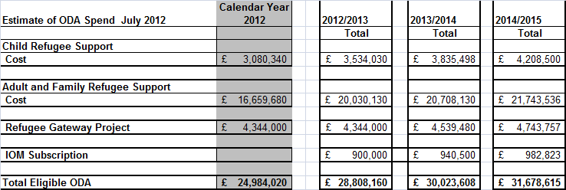
Child Refugee Support
These are payments to local authorities for the support they provide to asylum seeking children. This is a subset of the total amount paid (less than 10%) and only relates to a maximum of 1 year’s support given to those granted full refugee status. This is classed as support for “refugees in donor countries” by IATI.
Adult and Family Refugee Support
Payments to a number private providers (including local authorities acting as a consortium) for support for adult and family asylum seekers who are granted refugee status (max of first year support). Again this is a subset of the total paid and less that 10% of that support to all adult and family asylum seekers. This is classed as support for “refugees in donor countries” by IATI.
Refugee Gateway Project
This is funding to bring those identified as refugees by UN directly to UK. This cost includes costs of UKBA staff to travel to refugee camps to assess potential applicants and then the costs of supporting them (paid to a number of 3rd sector and other organisations) when they arrive in UK and supported for up to 1 year. It is part funded by the EU and the UKBA element relates to the support given and so is classed as support “refugees in donor countries” by IATI.
IOM Subscription
Payment directly to the IOM as part of the UK’s commitment. This is half the total subscription with the remainder paid by DfID. This is classed as “Core contributions to multilateral institutions” by IATI.

