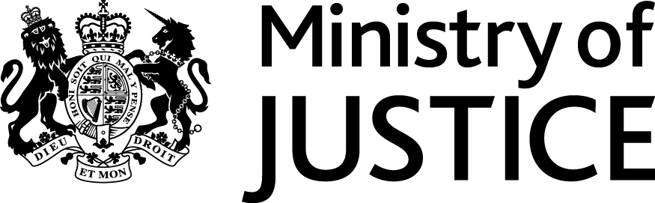 |  |  | www.gov.uk
 | Our Reference: 82323 |  | Date: May 2013

Freedom of Information Request

Thank you for your email in which you asked for the following information from the Ministry of Justice (MoJ):

"I would like to know if Cleveland & Co Solicitors have claimed legal aid for clients in immigration detention from the Legal Aid Agency (formerly known as the Legal Services Commission) where it later transpired that Cleveland and Co Solicitors were not eligible and what subsequent actions the LAA took, including regarding the return of Legal Aid. This request is for dates between January 2010 and now."

Your request has been handled under the Freedom of Information (FOI) Act 2000.

I can confirm that the department holds information that you have asked for, and I am pleased to provide this to you.

Firstly, I can confirm that Cleveland & Co Solicitors did claim legal aid for clients in immigration detention from the Legal Aid Agency (LAA – formerly the Legal Services Commission – LSC) where it later transpired that Cleveland & Co were not eligible, during the period January 2010 to present.

Regarding subsequent action taken by the LSC/LAA, I can confirm that the issue was raised with the firm and action taken so that they did not receive payment from the LAA for those ineligible claims. The firm have since reviewed their procedures to prevent a recurrence.

