

Our Reference: FOI/ 81984 | April 2013

Freedom of Information Request

You asked the following information.

1) A list of the identity of all Deputy Masters who are appointed across the Chancery Division, the Queen's Bench Division and the Appeal Court...including their date of appointment and the name of their main Employers / Chambers.

2) A list of all Deputy Registrars in the Bankruptcy Court...again including their date of appointment and the name of their main Employers / Chambers.

3) An explanation of specifically how these Deputies are appointed, and by whom. If there is some kind of nomination process, can the identity of the nominators also be provided?

4) An explanation of how Conflicts of Interest are managed when using Third Parties as Judicial Office Holders, with these Parties, more often than not being in Commercial Practice. For example is there some kind of Registar of Interests?

5) An explanation of how these Deputies are scheduled to work (i.e. around the permanent members of staff / allocated to specific cases)?

6) Confirmation whether a Hospitality Register (or similar) exists for Judicial Office Holders.

Your request has been passed to me because I have responsibility for answering requests relating to Her Majesty’s Courts & Tribunal Service in London and is being handled under the Freedom of Information Act 2000 (FOIA)

I can confirm that Her Majesty’s Courts & Tribunal Service holds some of the information that you have asked for, and I am pleased to provide this to you. I will respond to your questions in the same order that you have raised them.

Questions 1 & 2

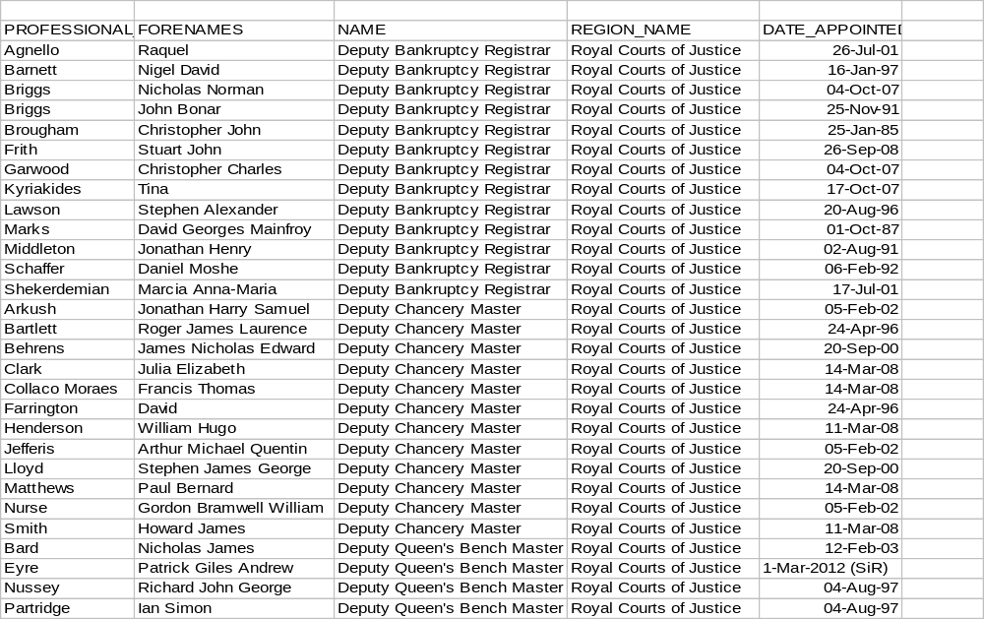

Question 3

Deputy Masters and Registrars have the same jurisdiction and recruitment process as for full-time office-holders. Independent selection to fill any identified vacancies is undertaken by the Judicial Appointments Commission (JAC). There is no nomination process, candidates have to apply for a vacancy advertised on the JAC website by completing an application form and will be subjected to a selection process. The JAC makes recommendations to the Lord Chancellor for his approval. Further information about the Judicial Appointments process can be obtained from the JAC website.

Question 4

Conflicts of interest are highlighted in paragraph 15- 18 in the attached terms and conditions for the Deputy Chancery Masters, Deputy Costs Judges.





I've also attached the Guide to Judicial Conduct, which covers fee-paid office holders as well as salaried office holders. The issue of conflict of interest is dealt with in section 3 and section 8, but the guide also deals with other issues of bias too which may be of interest to you.
Question 5
I can confirm that Her Majesty’s Courts & Tribunal Service does not hold the information that you have requested. To establish whether the information was held I conducted a thorough search, and made enquires with the following areas the Commercial court within the Rolls building, the Royal Courts of Justice, The Judicial Office and the Judicial Appointments Commission.

If the information was held by Her Majesty’s Courts & Tribunal Service it would have to be held by the above mentioned business area. It may help if I clarify that information is not held by MoJ because there is no legal or business requirement for Her Majesty’s Courts & Tribunal Service to hold the information being requested.

Please be advised that the FOIA does not oblige a public authority to create information to answer a request if the requested information is not held. It does not place a duty upon public authorities to answer a question unless recorded information exists. The FOIA duty is to only provide the recorded information held.

However outside the scope of the act I can inform you that deputies are utilised to cover the absences of permanent judicial members or to accommodate cases not allocated to a permanent judge. I can also inform you there is no allocation of specific cases to the Deputies.
You may also interested to note that sittings are dealt with in paragraphs 11, 12 and 13 within the attached terms and conditions for the Deputy Chancery Masters and Deputy Costs Judges.
Question 6
I can confirm that there is no hospitality register for the judiciary as judges are bound by the judicial code of conduct.

