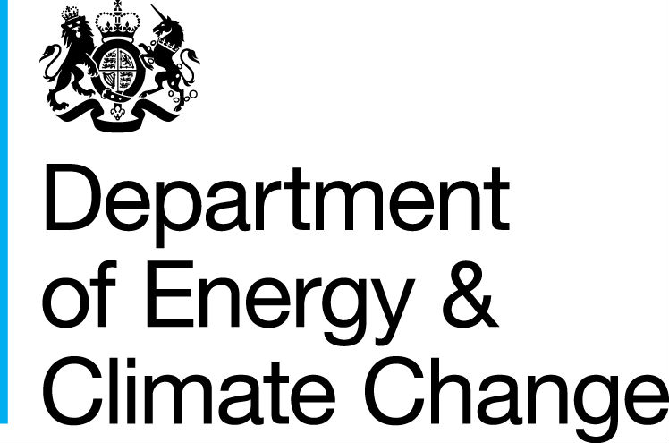2
27 June 2013
STATISTICAL RELEASE: EXPERIMENTAL STATISTICS
Domestic Green Deal and Energy Company Obligation in Great Britain, Monthly report
Introduction
This release presents the latest statistics up to 16 June on the Green Deal (GD) for the domestic sector. It also includes the latest statistics on measures installed under the Energy Company Obligation (ECO) up to the end of April and information on ECO brokerage to 16 June.

This is the first monthly release to include information on the number of Green Deal Plans, the number of measures installed through different funding mechanisms (Cashback and ECO) and the amount of cashback redeemed for measures installed. As in the previous three monthly reports, this report includes summary figures on GD Assessments, the GD supply chain and ECO brokerage.

The Green Deal launched on 28 January 2013 in England and Wales and on 25 February in Scotland. ECO started on 1 January 2013 for Great Britain. More detailed analysis of Green Deal Assessments in England and Wales that were lodged up to the end of March and the GD supply chain is also available in the new quarterly statistical release.

Key points
- 38,259 GD Assessments were lodged up to 16 June (Chart 1)

- There were 245 Green Deal Plans in the system for individual properties as at 16 June. Of these, 241 were ‘new’ Green Deal Plans and 4 were ‘pending’ (Chart 2).

- 5,118 cashback vouchers had been issued to 16 June. Of these, 968 cashback vouchers had been paid (following installation of measures) up to 16 June with a value of £263,452 (Chart 3). Most of the vouchers paid to date have been for boiler replacements.

- Provisional figures, which are subject to further checks by Ofgem, show there were 81,798 measures installed under ECO up to the end of April (measures data takes longer to report and there is therefore an additional lag of one month), the majority of these were for loft insulation (56 per cent of all ECO measures), cavity wall insulation (33 per cent) and boiler upgrades (10 per cent) (Chart 4)

- £131 million worth of contracts had been let through ECO brokerage up to 16 June (Chart 5)

- 206 GD Assessor Organisations and the 1,798 GD Advisors they employ had been accredited up to 16 June (Chart 6)

Chart 1 - Number of GD Assessments lodged, by month
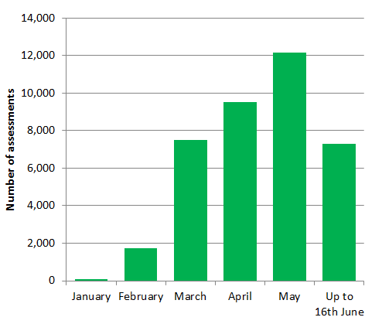
Charts
Chart 1 Number of GD Assessments lodged, by month
Chart 2 Number of 'new', 'pending' and 'live' Green Deal Plans in unique properties, cumulative totals by month
Chart 3 Number of Cashback vouchers where payments have been made, by month of installation
Chart 4 Provisional number of ECO measures installed, by obligation, up to end April 2013
Chart 5 Value of ECO brokerage contracts let, by auction
Chart 6 Development of the supply chain, cumulative totals

Detailed Results
This section of the report provides the latest available information on different elements of the Green Deal and ECO. This includes the number of Assessments and Green Deal Plans, Cashback vouchers spent, measures installed through Cashback and ECO, a summary of ECO brokerage and an overview of the supply chain.
Green Deal Assessments, by month (Table 1, Chart 1)
The first step in the Green Deal process involves a Green Deal Assessor coming to the home, talking to the owner/occupier about their energy use and seeing if they can benefit from making energy efficiency improvements to their property.
The main output from this process is that a Green Deal Advice Report (using information from an Energy Performance Certificate and Occupancy Assessment) will be produced and will be lodged on a national register. The customer is then able to view the energy efficiency measures which have been recommended and understand the potential costs and savings.

For more information on the GD assessment process see here.
At 16 June, there were 38,259 GD Assessments lodged in total. Chart 1 shows the number of Assessments lodged in each month between January and May and up to 16 June. The number of GD Assessments in May was 28 per cent higher than that in April (which in turn was 27 per cent higher than in March).
The Green Deal and ECO quarterly statistical report provides a range of analysis and further breakdowns on Assessments to the end of March.
‘New’, ‘pending’ and ‘live’ Green Deal Plans in unique properties, cumulative totals by month (Table 2, Chart 2)
Following an Assessment, for householders who choose to take on some of the recommended measures, there are a number of routes to pay for the improvements. Some customers may choose Green Deal finance to pay for part or all of their planned improvements, whilst others may choose to pay for measures out of savings or other sources of finance, and some may be part funded through ECO support.
For those who choose Green Deal finance, there are three stages in the life cycle of a Green Deal Plan for which reports are generated. In total, there were 245 Green Deal Plans in the system for individual properties as at 16 June. Of these, 241 were ‘new’ Green Deal Plans and 4 were ‘pending’. The three reporting stages are presented in Table 2 and Chart 2 and described below;
- the first stage (a ‘new’ Green Deal Plan) is after a customer has obtained a quote from a Green Deal Provider and confirmed they wish to proceed. The Green Deal Provider has then successfully requested a Green Deal Plan record prior to signature by the customer. It is possible that more than one Green Deal Plan may be requested for each household. There were 241 households with a ‘new’ Green Deal Plan reported up to 16 June.
- the second stage (a ‘pending’ Green Deal Plan) is when a Green Deal Plan has been signed by the customer, progress is being made to install Green Deal Plan measures and the Plan is being finalised so that charging can start. There were 4 households with ‘pending’ Green Deal Plans reported up to 16 June.
- the final stage (a ‘live’ Green Deal Plan) is after the measures have been installed in the property, the information required to disclose the plan to future bill payers has been attached to the Plan and the energy supplier has all the information required to bill Green Deal charges. At this stage the daily charge has been confirmed along with the date from when the charge will be accrued on their electricity bill. There were no ‘live’ Green Deal Plans up to 16 June.
It has only been possible for Green Deal Providers to request plans once commercial agreements between the Green Deal Finance Company and Green Deal Providers have been agreed. It took Green Deal Providers some time to prepare their businesses to bring offers to the market with Green Deal Plans being created from May onwards for the small number of GD Providers who have finalised their offer to date.
Chart 2 - Number of 'new', 'pending' and 'live' Green Deals in unique properties, cumulative totals by month
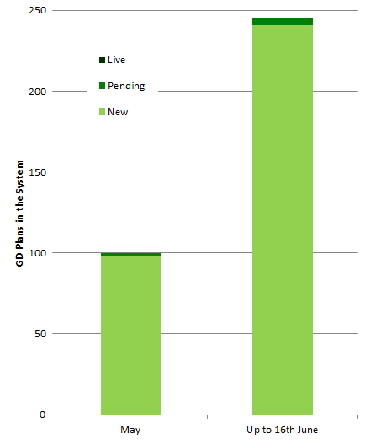
As ‘new’ and ‘pending’ Green Deal Plans lead to installation of measures and charges starting to accrue they will be replaced as ‘live’ Green Deal Plans in future monthly releases. Under the policy framework, it is expected that a high proportion of ‘new’ and ‘pending’ Green Deal Plans will result in measures installed and charges starting to accrue.

Cashback vouchers where payments have been made, by month of installation (Table 3, Chart 3)
The Cashback scheme has been available since January 2013 in England and Wales. It is a financial incentive specifically aimed to encourage domestic customers to get measures installed through the Green Deal process, although it is the customers’ choice whether they decide to take out Green Deal finance or other sources of finance to fund the installation of the measures. For more information on cashback please see the Cashback website
Table 3 and Chart 3 show that 968 cashback vouchers had been paid (following installation of measures) up to 16 June with a total value of £263,452. However, although data do not allow us to breakdown this information to the same level of detail, 5,118 cashback vouchers were issued up to 16 June with a total budget committed of around £1.5m. Many of these issued vouchers will not have been paid yet as payment is dependent on the installation of the measures.
Chart 3 - Number of Cashback vouchers where payments have been made, by month of installation
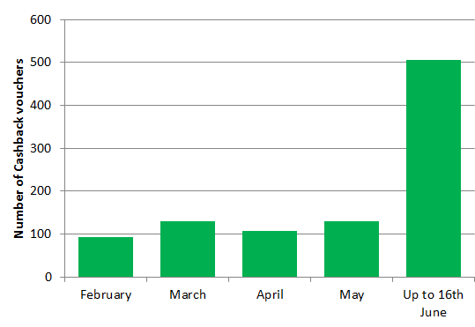
Cashback measures where payments have been made (Table 3a)
Table 3a shows that the main measure where cashback payments have been made to date is for replacement boilers (99 per cent of the number of payments made).
ECO measures installed by obligation, up to the end of April (Table 4, Chart 4)
The overall Energy Company Obligation (ECO) period runs until 31 March 2015. Information on measures installed under ECO is at a lag of a month compared to other figures presented in this release due to the time taken for information to be reported and verified. Hence, this release includes measures installed under ECO until the end of April 2013.
All measures installed under ECO are provisional until the end of the obligation period as checks are undertaken. Initial validation checks are undertaken by Ofgem in the month following receipt of data and longer-term audits are done over the obligation period (e.g. to verify the installation of the measures and the quality of installations and to ensure compliance with the ECO guidelines). Users should note that, in order to produce the most timely data possible, estimates in this report include a month of data that has yet to be through initial Ofgem validation checks (i.e. as reported by energy suppliers to Ofgem). Revisions to data will be included in future releases.
Table 4 and Chart 4 show the provisional number of measures installed under ECO by ECO sub-obligation. This shows that the majority of the 81,798 measures installed under ECO were for loft insulation (56 per cent of all measures installed under ECO), cavity wall insulation (33 per cent) and boiler upgrades (10 per cent). This table also shows the difference between measures and properties, as more than one measure can be installed in a property. Over 70,000 properties benefitted from one or more ECO measures being installed up to the end of April 2013.
By sub-obligation, 31 per cent of measures installed under ECO were delivered through the Carbon Saving Obligation (CSO), 37 per cent were delivered through Carbon Savings Communities (CSCO) and 32 per cent were delivered through Affordable Warmth (HHCRO).
Chart 4 - Provisional number of measures installed under ECO, by obligation, up to end April
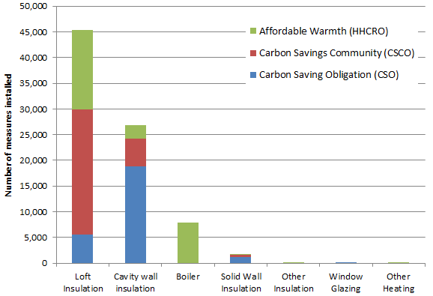
There were around 45,400 loft insulation measures installed under ECO up to the end of April, the large majority (80 per cent) of these were top ups. In addition, there were around 26,800 cavity wall insulation measures installed over the same period, the majority of which (70 per cent) were delivered to Hard to Treat cavity wall properties There were also around 1,600 solid wall measures installed over the same period, virtually all of which were for External Wall Insulation.
Measures installed through other finance routes
The figures in Tables 3a (cashback) and Table 4 (ECO) do not include estimates of measures installed following a Green Deal Assessment where a measure is financed outside of policy framework (i.e. no GD finance, no GD cashback and no ECO). Alternative sources of finance may include householder savings or loans; Local Authority funding (such as through the Core Cities or Pioneer Places schemes) and other sources.
However, recent research conducted by DECC on householders who have had a GD assessment up to the end of March stated that 33 per cent of households who had received a Green Deal Advice Report claimed to have installed at least one recommended measure, and a further 14 per cent were in the process of installing measures.
Around a third of those who had already installed measures stated self-finance as a method of payment and around two thirds of those intending to install something stated that they will finance the installation of measures themselves. Some of these households indicated that they were applying for cashback, but these findings suggest there may be a proportion of households installing measures which we will not pick up through our data sources, although the majority who plan to have measures installed have indicated they will be doing so through the GD/ECO framework. We will review this through further research.
ECO brokerage, as at 16 June (Table 5, Chart 5)
The ECO Brokerage system operates as a fortnightly anonymous auction where providers can sell ‘lots’ of future measures of ECO Carbon Saving Obligation, ECO Carbon Saving Communities and ECO Affordable Warmth, to energy companies in return for ECO subsidy. Chart 5 shows that up to 16 June there have been 11 auctions, with a total value of contracts let worth £131 million.

Chart 5 - Value of ECO brokerage contracts let, by auction

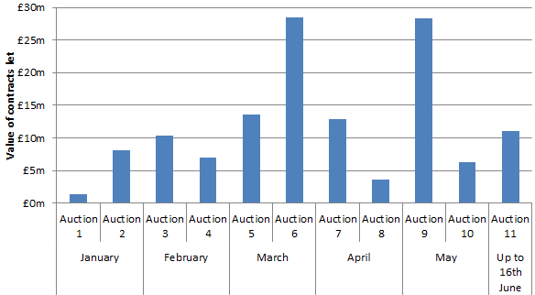
For more detail on the results of each auction, please see ECO Brokerage
Supply chain, as at 16 June (Chart 6)
The supply chain to support the Green Deal has been developing since October 2012. This includes individual Advisors (who carry out and produce Green Deal Advice Reports) and Assessor organisations (who employ authorised Green Deal Advisors), Green Deal Providers (who quote for and arrange Green Deal Plans with householders and arrange for the measures to be installed), and Installer organisations (who install energy efficiency improvements under the GD finance mechanism). Chart 6 shows the number of organisations and individuals who have been accredited up to 16 June 2013.
Chart 6 - Development of supply chain (cumulative numbers) at end of month
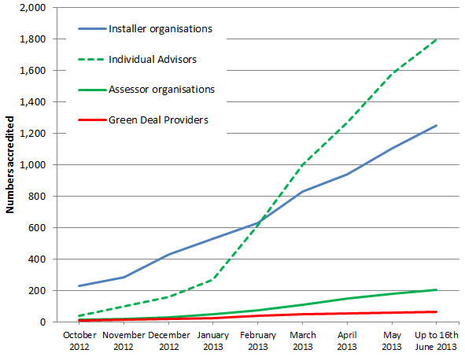
The numbers of accredited GD Assessor organisations and individual Advisors has been increasing sharply since December as individual Assessors complete their training and are accredited. At 16 June there were 206 organisations employing a total of 1,798 Advisors, compared to 48 and 270 respectively at the end of January 2013.
The number of Green Deal Providers has increased to 63 from 25 at the end of January 2013.
The number of accredited Installer organisations has increased steadily since the beginning of the year from 531 accredited at the end of January 2013 to 1,254 organisations accredited at 16 June 2013. These organisations will provide a wide range of different measures and in different geographical locations – more analysis on these measures and geographical coverage will be provided in the quarterly statistical releases.
The Green Deal Oversight and Regulation Body (ORB) produces publically available information on the supply chain, and the latest figures are available by using the search tool on the ORB website. There is also information available on contacts in local areas.
Annex A – Tables

Table 1: Number of Green Deal Assessments¹, month and cumulative total
 |  | Total in Month |  | Cumulative Total
Month |  | Green Deal Assessments |  | Green Deal Assessments
January 2013 |  | 74 |  | 74
February 2013 |  | 1,729 |  | 1,803
March 2013 |  | 7,491 |  | 9,294
April 2013 |  | 9,522 |  | 18,816
May 2013 |  | 12,146 |  | 30,962
Up to 16th June 2013 |  | 7,297 |  | 38,259
¹ As measured by the number of Green Deal Advice Reports were lodged on the central register against unique property.

Table 2: Number of 'new', 'pending' and 'live' Green Deal Plans^{1,2,3} in unique properties, cumulative total by month
Month | 'New'¹ Green Deal Plans |  | 'Pending'² Green Deal Plans |  | 'Live'³ Green Deal Plans |  | 'Total'⁴ Green Deal Plans
May 2013 | 98 |  | 2 |  | 0 |  | 100
Up to 16th June 2013 | 241 |  | 4 |  | 0 |  | 245
¹ A 'new' Green Deal Plan is after a customer has obtained a quote from a Green Deal Provider and confirmed they wish to proceed. The Green Deal Provider has then successfully requested a Green Deal Plan record prior to signature by the customer.
² A 'pending' Green Deal is when a Green Deal Plan has been signed by the customer, progress is being made to install Green Deal Plan measures and the Plan is being finalised so that charging can start
³ A 'live' Green Deal Plan is after the measures have been installed in the property, the information required to disclose the plan to future bill payers has been attached to the Plan and the energy supplier has all the information required to bill Green Deal charges
⁴ Total Green Deal Plans are the total number of Plan identifiers for unique properties on the Central Charge Database at the end of reporting month

Table 3: Number and value of Cashback vouchers paid, month and cumulative total, by month
 | Payments made
Installation Month | Number | Value (£)
February 2013 | 94 | 25,380
March 2013 | 131 | 35,370
April 2013 | 108 | 29,240
May 2013 | 129 | 36,162
Up to 16th June 2013 | 506 | 137,300
Total to date | 968 | 263,452

Table 3a: Number of measures installed with Cashback¹, up to 16th June 2013

 | Total number of Cashback measures delivered | Percentage of Measures
Boiler | 961 | 99
Gas Boiler | 902 | 93
Oil Boiler | 59 | 6
Cavity wall insulation | 2 | 0
Loft Insulation | 6 | 1
Loft Insulation | 6 | 1
Room in Roof Insulation | 0 | 0
Other Heating | 0 | 0
Electric Storage Heaters | 0 | 0
Flue Gas Heat Recovery Devices | 0 | 0
Heating Controls | 0 | 0
Warm Air Units | 0 | 0
Other Insulation | 0 | 0
Draught Proofing | 0 | 0
Flat Roof Insulation | 0 | 0
Hot Water Cylinder Insulation | 0 | 0
Passageway Walk-through Doors | 0 | 0
Under Floor Insulation | 0 | 0
Solid Wall Insulation | 5 | 1
Window Glazing | 0 | 0
Double Glazing | 0 | 0
Secondary Glazing | 0 | 0
Total number of measures | 974 | 100
¹ More than one measure can be installed with Cashback per unique property

Table 4: Number of ECO measures installed¹, by obligation, up to end April 2013
Measure Types | Obligation
 | Carbon Saving Target (CSO) | Carbon Savings Community (CSCO) | Rural (sub-obligation) | Affordable Warmth (HHCRO) | Total number of ECO measures delivered | Percentage of ECO Measures
Boiler | N/A | N/A | N/A | 7,857 | 7,857 | 10
Boiler: Installation of a Non qualifying boiler | N/A | N/A | N/A | 199 | 199 | 0
Boiler: Repair qualifying boiler 1 year warranty | N/A | N/A | N/A | 1 | 1 | 0
Boiler: Repair qualifying boiler 2 year warranty | N/A | N/A | N/A | 73 | 73 | 0
Boiler: Replacement qualifying boiler | N/A | N/A | N/A | 7,584 | 7,584 | 9
Cavity wall insulation | 18,814 | 5,464 | 0 | 2,558 | 26,836 | 33
Standard CWI | 50 | 5,378 | 0 | 2,543 | 7,971 | 10
HTTC: Cavity wall insulation solution | 18,682 | 86 | 0 | 15 | 18,783 | 23
HTTC: Solid wall insulation solution | 82 | 0 | 0 | 0 | 82 | 0
Loft Insulation | 5,604 | 24,250 | 0 | 15,552 | 45,406 | 56
Loft Insulation Ceiling Level Virgin | 1,674 | 4,586 | 0 | 2,836 | 9,096 | 11
Loft Insulation Ceiling Level Topup | 3,930 | 19,664 | 0 | 12,716 | 36,310 | 44
Loft Insulation Rafter | 0 | 0 | 0 | 0 | 0 | 0
Room in Roof Insulation | 0 | 0 | 0 | 0 | 0 | 0
Micro-generation | N/A | N/A | N/A | 0 | 0 | 0
Air Source Heat Pumps | N/A | N/A | N/A | 0 | 0 | 0
Biomass Boilers | N/A | N/A | N/A | 0 | 0 | 0
Ground Source Heat Pumps | N/A | N/A | N/A | 0 | 0 | 0
Micro CHP | N/A | N/A | N/A | 0 | 0 | 0
Micro hydro | N/A | N/A | N/A | 0 | 0 | 0
Micro wind | N/A | N/A | N/A | 0 | 0 | 0
Photovoltaics | N/A | N/A | N/A | 0 | 0 | 0
Other Heating | 0 | 0 | 0 | 1 | 1 | 0
Electric Storage Heaters | N/A | N/A | N/A | 0 | 0 | 0
DHS: Biomass boiler new connections | 0 | 0 | 0 | 0 | 0 | 0
DHS: Biomass boiler upgrades | 0 | 0 | 0 | 0 | 0 | 0
DHS: CHP new connections | 0 | 0 | 0 | 0 | 0 | 0
DHS: CHP upgrades | 0 | 0 | 0 | 0 | 0 | 0
DHS: Gas/Oil boiler new connections | 0 | 0 | 0 | 0 | 0 | 0
DHS: Gas/Oil boiler upgrades | 0 | 0 | 0 | 0 | 0 | 0
DHS: heat meters | 0 | 0 | 0 | 0 | 0 | 0
Flue Gas Heat Recovery Devices | N/A | N/A | N/A | 0 | 0 | 0
Heat Recovery Ventilation | N/A | N/A | N/A | 0 | 0 | 0
Heating Controls | N/A | N/A | N/A | 1 | 1 | 0
Radiator Panels | N/A | N/A | N/A | 0 | 0 | 0
Warm Air Units | N/A | N/A | N/A | 0 | 0 | 0
Other Insulation | 62 | 33 | 0 | 1 | 96 | 0
Flat Roof Insulation | 38 | 24 | 0 | 0 | 62 | 0
Draught Proofing | 0 | 9 | 0 | 1 | 10 | 0
Hot Water Cylinder Insulation | 24 | 0 | 0 | N/A | 24 | 0
Passageway Walk-through Doors | 0 | 0 | 0 | 0 | 0 | 0
Pipework Insulation | 0 | 0 | 0 | 0 | 0 | 0
Under Floor Insulation | 0 | 0 | 0 | 0 | 0 | 0
Solid Wall Insulation | 1,208 | 356 | 0 | 1 | 1,565 | 2
External wall insulation: Solid brick walls, built from 1967 | 214 | 55 | 0 | 0 | 269 | 0
External wall insulation: Solid brick walls, built pre 1967 | 379 | 284 | 0 | 1 | 664 | 1
External wall insulation: Solid non-brick walls | 611 | 15 | 0 | 0 | 626 | 1
Internal wall insulation: Solid brick walls, built from 1967 | 0 | 0 | 0 | 0 | 0 | 0
Internal wall insulation: Solid brick walls, built pre 1967 | 4 | 0 | 0 | 0 | 4 | 0
Internal wall insulation: Solid non-brick walls | 0 | 2 | 0 | 0 | 2 | 0
Park Home External wall insulation | 0 | 0 | 0 | 0 | 0 | 0
Window Glazing | 37 | 0 | 0 | 0 | 37 | 0
Total number of measures | 25,725 | 30,103 | 0 | 25,970 | 81,798 | 100
Total number of unique properties |  |  |  |  | 72,525
¹ As reported by energy suppliers to Ofgem in their monthly returns. Please see the accompanying Methodology Note for more details.

Table 5: Number of ECO brokerage auctions¹ and total amount traded, by month
Month |  | Number of auctions | Total amount traded
January 2013 |  | 2 | £9.5m
February 2013 |  | 2 | £17.4m
March 2013 |  | 2 | £42.0m
April 2013 |  | 2 | £16.6m
May 2013 |  | 2 | £34.6m
Up to 16th June 2013 |  | 1 | £11.1m
Total to date |  | 11 | £131.1m
¹ ECO brokerage auctions are scheduled to take place on a fortnightly basis.

Table 6: Number¹ of accredited Assessor organisations, individual Advisors, Green Deal Providers, and Installer organisations, cumulative totals by month
Month² | Assessor organisations | Individual Advisors | Green Deal Providers | Installer organisations
October 2012 | 13 | 40 | 8 | 231
November 2012 | 18 | 100 | 15 | 285
December 2012 | 29 | 159 | 20 | 429
January 2013 | 48 | 270 | 25 | 531
February 2013 | 77 | 618 | 40 | 629
March 2013 | 108 | 1,003 | 48 | 831
April 2013 | 152 | 1,274 | 55 | 942
May 2013 | 182 | 1,582 | 60 | 1,108
Up to 16th June 2013 | 206 | 1,798 | 63 | 1,254
¹ Numbers include domestic, both domestic and non-domestic and a small number of non-domestic only participants
² Months are approximate as they are based on numbers up to the end of the last full week in the month

Annex B – Background
Green Deal

The Green Deal (GD) was launched on 28 January 2013 in England and Wales (and on 25 February in Scotland) and will tackle a number of the key barriers to the take-up of energy efficiency measures.

Customers having Green Deal Assessments undertaken have the choice of how they proceed. They might take the view that their home is sufficiently energy efficient, or that they want to finance work through a Green Deal Plan or that they want to use alternative funding arrangements (e.g. use of savings).
The Green Deal process for households is briefly described below:

Step 1 – Assessment – A Green Deal assessor will come to the home, talk to the owner/occupier about their energy use and see if they can benefit from making energy efficiency improvements to their property.

Step 2 - Recommendations – The assessor will recommend improvements that are appropriate for the property and indicate whether they are expected to pay for themselves through reduced energy bills.

Step 3 – Quotes – Green Deal Providers will discuss with the owner/occupier whether a Green Deal Plan is right for them and quote for the recommended improvements, including the savings estimates, savings period, first year instalments and payment period for each improvement. A number of quotes can be obtained.

Step 4 – Signing a plan – The customer chooses to proceed with a given provider and package of measures. The owner/occupier needs to obtain the necessary consent to make improvements to the property before they can agree terms with the GD Provider of a Green Deal Plan, at which stage they enter a cooling-off period.

Step 5 – Installation – Once a Green Deal Plan has been agreed, the Provider will arrange for the improvements to be made by a Green Deal Installer. Once the installation has been completed a letter is sent to the Bill Payer and, at this stage, the Green Deal Plan goes ‘live’.

Repayments will be no more than what a typical household should save in energy costs.

Energy Company Obligation

The Energy Company Obligation (ECO) started on 1 January 2013 (although energy companies have been able to count against their targets measures delivered since 1 October 2012) and runs to 31 March 2015. It broadly takes over from two previous schemes (Carbon Emissions Reduction Target - CERT - and Community Energy Saving Programme - CESP) and focuses on providing energy efficiency measures to low income and vulnerable consumers and those living in 'hard-to-treat' properties. While ECO is not a financial target, DECC’s Impact Assessment estimated costs at around £1.3 billion a year.

There are three main ECO obligations – The Carbon Saving Obligation (CSO); Carbon Saving Communities (CSCO) and Affordable Warmth (HHCRO). The ECO Carbon Saving Obligation is estimated to be worth around £760 million per year. The Carbon Saving Community Obligation and ECO Affordable Warmth will together provide support worth around an estimated £540 million per year to low-income households and areas.

Carbon Saving Obligation - This covers the installation of measures like solid wall and hard-to-treat cavity wall insulation, which ordinarily can’t be financed solely through the Green Deal.

Carbon Saving Communities Obligation - This provides insulation measures to households in specified areas of low income. It also makes sure that 15 per cent of each supplier’s obligation is used to upgrade more hard-to-reach low-income households in rural areas.

Affordable Warmth Obligation - This provides heating and insulation measures to consumers living in private tenure properties who receive particular means-tested benefits. This obligation supports low-income consumers who are vulnerable to the impact of living in cold homes, including the elderly, disabled and families.

How do the Green Deal and ECO interact?

Following a GD Assessment there will be a range of measures which could improve the energy efficiency of the property. Some of these could be paid for through GD finance, up to the point where the expected annual cost will not exceed what a typical household should save in energy costs. However, depending on the measure or the property, other sources of finance may also be required. ECO funding could be one of these sources, for example for measures such as Solid Wall Insulation and hard-to-treat Cavity Wall insulation.

Green Deal Cashback

The Green Deal Cashback Scheme rewards the first Green Deal customers. It is a first-come, first served offer where householders can claim cash back from Government on energy saving improvements like insulation, front doors, windows and boilers with packages worth over £1000. It is available for households in England and Wales. For more information on cashback please see the Cashback website. For more information on the separate scheme that operates in Scotland please see the relevant website.

ECO Brokerage

The ECO Brokerage system operates as a fortnightly anonymous auction where GD Providers can sell ‘lots’ of future measures of ECO Carbon Saving Obligation, ECO Carbon Saving Communities and ECO Affordable Warmth, to energy companies in return for ECO subsidy.

This market-based mechanism has been introduced to support an open and competitive market for the delivery of the ECO. Brokerage allows a range of Green Deal providers to fairly compete on price to attract ECO support and enables energy suppliers to deliver their obligations at the lowest possible cost, thereby reducing the impact on customer energy bills.

Sellers (GD Providers) can make a competitive offer on brokerage by leveraging additional sources of finance, such as part funding measures through Green Deal Finance, partnerships with local authorities, or driving down costs by economies of scale.

The Supply Chain
To understand more about the organisations and infrastructure underpinning the Green Deal, this report also includes a section summarising the trends in the number of Green Deal Advisors (and Assessor organisations), the number of Green Deal Providers and the number of Green Deal Installer organisations.
Annex C – Sources and Methodology
The estimates in this and future Statistical Release use administrative data generated as part of the Green Deal and Energy Company Obligation processes.
There are seven main sources of information:
- Landmark – who manage the national lodgement of Green Deal Assessments in England and Wales
- Energy Savings Trust (EST) – who manage the national lodgement of Green Deal Assessments in Scotland
- Green Deal Central Charge Database – which manages the recording and administration of Green Deal Plans
- Ofgem – who administer the Energy Company Obligation and collect information from energy companies on measures installed under ECO.
- The Green Deal Oversight and Regulation Body (ORB) – who administer the certification of GD organisations (including assessors, installers and providers)
- Data on ECO brokerage is publically available following each auction.
- Capita – who administer the Green Deal Cashback Scheme

This report uses data from Landmark and the Energy Savings Trust for numbers of lodged Assessments, data from the Central Charge Database on Green Deal Plans, data from the Cashback Scheme Administrator on cashback vouchers issued and measures installed, data from Ofgem on ECO measures, data from the ORB for the supply chain and the published data on ECO brokerage.

Experimental Statistics

These estimates are released as Experimental Statistics which means they are official statistics undergoing an evaluation process prior to being assessed as National Statistics. They are published in order to involve users and stakeholders in their development, and as a means to build in quality assurance during development.
More information on the methodology is included here.
As with any new data collection, there are likely to be some data quality issues to resolve as the process beds in. Therefore data in the monthly reports should be treated as provisional and subject to revision.
Any revisions will be marked in the data tables and for any significant revisions we will provide an explanation of the main reasons.
Further Information and Feedback

Any enquiries or comments in relation to this statistical release should be sent to DECC’s Green Deal Statistics Team at the following email address:
EnergyEfficiency.Stats@decc.gsi.gov.uk

Contact telephone: 0300 068 5202

The statistician responsible for this publication is Matt Walker.

Further information on energy statistics is available at https://www.gov.uk/government/organisations/department-of-energy-climate-change/about/statistics

Next Releases

The next monthly publication is planned for publication at 9.30am on 18 July 2013 and will contain the latest available information on the number of Assessments and Green Deal Plans, Cashback vouchers spent, measures installed, a summary of ECO brokerage and an overview of the supply chain.
The next quarterly publication is planned for publication at 9.30am on 19 September 2013 and will contain more detailed information on activity up to the end of June, including geographic breakdowns of Assessments, Green Deal Plans and GD/ECO measures.

Affordable Warmth is also known as Home Heating Cost Reduction Obligation (HHCRO)
Where there is at least 60mm of existing loft insulation
Hard to Treat cavity wall properties are also sometimes known as ‘hard-to-fill’. This means that they cannot be insulated using the same methods and/or products as a standard cavity wall.
Unlike Advisors in Assessor organisations, individual Installers within an installer organisation do not need to register.
The Plan is a contract between the owner/occupier and the Provider – it sets out the work that will be done and the repayments.
For example, in the case of a Green Deal Plan that is regulated by the Consumer Credit Act 1974, the consumer will have 14 days to withdraw from the part of the Green Deal Plan which provides credit.

