The Women’s Business Council:
Starting Out Evidence Paper
Summary
This evidence paper considers the first stage of the life-cycle – “Starting Out” – and covers education and transition to the labour market. To maximise women’s contribution to economic growth, we need to ensure that young women are leaving education with the skills that are going to be demanded in future growth.
Girls out-perform boys in school and more women than men graduate from university. However, there are substantial differences in the subjects that girls and boys choose, and men are more likely to study the university subjects that lead to the highest earnings.
There are many ways that this could be addressed, for example through careers guidance, greater input from employers in education, better use of work experience or apprenticeships to broaden horizons or efforts to smooth the transition from education into employment, especially in the professions.
Introduction
To maximise the potential of women’s contribution to economic growth, it is critical that young women leave education with the qualifications and skills that are demanded and rewarded in the labour market.
Figure 1: Starting Out stages
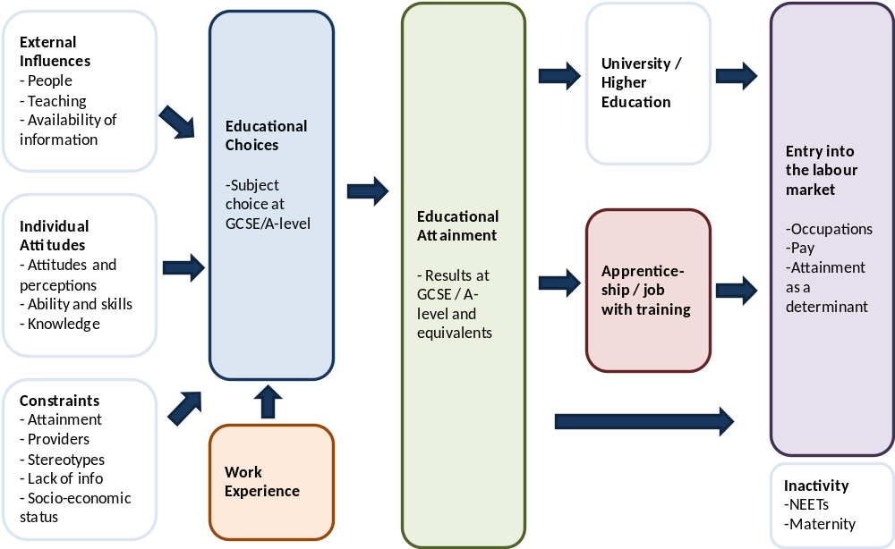
Focussing on areas where there are skills shortages and projected growth in employment would maximise the impact on growth, as businesses benefit from an increased supply of skilled labour. Taking into account areas where there are currently skills shortages in the labour market can benefit the economy by increasing the supply of skilled labour to meet these gaps.
Box 1: What are the skills needed in future economic growth?
Projections of employment to 2020 by the UK Commission for Employment and Skills suggest that there will be greatest jobs growth in professional and associate professional jobs. Combining this with data on skills shortages gives us an indication of areas where business would benefit from an increased supply of labour. These include: accountants, management consultants, actuaries, economists, architects and engineers, legal professionals, functional managers, literary and media professionals, sales and marketing, computer programmers and IT specialists. Many of these areas are currently male-dominated. More detail is included in Annex A.
There may also be benefit in addressing more work-related skills and work readiness, for example in planning and organisational skills and customer handling skills.
Educational choices and attainment
Pupil’s perceptions of the usefulness of a subject are affected by the way in which schools link subjects to specific careers, by the career value ascribed to subject by advisors and by family members.
At GCSE level, pupil’s enjoyment of a subject has a considerable influence on choices as well as their perceived ability and chances of getting a good grade. The usefulness of a subject has less of an impact, and there is evidence that pupils often have a very narrow understanding of the career relevance of a subject. Usefulness of a subject becomes a greater influence post-16. Family is also an influence, although it is one that diminishes over time. Parents often advise girls and boys differently and parental misconceptions can have an adverse effect on pupil choices.
Gendered choices are apparent from GCSE subjects and become more marked at A-level and in higher education. Gender stereotypes in vocational preferences appear even earlier - a survey by Ofsted found that primary school children held conventionally stereotyped views about men’s and women’s jobs and in years 7 and 9 girls are more interested in design, arts, crafts and performing arts, with boys more interested in leisure, sport and tourism, security and the armed forces. See Annex B for a summary of subject choice by gender. Annex C also summarises educational attainment and subject choice by ethnicity.
Nearly one in four young people say that they have not had enough information to make choices for their future and one survey found that 56% of girls aged 11-21 agreed that girls don’t get enough advice about choosing the right GCSEs and A-levels. Evidence suggests that effective careers education and guidance (CEG) can help pupils choosing post-16 routes make more informed and confident choices that they are more likely to be happy with afterwards.
Figure 2: Educational attainment by gender 2010/11 – girls outperform boys in education
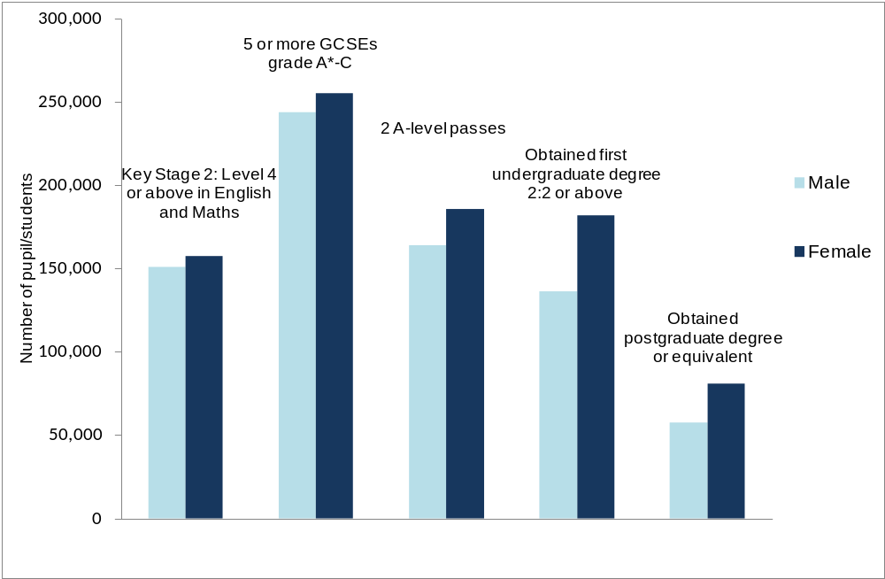

Box 2: Work experience
The Education and Employment Taskforce (EET) have argued that work experience is under-utilised as a means to stretch the career horizons of young people. There is evidence to suggest that work experience improves career decision making and can improve the chances of securing employment for a significant number of pupils (however, there is insufficient evidence to prove a positive impact on attainment).
Young people and their families are often left to find their own work experience placement and this leaves little scope for ensuring that placements match labour market demand or challenge gender stereotypes.
The EET have estimated that the requirement for health and safety inspections and managing relationships to cost schools about £62 per two-week work placement.
The occupational areas that placements are in are highly gendered. However, pupils do show an interest in trying non-traditional placements - in one survey, 36% of girls said they would be interested in a non-traditional placement.

Entering the labour market
For those aged 22-29, women working full-time earn, on average, slightly more than men (a gender pay gap of -2.5%). However, when full-time and part-time workers are included, men earn slightly more (gender pay gap 3.6%). This suggests that the gender pay gap only becomes significant for older age groups, reflecting three key factors: parenthood, the fact that at the moment younger women are better qualified than older women and their male peers and the fact that there is less progression in earnings for women than men.
In the first job young people take, educational attainment has a stronger correlation with wages for women than it does for men. This is partly explained by the fact that women with no or few qualifications earn, on average, much less than men with no or few qualifications, whilst the gap for graduates is smaller – see Figure 3.
The current tough economic conditions are having a profound effect on outcomes. Youth unemployment, at 613,000, is much higher than pre-recession. The percentage of recent graduates working in lower skilled jobs has increased from 27% in 2001 to 36% a t the end of 2011. More information on the occupations that young people are doing is in Annex D.
There are also suggestions that women with science, engineering and technology degrees do not stay in jobs in science, technology, engineering and mathematics – as many as 70% of women with a degree in these areas are not working in relevant jobs.
Figure 3: Average earning by gender and highest qualification held
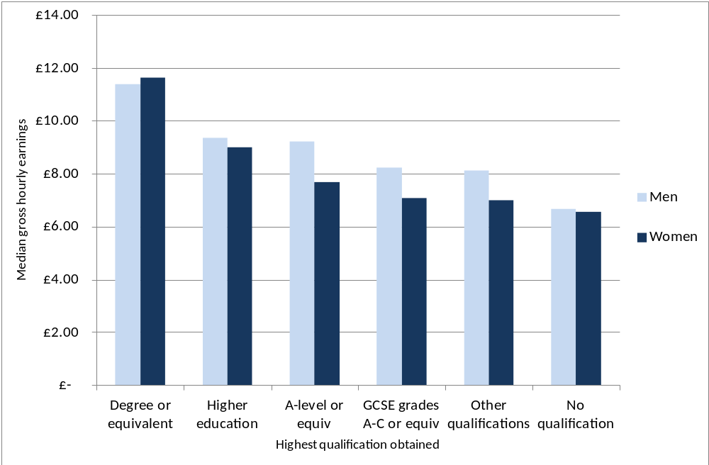
Box 3: Apprenticeships
Apprenticeships can provide a valuable route into jobs that require substantial training. In 2010/11, 54% the total number of apprenticeships started were women and there are twice as many women doing apprenticeships now as there were in 2008/09. However, the increase of women in apprenticeships has mostly been due to the expansion of apprenticeships into sectors with a large female workforce (such as customer service, health and social care, retail and business administration) rather than an influx of young women into traditionally better paid and male-dominated apprenticeships (just 5% of engineering apprentices are women).
Conclusion
To ensure that we maximise women’s contribution to economic growth, we need to ensure that young women are leaving the education system work-ready and with the skills and qualification that are needed in future growth.
Educational attainment is not an issue – girls outperform boys at school – but the subject choices that girls make tend to lead to lower pay in later life. There is a particular shortage of girls and women studying STEM subjects (Science, Technology, Engineering and Mathematics). However, there are also skills shortages and jobs growth in many other professional jobs in business services and greater numbers of women entering these professions could be beneficial.
There are many ways that these issues could be addressed, for example through greater employers’ engagement in work experience and information and advice, tackling stereotypes and encouraging non-traditional paths or efforts to smooth the transition into employment.
Annex A: Occupations with skills shortages and jobs growth
The UK Commission for Employment and Skills, in their Working Futures report, project jobs growth up to 2020. By mapping this against the skills shortages reported by employers in UKCES’s survey of employers and skills, we can predict areas where there is likely to be skills shortages and jobs growth in the UK over the next 8 years.
The areas where there are current skills shortages and projected jobs growth are:
Professional and associate professional jobs in business services. E.g. Business, research and administrative professions (including accountants, management consultants, actuaries, economists and statisticians); architects and engineers; legal professionals; functional managers in consultancy, advertising, market research and employment services; managers and proprietors in real estate; scientific research and development. Current employment in this category is 36% women.
Associate professional jobs in community, social and personal services. E.g. Artistic, literary and media occupations; sports and fitness occupations; sales and marketing in sports, amusement and recreation. Current employment in this category is 44% women.
Professional and associate professional jobs in transport and communications. E.g. computer programmers, IT specialists and technicians; media professionals; artistic and literary professionals; sales and marketing professionals; transport professionals (including pilots, air traffic controllers, ship officers). Current employment in this category is 25% women.
Professional jobs in health and social work. E.g. health, nursing and therapy professionals; welfare professionals (including social workers and probation officers). Current employment in this category is 75% women.
Caring jobs in health and social work. E.g. Childcare; care workers and home carers. Current employment in this category is 85% women.
Work-readiness
As well as occupations where there are skills shortages, young people can benefit from having the generic skills and work-readiness that employers need. Most employers who recruit straight from education (24% of all employers and 79% of large employers) find their recruits to be well prepared for work. The most common attribute reported (23% of employers recruiting 16 year-old school leavers and 8% of university leavers) as lacking among recruits is ‘experience of the working world, life experience or maturity’. 18% of employers recruiting 16 year-olds and 4% recruiting university leavers report poor attitude or a lack of motivation. Very few employers (below 4%) report a lack of numeracy or literacy skills.
In their skills survey UKCES found the greatest skills shortages in: planning and organisation skills; customer handling skills; oral communication skills; and problem solving skills.
Annex B: Subject Choice at GCSE, A-Level and Undergraduate level
Figure A1: Proportion of completed GCSEs by subject and gender
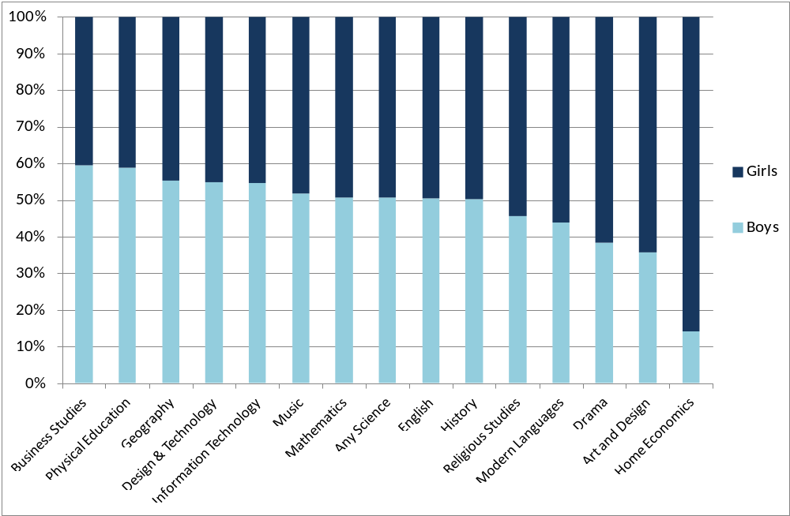
Figure A2: Proportion of completed A-levels by subject and gender
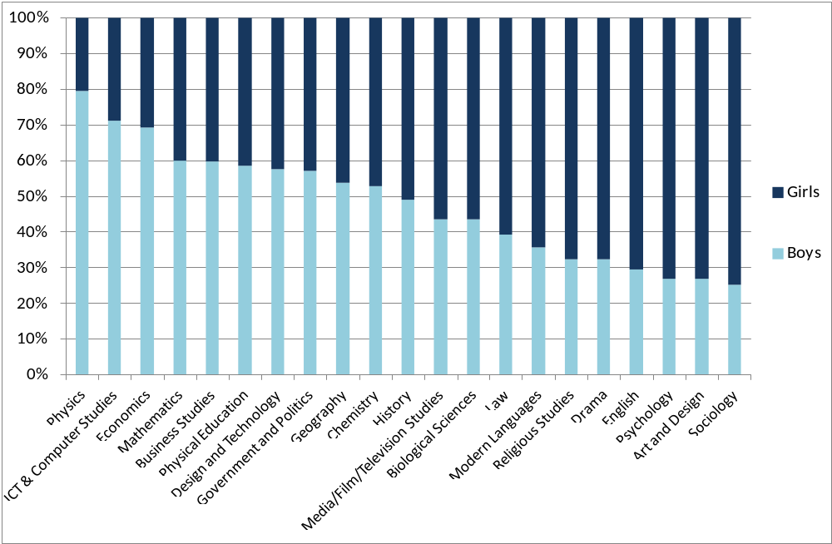

Figure A3: Proportion of completed undergraduate degrees by gender and subject
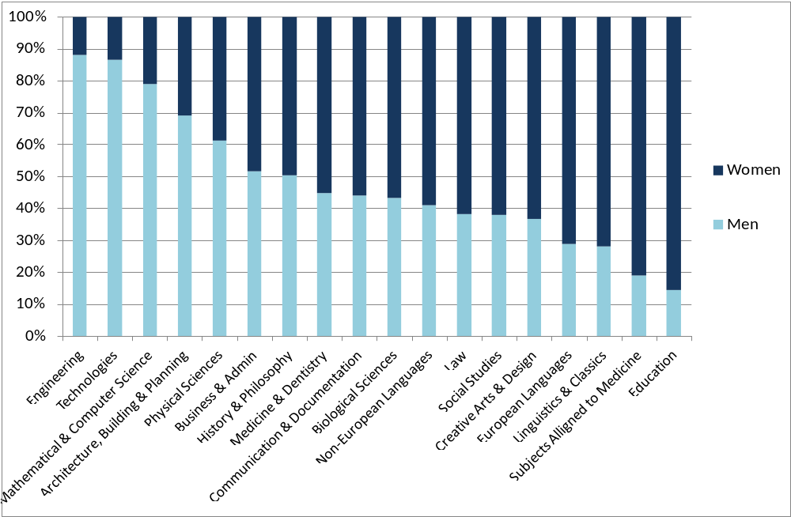

Annex C: Educational attainment by gender and ethnicity
Figure C1: Highest qualification obtained, by gender and ethnicity, England 2008
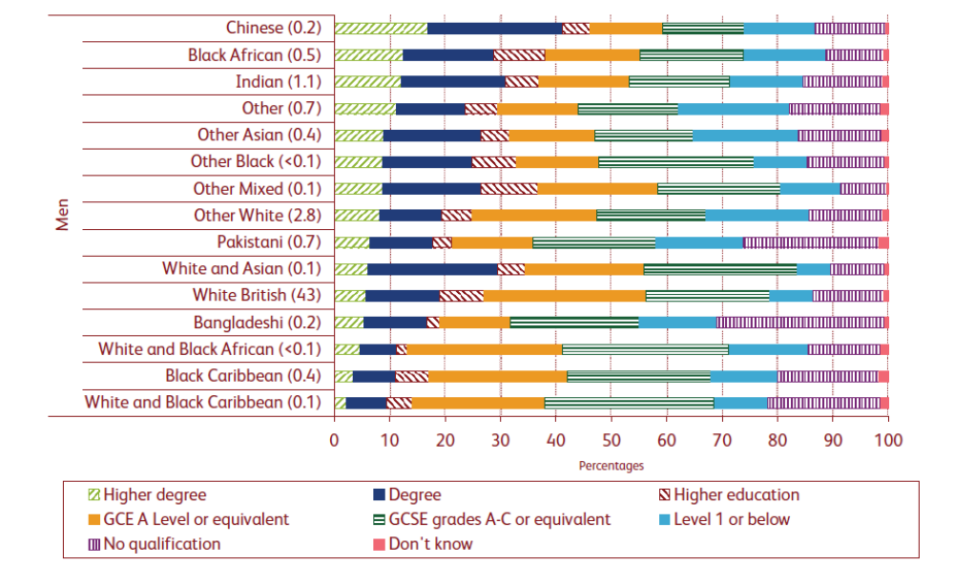
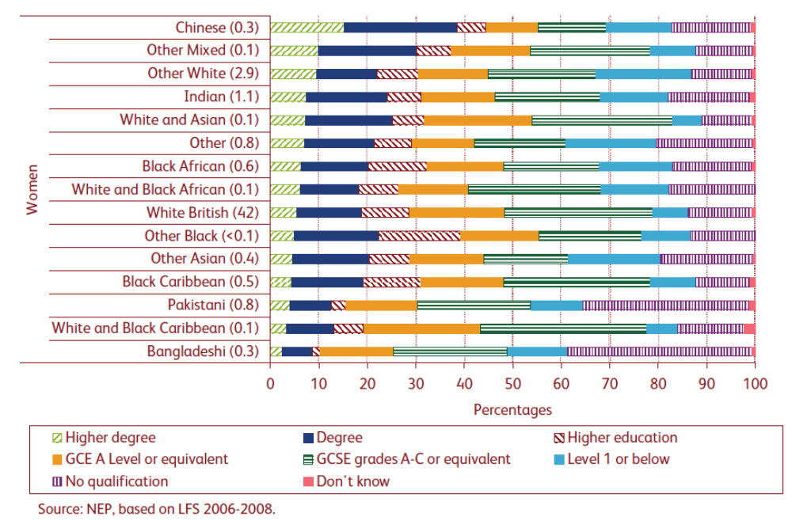
Figure C2: Subject choice in university applications by ethnicity, UK 2010
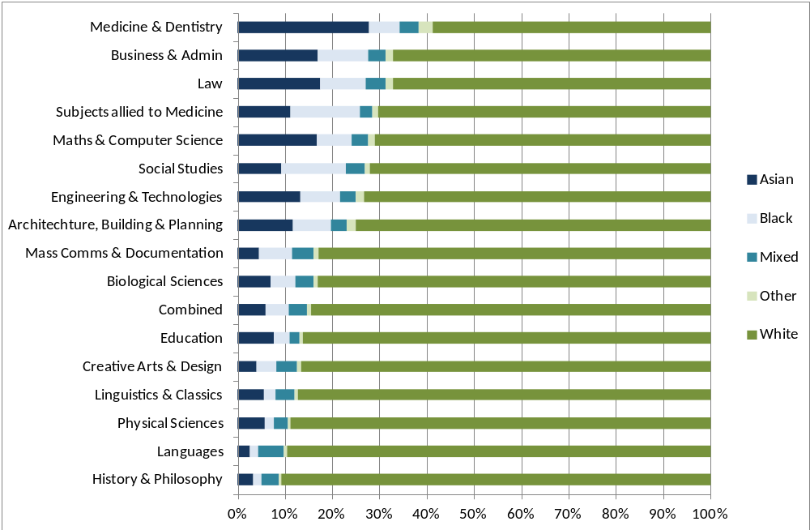
Annex D: Occupations for 16-24 year olds
Figure D1 below shows the major occupational groups that young men and women work in.
Figure D1: Major occupational groups, men and women aged 16-24
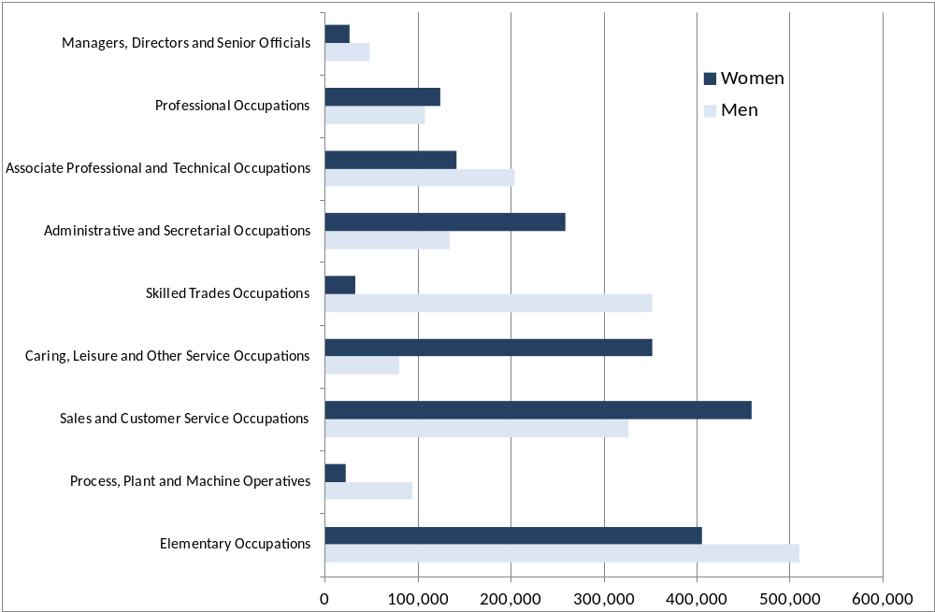

Most common jobs for young men (age 16-24) are:
- Sales assistants and retail cashiers (250,000)
- Elementary services occupations (200,000)
- Construction and building trades (90,000)
- Storage occupations (70,000)
- Electrical and electronic trades (60,000)
Most common jobs for young women (age 16-24) are:
- Sales assistants and retail cashiers (360,000)
- Elementary services occupations (300,000)
- Caring personal services (140,000)
- Childcare and related personal services (110,000)
- Administrative occupations (80,000)
References

UKCES (2012) ‘UKCES Working Futures 2010-2020’ UK Commission for Employment and Skills
McCrone et at (2005) ‘Pupil Choices at Key Stage 3: Literature Review’ NFER
Foskett et al (2003) ‘Pathways and Progression at 16+: ‘fashion’, peer influence and college choice’ Paper presented to the Conference of the British Educational Research Association September 2003 McCrone et at (2005) ‘Pupil Choices at Key Stage 3: Literature Review’ NFER
Vidal Rodeiro (2007) ‘A-Level subject choice in England: patterns of uptake and factors affecting subject preferences’ Cambridge Assessment
McCrone et at (2005) ‘Pupil Choices at Key Stage 3: Literature Review’ NFER Payne (2003) ‘Choice at the End of Compulsory Schooling: a research review’ DfES Research Report 414
Hutchinson, Rolfe, Moore, Bysshe & Bentley (2011) ‘All Things Being Equal? Equality and diversity in careers education, information, advice and guidance’ Equality and Human Rights Commission Research Report 71
Ofsted (2011) ‘Girls’ Career Aspirations’ Ofsted
Hutchinson, Rolfe, Moore, Bysshe & Bentley (2011) ‘All Things Being Equal? Equality and diversity in careers education, information, advice and guidance’ Equality and Human Rights Commission Research Report 71
Hutchinson, Rolfe, Moore, Bysshe & Bentley (2011) ‘All Things Being Equal? Equality and diversity in careers education, information, advice and guidance’ Equality and Human Rights Commission Research Report 71
Girlguiding Attitudes Survey 2011
Moon et al. (2005) ‘A Systematic Review of Recent Research (1988-2004) into the Impact of Careers Education and Guidance during Key Stage 4 on Young People’ Transitions into Post16 Opportunities. Morris, M. (2004) The Case for Careers Education and Guidance for 14-19 Year Olds. Literature review of research on the impact of careers and guidance related interventions. Slough: NfER
Department for Education; Higher Education Statistics Agency
Mann (2012) ‘Work Experience: Insights from the evidence’ Education and Employment Taskforce
Mann (2012) ‘Work Experience: Insights from the evidence’ Education and Employment Taskforce
Francis et al (2005) ‘Gender Equality in Work Experience Placements for Young People’ Equal Opportunities Commission
Annual Survey of Hours and Earnings 2011, Office for National Statistics
Bastagli & Stewart (2011) ‘Pathways and Penalties: Mothers’ employment trajectories and wage growth in the Families and Children Study’ CASE Working Paper 157, Centre for Analysis of Social Exclusion
Bukodi (2009) ‘Education, First Occupation and Later Occupational Attainment: Cross-cohort changes among men and women in Britain’ Centre for Longitudinal Studies Working Paper 2009/4
Labour Market Statistics May 2012, Office for National Statistics
ONS http://www.ons.gov.uk/ons/rel/mro/news-release/recent-graduates-now-more-likely-to-work-in-lower-skilled-jobs/recentgraduates0312.html
UKRC, http://www.theukrc.org/resources/key-facts-and-figures. As of 2008, some 620,000 women in the UK are graduates in SET. However, 70.2 per cent of these don’t work in STEM. Secondary analysis by the UKRC, Data source: Office for National Statistics. Social and Vital Statistics Division and Northern Ireland Statistics and Research Agency. Central Survey Unit, Labour Force Survey January – December 2008. Colchester, Essex: UK Data Archive [distributor]. In this analysis, women aged 16 to 59 and men aged 16 to 64 were included.
Labour Force Survey Q4 2011
National Apprenticeships Service, http://mireportslibrary.thedataservice.org.uk/apprenticeships/
National Apprenticeships Service, http://mireportslibrary.thedataservice.org.uk/apprenticeships/
UKCES (2012) ‘Working Futures 2010-2020’ UK Commission for Employment and Skills
UKCES (2012) ‘UK Commission’s Employer Skills Survey 2011: UK Results’ UK Commissions for Employment and Skills
UKCES (2012) ‘UK Commission’s Employer Skills Survey 2011: UK Results’ UK Commissions for Employment and Skills
Department for Education (2012) ‘GCSE and Equivalent Results in England 2010/11’: http://www.education.gov.uk/researchandstatistics/statistics/allstatistics/a00198393/dfe-gcse-and-equivalent-results-in-england-201011-provisional
Department for Education (2012) ‘GCE/Applied GCE A/AS and Equivalent Examination Results in England, 2010/11’: http://www.education.gov.uk/rsgateway/DB/SFR/s001055/index.shtml
UCAS, university applications 2010: http://www.ucas.ac.uk/about_us/stat_services/stats_online/
Hills et al (2010) ‘An Anatomy of Economic Inequality in the UK: Report of the National Equality Panel’ Government Equality Office and Centre for Analysis of Social Exclusion, London School of Economics and Political Science
UCAS, Statistics Online
Labour Force Survey Q4 2011
Labour Force Survey Q4 2011

