High Speed Two Limited
Engineering Options Report
West Midlands to Leeds
HS2-ARP-000-RP-RW-00007
March 2012

Ove Arup & Partners Ltd  13 Fitzroy Street  London  W1T 4BQ  United Kingdom  www.arup.com | This report takes into account the particular instructions and requirements of our client.  It is not intended for and should not be relied upon by any third party and no responsibility is undertaken to any third party.

Preface
This report was submitted to Government by HS2 Ltd at the end of March 2012 and is part of a suite of documents produced to provide preliminary advice to Government on potential options for phase two of the high speed rail network.
For details of the initial preferred scheme selected by Government, please see the Command Paper “High Speed Rail: Investing in Britain’s Future - Phase Two: The route to Leeds, Manchester and beyond”. The initial preferred scheme will form the basis of further engagement. A preferred scheme will be published in 2013 that will form the basis of full public consultation.
Anyone reading the March 2012 reports should be aware of the following:
- The reports describe the development of options. The base proposition referred to is not a recommended or preferred scheme.
- The reports describe route and station options serving Heathrow T5. The options do not reflect an initial preferred scheme. The Government has announced its intention to suspend work on high speed rail options to Heathrow until the Airports Commission has reported.
- Where the Ordnance Survey Licence Number is shown on maps it should read 100049190.

Contents

Page
1 Introduction 1
1.1 This Engineering Options Report 1
1.2 The Layout of This Report 1
1.3 Remit 2
1.4 Geography of the Route 2
2 Line of Route 7
2.1 Route Sections 7
2.2 The Whole Routes and Their Component Route Sections 11
2.3 HSL01: Water Orton (A) to Birchmoor (B) 15
2.4 HSL02: Birchmoor (B) to Sunny Hill (Derby) (C) 17
2.5 HSL03: Sunny Hill (C) to Breadsall (D) 25
2.6 HSL04: Breadsall (D) to Tibshelf (E) 29
2.7 HSL05: Tibshelf (E) to Killamarsh (F) 35
2.8 HSL06: Birchmoor (B) to Tonge (North of Measham) (G) 39
2.9 HSL07: Birchmoor (B) to Tonge (South of Measham) (G) 45
2.10 HSL08: Birchmoor (B) to Tonge via Twycross (G) 51
2.11 HSL09: Tonge (G) to Long Eaton (H) 59
2.12 HSL10: Long Eaton (H) to Sandiacre (I) 65
2.13 HSL11: Sandiacre (I) to Tibshelf (E) 69
2.14 HSL12: Long Eaton (H) to Trowell (J) 75
2.15 HSL13: Trowell (J) to Killamarsh (F) 77
2.16 HSL14: Killamarsh (F) to Tinsley (K) 85
2.17 HSL15: Tinsley (K) to Blackburn (L) 89
2.18 HSL16: Blackburn (L) to Cold Hiendley (M) 91
2.19 HSL17: Cold Hiendley (M) to Church Fenton (V) 97
2.20 HSL18: Cold Hiendley (M) to Church Fenton (V) 107
2.21 HSL19: Cold Hiendley (M) to Lofthouse (N) 115
2.22 HSL20: Lofthouse (N) to Holbeck (O) 119
2.23 HSL21: Cold Hiendley (M) to Woodlesford (Q) 121
2.24 HSL22: Woodlesford (Q) to Hunslet 1 (R) 125
2.25 HSL23: Woodlesford (Q) to Hunslet 2 (S) 127
2.26 HSL24: Killamarsh (F) to Cold Hiendley (M) – Main Line via Tinsley with Victoria Loop Option 129
2.27 HSL29: Sheffield Victoria Loop (F to M) 133
3 Stations 139
3.1 Overview of Final Options 139
3.2 Option EMI01 (HSL25) Derby Station 141
3.3 Option EMI25a (HSL26 & HSL27) Toton 151
3.4 Option SYI14 (HSL28) Meadowhall 161
3.5 Option SYI07b (HSL29) Sheffield Victoria 173
3.6 Option LST01a (HSL30) Leeds Station North 183
3.7 Option LST13e (HSL32) Sovereign Street South 193
3.8 Option LST13f (HSL31) New Lane 203
4 Depots 213
4.1 The Infrastructure Maintenance Depot 213
4.2 The Rolling Stock Maintenance Depot 215
5 Connections with the Existing National Rail Infrastructure 216
5.1 The Classic Compatible Concept 216
5.2 East Coast Main Line Connection 217
5.3 Classic Compatible Running into City Centres in a Region 218
6 Whole Route Comparisons 221
6.1 The ‘Whole Route’ Combinations 221
6.2 Journey Time Estimates 226
7 History of Line of Route Options 229
7.1 Long List of Routes 229
7.2 Short Listing 233
7.3 Selecting Options for Refinement 239
8 History of Station Options in the East Midlands 247
8.1 Selecting a Station for the East Midlands 247
8.2 Initial List of Station Options 249
8.3 Defining the Long List 250
8.4 Defining the Short List 255
8.5 Identification of Options for Further Refinement 259
8.6 Confirmation of Final Options 265
9 History of Station Options in South Yorkshire 267
9.1 Selecting a Station for South Yorkshire 267
9.2 Initial List of Station Options 269
9.3 Defining the Long List 270
9.4 Defining the Short List 274
9.5 Identification of Options for Further Refinement 279
9.6 Confirmation of Final Options 289
10 History of Station Options in Leeds 291
10.1 Selecting a Station for Leeds 291
10.2 Initial List of Station Options 293
10.3 Defining the Long List 294
10.4 Defining the Short List 299
10.5 Identification of Options for Further Refinement 303
10.6 Confirmation of Final Options 309
11 History of Depot Options 311
11.1 Introduction 311
11.2 Long List of Options 311
11.3 Short List of Options 313
11.4 Options for Further Development 315
12 History of Options for Connection with the Existing National Railway Infrastructure 326
12.1 East Midlands 326
12.2 South Yorkshire 327

- Introduction
  - This Engineering Options Report
        - Arup was commissioned by HS2 Ltd to undertake a study of route engineering options for a proposed high speed line between the West Midlands and Leeds, with a connection to the East Coast Main Line. Provision was to be made for serving the East Midlands and South Yorkshire.
        - This report describes the engineering layout and implications of the options which were studied, and it gives detailed descriptions of the sections of route developed and finalised. The report is complementary to HS2 Ltd’s report to Government entitled ‘Options for Phase Two of the High Speed Rail Network’ and does not duplicate its contents.
        - The report should also be read in conjunction with Volume 1 of the Engineering Report, entitled ‘Options for Phase Two of the High Speed Rail Network – Approach to Design’.
  - The Layout of This Report
        - This report is laid out as follows:
- This chapter, Chapter 1, is introductory in nature. It sets out Arup’s commission and the study remit;
- Chapter 2 contains a series of sub-chapters describing the so-called ‘Line of Route’ with an engineering description;
- Chapter 3 describes the station options;
- Chapter 4 describes the depots (the infrastructure maintenance depot and the rolling stock maintenance depot);
- Chapter 5 describes the infrastructure needed to deliver train services known as ‘Classic Compatible’;
- Chapter 6 links together the individual route sections into whole routes;
- Chapter 7 sets out the history of the ‘Line of Route’ options;
- Chapter 8 describes the history of station options in the East Midlands area;
- Chapter 9 describes the history of station options in the South Yorkshire area;
- Chapter 10 describes the history of station options in the Leeds Area;
- Chapter 11 sets out the history of depot options; and
- Chapter 12 sets out the history of the ‘Classic Compatible’ options.
  - Remit
        - The remit for this engineering study is contained in HS2 Ltd’s Report to Government. HS2 Ltd’s Report to Government also sets out principles and guidance that enabled the design of the routes. This guidance is not repeated in full here, but it is important to point out that the route was designed as a 400kph alignment, except for localised lower speeds to overcome site-specific constraints.
  - Geography of the Route

Terrain
        - The study area starts from the Birmingham area, specifically Water Orton, which is generally low-lying, but contains a large number of obstacles to route location.
        - The study area then turns north-east towards the Derby / Nottingham area, through undulating and largely rural landscapes. There is lower-lying land surrounding the River Trent (through the Burton on Trent area) but there is intervening higher ground of the Charnwood Forest.
        - On an east-west axis south of Derby and Nottingham, there is the confluence of the rivers Derwent and Trent, in a broad, deep and low-lying valley, characterised by sand and gravel workings. Any north-south routes would have to cross these obstructions.
        - The section of the study area between the East Midlands and South Yorkshire is characterised by the Peak District to the west, and the Nottinghamshire Coalfield to the east. The challenges for finding a route for a new railway are made difficult by the topographical challenge to the west in Derbyshire, and by the pattern of settlements of Nottinghamshire.
        - Sheffield is surrounded by challenging terrain through the presence of steep valleys created by the Rivers Don, Sheaf and Porterbrook. There is very hilly terrain to the south and south-west of the city, the only flat land running north-eastwards up the Don Valley towards Rotherham and Doncaster. East of Rotherham, the terrain is much less challenging, and routes were considered in this area.
        - Northwards from South Yorkshire into West Yorkshire, the terrain is again challenging. There are interwoven hills and valleys, and no suitable straight lines running in a north-south direction. Finding a path through this area is challenging, and extensive earthworks, viaducts and tunnels would feature on most routes.
        - Towards Leeds, there are few gaps in development, while the rivers Aire and Calder run east-west through this area, again presenting obstacles for route location.
        - The approaches to the centre of Leeds would have to mimic existing railways, or rely on tunnelling to reach the heart of the city.
        - Towards York and the East Coast Main Line, however, the terrain becomes considerably less challenging, with open agricultural land over modest rolling terrain. Route location here is determined largely by potential effects on features of environmental interest.

Route Geology
        - The route can be divided into three broad sections based on areas of similar terrain and geology. The table below indicates the approximate start and end locations and the length of each subsection.
Section | From | To | Length | Primary Geology
1 | Birmingham | Derby/Nottingham | 60km | Triassic Mercia Mudstone Group
2 | Derby/Nottingham | NE Leeds | 125km | Pennine Coal Measures Group
3 | NE Leeds | York | 60km | Permo-Triassic limestone / sandstone
        - The southerly section comprises rolling terrain between approximately 45m AOD and 220m AOD with generally low slope angles. The section is predominately underlain by Mercia Mudstone Group rocks, although the easterly route options cross parts of the small coalfields of Warwickshire, Lincolnshire and South Derbyshire. In the coalfield areas there are underground mineworkings as well as backfilled opencast sites.
        - The central section comprises undulating terrain between approximately 30m AOD and 180m AOD with generally steeper slope angles compared with those encountered between Birmingham and Derby / Nottingham. The section is predominantly underlain by Carboniferous Pennine Coal Measures, which include extensive deposits of coal, both at surface and at depth, with associated deposits of ironstone, fireclay and ganister.
        - The northern section passes through an area that generally comprises flatter terrain between approximately 10m AOD and 90m AOD with generally low slope angles. This section is predominantly underlain by Permian Zechstein Group rocks in the west and Triassic Sherwood Sandstone to the east. It should be noted that the Sherwood Sandstone is in turn overlain by a significant thickness of Quaternary deposits. The Permian strata include deposits of gypsum that are susceptible to natural dissolution and hence subsidence-related features are present in this area.
        - Natural superficial deposits are present in both the valley bottoms and flanks, as well as on areas of higher ground, and include compressible alluvium and glacial lake deposits, as well as River Terrace Gravels, over-consolidated glacial clays and glacial sand / gravel. Man-made superficial soils are generally backfill to opencast sites, landfill and general made ground deposits within previously developed areas.
        - The following issues influenced route selection, and will influence future route engineering:
- Subsidence of natural cavities, in particular in gypsum near Derby and north east of Leeds;
- Underground Mining. Shallow mine workings occur widely. Although primarily coal mining, there are also shallow mine workings associated with ironstone, sandstone and gypsum. Deep mine workings are limited to coal. Significant lengths of the routes cross coal mineworkings;
- Minewater. The cessation of minewater pumping can cause settlement, particularly differential settlement, to occur within deep mineworkings;
- Backfilled opencast coal sites (OCCS) are very common in the coalfields of Nottinghamshire, Leicestershire, South Yorkshire and West Yorkshire. It is common for landfill cells within the backfill to contain significant contamination;
- Backfilled quarries will typically be identified as landfill sites but will tend to involve abrupt changes in fill depth; and
- Landfill sites pose particular issues, with deep landfill sites containing hazardous and degradable wastes, posing issues of settlement, damage to containment and contaminated arisings.
        - Blasting is likely to be required only for the stronger siltstone / sandstone beds within the Coal Measures and igneous / meta-sedimentary rocks in Leicestershire. A wide variety of soils and rocks will be encountered in cuttings, and the gradient of cut slopes will vary accordingly. Very poor ground conditions will be rarely encountered in cuttings and instability should not pose significant problems, provided suitable cutting gradients are used or standard stabilisation measures are employed. Fill materials are not a significant issue, as all route options generally traverse similar geologies.
        - The routes traverse parts of the country with a long industrial history. Ground contamination is widespread, particularly close to industrial centres, such as the major cities, but also associated with outlying collieries, etc. The presence of ground contamination would be an issue for the excavation and disposal of contaminated arisings, and the regulatory requirement to carry out remediation under planning and environmental regulations.
        - Minewater discharges may arise due to excavations (cuttings / tunnels) into mineworkings or due to the effects of minewater rebound. Mine waters can be highly acidic and ochreous, requiring a separate drainage and treatment system.
        - The effect of tunnels / cuttings / earthworks on existing groundwater abstractions can be significant, with implications on the planning process.

Human Geography
        - Around Water Orton, man has created a complex network of railways, canals, major motorways and local road networks. Many people have tried to thread new infrastructure through this area, and HS2’s task is complicated by that legacy.
        - Towards the Derby / Nottingham area, there are a number of former coal mining towns. Major new transport corridors such as the M42 / A42 have successfully found a path through this area.
        - The cities of Derby and Nottingham present obstacles, but existing railways have entered these cities, on lower speed alignments. There is a gap in development between Derby and Nottingham, through which the M1 passes, but this is Green Belt. To the east of the M1, to Nottingham, development is quite intense.
        - The challenges for finding a route for a new railway are made difficult by the settlements, as there is an east-west barrier of towns: Ripley, Alfreton, Kirkby-in-Ashfield, Sutton-in-Ashfield and Mansfield. The Erewash Valley runs north / south, as does the M1; both present routing opportunities, but the lower-lying land is occupied by railways, canals and settlements, so finding a path for a new transport route in the valley bottoms is challenging. The M1 followed a route towards the east of the study area to overcome exactly the same issues.
        - Getting railways into Sheffield has always been a problem. The railway history of the city is characterised by being omitted from the earliest phases of railway development in the 1840s and 1850s, arising from the very hilly terrain. There is however a gap between Sheffield and Rotherham, which the M1 sought to exploit through the Meadowhall area, and this axis affords opportunities towards Leeds. East of Rotherham, the terrain is much less challenging, and routes were considered in this area.
        - Northwards from South Yorkshire into West Yorkshire, existing railways weave their way along the valleys on slow alignments. The mining towns are in the valley bottoms, along with a legacy of disused railways, canals, contaminated land and a large number of settlements, sometimes discrete, and sometimes merged.
        - Towards Leeds, there is an east-west line of towns: Dewsbury, Ossett, Wakefield, Normanton, Castleford. There are few remaining north-south gaps through these areas.
        - Leeds and its surrounding settlements present obstacles to new routes, as most available corridors are already intensively filled by transport routes, and any new route would need to follow existing railways, or rely on tunnelling to reach the heart of the city.
        - Towards York and the East Coast Main Line, however, there are many fewer settlements in this largely agricultural setting.

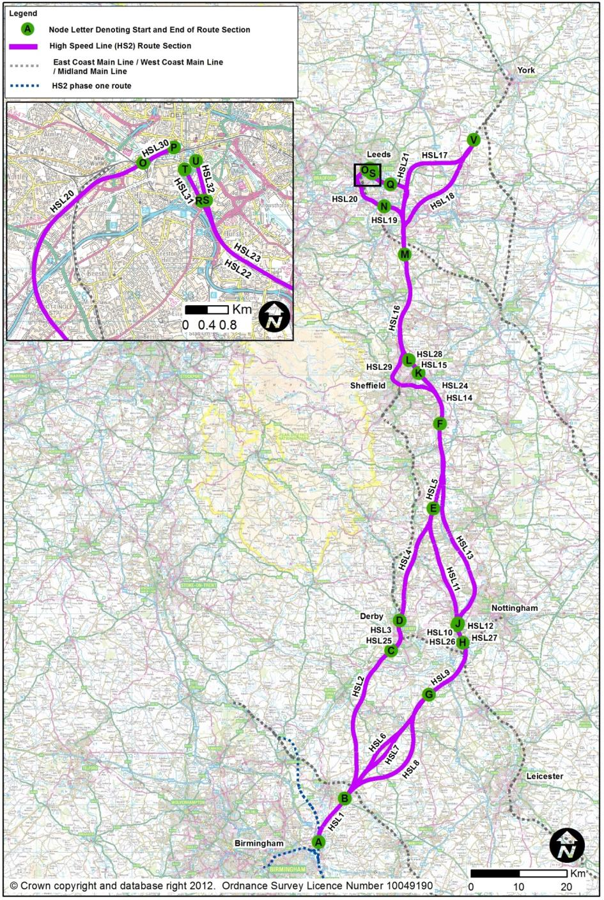
- Line of Route
  - Route Sections
        - This chapter describes a series of individual route sections, which can variously be combined to form continuous routes (as described in Chapter 6) from Water Orton in eastern Birmingham to Leeds and the ECML near Church Fenton. The text also makes reference to potential station locations in the East Midlands and South Yorkshire.
        - The main line of Phase 1 of High Speed 2, the London to West Midlands section, would run north-south to the west of Coleshill in Warwickshire on its way to the West Coast Main Line connection near Lichfield. At Coleshill, a triangular ‘delta’ junction would be provided to include a spur to central Birmingham. The northern apex of this triangular junction is the starting point for all of the Leeds options described in this report.
        - The key plan opposite presents the individual route sections and provides the reader with the guide to the layout of the rest of this chapter. Each route section was given a reference number, such as ‘HSL01’, covering a discrete geographical length. The report describes these sections. The total length may need to be sub-divided in order to allow a piece of text to be read against a map on the opposite page; typically, each map presents about 10 - 12 km of route.
        - The plan also shows that the route sections run between ‘Nodes’, such that the reader can identify the location they are interested in as, for instance, being ‘between Node F and Node G’. These node letters appear in the title of the chapter.
        - The plans show numbered features of interest, presented, for example, as (4) to allow the reader to study the route alongside a corresponding piece of text. The route sections are:
- HSL01: Water Orton (A) to Birchmoor (B)
- HSL02: Birchmoor (B) to Sunny Hill (Derby) (C)
- HSL03: Sunny Hill (C) to Breadsall (D)
- HSL04: Breadsall (D) to Tibshelf (E)
- HSL05: Tibshelf (E) to Killamarsh (F)
- HSL06: Birchmoor (B) to Tonge (North of Measham) (G)
- HSL07: Birchmoor (B) to Tonge (South of Measham) (G)
- HSL08: Birchmoor (B) to Tonge via Twycross (G)
- HSL09: Tonge (G) to Long Eaton (H)
- HSL10: Long Eaton (H) to Sandiacre (I)
- HSL11: Sandiacre (I) to Tibshelf (E)
- HSL12: Long Eaton (H) to Trowell (J)
- HSL13: Trowell (J) to Killamarsh (F)
- HSL14: Killamarsh (F) to Tinsley (K)
- HSL15: Tinsley (K) to Blackburn (L)
- HSL16: Blackburn (L) to Cold Hiendley (M)
- HSL17: Cold Hiendley (M) to Church Fenton (V)
- HSL18: Cold Hiendley (M) to Church Fenton (V)
- HSL19: Cold Hiendley (M) to Lofthouse (N)
- HSL20: Lofthouse (N) to Holbeck (O)
- HSL21: Cold Hiendley (M) to Woodlesford (Q)
- HSL22: Woodlesford (Q) to Hunslet 1 (R)
- HSL23: Woodlesford (Q) to Hunslet 2 (S)
- HSL24: Killamarsh (F) to Cold Hiendley (M) – Main Line via Tinsley with Victoria Loop Option
- HSL29: Sheffield Victoria Loop (J to M).
- HSL30: Leeds Station (Leeds Station North) 1a (O to P)
- HSL31: Leeds Station (New Lane) 13f (R to T)
- HSL32: Leeds Station (Sovereign Street South) 13e (S to U)
        - Some of the route sections above also relate to a potential high speed station covering the same section. These stations are identified by a separate HSL number. These are as follows:
- Section HSL03 is also HSL25 Derby Station
- Section HSL10 is also HSL26 Toton Station
- Section HSL12 is also HSL27 Toton Station
- Section HSL15 is also HSL28 Meadowhall Station
        - HS2 Ltd has identified four whole route combinations for analysis of the business case, with variations that might be considered to bring advantages such as reduced journey time, reductions in risk or increase in benefits. Essentially, there are two line of route options between the West Midlands and Tibshelf (one via Derby, the other via Toton and the Erewash Valley or the M1 corridor). There is a unique section of route between Tibshelf and the Normanton area. Then there are two Leeds station options (Leeds Station North, or Sovereign Street South / Mill Lane) which can be served off either of the two route options. This generates four whole route combinations.
        - All combinations would start at the ‘Delta Junction’ in the Water Orton area of Warwickshire; this junction lies on Phase 1 of HS2 from London to the West Midlands.
        - Between the West Midlands and the East Midlands, minor variations are considered in the Measham area along the M42 / A42 corridor to avoid the European-designated SAC of the River Mease.
        - A variation to serve the city centre of Sheffield has been considered via a loop from the route that passes through the Meadowhall area, with a station option on the redundant Sheffield Victoria site. This variation would omit a high speed station at Meadowhall.

        - In the Normanton area of West Yorkshire, all options would make passive provision for expansion of the high-speed rail network towards Northallerton and Newcastle. As the plan below shows, the layout would be designed as a main line to the North, with spurs off.
        - The two route options towards Leeds can be combined with two options towards the East Coast Main Line, either via Garforth, or via Castleford.
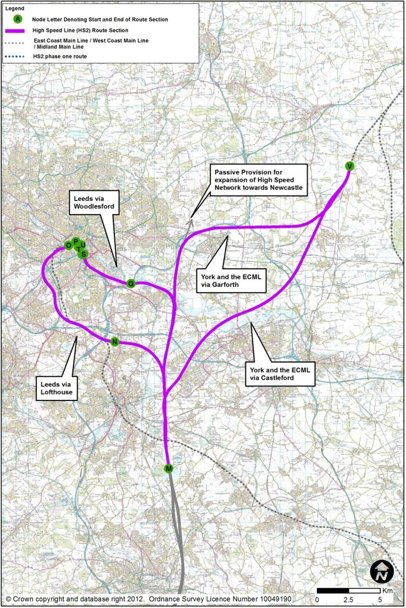
        - The Normanton area options are:
- York and the ECML (HSL17 via Garforth);
- York and the ECML (HSL18 via Castleford);
- Leeds (HSL19 via Lofthouse);
- Leeds (HSL21 via Woodlesford).
        - There are therefore four corresponding spur layout combinations:
- York and the ECML via Garforth, with Leeds via Woodlesford;
- York and the ECML via Garforth, with Leeds via Lofthouse;
- York and the ECML via Castleford, with Leeds via Woodlesford;
- York and the ECML via Castleford, with a spur to Leeds via Lofthouse.
        - Each of the combinations would form slightly differing layout options and the report attempts to convey these differences. Once the actual Leeds / York combination has been chosen, there could be minor changes in the design of the junctions, and of the main line to the North.
  - The Whole Routes and Their Component Route Sections
        - HS2 Ltd has identified four whole route combinations for analysis of the business case These whole route combinations, and the route sections which comprise them, are listed below:
        - Subtle variants exist along these routes. For routes heading towards Toton along the M42 / A42, HSL06 (North of Measham) can be replaced with either HSL07 (South of Measham) or HSL08 (avoiding the River Mease).
        - In South Yorkshire, HSL14, HSL15 and HSL16 can be replaced with HSL24 and HSL29 to enable a route via the centre of Sheffield (Sheffield Victoria) and therefore omitting a high speed station at Meadowhall.
- Derby, Meadowhall, Leeds 13f via Woodlesford and Garforth ECML connection. This route’s sections are:
  - HSL01: Water Orton (A) to Birchmoor (B)
  - HSL02: Birchmoor (B) to Sunny Hill (Derby) (C)
  - HSL03: Sunny Hill (C) to Breadsall (D) and HSL25: Derby Station
  - HSL04: Breadsall (D) to Tibshelf (E)
  - HSL05: Tibshelf (E) to Killamarsh (F)
  - HSL14: Killamarsh (F) to Tinsley (K)
  - HSL15: Tinsley (K) to Blackburn (L) and HSL28: Meadowhall Station
  - HSL16: Blackburn (L) to Cold Hiendley (M)
  - HSL17: Cold Hiendley (M) to Church Fenton (V)
  - HSL21: Cold Hiendley (M) to Woodlesford (Q)
  - HSL22: Woodlesford (Q) to Hunslet 1 (R) or HSL23: Woodlesford (Q) to Hunslet 2 (S).
  - HSL31: Leeds New Lane Station 13f (R to T) or HSL32: Leeds Sovereign Street South Station13e (S to U)
- Derby, Meadowhall, Leeds 1a via Transpennine and Garforth ECML connection. This route’s sections are:
  - HSL01: Water Orton (A) to Birchmoor (B)
  - HSL02: Birchmoor (B) to Sunny Hill (Derby) (C)
  - HSL03: Sunny Hill (C) to Breadsall (D) and HSL25: Derby Station
  - HSL04: Breadsall (D) to Tibshelf (E)
  - HSL05: Tibshelf (E) to Killamarsh (F)
  - HSL14: Killamarsh (F) to Tinsley (K)
  - HSL15: Tinsley (K) to Blackburn (L) and HSL28: Meadowhall Station
  - HSL16: Blackburn (L) to Cold Hiendley (M)
  - HSL17: Cold Hiendley (M) to Church Fenton (V)
  - HSL19: Cold Hiendley (M) to Lofthouse (N)
  - HSL20: Lofthouse (N) to Holbeck (O)
  - HSL30: Leeds Station North (O to P)
- Toton, Erewash, Meadowhall, Leeds 13f via Woodlesford and Garforth ECML connection. This route’s sections are:
  - HSL01: Water Orton (A) to Birchmoor (B)
  - HSL06: Birchmoor (B) to Tonge (North of Measham) (G)
  - HSL09: Tonge (G) to Long Eaton (H)
  - HSL10: Long Eaton (H) to Sandiacre (I) and HSL26: Toton Station
  - HSL11: Sandiacre (I) to Tibshelf (E)
  - HSL05: Tibshelf (E) to Killamarsh (F)
  - HSL14: Killamarsh (F) to Tinsley (K)
  - HSL15: Tinsley (K) to Blackburn (L) and HSL28: Meadowhall Station
  - HSL16: Blackburn (L) to Cold Hiendley (M)
  - HSL17: Cold Hiendley (M) to Church Fenton (V)
  - HSL21: Cold Hiendley (M) to Woodlesford (Q)
  - HSL22: Woodlesford (Q) to Hunslet 1 (R) or HSL23: Woodlesford (Q) to Hunslet 2 (S).
  - HSL31: Leeds New Lane Station 13f (R to T) or HSL32: Leeds Sovereign Street South Station 13e (S to U)
- Toton, Erewash, Meadowhall, Leeds 1a via Transpennine and Garforth ECML connection. This route’s sections are:
  - HSL01: Water Orton (A) to Birchmoor (B)
  - HSL06: Birchmoor (B) to Tonge (North of Measham) (G)
  - HSL09: Tonge (G) to Long Eaton (H)
  - HSL10: Long Eaton (H) to Sandiacre (I) and HSL26: Toton Station
  - HSL11: Sandiacre (I) to Tibshelf (E)
  - HSL05: Tibshelf (E) to Killamarsh (F)
  - HSL14: Killamarsh (F) to Tinsley (K)
  - HSL15: Tinsley (K) to Blackburn (L) and HSL28: Meadowhall Station
  - HSL16: Blackburn (L) to Cold Hiendley (M)
  - HSL17: Cold Hiendley (M) to Church Fenton (V)
  - HSL19: Cold Hiendley (M) to Lofthouse (N)
  - HSL20: Lofthouse (N) to Holbeck (O).
  - HSL30: Leeds Station North (O to P)

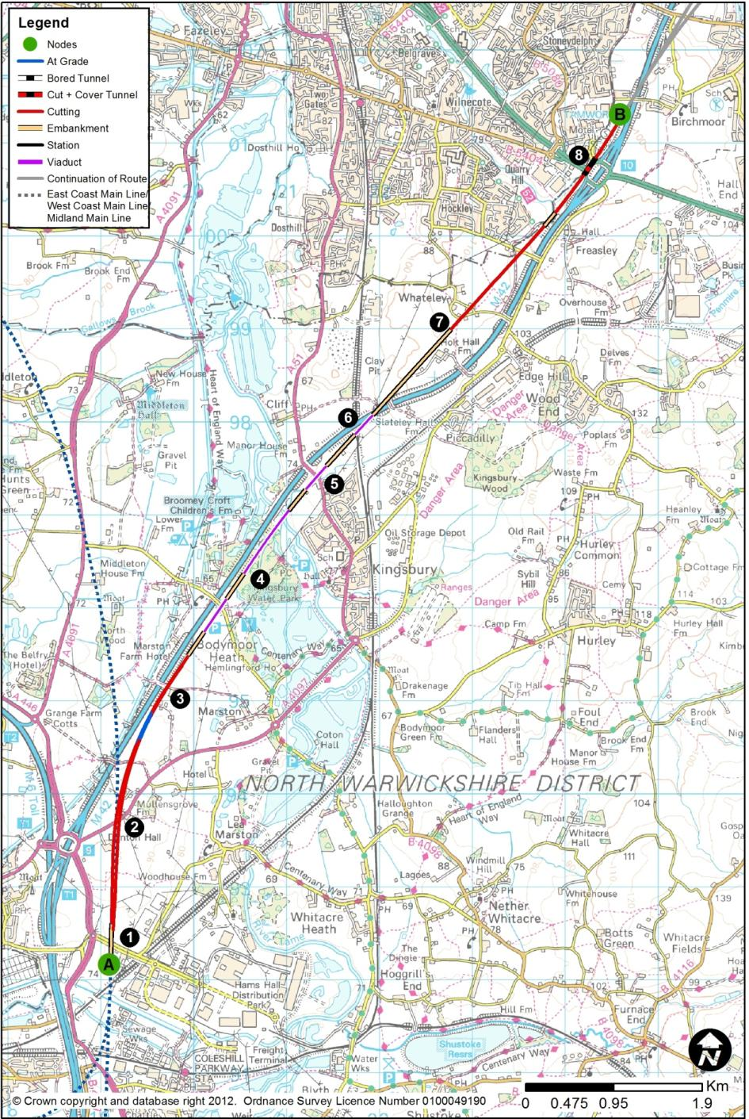
  - HSL01: Water Orton (A) to Birchmoor (B)
        - The route section between Water Orton and Birchmoor would be 11.0km long and start the West Midlands to Leeds leg of the high speed rail network. The route would connect to HS2 Phase 1 - London to West Midlands north of the spurs into Birmingham city centre. At Birchmoor, the route would continue north along HSL02 to Sunny Hill, or HSL06, HSL07 or HSL08 to Tonge. This route section would be common to all routing options.
        - The northbound link would diverge near Faraday Avenue (1), which would be realigned to the north. It would turn north-east and pass below the HS2 Phase 1 Manchester line about 500m south of the M42, at the existing location of Kingsbury Road (2), which would be diverted. It would then adopt the level of the M42, running alongside it to its south-east. The southbound link from Leeds would be at the level of the M42, and would rise to join the southbound line of HS2 Phase 1, again in the vicinity of Faraday Avenue. The design speed at the junction would be 230kph, rising to 250kph on the curve towards the M42.
        - The northbound and southbound links would converge towards a standard track spacing near Cocksparrow Farm (3). The whole of this junction area would be in cutting, up to 22m in depth.
        - The route would then initially run alongside the M42’s southerly side, passing over a flood plain and Bodymoor Heath Road on viaduct. Here, the design speed would rise to 400kph. There would be a short section on embankment, 8m in height, before another viaduct over part of Kingsbury Water Park (4), the River Tame and its flood plain, with potentially difficult ground conditions.
        - Having crossed the Tame, there would be another embankment section, and the route would start to rise to pass over the A51 (5) and a further flood plain on viaduct, of up to 15m in height.
        - North of the A51, the route would have to substantially gain height, in order to pass over the M42 at almost exactly the location where the motorway is passing over the Derby to Birmingham railway (6). It is at this point that the new route would change to the northern side of the M42. The construction of the viaduct’s pier in the central reserve of the motorway may require complex temporary works on the motorway, exacerbated by its proximity to the railway. At this multiple crossing point, the route would be typically 18m above ground level.
        - Now on the north-west side of the M42, the route could not follow the more sinuous alignment of the motorway, and would head in a relatively straight line towards the easterly fringe of Tamworth and towards Junction 10 of the M42. At its maximum, the route would be 400m from the motorway.
        - North from Whateley (7), the route would descend with the terrain, and would pass between Tamworth and Junction 10. New bridges would be required to carry Whateley Road and Overwoods Road over the route (8). Junction 10 would have to be extensively rebuilt on the western side of the M42 to incorporate new bridges and retained box structures. Extensive temporary motorway works would be expected. North of Junction 10, the route would enter a deep cutting, of typically 10-17m depth, to pass below the M42.
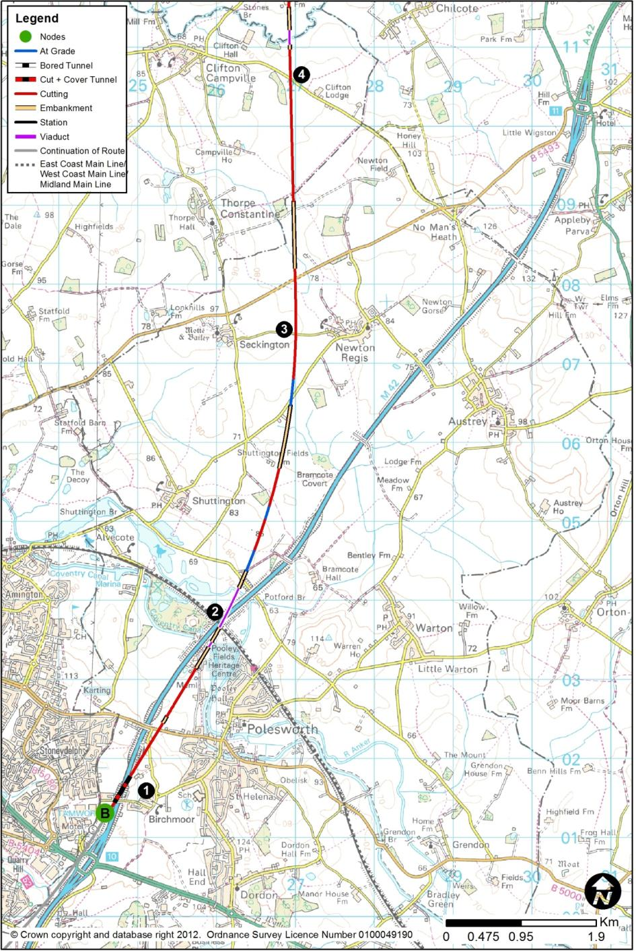
  - HSL02: Birchmoor (B) to Sunny Hill (Derby) (C)
        - The route section between Birchmoor and the Sunny Hill area of Derby would be 34.0km long. The section of route connecting to Birchmoor from the south would be HSL01 from Water Orton. At Sunny Hill, the route would continue north along section HSL03 (and HSL25 – Derby Station) to Breadsall. This route section would form part of a route through central Derby.

Birchmoor to Clifton Campville
        - The route would cross the M42 immediately north of Green Lane (1). Green Lane would have to be replaced on-line, involving temporary closure and some disruption. The route would pass below the M42 in a box structure, and extensive temporary motorway works would be expected. This crossing point would be close to Birchmoor.
        - The route would then pass below the B5000, which would have to be raised on its present alignment by about 4m to provide clearance. The route would be close to existing ground level just north of the B5000.
        - The route would then cross the West Coast Main Line (2) and the M42 on a viaduct, rising to a maximum of 23m above the valley floor. The construction of the viaduct’s pier in the central reserve of the motorway may require complex temporary works on the motorway, exacerbated by its proximity to the railway. The route would then swing almost due north, close to existing ground level, to pass west of Newton Regis and east of Seckington (3), before passing east of Clifton Campville (4).
        - The route section would cross the northern end of the Warwickshire Coalfield where coal may be present at relatively shallow depth.

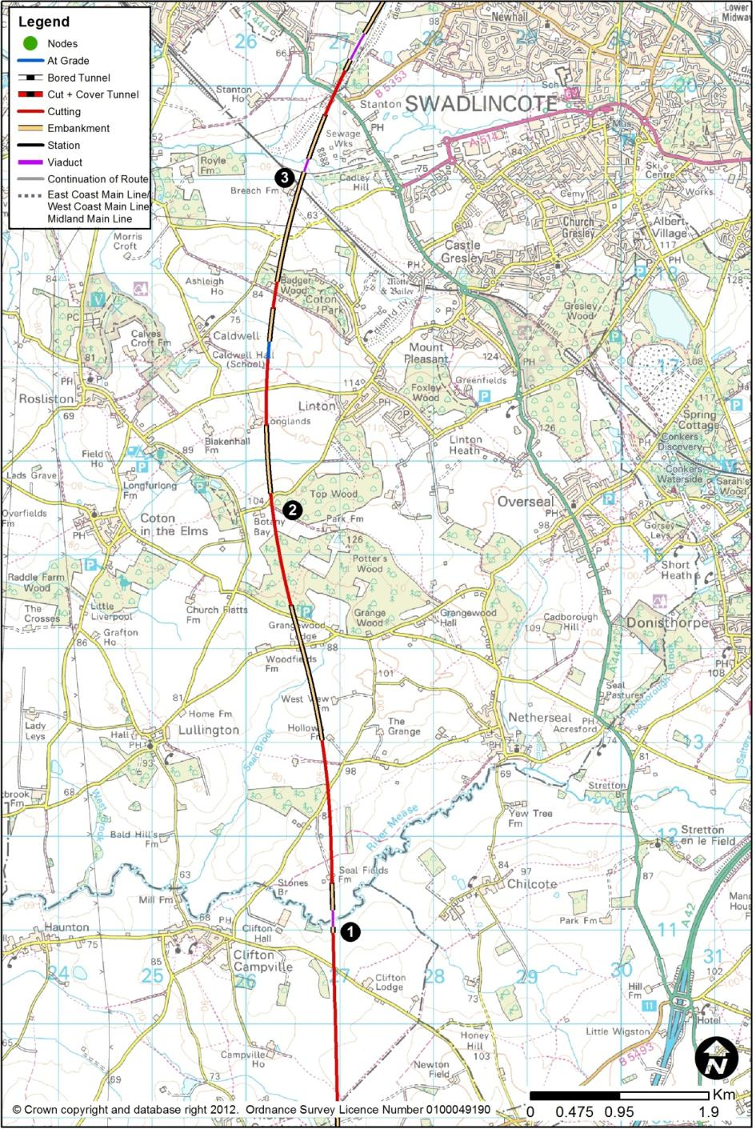

Clifton Campville to Stanton
        - East of Clifton Hall, the route would pass onto a 180m viaduct to cross the River Mease (1) and its flood plain, the main river channel being about 5m in width. It would then climb with the terrain, in cutting up to 9m deep and on embankment up to 12m in height, to the top of the hill near Botany Bay Farm (2).
        - North from Botany Bay, the route would then descend in cuttings of typically 7m, to pass west of Linton, before running on an embankment up to 17m height to pass over the Leicester to Burton railway (3), and then passing through the westerly edge of Swadlincote sewage works.

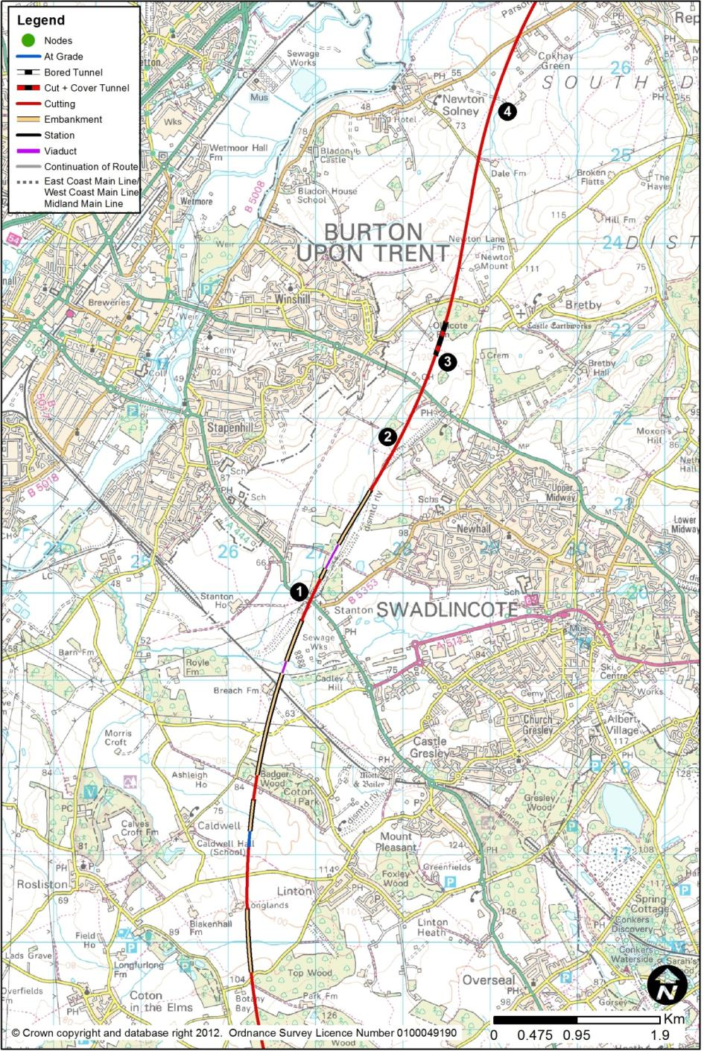

Stanton to Newton Solney
        - The route would pass through a relatively narrow gap between properties (1) at Stanton, passing under the A444 to the west of its junction with the B5353 Park Road.
        - The route would rise on embankment up to 6m in height, and a gradually deepening cutting to pass the eastern edge of Burton-on-Trent (2) near Stanhope Bretby, and through Burton Golf Club. The route would pass under the A511, about 11m below ground, before passing in cutting up to 35m deep at Jeff’s Wood. It is proposed to construct a 400m cut and cover tunnel here (3), refilling above the tunnel box to restore the existing ground level and features.
        - Between Stanton and Stanhope Bretby the route would cross the Swadlincote Coalfield where shallow coal seams have been worked by both opencast and underground mining. Some of the opencast sites have been used as landfills. Shallow mineworkings may also affect the cut and cover tunnel.
        - The route would then descend to pass east of Newton Solney (4) in shallow cutting.

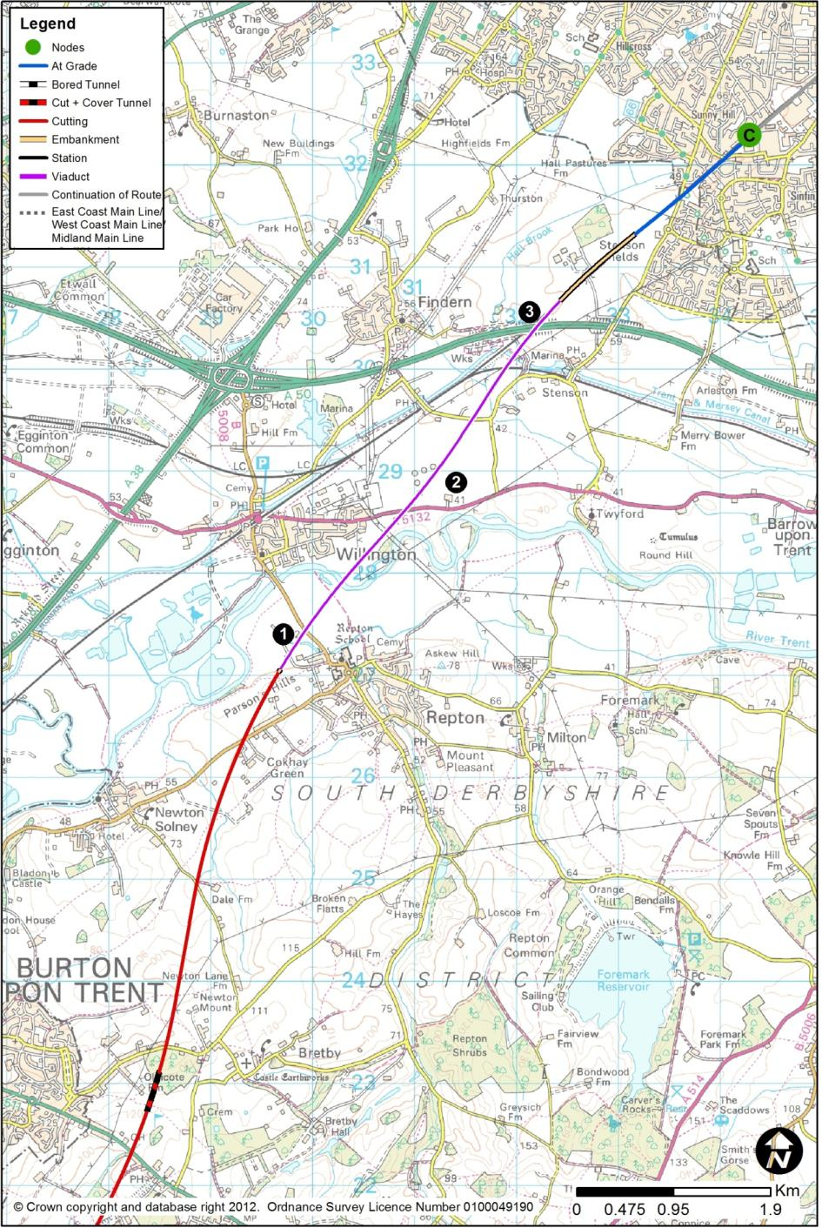

Newton Solney to Derby (Sunny Hill)
        - The route would run in a cutting up to 16m deep, expected to be primarily in mudstone, and under the B5008 near Cokhay, before passing to the west of Repton (1). It would then enter the River Trent flood plain as the landform drops into the valley, and it would run on to a viaduct at the western edge of the settlement.
        - The route would run through the extremity of the major development site at Willington Power Station (2) affecting part of the development site.
        - The route would then run on a 4.5km viaduct, typically 9m above ground, east of Willington, over the River Trent and its flood plain, over the Stenson Junction to Sheet Stores Junction railway, the Trent and Mersey Canal, the A50, and the Birmingham to Derby railway (3), before returning to ground level at Stenson Fields, by this time lying immediately to the west of, and adjacent to, the Birmingham to Derby line.

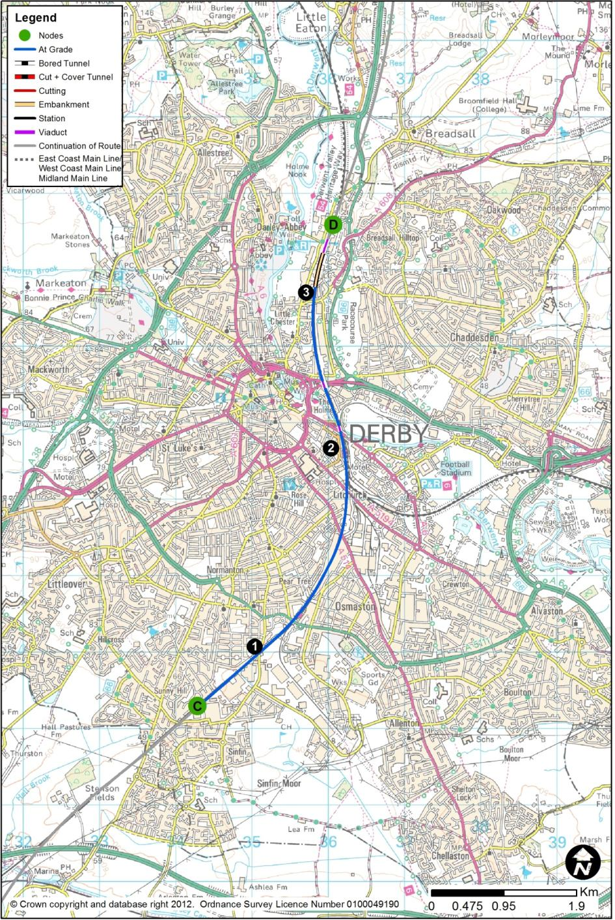
  - HSL03: Sunny Hill (C) to Breadsall (D)
        - This route section would include a station in central Derby (2), situated adjacent to the existing station. This station (HSL25) is described in Chapter 3.2.
        - This route section between Sunny Hill and Breadsall would be 7.0km long. The section of route connecting to Sunny Hill from the south would be HSL02 from Birchmoor. At Breadsall, the route would continue north along HSL04 to Tibshelf.

The Approach from the South (Sunny Hill to Derby)
        - From Stenson Fields into central Derby, the route would run alongside, and to the west of, the existing Birmingham to Derby line (1). Widening on the east side would have involved raising the high speed lines on viaduct over Derby South Junction (immediately south of the station), with consequential complicated side road works and two-level connections to the existing station.
        - The introduction of the new route, as well as the presence of the existing network lines, would involve almost complete re-building of the existing network infrastructure. Because of the height of high speed trains, and the overall widening required in the corridor, all structures along the route would be rebuilt. The restricted nature of the site, and work alongside an operational railway, would involve prolonged and costly working, with some disruption to existing train services.
        - The route would widen from the normal two-track route to a four-track route on the approach to the station. The route would pass under Stenson Road, alongside the existing line, and the bridge would have to be raised on its existing alignment. It may be necessary to close some roads for extended periods of time, with lengthy traffic diversions. This could be particularly problematic on the A5111 Derby Southern Ring Road, A514 Osmaston Road and A5194 London Road, as additional existing Network Rail tracks would need to be accommodated. Peartree Station would need to be closed.
        - The existing junction to the south of the station, Derby South Junction, is a significant constraint to rail traffic in the Derby area due to conflicting flows between services to and from the Trent direction with those to and from Birmingham, and to and from Sheffield. The proposed route and station reconfiguration would require a total rebuilding of the station and adjacent junctions, and this would address these conflict issues. It is understood that Network Rail are proposing improvements to the layout in the station area, though it is not yet a committed scheme, but their emerging proposals have been considered in the layout development.

Derby Station
        - At Derby, there would be a new station (HSL25), combining new platforms for the high speed services to the west, and a rebuilt Network Rail station to the east. This station is described in Chapter 3.2.

The Exit to the North (Derby to Breadsall)
        - North from Derby Station, the route would follow the existing Derby to Sheffield railway (3) towards Breadsall, also involving alterations to Network Rail infrastructure.
        - The route would pass under the bridge carrying the A6 Pride Parkway over the current railway. Because of the introduction of the new lines, and the re-arrangements of existing network lines, the existing bridge would have to be demolished and replaced to accommodate the new configuration.
        - The route would narrow from the four-track arrangement to the normal two-track layout, and north of the A6, the route would cross the A52 Derby Inner Ring Road (at Eastgate Bridge) and then pass Little Chester, with the new lines at the level of, and to the west of, the existing network lines. The route would then rise up to 16m above ground, on retained embankment and then on viaduct, to cross over the existing network lines in order to lie on their eastern side.

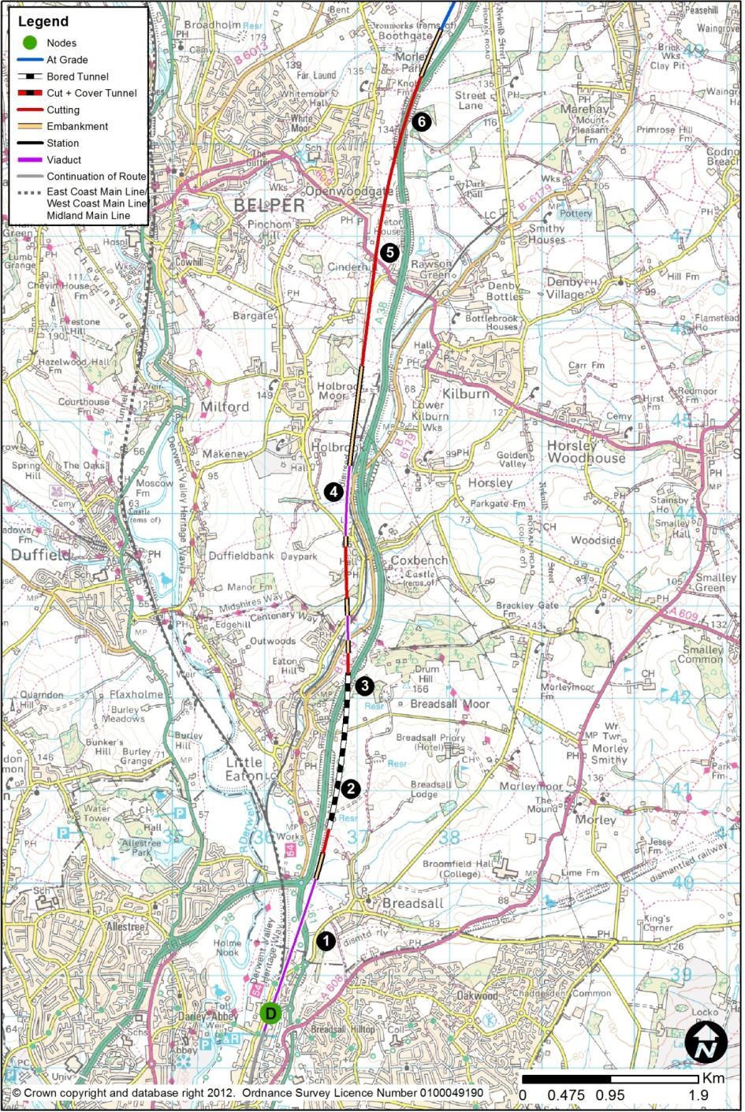
  - HSL04: Breadsall (D) to Tibshelf (E)
        - The route section between Breadsall and Tibshelf would be 25.1km long. The section of route connecting to Breadsall from the south would be HSL03 (and HSL25 – Derby Station) from Sunny Hill. At Tibshelf, the route would continue north along section HSL05 to Killamarsh. This route section would form part of a route through central Derby.

Breadsall to Belper
        - This section of route is characterised by an undulating landscape, resulting in substantial cuttings, embankments and tunnel sections. The route would pass over the Derby to Sheffield railway, the A61 Alfreton Road, Dam Brook and River Derwent flood plain on a 1.9km viaduct (1). Just north of Boosemoor Brook, to the immediate south of the tunnel, there would be a short length of embankment followed by a short cutting.
        - Little Eaton Tunnel (2) would be about 1.7km in length. It would consist of twin-bore, mined, single-track tunnels meaning that there would be two parallel tunnels, one carrying the northbound track, and the other the southbound. In plan, the southerly portal would be north of Boosemoor Brook, and the tunnels would pass under open countryside, with the northern exit portal just north of the A38 at Amberley (3). The B6179 (the former A38) would pass over a pair of retaining walls supporting the exit from the tunnel. The route would then cross Bottle Brook and its flood plain, passing close to Brookside Farm. The southern tunnel portal would be within the Bowland Shale Formation, which contains weak mudstones associated with landslides in this area.
        - The route would enter a cutting up to 13m deep west of Coxbench, and would then pass onto a 760m viaduct (4), running parallel with the B6179 and the A38 between Holbrook and Horsley, crossing Port Way, Bottle Brook and its flood plain. Following the viaduct, the route would run on a 1.2km embankment, typically 6m in height but up to a maximum of 17m. The route would then rise towards higher ground in cuttings, to pass between Cinderhill and Belper. The route would pass under Killis Lane and the A609 (5), with both roads requiring a minor increase in level to provide clearance.
        - Now in deep cutting, up to 23m deep, to the east of the Openwoodgate area of Belper, the route would climb and broadly follow the A38. It would then adopt the alignment and position of the A38, which would have to be re-aligned (6) to the east by a maximum of 100m over a length of about 2.1km, in the vicinity of Morrell’s Wood.

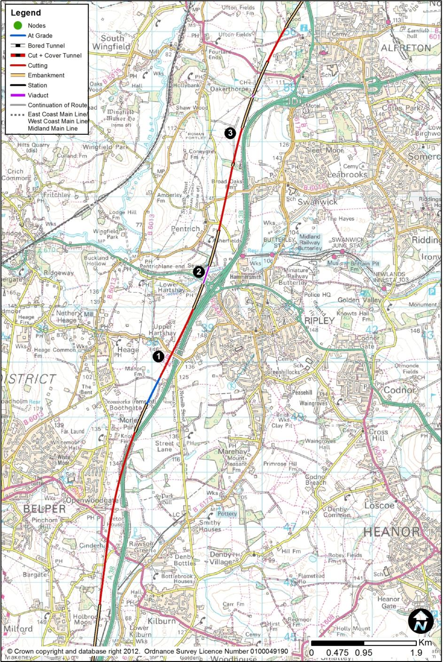

Belper to Oakerthorpe
        - The route would enter a deep cutting, up to 27m deep, at Upper Hartshay (1), and would then pass onto an embankment, then viaduct, up to 29m above ground, in order to cross over the A610 (2) which would be unaffected, just to the west of its junction with the A38. The viaduct would cross the sewage works, and the valley of the Hartshay Brook, before returning to ground level to the east of Pentrich. The route would enter a deep cutting of 25m to pass below Asher Lane and the B6016 near Broad Oaks Farm, both roads remaining in their present positions.
        - The route would then leave the A38 corridor, where the A38 turns sharply east (3).
        - Much of the northern part of this route section would cross shallow coal seams that may have been subject to underground mining. Backfilled opencast sites would be present to the north of Openwoodgate.

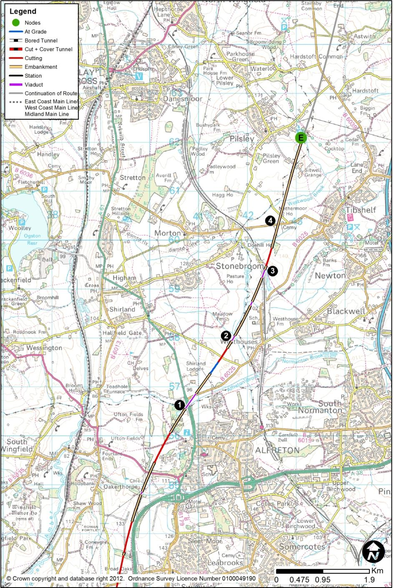

Oakerthorpe to Tibshelf
        - The route would pass over Oakerthorpe Brook, affecting Alfreton Golf Course, and crossing the A615 Wingfield Road. There would be a short cutting in Alfreton Park, west of Alfreton Hall, before the route again moved onto a viaduct, of length 360m and height 28m, to cross the A61 at the lowest point of the road (1). The viaduct would also cross Alfreton Brook, and the B6025.
        - After another very short cutting, the route would run on embankment up to 10m in height and run parallel to Morton Brook, to the west of Westhouses (2). Two sections of viaduct, 110m and 90m respectively, would be required to cross the Brook and its flood plain. Following the second crossing of Morton Brook, the route would continue on embankment with a typical height of 7m. The route would then pass over the Erewash Valley Line (3) on viaduct, 8m above the level of the existing railway.
        - There would be a very short cutting through an area of woodland, before the route rises onto embankment and crosses the B6014, which would remain on its current alignment (4). Pewit Lane would be lowered on its existing alignment. The route would continue to rise on embankment, up to a maximum height of 22m, and pass between Brookfield Farm and Sitwell Grange Farm.
        - Much of this section of the route would be underlain by shallow coal seams and areas affected by opencast coal mining.

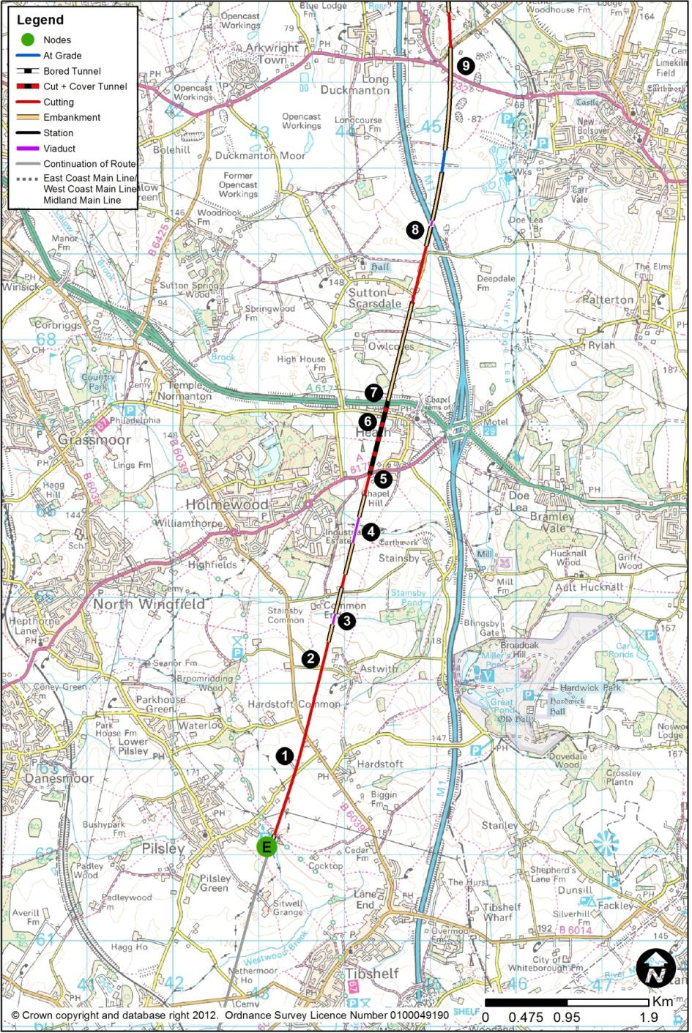
  - HSL05: Tibshelf (E) to Killamarsh (F)
        - The route section between Tibshelf and Killamarsh would be 17.9km long. The section of route connecting to Tibshelf from the south would be HSL04 from Breadsall (via Derby) or HSL11 from Sandiacre (via Toton). At Killamarsh, the route would either continue north along HSL14 that passes the Tinsley (M1) viaduct with a station at Meadowhall, or along HSL24 that passes the Tinsley (M1) viaduct with a loop to an alternative station for South Yorkshire at Sheffield Victoria (HSL29).

Tibshelf to Long Duckmanton
        - The route would continue into cutting, up to 20m deep. Hardstoft Road and the B6039 (1) would remain on their current alignments.
        - The route would then pass through a landscape of relatively steep hills and deep valleys running laterally across the line of the route, necessitating a series of cuttings, embankments and viaducts.
        - The route would then return briefly to ground level, before a cutting up to 14m deep, to pass directly under Branch Lane at its junction (2) with the lane from Lane End Cottage to Astwith. The route would pass to the west of Astwith, emerging from cutting at the northern fringe of the village, and appearing at ground level.
        - The route would then pass onto a viaduct (3) up to 23m high to carry the route over a minor watercourse, before again returning to ground level at Hawking Lane, which would have to be diverted under the viaduct. There would then be a 320m viaduct, up to 31m high, to carry the route over another watercourse, which runs east from the Holmewood Industrial Estate (4).
        - Much of this route section would be affected by underground and opencast coal mineworkings.
        - As the route passes under the A6175 (5), it would enter a cut and cover tunnel to minimise landtake. The tunnel would be created by enclosing the railway in a box structure, and re-filling above the roof of the box to restore the original ground surface. It would remain in a cut and cover tunnel for 830m to the west of Heath (6), emerging north of the A617 (7) to the north-west of the village.
        - Immediately north of the A617, the route would pass onto an embankment, of height up to 21m, through Owlcotes Wood, as it converges with the M1 corridor, followed by a 6m cutting at Palterton Lane, which would have to be raised slightly and realigned to allow the route to pass underneath.
        - The route would then cross to the east side of the M1, bridging over it (8) on a viaduct of 60m length, and up to 12m in height. The construction of the viaduct’s pier in the central reserve of the motorway may require complex temporary works on the motorway. The route would then run broadly at ground level, and would rise on embankment to pass east of the Markham Vale Environment Centre (9), bridging over the A632 Chesterfield Road and B6418 Buttermilk Lane, which would remain at their present levels.
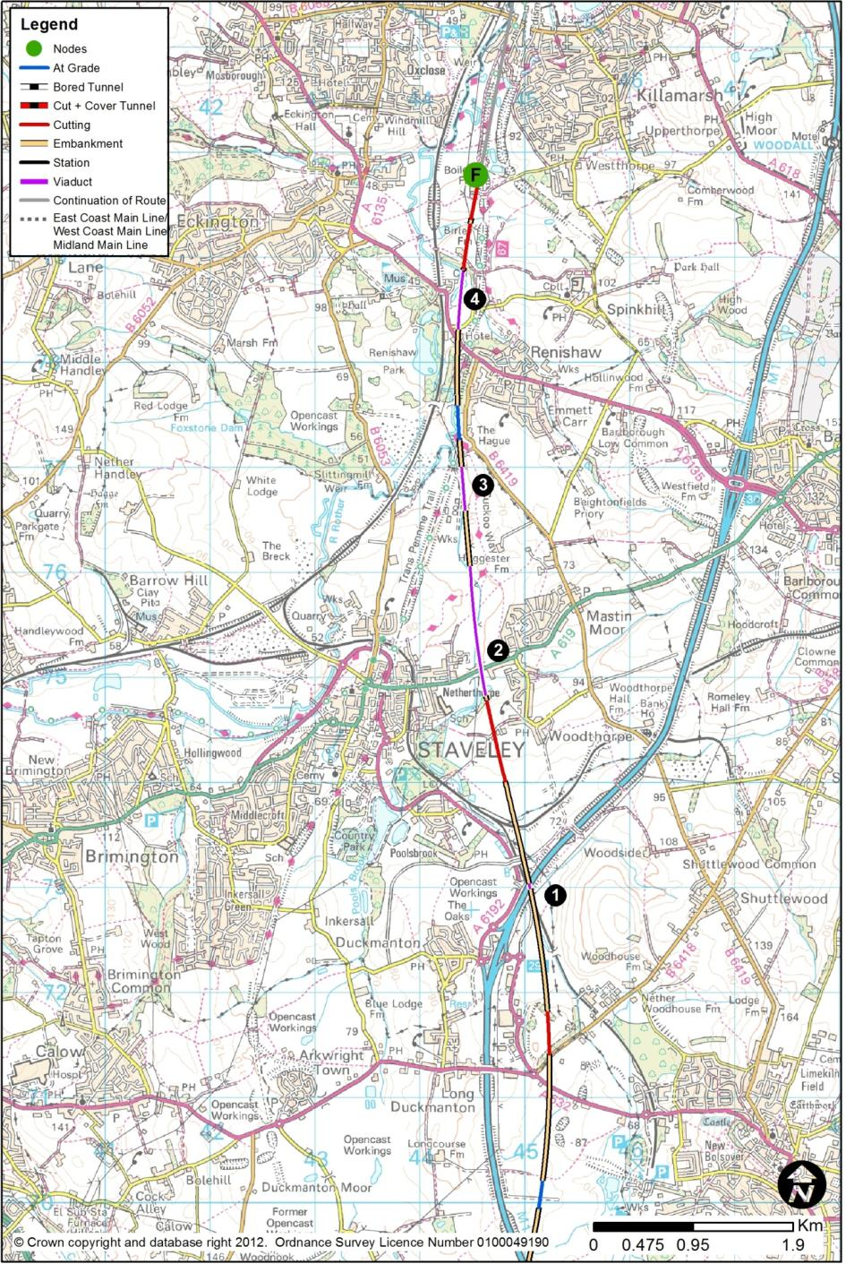

Long Duckmanton to Killamarsh
        - There would be a very short cutting up to 16m deep to the north B6418, and then the route would require an embankment up to 20m high, with a 70m viaduct over the M1, to re-cross to its western side (1). The construction of the viaduct’s pier in the central reserve of the motorway may require complex temporary works on the motorway.
        - While passing between Netherthorpe and Mastin Moor (2), the route would utilise a 1.2km viaduct 7m high to cross the River Doe Lea and its flood plain, and to pass over the A619, which would be unaffected. There would be a short embankment near the sewage works, before a second viaduct of 420m over part of the River Doe Lea flood plain (3). This section of route would have additional connections to the proposed Infrastructure Maintenance Depot, which is described in Chapter 4.1.
        - The route would then run to the west of Renishaw, about at ground level, close to the B6419 Hague Lane, at The Hague. The route would then rise to pass over A6135 (4) before passing onto a 520m viaduct over the River Rother’s meander, its flood plain and Spinkhill Lane. It would then run north in continuous cuttings between 7m and 12m deep, towards Rother Valley Country Park.
        - Much of this route section would be affected by underground and opencast coal mineworkings.

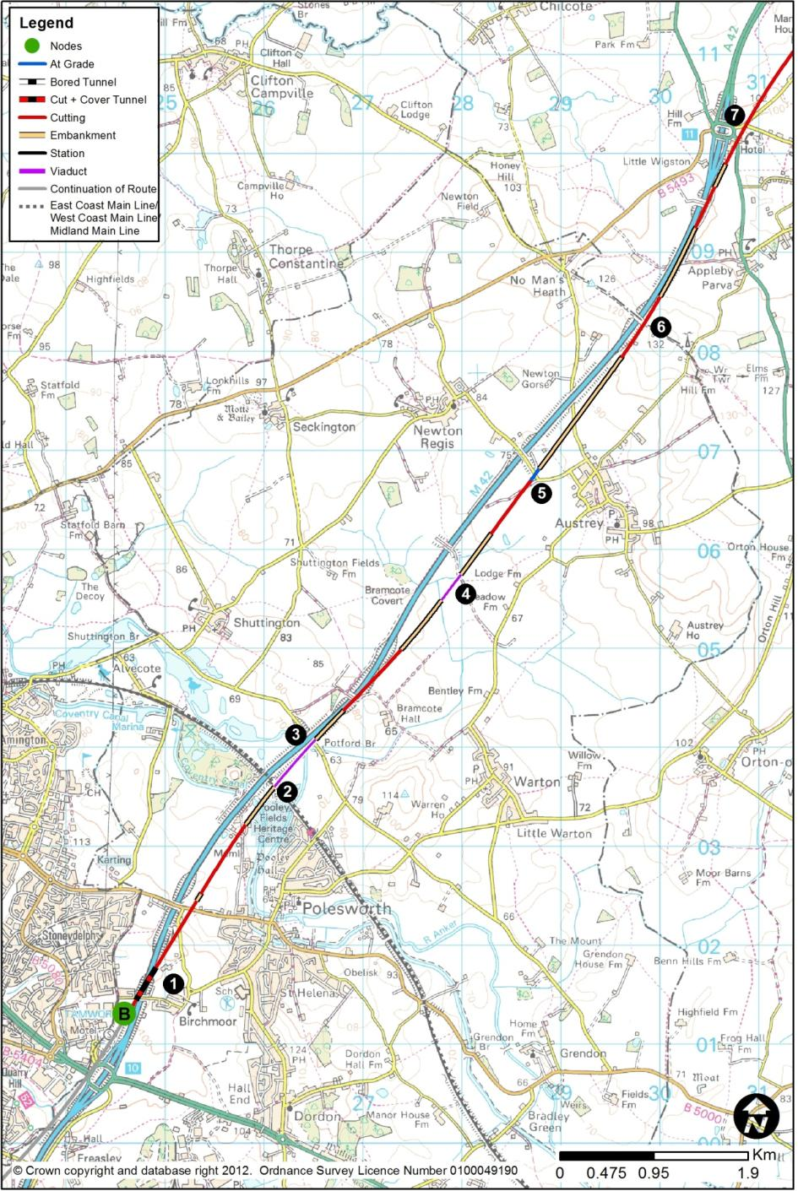
  - HSL06: Birchmoor (B) to Tonge (North of Measham) (G)
        - This route section between Birchmoor and Tonge would be 28.2km long. The section of route connecting to Birchmoor from the south would be HSL01 from Water Orton. At Tonge, the route would continue north along HSL09 to Long Eaton. This route would follow the M42 corridor towards Toton, passing north of Measham.

Birchmoor to Appleby Parva
        - The route would cross the M42 immediately north of Green Lane (1). Green Lane would have to be replaced on-line, involving temporary closure. The route would pass below the M42 in a box structure. Extensive temporary motorway works are expected. This crossing point would be close to Birchmoor.
        - The route would then pass below the B5000, which would have to be raised on its present alignment by about 4m to provide clearance. The route would be about at existing ground level just north of the B5000.
        - While still broadly following the M42 corridor, the route would not be able to closely follow its more sinuous course in view of the design speeds required.
        - The route would cross the Coventry Canal about 10m above the Canal’s level, and then it would cross the West Coast Main Line (2) north west of Polesworth, about 100m east of where the M42 crosses that railway. The high speed line would be at about the same level as the M42, affording the same clearance over the railway as currently exists at the M42 crossing.
        - The route section would cross the northern end of the Warwickshire Coalfield where coal may be present at relatively shallow depth.
        - The route would then pass onto a viaduct (3) to carry it over the River Anker, its flood plain and Linden Lane, at a typical height of about 16m above ground. Immediately north of Linden Lane, the route would briefly follow the motorway boundary. The route would then deviate from the motorway, heading towards Austrey Meadows, crossing the flood plain on a 310m length viaduct (4), about 7m above ground.
        - The route would pass west of the edge of Austrey (5), close to ground level. The route would rise with the terrain, being on embankment and bridging over No Man’s Heath Lane, about 8m above ground. It would then enter a deep cutting at the crest of the hill (6), to a maximum cutting depth of about 13m. This is the hill through which the M42 cuts, with its arched bridge at the summit. This bridge would have to be replaced with a new structure straddling a widened cutting which the railway and motorway would share.
        - As the motorway swings towards M42 Junction 11 (7), the railway would broadly follow its course, and would pass below the A444 Atherstone Road and Tamworth Road in cutting typically 11m deep. Both these roads would be diverted to accommodate the railway, all west of Appleby Magna.
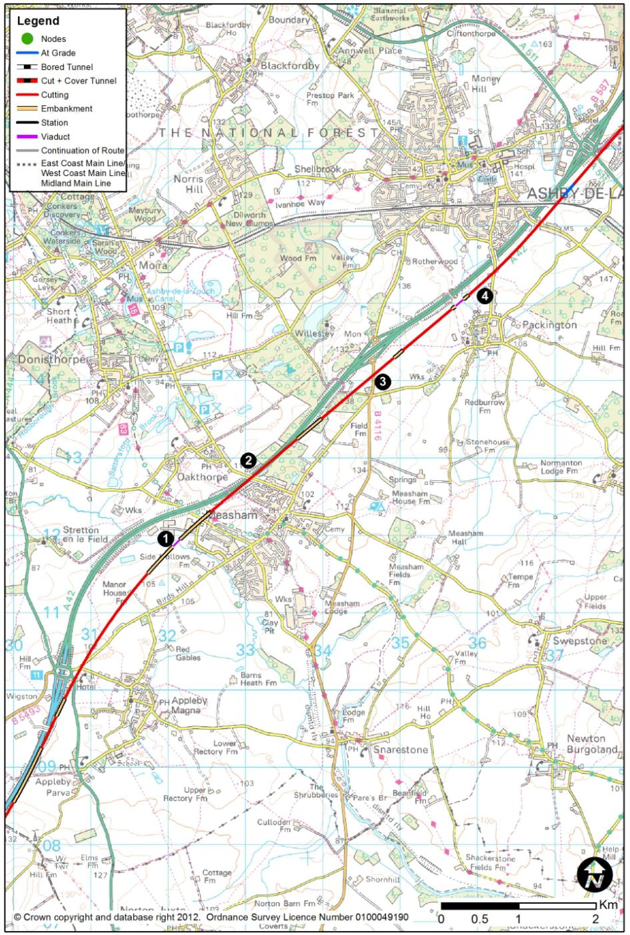

Appleby Parva to Packington
        - The route would descend to cross the River Mease (1) and its flood plain on a viaduct of 110m length, and 17m height. The main river channel is about 5m in width.
        - The route would then pass the westerly edge of Measham, rejoining the A42. It would be bridged over Repton Road, with Huntingdon Way realigned to Burton Road. The route would then rise, to the level of the A42, passing over Burton Road, using a retaining wall along its eastern boundary to minimise property effects at Measham.
        - The route would pass under New Street, adopting the alignment and position of the A42, which would have to be re-aligned laterally to the west by a maximum of 90m (2) and over a distance of 2.3km. The A42 realignment would have consequential effects on the roads it crosses, such as Burton Road and New Street. The route would lie to the north-west of the existing A42 noise and landscape bunding, which would be retained (the road effectively having moved away by a maximum distance of 90m).
        - This section of the route would cross an area of opencast coal workings, and underground mineworkings may be present.
        - From Measham northwards, and for the next 8 miles (13km), the route would follow the A42 rather more closely, typically lying 300m to its south-east. It would be in cutting, of depth about 14m, to pass under Willesley Road and Measham Road (3), which would remain at their present levels. There would be a shallow embankment before the route passed into another cutting, before a viaduct (4) of 130m length over a flood plain where Vicarage Road would have to be raised on its existing alignment to pass over the route west of Packington.

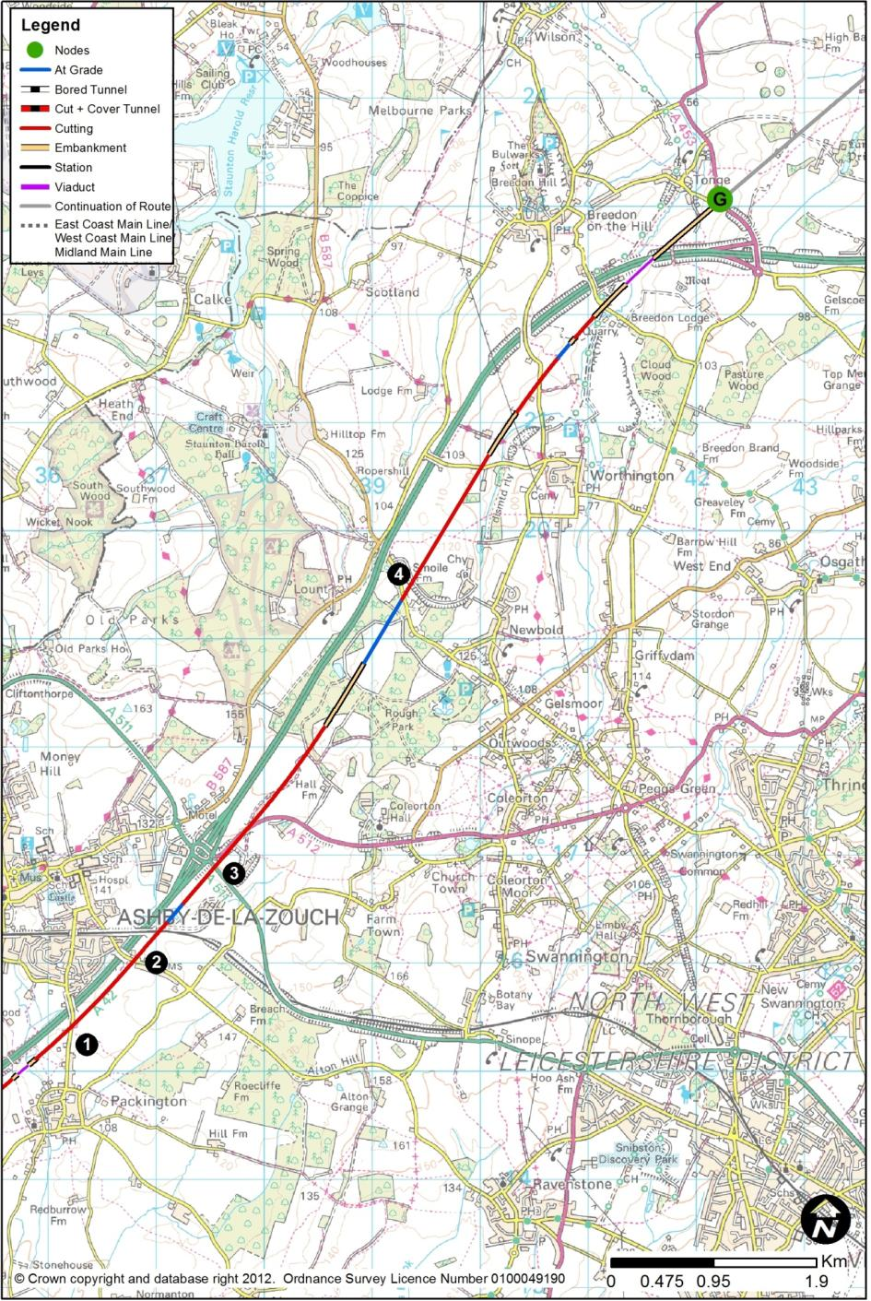

Packington to Tonge
        - By now closely paralleling the A42 on its eastern side, the route would pass under Ashby Road (1), which would remain at its present level. In shallow cutting, the route would pass under Leicester Road (2), and under the Leicester to Burton railway which would remain at its present level.
        - The route would then pass in close proximity to the A42’s junction with the A511 and the A512, affecting the eastern side of the roundabout (3). The railway would be at the A42’s level. A new easterly side roundabout junction would be created, involving the realignment of the A512 and the A511. There would be a new link road between this new roundabout and the existing A42 Junction 13 roundabout, under which the railway would pass in a retained box structure. The railway would be typically 12m below ground in this locality.
        - The route would then run north-eastwards, crossing Melbourne Road (4) at the road’s present level, so that the road would have to be raised on its present alignment to pass over the railway. The route would then cross under Long Hedge Lane, which would have to be raised.
        - Continuing to run broadly parallel to the A42, about 300m to its east in a mix of shallow cutting and embankment, the route would pass under Breedon Lane, which would need to be raised slightly, in cutting. The route would then pass over Stocking Lane and onto a 360m viaduct, up to 15m high, to pass over a flood plain and the A42. The route would then be on embankment of between 8m and 15m height to cross the A453 to the immiedate east of Tonge.
        - Much of this section of the route would cross backfilled opencast coal sites and potentially shallow mineworkings.

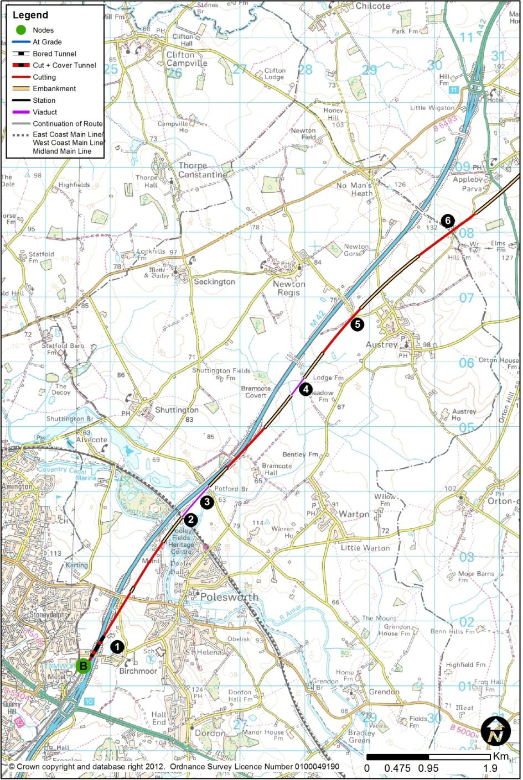
  - HSL07: Birchmoor (B) to Tonge (South of Measham) (G)
        - This route section between Birchmoor and Tonge would be 28.2km long. The section of route connecting to Birchmoor from the south would be HSL01 from Water Orton. At Tonge, the route would continue north along HSL09 to Long Eaton. This route section would run towards Toton, passing south of Measham. This route presents an alternative to route section HSL06 in terms of crossing the River Mease.

Birchmoor to Appleby Parva
        - The route would cross the M42 immediately north of Green Lane (1) which would have to be replaced on-line, involving temporary closure. The route would pass below the M42 in a box structure. Extensive temporary motorway works are expected. This crossing point is close to Birchmoor.
        - The route would then pass below the B5000, which would have to be raised on its present alignment by about 4m to provide clearance. The route would be about at existing ground level just north of the B5000.
        - While still broadly following the M42 corridor, the route would not be able to closely follow its more sinuous course in view of the design speeds required.
        - The route would cross the Coventry Canal about 10m above the Canal’s level, and then it would cross the West Coast Main Line (2) north west of Polesworth about 100m east of where the M42 crosses that railway. The HS2 line would be at about the same level as the M42, affording the same clearance over the railway as currently exists at the M42 crossing.
        - The route section would cross the northern end of the Warwickshire Coalfield, where coal may be present at relatively shallow depth.
        - The route would then pass onto a viaduct (3) to carry it over the River Anker, its flood plain and Linden Lane, at a typical height of about 16m above ground. Immediately north of Linden Lane, the route would briefly follow the motorway boundary, combining the earthworks of the A42 and HS2. The route would then deviate from the motorway, heading towards Austrey Meadows, crossing the flood plain there on a 310m length viaduct (4), about 7m above ground.
        - The route would climb, parallel to Appleby Hill, towards Appleby Parva, crossing Newton Lane (5), which would need to be raised to pass over the route. There would be an embankment up to 10m high, and the route would pass over No Man’s Heath Lane, which would be lowered slightly. The route would then enter a cutting, up to 17m deep, to pass under Austrey Road/Salt Street (6) at the crest of the hill.

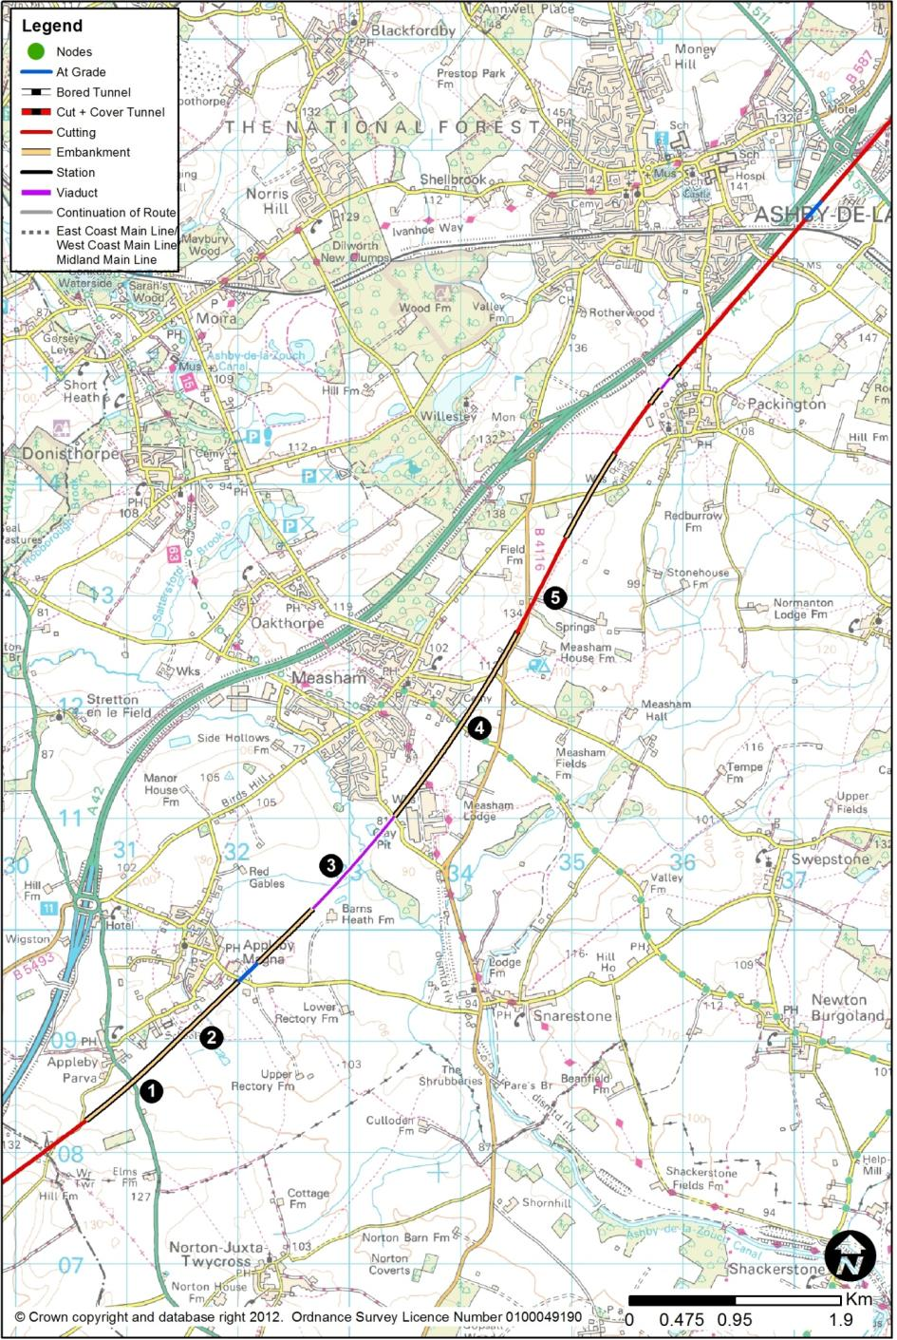

Appleby Parva to Packington
        - The route would emerge from cutting, with Austrey Road being realigned to cross the railway where the headroom allows. The route would run on embankment, typically 9m high, crossing A444 (1) at Appleby Parva; the A444 would have to be lowered slightly to pass below the route.
        - The route would run broadly parallel to New Road and Top Street, all to the south-east of Appleby Magna (2), and on an embankment of maximum height 10m. The route would cross Snarestone Road, which would have to be realigned vertically on its existing horizontal alignment to pass over the line.
        - The route would initially be at ground level, but would then need a 1.1km viaduct (3), typically 7m, but up 18m high, to pass over the River Mease and its flood plain, the clay pit and brickworks, and Atherstone Road. The main channel of the River Mease is about 5m in width
        - The route would continue on embankment up to 12m high to pass over Bosworth Road, then Leicester Road, both of which would remain in their present positions. All this section would be elevated to the south-east of Measham (4).
        - The route would then enter a cutting, of typical depth 12m to run along the alignment of, but below, B4116 (5), which would need to be diverted over the route. This section may be affected by the presence of shallow coal seams. The route would emerge from cutting to pass over Measham Road, which would be lowered by 2m, just west of Packington sewage works.

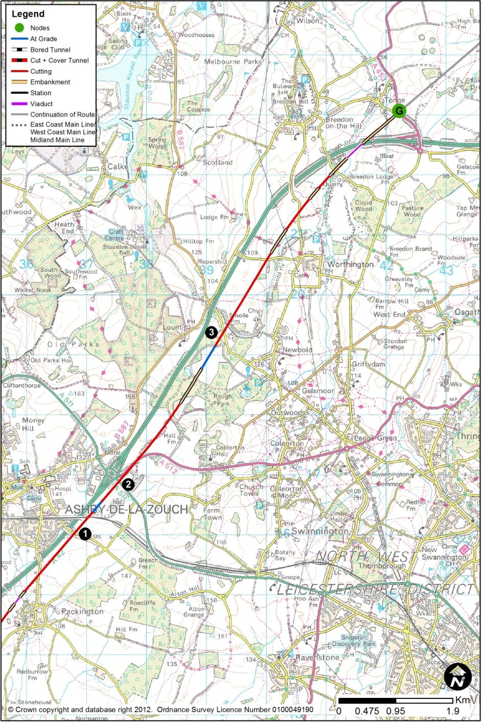

Packington to Tonge
        - The route would then pass between Packington and the A42, through the Sports Ground. Vicarage Lane would have to be raised to pass over the route, which would then pass on to a 130m viaduct, up to 11m high, to pass over a flood plain.
        - The route would return to ground level or shallow cutting, with Ashby Road elevated by about 4m to pass over the route.
        - The route would run close to, parallel with, and east of the A42 for the next 9km. To the south-east of Ashby-de-la-Zouch (1), the route would be close to the level of the A42, and would pass under Leicester Road in a similar manner to the A42. A bridge would be needed to take the route under the existing Leicester to Burton railway. The route would be at the level of the A42, typically 12m below ground in this locality.
        - The route would then pass in close proximity to the A42 junction with the A511 and the A512, affecting the eastern side of the roundabout (2). A new easterly side roundabout junction would be created, involving the realignment of the A512 and the A511. There would be a new link road between this new roundabout and the existing A42 Junction 13 roundabout, under which the railway would pass in a retained box structure.
        - The route would then ease north-eastwards, crossing Melbourne Road at the road’s present level, so that the road would have to be raised on its present alignment to pass over the route (3). The route would then cross Long Hedge Lane, which would have to be raised.
        - Continuing to run broadly parallel to the A42, about 300m to its east in a mix of shallow cutting and embankment, the route would pass under Breedon Lane, which would need to be raised slightly, in cutting. The route would then pass over Stocking Lane and onto a 360m viaduct, up to 15m high, to pass over a flood plain and the A42. The route would then be on embankment of between 8m and 15m height to cross the A453 to the immiedate east of Tonge.
        - Much of this section of the route would cross backfilled opencast coal sites and potentially shallow mineworkings.

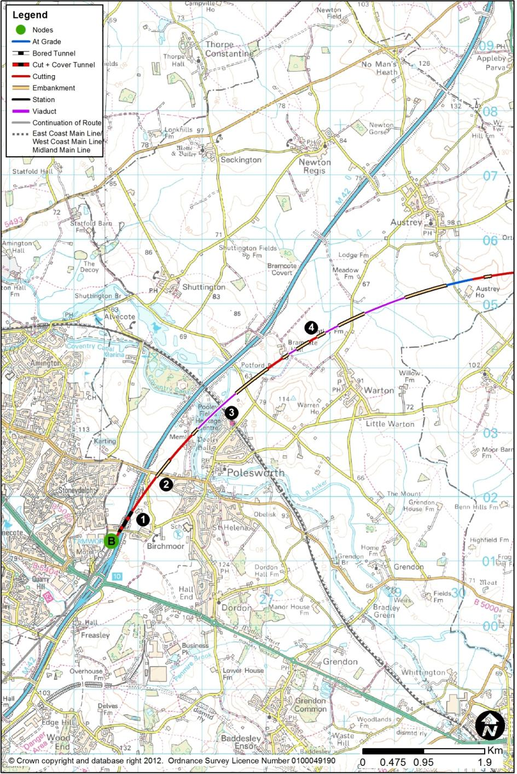
  - HSL08: Birchmoor (B) to Tonge via Twycross (G)
        - This route section between Birchmoor and Tonge would be 31.1km long. The section of route connecting to Birchmoor from the south would be HSL01 from Water Orton. At Tonge, the route would continue north along HSL09 to Long Eaton. This route presents an alternative to route sections HSL06 and HSL07 by heading further east to avoid the designated Special Area of Conservation part of the River Mease and its tributaries.

Birchmoor to Austrey
        - The route would cross the M42 immediately north of Green Lane (1). Green Lane would have to be replaced on-line, involving temporary closure. The route would pass below the M42 in a box structure. Extensive temporary motorway works are expected. This crossing point would be close to Birchmoor.
        - The route would then pass below the B5000 (2), which would have to be raised by about 8m to provide clearance. The route would be above existing ground level just north of the B5000.
        - The route would veer east to leave the M42 corridor. It would pass onto a viaduct of 800m length, typically 15m in height, to cross the Coventry Canal just north of Pooley Hall Farm about 10m above the Canal’s level, and to cross the West Coast Main Line (3) exactly where it crosses the River Anker.
        - The route would be on an embankment of about 7m in height to cross Linden Lane, which would be unaffected, before crossing a flood plain four times in succession (4) on a 70m viaduct, a 150m viaduct, a 240m viaduct, a bridge over Warton Lane, and the flood plain again on a 680m viaduct, all east of Bramcote Hall and north west of Warton.
        - The route would then climb, at ground level, to cross Orton Lane, which would have to be raised to pass over the route.
        - The route section would cross the northern end of the Warwickshire Coalfield where coal may be present at relatively shallow depth.

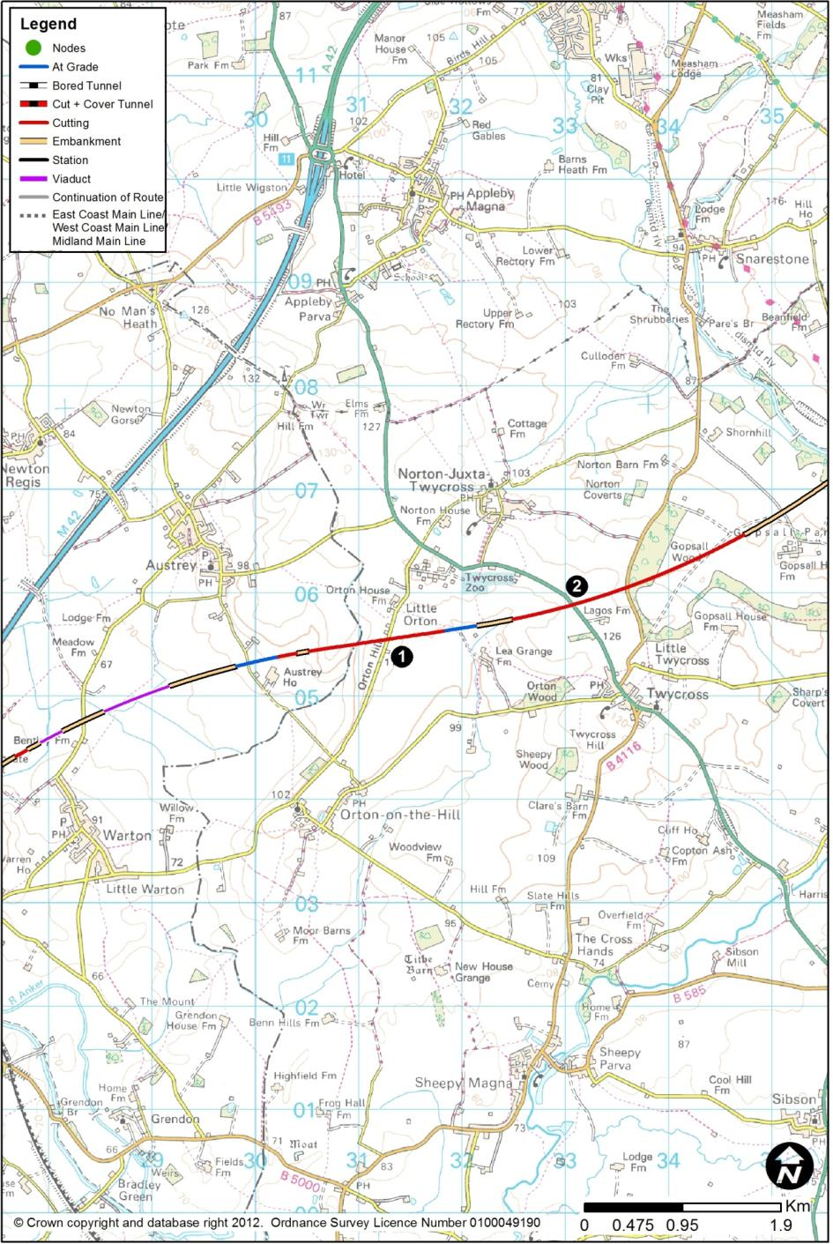

Austrey to Little Twycross
        - After a short cutting of 13m depth, the route would pass below Orton Hill (1) in cutting of 9m, the road remaining in its present position. The route would then run almost exactly at ground level to the south of Twycross Zoo and Little Orton.
        - The route would pass below the A444 (2) in cutting of 10m, the road remaining on its present alignment. It would then continue in cutting of 4m below Ashby Road, which would have to be raised slightly to pass over the route. The route would emerge from cutting east of Gopsall Wood.

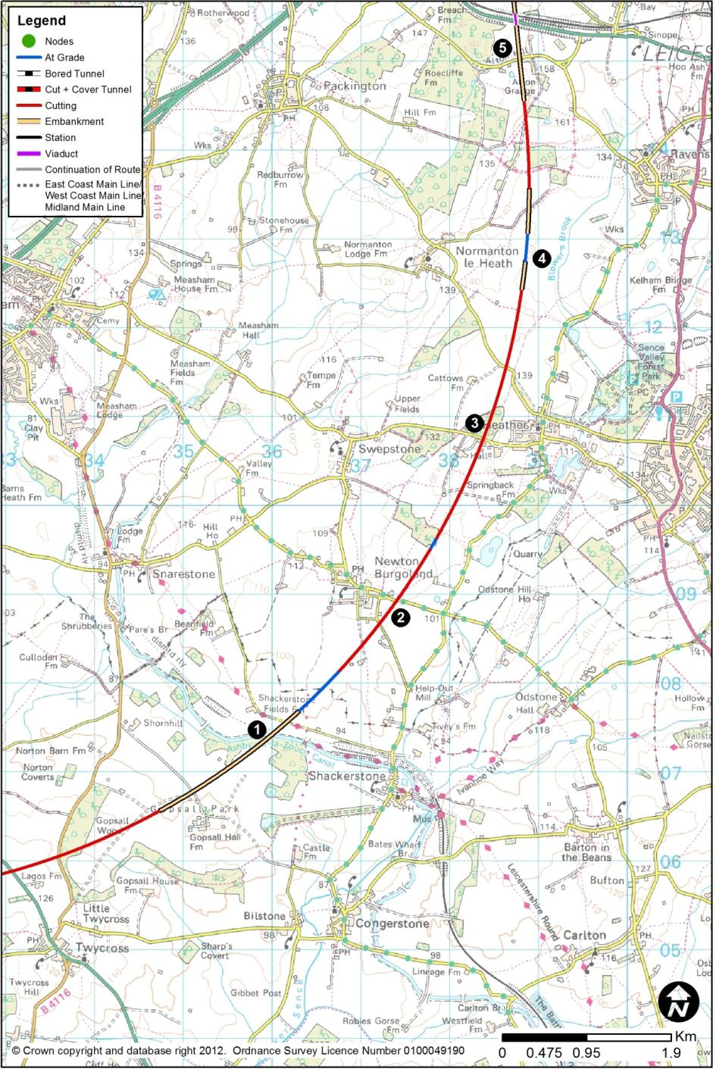

Little Twycross to Alton Grange
        - North from Gopsall Wood, the route would run at ground level, passing on to an embankment up to 6m high to pass west of Gopsall Hall Farm, and crossing the Ashby-de-la-Zouch Canal (1) and Derby Lane, which would be lowered slightly.
        - The route would then rise, in almost continuous cuttings of 7m deep at Odstone Lane east of Newton Burgoland (2), of 11m deep south of Swepstone Road and west of Heather, and 9m deep at Normanton Lane north-west of Heather (3), all the roads remaining unaffected and passing over the route. The route would return to ground level, east of Normanton-le-Heath (4). North of Heather the route would cross an area affected by opencast coal mining.
        - At Jubilee Plantation, the route would rise, entering a cutting of 16m depth, then passing onto embankment of typically 12m height to pass over Alton Hill (5), which would be unaffected.

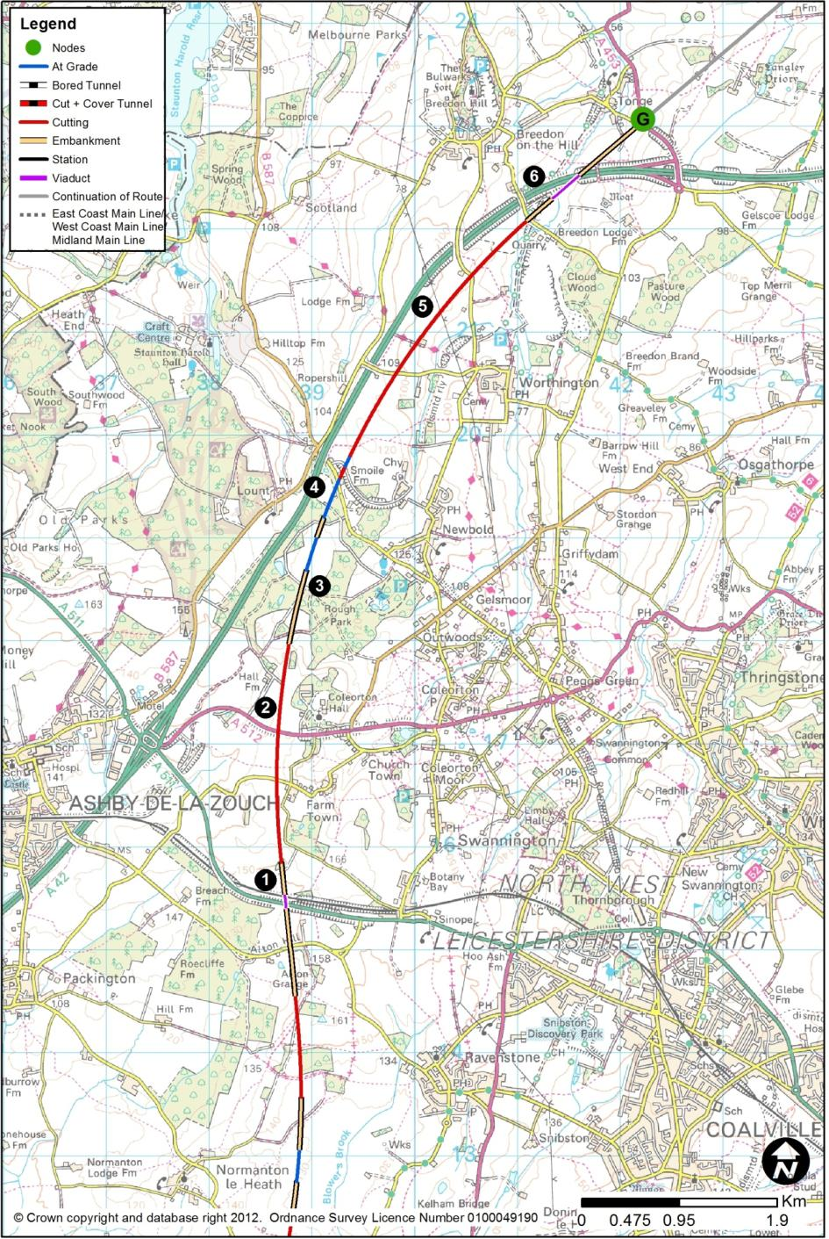

Alton Grange to Tonge
        - The route would pass onto a 130m viaduct to pass over A511 Ashby Road (1) and the Leicester to Burton railway, near Little Alton Farm.
        - The route would then enter a cutting of typically 10m, but up to 14m deep, to pass under Corkscrew Lane and the A512 (2), west of Coleorton Hall. The route would return to ground level at Rough Park (3).
        - The route would cross Melbourne Road (4), which would be raised to pass over the route. The route would run broadly parallel to the A42, about 300m to its east, and in a cutting (5) varying from 6m to 17m deep, between Melbourne Road and Breedon Lane. In doing so, it would pass about 10m below Long Hedge Lane, and about 10m below Breedon Lane, both of which would be unaffected.
        - The route would then pass over Stocking Lane which would be lowered slightly. The route would then pass on to a 340m viaduct (6), typically 9m but up to 16m in height, to pass over a flood plain and the A42. The route would then be on an embankment of between 8m and 15m height to cross the A453 to the immediate east of Tonge.
        - Much of this section of the route would cross backfilled opencast coal sites and potentially shallow mineworkings.

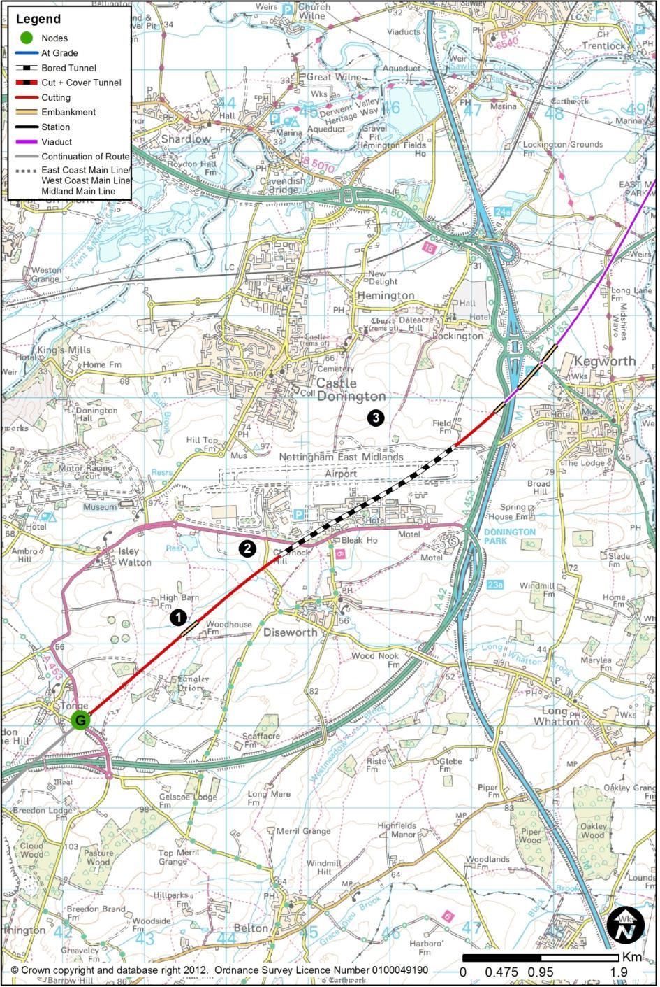
  - HSL09: Tonge (G) to Long Eaton (H)
        - The route section between Tonge and Long Eaton would be 14.3km long. The section of route connecting to Tonge from the south would be HSL06, HSL07 or HSL08, all from Birchmoor. At Long Eaton, the route would continue north along either HSL10 (and HSL26 – Toton Station) to Sandiacre, or HSL12 (and HSL27 – Toton Station) to Trowell. This route section would take the route through the Toton area, to provide a station there.

Tonge to Kegworth
        - From Tonge, continuing to head in a north-easterly direction, the new high speed railway would leave the A42 corridor.
        - The route would enter a cutting up to 14m depth, in order to allow the route to pass into the tunnel under East Midlands Airport. Near Woodhouse Farm (1), the route would be at ground level, but would then begin to descend before entering the deep cutting approaching the tunnel. At the tunnel’s southern portal (2), just south of the A453, the route would be about 25m below ground.
        - The tunnel would be 2.5km in length. It would consist of twin-bore, single-track tunnels, meaning that there would be two tunnels, one carrying the northbound track, and the other the southbound. In plan, the route would pass under the car parks and terminal buildings, before passing under the main runway about 400m from its easterly end. The north-easterly tunnel exit portal (3) would be close to the north-eastern edge of the airport, close to Field Farm. One intervention/ventilation shaft would be needed.
        - The tunnel would pass through Mercia Mudstone, and it is not expected that ground settlement would be an issue, as the depth of the proposed tunnel would be typically 35m under the airport. Groundwater issues may be of concern.

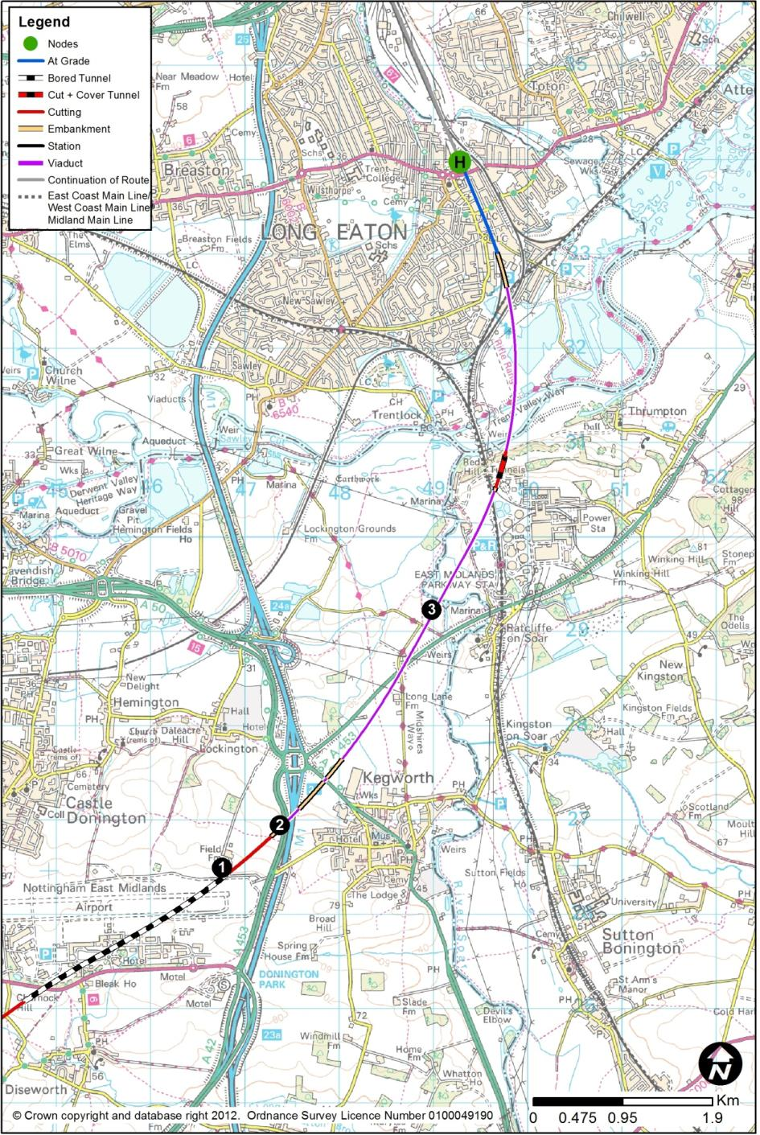

Kegworth to Red Hill
        - North of the tunnel exit portal (1), the route would emerge from the falling ground profile to run onto a 250m viaduct (2), up to 19m high, to pass over the A453, the M1 and its slip roads to Junction 24. The construction of the viaduct’s pier in the central reserve of the motorway may require complex temporary works on the motorway, exacerbated by the proximity of Junction 24, its slip roads, and the A453.
        - There would be an embankment of 21m height, before a bridge crossing the A6 to Loughborough. After a short section of 24m high embankment, the route would run onto a 3.3km viaduct (3), over the A453 to Nottingham near Barn Farm, the River Soar and its flood plain, the Midland Main Line and the rail access to Ratcliffe-on-Soar Power Station. On this structure, there would be a number of separate changes in horizontal and vertical curvature. At the southerly end, the viaduct would be about 24m above ground because of the height needed to cross the M1, and it would then pass over the A453, before lowering to typically 13m by the crossing of the Soar, and it would be at this height for the remainder of its length. It would be situated on difficult ground conditions, and with access difficulties.
        - At this point, the design speed would drop to 275kph due to the tight radius required as the route curves northwards towards Long Eaton.

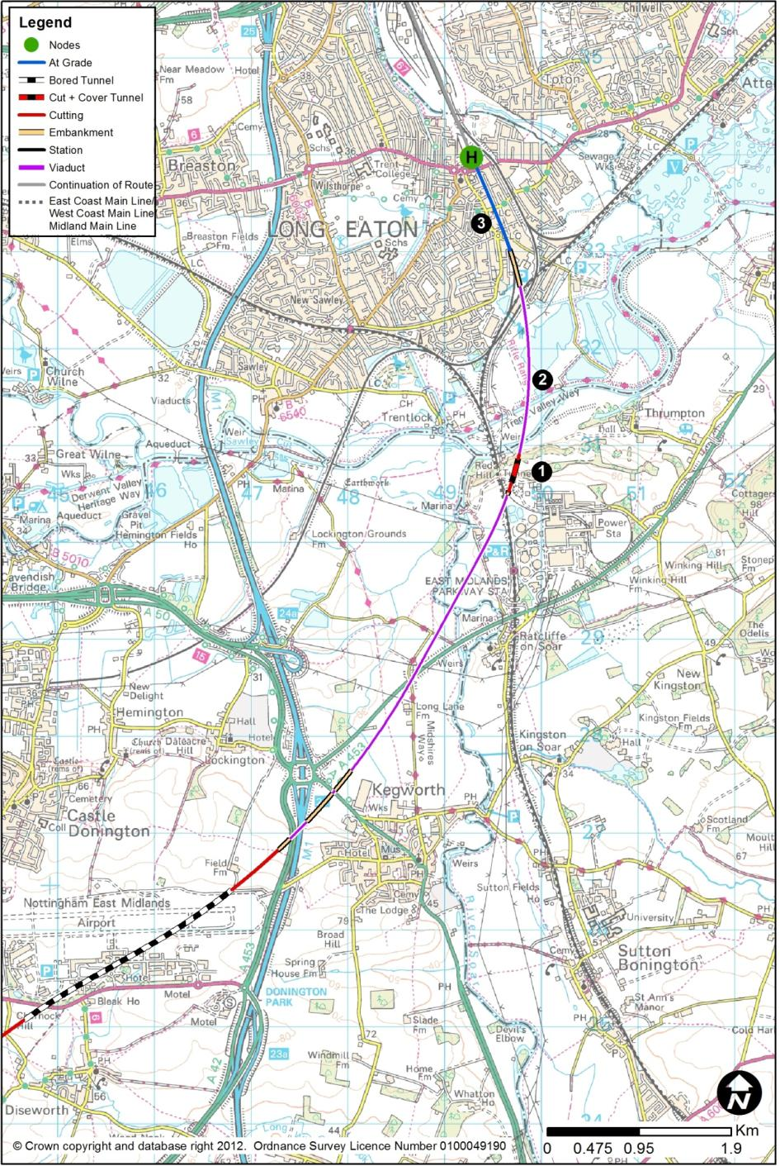

Red Hill to Long Eaton
        - The railway would pass through the escarpment of Red Hill, at a depth of 21m. There are beds of gypsum at shallow depth in this area, which may be affected by dissolution and hence could present a subsidence risk. After excavating the cutting, a short 250m cut and cover tunnel (1) would be created to preserve the ridge of the hill.
        - Immediately north of the north escarpment of Red Hill, the route would then pass onto a second viaduct (2) 1.8km long, to pass over another series of obstacles: the River Trent and its flood plain, the canalised cut-off near Cranfleet Farm, a lake west of Pasture Lane, Trent Lane, the Meadow Lane Junction to Trent South Junction railway (the high-level lines), and the Trent South Junction to Nottingham railway. This viaduct would typically be 15m above ground.
        - North of the end of the viaduct, the route would descend to run almost north-south, through Long Eaton, along, and at the level of, the present 2-track railway that runs north from Trent East Junction towards Toton (3). The closure of these ‘low level’ lines would involve consequential widening works on the ‘high level’ lines from 2 tracks to 4 tracks, as described in Chapter 2.12. As far as possible, these works would be contained within the existing corridor.
        - The existing level crossings at Main Street and Station Road would be closed, but east-west connections would be reinstated by major highway works. Traffic from Main Street would be diverted onto a new link road, about 500m in length starting at the junction of Fields Farm Road and Acton Grove. The link road would pass under an embankment north of the viaduct carrying the new high speed route, to a new junction on Meadow Lane near the existing railway bridge. Station Road would be closed at the level crossing position, and a replacement road would run from the existing roundabout at Fields Farm Road / Main Street, over the new route, to rejoin Station Road near East Street.
        - The A6005 is elevated above the current railway, but its bridge would be demolished and replaced at the higher level needed to allow the high speed trains to pass underneath. North of the A6005, the alignment would widen from two tracks to four, with the extra tracks forming deceleration lines to, and acceleration lines from, the proposed station at Toton.

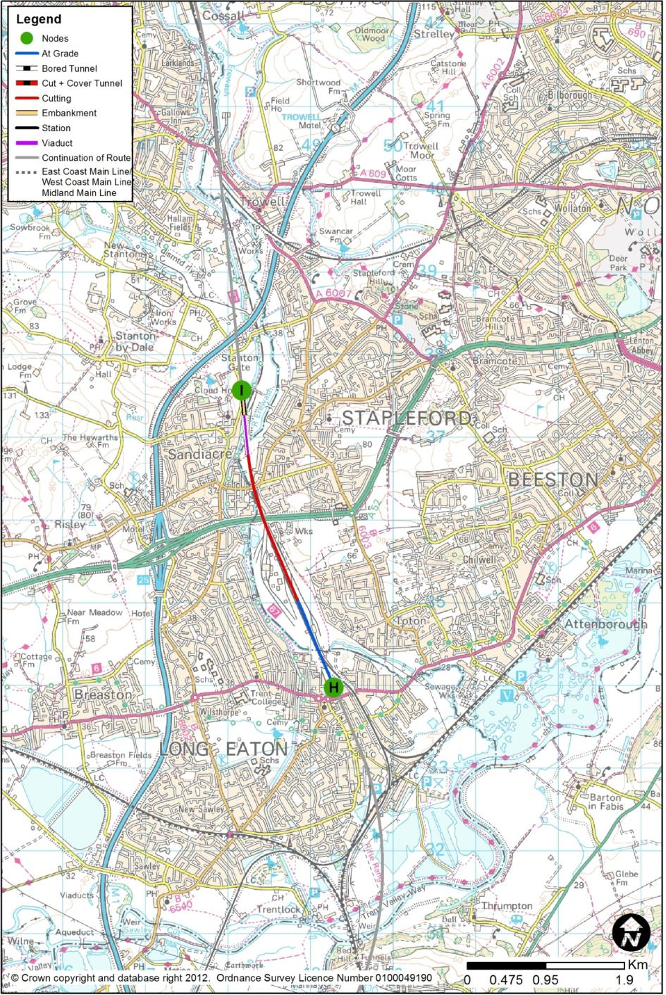
  - HSL10: Long Eaton (H) to Sandiacre (I)
        - This route section between Long Eaton and Sandiacre would be 3.8km long and would contain the proposed Toton Station. The section of route connecting to Long Eaton from the south would be HSL09 from Tonge. At Sandiacre, the route would continue north along HSL11 to Tibshelf. This section of route would include the proposed Toton Station (HSL26) which is described in Chapter 3.3.

Long Eaton to the Proposed Toton Station
        - In the Long Eaton area, there are two existing, broadly parallel, twin-track routes. Neither carries scheduled passenger services, though they are used for diversions off the Midland Main Line.
        - The westernmost (low-level) line is at ground level and has level crossings with the east-west elements of the local road network. It serves train movements to and from Toton Yard (on the western side of the tracks) and also carries freight services to and from the Erewash Valley to the Trent area, and hence to the routes towards Derby, Burton-on-Trent or Loughborough. The easternmost pair of lines are at a higher level, generally crossing over the east-west roads, These lines are grade-separated over the Derby to Nottingham line at Trent, and provide further freight route opportunities heading to and from the Slow (easterly) side of the Midland Main Line southwards towards Ratcliffe Power Station and to Loughborough. Both low-level and high-level routes serve internal movements on the existing network and those of other freight operators.
        - The new route would take over the position of the low-level lines, which would be closed to existing rail traffic, all of which would be transferred to the high-level lines, which would, in consequence, need to be widened from a two-track to a four-track route between Meadow Lane Junction and the station. This would involve embankment, retaining wall and structural works along a 1.0km length. In order to compensate for the loss of the low-level lines, a new connecting length of route on the existing network would be necessary in the Meadow Lane area to allow trains from the Derby and Trent direction to access the high-level lines. A new rail flyover over the high speed alignment would also be required, to provide freight access from these lines to the rail facilities on the westerly side of the layout, principally the Traction Maintenance Depot and Network Rail’s infrastructure maintenance facilities.

        - The alignment required to provide a 275kph line speed would not entirely fit within the confines of the existing railway boundaries, presenting difficulties in respect of working space and access for construction plant.
        - A new bridge on the existing network would be needed to allow trains from the high-level lines to access those parts of Toton Yard to the west of the high speed lines, replacing the present disused bridge near Worrall Avenue and Olive Avenue.

Toton Station
        - Toton Station (HSL26) is described in Chapter 3.3.
        - The station would provide a new transport interchange for the East Midlands. In addition to the four HS2 platforms, four new platforms would be provided on re-modelled national rail infrastructure to distribute passengers to and from Derby, Leicester, Nottingham and beyond; the NET2 tram system would be extended by 1km from its current proposed terminus; and highway infrastructure would provide ready connections to the M1 and the A52.
        - In the vicinity of the station and Toton Yard, the existing Trent Junction to Chesterfield (Erewash Valley) line would be diverted to pass through the proposed new classic network station, and it would lie to the east of the high speed alignment along this length.

Toton Station to Sandiacre
        - North from Toton, the route would reduce from six tracks to four tracks, and it would then pass under the bridge carrying the A52 Brian Clough Way over the current railway. The extent of the alteration of the lateral positioning of existing lines, as well as the introduction of the new route, would require that the existing bridge be demolished and replaced. As the A52 could not be closed for the duration required to achieve these works, a temporary off-line diversion and associated temporary structure would be needed.
        - North of the A52, Derby Road crosses the existing lines. There is insufficient vertical clearance under this structure to accommodate the new high-speed lines, and the structure would therefore have to be demolished and replaced, about 2m higher than existing, with a closure during construction.
        - About 550m north of Derby Road, the route would cross River Erewash and the Erewash Canal, on a 520m viaduct. North of the river, the railway would reduce from four tracks to two.
        - North of Toton station, but still on the western side, freight lines would run parallel to the high speed alignment before rejoining the existing Erewash Valley route.

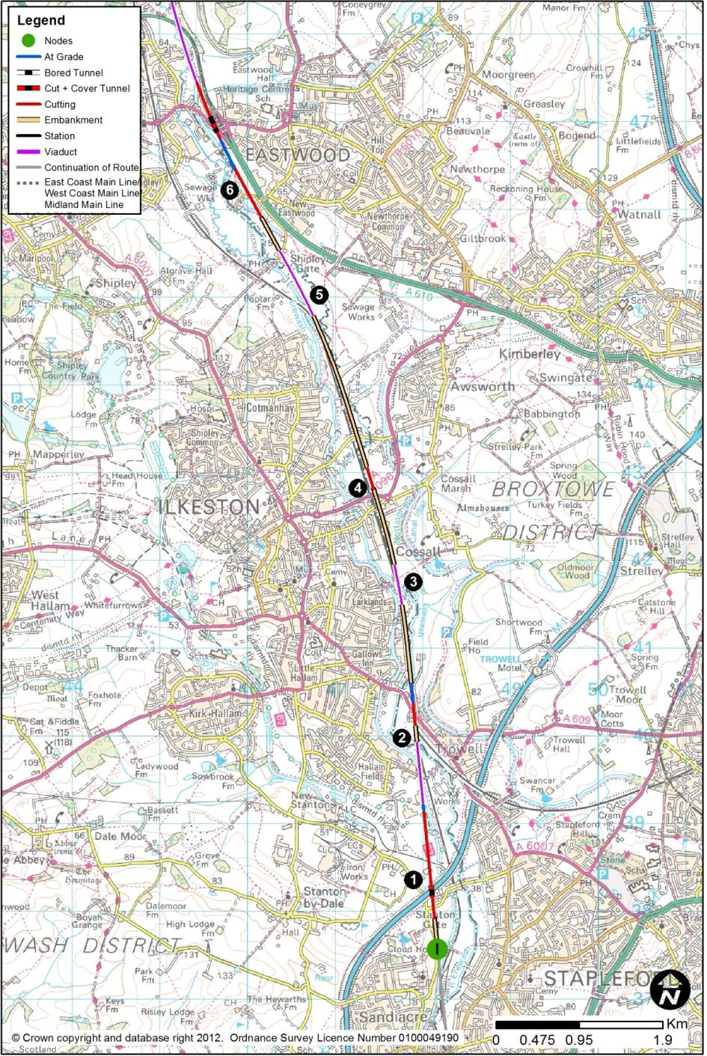
  - HSL11: Sandiacre (I) to Tibshelf (E)
        - This route section between Sandiacre and Tibshelf would be 25.5km long. The section of route to Sandiacre from the south would be HSL10 (and HSL26 – Toton Station) from Long Eaton. At Tibshelf, the route would continue north along section HSL05 to Killamarsh. This route would run through the Erewash Valley.

Sandiacre to Eastwood
        - The route would pass under the M1 at Stanton Gate (1). It would then cross the Erewash Canal, the River Erewash and its flood plain on a 710m viaduct, up to 7m in height, before dropping to the level of the existing Erewash Valley railway lines (2) in a very restricted strip of land between the Network Rail corridor and adjacent industrial premises. This would be a very restricted site for civil engineering works in close proximity to a live railway, with issues of contaminated land and buried services.
        - The new route would lie to the immediate west of the Network Rail lines, and Trowell Junction would be slewed to the immediate east. A retaining wall may be required between the new route and Network Rail lines to accommodate modest level differences. The A609 Ilkeston Road would need to be diverted in order to pass over the new route and the existing lines.
        - East of Larklands, the route would then rise on a 400m viaduct (3) laterally constrained as before, in order to pass over the Nottingham to Sheffield line to assume a position on its eastern side. The route would lie to the east, at existing track level, at Ilkeston Junction. The route would pass under the A6096 (4) which would need to be raised on its current alignment to provide the extra height needed for high speed trains. Awsworth Road would have to be raised over the route. Coronation Road would be realigned to the west to connect into the A6096.
        - For approximately 2km, the route would lie to the immediate east of the Erewash Valley lines, passing through a spare span of the Bennerley Viaduct, which appears to have sufficient headroom. Opposite Bennerley Fields School but still on the eastern side of the existing railway, the route would begin to rise on a viaduct (5) of 850m length and 10m height to run longitudinally along and over the River Erewash and its flood plain.
        - The route would then return to ground level, and deviate from the rail corridor, to run alongside the A610 between New Eastwood and Langley Mill (6). Tinsley Road would be diverted and raised over the route.
        - Over the whole of the length described in this section, there is likely to be a complex legacy of industrial uses, buried infrastructure, live and abandoned utilities, underground and opencast mineworkings, and contaminated land. There are numerous watercourse crossings, and the ground conditions could involve high-cost engineering solutions. The whole route is also close to an existing live railway, and in a confined corridor, constrained by residential and industrial / commercial uses.
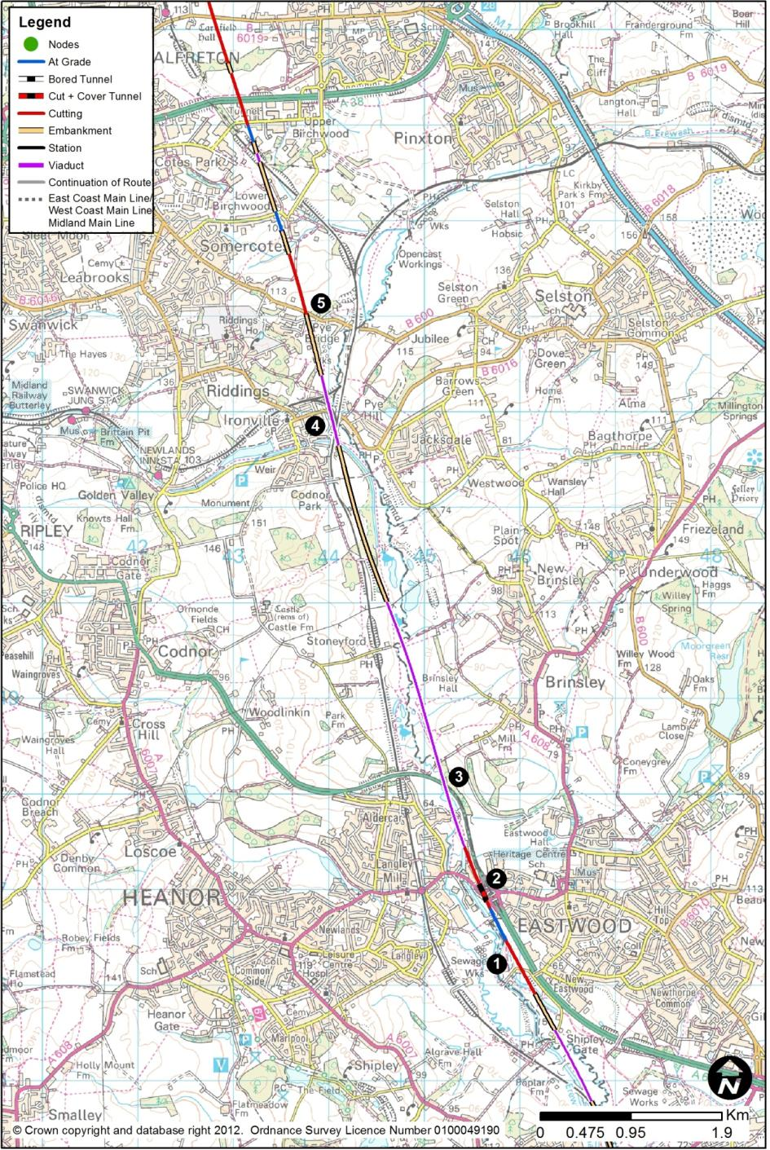

Eastwood to Somercotes
        - At New Eastwood, the route would run parallel to the A610 (1). A short diversion of the Erewash Canal would be needed in the vicinity of the sewage works, while lengths of retaining wall would be needed between the railway and the road to accommodate level differences.
        - The route would then cut through the roundabout (2) carrying the A608 New Derby Road over the A610. A new box structure would need to be constructed in phases to allow the route to pass under the roundabout, between the Cromford Canal and the A610, with the roundabout being extended. It would also be necessary to connect Anchor Road into the junction, using a realignment to pass over the Canal. This is a highly constrained site.
        - The route, north of the A608 junction, would rise on a 2.7km viaduct up to about 9m height, to cross the River Erewash and its flood plain. The A610 (3) would be realigned to pass over the route. The route would then run towards Ironville. There would be a 760m length viaduct (4) up to 15m high, to allow the route to pass over the Cromford Canal (disused), the River Erewash and its flood plain, the Erewash Valley railway, B6016 Victoria Street / Pye Hill Road, and the line to the Midland Railway Centre before returning to ground level near the sewage works.
        - The route would cross the B600 at Pye Bridge (5), at the road’s existing level; it would have to be raised on its current alignment as a consequence. The route would then enter a cutting up to 18m deep before returning to ground level at Birchwood Lane which would have to be raised.
        - Much of this route section would be affected by underground and opencast coal mineworkings.

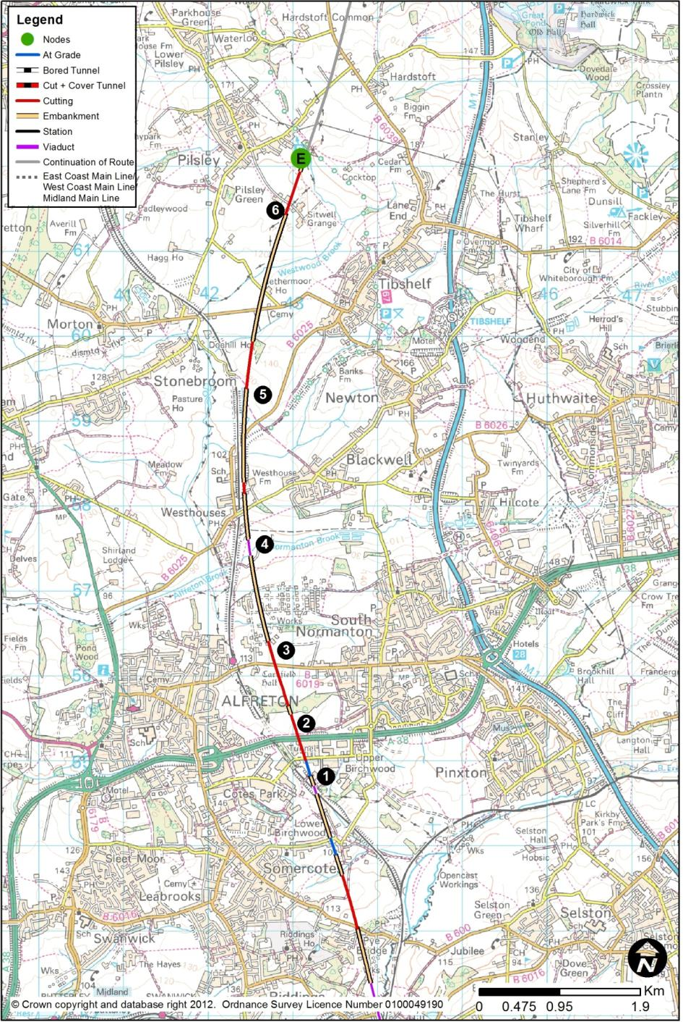

Somercotes to Tibshelf
        - At Somercotes, the new route would use a 130m viaduct up to 13m in height to cross to the eastern side of the Erewash Valley line (1) where the existing railway is in cutting on its approach to Alfreton Tunnel. The route would then pass under Clover Nook Road, which would have to be raised by a few metres to create the headroom needed for the route. Premises in the Clover Nook Industrial Estate could have their access arrangements affected.
        - The route would then pass under the A38 in a new box structure (2). This would require temporary lane restrictions, and may require a temporary diversion before restoring the road to its present alignment.
        - The route would continue in cut, before crossing B6019 Carnfield Hill which would have to be elevated to pass over the railway. North of Carnfield Hill (3), the route would pass through what is understood to be an industrial site with potential engineering and treatment issues. The route would continue north closing up to the Erewash Valley line, using a 190m viaduct up to 21m in height to cross Normanton Brook (4), and then the B6025 Alfreton Road.
        - The route would run parallel to the existing line for about 1.3km, before crossing Love Lane (5) at its present level; it would have to be raised over the route.
        - The route would rise out of the Erewash Valley first on embankment up to 15m high, and then back to ground level to pass to the west of Sitwell Grange Farm (6), and east of Pilsley.
        - Much of this route section would be affected by underground and opencast coal mineworkings.

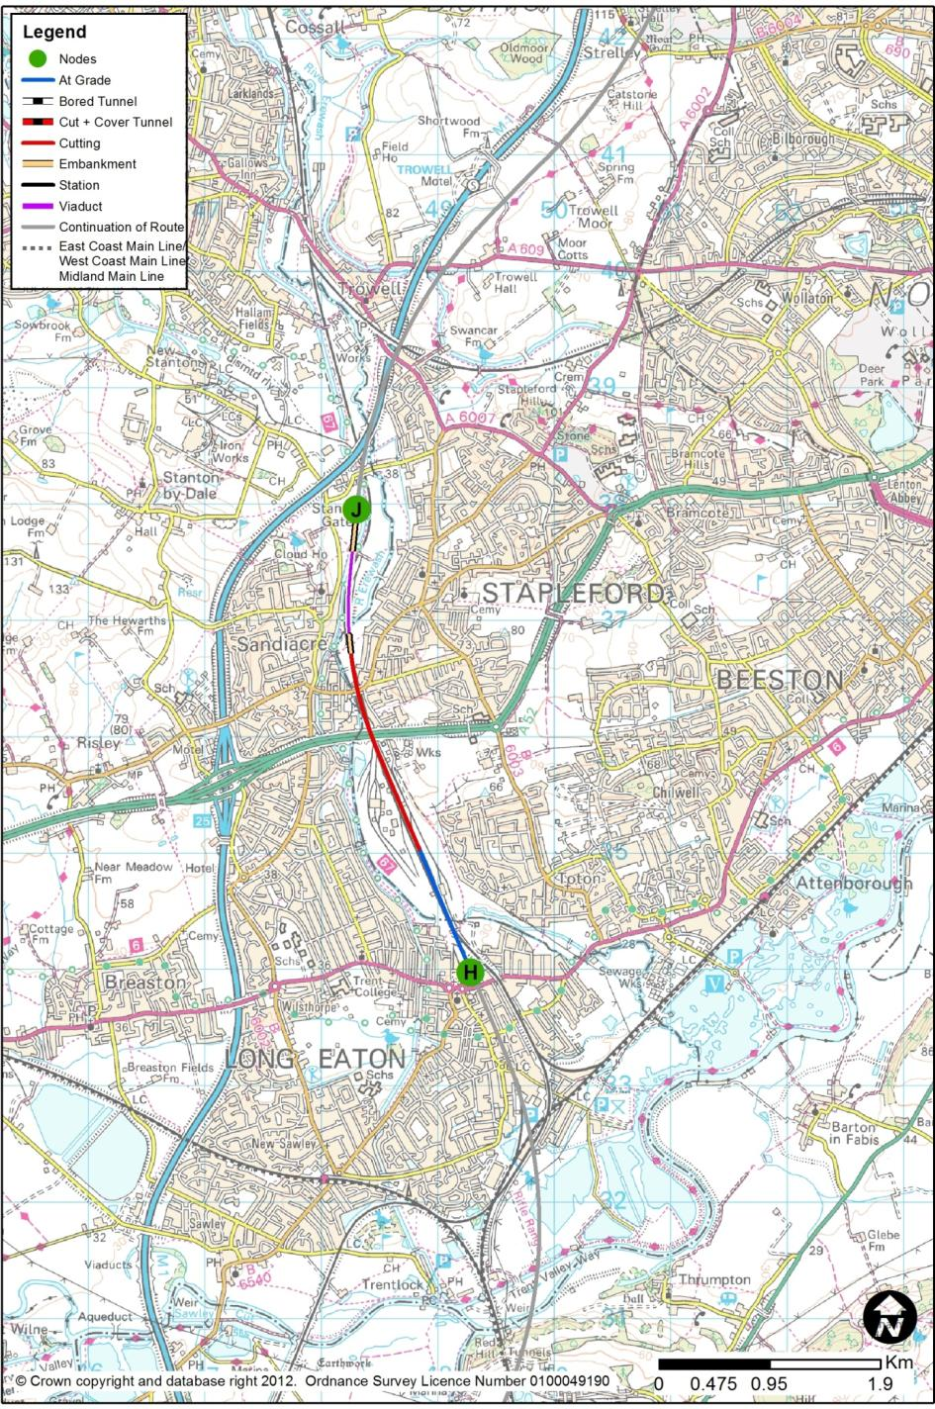
  - HSL12: Long Eaton (H) to Trowell (J)
        - This route section between Long Eaton and Trowell would be 4.1km long and would contain the proposed Toton Station (HSL27). The section of route connecting to Long Eaton from the south would be HSL09 from Tonge. At Trowell, the route would continue north along HSL13 to Killamarsh. This route would broadly follow the M1 corridor.

Long Eaton to Toton Station
        - From Long Eaton through the Toton Station site, and to the A52 Brian Clough Way crossing, the route would be as described for HSL10 in Chapter 2.12.

Toton Station
        - Toton Station (HSL27) is described in Chapter 3.3.
        - The station would provide a new transport interchange for the East Midlands. In addition to the four HS2 platforms, four new platforms would be provided on re-modelled national rail infrastructure to distribute passengers to and from Derby, Leicester, Nottingham and beyond; the NET2 tram system would be extended by 1km from its current proposed terminus; and highway infrastructure would provide ready connections to the M1 and the A52.
        - In the vicinity of the station and Toton Yard, the existing Trent Junction to Chesterfield (Erewash Valley) line would be diverted to pass through the proposed new classic network station, and it would lie to the east of the high speed alignment along this length.

Toton Station to Trowell
        - North from Toton, the route would reduce from six tracks to four tracks, and it would then pass under the bridge carrying the A52 Brian Clough Way over the current railway. The extent of the alteration of the lateral positioning of existing lines, as well as the introduction of HS2, would require that the existing bridge be demolished and replaced. As the A52 could not be closed for the duration required to achieve these works, a temporary off-line diversion and associated temporary structure would be needed.
        - North of the A52, Derby Road crosses the existing lines. There is insufficient vertical clearance under this structure to accommodate the new high-speed lines, and the structure would therefore have to be demolished and replaced, about 2m higher than existing, with a closure during these works.
        - About 550m north of Derby Road, the route would cross River Erewash and the Erewash Canal, on a 520m viaduct. North of the river, the railway would reduce from four tracks to two.
        - The route would then rise in level, climbing out of the Erewash valley, initially on embankment, and swing eastwards to run parallel to the M1, north of Stanton Gate.
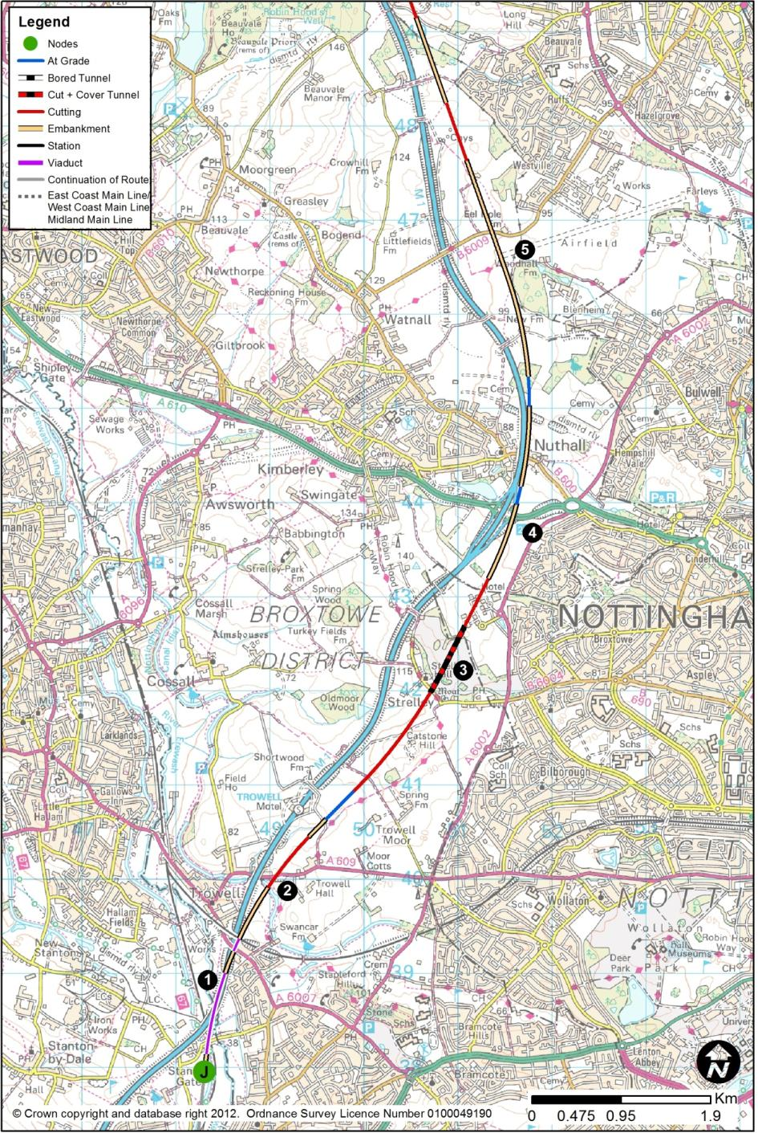
  - HSL13: Trowell (J) to Killamarsh (F)
        - The route section between Trowell and Killamarsh would be 44.3km long. The section of route connecting to Trowell from the south would be HSL12 (and HSL27 – Toton Station) from Long Eaton. This route would broadly follow the M1 corridor towards Killamarsh. At Killamarsh, the route would either continue north along HSL14 that passes the Tinsley (M1) viaduct with a station at Meadowhall, or along HSL24 that passes the Tinsley (M1) viaduct with a loop to an alternative station for South Yorkshire at Sheffield Victoria (HSL29).

Trowell to Misk Hill
        - The M1 (1) would be realigned over a length of 2.1km, moving about 125m west of its present position.
        - For the next 5.0km until Junction 26 of the M1, the route would broadly follow the south-eastern side of the motorway. The route would pass under the A609 Nottingham Road (2), which would retain its current position, before entering a cutting of up to 13m deep. It would then follow the rising ground level and pass into another section of cutting, with a depth of up to 24m.
        - The route would pass under Main Street in Strelley, and in doing so, enter a 790m long cut and cover tunnel (3) created by enclosing the railway in a box structure, and re-filling above the roof of the box to restore the original ground surface. The line speed would rise to 300kph, and the route would emerge from the cut and cover tunnel near Orchard Place and bear northwards to run alongside the M1 while still allowing the route to closely follow the existing alignment of the motorway. It would pass over the A610 to the east of M1 Junction 26 (4).
        - For the following 1.2km, the route would run very closely alongside the M1, requiring sections of retaining wall between the railway and motorway to allow for minor differences in level. It would pass over the B600 Nottingham Road, immediately adjacent to, and at the same level as, where the M1 currently crosses it.
        - The route would continue northwards and climb out of the valley, passing through New Farm Wood and to the west of Bulwell Wood. The speed would then increase to 400kph. It would then follow the motorway on its eastern side for about 10km, with up to 500m between the railway and M1, due to the sinuosity of the motorway corridor. A bridge would be required to pass over the B6009 Long Lane (5) which would remain in its present position.

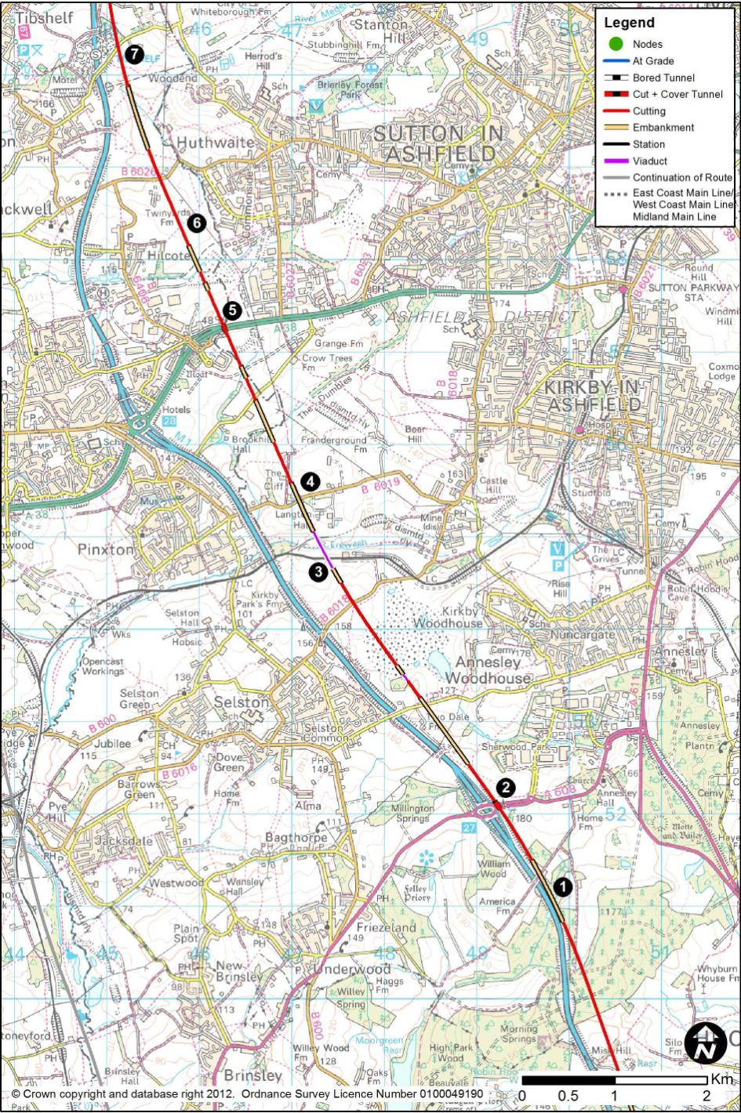

Misk Hill to Tibshelf
        - The route would continue to rise and follow the M1, passing through two sections of deep cutting at Misk Hill and Park Forest, with local depths of up to 19m and 29m respectively. It would then closely follow the motorway (1) again at The Dumbles, about 1.2km south of M1 Junction 27, where a section of retaining wall would be required to allow for minor differences in level between the motorway and railway. On the approach to the motorway junction, the route would descend into cutting, typically 12m deep, to allow the railway to pass under the A608 Mansfield Road.
        - At M1 Junction 27 (2), the roundabout would need to be extended on its eastern side to create the new bridges to allow the railway to pass underneath before the route would diverge from the motorway to the east as it would be unable to follow the curvature of the motorway at 400kph.
        - The route would descend in cutting, about 8m to 12m deep, before the sudden change in ground profile as the land falls rapidly into the valley of the River Erewash. The route would use a viaduct (3), of 450m length and up to 34m in height, to cross the valley bottom, the railway and the flood plain, with the railway being at a comparable level to the M1.
        - There would be an embankment, followed by a bridge over Kirkby Lane (4), which would remain in its present position and level. A cutting of depth 6m would be followed by a bridge over Maghole Brook, while Brookhill Lane would be diverted and raised to pass over the route.
        - The route would pass in cutting to the immediate east of the retail units, before passing below the A38 (5) at a depth of 17m. This is too shallow to tunnel, so it would be necessary to construct a box under the road. This would involve temporary widening and slewing of the road to facilitate construction of the box. After completion, the A38 would be returned to its present position and level.
        - The route would pass between the industrial / warehousing areas between Wincobank Way and Export Drive, and would cross a flood plain and historic landfill site, before passing east of Hilcote (6) in cuttings up to 9m deep. The route would pass under the B6026 Huthwaite Lane, which would be unaffected.
        - The route would rise with the landscape, passing to the immediate east of Tibshelf Motorway Services Area (7) which would be protected by a retaining wall to minimise land-take, and under Newtonwood Lane.
        - Much of this route section would be affected by underground and opencast coal mineworkings.

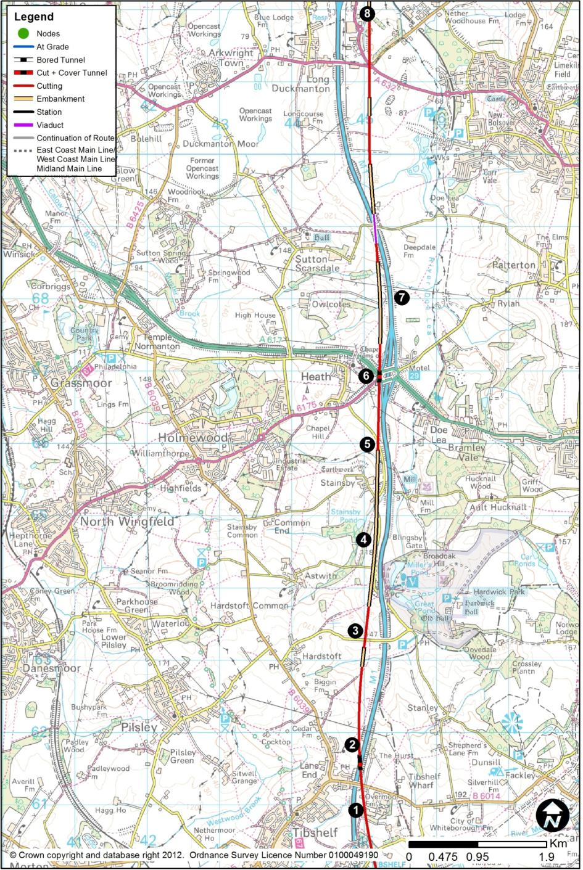

Tibshelf to Long Duckmanton
        - In cutting, at the crest of a vertical curve, the route would pass through some commercial premises south of the B6014 Mansfield Road in the Overmoor Farm area (1).
        - The route would now cross to the western side of the M1, passing below the motorway in a box structure (2) about 250m north of where it is crossed by Mansfield Road. The route would be 8m below the motorway. For the next 8km, the route would run in relatively close proximity to the M1 on the western side of the motorway. The route would, apart from a short length of about 250m, be in continuous cutting, with depths between 16m and 24m. The route would then pass under Deep Lane (3), which would remain on its present line and level. In this area, the route would run to the west of the M1, which itself runs to the west of Hardwick Hall.
        - The route would cross over Astwith Lane, and run almost north-south along the alignment of Mill Lane (4), which would be diverted over a considerable length. The route would be on embankments of between 8m and 18m where it would cross Mill Lane to the immediate east of the village of Stainsby.
        - Immediately north of Stainsby (5) the route would enter a cutting, as the ground levels rise, and it would pass below M1 Junction 29 (6) which would be extensively rebuilt on its western side to incorporate the connections to the A617 and the A6175. Retaining walls would be needed to reduce the land requirements. The route would not be able to follow the motorway exactly, but would pass onto an embankment up to 24m high about 1km north of the A617.
        - The route would then re-cross to the east side of the M1, bridging over it (7) on a viaduct of 250m length and up to 9m in height. The crossing point would be exactly where Palterton Lane presently crosses the motorway, and the lane would have to be diverted.
        - The route would run to the east of the Markham Vale Environment Centre (8), at the location of the roundabout at the junction of the A632, the A6192 and the B6418. There would be significant road works needed to restore the connectivity in this area, with a new bridge to carry the A632 over the motorway, and lengthy realignments on its approaches. There would be a cutting up to 25m deep to the north of this junction.
        - Much of this route section would be affected by underground and opencast coal mineworkings.

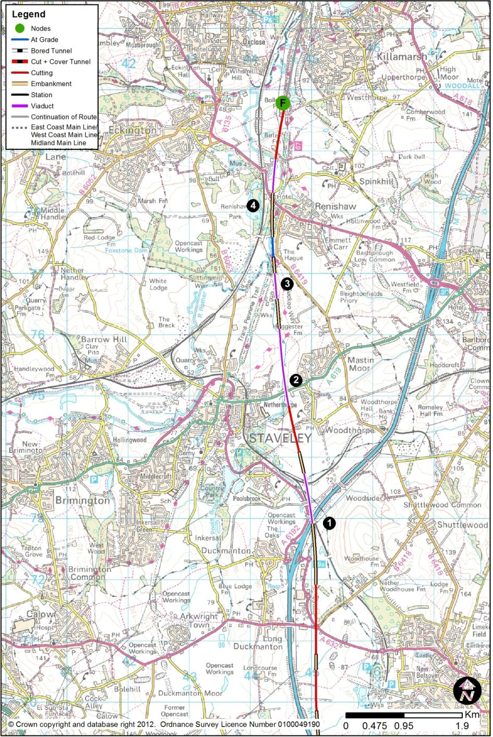

Long Duckmanton to Killamarsh
        - North from Long Duckmanton, the route’s longitudinal profile would remain level, but the falling ground would involve a 12m embankment and 830m viaduct, as the railway once again re-crosses the M1, to pass to its western side (1). The construction of the viaduct’s pier in the central reserve of the motorway may require complex temporary works on the motorway.
        - The motorway now starts to climb rapidly towards Junction 30, but the new route would leave the M1 corridor until rejoining it north of Meadowhall and the Chapeltown area.
        - The railway would pass into an 8m cutting under Bridle Road, which would be unaffected, and it would then pass to the immediate east of the Riverdale Park area of Netherthorpe.
        - While passing between Netherthorpe and Mastin Moor (2), the route would utilise a 1.2km viaduct 7m high to cross the River Doe Lea and its flood plain, at the same time passing over the A619 Worksop Road, which would be unaffected. There would be a short embankment near the sewage works, before a second viaduct (3) of 420m over part of the River Doe Lea flood plain. This section of route would have additional connections to the proposed Infrastructure Maintenance Depot, which is described in Chapter 4.1.
        - The route would then run to the west of Renishaw, about at ground level, just avoiding the B6419 Hague Lane, at The Hague. The route would then rise to pass over A6135 Main Road, before passing onto a 520m viaduct (4) over the River Rother’s meander, its flood plain and Spinkhill Lane. It would then run north in continuous cuttings between 7m and 12m deep, towards Rother Valley Country Park.
        - Much of this route section would be affected by underground and opencast coal mineworkings.

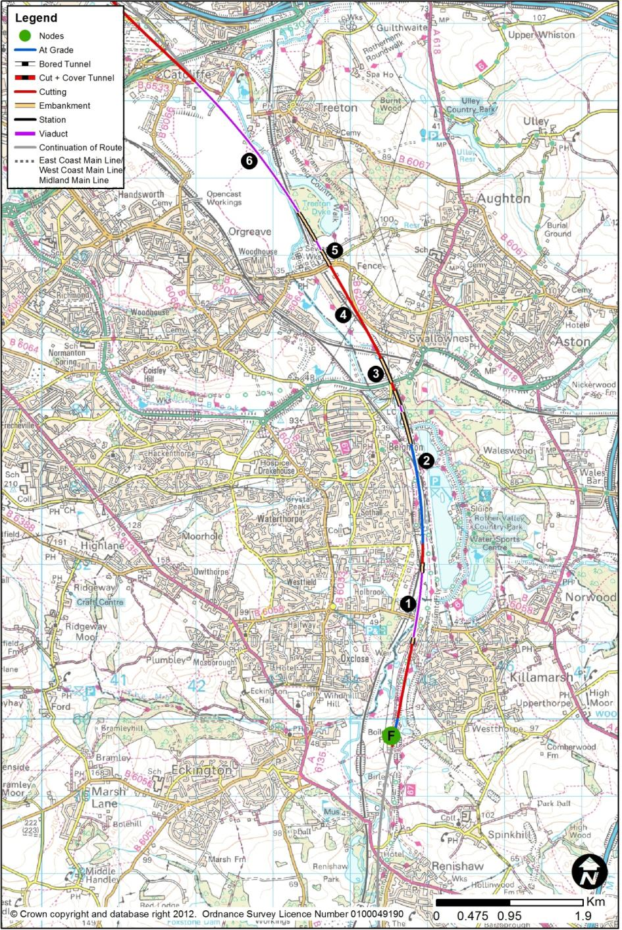
  - HSL14: Killamarsh (F) to Tinsley (K)
        - The route section between Killamarsh and Tinsley would be 12.4km long. The section of route connecting to Killamarsh from the south would be HSL05 from Tibshelf or HSL13 from Trowell.
        - This route section forms part of a longer grouping of links from Node F to Node M. Over the F to M length, this route would continue on HSL15 via Meadowhall, with a station there (HSL28). There is an alternative route between F and M (HSL24) which omits the station at Meadowhall, but contains a loop via Sheffield Victoria with a station there (as described in HSL29).

Killamarsh to Catcliffe
        - West of Killamarsh, the route would follow the line of the disused Chesterfield Canal. The design speed would fall to 360kph in order to minimise impacts on the Rother Valley Country Park. The route would pass onto an 850m viaduct (1) to cross Sheffield Road and, again, the River Rother flood plain.
        - The route would then adopt the alignment of the existing Chesterfield to Rotherham Railway which would have to be slewed (along with Beighton Junction itself) (2) approximately 30m westwards and over a length of 3.4km towards Holbrook, Sothall and Beighton to accommodate the route. The slewed existing railway and the new route would be at the level of the existing railway. East-west connectivity from residential areas and car parking areas to the Park would be maintained.
        - North from the Rother Valley Country Park, the route would remain at ground level, and the Network Rail lines would still be slewed to the west, but running in very close proximity. The new route would adopt the lateral and vertical position of the existing Chesterfield to Rotherham railway, requiring the diversion of the A57 Worksop Road (3). Further north, the route would pass under the Sheffield to Worksop line, and a new bridge would be required. North of the Sheffield to Worksop line, the route would adopt an independent alignment, and the Network Rail lines would remain in their current position.
        - This section would cross areas affected by shallow coal mining.
        - The route would be located along the alignment (4) of the B6200, and it may be necessary to create two culs-de-sac, with traffic diverted elsewhere. This would bring the railway in very close proximity to housing at Haigh Moor Way. A new bridge would be required to carry the B6200 Retford Road over the railway at a higher level to accommodate HS2 trains, resulting in extensive re-modelling of the local road network.
        - North of Retford Road (5), there would be a 130m viaduct over the River Rother flood plain, followed by a longer 2.2km viaduct (6) again over the same flood plain, the Chesterfield to Rotherham railway, and the B6066 Poplar Way. Both viaducts would typically be 8 to 10m above ground level. The route would pass through the Waverley Major Development site on the former Orgreave Colliery site.
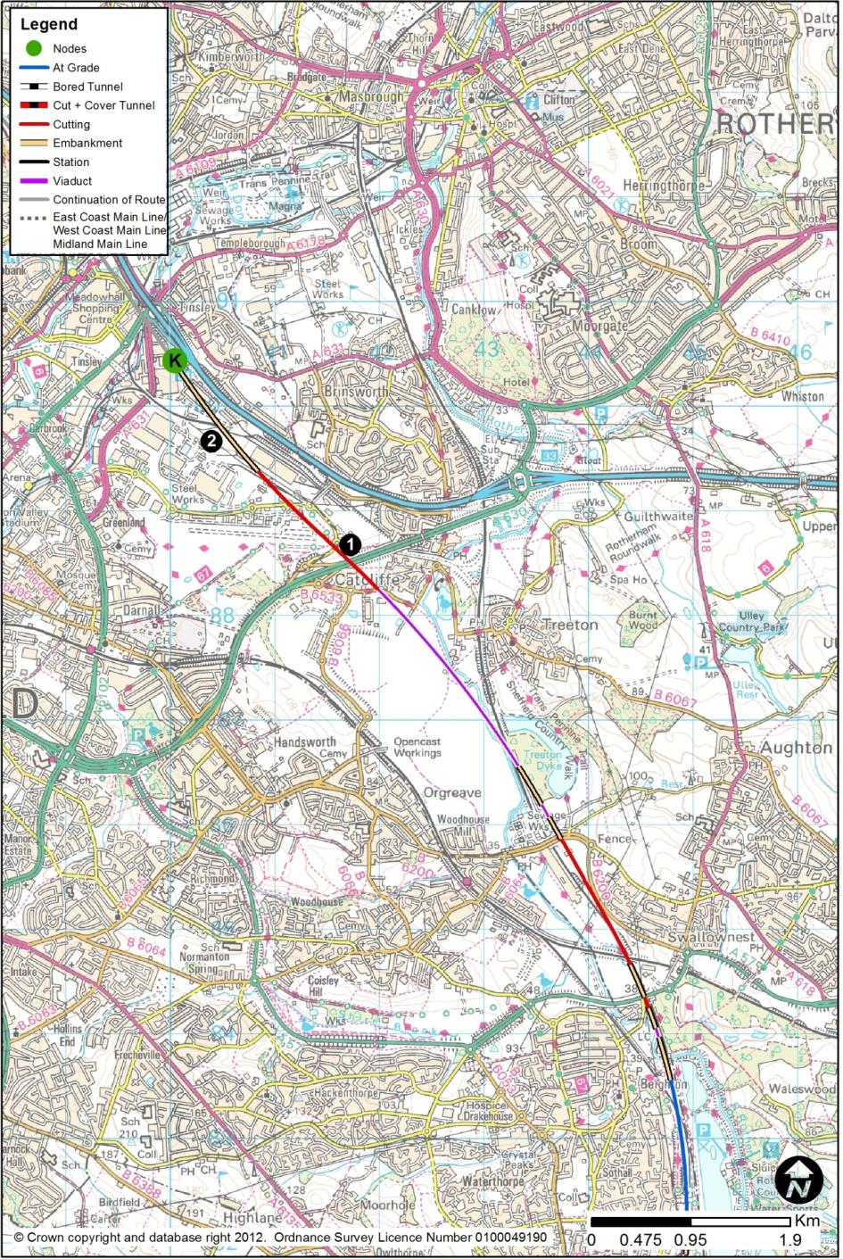

Catcliffe to Tinsley
        - The route would then enter a 22m deep cutting to pass beneath the A630 Sheffield Parkway (1) and, twice, under Europa Link. The route would emerge from cutting and would then pass on embankment along the site of the former Tinsley Marshalling Yard (2).
        - This section would cross areas affected by shallow coal mining and backfilled opencast sites, but would avoid most of the opencast areas. There are also likely to be areas affected by ground contamination, for example around the Outokumpu steelworks at the north end of this section.

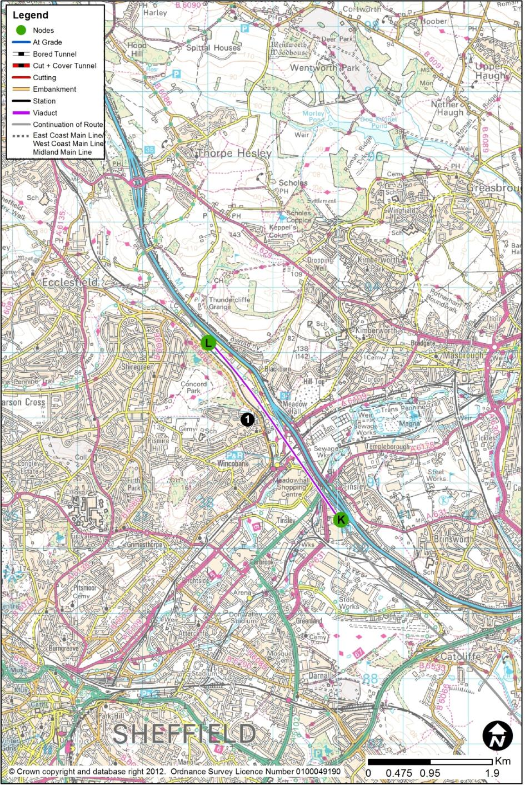
  - HSL15: Tinsley (K) to Blackburn (L)
        - This route section between Tinsley and Blackburn would be 3.4km long. The section of route connecting to Tinsley from the south would be HSL14 from Killamarsh. At Blackburn, the route would continue north along HSL16 to Cold Hiendley. This route section would contain the proposed Meadowhall Station (HSL28), which is described in Chapter 3.4.
        - In this area, there is also a marginally differing route option but without a station (HSL24); there would be a loop through Sheffield Victoria (HSL29), with a station there. This other alignment is described in Chapter 2.26.
        - For this route, north of Tinsley, the route would be on a viaduct (1) of length 4.1km up to 22m high across the Don Valley, this being at a comparable level to the M1 as it runs across its Tinsley viaduct. The route would widen from two tracks to four, and then to six at the station location. North of the station, the route would revert back to four, and then to two tracks.
        - The HS2 viaduct would run about 110m to the south-west of the M1 viaduct, crossing a series of obstacles: the A631 Shepcote Lane and A6178 Sheffield Road south of M1 Junction 34’s southern roundabout; the River Don and its flood plain; the South Yorkshire Supertram route; part of the Meadowhall Shopping Centre’s car park; Alsing Road; the Sheffield to Rotherham railway; the A6109 Meadowhall Road south of M1 Junction 34’s northern roundabout, and Blackburn Road.
        - The route would run along the alignment of the abandoned railway from Blackburn Junction to Wakefield and parallel to the existing Sheffield to Barnsley railway and B6082 Ecclesfield Road.

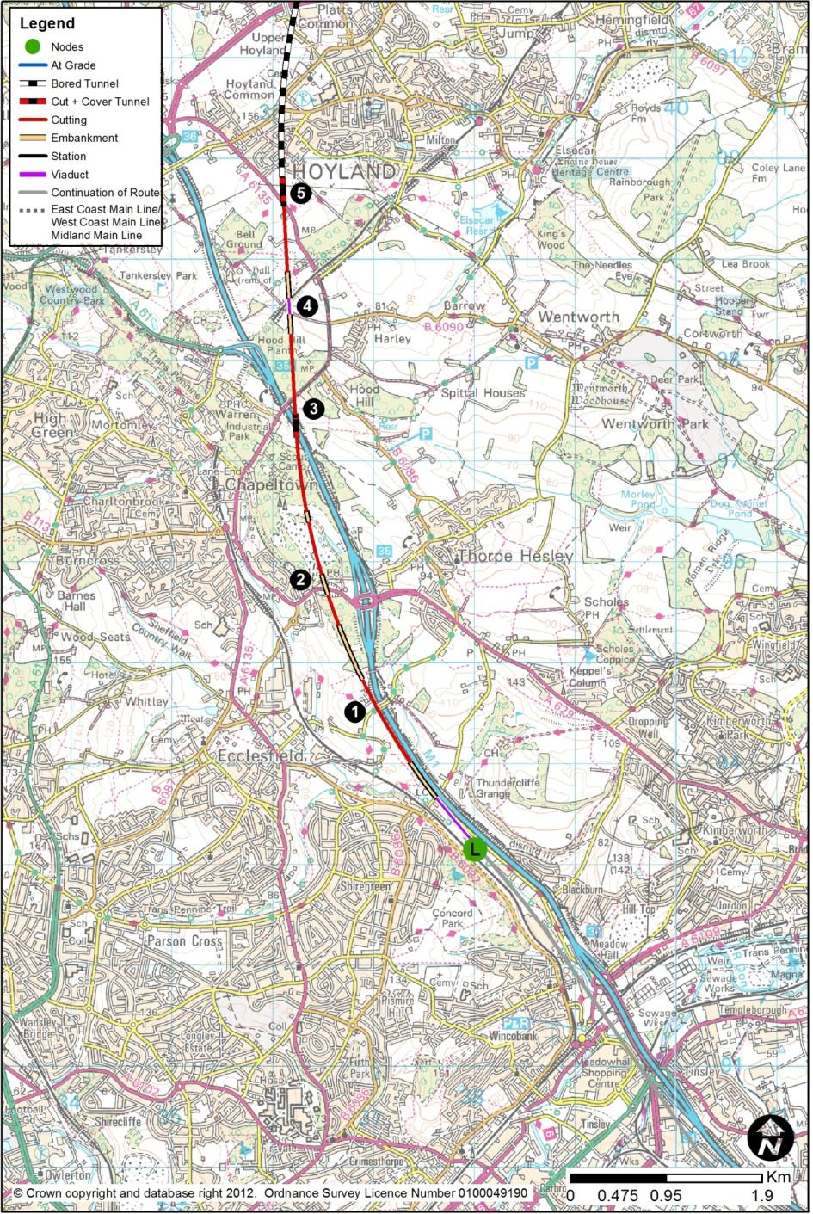
  - HSL16: Blackburn (L) to Cold Hiendley (M)
        - The route section between Blackburn and Cold Hiendley would be 23.1km long. The section connecting to Blackburn from the south would be HSL15 (and HSL28 – Meadowhall Station) from Tinsley. North of Cold Hiendley, in order to make passive provision for expansion of the high-speed rail network towards Northallerton and Newcastle, the layout would be designed as a main line to the North, with spurs to York and the ECML (HSL17 via Garforth or HSL18 via Castleford), and a spur to Leeds (HSL19 via Lofthouse or HSL21 via Woodlesford).

Blackburn to Hoyland
        - Northwards from Meadowhall, with a design speed of 360kph, the route would continue on a 4.1km viaduct. It would run parallel to the M1 and the Sheffield to Barnsley railway, and pass over Blackburn Brook flood plain and Deep Lane.
        - North of Deep Lane, the route would climb out of the Don Valley, close to existing ground levels, passing just under Jumble Lane (1). It would then depart from the M1 corridor, to pass to the west of Smithy Wood, and over Cowley Hill (2) some 280m west of Junction 35 of the M1. All this length of route would be on difficult terrain, and there could be complex earthworks stability issues to be faced, along with contamination from former industrial uses.
        - The route would then turn north through another area of former mine workings and waste tips, with potential contamination issues. The route would pass through Hesley Wood, then under the M1 about 250m south of the A6135, east of Warren (3). This would require the construction of a box structure under the M1 which would be complicated by the proximity to the existing bridge carrying the A6135 over the motorway. The route would then descend in cutting, before a 140m viaduct over the Sheffield to Barnsley railway line (4) about 260m north of its tunnel portal near Black Lane. The maximum height of the viaduct would be about 13m.
        - The landscape from this point north becomes more challenging, but the route would aim towards the lower-lying land of the Dearne Valley. On the approach to Hoyland Tunnel, the route would enter into a cut and cover tunnel, passing under the A6135 at Hoyland Common. At this crossing, the route would be about 17m below ground, and it would continue to descend towards the tunnel portal.
        - The route would then enter Hoyland Tunnel (5), whose southern portal would be south of Parkside Road and Stead Lane. The tunnel would be 1.8km in length. It would consist of twin-bore, single-track Sprayed Concrete Lining tunnels, meaning that there would be two tunnels, one carrying the northbound track, and the other the southbound. In plan, the tunnels would pass almost under the junction of the B6096 Hoyland Road and the B6097 Fearnley Road.

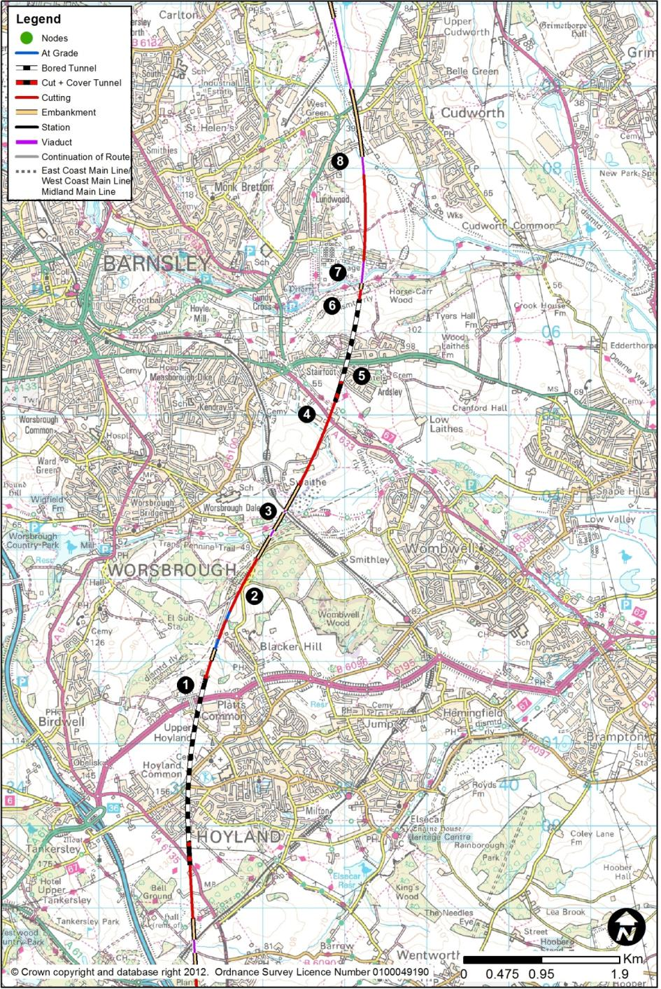

Hoyland to Cudworth
        - The northern tunnel exit portal would lie just north of the A6195 Dearne Valley Parkway. No intervention/ventilation shafts would be required. Mineworkings and opencast sites may affect the tunnel and its portals.
        - From the north portal (1) of Hoyland Tunnel, the route would involve a short embankment before descending in a cutting of depth typically between 8m to 18m, passing below Blacker Hill (2) and Wentworth Road near the bottom of the valley to the west of Wombwell Wood. The terrain here is challenging, and considerable lengths of retaining wall would be needed on the railway’s eastern side, involving ground improvement or anchored walls to minimise the cutting depths on this side.
        - The route would cross the River Dove and its flood plain on a 60m long viaduct, and, after a short embankment, cross over the Sheffield to Barnsley railway (3). The route would pass to the immediate east of Swaithe, in a cutting up to 25m deep, and a retaining wall would be provided to minimise the effect on Swaithe Hall Farm.
        - The route would pass under the A633 (4) about 740m south-east of the roundabout at the junction of the A633 and A635, at Stairfoot. The A633 would remain at its present level.
        - The route would then enter Ardsley Tunnel (5). The tunnel would be 1.0km in length. It would consist of twin-bore, single-track mined Sprayed Concrete Lining (SCL) tunnels, meaning that there would be two tunnels, one carrying the northbound track, and the other the southbound. The southern portal, in the land south of St. Paul’s Parade, is likely to prove challenging due to the proximity of residential properties, and being located in an area of active landfill. Therefore, special ground improvement measures in this area. In plan, the tunnels would pass beneath Ardsley and under Northumberland Way, at a depth of between 34m and 68m. The northern tunnel exit portal (6) would around 400m north of Northumberland Way, with the track level being about 30m below ground, 200m south of the River Dearne flood plain.
        - The route would then cross the River Dearne (7) and its flood plain on a viaduct of 270m length, about 7m above the valley floor. The route would then pass to the east of the sewage works, before entering a cutting up to 17m deep to pass east of Lundwood.
        - The route would emerge at ground level, and then pass onto a 185m viaduct, 13m high, to cross the Small Bridge Dike (8) flood plain. It would then continue on embankment up to 11m in height, for the next 800m, and bridge over Barnsley Road and the A628 Pontefract Road, which would both remain at their present positions. The route would then pass onto an 855m viaduct to cross Cudworth Dike and its flood plain, at a typical height of 9m. On this viaduct, the speed would increase to 400kph.

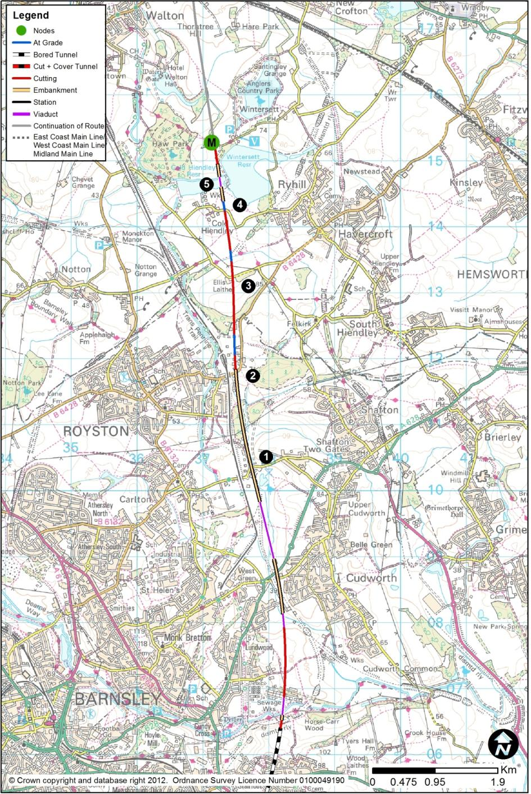

Cudworth to Cold Hiendley
        - The route would use an embankment to pass to the west of, and to avoid, Carlton Marsh Nature Reserve, but in doing so would bridge over Shaw Lane (1), affecting industrial property on Boulder Bridge Lane.
        - The route would lie on embankment, of typically 12m but up to 20m height, crossing a flood plain and Lund Hill Lane, which would be unaffected, on short bridges. The route would, at this general location, be running about 120m to the east of the former Midland Railway line from Wath-upon-Dearne to Normanton. Just north of B6428 Lund Hill Lane (2), the route would be at ground level. There would be a significant effect on industrial property in this area, and ground conditions are likely to be contaminated, particularly those associated with Monckton Coking Plant.
        - North of where the B6428 turns north-east, the route would enter a cutting up to 26m deep locally, before crossing Church Lane (3) near Gable Cottage. A retaining wall would be provided on the cutting’s west slope to lessen the residential land requirement in this area.
        - The route would then run at ground level or in shallow cuttings, approaching the Cold Hiendley Reservoir and the Wintersett Reservoir. It would be at ground level at Ryhill Pits Lane (4), which would have to be diverted to pass over the route. The route would be in very close proximity to Croftfield House.
        - The route would then cross Cold Hiendley Reservoir (5), about 50m west of the dam wall between it and Wintersett Reservoir. A 140m multi-span structure would be used to cross the reservoir.

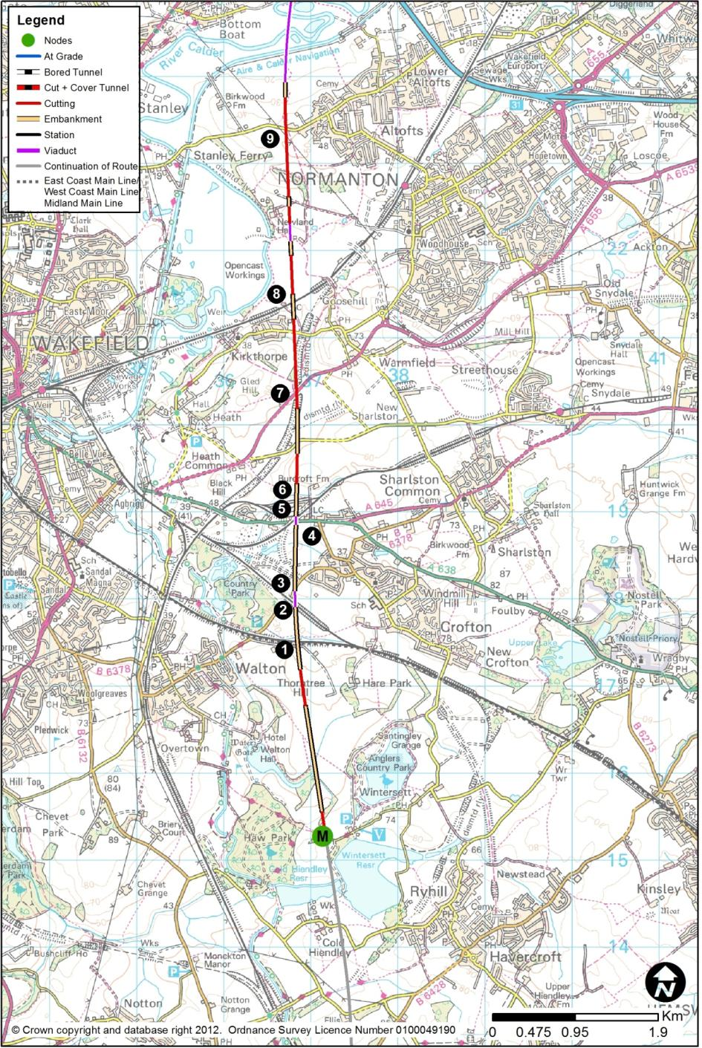
  - HSL17: Cold Hiendley (M) to Church Fenton (V)
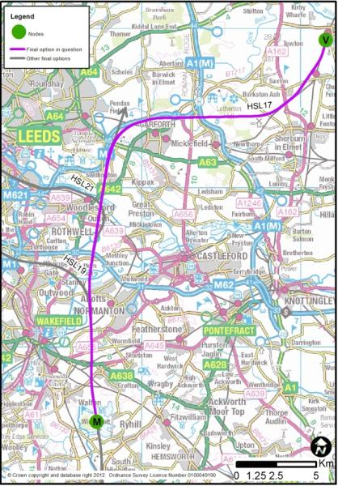
        - This route section between Cold Hiendley and Church Fenton would be 34.1km long. The section of route from the south would be HSL16 from Blackburn. The route would run north of Garforth, and, at its northern end, would connect into the section of existing railway between Church Fenton and Ulleskelf, to provide the connection to the East Coast Main Line.
        - This section of route would contain the proposed Rolling Stock Maintenance Depot at New Crofton, which is described in Chapter 4.2.
        - This route could be combined with a spur into Leeds City Centre via Lofthouse (HSL19) or Woodlesford (HSL21) as shown on the right.

Cold Hiendley to Altofts
        - North from Wintersett Reservoir, the route would descend into a shallow cutting, and then embankment, to run east of Walton Hall and west of Anglers Country Park. It would then pass onto a 3.0km embankment, typically 12m but up to 22m in height, to cross a series of obstacles: the Doncaster - Leeds railway (1); the Hare Park Junction to Crofton West Junction railway (2); B6378 Shay Lane (3); A638 Doncaster Road (4) and the Crofton East Junction to Crofton West Junction railway (5) at the point they already cross; the Crofton East Junction to Oakenshaw South Junction railway and the Bombardier Train Maintenance Facility (6).
        - The route would then enter cutting, up to 11m deep, west of Burcroft Farm, before running on a shallow embankment 4m high, passing in cutting below the A655 (7), which would be realigned to pass over the route. Continuing in cutting of 11m depth, it would then pass under a realigned Kirkthorpe Lane. The route would pass onto an embankment 8m high, bridging the Wakefield Kirkgate to Normanton railway line (8), which would be unaffected.
        - After a short cutting up to 11m deep, the route would gradually descend into the valley of the River Calder, in a cutting typically 19m deep to pass under Birkwood Road (9), which would remain. The route would lie at the south-western edge of Altofts.
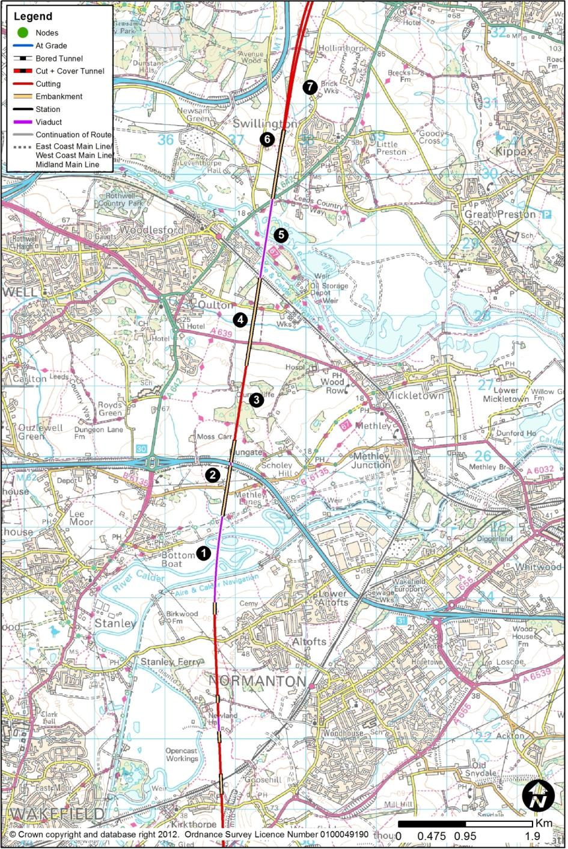

Altofts to Swillington
        - After emerging from cutting just north of Top Farm, the route would use a 1.2km viaduct (1), up to 19m high, to pass over the Aire and Calder Navigation, and multiple crossings of the River Calder and its flood plain.
        - The route would then rise on an embankment of 14m maximum height, to pass over a realigned Newmarket Lane, and over the M62 (2), which would remain. North of the M62, the route would fall, in a cutting up to 16m deep, with the use of a retaining wall of 130m length to minimise property effects at Clumpcliffe (3). This section of the route would cross several backfilled opencast sites.
        - The route would then use an embankment up to 16m high to pass over A639 Methley Lane (4), which would remain, over Oulton Beck flood plain, and over Fleet Lane, which would also remain.
        - There would then be a viaduct (5) of 1.2km length, up to 21m high, to carry the route over the Leeds to Normanton railway, the Aire and Calder Navigation, the River Aire and its flood plain, as well as the A642 Wakefield Road, before returning to ground level.
        - The route would then rise out of the Aire Valley, on a shallow embankment, passing to the eastern edge of Grimblethorpe Farm and to the west of Swillington (6). It would then enter cutting, up to 8m deep, at Woodside Farm. North-west of Swillington, the route would run in close proximity to the M1 for 100m close to Hollinthorpe Farm (7), but would be in a cutting up to 23m deep.

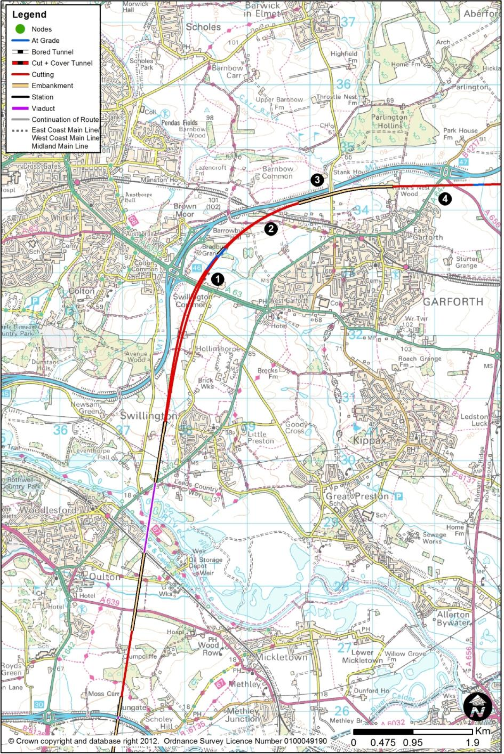

Swillington to Garforth
        - The route would pass below the A63 Selby Road (1), which would remain at its present level, about 300m east of Junction 46 of the M1.
        - The route would then swing eastwards, at 230kph, to follow the curve of the M1 in cutting, passing below the Leeds to York railway (2), which would remain at its present level. It would then run immediately adjacent to the M1’s southern boundary, broadly at the motorway’s level, between the railway and Barwick Road (3), which would have to be elevated to pass over both HS2 and the M1. Through this section, the route would closely follow the M1 for 4km.
        - The route would follow the rising ground towards M1 Junction 47 (4). It would pass immediately to the south of the junction, at the M1’s level, so the approaches from the south would bridge over the railway to tie in to the existing roundabout, which would remain at its current level.

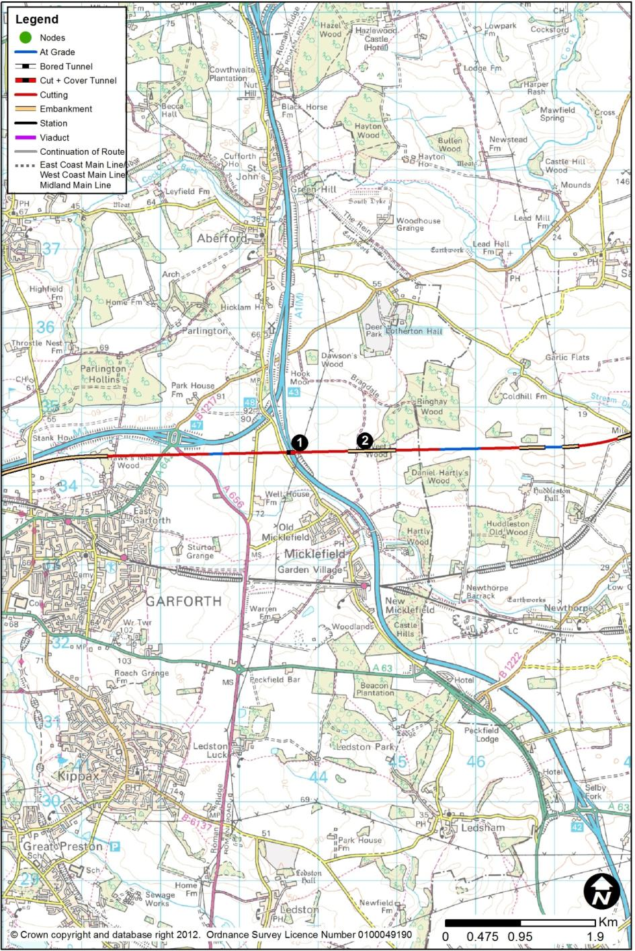

Garforth to Huddleston Old Wood
        - The route would then fall to pass below the Roman Road, and below the A1(M) north of Old Micklefield and south of Hook Moor, in cutting. A box structure would be used to carry the railway under the A1(M) (1).
        - The route would then emerge at ground level some 600m east of the motorway, near Weet Wood (2) and would run east in a series of shallow embankments and cuttings.

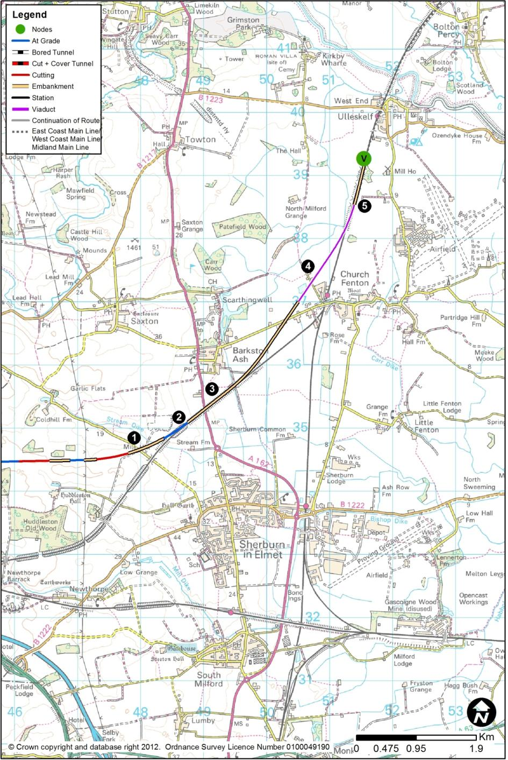

Huddleston Old Wood to Church Fenton
        - The route would head east, at ground level, crossing over Mile Hill (1) and a flood plain on viaduct, then on an embankment of maximum height of 17m, before turning north-east to run parallel to the existing railway between Micklefield and Church Fenton, on its northerly side and close to its level (2).
        - It would cross the A162 (3) on a localised embankment, passing south of Barkston Ash. Unable to follow the existing line through Church Fenton because of curvature, property and the station, the route would pass on a shallow embankment to its west, crossing Common Lane on a bridge. It would then run onto a 2.5km viaduct (4), typically between 9m and 12m high, to pass over Sandwath Lane within 100m of Sandwath Drive, over a flood plain, and over the Church Fenton to Ulleskelf section of existing railway, in order to return to ground on the railway’s eastern side (5). The existing railway would have to be altered in alignment to accommodate the new route arriving from the west.
        - Further modifications to the existing railway between the tie-in point and Colton Junction (at the East Coast Main Line) are described in Chapter 5.2.

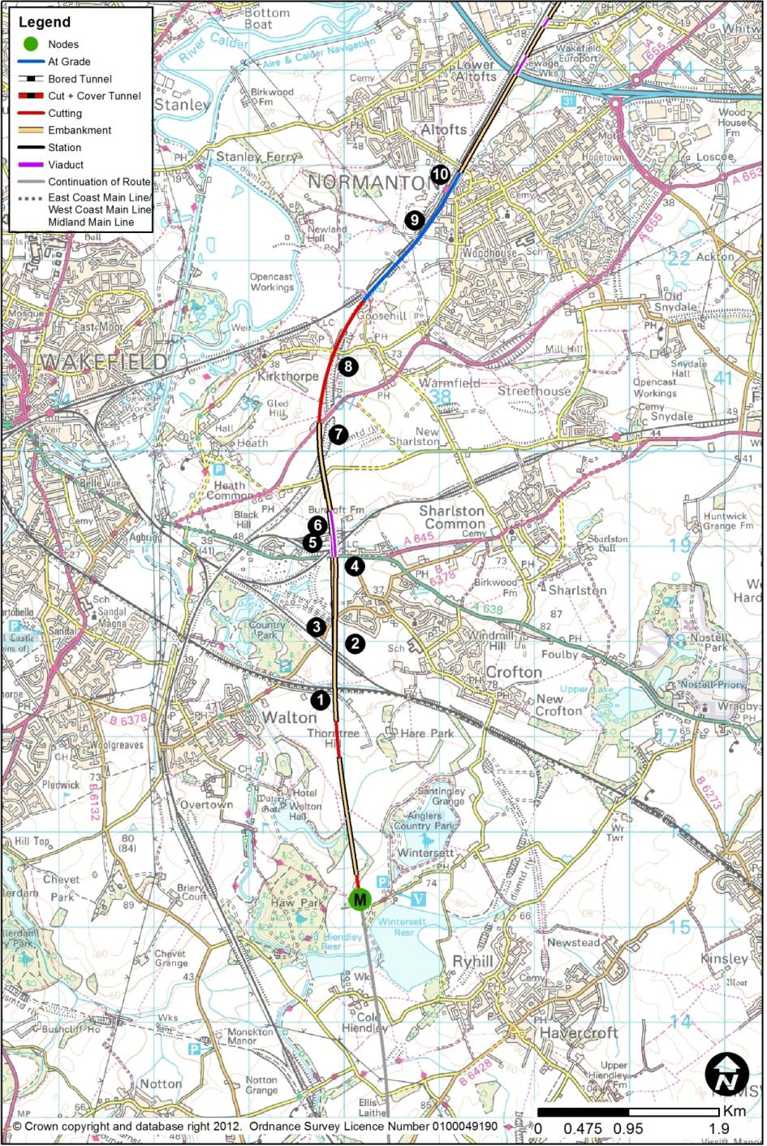
  - HSL18: Cold Hiendley (M) to Church Fenton (V)
        - This route section between would be 30.0km long. The route would run north of Castleford, and, at its northern end, would connect into the section of existing railway between Church Fenton and Ulleskelf, to provide the connection to the East Coast Main Line.
        - This section of route would contain the proposed Rolling Stock Maintenance Depot at New Crofton, which is described in Chapter 4.2.
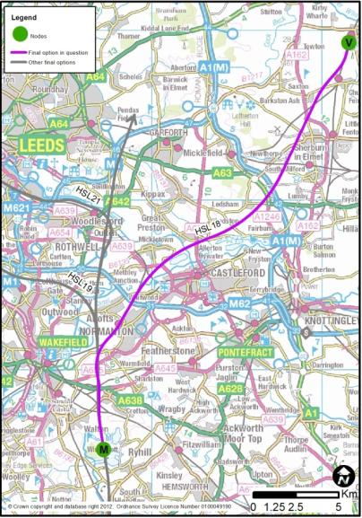
        - This route could be combined with a spur into Leeds City Centre via Lofthouse (HSL19) or Woodlesford (HSL21) as shown on the right.

Cold Hiendley to Altofts
        - This section of route would form the spur via Castleford towards Church Fenton.
        - North from Wintersett Reservoir, the route would be identical to HSL17. Between Walton Hall and the Bombardier Train Maintenance Facility (6) the speed would reduce to 230kph and HSL17 would be modified to allow insertion of turnouts to HSL18.
        - There would be two 490m long retaining walls here to separate the ECML spur from the main line. The northbound link would peel off north-west, while the southbound link would be elevated over the main line, this link being about 24m above the level of the A638 on a complex multi-level structure.
        - The route would cross the A655 (7), which would be realigned to pass under both the main line and this ECML spur. The spurs would then descend, turning north-east, to run in a cutting (8) up to 12m deep under the main line at Marshall Road, which would be realigned to pass over the spurs and the main line, with the extensive use of retaining walls to contain the junction layout.
        - The route would then run at existing ground levels parallel to the Wakefield Kirkgate to Normanton railway line (9), which would be slewed to the west over a length of about 2km. Newlands Lane would be bridged over the ECML spur and the slewed Network Rail lines. The line speed would rise to 375kph. A little further north-east, this railway slew would necessitate the rebuilding of Normanton Station (10) whose access to the town would be maintained. Altofts Road would have to be altered to accommodate the spurs and the slewed Network Rail route, and it would also be raised, on line, to create the headroom required.
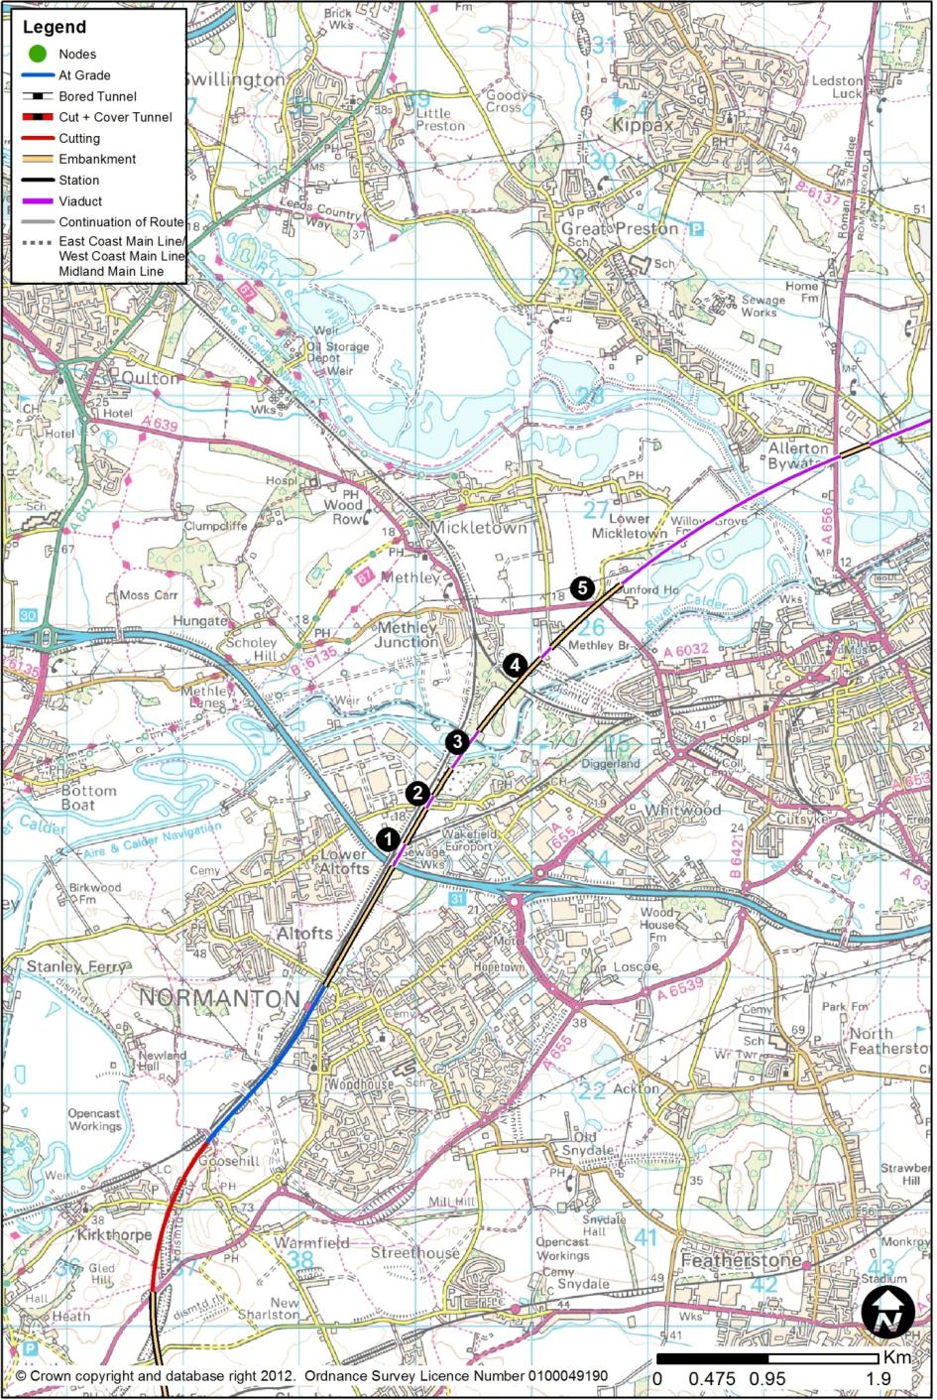

Altofts to Allerton Bywater
        - North-east of Altofts Road, the route would rise and would be continuously elevated, on bridges, viaducts and embankments over a succession of obstacles: a 260m viaduct to cross the M62 (1) and the Normanton (Altofts Junction) to Castleford (Whitwood Junction) railway, being typically 9m high over the line; a 9m to 12m embankment before crossing Pope Street and Express Way (2) on a bridge 12m high; a 350m viaduct (3), 18m high, to pass over the Aire and Calder Navigation and the River Calder and its flood plain; a bridge of 10m height over the Methley Junction to Whitwood Junction railway (4); and a bridge of 11m height over Barnsdale Road (5).

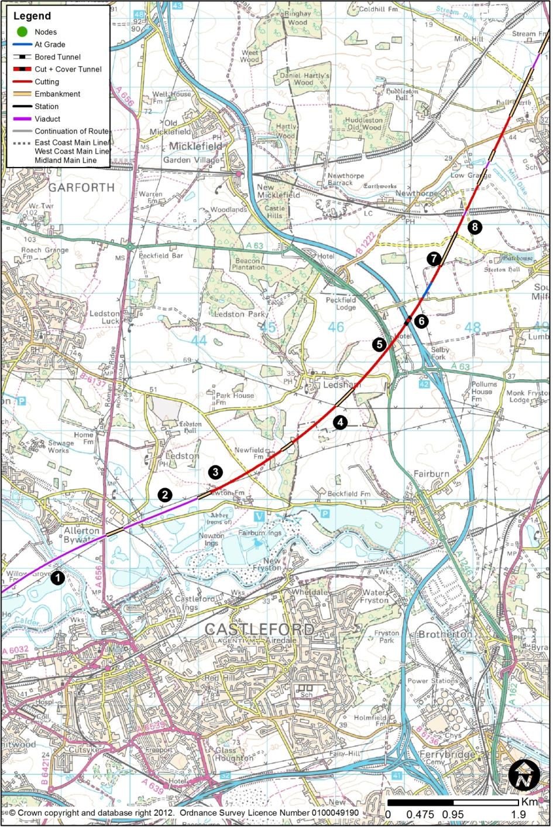

Allerton Bywater to Newthorpe
        - Now south-east of Allerton Bywater, the route would continue its elevated nature, using a 2.2km viaduct (1) typically 13m high to pass over the River Aire and its flood plain, and the A656 Barnsdale Road. Following a 250m section of embankment, it would then use a second section of viaduct (2) 1.2km in length, to pass over the River Aire flood plain and Newton Lane, which would remain. The route would return to ground level west of Newton Farm. The route would then lie in cutting typically 9m deep to pass to the south-east of Ledston (3) and under Back Newton Lane, which would remain at its present level.
        - The extent of viaduct over this length of route, and the ground conditions and obstacles to be crossed, particularly rivers, canals and flood plains, ensures this area has some engineering challenges to overcome, with extensive structural and ground improvement works.
        - The route would emerge briefly from cutting to pass over a small flood plain and it would then enter a shallow cutting of 5m depth, emerging at ground level almost due south of Ledsham (4). The route would cross Holyrood Lane at ground level, and as a consequence, the road would have to be diverted to pass over the route.
        - North of Holyrood Lane, the route would enter a cutting reaching a maximum depth of 19m at the point where the route would pass under the A63 (5), which would be permanently realigned. A continuation of the cutting would take the route in a box structure under the A1(M) (6), passing below it and Westfield Lane just south of where they cross. Both roads would remain in their present positions.
        - The route would sever the corner of Whin Lane (7) which would diverted to the south-east to avoid the railway, before passing in a cutting 9m below Whitecote Lane, which would remain in its present position. It would also pass 11m below the Leeds to Selby railway (8) east of Newthorpe, and 14m below Gorse Lane, which would be realigned with a new bridge over the route.

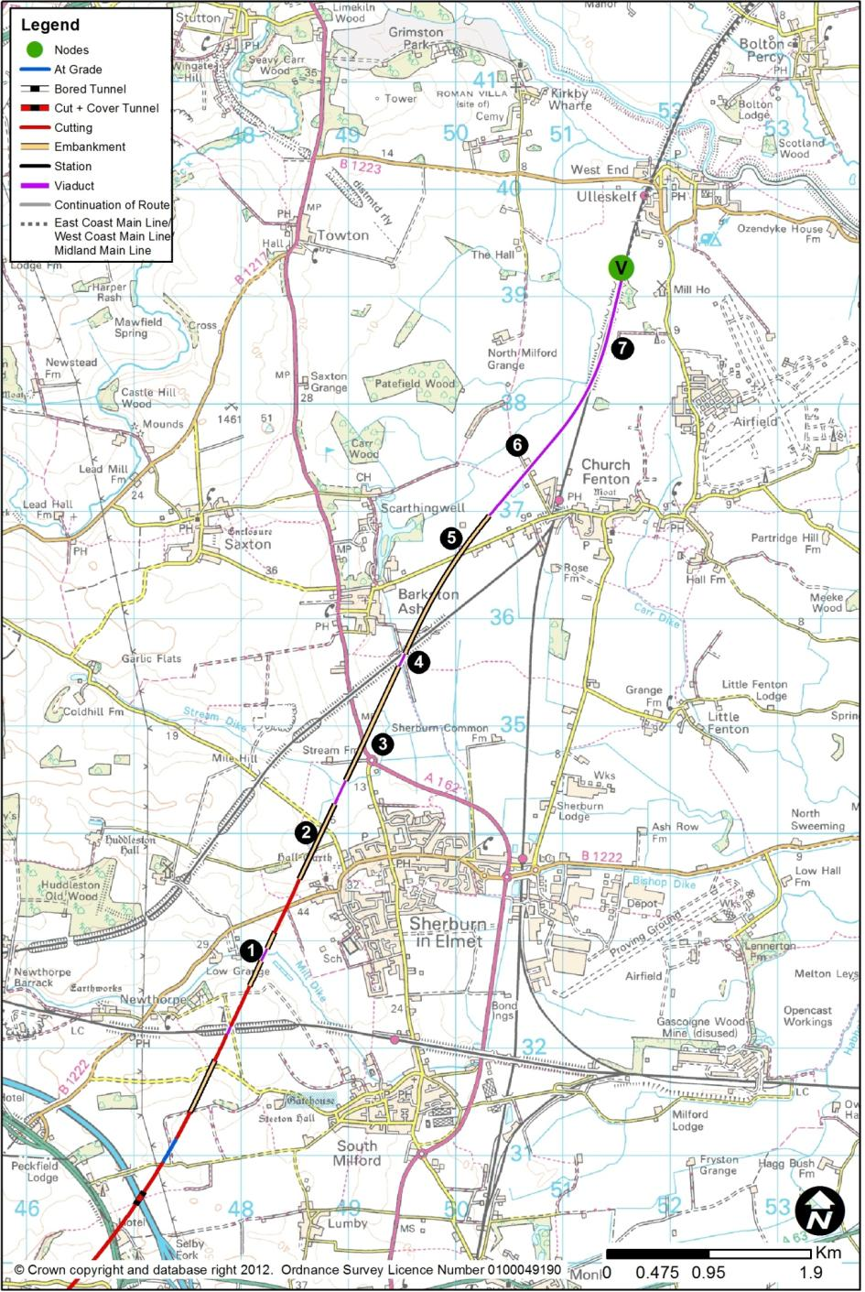

Newthorpe to Church Fenton
        - The route would emerge from cutting at Mill Farm, to pass over the flood plain (1) on a 50m structure, 4m high. It would enter cutting to pass under Church Hill Road in its present location, and the road would have to be raised to pass over the route.
        - The route would then emerge at ground level and on to embankment, typically 6m but up to 9m high to bridge over Coldhill Lane. Laith Staid Lane would be realigned to a junction with Coldhill Lane (2). The route then passes over Stream Dike and its flood plain on a bridge of height 9m. The route would then be continuously elevated to pass over the A162 London Road (3) on a bridge of 8m height, and then on a 170m viaduct 11m high over Bishop Dike and the Leeds to York line (4) where they cross south-east of Barkston, on a 12m embankment over Barkston Moor, and on a 13m bridge over Common Lane (5).
        - The route would use a 2.5km viaduct (6) 13m high over its entire length, to pass over Sandwath Road, a flood plain, and over the Church Fenton to Ulleskelf section of existing railway, in order to return to ground on the railway’s eastern side (7). The existing railway would have to be altered in alignment to accommodate the high speed alignment arriving from the west.
        - Further modifications to the existing railway between the tie-in point and Colton Junction (at the East Coast Main Line) are described in Chapter 5.2.

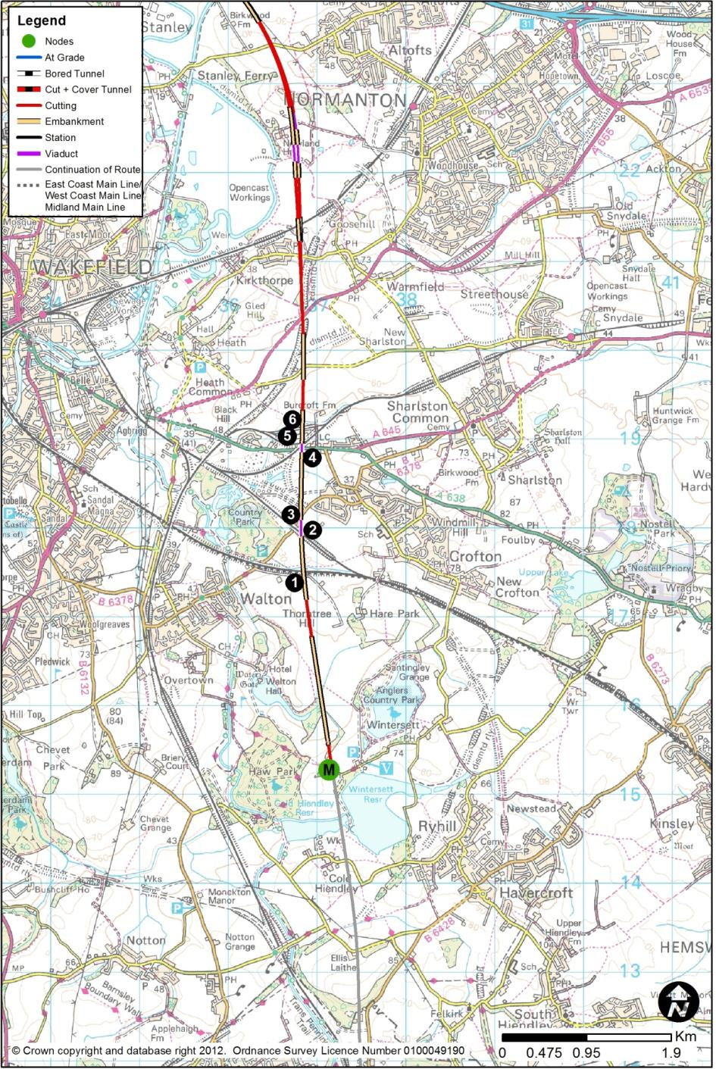
  - HSL19: Cold Hiendley (M) to Lofthouse (N)
        - The route section between Cold Hiendley and Lofthouse would be 12.6km long. The section of route connecting to Cold Hiendley from the south would be HSL16 from Blackburn. At Lofthouse, the route would continue north along HSL20 to Holbeck. This corridor serves the proposed Leeds Station North la in Leeds city centre (HSL30) which is described in Chapter 3.6.
        - This section of route would contain the proposed Rolling Stock Maintenance Depot at New Crofton, which is described in Chapter 4.2.
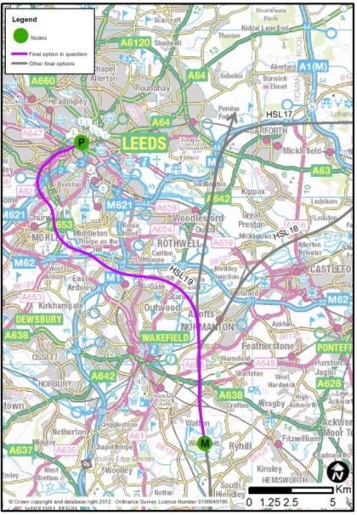
        - This route could be combined with a spur to the ECML via Garforth (HSL17) or Castleford (HSL18) as shown on the right.

Cold Hiendley to Kirkthorpe
        - North from Wintersett Reservoir, the route would be identical to that described in HSL17, between Walton Hall and the Bombardier Train Maintenance Facility (6). Here, the speed would reduce to 230kph.
        - The route would then enter cutting, up to 11m deep, west of Burcroft Farm.

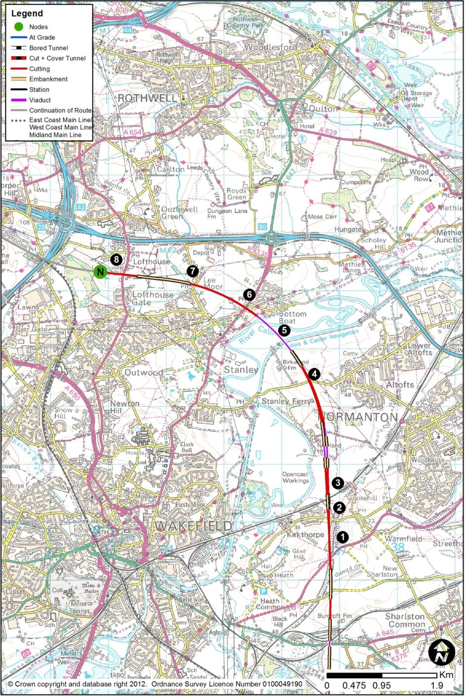

Kirkthorpe to Lofthouse
        - The junction spur towards Leeds would enter cutting, up to 11m deep, west of Burcroft Farm, before running on a shallow embankment 4m high, then into cutting to pass below the A655 (1), which would be realigned to pass over the route. The line speed would reduce to 230kph, and the route would then pass under Kirkthorpe Lane (2) in an 8m cutting, with the road remaining in its current position. The spur would pass onto an embankment 8m high, bridging the Wakefield Kirkgate to Normanton railway (3), which would be unaffected.
        - After a short cutting up to 10m deep through a hazardous waste landfill site, the route would rise, using retaining structures where necessary to separate the spurs from the main line running north. Viaducts of 180m length, up to 15m high, would carry the spurs over a disused brickworks, and then there would be a viaduct of 200m length, with a maximum height of 12m, to carry the southbound spur over the main lines.
        - The spurs would then descend, first in cutting up to 13m deep, and then in shallower cutting of up to 6m deep, to take the spurs under Birkwood Road (4), which would be raised slightly to carry it over the route.
        - The route would emerge from cutting about 300m north of Birkwood Road, and it would then be carried on an 860m viaduct (5), up to 12m high, over the Aire and Calder Navigation, the River Calder and its flood plain, while curving sharply west to aim for a narrow gap in property between Stanley and Bottom Boat. Immediately north of the River Calder, the route would climb, entering a cutting of 15m depth under A642 Aberford Road (6). The cutting would deepen to a maximum of 23m before reducing to 7m depth just north of the junction of Lee Moor Road, Lee Moor Lane and Fenton Road (7); all roads would remain in their current positions.
        - The route would continue to climb with the rising ground levels to pass over a flood plain. It would then pass 5m under the A61 Leeds Road (8) south of Lofthouse near Lofthouse Hill, with the road slightly raised to provide clearance.

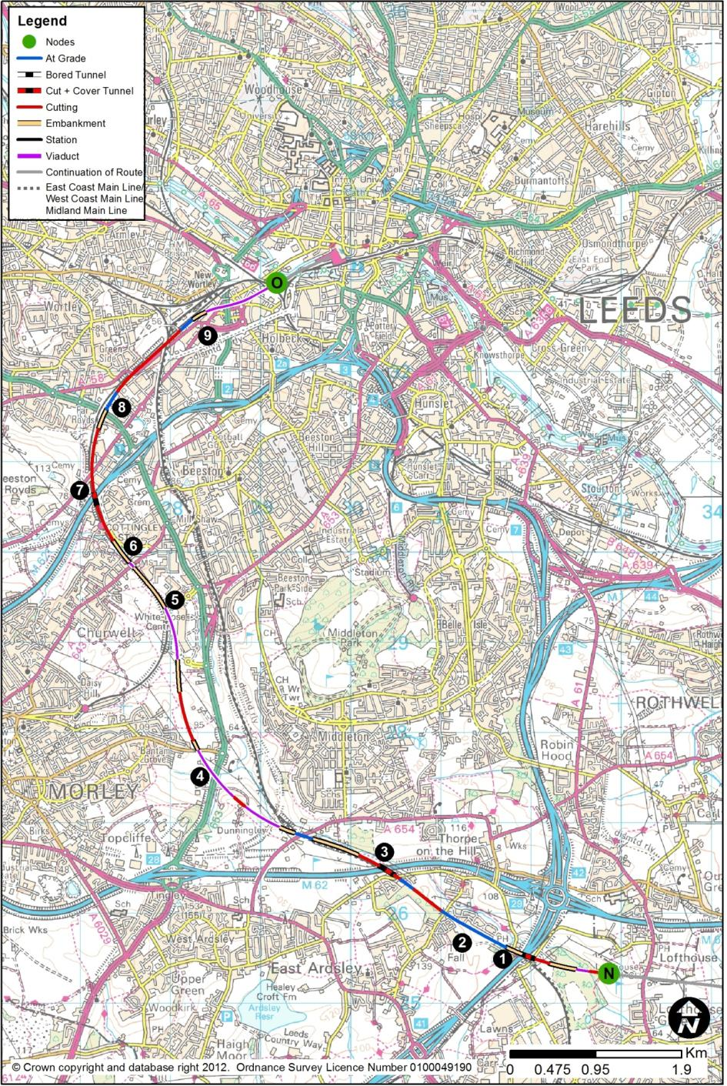
  - HSL20: Lofthouse (N) to Holbeck (O)
        - The route section between Lofthouse and Holbeck would be 11.8km long. The section of route connecting to Lofthouse from the south would be HSL19 from Cold Hiendley. At Holbeck, the route would continue north along to Leeds Station North la (HSL30). This station is described in Chapter 3.6.
        - The route would pass under M1 (1) in a box structure. The high speed lines would then occupy the formation of the existing Doncaster to Leeds line (2), which would be diverted southwards over a length of 1.7km prior to the high speed line construction. This diversion would not reduce its current line speed.
        - The route would pass under M62 (3) in a box structure to incorporate both the high speed route and the Doncaster to Leeds line. North and west of the M62, the Doncaster to Leeds line sinks into a cutting and through Ardsley Tunnel. The high speed route would climb to pass over the Network Rail tunnel at the current ground level before climbing onto embankment and then onto two viaducts. The first 450m long and 10m high, and the second (4) 650m long and up to 30m high, passing over the valley in which the A653 runs.
        - As the viaduct reaches ground level, the route would run on a short (100m) section of embankment before descending into a cutting. The route would generally then follow the valley side a few metres below ground level, however due to the undulating nature of the ground, this would lead to a series of short cutting and embankment sections with cut depths up to 4m and embankment heights up to 11m.
        - As the route approaches the Leeds to Huddersfield line it would swing north slightly before joining the existing Network Rail alignment. At this point, the line speed would reduce to 160kph to follow the existing line, with a viaduct (5) of 590m length and 10m height over part of the surface car parking at the White Rose Shopping Centre.
        - The route would run parallel to the Leeds to Huddersfield line where it is on embankment and where it passes over the A643 Elland Road (6) on a stone, arched viaduct. The high speed route would cross this valley on a parallel viaduct 80m long and 15m high, and descend into an 8m deep cutting alongside the Network Rail tracks past Cottingley Station.
        - Moving northwards the high speed route would pass in a box structure under the M621 (7). Running towards Leeds station, the high speed tracks would run parallel to the Network Rail lines. Between the M621 crossing and the point where the high speed tracks diverge (8) from the Network Rail tracks for their final approach to Leeds station, the high speed track would utilise former railway land.
        - About 1km from the ends of the platforms, the high speed route would diverge from the Network Rail tracks, which at this point are built on embankment around 5m above surrounding ground level. It would use a 1.1km long viaduct (9) of 10m to 15m height over a number of arterial roads and industrial premises to eventually cross over the western approach tracks to Leeds station before descending around 3m towards the station.
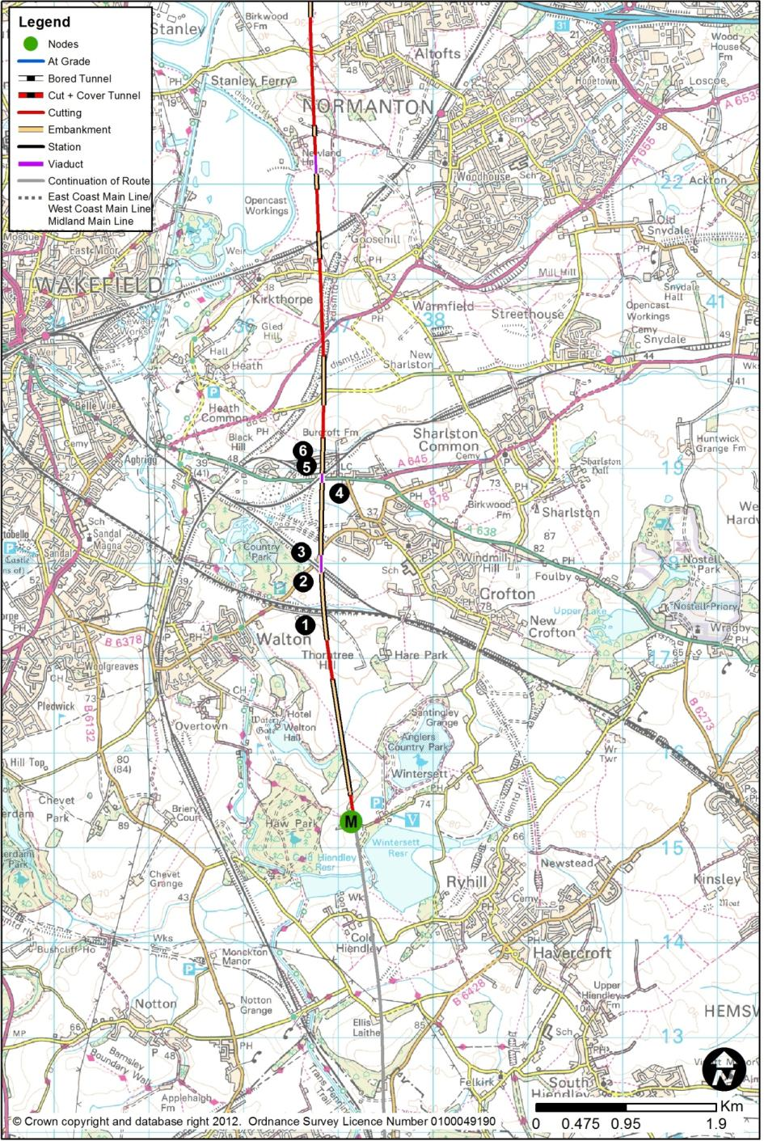
  - HSL21: Cold Hiendley (M) to Woodlesford (Q)
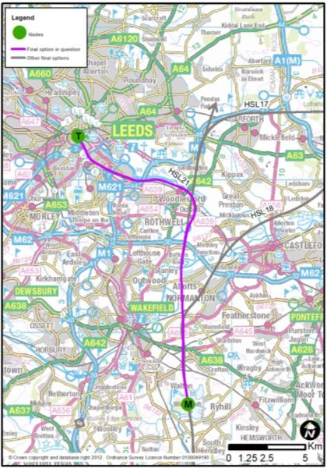
        - The route section between Cold Hiendley and Woodlesford would be 17.4km long. The section of route connecting to Cold Hiendley from the south would be HSL16 from Blackburn. At Woodlesford, the route would continue north along either HSL22 to Hunslet and a new station in central Leeds (New Lane 13f – HSL31), or along HSL23 and a new station in central Leeds (Sovereign Street South 13e – HSL32). These stations are described in Chapters 3.8 and 3.7, respectively.
        - This section of route would contain the proposed Rolling Stock Maintenance Depot at New Crofton, which is described in Chapter 4.2.
        - This route could be combined with a spur to the ECML via Garforth (HSL17) or Castleford (HSL18) as shown on the right.

Cold Hiendley to Kirkthorpe
        - North from Wintersett Reservoir, the route would be identical to that described in HSL17, between Walton Hall and the Bombardier Train Maintenance Facility (6).

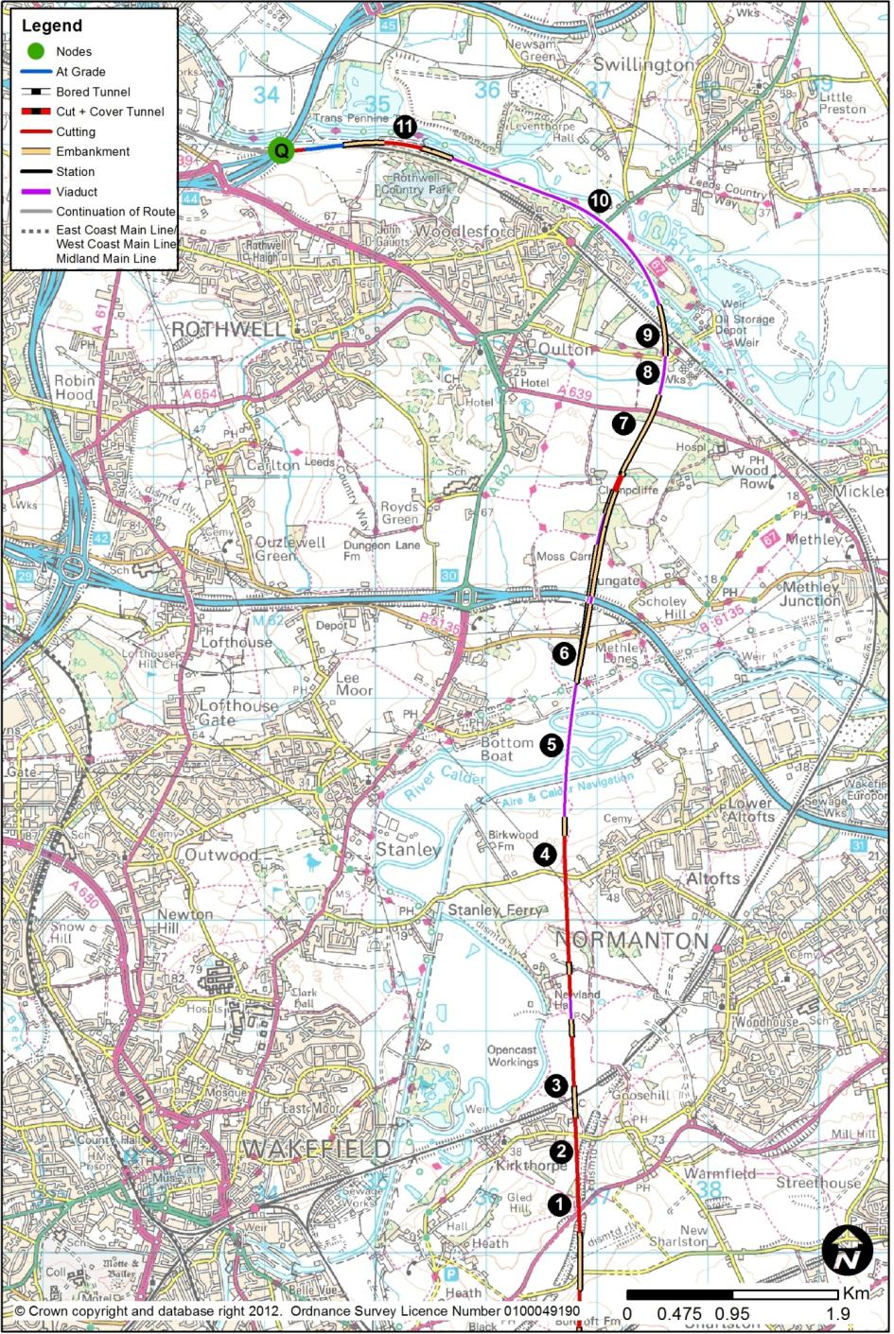

Kirkthorpe to Woodlesford
        - The route would enter cutting, up to 11m deep, west of Burcroft Farm, before running on a shallow embankment 4m high, then into cutting to pass below the A655 (1), which would be realigned to pass over the route. It would then pass under Kirkthorpe Lane (2) in a 4m cutting, so the road would be raised by about 4m on its existing alignment.
        - To the north-east of Kirkthorpe, the route would pass onto an embankment 8m high, bridging the Wakefield to Normanton railway line (3), which would be unaffected. After a short cutting up to 11m deep, the route would gradually descend into the valley of the River Calder, in a cutting typically 19m deep to pass under Birkwood Road (4), which would remain. The route would lie at the south-western edge of Altofts.
        - After emerging from cutting just north of Top Farm, the route would use a 1.2km viaduct (5), up to 19m high, to pass over the Aire and Calder Navigation, and multiple crossings of the River Calder and its flood plain.
        - The line speed would reduce to 230kph, and the route would use a 300m viaduct, up to 8m high, to carry the northbound spur over the main line to the north, as both northbound and southbound links run north-east to run on the eastern side of the main line. Extensive use would be made of retaining walls between the Leeds spurs and the main line in order to minimise the footprint of the junction.
        - The route would descend into the valley of the River Aire, on an embankment up to 15m high, taking the route over Newmarket Lane (6), which would be horizontally realigned.
        - Continuing on embankment up to 15m high, the route would bridge over the M62 and climb with the rising ground to a short length of shallow cutting at the crest before descending on embankment up to 13m high with a bridge to pass over A639 Methley Lane (7).
        - The route would then use a 350m viaduct, up to 16m high, to pass over Oulton Beck and its flood plain, and Fleet Lane (8), which would remain. After an embankment of 11m height, the line speed would fall further to 180kph, and the route would use a 60m viaduct (9) to cross the existing Leeds to Normanton railway. There would then be another viaduct (10), 2.4km long and up to 9m high, to take the Leeds spurs over the Aire and Calder Navigation, the Aire flood plain, and the A642 Aberford Road, north-east of Woodlesford.
        - The route would then run in a narrow neck of land (11) between the Aire and Calder Navigation, with a 280m long retaining wall to separate the route from the Canal. Throughout the whole of this length north-east of Woodlesford, the route would be running linearly along water bodies, with restricted working space, and with difficult construction access.

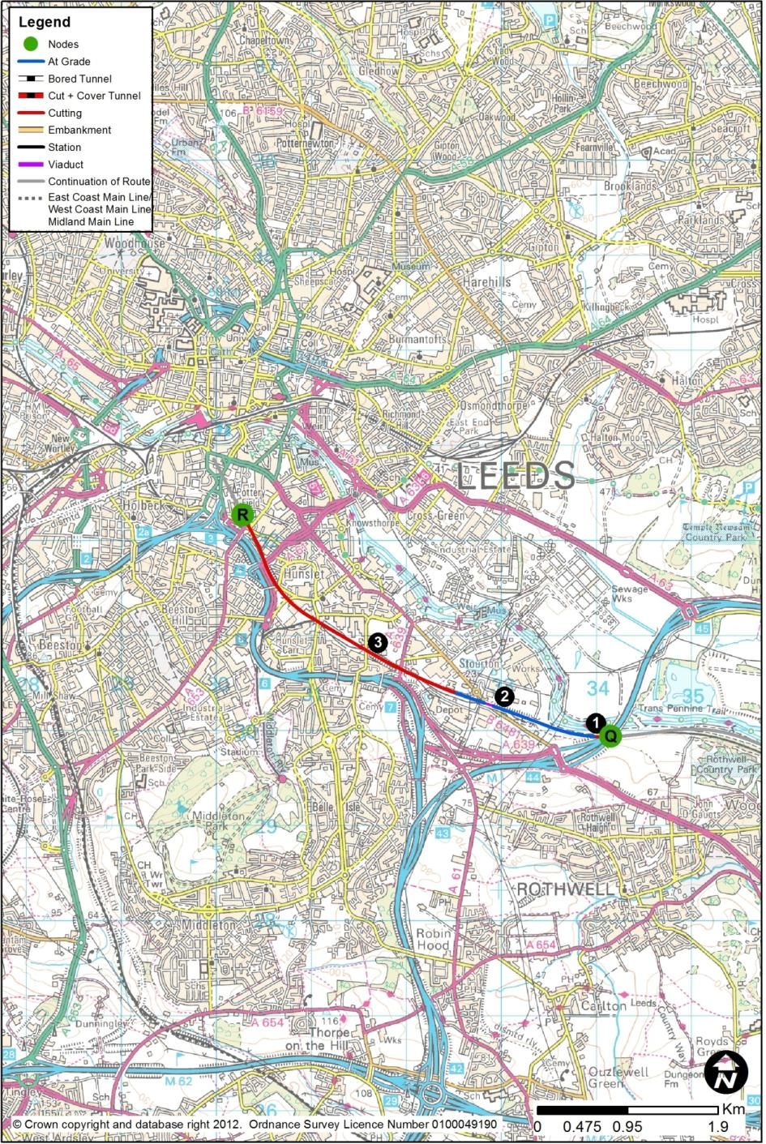
  - HSL22: Woodlesford (Q) to Hunslet 1 (R)
        - This route section between Woodlesford and Hunslet would be 4.7km long. The section of route connecting to Woodlesford in the south would be HSL21 from Cold Hiendley. At Hunslet, the route would continue north along HSL22 to Leeds New Lane station (HSL31). This station is described in Chapter 3.7.
        - The high speed tracks would pass under the M1 (1) on the formation of, and using the existing bridge span through it passes, the current Leeds to Woodlesford railway line. The Network Rail tracks would be diverted, over a total length of 2.1km, around 60m south, through a new box structure under the M1.
        - Immediately west of the M1 crossing, the high speed tracks would move northwards (2) and leave the Network Rail formation allowing the Network Rail tracks to return to their current alignment. This would allow the eastern approach to Stourton Freightliner Terminal to be preserved.
        - For the remainder of the route into Leeds, the high speed tracks would run parallel with the Network Rail tracks on their northern side (3). It would not be possible to run at exactly the same elevation due to the additional headroom required for the new rolling stock, and electrification, leading to a level difference of up to 4m. The A639 (Wakefield Road), Pepper Road, Balm Road, Beza Street, Hillidge Road and the slip roads from the M621 to the A61 would be temporarily closed during construction, but rebuilt on their current alignment with new bridges to span both the Network Rail and high speed tracks.
        - With the high speed tracks on the north side of the existing rail corridor, rail access to the two or three existing sidings and rail facilities on the northern side of this corridor would be severed.
        - As the tracks approach the station, they would diverge from the Network Rail corridor, approximately following the former rail approach to Hunslet Goods Yard, and would climb up to the station throat, at a line speed of 80kph to avoid conflict with the existing Network Rail lines.

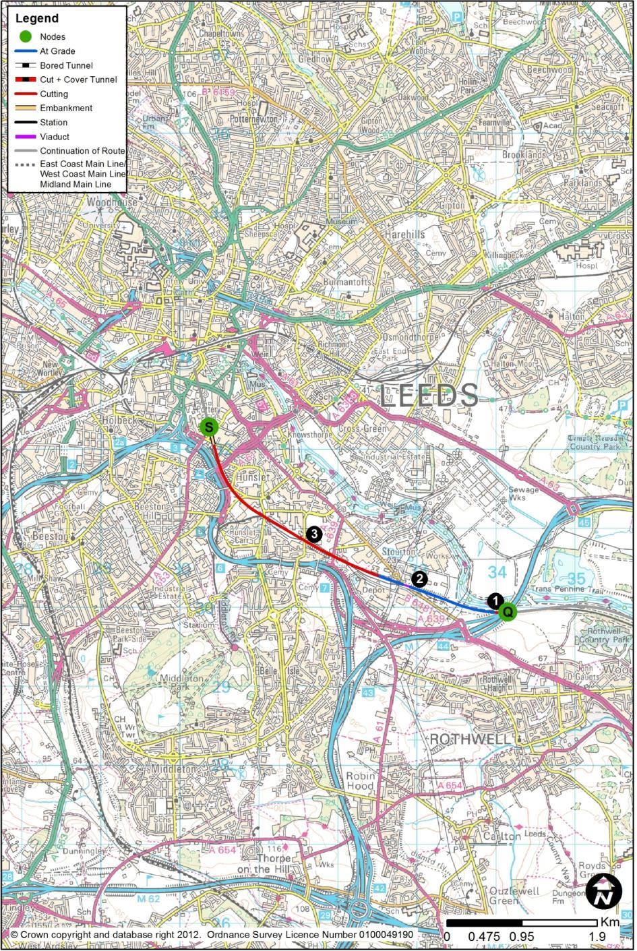
  - HSL23: Woodlesford (Q) to Hunslet 2 (S)
        - This route section between Woodlesford and Hunslet would be 4.7km long. The section of route connecting to Woodlesford in the south would be HSL21 from Cold Hiendley. At Hunslet, the route would continue north along HSL23 to Leeds Sovereign Street South station (HSL32). This section is described in Chapter 3.8. This route differs from HSL22 only over the last 300m.
        - The high speed tracks would pass under the M1 (1) on the formation of, and using the existing bridge span through which it passes, the current Leeds to Woodlesford railway line. The Network Rail tracks would be diverted, over a total length of 2.1km, around 60m south, through a new box structure under the M1.
        - Immediately west of the M1 crossing, the high speed tracks would move northwards (2) and leave the Network Rail formation allowing the Network Rail tracks to return to their current alignment. This would allow the eastern approach to Stourton Freightliner Terminal to be preserved.
        - For the remainder of the route into Leeds, the high speed tracks would run parallel with the Network Rail tracks on their northern side (3). It would not be possible to run at exactly the same elevation due to the additional headroom required for the new rolling stock, and electrification, leading to a level difference of up to 4m. The A639 (Wakefield Road), Pepper Road, Balm Road, Beza Street, Hillidge Road and the slip roads from the M621 to the A61 would be temporarily closed during construction, but rebuilt on their current alignment with new bridges to span both the Network Rail and high speed tracks.
        - With the high speed tracks on the north side of the existing rail corridor, rail access to the two or three existing sidings and rail facilities on the northern side of this corridor would be severed.
        - As the tracks approach the station, they would diverge from the Network Rail corridor, approximately following the former rail approach to Hunslet Goods Yard, and would climb up to the station throat, maintaining their line speed of 110kph.

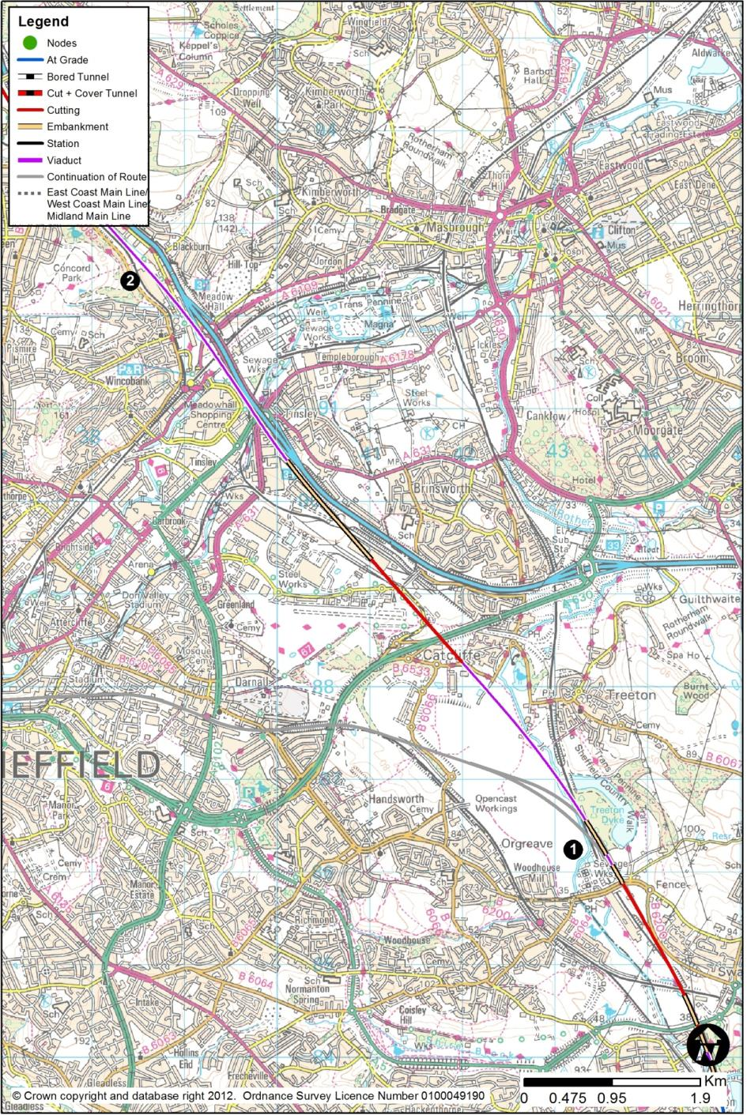
  - HSL24: Killamarsh (F) to Cold Hiendley (M) – Main Line via Tinsley with Victoria Loop Option
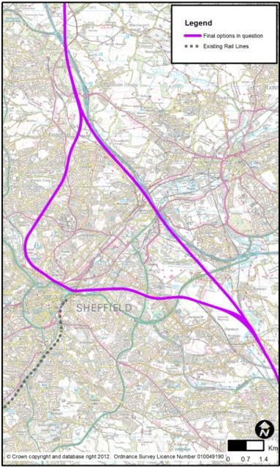
        - This route section between Killamarsh and Cold Hiendley would be 38.8km long. The section of route connecting to Killamarsh in the south would be HSL05 or HSL13. North of Cold Hiendley, the layout would be designed as a main line to the North, with a spur to York and the ECML, and a spur to Leeds.
        - Over this length of route from F to M, there are two route options, one with a station at Meadowhall; this has already been described as HSL14, HSL15 and HSL16. The route described in this chapter would not include a station at Meadowhall, but there would still be a main line from Killamarsh to Cold Hiendley, but on a marginally different alignment in the Meadowhall area arising from the deletion of the station. This main line (HSL24) would be supplemented by a loop via Sheffield Victoria, with a station there, as described in HSL29. This option is shown on the right.

Killmarsh to Catcliffe
        - From Killamarsh to Catcliffe, the route would be identical to that described in HSL14.
        - At Swallownest, just north of the B6200 Retford Road near Woodhouse Mill, (1), there would be a grade-separated junction at which the loop through Sheffield Victoria would leave the main through route.
        - From Catcliffe to Blackburn, the route would run alongside the M1 on a viaduct (2) of length 4.2km up to 22m high across the Don Valley, this being at a very comparable height to the M1 as it runs across its Tinsley viaduct. The new viaduct for the high speed line would run between 20m and 90m to the south-west of the existing M1 viaduct, crossing a series of obstacles: M1 Junction 34’s southern and northern roundabouts; the River Don; the South Yorkshire Supertram; Alsing Road; Sheffield to Rotherham railway; and Blackburn Road.

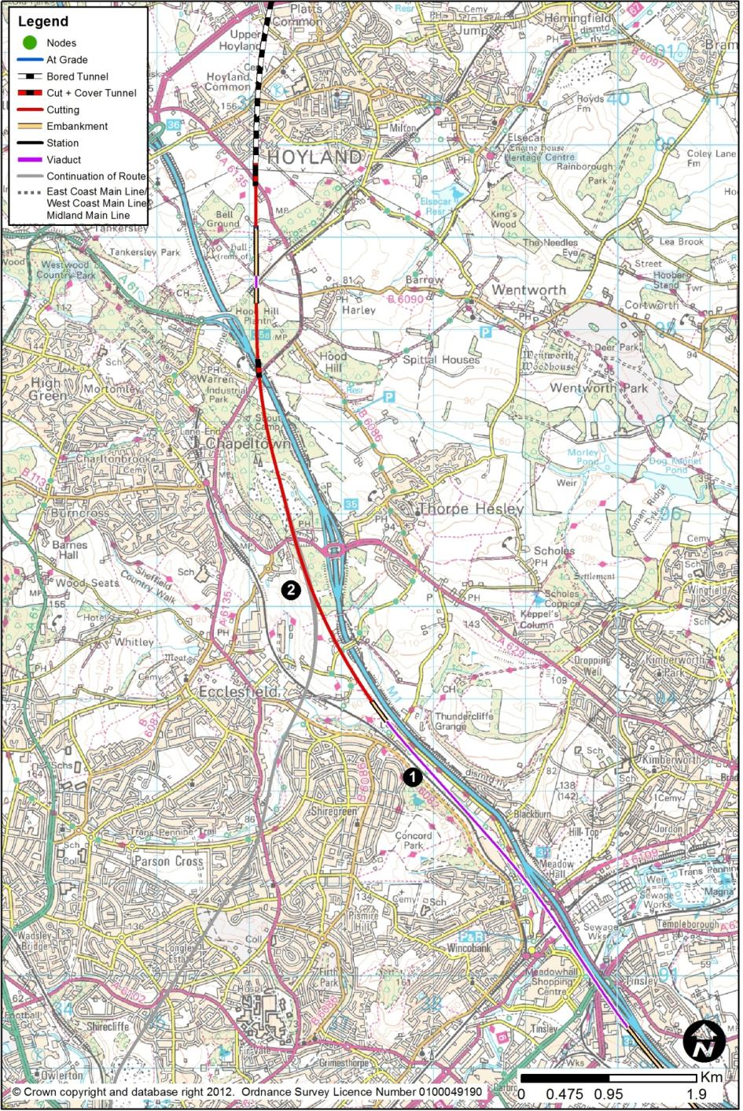

Catcliffe to Cold Hiendley
        - The route would run along the alignment of the abandoned railway from Blackburn Junction to Wakefield (1) parallel to the existing Sheffield to Barnsley railway and B6082 Ecclesfield Road.
        - From Blackburn to Chapeltown, the route would be identical to HSL16.
        - Near Chapeltown, there would be a marginal difference to include a short length of straight near Smithy Wood (2) (west of Junction 35 of the M1) to accommodate the northern grade-separated junction of the Sheffield Victoria Loop.
        - Between Chapeltown and Cold Hiendley, the route would be identical to HSL16.
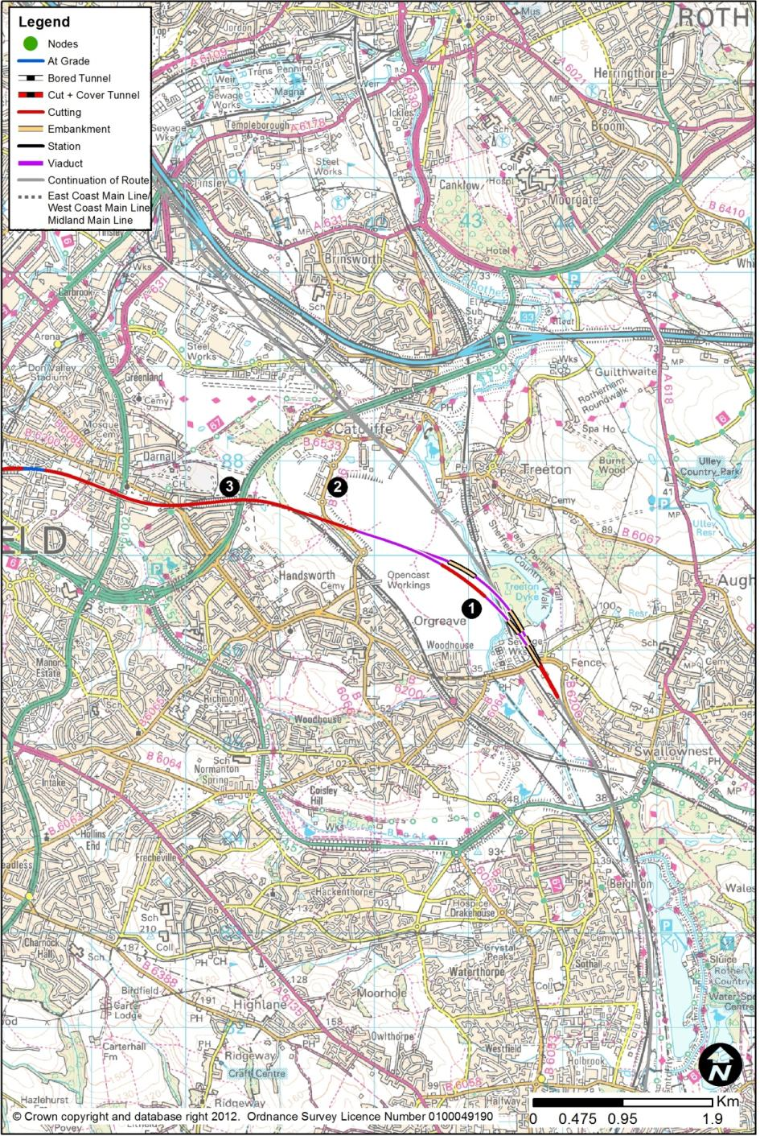
  - HSL29: Sheffield Victoria Loop (F to M)
        - The route section would contain the proposed Sheffield Victoria station and would be 18.5km long. It would connect into HSL24, the Victoria Loop through route, at both the northern and southern end of the loop.
        - In this route option, there would be a loop via Sheffield Victoria, and a station there. There would still be a main line running between Tinsley and Blackburn via Meadowhall, but with no station at Meadowhall, and adopting a marginally different alignment to that with a station, as described in Chapter 2.26 above.

Swallownest to Darnall
        - The loop via Sheffield Victoria would leave the north-south main line through Meadowhall at Swallownest, just north of the B6200 Retford Road near Woodhouse Mill, with the road raised above the route. At this location, the main line and the loop would be at ground level. The line speed would be 230kph.
        - The northbound loop (1) would use a 350m viaduct, up to 13m high, to cross the Chesterfield to Rotherham railway, and the River Rother and its flood plain. The southbound link (1) would use a viaduct of a length of 500m up to 18m high, to cross the HS2 main line, the Chesterfield to Rotherham railway, and the River Rother and its flood plain.
        - The northbound and southbound links would converge to form a more conventional 2-track route heading north-westwards between Catcliffe and Handsworth, on separate, and then combined viaducts, of overall length 1.0km. This section would pass through the Waverley Major Development site on the former Orgreave Colliery.
        - The route would return to the ground level (2) at B6066 Highfield Spring which would be raised to pass over the route. The route would then run in shallow cutting of 2m depth, converging on the Sheffield to Worksop railway, before the cutting would deepen to take the route under the A630 Sheffield Parkway (3), whose bridge over the existing line would have to be widened and raised by about 2m to clear the proposed and existing railways. At this point, the line speed would reduce to 165kph.

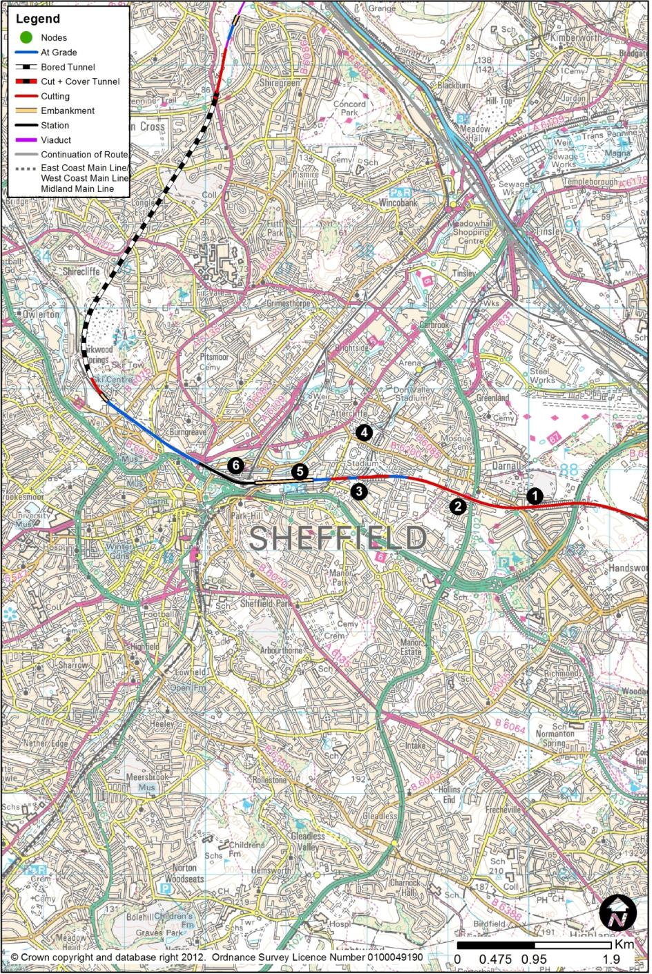

Darnall to Central Sheffield
        - West of the A630 and for the next 3.0km, the route would run parallel to and north of the existing Sheffield to Worksop line (1), at its existing level. In order to accommodate the increased width in the corridor, and to accommodate the increased height of the new trains, there would be extensive linear works along the route through Handsworth and Darnall.
        - The existing Network Rail tracks would be slewed over a distance of about 2.5km to the southerly side of the corridor, while the new high speed tracks would lie to the northerly side. All existing bridges over the railway would be widened and raised, and there would be 2.5km of retaining wall on the northerly side to minimise the effects on property. All bridges carrying the railway over roads, footpaths and flood plains would be widened, or demolished and replaced; though this cannot be stated with certainty at this time. Darnall Station (2) would be demolished and rebuilt to suit the more southerly alignment of the Network Rail tracks. All Network Rail assets on this corridor would be affected, and the signalling would need immunisation against the effects of the Overhead Line Equipment provided for the new high speed tracks.
        - At Woodburn Junction (3), the single-track Network Rail route approaches from Tinsley and the north. This line would have to be lowered in order to pass below the high speed route in a retained cutting, and the B6200 bridge (4) would have to be replaced as its foundations may be affected. The Tinsley line would then rise between the high speed route and the Sheffield to Worksop line, being contained between retaining walls (5) as it would regain the surface level, at which point it would form a junction with the Worksop route. The Worksop route would then peel off southwards, as now, towards Nunnery and Sheffield Midland, but there would be a junction to allow trains to continue on the single-track route towards Stocksbridge. At this point, the line speed would reduce to 75kph.
        - The route would approach the Sheffield Victoria station site (6), which would have 4 platform lines, the southernmost one of which would be shared with the Stocksbridge freight-only line, which currently runs east-west through the site of the former Victoria station.
        - Sheffield Victoria station is described in Chapter 3.5.

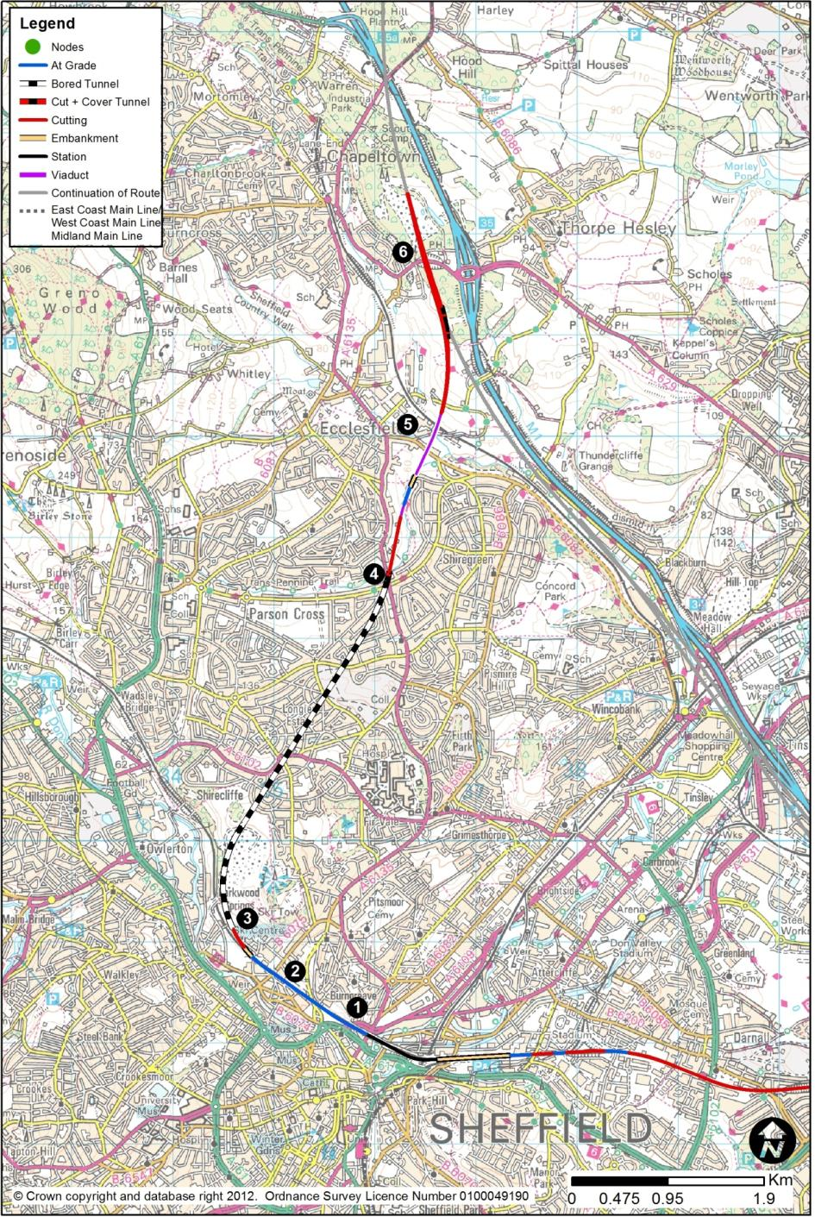

Central Sheffield to Chapeltown
        - West of Sheffield Victoria, the new route and the existing Stocksbridge line would be carried over the Wicker Arch, on a new viaduct superimposed over it. The new track level would be about 5m above the Arch, but the structural depth of the viaduct would leave a marginal gap between the underside of the structure and the top of the arch. The line speed would rise to 140kph.
        - The Stocksbridge line would be realigned to the south, while the high speed route would lie on the northerly side of the corridor (1), with property effects minimised by a 1.1km north side retaining wall between Pitsmoor Road and Douglas Road (2). The route would then turn north at Parkwood Springs, after Wallace Road, which would be realigned. The line speed would rise to 210kph, and the route would enter Sheffield North Tunnel.
        - The tunnel would be 3.9km in length, and would consist of twin-bore, single track TBM tunnels, with one bore for northbound trains, and a parallel bore for southbound trains. The south portal (3) would be situated in a complex sequence of landfills, both active and historic, with the potential for old coal workings. The geology of the area is complex, with a number of faults. Groundwater is likely to be high and contaminated from overlying landfill, adjacent works and former mining operations.
        - The north portal (4) would be on A6135 Highgreave Road, just north of its junction with Deerlands Avenue and Hartley Brook Road, and adjacent to the flood plain of the Sheffield Lane Dike. There would be a 100m length of cut and cover tunnel immediately to the north, on which Highgreave Road would be reinstated after temporary closure. In order to create the clearance near the tunnel portal, the Sheffield Lane Dike would need to be lowered by about 3m, and it would be re-graded as it flows north.
        - The route would then descend into a cutting up to 6m deep on the westerly side of the valley slope to the watercourse, running through rear gardens of property in the Cross Hill area. Because of the terrain, the cutting slopes would be much more extensive to the west rather than towards the valley floor to the east. There would then be a 110m viaduct, up to 9m high, to allow the route to cross the valley floor to the eastern side, and then there would be a 330m length retaining wall on the western side to minimise the impact on the flood plain.
        - The route would then use a 660m viaduct (5), up to 18m high to cross the B6082, the Sheffield to Barnsley railway, and Butterthwaite Lane, before returning to ground level at Loicher Lane, which would have to be realigned.
        - The route would enter a cutting up to 21m deep in the rising ground towards Smithy Wood. The line speed would rise to 230kph, and the northbound link would then merge into the main alignment from Meadowhall at the A629 (6), under which the route would pass. The southbound link would diverge from the main line about 500m north of Cowley Hill, and would descend into a cutting of typically 20m depth to pass under the main line. At the crossing point, there would be a 330m long box structure, formed in the cutting, and with the main line on its lid. South of the crossing, a 320m retaining wall would separate the southbound link from the northbound link.

- Stations
  - Overview of Final Options
        - At the beginning of the design process for the Birmingham-Leeds route, the remit was to locate stations in or around the East Midlands, South Yorkshire, and Leeds, and potential options for station locations were identified in each of these three areas.
        - A list of station location options was drawn up and developed through a staged sifting process, leading to a final list of options for each region. The final options are described in this chapter. Chapters 8, 9, and 10 of this report set out the full lists of options considered.
    - East Midlands
        - In the East Midlands, two options are presented. One option would be in central Derby, with, of necessity, the route passing through the city parallel to existing rail routes. The other option, at Toton Yard, would be better located to serve the wider East Midlands region, using the new station as a highly-accessible transport interchange. Journey times would be comparable for both options.
    - South Yorkshire
        - There are also two options in South Yorkshire. One option, Sheffield Victoria, would provide a city centre location, served by a loop at reduced speed off a main line which runs through Tinsley. The other option would place a station at Meadowhall on the main line, located so as to provide interchange for access to and from South Yorkshire as a whole (e.g. Rotherham, Doncaster, and Barnsley), with lower journey times to the north.
    - Leeds
        - There are three options at Leeds (Leeds Station North, Leeds Sovereign Street South and Leeds New Lane) and all of them are centrally located. The key differentiators are proximity to the existing station, ease of interchange, and access to the city centre (for these factors, the option at Leeds Station North is better). The New Lane and Sovereign Street South alternatives are distinguished by shorter journey times and proximity to the potential major development areas on the south bank of the River Aire. These would be located on relatively unconstrained sites, while the site of Leeds Station North is very constrained and more complex in construction terms.

1  2  3  4 | Derby Station
 | River Derwent
 | Etches Park Depot
 | Derby Roundhouse
5 | Railway Terrace
6 | Pride Park
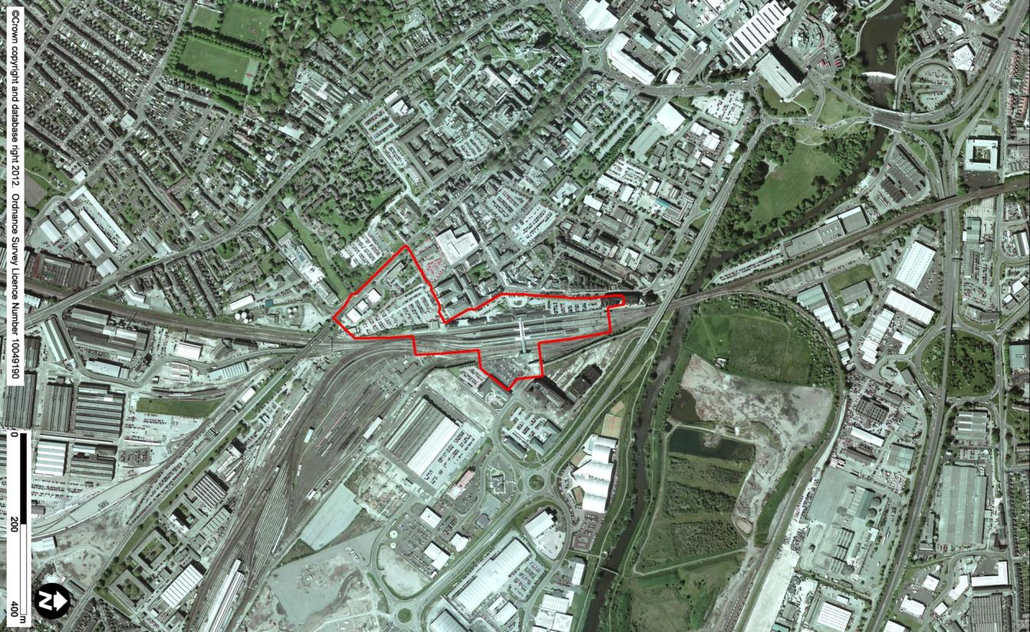
2

6

1

4

5

3

  - Option EMI01 (HSL25) Derby Station
    - Route Overview
        - From Stenson Fields into central Derby, the route would run alongside, and to the west of, the existing Birmingham to Derby line, requiring almost complete re-building of the existing conventional network infrastructure. The route would widen from the normal two-track route to a four-track route on the approach to the station. The proposed route and station would require the total rebuilding of the existing station, with new high speed platforms to the west, and platforms for conventional services to the east. These are described below. North of the station, the route would pass under the bridge carrying the A6 Pride Parkway and then follow the existing Derby to Sheffield railway towards Breadsall, again involving alterations to Network Rail infrastructure. For further details, see Chapter 2.5 (HSL03).
    - Station Location and Existing Site
        - The proposed high speed station would be situated on the site of the existing Derby station, to the southeast of Derby city centre and immediately to the south of the River Derwent.
        - Derby station (also known as Derby Midland station) is surrounded by roads on three sides, Pride Parkway (A6) to the north, Railway Terrace to the west and London Road to the south. Derby College is located on the east side of the station and is partially housed in the restored Grade II* listed Derby Roundhouse.
        - Derby station currently comprises six platform faces (five through and one south-facing bay), together with several through freight tracks on its east side. It is a major node on the railway network and is served by a range of east-west and north-south local and inter-city services, with destinations including Sheffield, Birmingham, Leicester, Nottingham, and London. Etches Park Depot is a train maintenance and stabling facility operated by East Midlands Trains, and is located to the southeast of Derby station.
        - The site has served as a railway station since 1840, and the station has been extended and remodelled multiple times. The final parts of the Victorian station were replaced in the mid-1980s. The platform footbridge was replaced in 2005, and new canopies were constructed between 2007 and 2009. Derby station handled 3.1 million passengers in 2009 / 2010.
        - A vehicular forecourt on Railway Terrace, to the west of the station, provides pick-up and drop-off as well as short-stay car parking, with a surface long-stay car park to the south, off Hulland Street. A smaller forecourt entrance on the east side of the station serves the Pride Park area. The station concourse and ticket offices are at forecourt level on the west side and from here a high level bridge provides access to all platforms.

1 | High Speed Platforms
2 | Relocated Platforms
3 | Concourse
4 | Forecourt
5 | Car Park
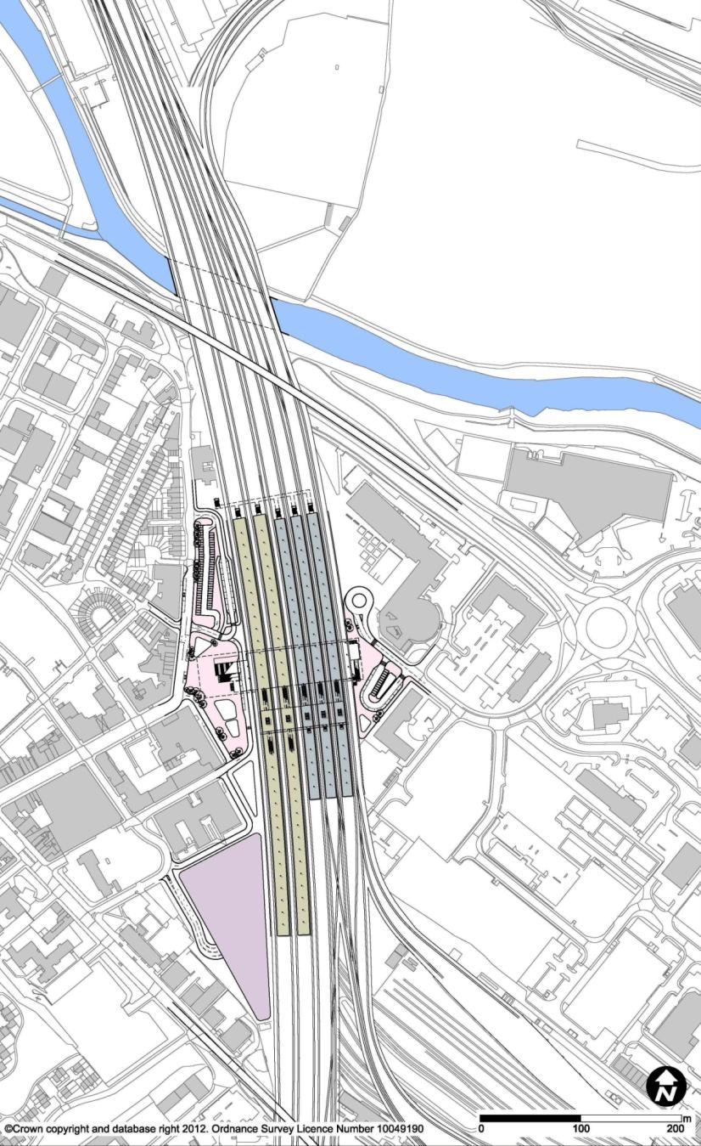
4

2

1

5

3

    - Station Description – Proposed Station

Platforms
        - The proposed station would have 10 platform faces: four for the high speed services based on two centrally-loaded islands, and six for the conventional network based on three centrally-loaded islands. Together they would be integrated to provide direct interchange between high speed and conventional rail services. There would be not be separate high speed through lines, as line speeds would be sufficiently low that through trains could pass the platform faces.
        - The high speed platforms would be 415m long and 12m wide. They would be at the same level as the existing platforms, and located on the west side of the station to avoid conflict with Derby South Junction. The conventional network island platforms would be relocated to the immediate east of the high speed platforms. On this side there would be adequate space to reconstruct the displaced platforms, though there would be a reduction in the number of sidings.

Concourse
        - The existing station concourse and forecourt layout would be completely reconfigured to provide the additional capacity required for high speed rail. An entrance foyer at street level would lead to a new central concourse bridge which would replace the existing platform access bridge, and provide access to all high speed and conventional network platforms. It would also provide a pedestrian link between the Derby city centre and Pride Park sides of the station.
        - The concourse, including all station facilities (ticket office, back of house, gates, etc.), would be located above the platforms on the concourse bridge. This arrangement would free up as much space as possible on the primary forecourt for pedestrian and vehicular circulation. Passengers would pass through a gateline located to one side of the new concourse bridge to reach a second bridge, from which escalators and lifts would provide access to the platforms.

Forecourt / Car Park
        - The station would have two forecourts. The primary forecourt would be a pedestrian zone located on the west side of the station. A secondary forecourt would be located on the east side, next to Derby College. The forecourts would accommodate the drop-off zones and short stay parking with further, long-stay parking provided on the site of the current long-stay car park at the southern end of the station.

1 | High Speed Platforms
2 | Relocated Platforms
3 | Concourse
4 | Forecourt
5 | Car Park
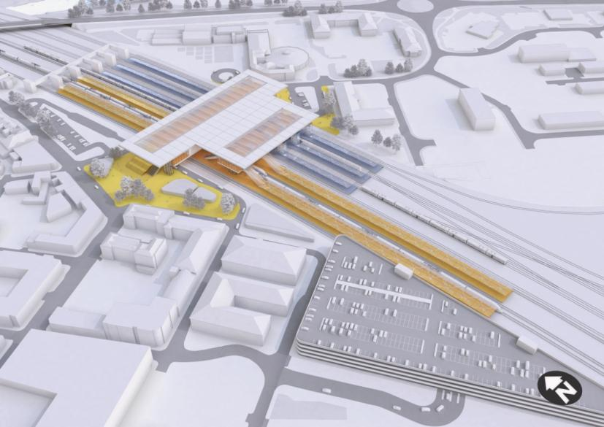
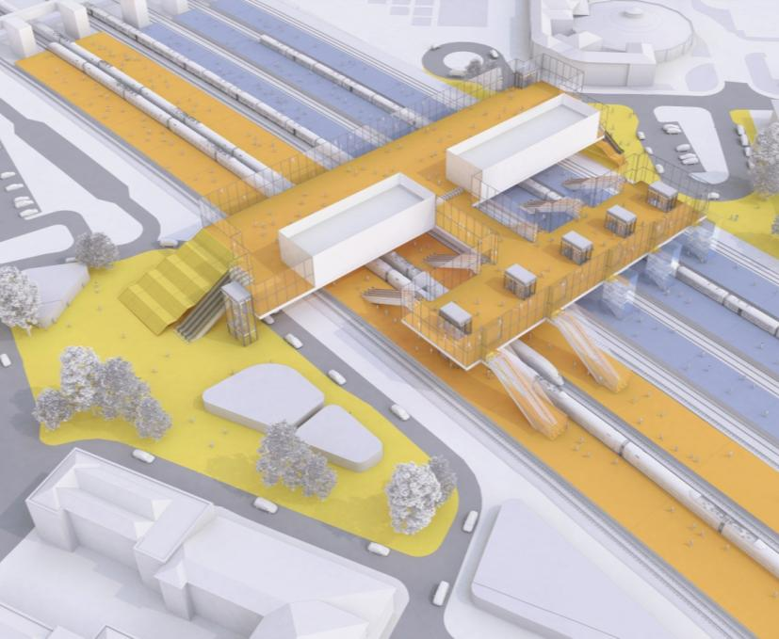
4

4

4

3

2

1

5

3

1

2

        - The concourse bridge linking the two sides of the station would improve on the situation at the existing Derby station, where the current public pedestrian routes across the railway are limited to the underpass at the north end.
    - Accessibility
        - Vehicle access to the station would be from Railway Terrace on the west and Roundhouse Road on the east. Railway Terrace and the west concourse would connect to the city centre and the city’s northern, western, and southern suburbs, via London Road and Station Approach / Pride Parkway. The east concourse would serve Pride Park, Derby’s eastern suburbs, and traffic from the A52.
        - The streets which provide the most direct connection between the station and the city centre are currently low-density and suburban in character. Existing pedestrian routes to the city centre follow these streets, and the city council is working to improve them.
        - The arrangement of the primary forecourt would retain access to the Midland Hotel on the southwest side of the forecourt. Other local highways impacts would be minimised.
    - Intermodal Interchange
        - As outlined above, the proposed station layout would facilitate efficient interchange between high speed and conventional network platforms, giving opportunities for passengers to reach destinations across the wider East Midlands region.
        - The site would have good road connections to Pride Parkway (A6) and London Road (A5194), and onward to Derby’s inner ring road and the A52.
        - Good bus connectivity to central Derby and its southeastern suburbs would be available directly outside the station, with bus bays located adjacent to the station entrance by Railway Terrace. Provision for a bus bay could also be made on the east (Pride Park) side.
        - The new primary forecourt would include taxi pick-up and drop-off spaces for taxis and cars. The secondary forecourt would also incorporate drop-off and pick-up spaces.
        - Short-term parking for private cars would be located next to the station on the primary forecourt, with a multi-storey car park for long-term parking on the site of the existing station car park to the southwest of the station.

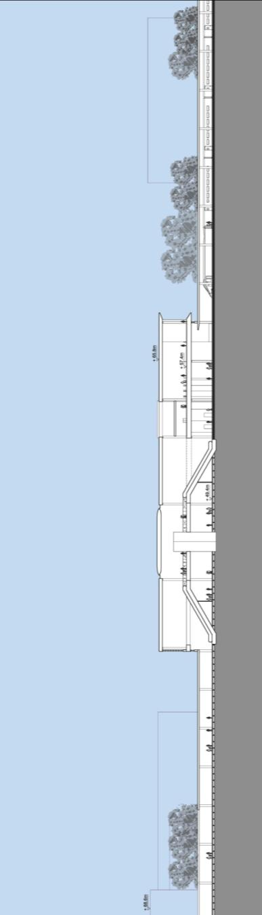
Cross-section looking south
Long section looking west
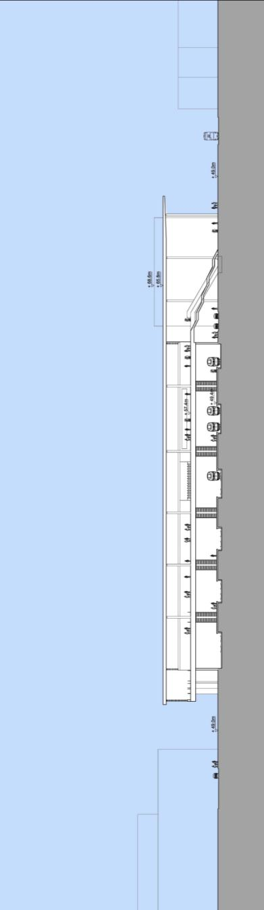
Concourse
High Speed Platform
East Forecourt
Main Forecourt
Concourse
High Speed Platform
    - Site Constraints
        - Constraints at Derby include:
- the location of the high speed tracks and platforms to optimise new arrangements for existing rail services, especially in relation to Derby South Junction;
- maintaining the operation of existing rail corridors to both the north and the south of the station site during construction;
- providing a reasonable design speed for high speed trains while following the existing curved rail corridor through the city;
- balancing improved freeboard for extreme flood levels with the vertical rail alignment at the new bridge over the River Derwent, north of the station;
- the presence of listed buildings on both sides of the station; and
- close proximity to housing and other properties.
    - Constructability
        - Construction of a high speed station at Derby would involve complete reconstruction of the existing station and existing rail facilities. There would be changes to the freight lines on the east of the present layout, and re-modelling of Derby South and North Junctions. Access to the Etches Park Depot would be maintained throughout the construction process.
        - The new station platforms would be located at ground level, with access from elevated concourse structures spanning across the station. These would likely be constructed in reinforced concrete with intermediate supporting columns on the centre lines of the platforms below.

Phasing
        - A key assumption is that a minimum of four through platform faces on the conventional network would be needed at all times. This assumption, which would need verification, is based on the reduced platform provision used during the reconstruction of the station roofs in 2007-09.
        - Derby station would be reconstructed in two main phases; Phase One would include construction of the new platforms to the east, while Phase Two would involve switching services to these new platforms, with the high speed platforms constructed on the liberated space. A more complex three-phase approach would be required if five platform faces must be maintained during the works.

Phase One
- Reconstruction of Pride Parkway Bridge would be required on a new alignment and to a new level. A temporary bridge may be required, or a temporary closure with alternative routes being kept free of works during this period;
- remove the freight tracks to the east of station and the new Derby College building. Platform 6 may need to be temporarily closed during these works;
- construct the four new eastern-most platform faces (two islands) on the liberated space, along with the elevated concourse, tracks, OLE etc.;
- construct the east section of new rail bridge over the River Derwent – the existing rail bridge would remain operational during these works;
- construct the multi-storey car park – as the car park works would not be on the critical path, there is flexibility in its programme;
- construct a temporary footbridge from the existing northern station car park to the new eastern platforms to maintain passenger access during Phase Two; and
- test, commission and bring into use the four eastern-most new platform faces.

Phase Two
- Rebuild London Road bridge to new alignment and clearances, after re-opening Pride Parkway;
- demolish existing platforms and station buildings;
- complete, commission and bring into use the remaining island platform to provide six platform faces for use by services on the conventional network, which would move the contractors’ boundary fence westwards;
- construct the west section of the new rail bridge over the River Derwent – the existing rail bridge would be demolished as part of these works;
- construct new high speed lines / platforms with concourse link above, forecourt and west entrance structure – open the concourse and entrance, once available, to provide access for passengers using the conventional network;
- install high speed railway systems – lay track, install OLE, signalling etc.; and
- commission and open the high speed platforms.
        - It is not expected that multiple interim track alignments would be required to serve the station during construction, provided that the switch between the existing and the future east platforms on the conventional network were to occur during a Christmas or Easter blockade. Temporary track alignments may be required to maintain the northern entry and exit to Etches park depot and the Bombardier plant.

Access & Site Compounds
        - Construction access could be gained from both sides of the site. A haul road from Derby Cattle Market could provide access to the north of the River Derwent, which could continue south across the river to the station via a Bailey bridge. The station building itself could be accessed from the west of the railway via Railway Terrace and from the east via Roundhouse Road. A haul road could be constructed off Hudson Way to provide road access for the remodelling of Derby South Junction.
        - Construction compounds could be established north of the River Derwent to the east of the proposed bridges, in the existing Derby station car park and at the northeast end of Etches Park Depot.

Programme
        - It is estimated that it would take approximately four and a half years to reconstruct Derby station. The main construction stages are:
- year 1 – enabling works, including site set up, utility diversions and demolitions;
- year 2 to year 3 – Phase One works in order to relocate conventional network platforms; and
- year 3 to year 5 – construct high speed platforms and tracks.
        - The four new platform faces on the conventional network would be operational during year 3, with the full six platform faces on the conventional network available in year 4. The high speed station would be ready for installation of railway systems (track, signalling, OLE etc) during year 4, with the station available for full high speed train operations in year 5.

1 | Toton Yard
2 | Long Eaton
3 | A52 Brian Clough Way
4 | Traction Maintenance Depot
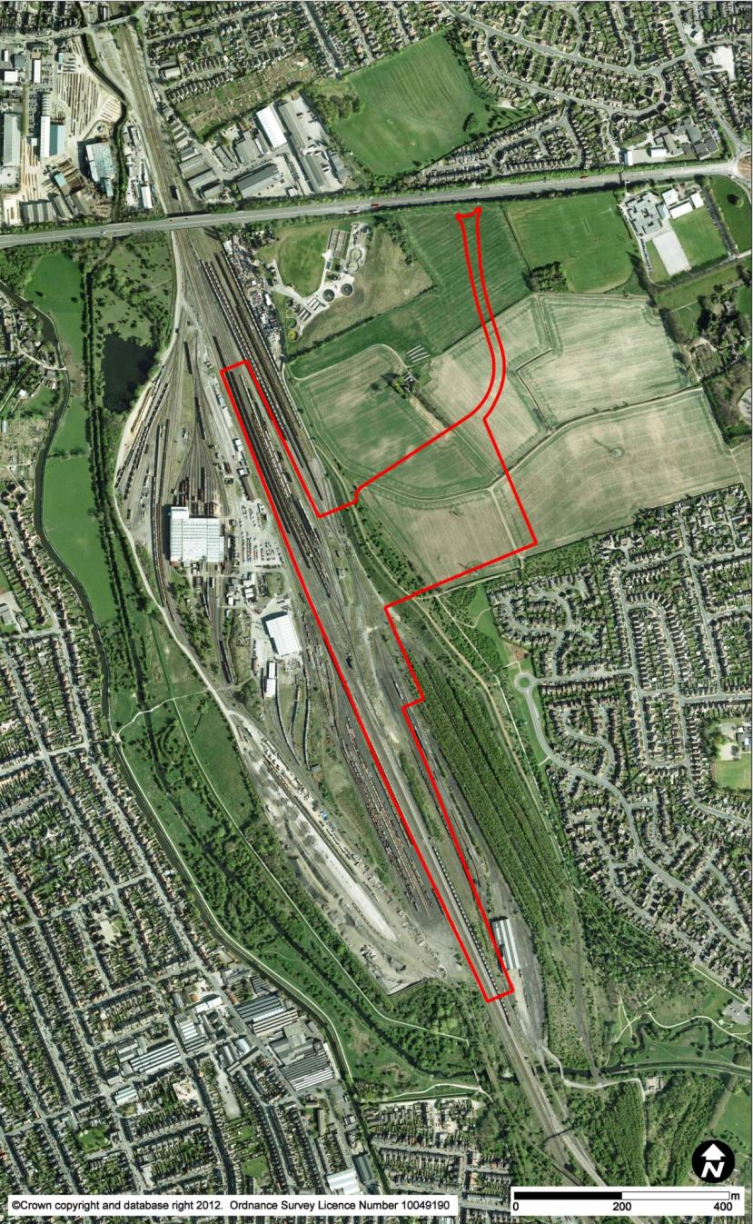
4

3

2

1

  - Option EMI25a (HSL26 & HSL27) Toton
    - Route Overview
        - Through Long Eaton, the new route would approach Toton station along, at the same level as, but replacing, the present low-level 2-track railway that runs north from Trent East Junction. The level crossings at Main Street and Station Road would be closed and new or realigned road links across the high speed line would be provided. Because the new route would take over the position of the low-level lines, the high-level lines would be widened from a two-track to a four-track route between Meadow Lane Junction and the station. This would involve embankment, retaining wall and structural works along a 1.0km length. A new connecting length of route would be necessary in the Meadow Lane area to allow trains from the Derby and Trent direction to access these high-level lines. For further details, see Chapter 2.11 (HSL09)
        - North of the A6005, the alignment would widen from two tracks to four, with the extra tracks forming deceleration lines to, and acceleration lines from, the proposed station.
        - The station is described below, and would involve alterations to Network Rail facilities and the Traction Maintenance Depot in the area; these too are described.
        - North from Toton, the route would reduce from six tracks to four tracks, and would pass under the A52 Brian Clough Way where the existing bridge would be demolished and replaced. At Derby Road, the bridge would be demolished and replaced, with a closure during construction. The railway would then reduce from four tracks to two. For further details, see Chapters 2.12 (HSL10) and 2.14 (HSL12).
    - Station Location and Existing Site
        - Toton would be a new station on the site of the Toton Yard approximately 11km southwest of Nottingham city centre. It would lie to the east of the M1 and north of Long Eaton. It would be 14km east of Derby and 40km north of Leicester.
        - The site is bounded to the north by A52 Brian Clough Way, by the existing rail facilities to the west and south, and by fields and residential development to the east. Toton Yard is extensive in area and is mostly flat, with a sharp rise in level to the east. Much of the site is designated as Green Belt.
        - Large parts of Toton Yard are occupied by sidings, many of which are currently little used, particularly on the east side. The yard also contains the DB Schenker Traction Maintenance Depot and a Network Rail infrastructure maintenance facility. These lie largely to the west of the proposed station and, apart from changes to access routes, these facilities would not be significantly impacted.

2  3  4  5  6  7  8  1 | High Speed Platforms
 | Conventional Platforms
 | Relocated Conventional Lines
 | Concourse
 | Forecourt
 | Car Park
 | Link Road to A52
 | Proposed NET Extension
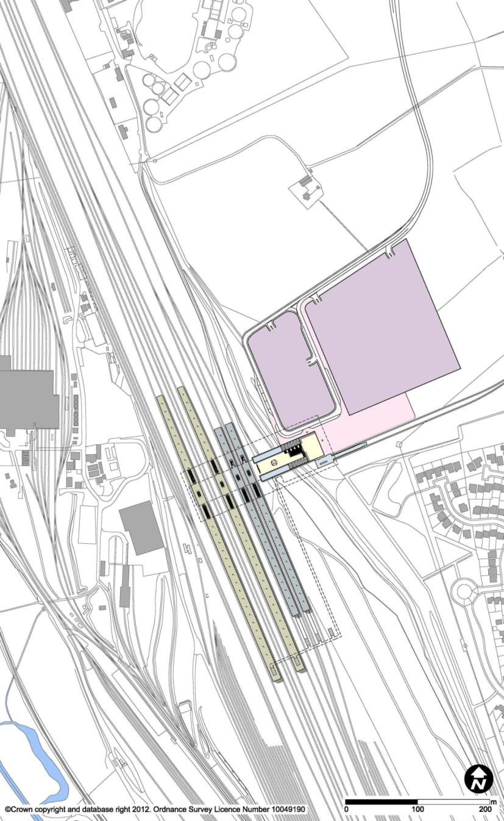
6

1

7

5

8

3

2

4

    - Station Description – Proposed Station

Platforms
        - In total, the station would have eight platforms.
        - For the high speed route, there would be four platforms for stopping services, and two through lines for non-stopping trains. The four platform faces would comprise two island platforms, one for northbound services and one for southbound services. The high speed platforms would be 415m long and 12m wide.
        - For conventional services, the four platform faces would be provided alongside the high speed station, to afford interchange for passengers to reach the wider East Midlands region, including Derby, Nottingham and Leicester via the existing rail network. These platforms would be served from the Trent Junction direction.
        - Reflecting the topography of the site, the station platforms would be located at existing ground level, and the station entrance and forecourt would be located on the higher ground to the east. A concourse connecting the platforms and station entrance would be located at an intermediate level.

Concourse
        - The station concourse would be arranged on two levels, reflecting the topography of the site. The entrance to the station would be at high level, with an entrance to the upper concourse at the same level as the station forecourt located on the hill to the east. From here a stair, escalator bank, and lifts would lead down to the lower concourse. This concourse would extend out over, and provide access to, each platform by two banks of two escalators and two lifts. Escape bridges would be provided at the extreme ends of the platforms to the south.

Forecourt / Car Park
        - The forecourt would be located directly outside the passenger entrance to the upper concourse, on the higher ground above the existing rail maintenance yard, with access from the east.
        - Vehicular access to the station forecourt would provide access for cars, taxis, buses and coaches. In addition, it is proposed that the station would be served by tram by extending the Nottingham Express Transit (NET) to the site, which would be accommodated in the station forecourt.

1 | High Speed Platforms
2 | Conventional Platforms
3 | Relocated Freight Access
4 | Concourse
5 | Forecourt
6 | Car Park
7 | Link Road to A52
8 | Proposed NET Extension
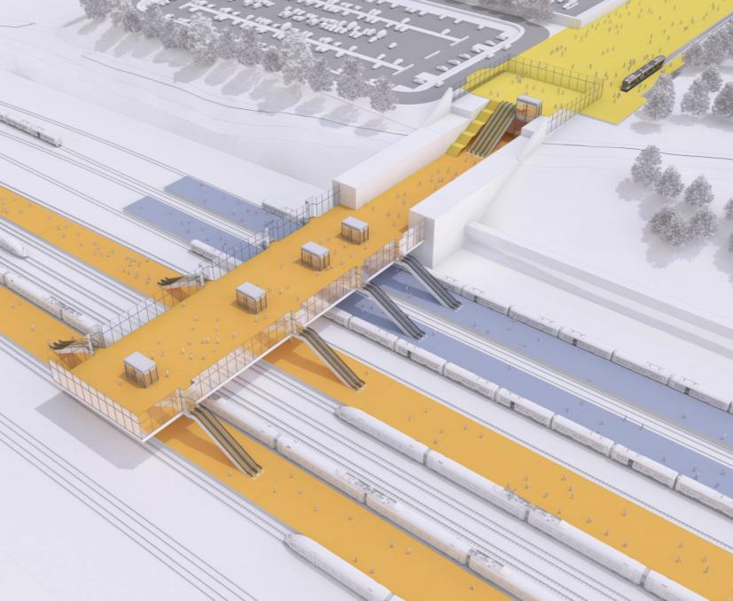
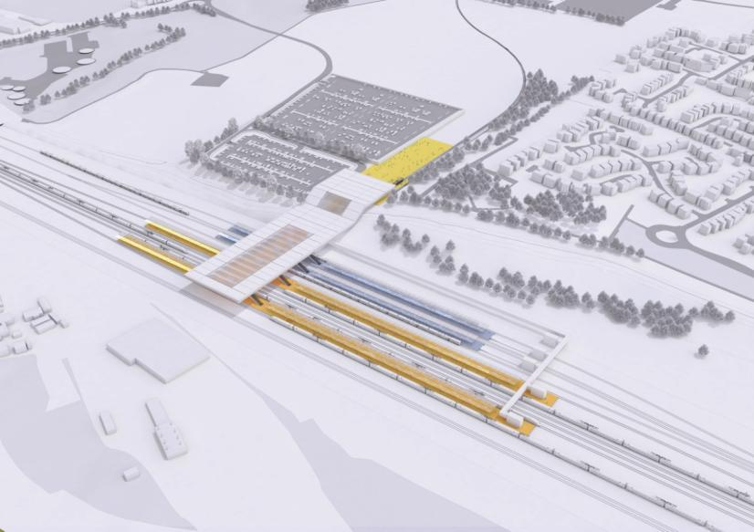
8

7

6

6

5

4

4

3

2

1

1

5

3

2

1

    - Accessibility
        - Vehicular access to the station would be from a new junction on the A52, where a new link road would lead to the station car parks and forecourt. The A52 provides links to Nottingham and Derby, as well as to the M1 Junction 25, which is 1.9km away and would provide highway access to Leicester and the wider East Midlands region.
    - Intermodal Interchange
        - The station would have major road access and car parking provision, but would also be well-connected to public transport.
        - In addition to the high speed platforms, the station would include four platform faces to allow direct passenger interchange to services on the existing rail network. While there are currently no passenger services to the site, this station could be served by services on the conventional network linking to the East Midlands region, including Derby, Nottingham and Leicester.
        - It is proposed that the proposed Nottingham Express Transit Line 3, Phase II scheme would be extended by 1km across Toton Lane to the station site. This would provide a direct interchange between high speed rail, Nottingham city centre, the residential areas of Beeston and Chilwell, the University of Nottingham, and the Queens Medical Centre. The tram stop would be located in the forecourt, connecting directly to the upper concourse.
        - Modifications to the local and regional bus network would be required in order to provide an expanded service to a station at Toton. Bus bays would be incorporated into the station forecourt layout. Pick-up and drop-off bays for taxis and private vehicles would also be located in the forecourt directly outside the station entrance. The site would have ample space for provision of short-term and long-term parking adjacent to the forecourt, either at grade or in a multi-storey configuration.

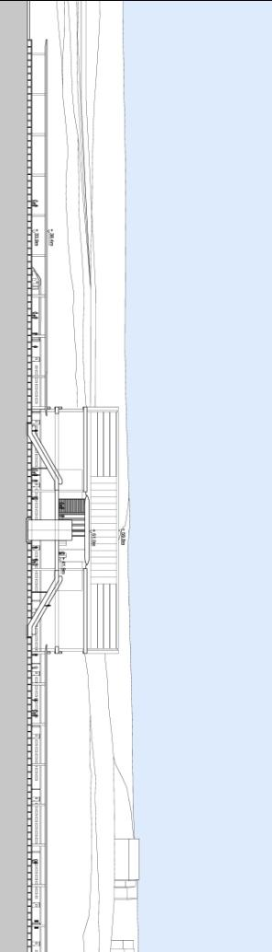
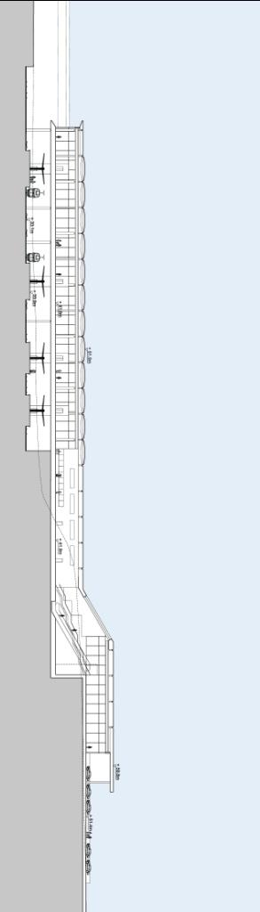
High Speed Platform
Conventional Platforms
Concourse
Forecourt
High Speed Platform
Concourse
Long section looking east
Cross-section looking north
    - Site Constraints
        - Constraints at Toton would include:
- maintaining the operation of existing lines, including the freight and maintenance facilities at Toton Yard;
- providing infrastructure with sufficient capacity to allow new passenger services to operate on the conventional network to access Toton station, while minimising residential demolitions in Long Eaton;
- achieving an adequate design speed for the through route (over 200kph) while following the existing rail corridor through Long Eaton and Sandiacre; and
- minimising the impact of the station and railway on the existing adjoining suburban areas.
    - Constructability
        - There would be changes to access arrangements to the Traction Maintenance Depot to the west, with realignment of the conventional through lines to the locations needed for the four platform faces for interchange to conventional rail. Potential alterations to the bridge carrying A52 Brian Clough Way were discussed in Chapters 2.12 (HSL10) and 2.14 (HSL12).
        - It has been assumed that two through tracks would be maintained on the existing network at all times, supported by at least three sidings capable of accommodating full-length freight trains.
        - The new station platforms would be located at the same level as the existing goods yard. These would be accessed from an elevated bridge structure spanning across the station to a new ground-level concourse above on the east side. The bridge structures would be formed in reinforced concrete with intermediate supporting columns on the centre lines of the platforms below.
        - It is proposed that Toton station would be constructed in two main phases. The first phase would be the relocation of existing services to the west side of the corridor to free up the station construction site. Phase Two would involve switching train services to their new locations, while the high speed route and station are constructed. These two phases are described below:

Phase One
- Carry out works on the west side of the station, siding works, etc. within the Traction Maintenance Depot and maintenance facility;
- transfer all services on the existing network to the west side of the site, involving some temporary track alignments;
- construct new over-bridges to provide access to the Traction Maintenance Depot over the high speed line;
- close and widen the ‘high-level’ lines, with traffic diverted to the low level lines, including works at Trent Junction;
- build a temporary diversion of the A52 Brian Clough Way with suitable pier positions;
- construct a new junction on the A52 to provide site access for the contractor;
- build the realigned Nottingham to Sheffield railway (Erewash Valley Line), and the new platforms on the conventional network; and
- construct station roads, car park and tram extension.

Phase Two
- Build new A52 Brian Clough Way viaduct to new track postions;
- switch tracks from low-level to high-level lines;
- switch tracks through the station site to the east side (the new permanent alignment) (access to the Traction Maintenance Depot to be maintained throughout);
- construct new high speed track beds and platforms with a concourse link above – contractors would switch mainly to the west side of the site, with access also available over the tracks of the conventional network;
- install high speed railway systems – lay track, install OLE, signalling etc.; and
- commission and open the high speed platforms.
        - It is expected that interim track alignments would be required for Network Rail infrastructure during construction to provide clear access to the east side of the site, to accommodate the A52 bridge and to maintain access to the Traction Maintenance Depot.

Access & Site Compounds
        - On the west side, use could be made of the existing access road to the Traction Maintenance Depot, providing that suitable enabling works were carried out. To the north, use could be made of Bessell Lane, but the size and frequency of construction vehicles may be limited by road geometry and the presence of residential properties. Once constructed, the new roundabout on the A52 would allow direct access to the site from the trunk road network. The site could also be accessed from the east via a haul road from Toton Lane.
        - Construction compounds could be established on the east side, utilising the land available here. It may also be possible to use the site of the scrap yard on Bessell Lane for the reconstruction of the A52 viaduct. Providing a sizeable compound on the west side of the rail corridor is likely to be more difficult as this land is currently occupied by the Traction Maintenance Depot.

Programme
        - It is estimated that it would take approximately four and a half years to construct Toton station. The main construction phases are:
- year 1 – enabling works, including site set up, utility diversions and demolitions;
- year 2 to year 3 – works in order to relocate conventional network tracks and roadworks; and
- year 3 to year 5 – construct high speed network platforms and tracks.

4  1 | M1 Tinsley Viaduct
2 | M1 Junction 34
3 | Meadowhall Shopping Centre
 | River Don
5 | Meadowhall Interchange
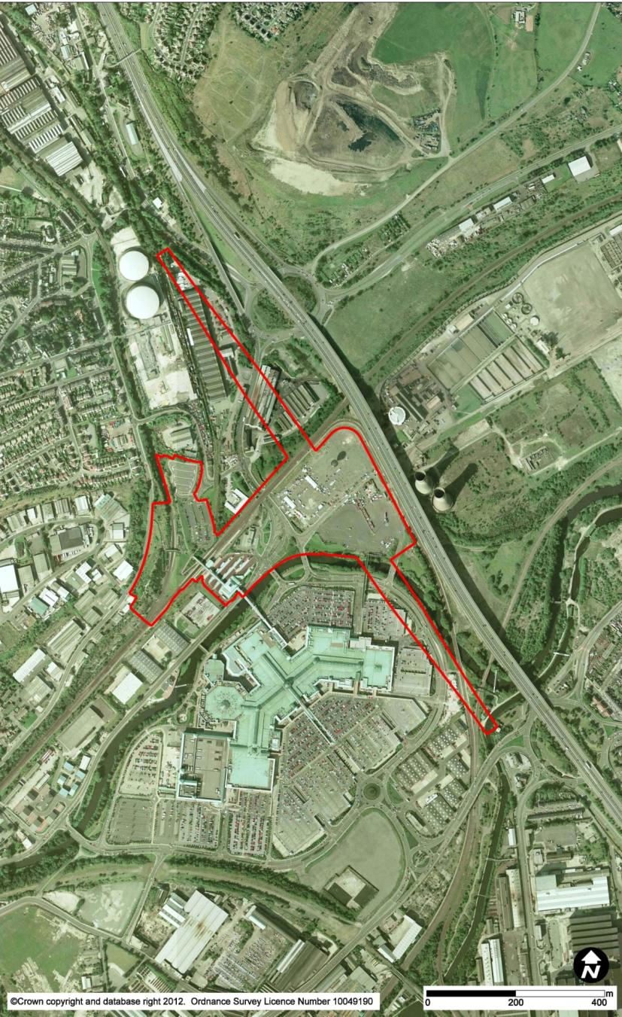
1

5

4

3

2

2

  - Option SYI14 (HSL28) Meadowhall
    - Route Overview
        - The route would approach the station on viaduct from Tinsley, the viaduct then crossing the Don Valley. The route would widen from two tracks to four, and then to six on the approach viaduct. The viaduct would be 4.1km long, up to 22m high, and at a comparable level to the M1’s Tinsley Viaduct. The viaduct would run about 110m to the south-west of the M1, crossing Shepcote Lane, Sheffield Road, the River Don and its flood plain, the South Yorkshire Supertram route, part of the Meadowhall Shopping Centre’s car park; Alsing Road; the Sheffield to Rotherham railway; Meadowhall Road and Blackburn Road.
        - The station is described below and would also be situated on this viaduct.
        - North of the station, still on this viaduct, the route would revert back to four, and then to two tracks. The route would run along the alignment of the abandoned railway from Blackburn Junction to Wakefield and parallel to the existing Sheffield to Barnsley railway and B6082 Ecclesfield Road. For further details, see Chapter 2.17 (HSL15).
    - Station Location and Existing Site
        - The new Meadowhall high speed station would be located between Meadowhall shopping centre to the west and the M1 Tinsley Viaduct to the east. Meadowhall is located in the Lower Don Valley, approximately 6.5km to the northeast of Sheffield and 4.5km to the southwest of Rotherham. The existing Meadowhall Interchange station lies to the west of the proposed high speed station. It incorporates the existing Meadowhall station on the conventional rail network, and is also served by buses and the Supertram.
        - The majority of the station site is on vacant land currently used as an overflow car park for the adjacent Meadowhall Shopping Centre, which is ringed by surface car parks. Some of the multi-storey car parks to the northeast of the shopping centre would need to be reconfigured to accommodate the station. The River Don lies along the north edge of the shopping centre and crosses under the station site, and there are a number of industrial buildings to the north.

1 | High Speed Platforms
2 | Conventional Platforms
3 | Concourse (beneath)
4 | Forecourt
5 | Car Park
6 | Supertram Stop
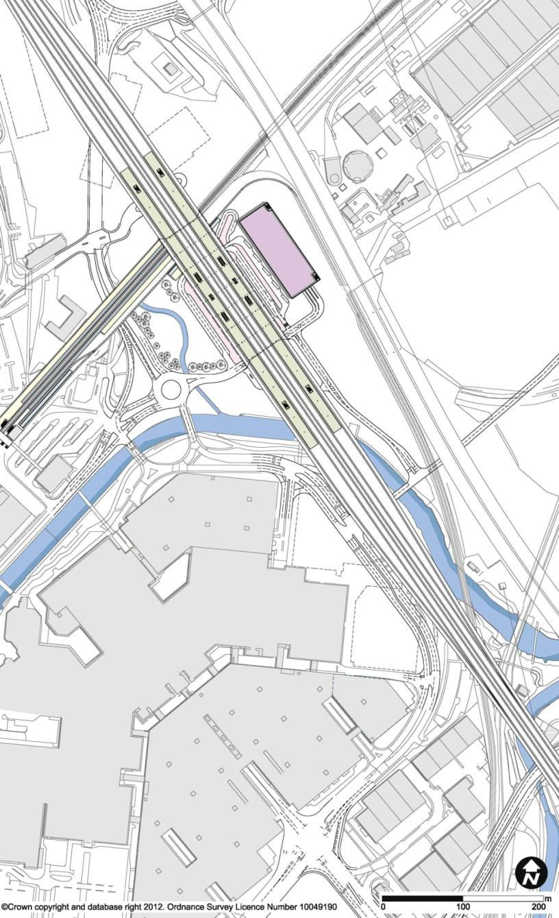
3

2

6

6

4

4

1

5

    - Station Description – Proposed Station

Platforms
        - Meadowhall high speed station would be located on a viaduct structure running from southeast to northwest across the Don Valley, approximately 22m above ground level. This would be comparable to the adjacent level of the M1 Tinsley Viaduct. In the immediate area of the platforms there would be six tracks. The two centrally-situated tracks would be through lines for non-stopping trains, and these tracks would not have platform faces adjacent to them. There would be four tracks for stopping trains, based around two centrally-loaded island platforms, one for northbound services and one for southbound services. The platforms would be 415m long and 12m wide.
        - At ground level, the four-platform conventional network station at Meadowhall Interchange would be modified by moving the Rotherham platforms (for trains to Sheffield, Rotherham Central and Doncaster) nearer to the high speed station and constructing new pedestrian links.

Concourse
        - The station would have multiple entrances, for access to and from different travel modes.
        - The primary station entrances and main concourse with ticket hall and other station facilities would be located at ground level, beneath the viaduct, raised approximately 1m from the current ground level to lift it clear of the flood plain, and surrounded by the station forecourt.
        - From ground level, a series of escalators and lifts would provide vertical circulation for access to the platforms via an upper concourse. The main bank of escalators from ground level would lead up to the upper concourse, and from there, further banks of escalators and lifts would lead up to the centrally-loaded platforms.
        - On the upper concourse, a further entrance would also be located at the northwest end, where a bridge would lead to the Supertram and conventional network platforms at Meadowhall Interchange. A pedestrian bridge at the southeast end of this level would give direct access to a multi-storey car park.

1 | High Speed Platforms
2 | Conventional Platforms
3 | Concourse
5  6  4 | Forecourt
 | Car Park
5 | Supertram Stop
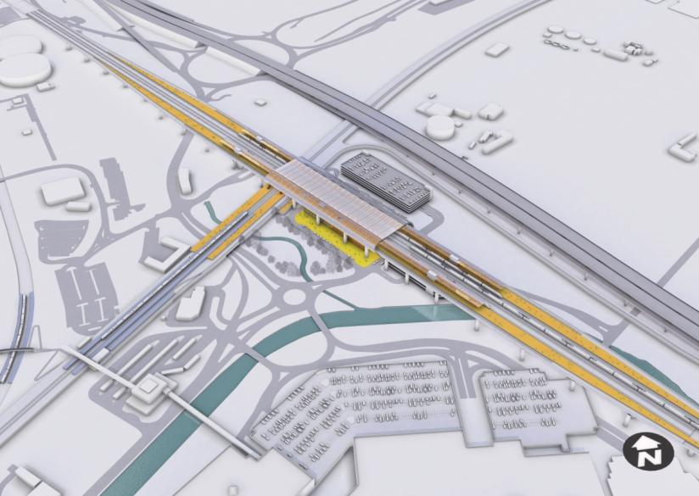
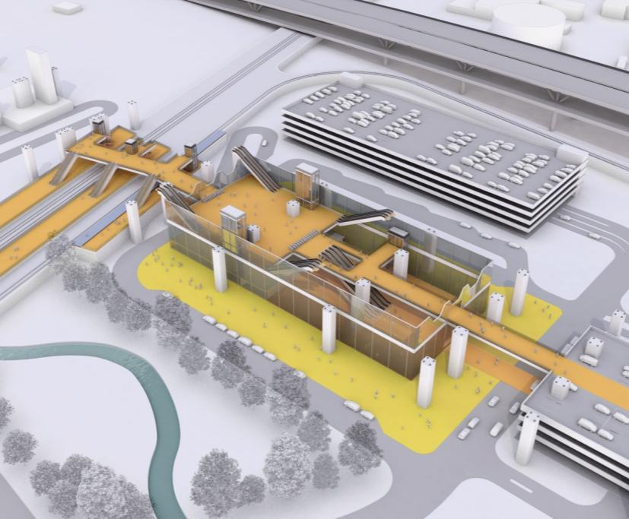
5

6

5

4

2

6

6

4

3

2

1

Forecourt / Car Park
        - The forecourt for the station would be situated underneath the high speed viaduct and would surround the station building, with station entrances at ground level on both the northeast and the southwest faces. Drop-off and pick-up points for taxis and private cars would be provided in the forecourt, as would a taxi rank and bus stops.
        - Multi-storey car parks would be provided underneath the platforms to the southeast of the station concourse and alongside to the northeast.
    - Accessibility
        - The station would be located between Sheffield and Rotherham and would have direct highway connections to both. The nearby M1 Junction 34 would give direct access to the wider South Yorkshire region. Road access to the station would be provided by means of an enhanced road junction on Meadowhall Road, leading to the station via Meadowhall Way. Realignment of Meadowhall Way would be required to avoid a clash with the supporting piers for the station viaduct. The proposed Tinsley Link would provide access for traffic from the east, avoiding Junction 34.
        - There are concerns regarding the capacity of the M1 and congestion of the junction. Further enhancements to address the capacity concerns at Junction 34 could range from widening and reconfiguration of the roundabouts to new roads and links onto and from the M1. The level of provision of capacity enhancements would need to be determined by further work in conjunction with the Highways Agency and local transport authorities, and would include, for example, detailed traffic modelling.
        - Access would also be by Supertram, immediately underneath the high speed platforms, and by train at the adjacent Meadowhall Interchange.

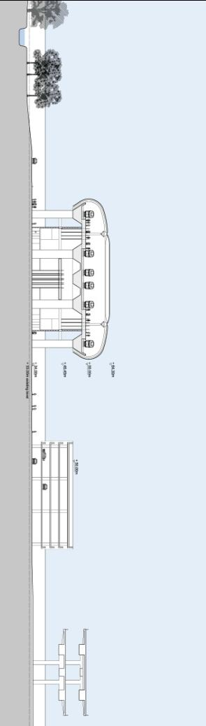
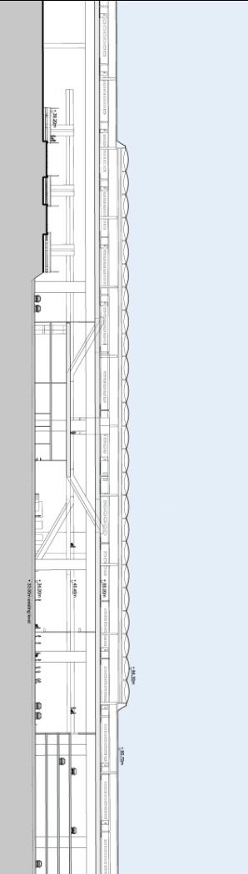
Cross-section looking northwest
Long section looking northeast
Concourse
High Speed Platform
M1
Car Park
High Speed Platform
Concourse
Forecourt
Car Park
    - Intermodal Interchange
        - As the new Meadowhall station would be outside the main Sheffield and Rotherham urban areas, it would be essential that it links to other modes of transport so that passengers could complete their journeys to Sheffield city centre and the surrounding areas. As a result, access to the station was designed with a view to optimising interchange with other public and private transport modes, and particularly to create good pedestrian links between the high speed station, the existing rail network and the tram.
        - Meadowhall station would provide opportunity for interchange between rail, tram, and bus, as well as major road access and car parking provision.
        - The high speed station would be located approximately 300m to the east of the existing Meadowhall Interchange, which is served by trains, buses and trams as well as providing park-and-ride facilities.
        - The existing Meadowhall station on the conventional network has two sets of platforms. One set is on the Sheffield to Barnsley line, with curved platforms to the southwest of the main interchange. The other platforms are on the Sheffield to Rotherham line, are located on the same axis as the tram line, and pass directly underneath the high speed route alongside the proposed high speed station location.
        - The current minimum travel time between the existing Meadowhall station and Sheffield Midland station is five minutes. The current peak hour service to Sheffield Midland is nine trains an hour, on average one every seven minutes, as follows:
- five trains an hour via Platform 1 (an additional two trains pass the platform but do not stop); and
- four trains an hour from Platform 3.
        - The interchange between the high speed platforms and the existing Meadowhall Interchange would be facilitated by:
- provision of a direct pedestrian link between the upper concourse of the high speed station and the existing platforms; and
- moving the platforms on the Sheffield to Rotherham line to the northeast, to be nearer to the high speed station, and provision of an improved pedestrian link to the platforms on the Sheffield to Barnsley line.
        - Further enhancement could be achieved by the relocation of the platforms on the Sheffield to Barnsley line nearer to those on the Sheffield to Rotherham line and the high speed station, in order to form a completely-integrated station. This would involve diversion of approximately 3km of double-track railway, together with construction of a flyover at Wincobank Junction (where the Sheffield to Barnsley line meets the Sheffield to Rotherham line), just south of the current Meadowhall Interchange.
        - In order to provide a direct interchange with the Supertram, a new tram stop would be proposed below the high speed station.
        - Bus provision would incorporate the existing bus station at Meadowhall Interchange and new bus bays on the high speed station forecourt. Future design would investigate the desirability of merging these facilities.
        - The South Yorkshire Passenger Transport Executive (SYPTE), with Rotherham Metropolitan Borough Council (RMBC) and Sheffield City Council (SCC), has proposed the introduction of a Bus Rapid Transit (BRT) system of fast bus services between Rotherham and Sheffield. One of the proposed routes, the Northern Route, would pass directly under the high speed station and so would create a fast bus route from the station to Sheffield and Rotherham, and augment the other transport modes discussed above.
    - Site Constraints
        - Constraints at Meadowhall would include:
- the height of the land on either side of the Don valley;
- the M1 and congestion at Junction 34;
- the existence of the flood plain on the station site;
- Meadowhall shopping centre; and
- the objective of achieving a good connection to Meadowhall Interchange.
    - Constructability
        - The construction would involve building a reinforced concrete viaduct, up to approximately 23m high and 4.1km long. This viaduct would need to support both the high speed tracks and the station platforms. This structure could be challenging in view of the industrial history of the area, with the previously-worked coal seams probably needing a significant drilling and grouting programme.
        - The station entrance and concourse levels would be located immediately below the viaduct. The entrance level would provide access to the elevated concourse above, which would span over and link to the adjacent lines serving Doncaster on the conventional rail network. These structures would be formed in reinforced concrete supported by secondary concrete framing within the primary viaduct structural zone.
        - Highway works would be required to the surrounding road network with temporary restrictions on capacity. The multi-storey car parks to the northeast of Meadowhall shopping centre would be demolished and replaced.
        - Construction would be carried out in three broad phases. These would comprise an enabling works phase; Phase One, which would be the construction of the station sub-structure; and Phase Two, the construction of the station building and erecting the platforms. These are described below:

Enabling Works Phase
- Demolish existing buildings and clear the site, including parts of the shopping centre car park and the Firth Rixon and Chesterfield Cylinders factories. Demolition of the car parks will need to be phased, with possible temporary provision, in order to minimise the impact upon parking capacity at the shopping centre;
- divert utilities;
- carry out ground remediation;
- divert Meadowhall Way prior to major construction operations starting; and
- carry out grouting operations.

Phase One
- Construct the permanent road system, potentially with a sacrificial top layer;
- construct the foundations and piers for the approach viaducts and station;
- modify the existing Meadowhall Interchange station simultaneously with the main works, taking advantage of any possessions required for the viaduct construction.

Phase Two
- Construct the viaduct and platform superstructure;
- construct the reinforced concrete frame of the main station building and associated facade;
- complete car park construction while the main platform above is being worked on;
- construct the platform roof and fit out station;
- install railway systems – lay track, install OLE, signalling etc.; and
- commission and open station.

Access & Site Compounds
        - Primary construction access would be via the proposed road linking the station to the junction between Meadowhall Way and Meadowhall Road. Assuming that the Tinsley Link was constructed prior, it could provide access to the site from both the southern side of the Don Valley and from Rotherham. Access to the north part of the viaduct could be gained via the Firth Rixson site off Meadowhall Road, whereas access to the southern portion of the viaduct would be more complicated due to the proximity of a railway, a canal, the river and the M1 viaduct.
        - There is currently sufficient spare space in the vicinity of the station building and the viaduct for a construction compound and laydown areas.

Programme
        - It is estimated that it would take approximately four and a half years to construct Meadowhall station. This four and a half year period would be made up of:
- year 1 – enabling works, including site set up, utility diversions, road diversions, decontamination activities and demolitions;
- end of year 1 to end of year 3 – viaduct construction; and
- year 3 to year 5 – construct, fit out and commission station.
        - The station would be ready for installation of railway systems (track, signalling, OLE etc.) during year 4, with the station available for full commissioning in year 5, and available for full train operations towards the end of year 5.

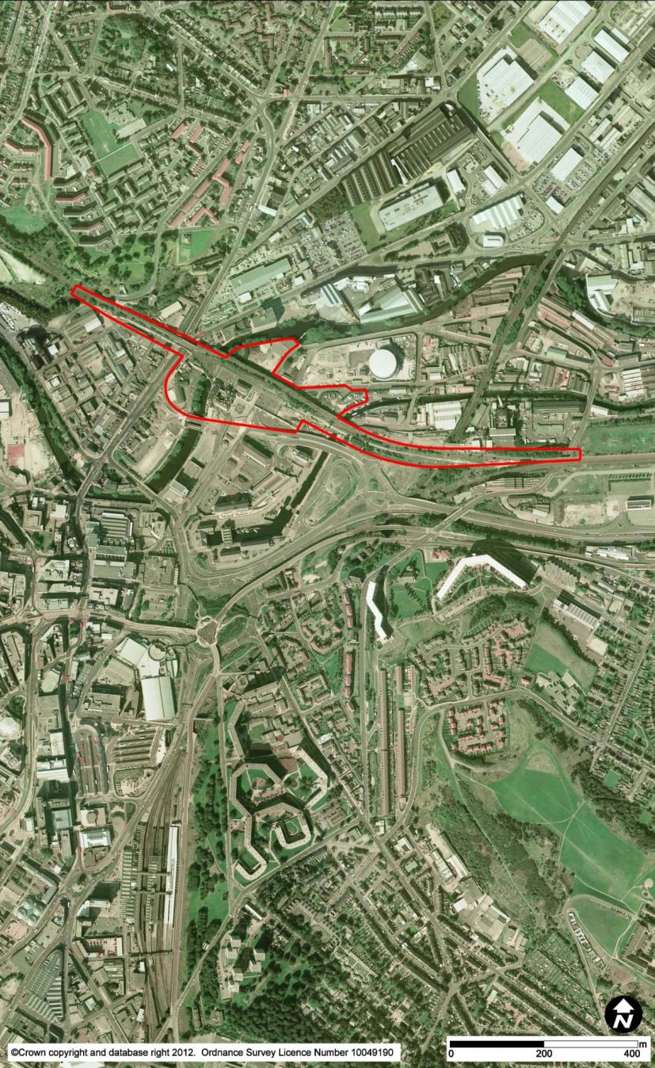
1 | Sheffield Victoria Station
2 | A61 Derek Dooley Way
3 | River Don
4 | Sheffield & Tinsley Canal
5 | Royal Victoria Hotel
65 | Wicker Arch
76 | Victoria Station Road
85 | Exchange Place
95 | Sheffield Midland Station

3

4

85

95

1

76

5

65

2

  - Option SYI07b (HSL29) Sheffield Victoria
    - Route Overview
        - The twin-track route would approach the station from Woodburn Junction, which would be reconfigured to place the Stocksbridge freight route to the south of the high-speed lines. The two high speed lines would bifurcate to form a four-track route, leading to four platforms. There would be no through lines, as all trains would stop at the station. The freight line, which currently runs through the site of the former station, would run past, and share, the southernmost platform.
        - The station is described below.
        - West of the station, the new route and the freight line would be carried over the listed Wicker Arch, with a new viaduct superimposed over it. The new track level would be about 5m above the Arch, to allow for circulation and station concourse above viaduct level. The route would rejoin the main line in the Orgreave area. For further details, see Chapter 2.27 (HSL29).
    - Station Location and Existing Site
        - The proposed station at this location would be on the site of the former Sheffield Victoria station. This lies to the northeast of the city centre, on the north side of the A61 Derek Dooley Way inner ring road dual carriageway. The River Don and the Sheffield and Tinsley Canal both pass under the site.
        - Victoria station was built on an elevated structure, and was opened in 1851 by the Manchester, Sheffield and Lincolnshire Railway. The station and viaduct, including the Wicker Arch which carried the rail lines over Wicker, were designed by John Fowler. The station was closed in 1970 and much of the railway infrastructure was demolished in 1989, though the Royal Victoria Hotel remains. An extension to the hotel and car park has since been built on part of the site. A single track remains and is used by freight trains serving the Stocksbridge Works to the northwest of Sheffield.
        - The elevated structure is approximately 10m above the adjacent street level and comprises a steel viaduct to the east. To the west are viaducts with masonry arches and the Wicker Arch. In the centre, the footprint widens and is surrounded by back-filled retaining walls which form a high-level area on which the forecourt of the former station was located. The Royal Victoria Hotel is also at this level. A long ramp (Victoria Station Road) links the elevated area with the lower street level to the south at Exchange Place. The Wicker Arch and station viaduct are listed Grade II*, while the Royal Victoria Hotel and the access ramp are listed Grade II. The River Don flows underneath the viaduct between the hotel and the Wicker Arch.

High Speed Platforms | Relocated Freight Lines | Concourse | Forecourt | Car Park | Supertram Loop (potential)
6
5
4
21
1
3

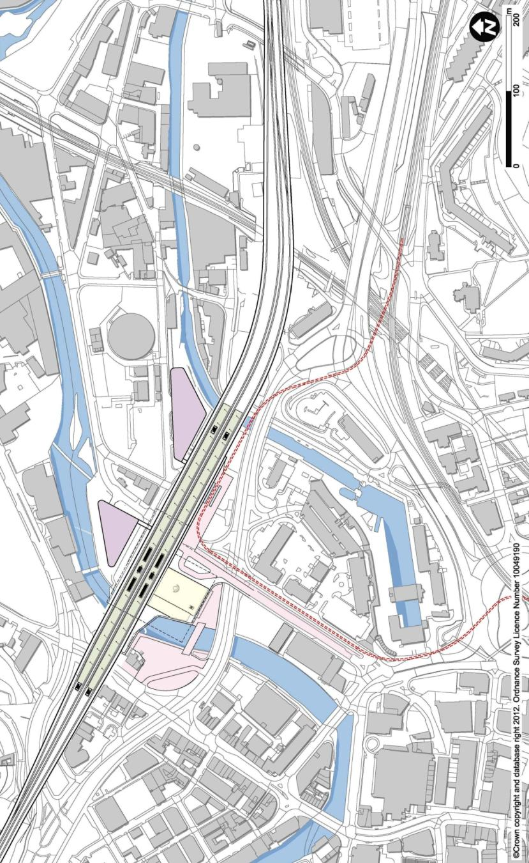
6
5
5
3
21
1
4
4
    - Station Description – Proposed Station

Platforms
        - The station would have two 415m-long, 12m-wide island platforms, providing four platform faces, and tapering at the west end. The two platforms would be raised approximately 5.9m above the level of the viaduct, located above the site of the former station platforms. They would be centrally-loaded and reached from below (the station concourse level) by escalators and lifts.
        - The existing structure on which the original Victoria station platforms was located would have limited space for the high speed station, platforms, and access arrangements. The platforms would therefore be elevated on a new viaduct above the existing structure in order to accommodate the platform lengths and station access, including the concourse, forecourt, and short-term parking. This arrangement also spans over the Wicker Arch and retains it in its entirety.
        - Means of escape would be provided at the extreme ends of the platforms by ancillary stairs.

Concourse
        - The new high speed station concourse, forecourt and short-term parking would be at the level of the former station and platforms, and located directly to the south of the new platforms. This arrangement would require demolition of the existing Grade II listed Royal Victoria Hotel. Stairs and lifts would take passengers down from the upper concourse to a lower entrance, and forecourt at street level.

Forecourt / Car Park
        - Due to space constraints, the forecourt arrangements at Victoria would be split into two areas.
        - The east side of the concourse, providing the main station entrance and the forecourt for private car and taxi traffic, would be accessed by Victoria Station Road, which rises from ground level at a junction at Exchange Place. This concourse would extend along the side of the station to provide space for a potential tram stop.
        - At street level, a new footbridge across the River Don would provide pedestrian access from the lower concourse across to Wicker, where enhanced bus facilities would be provided.
        - Short-term car parking would be provided underneath the station. Long-term car parking would be in multi-storey car parks to the north of the station, connected by pedestrian links, with road access from Sussex Street.

1  3 | High Speed Platforms
2 | Relocated Freight Line
 | Concourse
4 | Forecourt
5  5 | Car Park
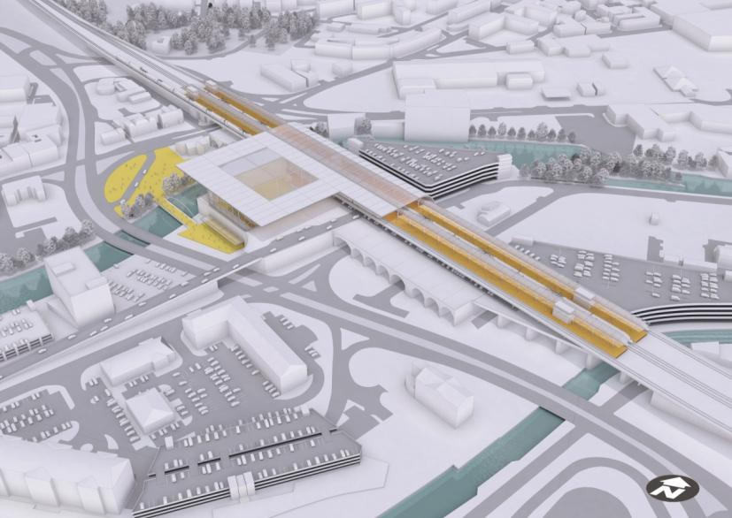
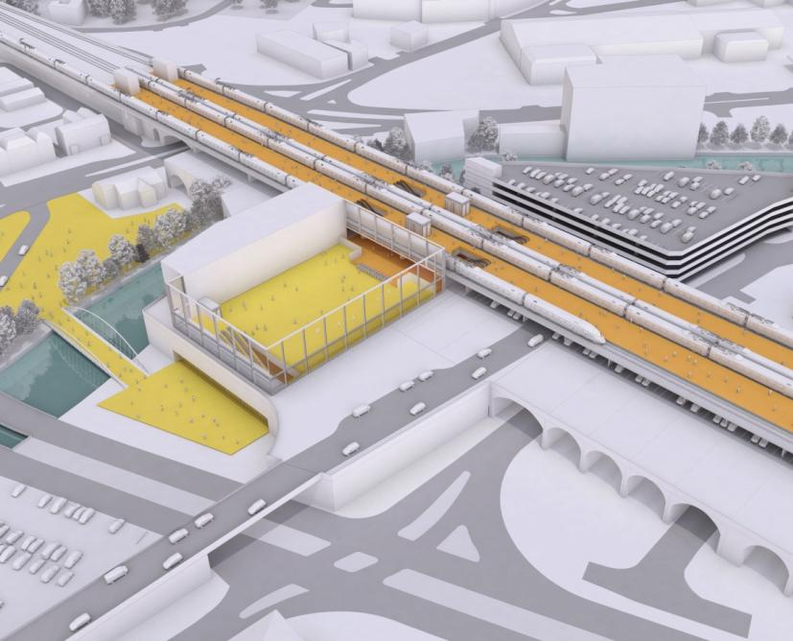
2

1

5

4

4

4

3

5

4

3

2

1

    - Impacts on Existing Stocksbridge Line
        - Services on the Stocksbridge Line (freight only) currently run through the site on a single track. This track would be realigned to run generally parallel to the approaches to the high speed station on dedicated lines either side of the station, but would join the new route, and continue on one of the platform lines, through the station itself.
    - Accessibility
        - The station would serve Sheffield city centre and the wider South Yorkshire region with major road access and car parking provision.
        - The vehicular forecourt for taxi and car pick-up and drop-off would be accessed by the existing ramped Victoria Station Road, which rises from ground level at a junction at Exchange Place. The multi-storey car parks would be accessed from Furnival Road and Derek Dooley Way (A61). Wider highway connections from these would provide access to the city centre, Sheffield’s suburbs, and connect to the M1 and Rotherham. As a result of the increased vehicle turning movements, local junction modifications would be required.
        - The city centre would be a ten-minute walk by existing routes. Pedestrian approaches to the station would include the Victoria Station Road ramp and the street-level entrance off Wicker.
    - Intermodal Interchange
        - Sheffield Midland station, with connections to the existing rail network, would be located 1km away. While this is too far to provide a direct interchange, connection times would be minimised by either a dedicated bus service or by connection to the Supertram network via a new loop. A new connection to the Supertram would also improve access to the wider city.
        - The east side of the concourse would provide the main station entrance and the forecourt for private car and taxi pick-up and drop-off. This concourse would extend along the side of the station to provide space for a potential tram stop, proposed as a new loop on the Supertram. In conjunction with new bus facilities at street level, this would improve public transport accessibility.

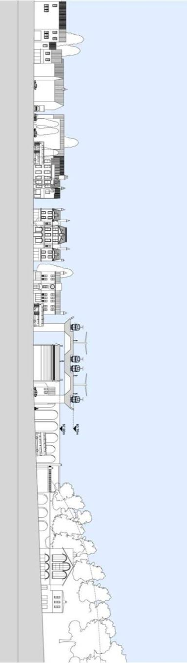
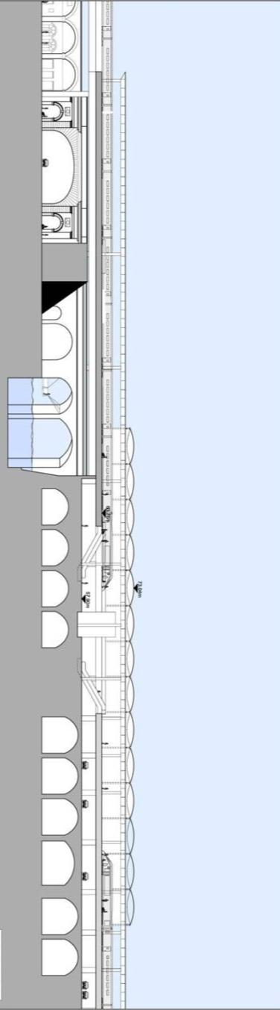
Cross-section looking west
Long section looking north
Wicker Arch
Wicker Arch
High Speed Platform
Concourse
Car Park
Forecourt
High Speed Platform
        - An enhanced bus interchange would be provided on Wicker, to the south of the Wicker Arch.
        - Short-term parking would be provided underneath the station platforms, with sufficient space for drivers waiting to pick up arriving passengers. Two multi-storey long-term car parks would be located to the north of the station.
    - Site Constraints
        - Constraints at Victoria would include:
- retaining and minimising impacts to the listed Wicker Arch and heritage structures, both in design and during construction;
- the limited space available on the upper level, where the station forecourt and upper concourse are located;
- the need to maintain operation on the Stocksbridge freight line;
- the need to provide vehicular access to the station, as well as interchange with buses on Wicker; and
- the narrow corridor for the high speed lines east of the station, bounded by the Bernard Road Service Centre waste management facility to the north and Hartshead House to the south.
    - Constructability
        - The high speed alignment would run over the existing railway arch structures on the approach to the station from the east. As the high speed alignment would be wider than the existing arches, the tracks would be partially supported on the existing arches, with wall piers over the arch springing points supporting a suspended reinforced concrete slab deck. Where the station spans over the River Don and the Wicker Arch, a new structure would be provided independent of the existing arches. This would be formed of a reinforced concrete deck with spans of up to 60m, supported on new concrete columns and abutments. Construction of the new viaduct would be carried out in phases, to allow continued operation of the freight line.
        - The station site is highly constrained, with primary site access from the A61, and a temporary partial closure of Derek Dooley Way may be required for construction access.
        - Construction would take place in three phases. Enabling works would realign the existing freight line on the viaduct; in Phase One, the elevated station deck and station approaches would be constructed; and Phase Two would comprise the platform and station fit-out. These are described below:

Enabling Works Phase
        - It is assumed that the existing freight line would remain operational during construction. Due to the need to construct wall piers across the existing viaduct to support the slab, it may not be feasible to keep the freight track operational in its current location, but this could be accomplished through temporary realignments during the course of construction.

Phase One
- Construct the foundations for the new structures – works would occur over at least three work fronts, focusing on the central station area, which would be on the critical path;
- carry out works to repair, modify and strengthen the existing brick arches;
- construct the columns and new rail deck over the River Don, canal, local roads and some of the existing arches;
- construct the platforms – the platforms would be constructed with associated vertical circulation routes;
- construct the new station concourse structure – the structural works and cladding of the new station concourse building; and
- construct the multi-storey car park foundations and superstructure.

Phase Two
- Fit out the station concourse to include vertical circulation and back of house areas;
- install track, install OLE, signalling etc.;
- complete fit out of the two multi-storey car parks along with the car park underneath the new viaduct;
- commission the rail systems – make new tracks operational;
- construct and complete the forecourt – car, bus and taxi areas along with general public realm; and
- commission and open the station.

Access & Site Compounds
        - Primary construction access would be via Victoria Station Road and Exchange Place. This route connects to the Sheffield Parkway (A61) at Park Square. Access to the viaduct structure at ground level would be via local streets such as Walker Street, Sussex Street and Cadman Street. These would be accessed by Furnival Road and Derek Dooley Way.
        - There is the possibility that the railway track, which would be diverted during the enabling works, could be used to deliver materials. This would reduce the traffic impact of station construction.
        - It would be preferable to establish two or three compounds to provide storage areas and welfare facilities. The two multi-storey car park sites would form good areas in this respect, and, ideally, supporting areas would also be found towards the ends of the new viaduct.

Programme
        - It is estimated that it would take approximately four and a half years to construct Victoria station. This period is made up of:
- year 1– enabling works;
- year 2 to year 3 – viaduct and station construction; and
- year 4 to year 5 – fit out and commission station.
        - The station would be ready for installation of railway systems (track, signalling, OLE etc) during year 3, with the station available for full commissioning in year 4 and available for full train operations in year 5.

1 | Leeds Station
2 | River Aire
3 | Queens Hotel
4 | Neville Street
5 | Princes Square
65 | New Station Street
75 | Inner Ring Road
85 | M621
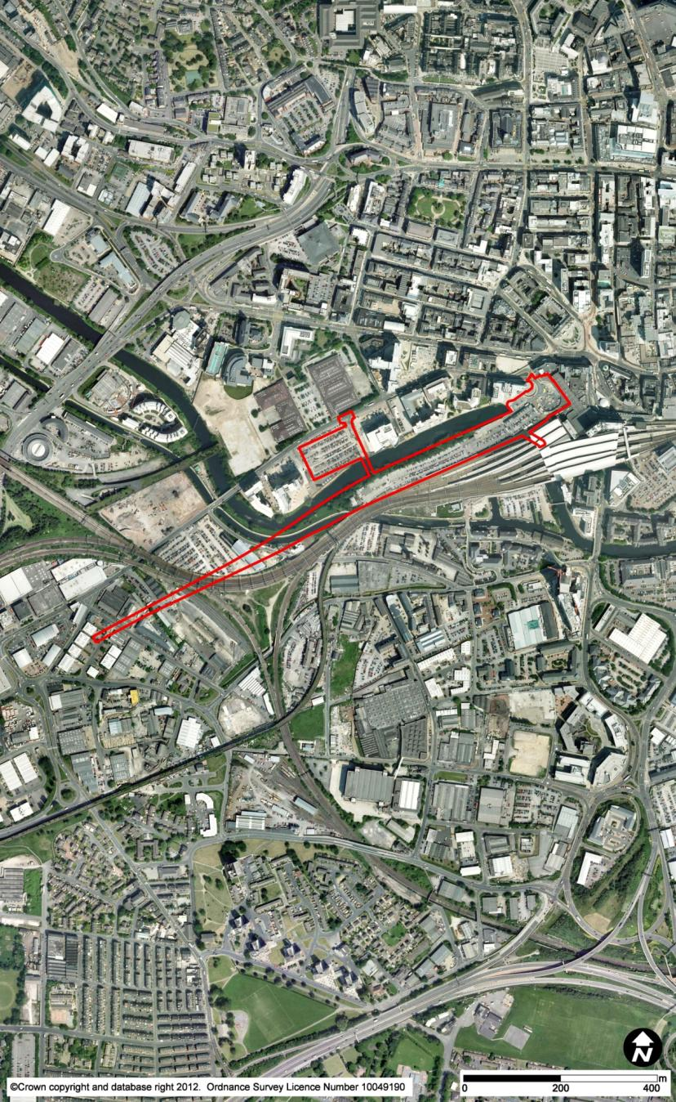
85

75

65

5

4

3

2

1

  - Option LST01a (HSL30) Leeds Station North
    - Route Overview
        - The route would approach the station, on viaduct, as a twin-track route, and there would then be a series of turnouts to widen from two to three and then five tracks to allow access to and from all the proposed five platform faces. All of this layout would be on elevated structure over and east of Whitehall Junction. For further details, see Chapter 2.22 (HSL20).
    - Station Location and Existing Site
        - The proposed high speed station would be located adjacent to and directly north of the existing Leeds station. It would be on a long narrow site, oriented east-west, tightly bounded on one side by the existing station and the other by the River Aire. The site is currently occupied by the station car park, comprising an extensive area of parking at grade, with a multi-storey car park at the east end, near the station entrance. The existing station is elevated on a Victorian arch structure over Neville Street and Swinegate, and the river flows underneath.
        - The current location of Leeds station is due to the historical development and amalgamation of railways in Leeds. This dates to 1846, when Wellington Station was built on the site of the proposed high speed station. In 1869, New Station was opened to the south of Wellington Station, with a viaduct connecting the rail lines in the east with those in the west. The two stations were merged to create Leeds station. While there were a number of other stations in Leeds, these have all since been demolished.
        - The existing Leeds station currently comprises 17 platform faces (ten terminating and seven through). It is the busiest station in the north of England and the third busiest in the UK outside London, after Birmingham New Street and Glasgow Central, with 22 million passengers in 2009 / 2010. Services from Leeds connect to London, the south west, the Midlands, the north west, the north east, and regionally within Yorkshire. Leeds station was extensively remodelled between 1999 and 2002, and a new footbridge which provides the primary means of platform access was built. The north concourse and the adjoining Queens Hotel are Grade II listed.
        - The main entrances to the station are on Princes Square, on the northwest side of the station, and on New Station Street, to the east. Both lead to the concourse. A forecourt for pick-up and drop-off is located on Princes Square and gives access to car parking at grade and in a multi-storey car park along the north side of the station. Bus interchange and taxi pick-up is provided on New Station Street.

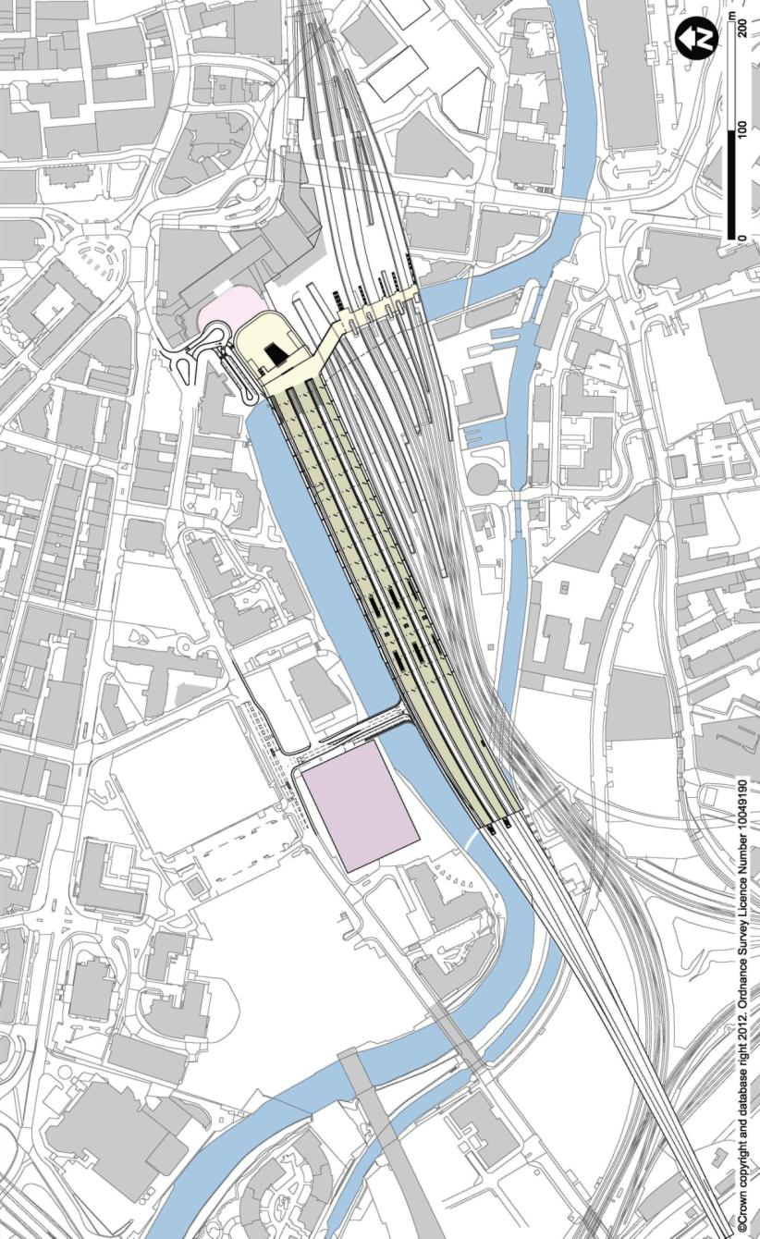
High Speed Platforms | High Speed Concourse | Bridge to West Entrance | Forecourt | Car Park | Existing Leeds Station
4
1
5
6
2
3
3
2
4
6
1
5
        - Metro (the West Yorkshire Passenger Transport Executive) and Network Rail are working in partnership to construct a new entrance on the southern side of the station, at the point where the River Aire emerges from under the station. The design of this entrance includes escalators, stairs, and lifts, to bring passengers up to the high-level footbridge with a new gateline and ticketing facilities.
    - Station Description – Proposed Station

Platforms
        - The station would comprise five platform faces, incorporating two 12m-wide island platforms providing four platform faces and one 7.5m-wide side platform. The platforms would be 440m long, including buffer zones. At their western ends, they would be curved, and the island platforms would taper, to minimise the overhang of the cantilevered station structure over the River Aire and allow the station to be accommodated within the tight site.
        - The high speed platform level would be at a similar elevation to the existing station footbridge. The proposed elevation of the high speed platforms is a consequence of the need for the tracks on the approach to the station to cross over Whitehall Junction.
        - The station would be rotated slightly from the alignment of the existing platforms to avoid conflicts with the northernmost existing tracks in Leeds station. Accommodating the necessary platform arrangement of the high speed station would preclude the northward expansion of the existing station.

Concourse
        - There would be two concourses, one at the east end, and one located towards the west, providing access to the centre of the platforms.
        - The east high speed station entrance would be located at grade on Princes Square, opposite the Queens Hotel ticket hall. The concourse area would be directly connected to the adjacent existing concourse for conventional rail via a walkway along the southern side of Princes Square. Primary access to the upper level containing the east concourse and platforms would be via a bank of six escalators up from the station entrance in a double-height glazed volume. The upper concourse would be directly connected to the high-level footbridge in the existing station.
        - The west concourse would enable direct pedestrian access from the external multi-storey car park. From here, platform access points would be provided via escalator banks approximately half-way along the platforms and thereby give more evenly distributed platform access. The west concourse would have a direct connection to the east concourse at ground level.

1  4  5  2  3 | High Speed Platforms
 | High Speed Concourse
 | Forecourt
 | Car Park
 | Existing Leeds Station

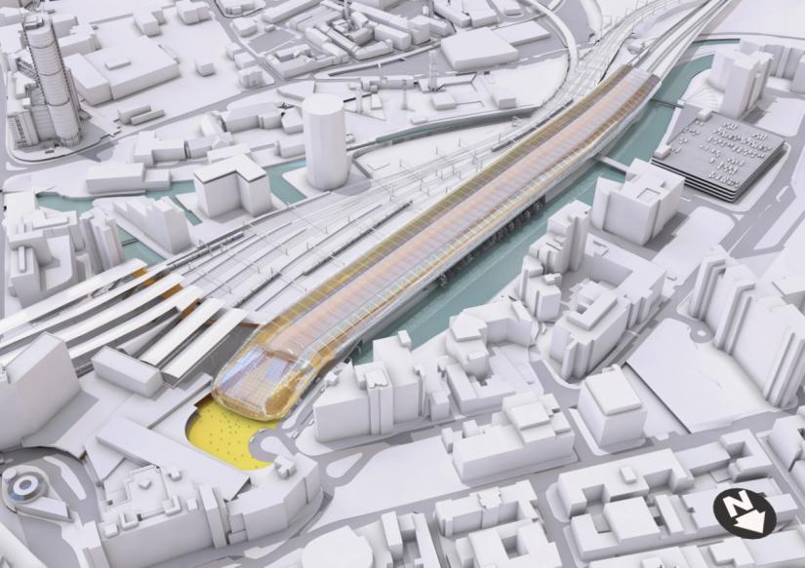
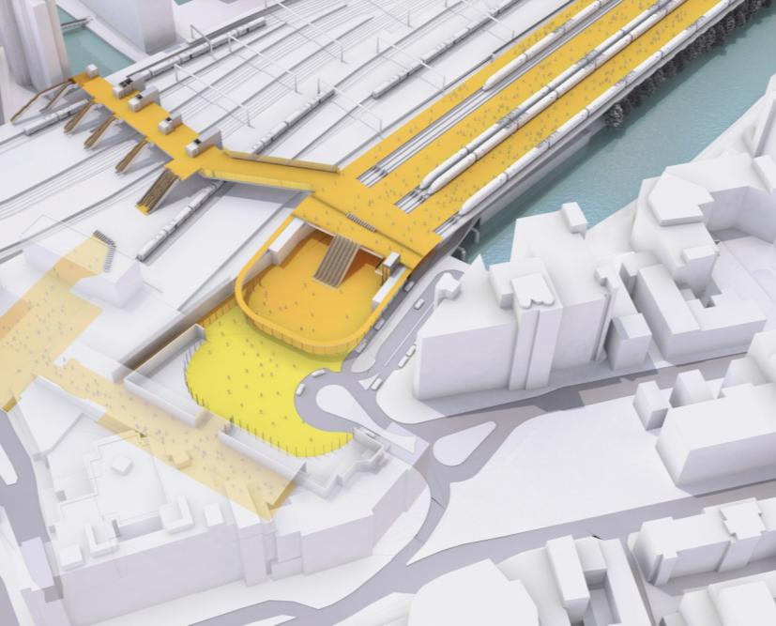
5

3

1

4

3

5

2

Forecourt / Car Park
        - A new arrangement of the station forecourt would provide an opportunity to completely reconfigure the station entrance, creating a new gateway to Leeds. This would incorporate part of the existing pedestrian plaza and surface car park at the Princes Exchange building. Relocating taxi pick-up and drop-off to the forecourt would create space on New Station Street for improvements to the existing access arrangements.
        - A multi-storey car park would be located on the north side of the River Aire, just south of Whitehall Road, on a vacant site currently in use as a surface car park. A dedicated pedestrian route would be provided from the car park to the west entrance. Short-term car parking only would be located at the ground floor under the station. Locating all car parking under the station has been considered and would be feasible, but this would involve considerable excavation and have significant cost implications.
    - Accessibility
        - A new road off Whitehall Road would provide access to the new car park on the north side of the river. The road would continue on a new bridge to the west concourse entrance and along the north side of the station to the forecourt and pick-up / drop-off area at Princes Square. This route would provide access to the parking provision underneath the platforms, incorporate taxi ranking, and contribute to easing congestion at Princes Square.
        - The station location would provide direct and short walking routes to the city centre, from the station forecourt on Princes Square to Aire Street and on to City Square, as well as through the existing station concourse to Bishopsgate Street.
        - The station car park and forecourt would lead to Wellington Street, which provides access to the Inner Ring Road on the west boundary of Leeds City Centre for suburbs in the north and northeast, and from the southbound Inner Ring Road to the M621 and M1 to the south, west, and east of Leeds.

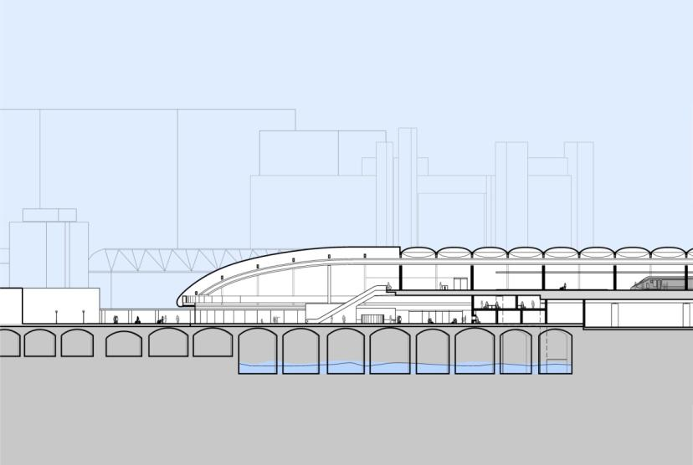
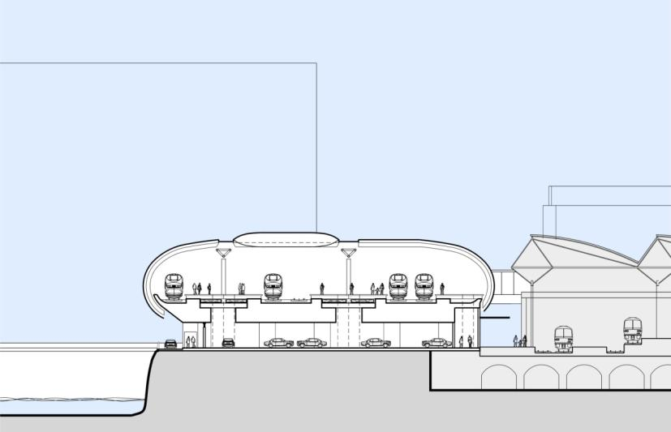
Long section looking south
Cross-section looking east
Platform
Car Park
Forecourt
Concourse
Platform
    - Intermodal Interchange
        - The high speed station would enable direct interchange with the existing rail services at Leeds station. This would be provided by the high-level walkway connection into the existing station footbridge as well as via the existing concourse.
        - Bus provision would remain as it is for Leeds station, on New Station Street. Moving the taxis off New Station Street would create additional room for buses and improve the pedestrian environment.
        - The loop road running alongside the station on its north edge, in between the station and the river, would provide a taxi rank, leading to the taxi pick-up points on the station forecourt.
    - Site Constraints
        - Constraints at Leeds Station North would include:
- the river to the north and canal to the south and west;
- the existing station to the south and the Queens Hotel to the east, which limit extension of the station and forecourt further in those directions;
- the limited space on the site, resulting in the need to locate car parks on the north side of the river;
- the approach over Whitehall Junction, with constraints on the curvature of the station throat, and the vertical alignment of the track as it enters the station; and
- complexities in construction planning due to the need to build the station throat over the river, with the station partially overhanging the river, and adjacent to an operational rail station on a constrained site.
    - Constructability
        - The primary challenges in construction would include the provision of a viaduct over Whitehall Junction, minimising impacts on the existing station, and construction adjacent to and over the canal and river.
        - The elevated station platform would be supported on a reinforced concrete deck on a concrete substructure. At the west end of the station, it would be supported by a series of transverse concrete portals cantilevered over the River Aire. Because of the highly constrained nature of the site, there would be several phases during the construction.
        - Access to the site is good with routes from the inner ring road to the east end of the station via Wellington Street, and to the west end of the station via Springwell Street and Whitehall Road. This route would also give access to a new bridge over the river, which would serve as a construction access to the midpoint of the station.
        - As the existing station is immediately adjacent to the new station, construction would cause some disruption to the operation of services in the existing station, particularly those using the two closest tracks and the northern-most platform. A new high-level pedestrian connection provided by modifications to the existing footbridge would also require progressive possessions across a significant part of the station.
        - It is proposed that the construction of Leeds North station would be carried out in two broad phases. Phase One would be the construction of the station sub-structure, and Phase Two would be the construction of the station superstructure and platforms. These two phases are described below:

Phase One
- Clear the site and divert utilities;
- construct the foundations and piers for the approach viaduct;
- install piles and sub-structure for platforms and car park;
- construct permanent access bridge across the River Aire – this structure would be used for construction access; and
- assess and repair the River Aire arches – the existing arched structure that allows the river to flow beneath the station would be assessed, repaired and strengthened if required.

Phase Two
- Install the deck of the approach viaduct;
- construct the superstructure for car park and platform deck;
- install the platform deck structures and station canopy;
- construct the high speed station concourse and forecourt over the existing River Aire and Dark Arches;
- install railway systems – lay track, install OLE, signalling etc.; and
- commission and open the station.

Access & Site Compounds
        - There are three possible access routes into the Leeds North station site. These all connect to Whitehall Street, which connects into the Inner Ring Road (A643 / A58). Moving from east to west, these are:
- via Princes Square – this route currently exists and would provide access to the east end of the station building;
- via the new station access bridge – the proposed station design includes a new access bridge across the river Aire near Northern Street; and
- via temporary bridges, which could be provided across the Leeds and Liverpool canal to link a compound area on Globe Road to the station.
        - The site is extremely constrained on all sides, and site compounds would have to be located within the footprint of the station. A remote compound could be created to the west of the canal in an area of waste land bounded by Whitehall Road and Globe Road.

Programme
        - It is estimated that it would take approximately five years to construct Leeds North station. This five-year period would be made up of:
- year 1: enabling works, including site set up, utility diversions, detailed survey of arches and installation of retaining structure between the existing and high speed stations;
- year 2 to 3 – installation of the bridge over River Aire, construction of viaduct piles and piers, and station sub-structure;
- year 3 to year 4 – construct the station and platform structures; and
- year 5 – fit out and commission the station.
        - The critical path for the station construction is expected to run through the construction of the sub-structure, the construction of the platform structures and the fit out of the railway track and systems.
        - The station would be ready for installation of railway systems (track, signalling, OLE etc.) during year 4, with the station available for full commissioning in year 5 and available for full train operations at the end of year 5.
        - The programme assumes that no major strengthening or repair works would be required to the arched structure over the River Aire; if this is required, the programme could need to be extended by approximately one year.

1 | Leeds Station
2 | River Aire
3 | Sovereign St. Development
4 | Asda Headquarters
5 | Leeds City Office Park
65 | Former Tetley Brewery
76 | Crown Point Retail Park
85 | Meadow Lane
95 | Great Wilson Street
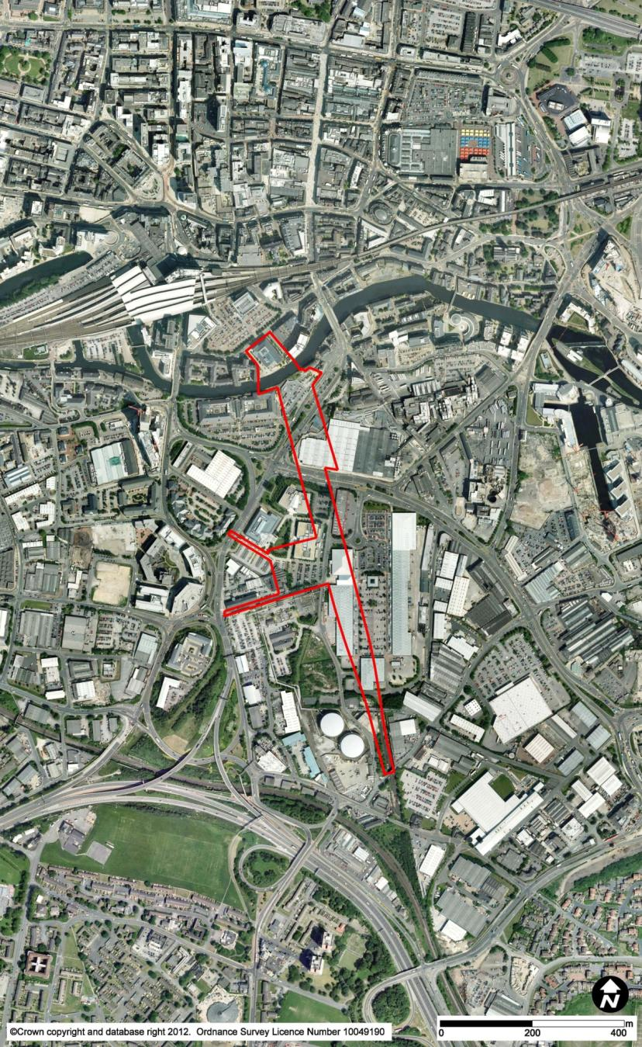
2

1

95

85

76

65

5

4

3

  - Option LST13e (HSL32) Sovereign Street South
    - Route Overview
        - The route would widen from a twin-track railway to three and then five tracks to allow access to and from all the proposed five platform faces, rising from below ground level onto retained structure as it does so. The station approach layout would then pass from retained embankment onto the elevated structure on which the station would be situated. For further details, see Chapter 2.25 (HSL23).
    - Station Location and Existing Site
        - Leeds Sovereign Street South would be a new station, located approximately 200m south of the existing Leeds station, and would be aligned roughly north-south.
        - A pedestrian entrance to the north concourse would be located on the north side of the River Aire, on the west side of Concordia Street, and would front onto the new public plaza associated with the currently proposed Sovereign Street Development. The design would complement these proposals by stopping the station south of Sovereign Street and developing a station forecourt that becomes an extension of the proposed plaza.
        - The tracks would terminate on the southern side of the River Aire, to the east of the Asda headquarters building and Leeds City Office Park and to the west of the former Tetley Brewery and Crown Point Retail Park. The station would be elevated above Meadow Lane and Great Wilson Street to offer public facilities at ground floor level and minimise east-west severance of adjacent transport routes, communities and facilities.

1  3  4  5 | High Speed Platforms
2 | Concourse
 | Forecourt
 | Sovereign Street Public Plaza
 | Existing Leeds Station
6 | Leeds Station New Access
76 | Car Park
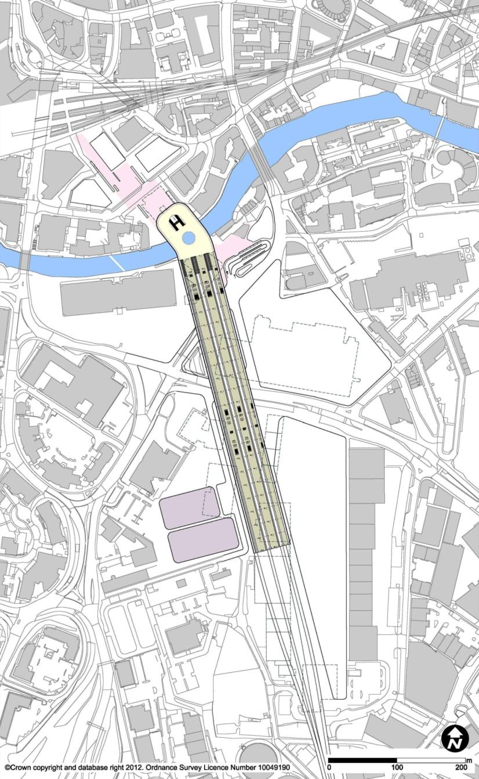
2

5

6

4

3

1

3

7

3

    - Station Description – Proposed Station

Platforms
        - The station would comprise five platform faces, arranged as two island platforms (440m long, including buffer zone, and 12m wide) providing four platform faces and one 7.5m-wide side platform.
        - The platforms would be elevated so as to pass over the city streets in order to allow traffic to pass underneath and thus provide permeability. Access would be by escalators and lifts from the north and south ends of the platforms.
        - Locating the termini of the platforms to the south of the river allows use of a lighter-weight structure across the river. As a result, the visual impact of the structure on the river can be minimised.

Concourse
        - The station would have two concourses. The north concourse on the north side of the river would be accessed by pedestrians for city centre, bus, and rail interchange. The north concourse would also be accessed by the vehicular forecourt on the southern bank of the river, for passengers arriving or departing by bus, car, and taxi. The south concourse, to the southern end of the station, would provide access for passengers arriving or departing by car via the M621, for drop-off or pick-up and for long-term parking. There would be a dedicated first-floor link between the concourses, and passengers would be able to access the platforms from both station entrances.

Forecourt / Car Park
        - Pedestrian access to the north concourse would primarily be from the north of the river leading to Leeds station and the city centre. The pedestrian forecourt on the north side of the river would be designed to complement the plaza proposed for the Sovereign Street development and to integrate the station into the public realm. This forecourt would lead through the new plaza to the existing station, where a new entrance would be provided, enabling direct access to the platforms through the arches. Bus, taxi and vehicle access would be from a forecourt sited just south of the river on the east side of the station.
        - A long-term car park would be located adjacent to the southern end of the station, south of Great Wilson Street. The close proximity of this car park to the M621, the Inner Ring Road and the wider motorway network would provide convenient access for passengers from the Leeds suburbs and the wider West Yorkshire region.

4  5  1  2  3 | High Speed Platforms
 | Concourse
 | Forecourt
 | Leeds Station New Access
 | Car Park
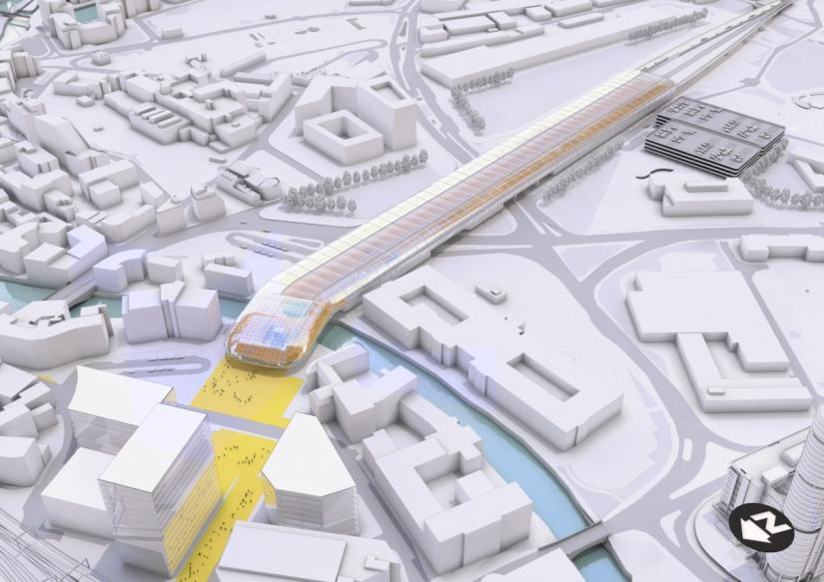
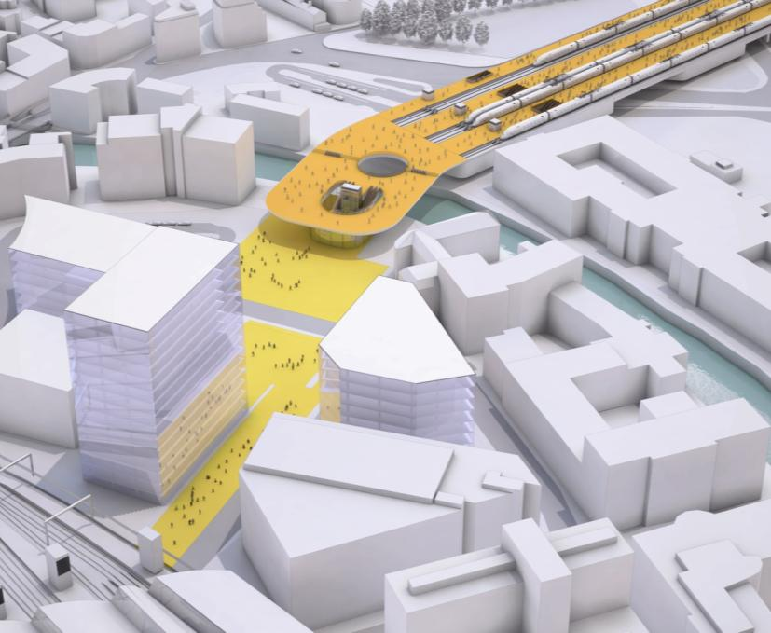
3

4

4

3

56

3

2

1

        - In addition to the separate long-term car park, limited short-term car parking would be incorporated into the station undercroft. A smaller forecourt would be located towards the southern end of the station, providing access to the south concourse.
    - Accessibility
        - Pedestrians from the city centre would be able to access the station by walking through the Leeds station viaduct arches to the north entrance. Easy access from other destinations on the south of the river, e.g. Holbeck Urban Village, would be provided via the forecourt on Meadow Lane.
        - Highway access to the north forecourt would be off Meadow Lane. This would require local highway modifications, to be designed in accordance with Leeds City Council objectives regarding downgrading of Meadow Lane and Great Wilson Street. Meadow Lane provides access to Leeds city centre via the road bridges at Neville Street and Bridge End.
        - The south entrance to the station would be well-located for highway access leading to the Inner Ring Road and motorway network, for destinations in the West Yorkshire region.
    - Intermodal Interchange
        - Passengers connecting to the existing Leeds station would gain access through the new public plaza at Sovereign Street. This would link the north pedestrian entrance of the high speed station with a new southern entrance to Leeds station. It is proposed that escalators would lead up to platform level from the arches in the station viaduct. Opening up the arches in the station viaduct would create potential for new pedestrian routes to the city centre in addition to station facilities and access.
        - The vehicular forecourt serving the north concourse, located south of the river and on the east side of the station, would provide facilities for bus, taxi pick-up and drop-off, and private car drop-off.
        - Bus stops would be located in proximity to this forecourt, in addition to the existing Leeds station bus provision on New Station Street, which would be within walking distance for passengers requiring interchange with services provided there.
        - A taxi rank would be located along the east side of the station and fed from Great Wilson Street, with a second drop-off point at the south station entrance, for passengers arriving from the suburbs.

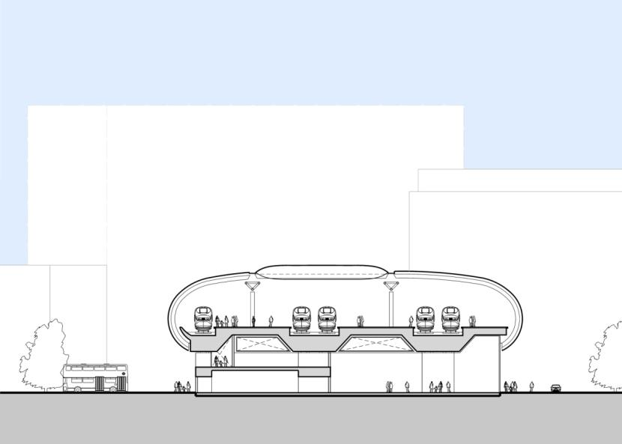
Cross-section looking south
Concourse
Forecourt
Forecourt
Platform
    - Site Constraints
        - The range of constraints for this station option would include:
- preventing negative impacts on the Sovereign Street Development Site;
- minimising impacts to the existing listed building and residential building north of the River Aire, as well as to sites south of the river;
- creating a link to the existing Leeds station;
- devising workable vehicle forecourt arrangements on a tight site on the south side of the river;
- minimising impact on the River Aire; and
- the existing roads on the southern side of the river, including maintaining east-west permeability.
    - Constructability
        - This option would comprise both the new high speed station and modifications to the existing station, to improve interchange between the two. The works to the existing station would include construction of a new passenger access up through the existing railway arches to platform level.
        - The main station viaduct would be constructed in reinforced concrete with decks spanning onto transverse frames.
        - The site would be split into several parcels of land by the river and the main highways. As access would be available to all parcels, this would be not a major issue, although the crossing of the river would add complexity. There would be a need for traffic management where construction crosses over streets.
        - It is proposed that the construction of Sovereign Street South station would be carried out in two broad phases. Phase One would be the construction of the station sub-structure, and Phase Two would be the construction of the station superstructure and platform level. These two phases are described below:

Phase One
- Clear the site and divert utilities;
- carry out ground remediation – the extent of required ground remediation is unknown at this time, but the site history suggests that some provision should be made;
- construct the foundations and piers for the approach viaduct; and
- install piles and sub-structure for platforms and car park.

Phase Two
- Install the deck of the approach viaduct;
- construct superstructure for platform tracks;
- install platform deck structures and station canopy;
- construct station building and forecourts;
- install railway systems – lay track, install OLE, signalling etc.; and
- commission and open station.

Access & Site Compounds
        - Access routes for the construction of the Sovereign Street station could be created by connecting to the roads leading to Junction 3 of the M621 without passing through the city centre.
        - The construction of Sovereign Street station would require demolitions in proximity to the site. As not all of this land would be occupied by the permanent works, it is anticipated that sufficient spare space would be available in these areas for contractors’ compounds and laydown area

Programme
        - It is estimated that it would take approximately four and a half years to construct the Sovereign Street station. This period is made up of:
- year 1 – enabling works, including site set up, utility diversions, decontamination activities and demolitions;
- years 2 and 3 – construction of the station structure; and
- years 4 and 5 – fit out and commissioning of the station.
        - The station would be ready for installation of railway systems (track, signalling, OLE etc) at the end of year 3, with the station available for full commissioning in year 5 and available for full train operations towards the end of year 5.

1 | Leeds Station
2 | River Aire
3 | Asda Headquarters
4 | Victoria Bridge
5 | Bridgewater Place
65 | New Lane
76 | Leeds City Office Park
85 | Dewsbury Road
95 | Neville Street
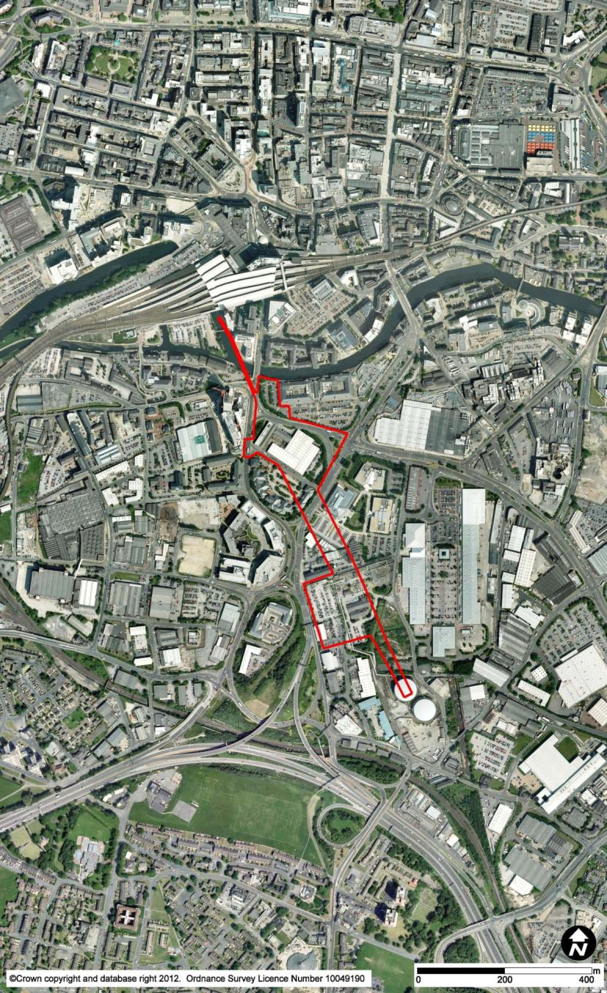
4

85

95

65

5

3

2

1

76

  - Option LST13f (HSL31) New Lane
    - Route Overview
        - The route would widen sequentially from a twin-track railway to three, four, and five tracks, to allow access to and from all the proposed five platform faces, rising from below ground level onto retained structure as it does so. The station approach layout would then pass from retained embankment onto the elevated structure on which the station would be situated. For further details, see Chapter 2.24 (HSL22).
    - Station Location and Existing Site
        - Leeds New Lane station would be a new station, located approximately 200m south of the existing Leeds station, immediately to the south of the River Aire, and would be aligned approximately north-south.
        - The site would be situated to the west of the Asda headquarters building and along the east boundary of Victoria Road, just south of Victoria Bridge and across from Bridgewater Place. The station would be built on the sites of the existing commercial premises on either side of New Lane. To the south, it would pass to the west side of the Leeds City Office Park and, further south, to the east of Dewsbury Road. Across the river and to the north of the station, Neville Street leads under the existing Leeds station to the city centre. A new pedestrian entrance proposed by Network Rail would provide passengers with a southern access to the existing Leeds station.
        - The station would be positioned so as to end directly on the south side of the River Aire, with a small pedestrian plaza to the north (in between the station and the river) and a forecourt for vehicular access to the east. The station would be elevated above Meadow Lane and Great Wilson Street to offer public facilities at ground floor level and minimise east-west severance of adjacent transport routes, communities and facilities.

1 | High Speed Platforms
2 | Concourse
3 | Forecourt
4 | Link to Leeds Station
 | Existing Leeds Station
5 | Leeds Station South Access
76  6 | Car Park
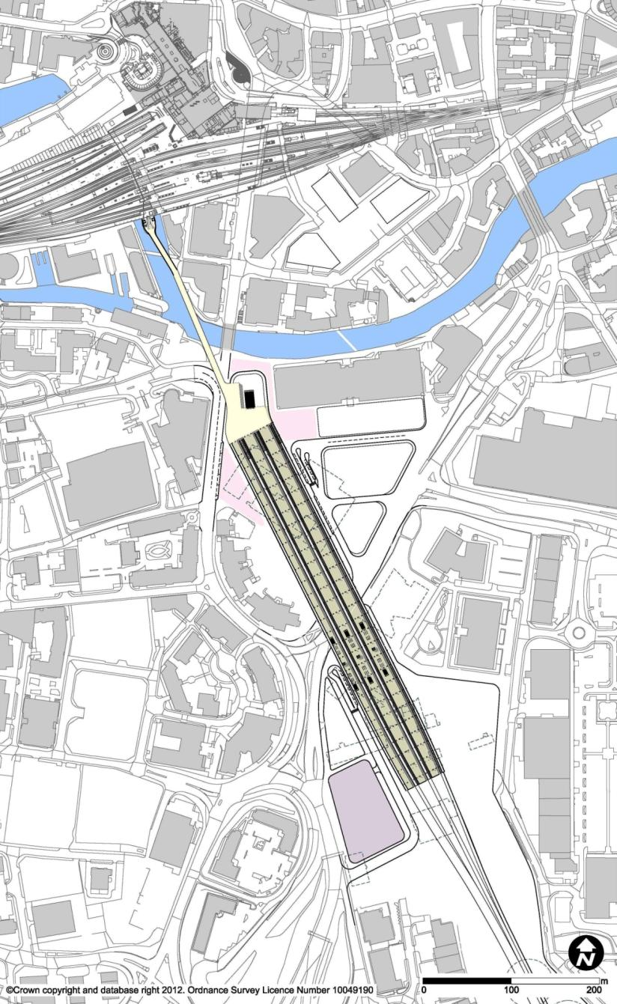
7

1

5

4

3

2

6

3

    - Station Description – Proposed Station

Platforms
        - Like Sovereign Street South station, the station would comprise five platform faces, arranged as two island platforms (440m long, including buffer zone, and 12m wide) providing four platform faces and a single 7.5m-wide side platform. The island platforms would be tapered to accommodate the station throat and approach alignment. The side platform would be curved to follow the taper of the island platforms, but would not itself be tapered.
        - The platforms would be elevated above Meadow Lane in order to accommodate the existing road and avoid negative impacts on permeability. Access would be from the north and south ends of the platforms.

Concourse
        - The station would have two concourses. The north concourse would be accessed by the forecourt on the south side of the river for pedestrians for the city centre, bus, and rail interchange. The south concourse, to the southern end of the station, would provide access for passengers from suburban locations, arriving or departing by car via the M621, for drop-off or pick-up and for long-term parking. There would be a dedicated first-floor link between the south concourse and the north concourse, and passengers would be able to access the platforms from both station entrances.
        - A direct link crossing the River Aire would be proposed for passenger interchange with Leeds station. This would be a pedestrian bridge leading from the high speed station platform level to the existing platform footbridge via the currently-proposed new southern entrance at Leeds station. Other forms considered for this link include travelators, a monorail, or a cable car.

Forecourt / Car Park
        - The north vehicular forecourt and entrances for passengers arriving and departing by taxi and private car would be located on the east side of the station, just south of the river. Bus stops and a station entrance would be provided on Victoria Road, on the west side of the station concourse, in addition to the existing provision on Meadow Lane. To accommodate this arrangement, the western end of Great Wilson Street would be occupied by the station and vehicular forecourt, and so would be closed to through traffic. New Lane would also be closed. East-west permeability would be provided through opening up pedestrian routes at ground level, under the station platforms.
        - A long-term car park would be located adjacent to the southern end of the station, adjacent to Dewsbury Road. The close proximity of this car park to the M621, the Inner Ring Road and the wider motorway network would provide convenient access for passengers from the Leeds suburbs and the wider West Yorkshire region.
1  2 | High Speed Platforms
 | Concourse
3 | Forecourt
4 | Link to Leeds Station
5 | Leeds Station South Access
6 | Car Park
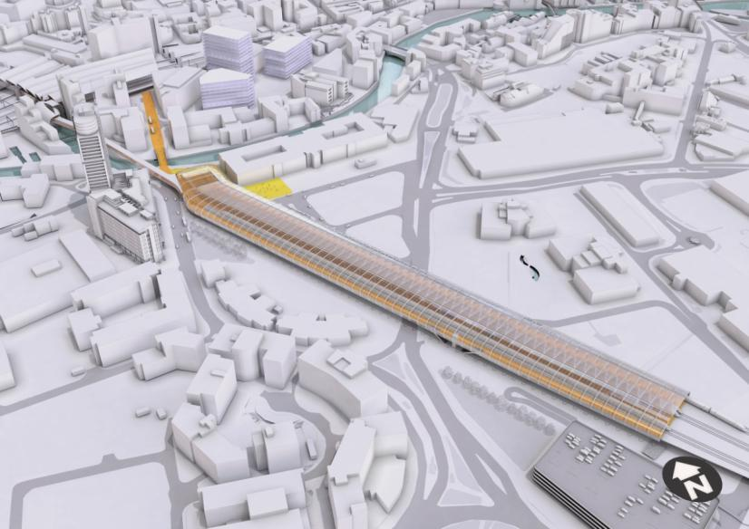
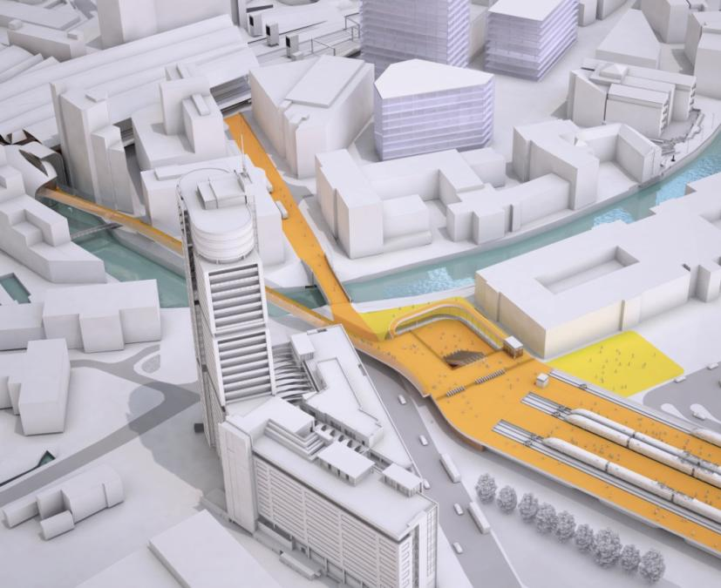
3

1

3

2

3

4

5

4

3

6

        - In addition to the separate long-term car park, some short-term car parking would be provided in the station undercroft. A smaller forecourt would be located towards the southern end of the station, providing access to the south concourse.
    - Accessibility
        - Pedestrian access to the north concourse would primarily be from the north of the river via Neville Street and the Victoria Bridge. Neville Street would be remodelled as a pedestrian route and to provide vehicular access for public transport only, to improve links to the city centre and the existing Leeds station.
        - The station would also be well placed for easy access from other destinations on the south of the river, such as the Holbeck Urban Village and other developments in the vicinity of the station.
        - Access to the north vehicular forecourt would be off Great Wilson Street. This would require local highway modifications, including the closure of the western end of Great Wilson Street as already described.
        - The south station entrance would provide good access for passengers and car parking to the south of the station from the A653 gyratory (Meadow Road and Dewsbury Road), which would need to be remodelled, and from the M621 and the Inner Ring Road, leading to the suburbs and the motorway network, for destinations in the West Yorkshire region.
    - Intermodal Interchange
        - Direct interchange with the existing Leeds station would be via a covered bridge link from the high speed station, crossing the River Aire in a sheltered environment with minimum level changes to the new south entrance of the existing station, and leading to the high-level footbridge in the existing station.
        - Bus, taxi and vehicle access to the north concourse would be from the forecourt sited on the east side of the station, with further bus stops on the west side of the station.
        - Access to the north entrance by bus would be from Victoria Road as well as from Meadow Lane.
        - Taxi ranking would be located along the east side of the station and fed from Meadow Lane, with a second drop-off point at the south station entrance, for passengers arriving from the suburbs.
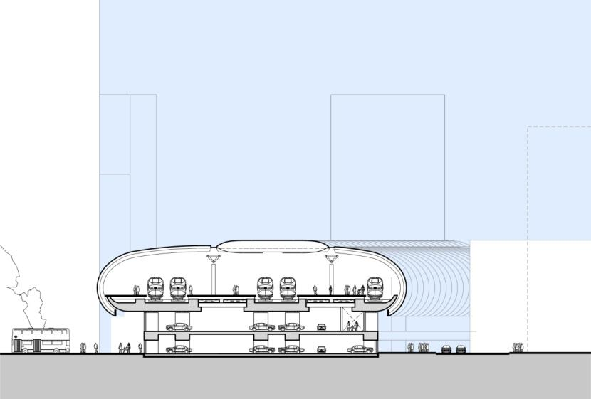
Cross-section looking south
Car Park
Forecourt
Forecourt
Platform
    - Site Constraints
        - The range of constraints for this station option would include:
- maintaining east-west permeability and a suitable local road network;
- minimising impacts to the River Aire, the listed Victoria Bridge, and other developments;
- creating a link to the existing Leeds station while minimising impacts to the Granary Wharf conservation area; and
- devising workable vehicle and pedestrian forecourt arrangements on a tight site on the south side of the river.
    - Constructability
        - This option would comprise both the new high speed station and a pedestrian bridge connection between the new station and the new southern entrance to the existing station.
        - The site would be split into several parcels of land by the main highways, although a river crossing would not be necessary. As access would be available to all parcels, this would be not a major issue. There would be a need for traffic management where the construction work crosses over streets.
        - The main station viaduct would be constructed in reinforced concrete with decks spanning onto transverse frames.
        - Constructing the footbridge link to Leeds Station with its long spans over the river would be challenging, particularly given the restricted access to sites north of the river and the complexity of connecting to the operational station.
        - It is proposed that the construction of New Lane station would be carried out in two broad phases. Phase One would be the construction of the station sub-structure, and Phase Two would be the construction of the station superstructure and erecting the platforms. These two phases are described below:

Phase One
- Clear the site and divert utilities;
- carry out ground remediation – the extent of required ground remediation is unknown at this time, but the site history suggests that provision should be made;
- construct the foundations and piers for the approach viaduct; and
- install piles and sub-structure for platforms and car park.

Phase Two
- Install the deck of the approach viaduct;
- construct the superstructure for platforms;
- install the platform deck structures and station canopy;
- construct the station building and forecourts – the station building would be constructed in parallel to the platform construction works, and pedestrian link to existing station;
- install railway systems – lay track, install OLE, signalling etc.; and
- commission and open the station.

Access & Site Compounds
        - There are two main access routes that could be used for the construction of the New Lane station; both connect to Junction 3 of the M621. From north to south, these accesses are:
- via Meadow Lane and New Lane – this route would provide access to the north end of the station; and
- via a new access from Dewsbury Road near Holmes Street – this route would use the southern station access road to access the southern section of the site.
        - The construction of New Lane station would require demolitions in proximity to the site. As not all of this land would be occupied by the permanent works, it is anticipated that sufficient space would be available in the immediate vicinity of the station for contractors’ compounds and laydown areas.

Programme
        - It is estimated that it would take approximately four and a half years to construct the New Lane station. This period is made up of:
- year 1 – enabling works, including site set up, utility diversions, decontamination activities and demolitions;
- years 2 and 3 – construction of the station structure; and the pedestrian link to existing station
- years 4 and 5 – fit out and commissioning of the station.
        - The station would be ready for installation of railway systems (track, signalling, OLE etc) at the end of year 3, with the station available for full commissioning in year 5 and available for full train operations towards the end of year 5.

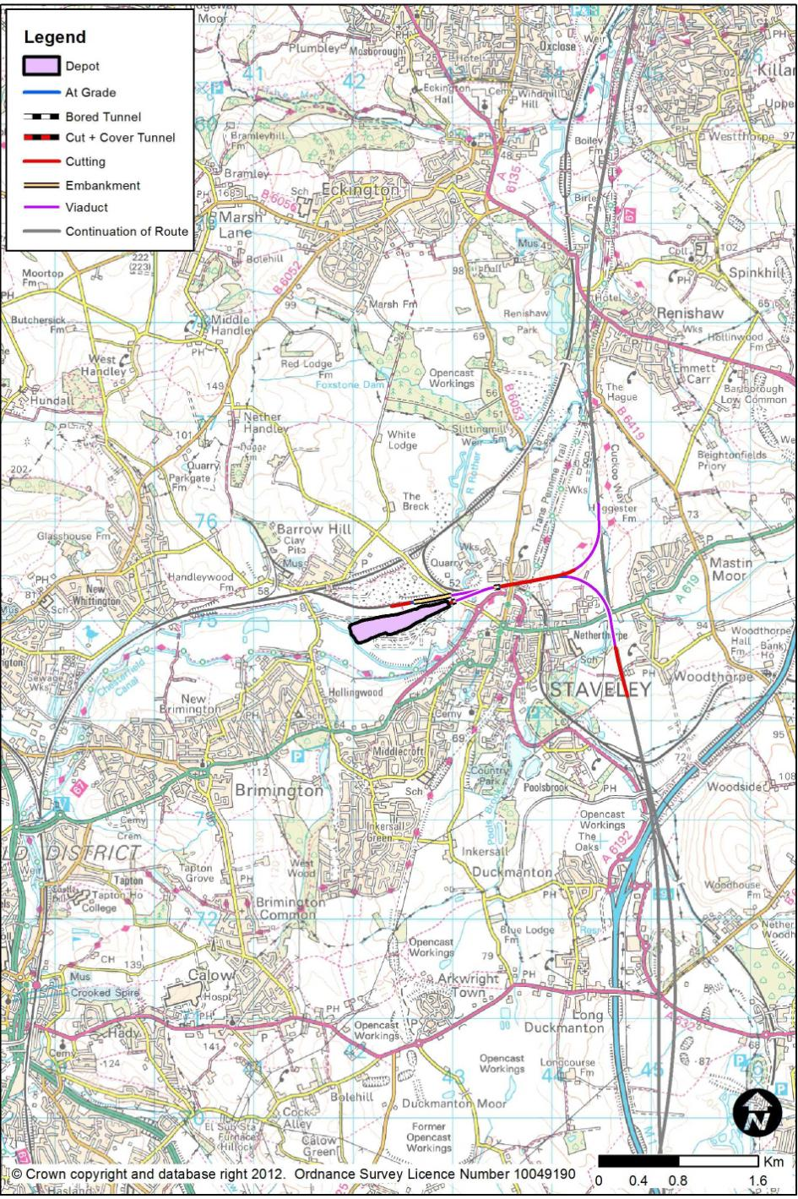
- Depots
        - Two depots would be required for the operation of the West Midlands to Leeds section of HS2. One would be an Infrastructure Maintenance Depot (IMD) as a base from which to carry out engineering activities to maintain and renew the track and other elements of fixed infrastructure such as electrification systems. The other would be a Rolling Stock Depot (RSD) as a base where the trains for the route would be stabled overnight, for cleaning and maintenance.
  - The Infrastructure Maintenance Depot
        - This section of the report concerns the proposed IMD, for which a site at Staveley was selected as the preferred site. Chapter 11 describes other, less favoured, options.

Staveley
        - Staveley IMD would be located south of the existing Chesterfield to Rotherham railway which passes the site. This line forms the principal freight route between the Midlands and the North of England and has a junction with an out-of-use branch to Seymour Junction and various former colliery lines.
        - The depot would occupy 11 hectares of the southern part of the brownfield site where a former iron works stood. This site has a long history of industrial activity and is also located within a flood plain.
        - High speed rail access would be via flat junctions off the mainline (HSL05) onto curves leading toward the depots. These curves would merge together and run into the eastern end of the depot. Access from the existing rail network would be near the existing sidings at Barrow Hill, utilising Seymour Junction for access into the depot. Road access to the site would be off Works Road which already serves heavy goods vehicles and therefore road upgrades would likely not be required.
        - The depot would be single-ended facing the high speed route, and it would be laid out in accordance with the HS2 Ltd Technical Specification.
        - The IMD would stable and service / maintain a variety of On Track Plant and Engineering Supply Train equipment. It would also provide strategic engineering material stores. There would be no intention for ballast or rail to be stored at the IMD, and all ballast and spoil wagons would need to be able to run on and off the existing rail network, bringing supplies.
        - As the site is brownfield, the site may contain contaminated land which would need to be dealt with as part of the proposals. A river diversion would be required and flood plain compensation may also be required. Due to the size of the site, it is envisaged sufficient space would be available for this within the site boundary. Other than thesee contaminated land and flood issues, construction of the depot would use standard methods.
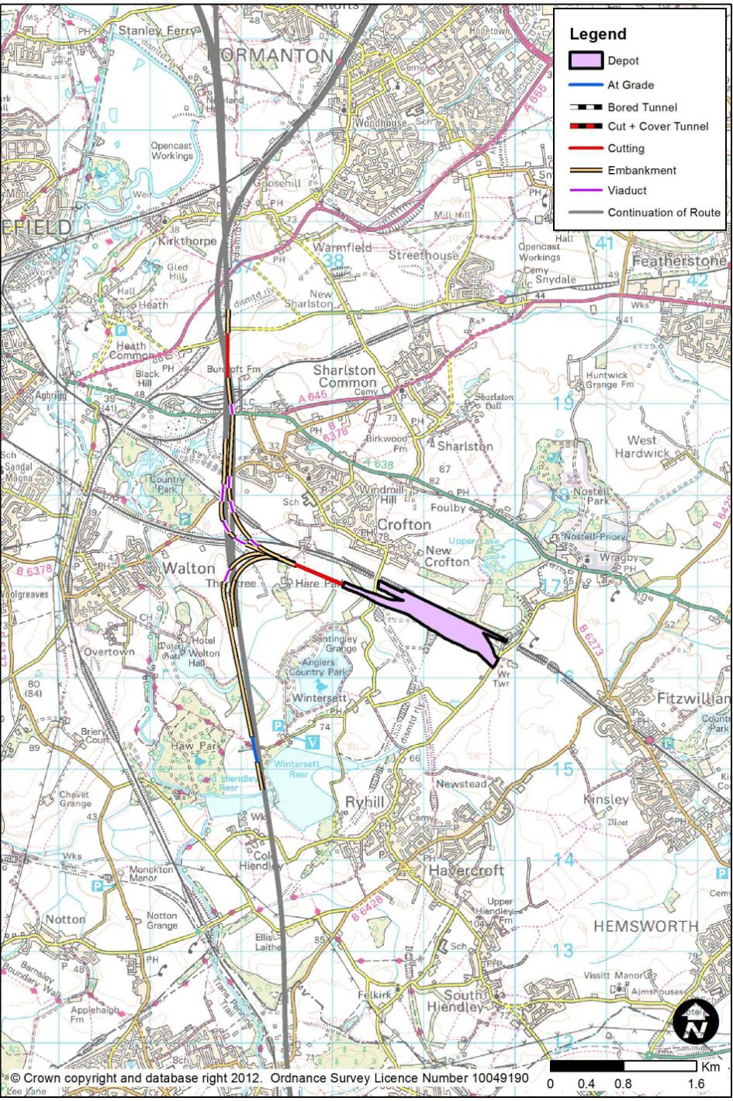
  - The Rolling Stock Maintenance Depot
        - This section of the report concerns the proposed RSD, for which a site at New Crofton was selected as the preferred site. Previous options not taken forward are described in Chapter 11.

New Crofton
        - The depot would be located approximately 22km south of Leeds and 6km south east of the centre of Wakefield. The site would be on a disused coal disposal plant adjacent to the existing Doncaster to Leeds line. The village of New Crofton lies approximately 200m north of the proposed site on the opposite side of the Network Rail line.
        - This site would offer good rail connections and it would be the only site that would also provide connections onto the electrified existing rail network. The site’s location south of the Leeds delta junction would also provide access to both Leeds and the spur to the East Coast Main Line.
        - The depot would be laid out as a single ended depot in accordance with the HS2 Ltd Technical Specification.
        - Connections to the main route would overlap with, and be combined with, the Leeds delta junctions just to the north. The depot connection design would include the necessary modification to the current proposals for the mainline and Leeds spurs. The current track designs result in the mainline having a design speed of 320kph but this could potentially be increased. High speed grade-separated connections would be provided to the north and south, and onto the Leeds and East Coast chords, though further work is required to model the complexities of the junction design to access New Crofton Rolling Stock Depot.
        - The site requires the refurbishment of a Network Rail siding connection and the associated changes to signalling on the existing network.
        - Road access to the site would be proposed off Swine Lane which connects to the main A638 Doncaster Road.

- Connections with the Existing National Rail Infrastructure
  - The Classic Compatible Concept
        - Some high speed trains would run entirely on high speed infrastructure while others, starting on HS2, would use Network Rail (‘Classic’) lines to complete their journeys. These trains would be ‘Classic Compatible’ (CC).
        - This chapter describes the infrastructure needed to deliver train services in a ‘Classic Compatible’ manner; the train services themselves are not described. The options which were not pursued are described in Chapter 12.
        - There are 3 situations where such provision would be considered:
- To allow CC trains to serve York and the North East of England via a connection to the East Coast Main Line in the Church Fenton area;
- To allow CC trains to serve central Nottingham with the potential to serve the wider East Midlands;
- To allow CC trains to serve the centre of Sheffield, as a complementary service to those provided at a Meadowhall station option.

  - East Coast Main Line Connection
        - There would be a viaduct in the Church Fenton area in order to create a grade-separated junction with the existing Church Fenton to Ulleskelf section of line. The new lines would cross the westernmost 3 of the 4 tracks in this area, and would come to ground level between the northbound and southbound lines.
        - In order to achieve this grade-separated junction, the following work would be required on the existing lines:
- The easternmost of the 4 lines in this area would be slewed to the east.
        - In order for the ECML connection to perform satisfactorily in train service terms, the following works would be needed:
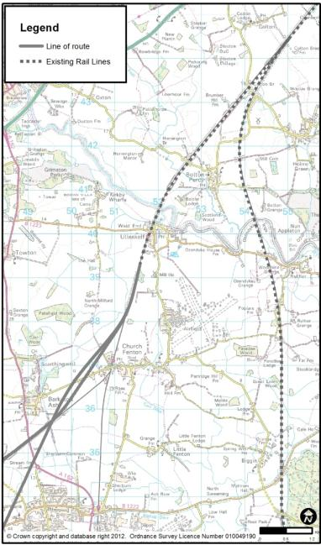
- A new crossover on the Leeds to York lines to the south-west of Church Fenton station;
- A new crossover to complete Church Fenton North Junction;
- The removal of Colton South Junction, and the replacement of its functionality by providing a double, parallel junction between Church Fenton and Ulleskelf.

        - These works would effectively leave the existing pair of tracks through Ulleskelf Station without any services, and hence capable of accepting CC trains. As a consequence, the following work would be needed at Ulleskelf Station:
- Ulleskelf Station platforms would be moved to the Leeds to York lines rather than the York to Sherburn-in-Elmet lines.
        - Trains would then run towards York on the easterly pair of lines. The high speed trains would join the ECML proper at the existing Colton Junction. It is assumed that no capacity works would be necessary there, to accommodate the total train service frequency.
  - Classic Compatible Running into City Centres in a Region

Nottingham (via the Proposed Toton Station)
        - Crossovers would be required on the widened length of railway on the high-level lines at Long Eaton. At Attenborough Junction, grade-separation may be required across the junction in the east to north-west direction to prevent conflict between increased service in this direction and the existing Nottingham-bound trains from the south.
        - Resignalling would be required between the new intersection and Trent Junction as the existing headway may not support the increase in trains. All affected lines would need to be electrified unless the potential Midland Main Line electrification had already undertaken such works.
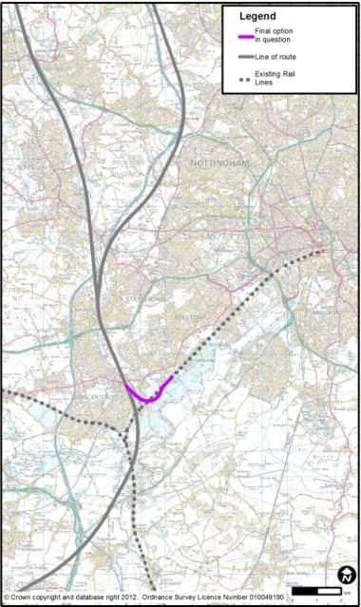

Sheffield
        - The infrastructure required would initially be identical to that proposed for the Sheffield Victoria Loop option, HSL29 as described in Chapter 2.27, between Orgreave and the A630 Sheffield Parkway. There would be a grade-separated junction on the main route near Orgreave; the station at Meadowhall would still be needed. A minor modification of the route would be needed to accommodate the junction.
        - West of the junction, there would be a new twin-track railway turning west, to join the existing Sheffield to Worksop route at a ‘flat’ (i.e. not grade-separated junction) route near A630 Sheffield Parkway.
        - The CC trains would approach Sheffield on the existing route from Worksop to Sheffield, passing Darnall Station which would be unaffected. Trains would continue towards the Nunnery area, and would then turn south to follow the existing Nunnery Curve to reach Nunnery Main Line Junction (on the route from Meadowhall towards Sheffield) in order to enter Sheffield Midland from the north. Throughout all of this length, the route would need to be electrified, and existing bridges over the route may need to be raised to provide the electrification clearances.
        - Returning towards London, the trains would run on the easternmost track against the prevailing southbound flow in the station’s northern approach junctions. North of Nunnery Main Line Junction, a new crossover would return trains to the Sheffield to Worksop line. This crossover would allow a parallel move with an incoming train from Meadowhall to reach the westerly side of the layout.
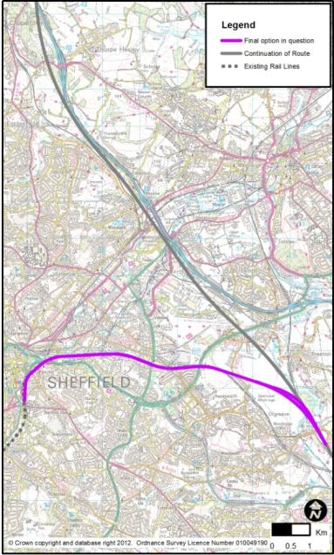

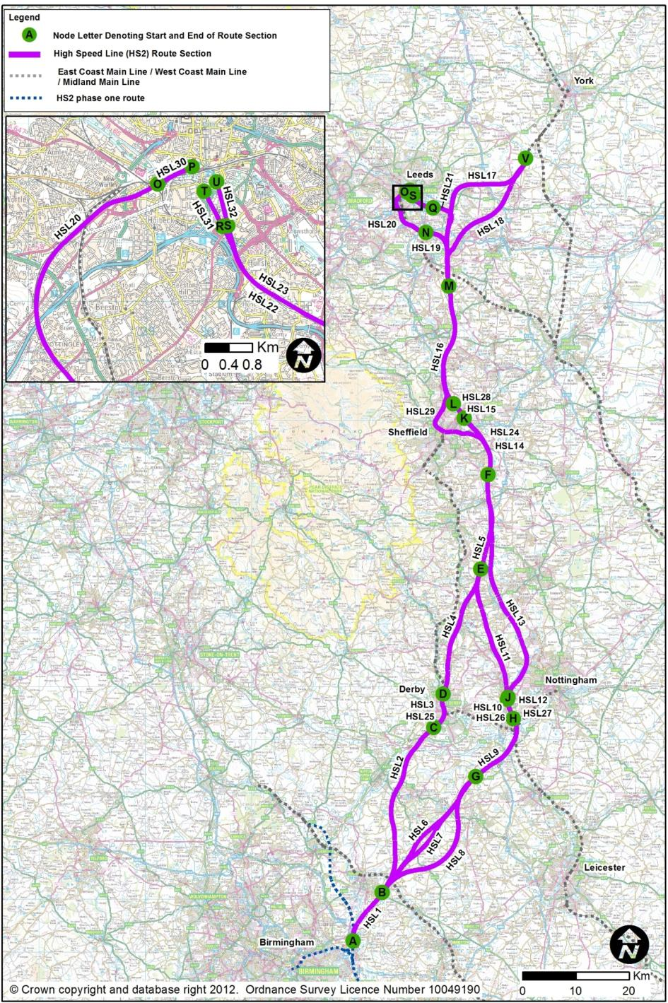
- Whole Route Comparisons
  - The ‘Whole Route’ Combinations
        - The individual route sections described in Chapter 2 can be combined to produce whole route combinations as shown on the left.
        - Between Water Orton and South Yorkshire, there would be 7 possible route combinations. Through South Yorkshire, there would be 2 possible combinations. Towards Leeds and York, there would be 4 possible combinations. This means that there would be 56 possible ‘whole route’ combinations.
        - For the purpose of evaluation, 4 of these options, indicated below and illustrated on the following pages, have been considered. Section 6.2 summarises the journey time estimates of these combinations, including the implications of selecting alternative combinations.
- Derby, Meadowhall, Leeds 13f via Woodlesford and Garforth ECML connection.
- Derby, Meadowhall, Leeds 1a via Transpennine and Garforth ECML connection.
- Toton, Meadowhall, Leeds 13f via Woodlesford and Garforth ECML connection.
- Toton, Meadowhall, Leeds 1a via Transpennine and Garforth ECML connection

- Derby, Meadowhall, Leeds 13f via Woodlesford, Garforth ECML connection.
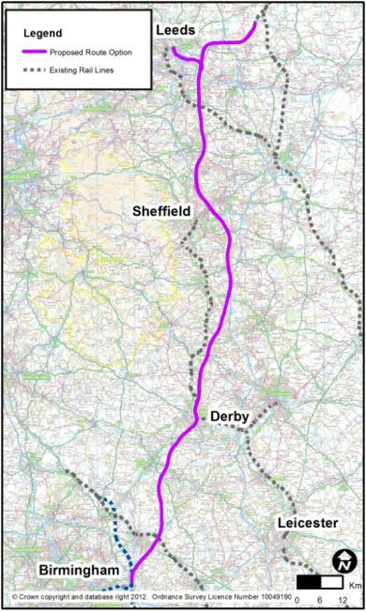
This route’s sections are:
  - HSL01: Water Orton (A) to Birchmoor (B)
  - HSL02: Birchmoor (B) to Sunny Hill (Derby) (C)
  - HSL03: Sunny Hill (C) to Breadsall (D) and HSL:25: Derby station
  - HSL04: Breadsall (D) to Tibshelf (E)
  - HSL05: Tibshelf (E) to Killamarsh (F)
  - HSL14: Killamarsh (F) to Tinsley (K)
  - HSL15: Tinsley (K) to Blackburn (L) and HSL28: Meadowhall station
  - HSL16: Blackburn (L) to Cold Hiendley (M)
  - HSL17: Cold Hiendley (M) to Church Fenton (V)
  - HSL21: Cold Hiendley (M) to Woodlesford (Q)
  - HSL22: Woodlesford (Q) to Hunslet 1 (R) or HSL23: Woodlesford (Q) to Hunslet 2 (S)
  - HSL31: Leeds New Lane 13f (R to T) or HSL32: Leeds Sovereign Street South 13e (S to U).
- Derby, Meadowhall, Leeds 1a via Transpennine, Garforth ECML connection.
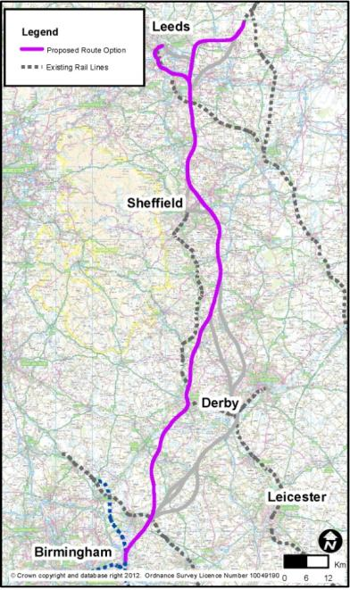
This route’s sections are:
  - HSL01: Water Orton (A) to Birchmoor (B)
  - HSL02: Birchmoor (B) to Sunny Hill (Derby) (C)
  - HSL03: Sunny Hill (C) to Breadsall (D) and HSL25: Derby station
  - HSL04: Breadsall (D) to Tibshelf (E)
  - HSL05: Tibshelf (E) to Killamarsh (F)
  - HSL14: Killamarsh (F) to Tinsley (K)
  - HSL15: Tinsley (K) to Blackburn (L) and HSL28: Meadowhall station
  - HSL16: Blackburn (L) to Cold Hiendley (M)
  - HSL17: Cold Hiendley (M) to Church Fenton (V)
  - HSL19: Cold Hiendley (M) to Lofthouse (N)
  - HSL20: Lofthouse (N) to Holbeck (O)
  - HSL30: Leeds Station North 1a (O to P).
- Toton, Erewash, Meadowhall, Leeds 13f via Woodlesford, Garforth ECML connection.
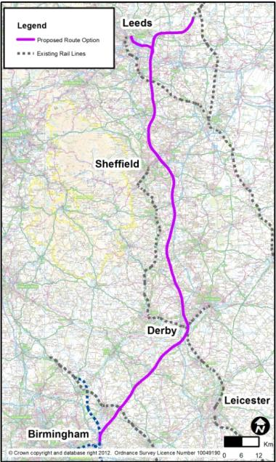
This route’s sections are:
  - HSL01: Water Orton (A) to Birchmoor (B)
  - HSL06: Birchmoor (B) to Tonge (North of Measham) (G)
  - HSL09: Tonge (G) to Long Eaton (H)
  - HSL10: Long Eaton (H) to Sandiacre (I) and HSL26: Toton station
  - HSL11: Sandiacre (I) to Tibshelf (E)
  - HSL05: Tibshelf (E) to Killamarsh (F)
  - HSL14: Killamarsh (F) to Tinsley (K)
  - HSL15: Tinsley (K) to Blackburn (L) and HSL28: Meadowhall station
  - HSL16: Blackburn (L) to Cold Hiendley (M)
  - HSL17: Cold Hiendley (M) to Church Fenton (V)
  - HSL21: Cold Hiendley (M) to Woodlesford (Q)
  - HSL22: Woodlesford (Q) to Hunslet 1 (R) or HSL23: Woodlesford (Q) to Hunslet 2 (S)
  - HSL31: Leeds New Lane 13f (R to T) or HSL32: Leeds Sovereign Street South 13e (S to U).
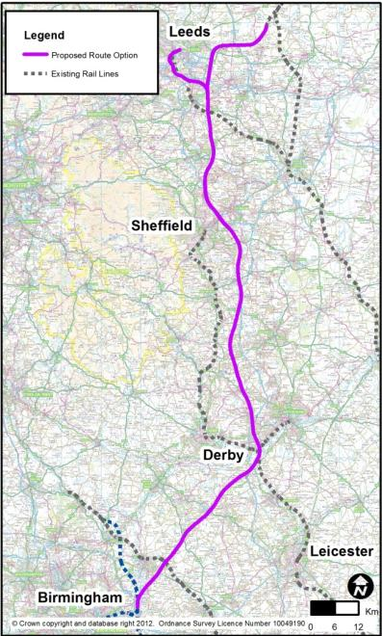
- Toton, Erewash, Meadowhall, Leeds 1a via Transpennine, Garforth ECML connection.

This route’s sections are:
  - HSL01: Water Orton (A) to Birchmoor (B)
  - HSL06: Birchmoor (B) to Tonge (North of Measham) (G)
  - HSL09: Tonge (G) to Long Eaton (H)
  - HSL10: Long Eaton (H) to Sandiacre (I) and HSL26: Toton station
  - HSL11: Sandiacre (I) to Tibshelf (E)
  - HSL05: Tibshelf (E) to Killamarsh (F)
  - HSL14: Killamarsh (F) to Tinsley (K)
  - HSL15: Tinsley (K) to Blackburn (L) and HSL28: Meadowhall station
  - HSL16: Blackburn (L) to Cold Hiendley (M)
  - HSL17: Cold Hiendley (M) to Church Fenton (V)
  - HSL19: Cold Hiendley (M) to Lofthouse (N)
  - HSL20: Lofthouse (N) to Holbeck (O)
  - HSL30: Leeds Station North 1a (O to P).
  - Journey Time Estimates
        - Journey times for the various options of Phase 2 of the high speed rail network were calculated using the methodology described in HS2 Ltd’s Report to Government.
        - The times are based on a notional stopping pattern for trains on the Leeds / York leg of the high speed network. Where station stops have been included, a 2 minute dwell has been assumed. All times from London include a stop at Old Oak Common.

Journey Time Results
Route | Stops | Journey Time
 |  | London to Leeds | London to York | Birmingham to Leeds | Birmingham to York
Derby, Meadowhall, Leeds 13f via Woodlesford and Garforth ECML Connection | No stop | 01:14:15 | 01:22:30 | - | -
 | Derby | 01:17:30 | 01:25:45 | - | -
 | B’ham Int and Meadowhall | 01:24:45 | 01:33:00 | - | -
 | Derby and Meadowhall | 01:22:45 | 01:31:00 | 00:50:15 | 00:58:30

Route | Stops | Journey Time
 |  | London to Leeds | London to York | Birmingham to Leeds | Birmingham to York
Derby, Meadowhall, Leeds 1a via Transpennine and Garforth ECML Connection | No stop | 01:15:45 | 01:22:30 | - | -
 | Derby | 01:19:00 | 01:25:45 | - | -
 | B’ham Int and Meadowhall | 01:26:15 | 01:33:00 | - | -
 | Derby and Meadowhall | 01:24:15 | 01:31:00 | 00:51:30 | 00:58:30

Route | Stops | Journey Time
 |  | London to Leeds | London to York | Birmingham to Leeds | Birmingham to York
Toton, Erewash, Meadowhall, Leeds 13f via Woodlesford and Garforth ECML Connection | No stop | 01:14:30 | 01:22:45 | - | -
 | Toton | 01:18:30 | 01:26:45 | - | -
 | B’ham Int and Meadowhall | 01:25:00 | 01:33:15 | - | -
 | Toton and Meadowhall | 01:23:45 | 01:32:00 | 00:51:00 | 00:59:15

Route | Stops | Journey Time
 |  | London to Leeds | London to York | Birmingham to Leeds | Birmingham to York
Toton, Erewash, Meadowhall, Leeds 1a via Transpennine and Garforth ECML Connection | No stop | 01:16:00 | 01:22:45 | - | -
 | Toton | 01:20:00 | 01:26:45 | - | -
 | B’ham Int and Meadowhall | 01:26:30 | 01:33:15 | - | -
 | Toton and Meadowhall | 01:25:15 | 01:31:00 | 00:52:30 | 00:59:15
        - It can be noted from the table that the journey times to Leeds Station 1a are slower by 1 min 30 seconds than to Leeds Station 13f.
        - It can also be noted that the non-stop journey time to Leeds station along the route via Derby is 15 seconds faster than the route through Toton.
        - Although NOT shown in the table, it should be noted that:
- The times shown are via the Erewash Valley route (HSL11). If the M1 route (HSL13) north of Toton station were selected instead, it would add up to 45 seconds for non-stopping trains and 30 seconds for stopping trains.
- A stopping train routed via Sheffield Victoria (via HSL29) would be 3 minutes 30 seconds slower than a train routed via Meadowhall (HSL16) and stopping there.
- The times shown are to the East Coast Main Line connection via Garforth (HSL17). If the connection via Castleford (via HSL18) were selected instead, it would save 1 minute 15 seconds, because the route would not be constrained to 230kph by the existing curvature of the M1 motorway north of Garforth.
        - Although NOT tabulated, it should be noted that the modelled high speed time to York is 29 minutes 45 seconds quicker than the fastest, non-stop equivalent timing on the East Coast Main Line. All trains to points north of York, such as Newcastle, would therefore also be 29 minutes 45 seconds faster.

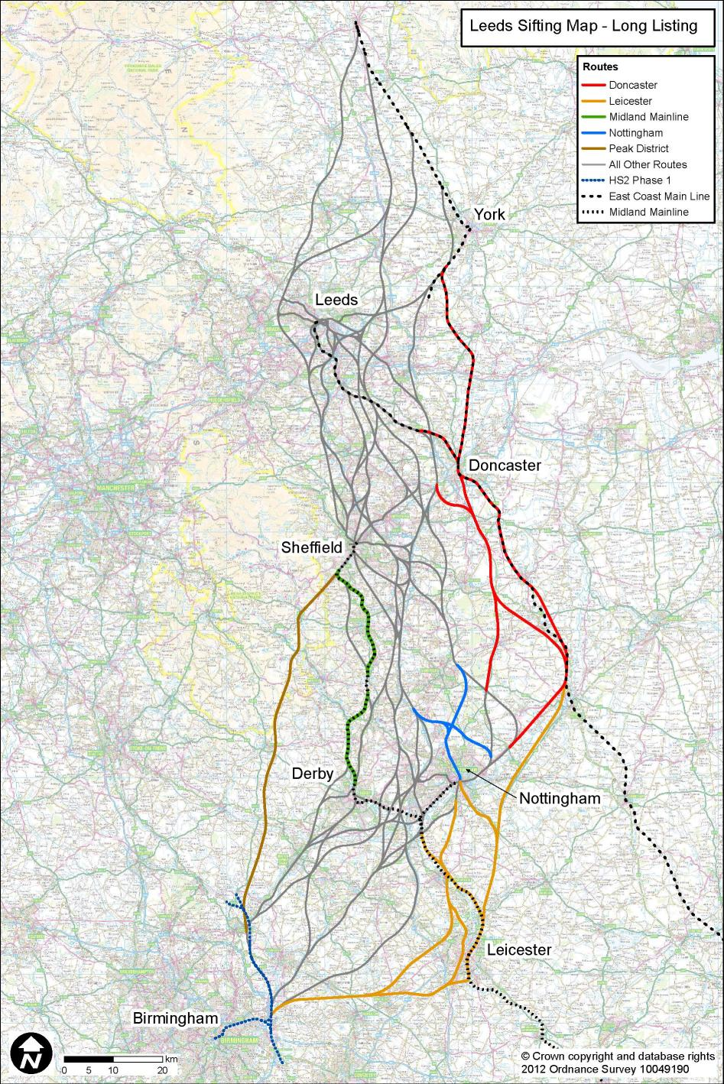
- History of Line of Route Options
  - Long List of Routes

Introduction
        - The coloured lines shown on the map on the left present those routes which formed part of the long list, but which did not progress beyond that stage. The text following this map explains the main engineering implications of those routes (which was not necessarily the reason why they did not progress further).

Route via the Peak District
        - This route would be a relatively straight line between Lichfield and Sheffield, and would, indicatively, run via Ashbourne and Bakewell through the Peak District National Park, passing close to Chatsworth House.
        - The main engineering issues were that it would not meet the engineering remit to serve the East Midlands. It would be difficult to obtain a 400kph alignment through the Derbyshire section, though the length through Staffordshire could potentially achieve the desired speed, but its relatively direct routing could offer a sensible journey time to the south of Sheffield. Again because of the terrain and access issues, cost would be relatively high. Construction traffic access routes in the Peak District would be poor and relatively remote.

Routes via Doncaster
        - This group of routes would pass through, or to the east of Doncaster, from the Nottingham area towards the York area.
        - These routes would not serve a large part of South Yorkshire. A route via Doncaster would provide no connection to the shortlisted South Yorkshire stations. Constructing a high speed route through the Doncaster Station area itself would be complex and potentially very disruptive to the existing rail network, as this is a busy railway complex with no grade-separation, operating at close to maximum capacity. The route could not offer speeds in excess of about 170kph in this area. It would be difficult to find an acceptable engineering solution.

Route via the Midland Main Line from Derby to Sheffield
        - This route would involve adding two additional tracks alongside the Midland Main Line (MML) from the Derby area through Ambergate and Belper, and via Chesterfield to Sheffield via Dore.
        - The route would involve upgrading of MML whose tortuous route produces a succession of changes in line speed, but typically 140kph, providing a less-than-high-speed service from Derby to Sheffield and not meeting the aspired journey times. There would be heavy engineering works in this area of challenging terrain, with considerable use of tunnels and viaducts along the meandering valleys that the present line follows. There would be major disruption to existing train services during construction.

Routes via Leicester
        - This group of routes would run from the Water Orton area eastwards towards Leicester, some options passing to the west of the city, or through the city centre alongside the present Midland Main Line or along the formation of the disused Great Central formation. The routes would then generally run towards Nottingham, approaching it from the south.
        - There would be no significant engineering challenges in the rural elements of this group of routes, but construction in central Leicester would be disruptive and costly.
        - All such routes would have a negative journey time impact of 5 to 9 minutes for all passengers travelling to / from anywhere north of Leicester. There would be a major benefit for London to Leicester journey times of 13 minutes, but committed Network Rail schemes would reduce this advantage over journeys on the (modified) existing network to 9 minutes. There is scope for further improvements by Network Rail which could reduce this journey time benefit to 6 minutes.

North-South Routes through Nottingham
        - Routes running north-south through Nottingham would attempt to follow the abandoned Great Central formation through the former Nottingham Central Station.
        - Most of this corridor has been lost to development, and it would be a major engineering and property challenge to restore the corridor. The abandoned tunnels to the north of the station would be unusable in view of the gauge requirements of high speed trains. New, and consequently expensive tunnels would be required, unless the issue were resolved by an even greater length of tunnelling throughout the urban areas.

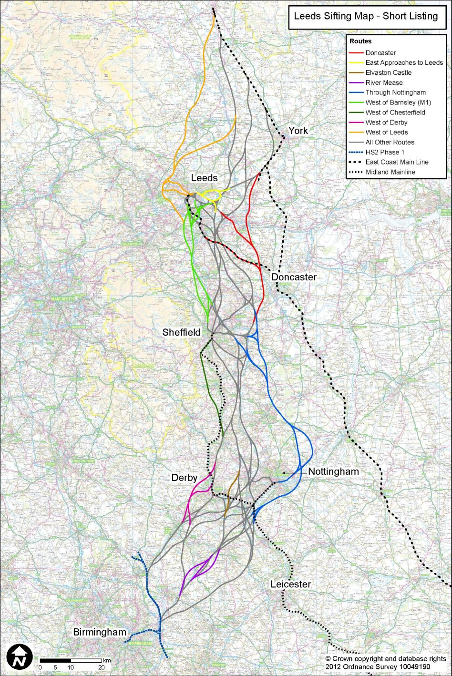
  - Short Listing

Introduction
        - The coloured lines shown on the map on the left present those routes which formed part of the option refinement process, but which did not progress beyond that stage. The text following this map explains the main engineering implications of those routes (which was not necessarily the reason why they did not progress further).

Routes crossing the River Mease North of the M42
        - Three route options were considered that crossed the Special Area of Conservation-designated River Mease near Measham alongside the M42 motorway.
        - One option would pass in an 8km tunnel under Appleby Parva, Appleby Magna, the River Mease and Measham but it was found to be costly and less competitive that alternative routes through this area.
        - One option would pass immediately east of Appleby Parva, Appleby Magna and Measham by crossing the tributaries of the River Mease rather than the river itself, but it would be of greater length and the number of viaduct crossings would increase costs.
        - The final option would cross to the western side of the M42 at Polesworth, passing west of Newton Regis before rejoining the A42 alongside Oakthorpe, and then crossing over the River Mease and the A42 north of Measham. The additional length of this route, coupled with the number of viaduct crossings of the M42 / A42 and water bodies, would increase the cost with little overall benefit in relation to alternative routes through this area.

Routes West of Derby
        - Routes were considered that either ran around the western side of Derby, ran through Derby via the former Great Northern (Derby Friargate) route, or a combination of the two to form a bypass line and a city loop.
        - The route that passed around the western edge of Derby would not be unduly challenging to engineer or construct, but a station on such a route would not serve the centre of Derby, nor provide interchange with existing rail services, so would poorly serve the East Midlands region.
        - A route that passed through Derby via the former Friargate station would have a low design speed due to the geometrical constraints of the Great Northern corridor. In addition, this corridor has been partially built over by a range of developments. A station on this route would also not be able to provide interchange with existing rail services.
        - A combination of the western Derby bypass combined with a Derby Friargate loop was considered, but this would require twice the length of new railway construction than other options while still not providing the ability to interchange with existing rail services.

Route near Elvaston Castle
        - A route was considered that would run would run through the tree-lined avenue in close proximity to Elvaston Castle before passing through the gap between the villages of Borrowash and Spondon. This route would not create any significantly greater engineering challenges than its direct competitor routes, but nor would it offer any particular benefits. The station that would have been located on this route did not progress past the short listing stage.

Through Nottingham
        - If the route were to pass through central Nottingham, it would include a station in the vicinity of the existing Nottingham Midland station. This would cause the new tracks to follow an approximately east-west axis through the city. Two routes were considered east of the city for the northward curve that would be required to enable the route to head towards the urban centres of South Yorkshire.
        - One option would follow the Nottingham to Newark railway to Burton Joyce, involving the reconstruction of Carlton station. North of a Burton Joyce tunnel, the route would cross hilly terrain, requiring costly tunnels and viaducts. The design speed would be 320kph through Burton Joyce and Lowdham, rising to 360 - 400kph for the remainder of the route. Journey times to the north would be greater than more direct routes via the Derby – Nottingham gap or via Toton.
        - A second option would follow the Nottingham to Newark railway line to Lowdham. This would involve the reconstruction of existing stations at Burton Joyce and Lowdham. The route would avoid tunnelling. The speed would be 225kph in the existing rail corridor, rising to 275kph between Lowdham and Southwell and then increasing to 400kph. Journey times to the north would be greater than more direct routes via the Derby – Nottingham gap or via Toton.
        - A route south of Nottingham, with a station at Clifton, was considered. It would run through unchallenging territory, but would involve a crossing of the River Trent. It would not serve central Nottingham, nor any locations to the west. Journey times to the north would be greater than more direct routes via the Derby – Nottingham gap or via Toton.

Routes to the West of Chesterfield
        - A route option was considered that would pass around the western side of Chesterfield before joining the existing railway corridor through Dore to reach Sheffield Midland station.
        - A route to the west of Chesterfield would pass through the challenging topography of the foothills of the Derbyshire Peak District. This would require the route to include approximately 10km of new tunnel, several viaducts and extensive earthworks. The route would also require the existing railway between Dore and Sheffield Midland to be widened, and for Sheffield Midland station to be reconstructed.

Routes West of Doncaster
        - A route option was considered that would broadly follow the A1 north of the Doncaster area with the aim of following an existing transport corridor. This route would cross open rolling country requiring relatively simple construction apart from a tunnel under Shooters Hill near Upton, a viaduct across Hampole Valley and the reconstruction of part of the Leeds to Castleford Line.
        - The A1 corridor passes approximately 10km to the east of Leeds. This distance would mean that the point where the route to Leeds and the route to the ECML would diverge would be located south of Pontefract. This would require a greater length of new track construction than other comparable routes.
        - North of the point where the two branches of the route would diverge, the spur to the ECML would follow the A1 past Knottingley and Ferrybridge. This section would be challenging to construct due to the density of highway and electricity infrastructure, together with the proximity of urban areas.

Routes to the West of Barnsley
        - Two routes were considered between Sheffield and Leeds that would pass to the west of Barnsley and broadly follow the M1 corridor. These two route options would be common to south of West Bretton, here they would diverge with one route continuing to follow the M1 to Leeds whereas the other would take a more direct route that would pass between Ossett and Dewsbury.
        - North of Sheffield the M1 runs through hilly terrain. Several towns and villages have grown towards the motorway treating it as a growth boundary. These two factors would result in any railway alignment through this area requiring the extensive use of steep gradients, tunnels and significant earthworks.
        - North of West Bretton, the most significant engineering challenge is the Calder Valley and the string of towns that run along its northern bank. A direct route into Leeds that ran between Ossett and Dewsbury would be able to cross the Calder Valley on a viaduct. However, no acceptable route for a branch off this route linking to the ECML via the low ground on the eastern side of Leeds was identified.
        - A route north of West Bretton that would follow the M1 corridor would be able to link to the ECML via eastern Leeds, but this link would either have a low ( <200kph) design speed or would be costly because of the urban nature of the area near the confluence of the M1 and M62. The crossing of the Calder Valley would likely require a tunnel if it were made close to the M1 due to the need to minimise residential demolitions in Horbury.

Routes around the Western Side of Leeds
        - A group of routes were considered that would pass around the western side of Leeds in order to reach the ECML.
        - In order to pass around the western side of Leeds, the route would be required to pass to the west of Barnsley. It would not be practical to connect to the ECML much to the south of Northallerton due to topographical and urban impact constraints as well as the desire to provide a reasonably direct route. This would mean that high speed trains would not be able to serve York. It would also mean that a greater length of new high speed route would be needed.
        - The topography on the western side of Leeds would be challenging for railway construction. For example, the base of the Aire Valley is approximately 170m below the crests of the hills on its northern edge in the vicinity of Leeds-Bradford airport. This topography would require the use of substantial lengths of tunnels and viaducts.

Routes Approaching Leeds from the East
        - Two route options were considered that would serve an east-facing Leeds station, whose site was not favoured for reasons discussed in Chapter 8. One route would follow the existing rail corridor via Cross Gates station and Neville Hill into the city. The alternative route would follow the A63 dual carriageway from M1 Junction 45 to Neville Hill, from where it would join the existing rail corridor to reach Leeds city centre.
        - Both routes would require the reconstruction of the existing railway corridor in order to accommodate the new tracks between Neville Hill and the city centre. The Cross Gates option would extend the length of reconstruction to the edge of Leeds near Manston. Whereas, the A63 option would virtually all be ‘green field’ type construction south east of Neville Hill.
        - Due to the geometrical constraints of following an existing urban rail corridor, the construction of two additional tracks would be costly, and disruptive to existing rail operations and the adjacent communities. The Cross Gates route would not offer attractive journey times, especially for trains operating between Leeds and cities to its south.

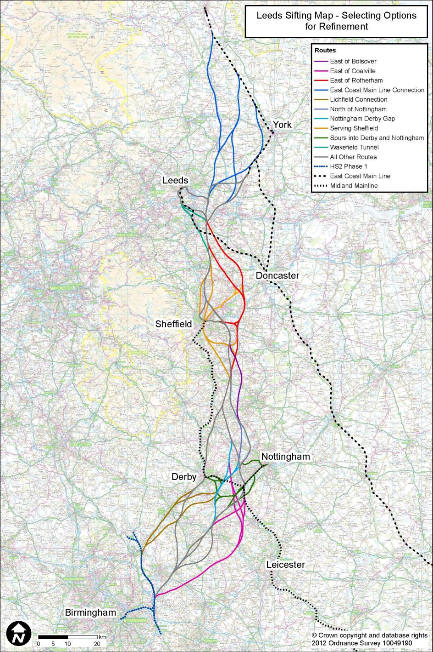
  - Selecting Options for Refinement

Introduction
        - The coloured lines shown on the map on the left present those routes which formed part of the short list, but which did not progress beyond that stage. The text following this map explains the main engineering implications of those routes (which was not necessarily the reason why they did not progress further).

Lichfield Junction
        - To provide a junction at Lichfield, the route would continue along the Phase 1 route (London to West Midlands) from Water Orton. This would involve building the Phase 1 scheme as a 4-track railway or by a later on-line widening adding two extra tracks. The number of tracks would need to be increased to provide required operational capacity for the planned timetable for trains heading towards Manchester and Leeds. At Lichfield, a grade-separated junction would be required to enable the route to generally follow the A38 towards Derby.
        - The routes towards the East Midlands would broadly follow the A38 and either run alongside the Birmingham to Derby railway through Burton-upon-Trent or bypass the town to the south. Passing through Burton-upon-Trent would involve the realignment of the existing railway for 6.7km and a number of retaining walls to accommodate the new route alongside, as well as the rebuilding of Burton Station to avoid demolition of a listed bridge to the east. Passing to the south of Burton-upon-Trent would require a tunnel to pass through the area of higher ground in between Burton-upon-Trent and Swadlincote.
        - Any route broadly following the A38 from Lichfield would have few geotechnical issues but would require substantial viaduct crossings of the River Trent flood plain of up to 5km. Journey time penalties for adopting a junction at Lichfield would be up to 5minutes and it would lengthen the route up to 15km.

East of Coalville
        - This group of routes would start at Water Orton and would pass east of Coalville, generally following the M1 motorway south of Nottingham on either its western or eastern side for up to 13km.
        - These routes would pass through hilly terrain and this would be reflected in the engineering proposals, resulting in a number of tunnels, large embankments and cuttings. A 450m tunnel would be required at Baddesley Common and a retained section near Bagworth to minimise landtake. By remaining on the western side of the M1, further tunnels, total length up to 3.7km, would be required to pass under Birch Hill, Lubcloud and East Midlands Airport. By passing to the eastern side of the M1, gradients up to 3.3% would be required to follow the existing terrain as well as complicated M1 motorway crossings.
        - This group of routes would also cross the River Soar and Trent flood plains at their confluence leading to long viaducts up to 5km to cross them, with significant effects on the rivers.
        - The complications of the challenging terrain that this group of routes would pass through would be offset by the fewer geotechnical and mining-related issues that would exist. However the implications of passing east of Coalville would add 5km to any route length and add approximately 2 minutes to journey times.

Spurs into Derby and Nottingham
        - This group of routes consisted of spurs into Derby, or Nottingham, or both, as alternatives to through route options.
        - Spurs into Nottingham would consist of either following the Castle Donnington freight line for 7km before crossing the River Trent on a series of viaducts before joining the Midland Main Line, or passing under East Midlands Airport in a 2.8km tunnel on a reasonably direct route into Nottingham which would involve crossing a number of existing railways, or alternatively passing to the south side of Thrumpton after emerging from the tunnel to avoid the numerous rail crossings. The common section for all these options would be the Midland Main Line section into Nottingham from Attenborough / Beeston which would require the reconstruction of up to two stations and other rail works to accommodate the new route alongside. A spur would add approximately 26km to the overall route length.
        - The spur into Derby would involve running alongside the Leicester to Derby line for up to 7km after passing around the north-eastern edge of Elvaston Castle Country Park at speeds of up to 175kph. To accommodate HS2 alongside the Leicester to Derby line, localised slewing would be required along with a number of bridges being rebuilt increasing the disruption to classic services. A spur would add 15km to the overall route length.
        - These spurs would be costly in relation to the benefits they would bring. They would result in significant disruption to services on the existing network and road users during construction and offer little benefit in terms of journey times when weighed against through route station options. The journey time penalty for trains to Leeds via a spur into Nottingham would be up to 13 minutes, and 7mins via Derby. Journey time penalties to an East Midland station compared to alternative through options would be up to 3mins to Nottingham and 2mins to Derby.

East of Bolsover
        - This route would pass to the east of Hardwick Hall and Bolsover to mitigate the related noise and visual impacts of running along the valley floor to the west. At Selston, the route would diverge from the M1 to head to the east side of Bolsover. As the terrain would be challenging, a 1.3km tunnel would be required under Sutton-in-Ashfield and large cuttings and embankments would be required to reach the high plateau to the east of Hardwick Hall.
        - Beyond Bolsover, the vertical alignment would fall at a 2.5% gradient towards Renishaw for 2km. Again, large cuttings would be required to descend from the higher land to contain the vertical gradient to within design standards. There would be a retained box structure under the M1 motorway, before the route aimed for the valley of the River Rother.
        - The challenges of the terrain and proximity of urban conurbations would require speed reductions to 375kph for 6km. Furthermore, the required earthworks and tunnel were found to be costly and less competitive than alternative routes through this area.

The ‘Gap’ between Nottingham and Derby
        - The group of routes would pass through the ‘Gap’ near Draycott, between Nottingham and Derby, and would generally traverse the Derwent Valley on viaducts up to 3km long, 10m to 15m high, crossing the River Derwent and its flood plain. A complicated crossing of the A6 / A50 road junction would also be required.
        - To meet the remit of serving the East Midlands, a station would be required in the vicinity of Draycott. It would be challenging to incorporate a level gradient at the station location on account of the rising terrain on the northern side of the Derwent Valley. Furthermore, part of the station would need to be elevated above the Derwent flood plain. Alternative through route stations would not encounter the same issues. The station location was ruled out at the option refinement stage because of its effect on the Green Belt.
        - Towards the top of the northern side of the Derwent Valley, tunnels or large cuttings would be required to pass through the crest near Hopwell and Risley to continue the alignment towards South Yorkshire.

North of Nottingham
        - This route would provide a fast direct route north from a potential station at Toton before joining the M1. On the exit out of Toton, a number of crossings both over and under would be required to cross the River Erewash, Erewash Canal, M1 and existing Erewash Valley railway, before entering a short 450m tunnel to pass under Cossall on its approach to the M1. Due to the urban conurbations of Awsworth and Kimberley and the A610 linking the two, a 900m viaduct would be required to cross the road before entering a 200m retained box to pass under the M1 a second time.
        - There would be significant engineering challenges with this route as a consequence of achieving a line speed of 400kph but no more so that an alternative route through this area, even at a lower speed.

Serving Sheffield
        - Various options for serving Sheffield on a through route or a loop directly from the south and continuing to the north were explored. Particularly, loop options would involve lengthy and very costly construction, if the aim were to serve central Sheffield at speeds approaching the desired 400kph. Any loop option would involve the construction of two grade-separated junctions on the through route, as well as the required length of additional new track, potentially up to 25km in length. In addition to the route costs, Sheffield would need a new multi-platform high-speed station, possibly in a sub-surface cavern, and with potential flooding issues in the Sheaf Valley.
        - The group of options from the south would all consist of tunnels under the hilly terrain and would pass under urban conurbations. Reducing the speed would only have a marginal impact on cost, as the route would be longer and tunnels would still be required. Added to this, the area south of Sheffield historically has been heavily mined, leading to particular geotechnical concerns. The more direct options required total tunnel lengths up to 12km to pass under Sutton Scarsdale, Staveley and the Gleadless Valley to emerge in the centre of Sheffield. Lower speed options would reduce these tunnel lengths up to 6km by avoiding urban conurbations and being better aligned with valleys but nonetheless would still result in high capital costs compared with the potential benefits.
        - Options north would involve either following the Sheffield to Rotherham or Sheffield to Stocksbridge railway lines at a low speed or entering a tunnel to pass under the northern suburbs of Sheffield. Following the existing railway lines would require the route to be largely elevated due to the existence of flood plains and impracticalities of moving existing infrastructure. Tunnels to the north would either pass under Parson Cross or Burngreave / Shiregreen and give a total tunnel length of between 5km and 15km depending on the route.
        - The direct route options were found to be costly due to the length of tunnel required and outweighed the benefits the routes would bring. Lower speed options would bring negative journey time impact with reduced capital costs but would not bring the required benefits to make the routes attractive.

East of Rotherham
        - The group of routes east of Rotherham would broadly follow the M18 for 2.2km, and then pass through available gaps between existing towns on their approach towards Leeds. In broad terms, these routes would only serve parts of South Yorkshire, and would be remote from the largest single market of Sheffield.
        - By passing through the gap between Swinton and Mexborough, the route would be constrained by flood plains and existing railways, which would require a series of long viaducts. A tunnel would also be required under Cudworth. By passing through the gap between Mexborough and Conisborough, the route would require a 2km tunnel to pass under Hickleton before skirting around South Kirby, Hemsworth and Crofton towards Leeds.
        - The routes east of Rotherham would be sufficiently far to the east to avoid the large concentrations of shallow mining and opencast working associated with the Middle Coal Measures strata, but would not be without risk due to unknown historical data.
        - The consequence of these routes would be that they would not directly serve Sheffield and access could only be achieved by a spur off these routes, adding to the capital cost through additional route length. Journey times to central Sheffield would be less competitive than a direct route. There would be potential for placing an intermediate station on a through route but this would be remote from the urban areas where demand is concentrated, and these station options were ruled out.

Wakefield Tunnels
        - Routes passing under Wakefield offered fairly direct connections to potential stations west of the existing Leeds station limiting the impact on journey times. Therefore numerous options were explored which resulted in varying tunnel lengths from 5km to 11km.
        - These options included entering a tunnel south of Wakefield and emerging north of Wakefield station near Alverthorpe before broadly following the Doncaster to Leeds railway as far as Middleton, at 125kph or continuing in tunnel until just north of the M62 motorway crossing east of Morley at faster speeds of 300kph. A route entering a tunnel north of Wakefield near Outwood and emerging east of Morley was investigated offering speeds of up to 300kph.
        - The required length of tunnel for these options were found to be costly and had additional concerns of passing through ground which had known historical mining activities, increasing construction risk.

East Coast Main Line Connection
        - A number of options were explored for connecting into the East Coast Main Line at various locations between Colton Junction and Northallerton (and hence beyond to an aspired high-speed destination of Newcastle). On joining the East Coast Main Line, Classic Compatible trains would run onwards towards Newcastle.
        - These options included:
- A grade-separated connection at Colton Junction with trains running through York station towards Newcastle;
- a grade-separated connection south east of Tollerton forming a short York bypass by broadly following the A1237 York Ring Road;
- a grade-separated junction just north west of Raskelf after leaving the route following the A1 (M) and passing through the disused airfields of Tockwith and Tholthorpe Moor.
        - As this group of routes would all pass through the Vale of York, there would be no significant engineering challenges other than the operational complications of sharing the same corridor as existing rail.
        - As none of these routes would travel directly to Northallerton from the south, they would all have negative journey time impacts increasing from 3 minutes for a connection at Raskelf to 14 minutes at Colton Junction. By increasing the journey time impact, the costs reduce to account for the reduced length of new line needing to be built.
        - The key issue associated with any route bypassing York, and connecting north of it, is that of staged expenditure. However attractive such options might be in terms of journey time savings, they would involve a much greater length of construction than more modest options connecting between the Normanton / Castleford area and York itself.
        - Options connecting between Normanton / Castleford and York were considered, and there was a clear trade-off between short lengths of new construction (which favoured connections in the Castleford area) against the slower journey times that would be involved in utilising slow existing Network Rail infrastructure in the Castleford, Sherburn-in-Elmet and Church Fenton areas. It was therefore concluded that a connection near Church Fenton offered the best balance of capital cost and journey times.

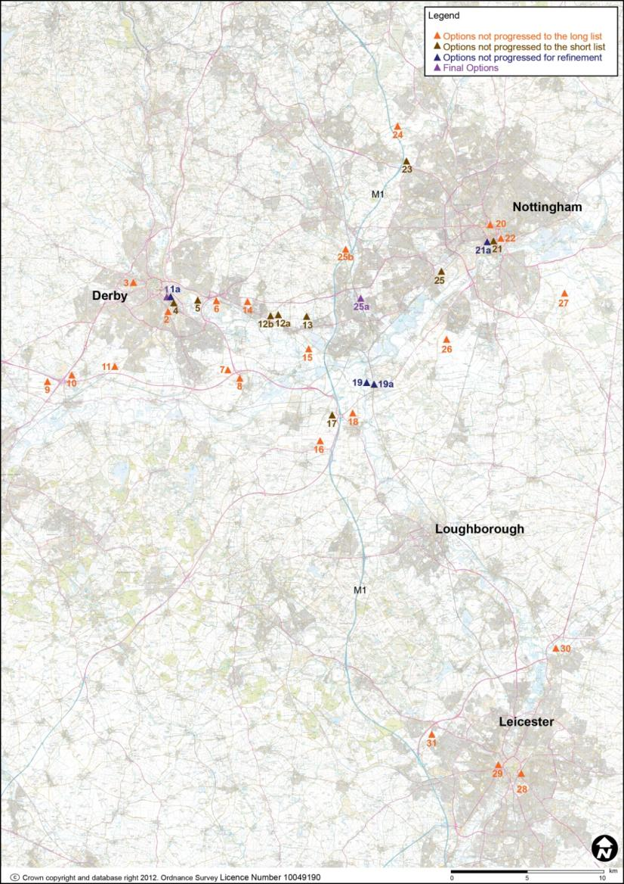
- History of Station Options in the East Midlands
  - Selecting a Station for the East Midlands
        - This chapter sets out all the station options which were developed in the East Midlands during the process of station selection.
        - At the beginning of this process, a wide-ranging list of options was drawn up. This list was gradually reduced, through a sifting process over a number of stages, as follows:
- Initial list;
- Long list;
- Short list;
- Options for further refinement; and
- Final options.
        - At each stage of the station selection process, the station designs selected for further development were elaborated in greater detail, in parallel with the line of route process. While generic station designs were used for decision-making at the earlier stages, these were adapted to individual sites as the process progressed.
        - The criteria by which station options were assessed included considerations of site availability and fit, impact on surrounding infrastructure, connectivity, engineering feasibility and constructability, sustainability, proximity to demand, and cost. These were considered in conjunction with the viability of the business case.

The map on the previous page sets out all the station location options which were considered in the East Midlands area. The chart below illustrates the stages of the sifting process through which each option was developed:
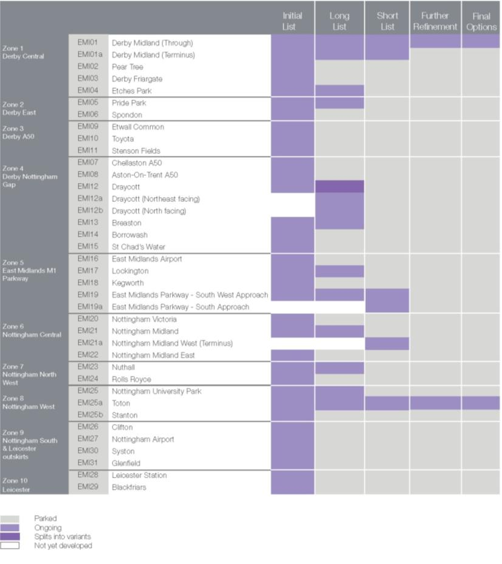
  - Initial List of Station Options
    - List of Stations
        - The initial list of station options in the East Midlands was:
EMI01 Derby Midland (Through)
EMI01a Derby Midland (Terminus)
EMI02 Pear Tree
EMI03 Derby Friargate
EMI04 Etches Park
EMI05 Pride Park
EMI06 Spondon
EMI07 Chellaston A50
EMI08 Aston-on-Trent A50
EMI09 Etwall Common
EMI10 Toyota
EMI11 Stenson Fields
EMI12 Draycott
EMI13 Breaston
EMI14 Borrowash
EMI15 St. Chad’s Water
EMI16 East Midlands Airport
EMI17 Lockinton
EMI18 Kegworth
EMI19 East Midlands Parkway
EMI20 Nottingham Victoria
EMI21 Nottingham Midland
EMI22 Nottingham Midland East
EMI23 Nuthall
EMI24 Rolls Royce
EMI25 Nottingham University Park
EMI25a Toton
EMI25b Stanton
EMI26 Clifton
EMI27 Nottingham Airport
EMI28 Leicester Station
EMI29 Blackfriars
EMI30 Syston
EMI31 Glenfield
  - Defining the Long List
    - Options Not Progressed to Long List
        - Where a description applies to a group of stations as a whole, these have only been described as a group.

EMI02 Pear Tree
        - This station would be situated to the southeast of Derby city centre in the Pear Tree area adjacent to the existing Derby / Birmingham line. It would be 1km from the existing Derby Midland station and 1.9km from the city centre and so not within reasonable walking distance. New platforms could potentially be constructed on the Derby-Birmingham line to provide interchange with conventional network services, but given the proximity to Derby Midland station this would have significant service implications. Very few trains currently call at the existing Pear Tree station.

EMI03 Derby Friargate
        - This station would be located to the west of Derby city centre on the site of the former Derby Friargate station. This station would be 1km from the city centre and 2km from the existing Derby stations. Approaches to this station would have severe alignment constraints with achievable design speeds in the order of 80kph and so this station would not be on a through route. The station would not offer potential for interchange with the existing rail network.

EMI06 Spondon
        - This station would be east of Derby city centre adjacent to existing Spondon station. It would not offer pedestrian connectivity to Derby as it would be approximately 4.5km from the city centre. It would have good interchange with conventional network trains on east / west routes, but very poor interchange on north / south routes. The station would impact significantly on the adjacent industrial estate but it is understood that the site is already identified for redevelopment.

EMI07 Chellaston and

EMI08 Aston-on-Trent A50
        - These station options would be located 7.5km southeast of Derby city centre adjacent to the A6 / A50 junction. One option would be northwest of the junction and the other to the south of the junction closer to Aston on Trent. They would be through stations, elevated to enable the main line to cross over the A50. They would be approximately 6.7km from the A50 junction with the M1. The stations would not be near the existing rail network and would have very poor public transport connections with the region.

EMI09 Etwall Common,

EMI10 Toyota, and

EMI11 Stenson Fields
        - These options would be located approximately 9.6km southwest of Derby adjacent to the junction of the A50 and the A38 (Burton Road). This group would be distant from Derby and Nottingham and 22km west of the M1 and so not well located to serve the main centres of demand and the wider region. Only EMI11 Stenson Fields would have potential for interchange with the existing rail network. EMI09 Etwall Common and EMI10 Toyota would be on embankments, as the through alignment would be elevated to cross over the adjacent highways.

EMI14 Borrowash
        - This station would be located in the narrow gap between Borrowash and Spondon in open fields, spanning Borrowash Bypass (A52) and Derby Road (A6005). Interchange with the conventional network would be possible with a new station on the existing Derby / Nottingham line and the A52 would provide good highway access.
        - The approach from the south would have to be tunnelled as a result of the heritage implications at Elvaston Castle. The approach from the north would be in cutting. The station and approaches would be close to the residential areas of Borrowash and Spondon.

EMI15 St. Chad’s Water
        - This station option would be located in the flood plain of the River Derwent, on the west side of the Church Wine Reservoir. It would be 10km from Derby and 16km from Nottingham. It would be an elevated through station on the main line, as the approach would require a 1.5km-long viaduct over the rivers Trent and Derwent. The station would have poor access from the local trunk road system and no potential to interchange with the existing rail network.

EMI16 East Midlands Airport
        - This station would be located directly below the East Midlands Airport. It would provide a direct connection for the airport and would be well connected to the highway network. The nearest connection to the existing rail network would be at East Midland Parkway station.
        - The alignment in this area would pass under the airport in tunnel and the station would be in a cavern extending under the existing operational airport runway. There would be significant engineering risks associated with constructing the large station cavern under the operational runway.

EMI18 Kegworth
        - This station option would be located directly east of the junction of the A50 and A453 and M1 Junction 24. The station would be 15.5km from Derby and 15km from Nottingham but would serve the East Midlands Airport 3.7km away. This option would be a through station on the main route and would be constructed in cutting due to its southwest approach passing below major highways.

EMI20 Nottingham Victoria
        - This station would be located in Nottingham city centre directly below the Victoria Centre, on the site of the former Victoria station. The option would be well located to serve the Nottingham market. A fully tunnelled approach would be the only realistic option as the historic railway corridor has been heavily developed. The existing approach tunnels to the former station are likely to be too small for high speed rail requirements.

EMI22 Nottingham Midland East
        - This station option would be immediately north east of the existing Nottingham Midland station on the site of the former Great Northern railway station. It would be 800m from the city centre and would offer good access and connectivity. This location would have direct access to the tram line and inner city ring road and would be 1km from the main bus station.
        - It could be either a terminus or a through station at grade. The west approach to the station would have significant impact on the city, and being oriented east-west is not ideal for a through route.

EMI24 Rolls Royce
        - The station would be located 8.8km north / west of Nottingham city, adjacent to the Rolls Royce airfield and test facility. The approach from the south would require property demolition at Nuthall. Connectivity at this location would be poor.

EMI25b Stanton
        - This station option would be a through station, at grade, on the main line. It would be located approximately 14km from Derby city centre and 11km from Nottingham city centre. There would be an opportunity for interchange with the existing rail lines which would run east of the site, subject to construction of a new station. The site would have poor highway access.

EMI26 Clifton and

EMI27 Nottingham Airport
        - This group of station options would be located south of Nottingham and north of Leicester. The viability of these station options would be dependent on a route approach from Leicester.

EMI28 Leicester Station
        - This station option would be located at the existing station, about 900m from the city centre. This option would be a through station on the main line, at grade. It would have very good connectivity to the inner city road network and buses.
        - Key issues would include the complexity of the station approach and its impact on the existing rail network and station.

EMI29 Blackfriars
        - This station option would be located about 800m west of Leicester city centre and would be an elevated through station on the main line.
        - Key issues would be the approaches, where line speeds would be heavily constrained. Also, the preserved Great Central Route and Heritage Railway would be compromised and, therefore, the possibility of tunnelled approaches should be considered.

EMI30 Syston
        - This station would be a through station on the main line, north of Leicester by the village of Syston, on the south side of the junction of the A46 and A607.
        - Key issues would be pedestrian access, which would be limited to local access for the village; and lack of major access to the road network.

EMI31 Glenfields
        - This station option would be a through station, at grade, on the main route . The station would be located 6.5km west of Leicester, on the south side of the A46. Junction 21A of the M1 would be 4km away.
        - Key issues to be addressed would include the southern approach, which would require widening of approximately 25km of the existing rail corridor, and the level of demand associated with this station’s rural location.

    - Stations Introduced or Modified
        - Station option EMI12, at Draycott, was developed as EMI12a and EMI12b to reflect the orientation of two alternative route options as they pass the station location.
    - Options Progressed to Long List
EMI01 Derby Midland (Through)
EMI01a Derby Midland (Terminus)
EMI04 Etches Park
EMI05 Pride Park
EMI12a Draycott (Northeast facing)
EMI12b Draycott (North facing)
EMI13 Breaston
EMI17 Lockington
EMI19 East Midlands Parkway
EMI21 Nottingham Midland
EMI23 Nuthall
EMI25 Nottingham University Park
EMI25a Toton
  - Defining the Short List
    - Options Not Progressed to Short List

EMI04 Etches Park
        - This station option would be located on existing railway land adjacent to Etches Park train maintenance depot, approximately 1.5km from Derby city centre. It would be a terminal station, at grade, served by a spur from the main line. At 500m from the existing rail station, passenger interchange times would be relatively long. Walking routes to the city would involve crossing the existing railway and bus connection would be poor. There would be impacts on existing rail operations including the Etches Park maintenance depot.

EMI05 Derby Pride Park
        - This station option would be an outer city station alongside the existing Derby-Nottingham line. It would be approximately 3km from the city centre and 1.5km from the existing railway station, making interchange on foot non-viable. It would also be 2.3km from the A52 / A511 junction and 5km from the A6 / A50 junction. Interchange with the conventional rail network could be provided with a new station on the adjacent existing line. The station and its approaches would be slightly elevated to raise them above the flood plain, as is the existing line.

EMI12a Draycott (Northeast facing),

EMI12b Draycott (North facing), and

EMI13 Breaston
        - These options would be located in the designated greenbelt area between Derby and Nottingham. The three options would be similar except that each one would be on a different line of route option. They would be approximately 10.4km from Derby and 16km from Nottingham, and so interchange to other modes would be required to serve these centres of demand. Interchange with the existing rail network would be achieved by construction of a new station on the Derby-Nottingham line. These stations would also have good highway connectivity to the region via the adjacent A52, on which a new junction would be required to provide access to the station.
        - Approach to each station from the south would require a long viaduct over the River Derwent as well as elevated crossings over the A6005 and Derby / Nottingham railway line. The southern approach to the Breaston option would also pass through the village of Breaston. The northern approach would be in cutting / tunnel as the land rises through hilly terrain to the north.

EMI17 Lockington
        - This station option would be on the main high speed route located directly west of the junction of the A50 and A453 and M1 Junction 24, to the east of the village of Lockington. The station would be on a sloping site leading to some significant engineering challenges. The station would be sub-surface with tunnelled approaches from the south under East Midlands Airport and to the north would cross the A50 and the Trent valley. It would be 15km from Derby and 16km from Nottingham but would provide access to the East Midlands Airport 2.5km away. Interchange with the existing rail network would not be possible at this location.

EMI21 Nottingham Midland
        - This station option would be immediately south of the existing Nottingham Midland station. It could be either a terminus or a through station at- grade. It would be 800m from the city centre and would offer excellent access and connectivity to the city due to availability of interchange to several different modes at the site, including the existing rail network, tram and bus.
        - The east-west orientation, together with restrictions on the approach corridors through the city, would impact overall journey times for a through route. The approach from the west would have to pass under Carrington Street and would impact the Grade II* listed station bridge structure as well as adjacent roads. The eastern approach would have to address the alignment challenges posed by having to pass under the A60 and over the adjacent canal.

EMI23 Nuthall
        - This station option would be located to the northwest of Nottingham in the village of Nuthall on the east side of the M1. It would be about 7km from Nottingham city centre and the nearby M1 Junction 26 would provide good highway access, though it would be toward the north side of the East Midlands region. There would also be potential to extend the tram service to this station to provide further connectivity to Nottingham.
        - This option would be an elevated through station on the main route through the village and would require property demolitions. The through alignment would be on a curve as it passes east of the M1, which could lead to a wider footprint for the station as well as speed restrictions on the main line.

EMI25 Nottingham University Park
        - This station option would be located south west of Nottingham city centre, adjacent to the existing railway to the south of Nottingham University. The Boots Campus and Enterprise Zone, would be immediately to the south. This option would be at grade and would require realignment of the existing lines to accommodate the high speed alignment. It would be about 3.5km from the city centre but highway access would be poor due to a lack of main trunk roads nearby. Good connectivity with the adjacent existing lines could be provided with new platforms adjacent to the high speed ones. The proposed NET extension along University Boulevard would not provide good tram proximity to the station but it may be possible to extend the tram nearer to the station.
    - Stations Introduced or Modified
Following short listing, option EMI19a at East Midlands Parkway was introduced to reflect a different line of route. Option EMI01 was reconfigured to maximise train speed for that option. Option EMI21 at Nottingham Midland was not progressed, but a new option, EMI21a, was introduced to the west and named
Nottingham Midland West (Terminus) to mitigate effects on the existing listed station building and the local road network. This was a spur station stopping just west of Carrington Street.
    - Options Selected for Further Refinement
EMI01 Derby Midland (Through)
EMI01a Derby Midland (Terminus)
EMI19 East Midlands Parkway (South West Approach)
EMI19a East Midlands Parkway (South Approach)
EMI21a Nottingham Midland West (Terminus)
EMI25a Toton

1 | High Speed Platforms
2 | Existing Derby Station
3 | Concourse
4 | Forecourt
5 | Car Park
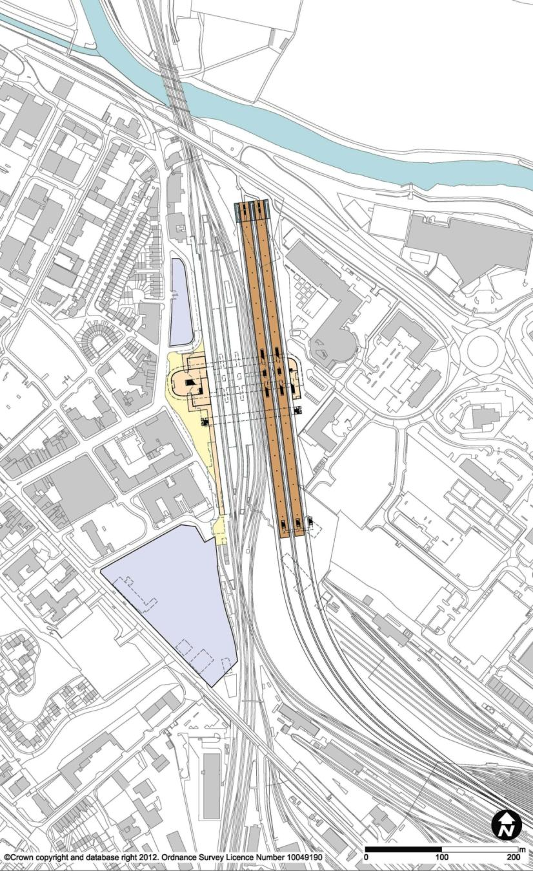
3

5

2

1

4

5

  - Identification of Options for Further Refinement
    - Options Not Progressed for Further Refinement

EMI01a Derby Midland (Terminus)
        - This station option would be located immediately adjacent to the existing Derby station, southeast of the city centre on the east side of the City Ring Road. It would comprise a new integrated rail concourse and forecourt, and would involve extensive remodelling of the existing station concourse and forecourt. This option would be a terminus on a spur from the main line, constructed at grade on a curved approach, and would thus not provide a through service.
        - The existing centrally-loaded platforms would remain, and the high speed platforms would be located to the east. The platforms would be accessed from above by a paid link concourse / bridge. This bridge would connect the main forecourt and concourse with a pedestrian entrance on the east side of the station for access to and from Pride Park, including Derby College, and Derby County Football Club. A new pedestrian footbridge would provide an unpaid link between the east and west sides of the station.
        - The station would be approximately 1.1km from the city centre, with the main bus station within walking distance. It would also offer direct interchange with the existing rail services to Nottingham and other local destinations.
        - Key issues would include operational constraints as a terminus, impact on the existing station, and ability to serve the wider region, as well as demolition of the new Derby College building and impacts on approach tracks to Etches Park depot to the east of the existing station.

1 | High Speed Platforms
2 | Existing EM Parkway Station
3 | Concourse
4 | Forecourt
5 | Car Park
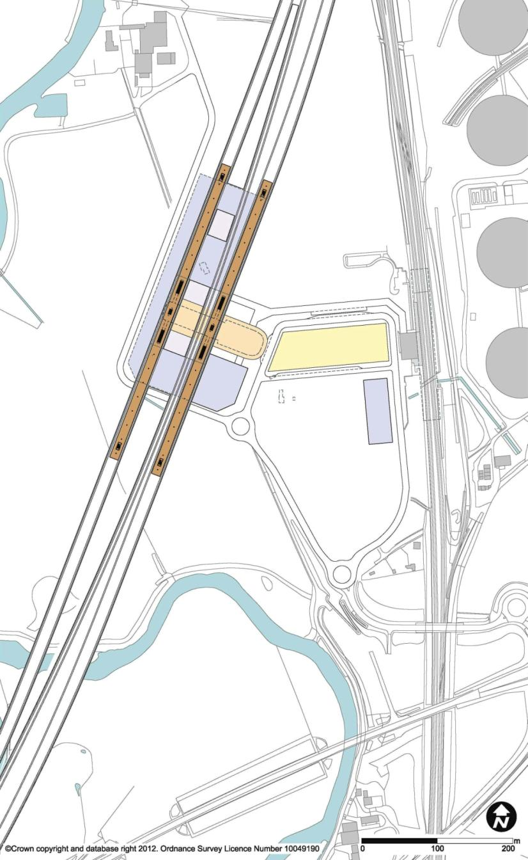
3

2

5

4

1

1

5

EMI19 East Midlands Parkway (South West Approach)
        - This station option would be located in a rural location, adjacent to and west of the existing East Midlands Parkway station, which itself lies just to the west of the Ratcliffe-on-Soar Power Station. It would be an elevated, centrally-loaded through station, with the curved tracks raised over the valley on viaducts to clear the A453 and existing rail tracks, and going through the Red Fort Hill Scheduled Ancient Monument in a cutting. Junction 24 of the M1 would be approximately 2.5km to the west.
        - Multi-storey car parks would be provided underneath the station, with the concourse located on an intermediate level. A covered pedestrian link would facilitate interchange with the existing rail station and provide access to the forecourt.
        - The station would offer interchange with rail on the conventional network via the East Midlands Parkway station, but would be 2.8km from the A50 / A453 junction and 5km from East Midlands Airport. Derby would be 16km away and Nottingham 13km.
        - Key issues would include the level of the northern approach and the curvature of the alignment, the demand associated with its rural location, the long walking distance between the high speed station and the existing station, and the impact of the elevated station (which would have a wide footprint) and alignment on the rural setting, which is in Green Belt land and in a flood risk zone.

1 | High Speed Platforms
2 | Existing EM Parkway Station
3 | Concourse
4 | Forecourt
5 | Car Park
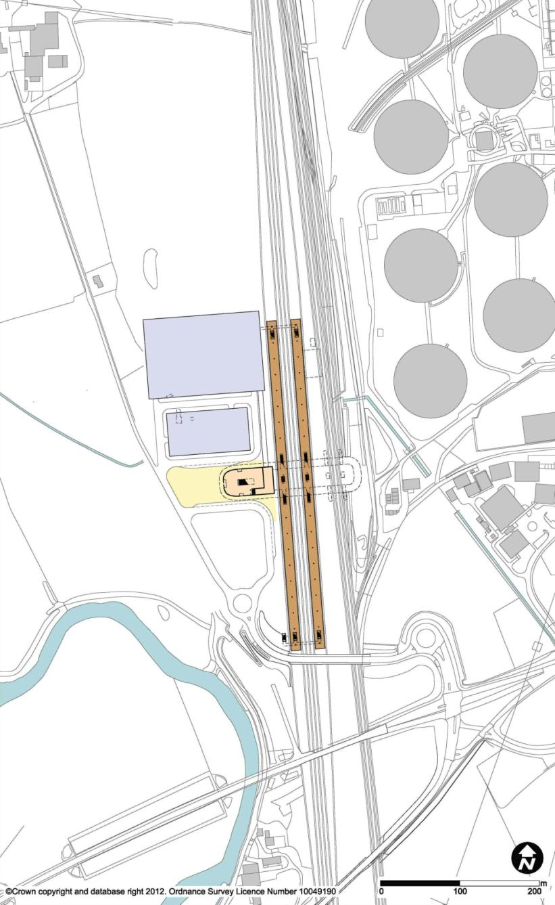
3

5

5

4

2

1

EMI19a East Midlands Parkway (South Approach)
        - This station option was developed only during the design stage leading to the short-list. It would be similar in connectivity and location to option EMI19, but on a different line of route.
        - Unlike EMI19, the option EMI19a station would be integrated with the existing East Midlands Parkway station, which would be completely reconfigured. The station would be situated at grade, with a centrally-loaded concourse above providing access to new platforms for the existing rail services as well as the high speed services on the west side. There would be a new road layout configuration, pedestrianised forecourt, access and parking on the west.
        - Key issues included disruption to existing services due to the necessary complete realignment of the Midland Main Line, impacts on a nearby Scheduled Ancient Monument, and demand associated with the rural location.

High Speed Platforms | Existing Nottingham Station | Concourse | Forecourt | Car Park | Nottingham Express Transit
3
6
2
1
4
5
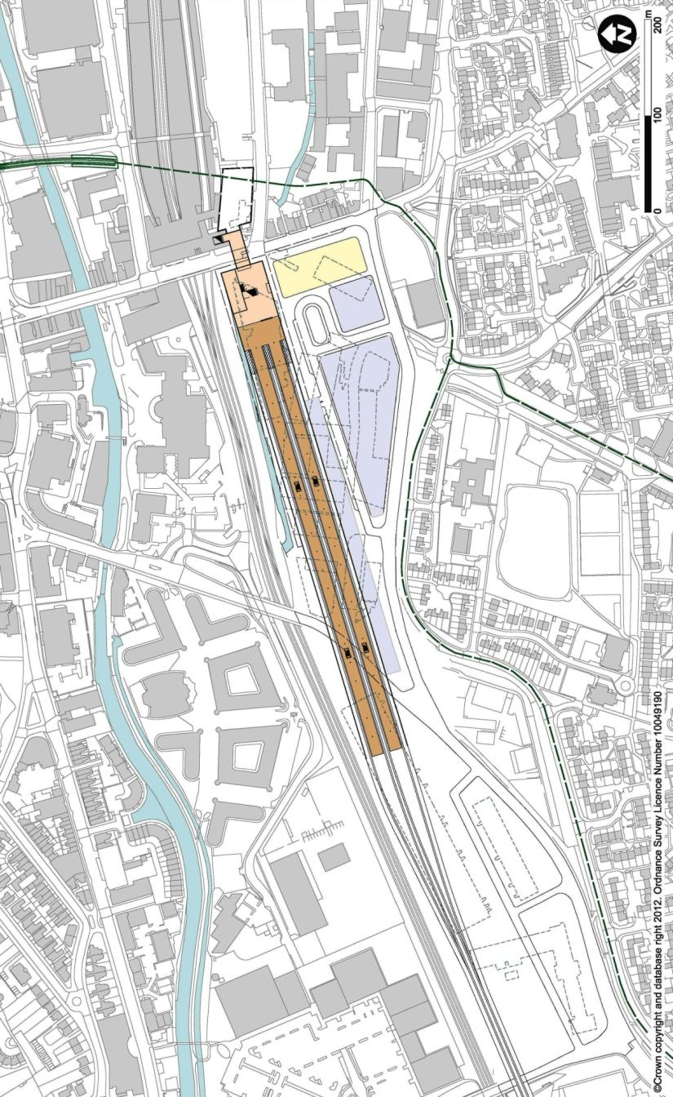
6
2
3
1
5
5
4

EMI21a Nottingham Midland West (Terminus)
        - This station option was introduced at short list stage, replacing station option EMI21, to investigate additional options at Nottingham Midland station, in order to minimise impacts on the existing infrastructure. It would be a terminus station located to the west of the existing Nottingham Midland station and would thus not be able to accommodate through high speed services. The integration with the existing station would offer excellent interchange with existing rail services. The station would be situated at grade, with tracks and end-loaded platforms at the level of the existing station. Access for pedestrians from the city would be via an upper concourse at street level fronting onto Carrington Street. A forecourt for vehicular access and a car park would be located to the south of the station. Direct interchange with the existing station would be via a link under Carrington Street.
        - The route from the west would pose significant engineering and environmental challenges. An extensive length of the existing two-track corridor would have to be altered to accommodate the additional lines required, including road crossings.
    - Stations Introduced or Modified
        - The designs of the station options progressing through to confirmation of the final options were refined further during this stage. While no new station options were introduced, further study of the alignment through Derby was carried out in order to optimise through line speed.
  - Confirmation of Final Options
        - The final options were:
EMI01 Derby Midland (Through)
EMI25a Toton
        - Full descriptions of the final options are to be found in sections 1 and 2 of Chapter 3.

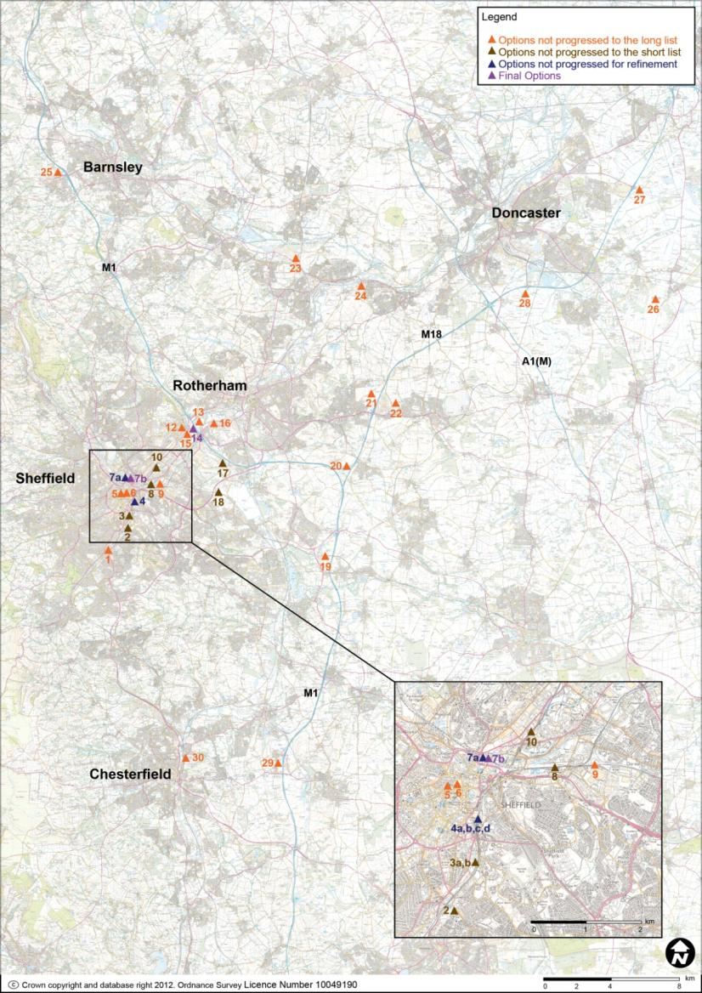
- History of Station Options in South Yorkshire
  - Selecting a Station for South Yorkshire
        - This chapter sets out all the station options which were developed in South Yorkshire during the process of station selection.
        - At the beginning of this process, a wide-ranging list of options was drawn up. This list was gradually reduced, through a sifting process over a number of stages, as follows:
- Initial list;
- Long list;
- Short list;
- Options for further refinement; and
- Final options.
        - At each stage of the station selection process, the station designs selected for further development were elaborated in greater detail, in parallel with the line of route process. While generic station designs were used for decision-making at the earlier stages, these were adapted to individual sites as the process progressed.
        - The criteria by which station options were assessed included considerations of site availability and fit, impact on surrounding infrastructure, connectivity, engineering feasibility and constructability, sustainability, proximity to demand, and cost. These were considered in conjunction with the viability of the business case.

        - The map on the previous page sets out all the station location options which were considered in the South Yorkshire area. The chart below illustrates the stages of the sifting process through which each option was developed.
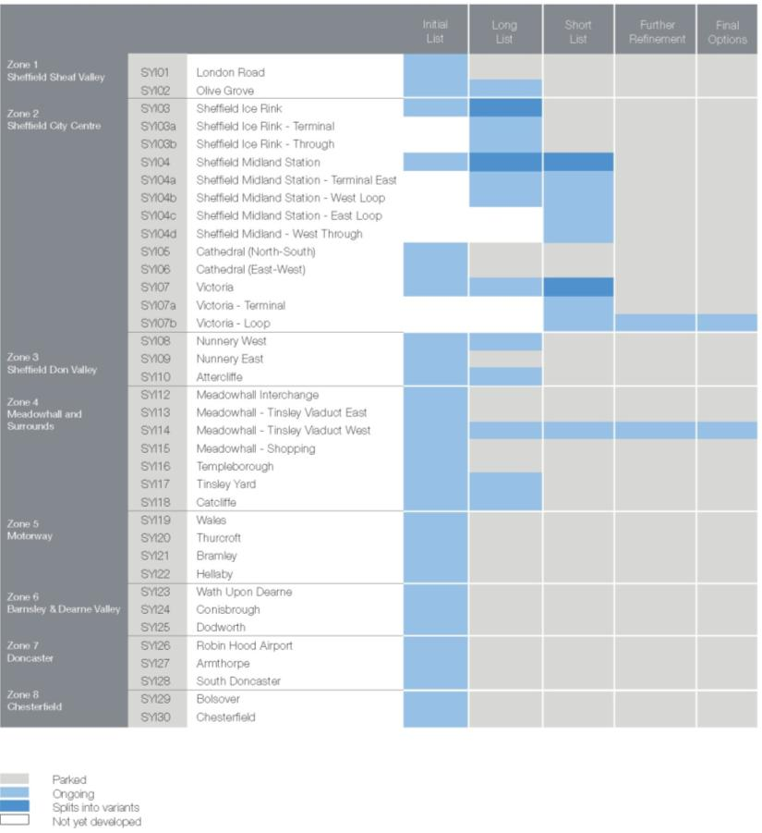
  - Initial List of Station Options
    - List of Stations
        - The initial list of station options in South Yorkshire was:
SYI01 London Road
SYI02 Olive Grove
SYI03 Sheffield Ice Rink
SYI04 Sheffield Midland Station
SYI05 Cathedral (North-South)
SYI06 Cathedral (East-West)
SYI07 Victoria
SYI08 Nunnery West
SYI09 Nunnery East
SYI10 Attercliffe
SYI12 Meadowhall Interchange
SYI13 Meadowhall – Tinsley Viaduct East
SYI14 Meadowhall – Tinsley Viaduct West
SYI15 Meadowhall – Shopping
SYI16 Templeborough
SYI17 Tinsley Yard
SYI18 Catcliffe
SYI19 Wales
SYI20 Thurcroft
SYI21 Bramley
SYI22 Hellaby
SYI23 Wath upon Dearne
SYI24 Conisbrough
SYI25 Dodworth
SYI26 Robin Hood Airport
SYI27 Armthorpe
SYI28 South Doncaster
SYI29 Bolsover
SYI30 Chesterfield

  - Defining the Long List
    - Options Not Progressed to Long List
        - Where a description applies to a group of stations as a whole, these have only been described as a group.

SYI01 London Road
        - This station would be in a suburban location 3km south of Sheffield City Centre next to the Midland Main Line approach to Sheffield. The station would be on a four track corridor, currently only occupied by two tracks, on a curved section of track with a steep escarpment on the inside of the curve. Local roads operating at capacity during peak hours are unlikely to be able to provide sufficient capacity to cater for the volume of passengers from frequent high speed rail services. Adjacent land uses are light industrial and terraces / semi-detached residential to the west.

SYI05 Cathedral (North-South) and

SYI06 Cathedral (East-West)
        - These two options would be underground stations under the city centre, one facing east-west and the other north-south. Route approaches to the station would be by long tunnels under the city. These stations would be in substantial and costly underground structures likely to be constructed by mining to create underground platforms, concourse and access facilities. If more than two platform faces were provided, forming tunnels to accommodate splitting and joining of tracks from the main route to serve the platforms would be complex. Because the through lines would have to pass through the station in tunnels, the speeds on these lines would be limited.

SYI09 Nunnery East
        - This station would be approximately 3km east of the city centre at Nunnery. It would be located on underused former industrial land, and would combine high speed and conventional platforms. At 3km from the city centre, it would be beyond walking distance to Sheffield city centre or Midland station. The station could be a through alignment from east to west or on a loop, or an east-facing terminus. The station would overlap with Woodburn Junction.

SYI12 Meadowhall Interchange
        - This would be an elevated station to the east of Sheffield adjacent to the existing Meadowhall Interchange station. The station would be fully integrated with the existing station on the conventional network. This option would also provide good transfer to tram network, bus and car parking. The east-west orientation of the station would not, however, work well with a high speed through route. There may be some conflict with current aspirations to grade- separate Wincobank Junction.

SYI13 Tinsley Viaduct East
        - This option would be on vacant land just east of the M1 Tinsley viaduct at Meadowhall. It would be an elevated station with tracks likely to be approximately at same elevation as the M1 as the route crosses the Don Valley and to clear existing railway lines and connecting highways. It would be approximately 1km from Meadowhall Interchange station with potentially 15m vertical elevation difference and so interchange would not be good. This station would require a substantial support structure and access arrangements. It should be noted that Tinsley Viaduct is aligned as an 'S' curve and hence to provide a straight high speed station, the high speed lines would need to be offset from Tinsley Viaduct by up to 100m.

SYI15 Meadowhall Shopping Centre
        - This option would be an elevated station oriented north-south above the existing Meadowhall shopping centre. It would be several hundred metres from the M1 corridor and would have significant impact on the shopping centre. It would need to be approximately 30m above ground level to clear the Sheffield to Rotherham rail line to the north. It would also be some distance from Meadowhall Interchange station.

SYI16 Templeborough
        - This option would be located on vacant land to the east of the site of the Templeborough Works by Manga Leisure complex, approximately 1km east of the Tinsley Viaduct. It would be an elevated station above the River Don and adjacent highways but it could be lower than other parallel options in the Rother Valley, as northern and southern approaches may need to be tunnelled to minimise impact on nearby residential properties. The site would have good highway access but interchange with other modes would be poor.
        - The viability of this option would depend on the ability to achieve an acceptable vertical alignment which does not conflict with the existing rail network, flood requirements and residential properties on the north and south side of the Don Valley.

SYI19 Wales,

SYI20 Thurcroft,

SYI21 Bramley, and

SYI22 Hellaby
        - This group of stations would be located to the east of Sheffield and Rotherham adjacent to the junction of the M1 and M18. This group would be remote from Sheffield city region, and the only viable means of access would be by car. They would be in open fields with ample space for car parking but terrain would be reasonably hilly.

SYI23 Wath upon Dearne and

SYI24 Conisbrough
        - These stations would be located to the north and west of Sheffield and Rotherham. This group would be approximately 18km from Sheffield city region, and consequently remote from centres of demand. The options would have poor connectivity.

SYI25 Dodworth
        - This station would be located at Dodworth near Barnsley on the west side of M1 Junction 17. It would be approximately 18km north of Sheffield. It would have very good highway links via the adjacent motorway but interchange potential with other modes would be poor. The station would possibly be an underground station adjacent to the residential area of Dodworth.

SYI26 Robin Hood Airport,

SYI27 Armthorpe, and

SYI28 South Doncaster
        - This group of stations would be located in the Doncaster area. At over 30km from Sheffield and Rotherham, they would be remote from the main centres of demand in the South Yorkshire region.

SYI29 Bolsover and SYI30 Chesterfield
        - This group of stations would be located close to Bolsover and Chesterfield, approximately 16km to the south of Sheffield. While each would have particular advantages in terms of connectivity, they would be distant from the Sheffield city region and consequently remote from the main areas of demand.
    - Stations Introduced or Modified
        - Following long-listing, SYI03 was re-named to SYI03a, and SYI03b was introduced.
        - SYI04 was developed into multiple station options after long-listing. During the development phase leading to option refinement, SYI04a (a north-facing terminus) and SYI04b (either a through station or on a loop, with two platforms only on the west side of the station) were introduced.

    - Options Progressed to Long List
SYI02 Olive Grove
SYI03a Sheffield Ice Rink – Terminal
SYI03b Sheffield Ice Rink – Through
SYI04a Sheffield Midland Station – Terminal East
SYI04b Sheffield Midland Station – West Through / Loop
SYI07 Victoria
SYI08 Nunnery West
SYI10 Attercliffe
SYI14 Meadowhall – Tinsley Viaduct West
SYI17 Tinsley Yard
SYI18 Catcliffe

  - Defining the Short List
    - Options Not Progressed to Short List

SYI02 Olive Grove
        - This station would be located to the south of Sheffield city centre adjacent to the Midland Main Line approach to Sheffield station. It would be oriented northeast-southwest, would be at grade, and lie parallel to the existing railway on the site of the current council salt depot. Ground level rises steeply to the southeast with mostly residential properties and light industrial / retail buildings to the northwest.
        - The station could operate as either a terminus from a spur to the east along the Darnall corridor, or as a through station on a loop from the River Sheaf corridor to the south and towards Meadowhall to the north.
        - At approximately 1km south of Sheffield Midland station, pedestrian interchange would not be practical, and either an extension to the Supertram or travelators would therefore be required. As the station option would also be some distance from the city centre (approximately 2km), it would not provide easy pedestrian access. The local road network runs parallel to the proposed station (A61 London Road), but this is a conventional two-lane road and is congested in peak hours.
        - A north approach to the station would have significant impact on the existing Midland station southern approach junctions, and there would also be impact on the adjacent highway network.

SYI03 Sheffield Ice Rink,

SYI03a Sheffield Ice Rink – Terminal, and

SYI03b Sheffield Ice Rink – Through
        - These stations would be located to the south of Sheffield city centre on the former ice rink site immediately south of the existing Sheffield Midland station. These options would be oriented north-south and lie adjacent to the existing railway corridor. In its development in the long list, SYI03 was considered as either a terminus or a through station. Following long-listing, it was developed as a north-facing terminus from a spur to the east along the Darnall corridor in SYI03a, and as a through option in SYI03b. This would be in a similar location but on a loop from the River Sheaf corridor to the south to the Darnall corridor to north Meadowhall.
        - The approach to SYI03a would pass to the east of the existing station while SYI03b would pass to the west. All options would have significant impact on the existing station and its approaches, but SYI03b would be more significant in its impact. A number of roads located on bridges over the high speed line would also need to be realigned.
        - Interchange with the existing station would be on foot, but would involve a walking distance of approximately 400m. Pedestrian access from the city centre would, however, be limited at 1.2km distance. The Supertram network would serve this station. Road access would be from the A61, which runs parallel to the station but is congested at peak times.

SYI08 Nunnery West
        - This station option would be located to the northeast of the Sheffield city centre on former industrial land adjacent to Nunnery Square. It would be oriented east-west, and would be parallel to the existing Darnall rail corridor. The station would likely be a terminus although a through station following the Stocksbridge line to the west or the River Sheaf Corridor to the south would also be possible. A station at this location would require realignment of the existing railway, the tram line and some local roads.
        - The station would be approximately 2km from the city centre and 1.5km from the existing Midland station. It would, however, be adjacent to the Supertram depot, which would facilitate interchange. The existing line to Worksop carries only one train per hour to Worksop, but it could also be utilised to provide shuttle services to the Midland station.

SYI10 Attercliffe
        - This station option would be to the northeast of Sheffield city centre on former industrial land close to the site of the former Attercliffe station. It would be oriented north-south, on a new structure alongside, and at the same level as, the existing two-track Doncaster Line railway viaduct. It would be just north of, and perpendicular to, the former Victoria station viaduct. Both terminus and through station options would be possible.
        - At 2.3km to Sheffield city centre, this station would be beyond walking distance to the city centre or Midland station (1.5km) for most passengers. Rail, Supertram and road dispersal would be poor as currently configured. The station would be adjacent to the A6109 leading to M1 Junction 34 approximately 6km to the north.

SYI17 Tinsley Yard
        - This station option would be located at or close to grade on the old marshalling yard site at the south end of the Meadowhall area. As the yard is in a deep excavation, the new station may require elevation on embankment. The station would be a through station on the main line and would be aligned with and immediately adjacent to the M1 corridor.
        - The station would be approximately 6.3km from the city centre. There are no currently no rail passenger services nearby, but since Tinsley Yard has had rail connections in the past it would theoretically be possible to provide a service or light rail shuttle to Rotherham and Sheffield. The site is not served by Supertram but this could also be extended to serve this station. Junction 33 of the M1 would be approximately 2km from the station, and the A630 serves both the City and Rotherham about 4km to the north east.

SYI18 Catcliffe
        - This station would be located south of the A630 Sheffield Parkway adjacent to the development site on the former Orgreave colliery. This option would be a through station either on the main line or on a loop from a main route along the M1 corridor, though a through line may not achieve a desirable alignment. The station would be located at grade with its northern approach rising on a viaduct over the Meadowhall area to rejoin the M1 corridor in the Grange Lane area.
        - The station would be approximately 5.6km from Sheffield city centre and 5.8km from the centre of Rotherham. The station would be served from Sheffield Parkway (A630) and would be about 4km from M1 Junction 33. The Worksop line would lie close to the south end of the station, offering potential interchange and a shuttle service to Sheffield Midland station. The station would not be close to the Supertram.
        - Key issues would include the creation of a new transport corridor crossing Meadowhall at high level to the north, the impact of the southern approach, over strategic development land and the demand associated with its location out of town.
    - Stations Introduced or Modified
        - Preceding the stage of further refinement, the options at Sheffield Midland station, SYI04a and SYI04b, were expanded to include SYI04c and SYI04d, in order to understand further the different arrangements by which the location could be served by the high speed route. Option SYI04c would be on a loop on the east side of the existing station. Option SYI04d would be on the same side as SYI04c, but configured as a through station instead of on a loop, with the platform faces further apart to make room for two running lines in the centre. At this point, the number of platform faces at SYI04a was also reduced from four to two, and SYI04b was confirmed as a loop option, with platform arrangements altered from one island to two side faces. As a result, all four options at Sheffield Midland station would have two side platforms.
        - SYI07 at Victoria was split into two options. One (SYI07a) would be a terminus, with the other (SYI07b) on a loop using the existing listed viaduct and the corridor west through Owlerton (the Stocksbridge Line).

    - Options Selected for Further Refinement
SYI04a Sheffield Midland Station – Terminal East
SYI04b Sheffield Midland Station – West Loop
SYI04c Sheffield Midland Station – East Loop
SYI04d Sheffield Midland Station – West Through
SYI07a Victoria – Terminal
SYI07b Victoria – Through / Loop
SYI14 Meadowhall – Tinsley Viaduct West

  - Identification of Options for Further Refinement
    - Options Not Progressed for Further Refinement

Sheffield Midland Station Options
        - The four variations on high speed stations at Sheffield Midland differed as to whether the station was served as a through station, a loop, or a terminus. Platform locations and layout were varied to suit the direction and configuration of the approach. Each had significantly differing impacts on the existing station and local highway infrastructure, but they also shared certain common traits.
        - All four options would be located at the existing Sheffield Midland station, with the city centre to the west and Park Hill to the east. In all cases, the main station entrance would open onto Sheaf Square, and would involve enlargements to the existing station forecourt and car parking facilities. A new concourse and platform access bridge would be built in addition to the existing ones. Substantial parts of the existing station, including the concourse and the Victorian platform buildings, are listed Grade II.
        - Due to their location on the site of the existing station, the four options would have good proximity to Sheffield city centre, with good walking routes. They would also offer excellent direct interchange with existing rail and the adjacent Supertram, with the bus station a short walk away.
        - A two-platform station layout was proposed for all four Sheffield Midland station options, in order to minimise impacts on this complex and restricted site. Two platforms would provide less operational flexibility than a station with four platform faces. Where possible (in SYI04a, SYI04b, and SYI04c), it would be mitigated to an acceptable level by the provision of a turnback siding.
        - For the through station case, speeds on through trains passing through the station would be relatively low. This would be in contrast to the spur option and options on a loop off the main line, which would not affect the speed of through trains not stopping in Sheffield. Fewer trains would be likely, however, to call at Sheffield if an option off the through route were chosen.
        - The site is in a restricted flood zone, which would need careful consideration.

1 | High Speed Platforms
2 | Existing Sheffield Station
3 | Concourse
4 | Forecourt
5 | Car Park
6 | Supertram
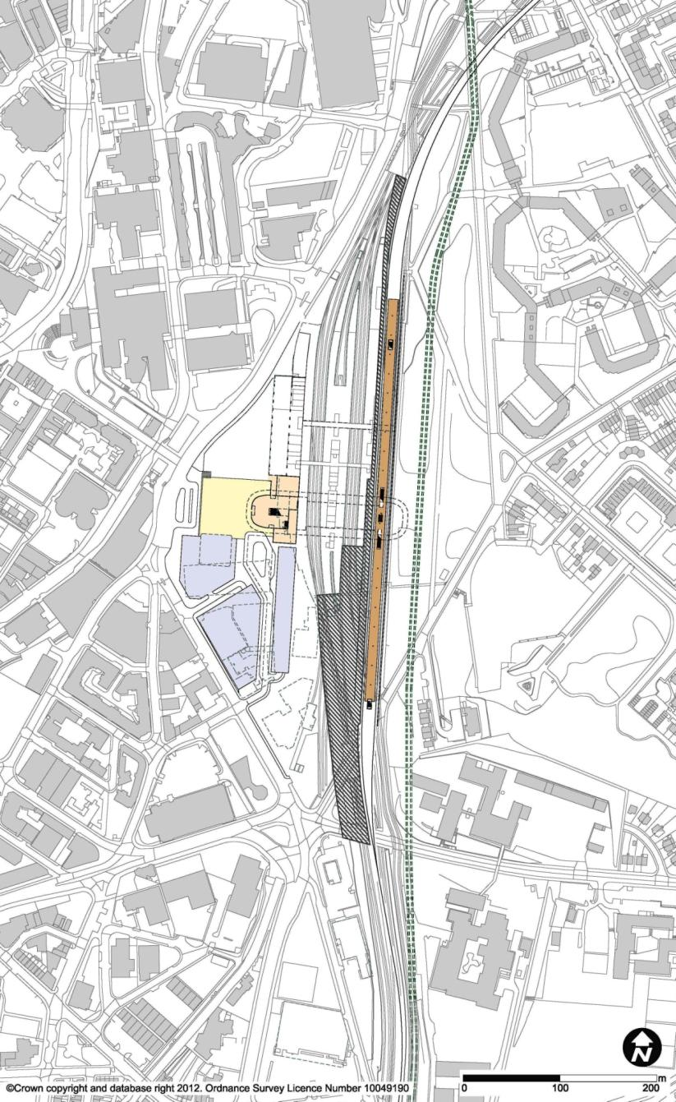
3

6

2

5

5

5

4

1

SYI04a Sheffield Midland Station – Terminal East
        - The SYI04a station option would have two high speed platforms on the east side of the existing station. The platforms would be terminating platforms approached from the north along a route following the Worksop corridor. There would be a turnback siding to the south of the station.
        - The new station would extend the footprint of the existing station to the east into the sloping hillside. Remodelling of the existing Platforms 7 and 8 would be required, together with significant civil engineering works to widen the station footprint into Park Hill to make the site available. The deep cutting at the northern throat of the station would also have to be widened to accommodate the additional tracks. The adjacent tram would have to be realigned further to the east. To the south of the station, the existing lines would need to be reorganised to accommodate the turnback siding, and the down passing loop (currently within the footprint of the existing station) would need to be re-sited.

1 | High Speed Platforms
2 | Existing Sheffield Station
3 | Concourse
4 | Forecourt
5 | Car Park
6 | Supertram
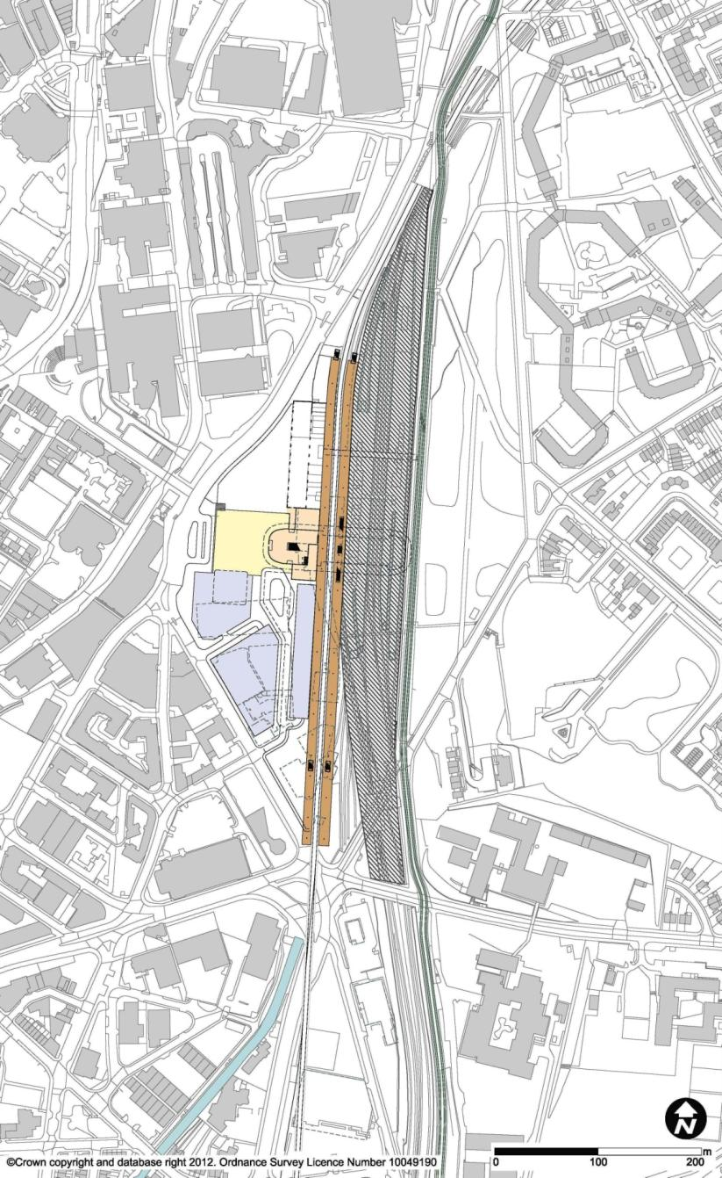
4

3

5

1

5

6

2

5

SYI04b Sheffield Midland Station – West Loop
        - The SYI04b station option would have two through high speed platforms on the west side, with the existing platforms displaced eastwards to accommodate the new high speed platforms. It would not require extension of the station boundary into the hillside on the east. The station would be served by a loop from the high speed main line, which would pass to the east of Sheffield. The loop would pass under the southeast suburbs of Sheffield in tunnel, emerging just south of the station, and passing on the west side of the station to run parallel to the existing line to Meadowhall. The route would reconnect to the main line north of Meadowhall. A turnback siding would be provided to the south of the station.
        - Total remodelling of Sheffield Midland station and its approach tracks would be required to make this site available. This option would cause major and prolonged disruption to train services and passengers during reconfiguration. To the north, the cutting for the existing approach to the station would have to be widened to accommodate the new tracks. At the southern end, the high speed platforms and tracks would affect the southern throat of Sheffield Midland station, and as the new lines emerge north of the tunnel portal, they would need to pass under the existing lines in a cutting.
        - There would also be major impacts on the local highway infrastrastructure in order to accommodate the station and its approaches, especially to the south of the station. Granville Square junction would require major remodelling, including realignment of all the roads leading to it, i.e. A61 Queens Road, A61 Suffolk Road and A61 St Mary’s Road. It also likely that it would be necessary (subject to more work) to permanently close and remove the lengths of Shrewsbury Road and Duchess Road over the railway.
        - Flooding would be a major risk. The tunnel portal to the south of the station would be in the flood plain of the River Sheaf and Porter Brook, and the area is also understood to be prone to flooding by runoff from the local highway network. This would pose a major risk to flooding of the tunnel and operation of the railway, particularly as means for potential mitigation are unclear.

1 | High Speed Platforms
2 | Existing Sheffield Station
3 | Concourse
4 | Forecourt
5 | Car Park
6 | Supertram
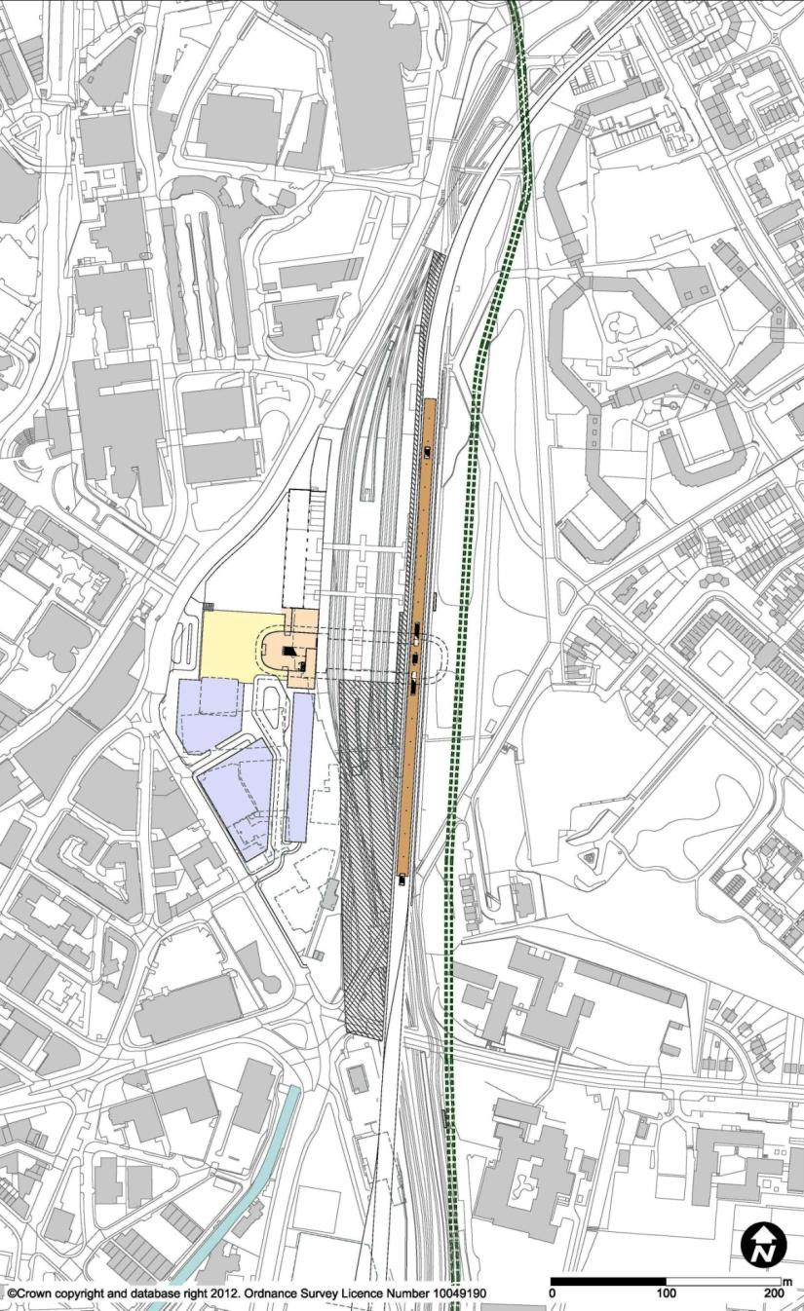
5

5

5

3

6

1

4

2

SYI04c Sheffield Midland Station – East Loop
        - The SYI04c station option would have two through high speed island platforms on the east side of the existing station. The station would be approached from the south via a tunnel under the southeast suburbs of Sheffield and from the north via the Worksop corridor.
        - The proposed layout would be designed to minimise excavation into the adjacent hillside, while still accommodating current and reasonably foreseeable requirements on the conventional network. Remodelling of the existing station Platforms 7 and 8 would be required, necessitating alteration of the Grade II listed platform buildings, as well as significant civil engineering works to widen the station footprint into Park Hill. The adjacent tram would also have to be diverted and realigned approximately 15m up the hill to enable extension of the station to the east, over a length of approximately 500m.
        - Remodelling of Granville Square, with enhanced capacity at the Granville Road / Shrewsbury Road junction, Shrewsbury Road, and Granville Road would be necessary.
        - Flood risk associated at the tunnel portal would be similar to that described for option SYI04b, altough less so given this option is on the east side.

1 | High Speed Platforms
2 | Existing Sheffield Station
3 | Concourse
4 | Forecourt
5 | Car Park
6 | Supertram
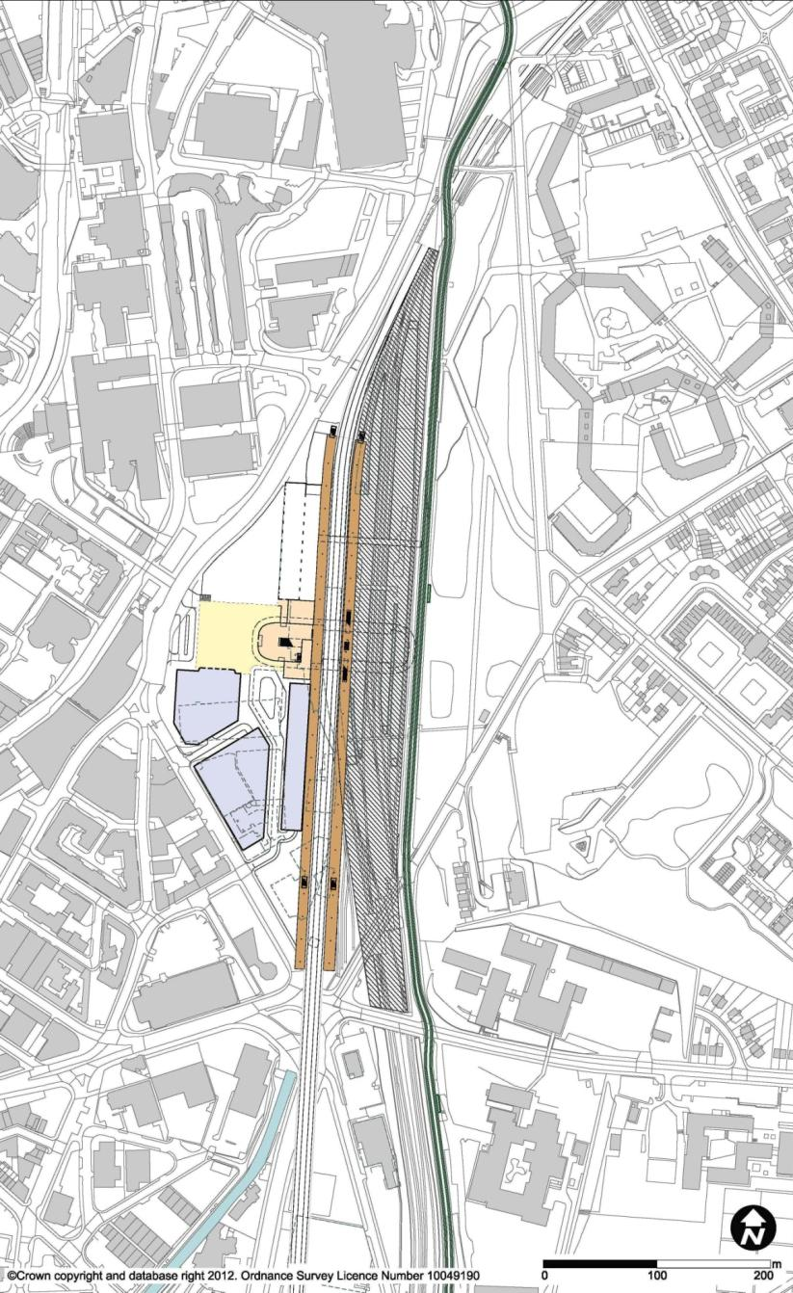
5

5

5

4

2

1

6

3

SYI04d Sheffield Midland Station – West Through
        - This station option would be a through station located on the high speed main line, with the high speed lines and platforms on the west side. The existing platforms would be displaced eastwards to accommodate the new high speed platforms. The imapcts would be very similar to those for SYI04b.
        - Total remodelling of Sheffield Midland station together with the north and south throats would be required to make this site available. The two up-station sidings between Platforms 5 and 6 would need to be relocated south of the station to accommodate the reconfigured station. To the north, the cutting for the existing approach to the station would have to be widened to accommodate the new tracks, and the tram would be realigned to suit the widened railway cutting. At the southern end, the high speed platforms and tracks would affect the southern throat of Sheffield Midland station, and as the new lines emerge from the tunnel portal they would need to pass under the existing lines in a cutting.
        - The station could have two or four platform faces. As a station with two platform faces, it would probably not require extension of the station boundary into the hillside on the east, while a high speed station with four platform faces would. More radical reconfiguring of the existing station platform layout would be required.
        - A turnback siding would not be advisable, as it would require crossovers on the through line. This would significantly impact on the operational feasibility of terminating services at the station for the two-platform case.
        - There would be major risk of flooding associated at the tunnel portal, in the same way as described for option SYI04b.
        - Major remodelling of the local highway netwrok would also be required to accommodate the station, along the lines described for option SYI04b.

High Speed Platforms | Relocated Freight Line | Concourse | Forecourt | Car Park
3
2
4
5
1
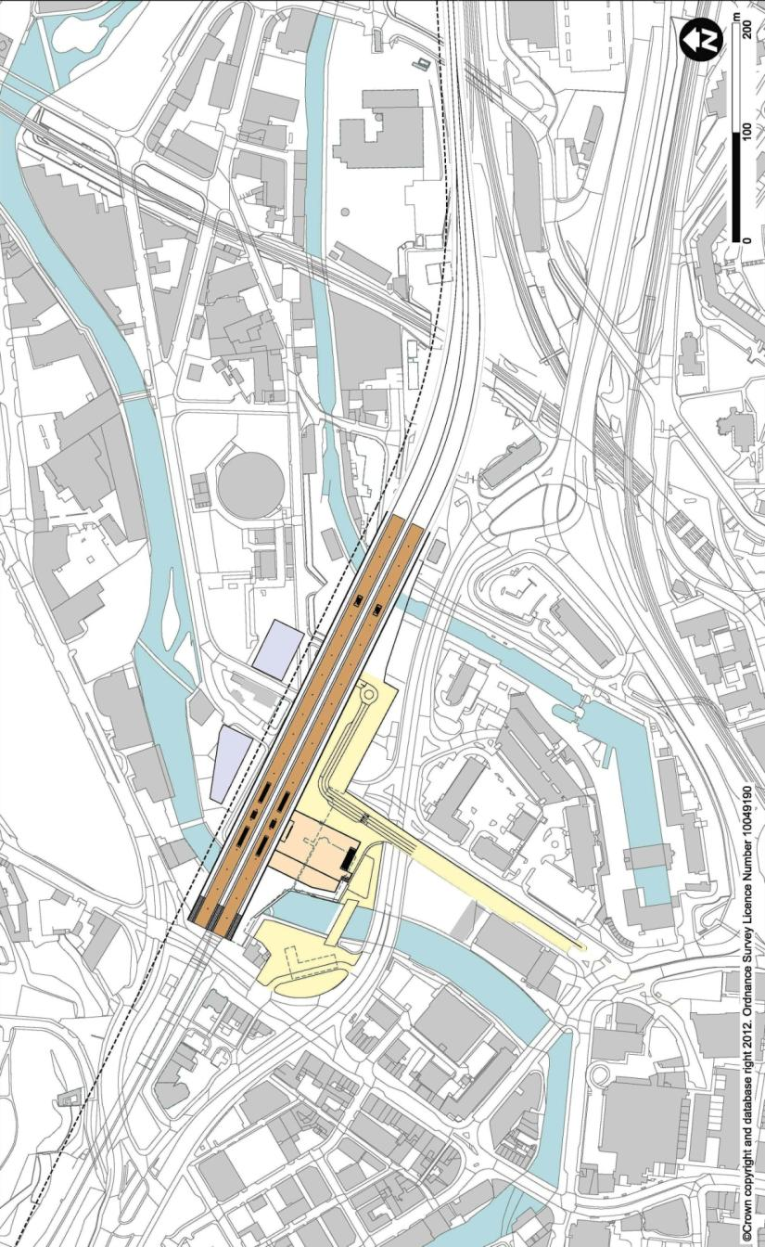
5
4
5
4
3
2
1

SYI07a Victoria – Terminal
        - Station option SYI07a would be located to the northeast of Sheffield city centre, on the site of the former Great Central Victoria station. It would be a terminus station with four platform faces, and thus would not be able to provide through services. In other respects, the station would be similar to option SYI07b, as described in Chapter 3 of this report. The station would be situated on the existing Grade II* listed railway viaduct, adjacent to the Royal Victoria Hotel, and be elevated approximately 6m higher than the former station level. The concourse and taxi and car drop-offs and pick-ups would be located beneath the platforms at a similar level to the Royal Victoria Hotel. Escalators would connect to a small lower-level concourse at street level for interconnection to bus routes.
    - Stations Introduced or Modified
        - The designs of the station options progressing through to confirmation of the final options were refined further during this stage. No major changes were necessary, nor were any new station options introduced.
  - Confirmation of Final Options
        - The final options were:
SYI07b Victoria – Loop
SYI14 Meadowhall
        - Full descriptions of the final options are to be found in sections 3 and 4 of Chapter 3.

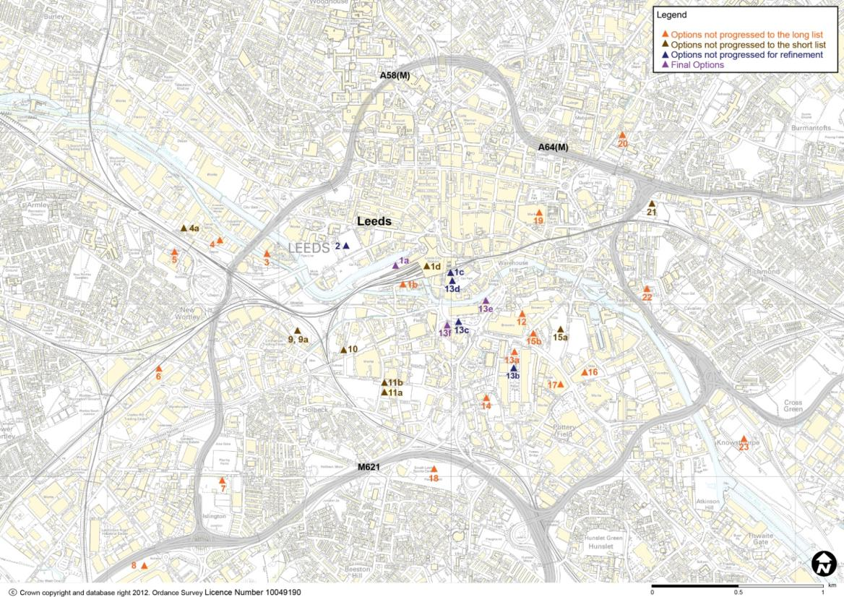
- History of Station Options in Leeds
  - Selecting a Station for Leeds
        - This chapter sets out all the station options which were developed in the Leeds area during the process of station selection.
        - At the beginning of this process, a wide-ranging list of options was drawn up. This list was gradually reduced, through a sifting process over a number of stages, as follows:
- Initial list;
- Long list;
- Short list;
- Options for further refinement; and
- Final options.

        - At each stage of the station selection process, the station designs selected for further development were elaborated in greater detail, in parallel with the line of route process. While generic station designs were used for decision-making at the earlier stages, these were adapted to individual sites as the process progressed.
        - The criteria by which station options were assessed included considerations of site availability and fit, impact on surrounding infrastructure, connectivity, engineering feasibility and constructability, sustainability, proximity to demand, and cost. These were considered in conjunction with the viability of the business case.

        - The map on the previous page sets out all the station location options which were considered in the Leeds area. The chart below illustrates the stages of the sifting process through which each option was developed.
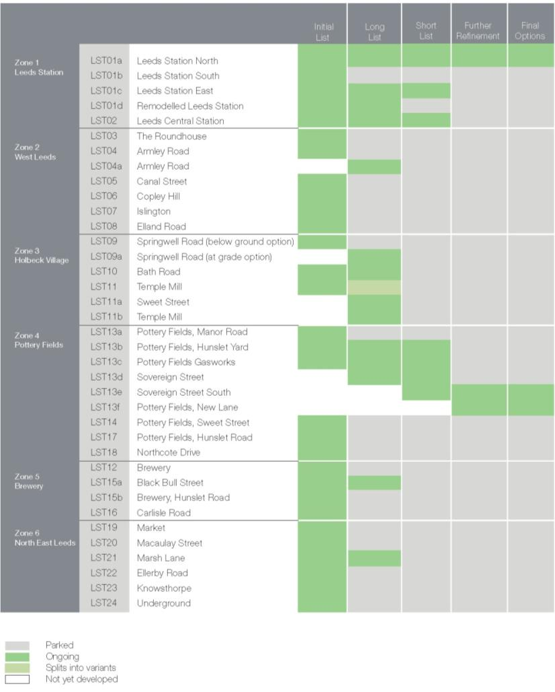

  - Initial List of Station Options
    - List of Stations
        - The initial list of station options in Leeds was:
LST01a Leeds Station North
LST01b Leeds Station South
LST01c Leeds Station East
LST01d Remodelled Leeds Station
LST02 Leeds Central Station
LST03 The Roundhouse
LST04 Armley Road
LST05 Canal Street
LST06 Copley Hill
LST07 Islington
LST08 Elland Road
LST09 Springwell Road
LST10 Bath Road
LST11 Temple Mill
LST12 Brewery
LST13a Pottery Fields, Manor Road
LST13b Pottery Fields, Hunslet Yard
LST13c Pottery Fields Gasworks
LST14 Pottery Fields, Sweet Street
LST15a Black Bull Street
LST15b Brewery, Hunslet Road
LST16 Carlisle Road
LST17 Pottery Fields, Hunslet Road
LST18 Northcote Drive
LST19 Market
LST20 Macaulay Street
LST21 Marsh Lane
LST22 Ellerby Road
LST23 Knowsthorpe
LST24 Underground

  - Defining the Long List
    - Options Not Progressed to Long List
        - Where a description applies to a group of stations as a whole, these have only been described as a group.

LST01b Leeds Station South
        - This station would be on the south side of the existing Leeds station, to the west of Neville Street, on recently developed land including the site of the Mint Hotel and Candle House. It would be partially constructed over the Leeds and Liverpool Canal and the River Aire. It would be a terminal station, oriented east-west, and approached from the west. This option would offer good interchange with the existing station, though extensive work would be required to provide adequate capacity for the additional passenger numbers. The option would not provide through connections towards York, and access to the ECML via a northern route would not be viable.

LST03 The Roundhouse,

LST04 Armley Road, and

LST05 Canal Street
        - These three options would be to the west side of Leeds city centre, just to the north of Whitehall Junction. LST03 would be just east of the Roundhouse on the Roundhouse Business Park and the Wellington Road Industrial Estate. LST04 and LST05 would be to the north of the Inner Ring Road (A58) either side of the Harrogate, Ilkley and Skipton lines, with LST04 on the north side of the line on the site of the Castleton Close Industrial Estate, and LST05 to the south of the line on the site of the British Gas national training centre.
        - All options would be elevated stations due to the approach from the south having to cross over the Inner Ring Road, Whitehall Junction and multiple rail crossings in order to reach the Woodlesford corridor. The stations would be approximately 1.25km from the city centre and 1km from the existing Leeds station. Connectivity would therefore be limited to the immediate regional services (Ilkley, Skipton and Harrogate).
        - Following long listing, these three options were rationalised into one option, LST04a Armley Road, which was taken forward to the long list.

LST06 Copley Hill,

LST07 Islington, and

LST08 Elland Road
        - This group of stations would be located to the south west of the city centre, over 1.5km from the existing Leeds station. LST06 would be located near New Wortley on the railway line to Huddersfield and on the site of the Copley Hill Trading Estate. LST07 would be at Islington, adjacent to the A643 on the north east side of the M621 Junction 2, on open land and playing fields. LST08 would be south west of the M621 Junction 2, on land surrounding Leeds United football club, adjacent to the Doncaster railway line.
        - All of these options would be remote from the city centre with poor connectivity, thought the latter two options would have good highway access due to the nearby M621. Two of the options could provide interchange with the nearby existing rail lines but services on these lines would serve only a limited area.
        - Developing a cost-effective route to reach these stations would be a challenge, particularly LST07 where the only feasible option would be a fully tunnelled approach. Onwards connections to the north for reconnection to the East Coast Main Line would also be particularly challenging.

LST12 Brewery
        - This option to the south east of Leeds city centre would occupy the Tetley's brewery site, running to the east of the Hunslet Road. It would be a spur from the main line. This option would require difficult south west approaches, for example, high level viaduct approaches over complex road networks would be necessary in order to reach any feasible approach corridors. This option is not suitably oriented to provide a direct connection to the ECML.

LST15b Brewery, Hunslet Road
        - This option would be located 500m to the east of Leeds city centre, with an approach across the Knowsthorpe area and the River Aire, sited on the Tetley's brewery site. This option would allow a reasonable range of approaches from South Yorkshire, with high level viaduct approaches over major road networks and low speed connections to the Woodlesford corridor. However, this option would only allow for an indirect and tortuous route connection to the ECML via the Woodlesford corridor.

LST16 Carlisle Road
        - This option would be an elevated station approximately 800m to the east of Leeds city centre south of the Armouries with an approach from the east across the Knowsthorpe area and the River Aire.

LST13a Crown Point,

LST14 Pottery Fields Sweet Street, and

LST17 Pottery Fields Hunslet Road
        - A number of options were considered in the Pottery Fields area of the city. Different orientations and locations within the area were considered. Of these, two options were taken forward to long listing and the three options discussed here were not developed further.
        - LST13a would be oriented east-west on the south side of Great Wilson Street, over the Leeds City Office Park and Crown Point Retail Park. It would be an elevated terminus station.
        - LST14 would also be oriented east-west, approximately 200m south of LST13a, and would occupy the site of the Apex Business Centre and the south end of the Crown Point Retail Park. It would end just east of Dewsbury Road.
        - LST17 would be oriented northwest-southeast between Hunslet Road and Crown Point Retail Park, currently occupied by the Sovereign Business Park.
        - These options would allow for connections from South Yorkshire, but the station orientation would make a reasonably feasible approach difficult, unless fully tunnelled or elevated, with lengthy and intrusive structures and property impacts.
        - Given the location of these options so far south of the river, proximity to the city centre and Leeds station would be poor.

LST18 Northcote Drive
        - This option would be just south of M621 Junction 3, on land currently occupied by South Leeds Sports Centre Playing Fields. This option would allow a range of approaches from South Yorkshire, but with complex engineering required for a connection to the Woodlesford Corridor. This station location would offer very poor connectivity to the city centre and Leeds station.

LST19 Market
        - This station would be located on the site of the existing Leeds Market, to the north of the line to York. It would be approximately 400m from the existing Leeds station. It could be a loop or through option.
        - The construction of the proposed station would have to be integrated with the existing Leeds Market. A new market building and bus terminus would be required. This option would require grade separation over existing railways in order to reach the south side of Neville Hill Corridor near Richmond Hill. The south side of the corridor would appear to be the simplest and least costly approach from a range of routes to the east of Leeds. Key issues would include construction within a listed building, and integration with the existing rail network.

LST20 Macaulay Street
        - This station would be to the north east of the city centre, to the north of Quarry Hill on the site between Macaulay Street and Mabgate. It would be just north of the Inner Ring Road.
        - This station would be a loop or through option. Approaches for this option would be challenging and would require tunnels.

LST22 Ellerby Road
        - This option would be located to the east of the River Aire on land adjacent to the A63, currently occupied by recreation grounds, approximately 1.3km to the east of the existing station on the conventional network. This station location would offer very poor connectivity to the city centre and Leeds station.
        - This option would be a spur from the main line and would be at-grade and therefore of simpler construction. No surface connection, however, would be available, and a lengthy and costly viaduct or tunnel would be required before an above-ground approach could be found.

LST23 Knowsthorpe
        - This option would be located to the east of the River Aire on land south of the A63, approximately 2km to the southeast of the existing station, sited in an area which is currently industrial / underused land. This station location would offer very poor connectivity to the city centre and Leeds station.
        - This station would be a loop or south-facing spur option. This station would be at grade and therefore of simpler construction, but would require a 2-3km viaduct or tunnelled approach.

LST24 Underground
        - This would be an underground option, located as necessary to suit demand and connectivity, and assumed to be running north-south beneath the existing Leeds station. It would be a terminus or a through station and would give excellent interconnection to existing rail services as well as pedestrian connections to Leeds city centre.
        - Key issues for this option would be cost, disruption, and the associated risks during construction. It would rely on a 4km-long tunnel from the south for a terminus, with a further 7km-long tunnel to the northeast for a through route, and would have adverse effects on train running times.
    - Stations Introduced or Modified
        - Following the long-listing, options LST03, LST04, and LST05 were rationalised into a single option LST04a. Option LST09 was elaborated as both LST09 (below ground) and LST09a (at grade), and LST11 Temple Mill was split into LST11a and LST11b at Sweet Street to study proximity to the Temple Mill and variations on the approach. An option LST13d, at Sovereign Street, was added to further study the stations approaching the city centre from the south.
    - Options Progressed to Long List
LST01a Leeds Station North
LST01c Leeds Station East
LST01d Remodelled Leeds Station
LST02 Leeds Central Station
LST04a Armley Road
LST09 Springwell Road (below ground option)
LST09a Springwell Road (at grade option)
LST10 Bath Road
LST11a Sweet Street
LST11b Temple Mill
LST13b Hunslet Yard
LST13c Gasworks
LST13d Sovereign Street
LST15a Black Bull Street
LST21 Marsh Lane

  - Defining the Short List
    - Options Not Progressed to Short List

LST01d Remodelled Leeds Station
        - In this station option the existing Leeds station is remodelled to accommodate new platforms for high speed trains within the current footprint of the station. This would provide a fully integrated rail station in Leeds and permit direct interchange for passengers between existing and high speed trains.
        - The high speed platforms, which would be at the same level as the existing platforms, would be located towards the east end of the station, connecting to the Neville Hill corridor to the east and the Woodlesford or Transpennine corridor to the southwest.
        - Complete remodelling of the existing station would be required to provide space for the new services while maintaining existing capacity. It would also include additional bay platforms north of Platform 1. The option would therefore have major impact and disruption to rail operations for several years while the works are being carried out.

LST04a Armley Road
        - This station option would be located to the west of Leeds city centre just northwest of Whitehall Junction. The station would be oriented north-south on the site of Castleton Close Industrial Estate, and along the northern boundary of the Harrogate, Ilkley and Skipton lines to the west of the Inner Ring Road. This option is a rationalisation of the initial options in the area, LST03, LST04 and LST05.
        - It would be a terminus station with a south-facing approach along the Woodlesford corridor. The approach alignment would diverge from the existing corridor in the Holbeck village area to avoid the low speed curves on the existing line. A connection to the north from this station would not readily serve York unless it were a through station and would involve a lengthy approach from the northwest. The station would be elevated above the existing railway due the approach having to cross over Whitehall Junction and the Inner Ring Road.
        - The station could provide an interchange via a new station on the adjacent conventional network, though an additional stop here would raise operational concerns because of its proximity to the existing Leeds station. The station would be approximately 1.3km from the city centre, which is excessive for pedestrian access, and 1km from the existing Leeds station, again too far for unassisted interchange. Therefore, connectivity would be limited to the immediate regional services (Ilkley, Skipton and Harrogate).

LST09 Springwell Road (below ground) and

LST09a Springwell Road (at grade)
        - These two station options would be located southwest of Leeds city centre on the Emmanuel Trading Estate site on the west side of Whitehall Junction. Both would be terminus stations approached via the Woodlesford corridor. For Option LST09, the approach would be along the east side of the corridor and so would have to pass under the existing line to reach the station requiring that it be located subsurface. For Option LST09a, the approach would be along the west side of the corridor and so could approach the station at grade. Both approach options would require significant works at the M621 Junction 3.
        - This station would be approximately 1.3km from the city centre, which, as well as being on the opposite side of Whitehall Junction, would not be favourable to pedestrian access from the city centre. Interchange with other modes would also be poor, as the station would be approximately 800m from the existing station and not on any significant bus routes.

LST10 Bath Road
        - This station option would be located to the southwest of the existing Leeds station, oriented northwest-southeast, on the site of Holbeck Urban Village. It would be adjacent to the Woodlesford corridor. The station would be served from the Woodlesford corridor with an extended throat due to the tight curve leaving the station platforms. It would be below ground level in a cutting to suit the approach passing under the adjacent motorway junction, which would also minimise visual impact on the Grade I listed Temple Mill.
        - It would be approximately 1.3km from the city centre, which precludes easy pedestrian access, and 500m from the existing station, which would provide poor connectivity with regional services.

LST11a Sweet Street and

LST11b Temple Mill
        - These options would be south of the current Leeds station towards the south side of Holbeck Village. Oriented east-west, the stations would lie parallel to Sweet Street by the Grade I listed Temple Mill. Option LST11a would be to the south of Sweet Street, and LST11b just to its north. As the approach would pass over the adjacent Woodlesford Line, both options would be elevated. They would be terminal stations, fed via the existing disused railway viaduct from the west, leading to the existing rail corridors.
        - The stations would be approximately 1.3km from the city centre which would not provide easy access for pedestrians, and 500m from the existing station, again providing poor connectivity with regional services.

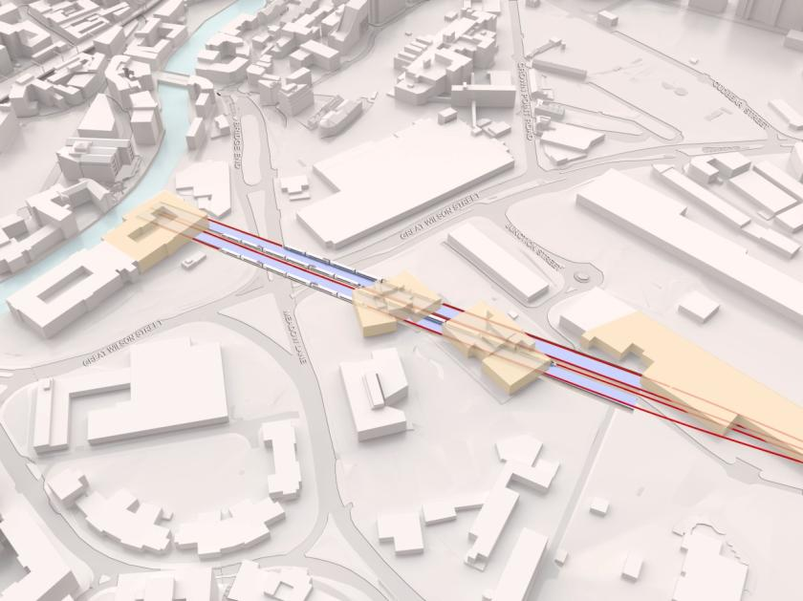
LST15a Black Bull Street
        - This option would be located 1km to the east of Leeds station, to the south of the River Aire and north of Hunslet Road. The site is currently derelict land on the west side of Black Bull Street previously occupied by Yorkshire Chemicals, and the Yorkshire Steel Foundry.
        - Oriented north-south, the station would be a terminus, elevated to span over the adjacent street network. It would be served from the Woodlesford corridor to the south.
        - The station would be approximately 1.3km from the city centre, making it too far to offer practical pedestrian access, and 500m from the existing station, leading to poor interconnectivity with regional services on the conventional network.

LST21 Marsh Lane
        - This would be located to the east of Leeds city centre by Marsh Lane. Oriented approximately east-west, it would be on the site of the former Marsh Lane station on land currently used for rail freight operations. The station could be moved westwards over Marsh Lane on to Quarry Hill to maximise proximity to the city and avoid passengers having to cross the busy Marsh Lane highway. This would mean a clash with the Quarry House building on that site.
        - The station would be a terminus approached from the east along existing rail corridors. At Neville Hill there would a grade separated crossing over the existing lines with extensive works to enclose the existing railway.
        - This station option would be located approximately 1.3km east of the existing Leeds station and effective interchange would require some form of shuttle service. In spite of its proximity to the city centre, it would provide poor pedestrian and access connectivity.
    - Stations Introduced or Modified
        - Option LST13e at Sovereign Street East was introduced as part of a study to avoid impacts on the Sovereign Street Development Site while still achieving a good connection to Leeds station.
    - Options Selected for Further Refinement
LST01a Leeds Station North
LST01c Leeds Station East
LST01d Remodelled Leeds Station
LST02 Leeds Central Station
LST13b Hunslet Yard
LST13c Gasworks
LST13d Sovereign Street
LST13e Sovereign Street East

High Speed Platforms | Existing Leeds Station | Concourse (below) | Forecourt | Car Park
5
3
2
4
1
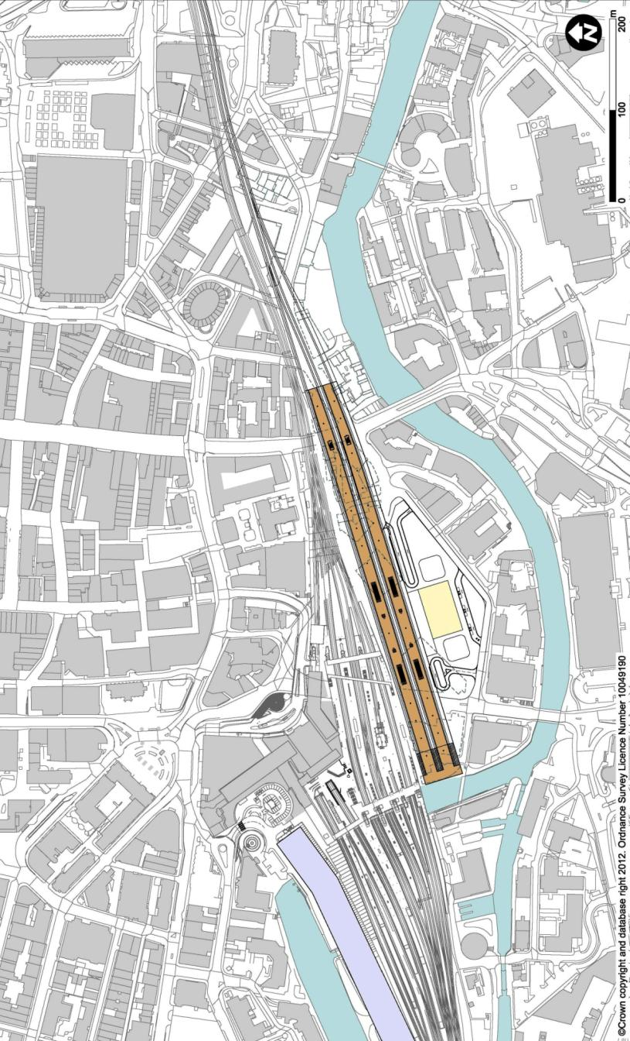
3
1
2
5
4
  - Identification of Options for Further Refinement
    - Options Not Progressed for Further Refinement

LST01c Leeds Station East
        - This station option would be a terminus station located immediately adjacent to the existing Leeds station along its southeast boundary. The station would be 750m from the city centre and would have excellent connectivity with the regional existing services in the adjacent station. The station would also be well-configured to serve connections to the ECML and York.
        - The station would provide four platform faces (probably arranged as two island platforms) and be served from the Neville Hill Corridor from the east.
        - The station would be elevated to the same level as the existing station with an approach alongside the existing viaducts serving the Neville Hill corridor to the east. This would require construction of a new viaduct. The new viaduct would require extensive property demolitions, including some Grade II listed buildings, and impact on the local road network and conservation areas. It would pass close to, but would not require demolition of, the Grade I listed Leeds Parish Church.
        - This station would provide optimum connectivity with the existing Leeds station and very good proximity to the city centre and bus station. It would also provide optimum access to the ECML and stations to the north via the Neville Hill Corridor.
        - Key issues would include the extensive demolitions and spatial planning on the available site due to the river and surrounding highway network.

High Speed Platforms | Existing Leeds Station | Concourse | Forecourt | Car Park
4
1
2
3
5
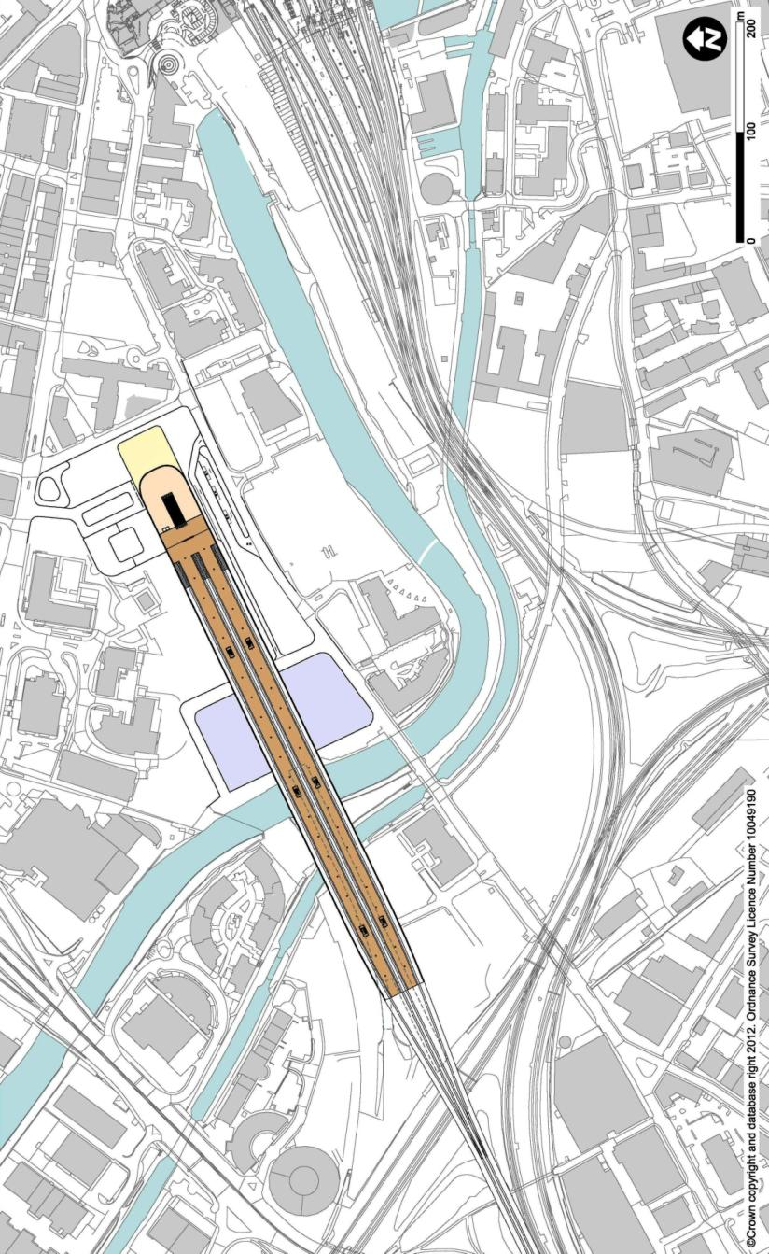
2
4
3
5
5
1

LST02 Leeds Central Station
        - This station option would be located on the Leeds Central station site, about 400m from the existing Leeds station. It would be an elevated terminus with approach from the ECML corridor on a viaduct above the existing Whitehall Junction complex. The station would therefore be approximately 25m above ground level (as was the original Leeds Central station). The station would be built over the remaining parts of the Grade II listed viaduct of the former station.
        - The station would be 750m from the city centre; walking distance to the existing Leeds station would be long for effective interchange. As a west-facing station, this would not be well placed for connection to the ECML and York.
        - Key issues would include connectivity and interchange with existing services, its effect on demand, and the complexity of construction over Whitehall Junction.

1 | High Speed Platforms
2 | Existing Leeds Station
3 | Concourse
4 | Forecourt
5 | Car Park
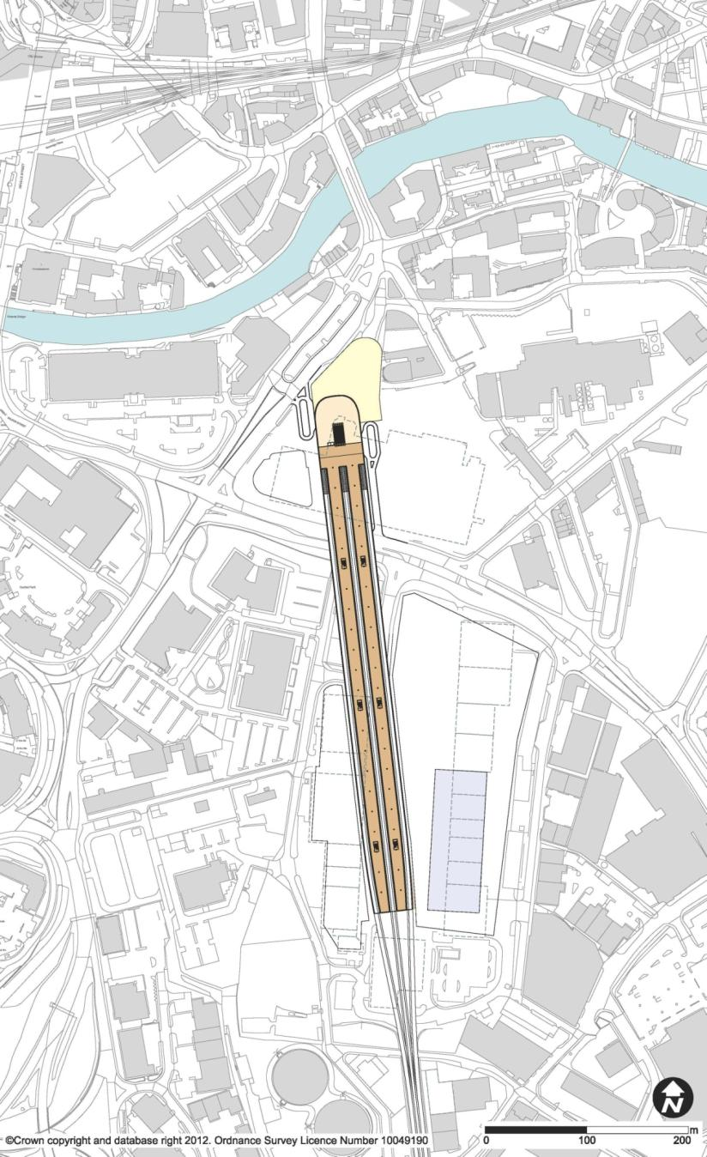
3

4

1

2

5

LST13b Hunslet Yard
        - This station option (which was initially named ‘Pottery Fields, Hunslet Yard’) would be located southeast of the existing Leeds station, occupying the site of the former Hunslet Goods Yard. It would be a terminus station at grade, feeding from the Woodlesford corridor to the south. It would be elevated over the local highway network.
        - It would be about 1.5km from the city centre, which would, for practical purposes, preclude pedestrian access, and 700m from the existing station, offering poor connectivity with regional rail unless the station were realigned to the northwest.
        - The key issues would be connectivity (including crossing the River Aire) and interchange with existing services, and curvature of the approach leading to a 1.5km distance between the crossovers and the platform ends, presenting a serious operational issue.

1 | High Speed Platforms
2 | Existing Leeds Station
3 | Concourse
4 | Forecourt
5 | Car Park
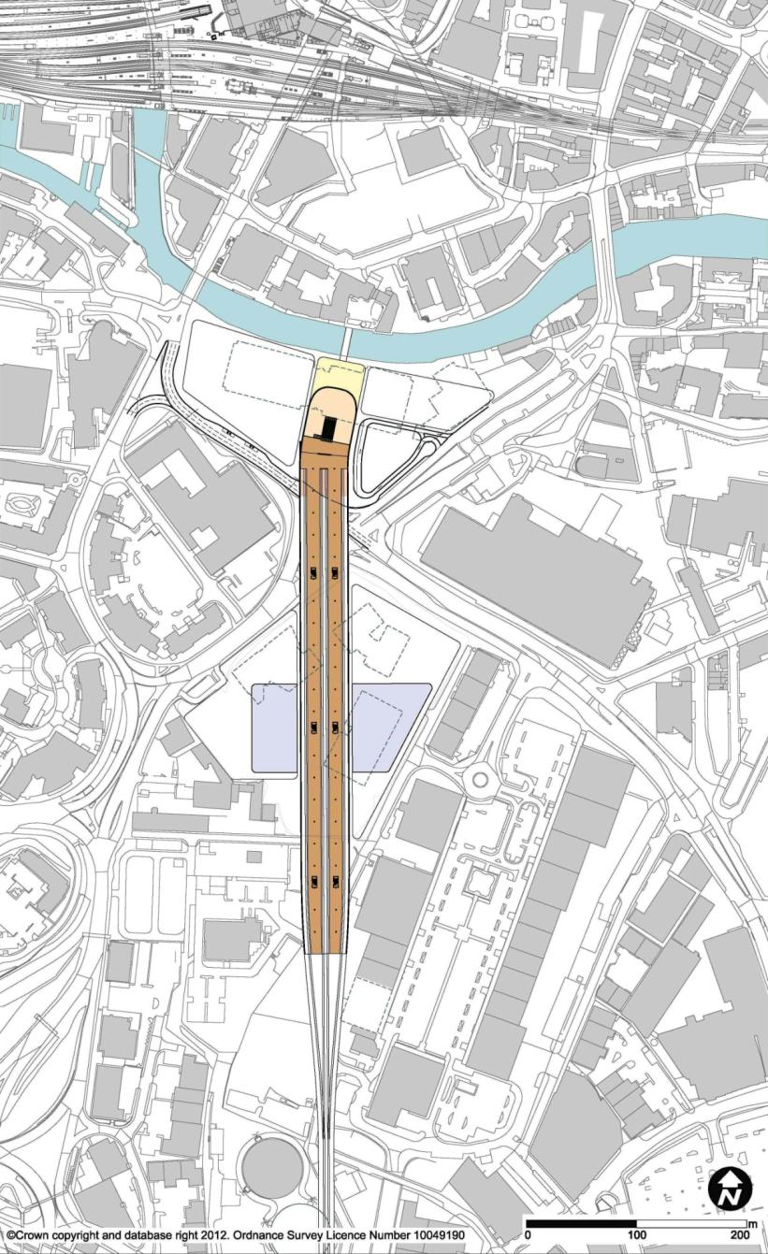
4

3

5

5

1

2

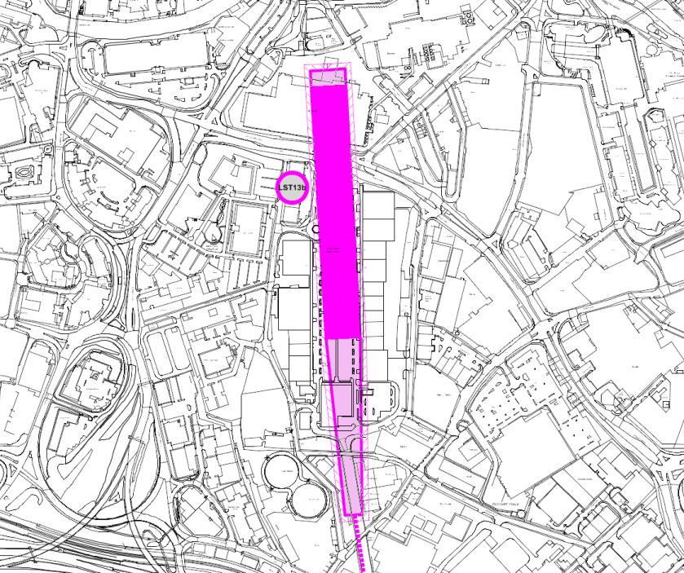
LST13c Gasworks
        - This station option (which was initially named ‘Pottery Fields, Gasworks’) would be located 300m south of the existing station, occupying a previous gasworks site, and would be approximately 1.2km from the city centre. It would cross directly over the Meadow Lane / Great Wilson Street junction and terminate on the current site of the Asda headquarters building, just short of crossing the River Aire. The station platforms would reach the southwest edge of the Crown Point retail park, just to the east of the twin gasholders. The station would be an elevated terminus served by the Woodlesford corridor to the south. It would not offer direct interchange with the existing Leeds station.
        - Passenger accessibility and connectivity would not be as good for this station as for other options like LST13e and LST13f.
    - Stations Introduced or Modified
        - The designs of the station options progressing through to confirmation of the final options were refined further during this stage. Option LST13e, Sovereign Street East, was repositioned southward to minimise impact on the proposed Sovereign Street development, and accordingly renamed Sovereign Street South. Option LST13f at New Lane was also introduced as a new option with a southern approach to the west side of the South Bank development area and with good proximity to Leeds station.
  - Confirmation of Final Options
        - The final options were:
LST01a Leeds Station North
LST13e Sovereign Street South (previously named Sovereign Street East)
LST13f New Lane
        - Full descriptions of the final options are to be found in sections 5, 6, and 7 of Chapter 3.

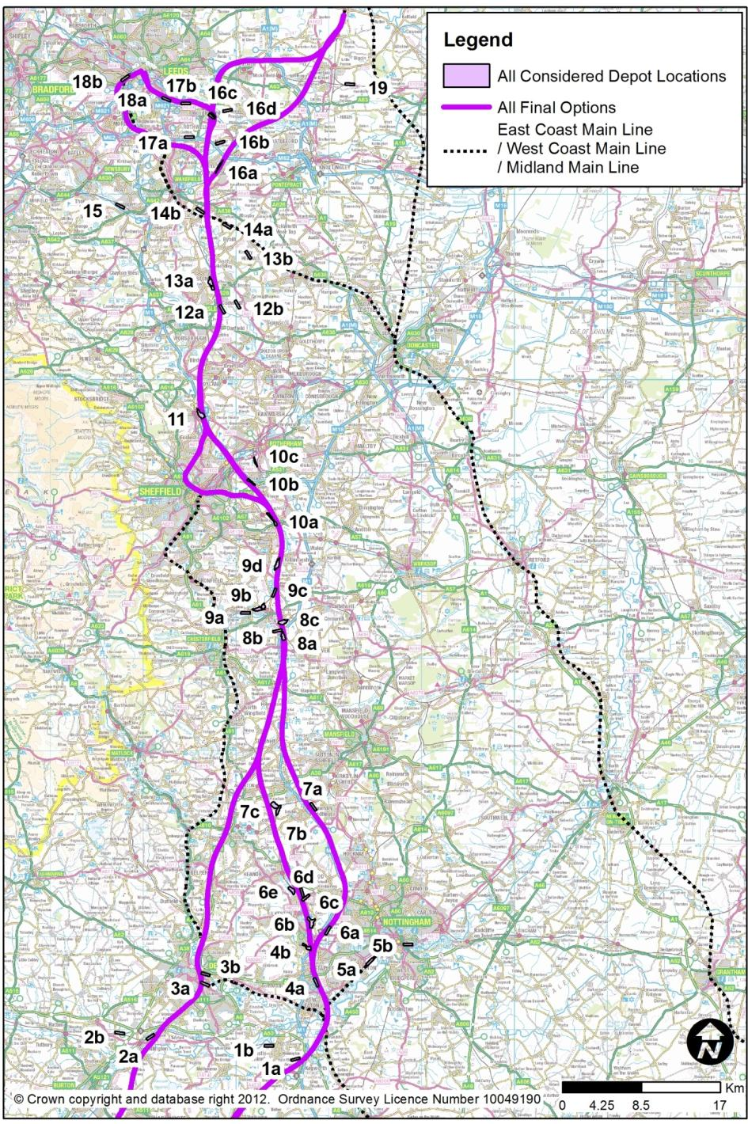
- History of Depot Options
  - Introduction
        - Two depots would be required for the operation of the West Midlands to Leeds section of HS2. One would be an Infrastructure Maintenance Depot (IMD) as a base from which to carry out engineering activities to maintain and renew the track and other elements of fixed infrastructure, and the other would be a Rolling Stock Depot (RSD) as a base for the trains which would operate on the route, and where they would be cleaned and maintained.
        - This chapter addresses both types of depot, as many of the sites considered would be suitable for either or both purposes.
  - Long List of Options
        - A preliminary study identified 48 possible sites which would:
- have the potential to provide the facilities required for rolling stock and / or infrastructure maintenance.
- occupy sites large enough to accommodate either, as identified internally and through discussions with external stakeholders who did not have any knowledge of the route. Subsequently some of these sites were found to be remote from the remaining Line of Routes i.e. Gascoigne Wood.
        - The long list of sites was as follows, with details of whether they were taken forward for further design or parked for engineering reasons:
Site ID | Site Name | Action taken
1a | Castle Don’ton nr airport | No Classic Rail Connection for IMD – Parked
1b | Castle Don'ton Power Stn | Too far from potential HS2 route – Parked
2a | Willington Power Station | Too far south to serve as an IMD – Parked
2b | Egginton Common | Too far south to serve as an IMD – Parked
3a | Derby Etches Park | Site too small – Parked
3b | Chaddesden Sidings | Too far south to serve as an IMD – Parked
4a | Toton | Too far south to serve as an IMD – Parked
4b | Stanton Iron Works | Poor size and orientation to serve route – Parked
5a | Beeston Area | Site too small and unsuitable location – Parked
5b | East of Nottingham | Site too small and unsuitable location – Parked
6a | Trowell | Poor access and challenging terrain – Parked
6b | Ilkeston / Cossall | Challenging terrain – Parked
6c | Awsworth old depot | Taken forward – Combined with 6d
6d | Awsworth | Taken forward – Combined with 6c
6e | North of Cotmanhay | Poor access and challenging terrain – Parked
Site ID | Site Name | Action taken
7a | Kirkby Park | Poor rail access and challenging terrain - Parked
7b | Pye Bridge (East) | Site too small – Parked
7c | Pye Bridge (North) | Site too small – Parked
8a | Markham Vale | Site too small – Parked
8b | Duckmanton | Site too small – Parked
8c | Seymour / Oxcroft Jncs | Site too small – Parked
9a | North of Staveley 1 | Taken forward – Combined with 9b
9b | North of Staveley 2 | Taken forward – Combined with 9a
9c | Renishaw | Site too small – Parked
9d | Killamarsh | Poor access – Parked
10a | Woodhouse Jcn | Taken forward for further design
10b | Tinsley | Taken forward as both IMD and RSD
10c | Masboro / Ickles | Site too small – Parked
11 | Chapeltown (Sheffield) | No Classic Rail Connection for IMD – Parked
12a | Cudworth 1 | Taken forward – Combined with 12b
12b | Cudworth 2 | Taken forward – Combined with 12a
13a | Carlton / Shafton | Limited access from route – Parked
13b | Havercroft / Hemsworth | Taken forward
14a | New Crofton | Taken forward
14b | Walton | Challenging terrain – Parked
S14C | Crofton | Poor access and challenging terrain – Parked
15 | Healey Mills | Too remote from potential routes - Parked
16a | Normanton | Site too small – Parked
16b | Methley Junction | Taken forward
16c | Woodlesford | Site too small – Parked
16d | Great Preston | Poor access and challenging terrain – Parked
17a | Lofthouse | Limited access – Parked
17b | Rothwell | Challenging terrain and limited access – Parked
18a | Stourton Freight Depot | Site too small – Parked
18b | Copley Hill | Site too small - Parked
S18C | Wortley | Poor access and unsuitable location – Parked
19 | Gascoigne Wood | Too remote from potential routes - Parked
S20 | Alfreton | Poor access and unsuitable location - Parked

        - The sites taken forward for further design were as follows:
        - Infrastructure Maintenance Depot
- Awsworth (6c / 6d)
- Staveley (9a / 9b)
- Woodhouse Junction (10a)
- Tinsley (10b)
        - Rolling Stock Depot
- Tinsley (10a)
- Cudworth (12a / 12b)
- Havercroft / Hemsworth (13b)
- New Crofton (14a)
- Metheley (16b)
        - Combined Infrastructure Maintenance Depot and Rolling Stock Depot
- Tinsley
        - The depot site at Woodburn Junction (10a) was subsequently parked. The site would be bisected by the Sheffield to Worksop railway line with a current clearance of 5m from existing ground. It would not be feasible to lift this railway to create adequate clearance as the railway falls rapidly to Woodhouse Junction north of Beighton. Furthermore, access to the depot would have involved flat junctions across the classic lines, constraining railway capacity of both the high speed route and the Chesterfield to Rotherham railway.
        - The depot site at Havercroft / Hemsworth (13b) was also parked prior to option refinement as the applicable Line of Route it served was parked.
  - Short List of Options
        - At this stage all the options were considerable viable to be taken forward.

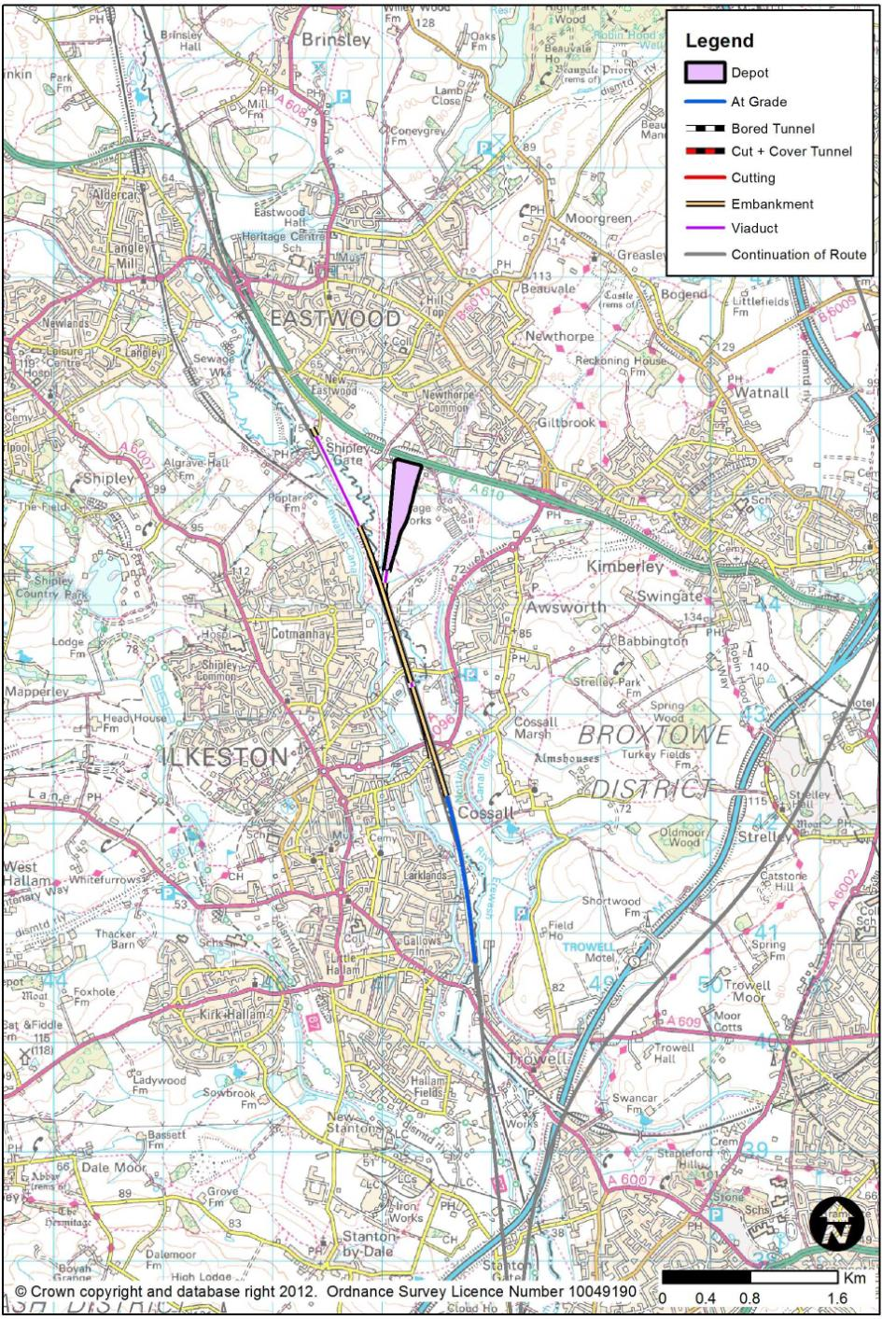
  - Options for Further Development

Rejected IMD Options following Further Design
        - This section of the report describes the less-favoured IMD options.

Awsworth
        - Awsworth depot would be located approximately 11km north west of Nottingham and 200m south of the village of Eastwood. The site would be located on green-field land and partially on a flood plain. The site is largely agricultural and contains a sports ground.
        - The Depot would be single ended and approximately 10 hectares in size.
        - Access to the depot would be from a pair of reception sidings, located in the 40m gap between the main line and the Nottingham to Sheffield (Erewash Valley) railway where the two run parallel to each other. Access from both lines onto these reception sidings would be via flat junctions. Northern access into the depot would be via a turn back arrangement on these reception sidings. This would not be expected to pose an operational issue. A connection would run from the reception sidings under the mainline and into the depot. Direct road access would be from the A610 dual carriageway.
        - As the depot would span the River Erewash and sit partly within its flood plain, some river diversion would be required in addition to that already required for the mainline. Some flood compensation may also be required. As the depot reception sidings would cross under the listed Bennerley Viaduct to the south, the tracks would pass between the existing piers to minimise any detrimental impact.
        - This site was considered to be too far south to serve as an Infrastructure Maintenance Depot and hence was parked.

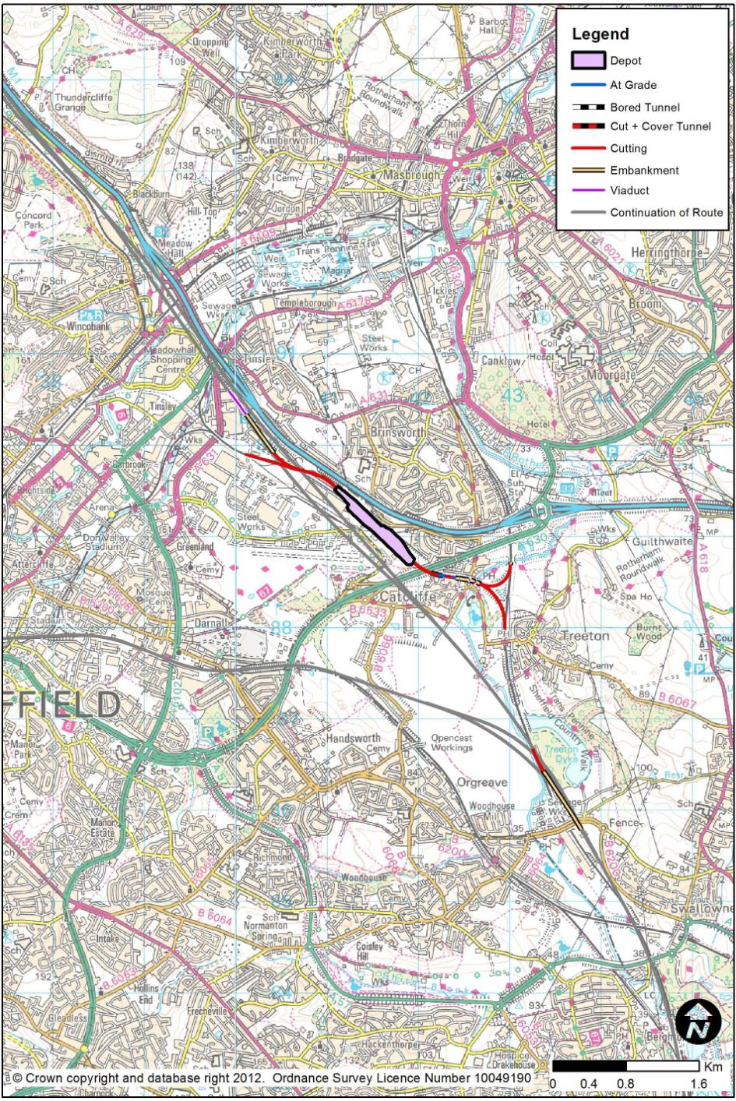

Tinsley
        - Tinsley depot would be located approximately two thirds of the way between Birmingham and Leeds approximately, 2km south of Sheffield’s Meadowhall stopping centre. The brownfield site was formerly a railway marshalling yard created in the early 1960s to serve the South Yorkshire area. The yard closed to most rail use in the early 1990s, and parts of the site have now been redeveloped. There are limited rail movements in this site due to the freight terminal (Sheffield International Rail Freight Terminal – SIRFT) at one end of the site.
        - The Depot would be double ended, approximately 10 hectares in size and be situated towards the southern end of the existing site.
        - Access to the new route and existing lines would be possible at both ends of the depot. To the south, the disused Catcliffe / Treeton chords would be reinstated to provide a spur to the classic Rotherham to Chesterfield freight route. The new route would share this railway for 1km from the mainline near Swallownest. Flat junctions with the mainline would be proposed. The existing railway would require upgrade through this section to ensure compatibility with the headroom requirements for high speed trains.
        - The northern connection would be via a new single track spur to the southbound platforms at Meadowhall station. This spur would require the widening of the proposed main line viaduct over Meadowhall. The classic rail connection would utilise the existing freight terminal tracks onto the existing railway network.
        - Road access to the site would be off the new Wood Lane diversion and link.
        - The layout would conflict with the Sheffield International Rail Terminal units and also impact on current rail activities in the yard, with the removal of some sidings.
        - The complicated railway accesses to the Depot, coupled with actual site size constraints added to the cost of the option. This option therefore was considerably more expensive that alternative options and such parked.

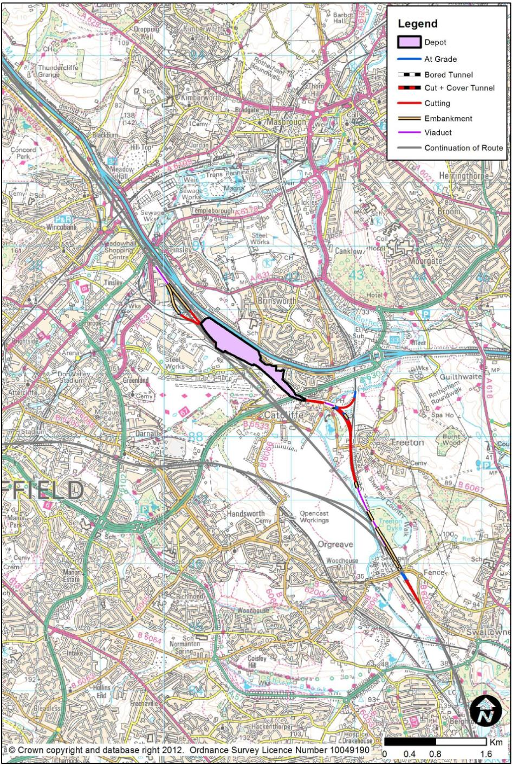

Rejected RSD Options following Further Design
        - This section of the report describes the less-favoured RSD options.

Tinsley
        - Tinsley depot would be located approximately two thirds of the way between Birmingham and Leeds, approximately 2km south of Sheffield’s Meadowhall stopping centre, and 52km from a proposed station in Leeds. The brownfield site was formerly a railway marshalling yard created in the early 1960s to serve the South Yorkshire area. The yard closed to most rail use in the early 1990s, and parts of the site have now been redeveloped. There are limited rail movements in this site due to the freight terminal (Sheffield International Rail Freight Terminal – SIRFT) at one end of the site.
        - The Depot would be single ended, approximately 25 hectares in size and the site boundary would extend beyond the available space within the former marshalling yard.
        - Access to the high speed line and existing lines would be possible at both ends of the depot. To the south the disused Catcliffe / Treeton chords would be reinstated to provide a spur to the Rotherham to Chesterfield railway. The route would run alongside this railway for 1km after spurring off the mainline near Swallownest via a grade-separated junction.
        - The northern connections would be via grade-separation with the main line with trains running through the platform face tracks at Meadowhall station. These spurs would require the widening of the proposed mainline viaduct over Meadowhall. The northbound connection would pass under the mainline in a box structure before rising at 1.8% vertical gradient to join the mainline.
        - Road access to the site would be off the new Wood Lane diversion and link.
        - The layout would require the demolition of the Sheffield International Rail Terminal buildings to accommodate the required depot footprint, as well as new retaining walls adjacent to the M1 motorway. The northbound connection would also cross over a complex area of transport infrastructure which includes Super Tram, an existing railway and road network, further complicating its construction.
        - The complicated railway accesses to the Depot, coupled with actual site size constraints added to the cost of the option. The site would also be located 30km further south that alternative options so would not serve Leeds as effectively. For these reasons, this depot option was parked.

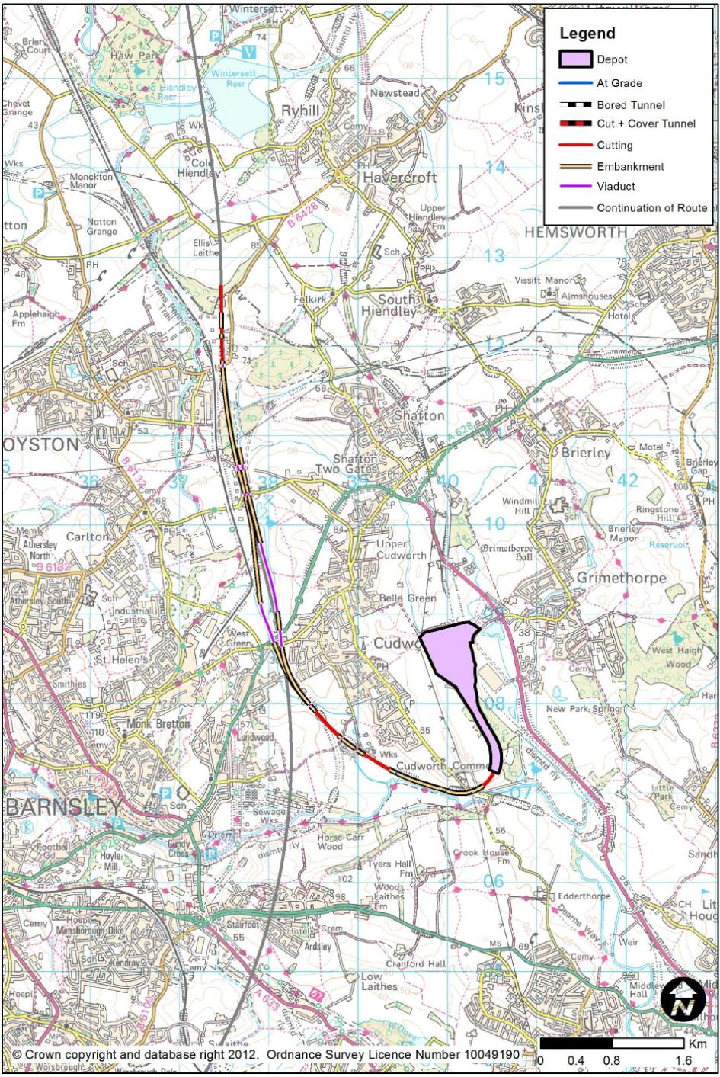

Cudworth
        - Cudworth depot would be located approximately 6km north east of Barnsley and 32km south of a proposed station in Leeds. This site would be located on a mix of green-field and brownfield land adjacent to an existing business estate. As the site would be remote from the mainline, approach lines to the depot would utilise the abandoned former Midland railway.
        - The depot would be single ended and approximately 23 hectares in size. The remoteness of the site from the mainline would mean that the depot would be easy to operate, particularly with the carriage washer being situated on the approach spurs.
        - Access into and out of the depot would be via parallel bi-directional lines providing full grade-separated high speed access. It would be proposed that southbound access would be achieved by reversing trains on the northbound access tracks. It would not be possible to create direct southbound access because the route would be tunnelled under Ardsley immediately to the south of the junction. Good classic railway access would not be practical, requiring significant upgrades to a nearby single line freight only railway.
        - There would be direct road access to the site using the adjacent A6195 that passes alongside Pen Hill Industrial estate.
        - As the approach links would be adjacent to and within the flood plain of the River Dearne and Cudworth Dike, protection measures and flood compensation could be required.
        - As this depot would be located 10km further south than alternative options, it would not serve Leeds as effectively. Furthermore, the long approach tracks to the depot add to the cost of the option. For these reasons, this depot option was parked.

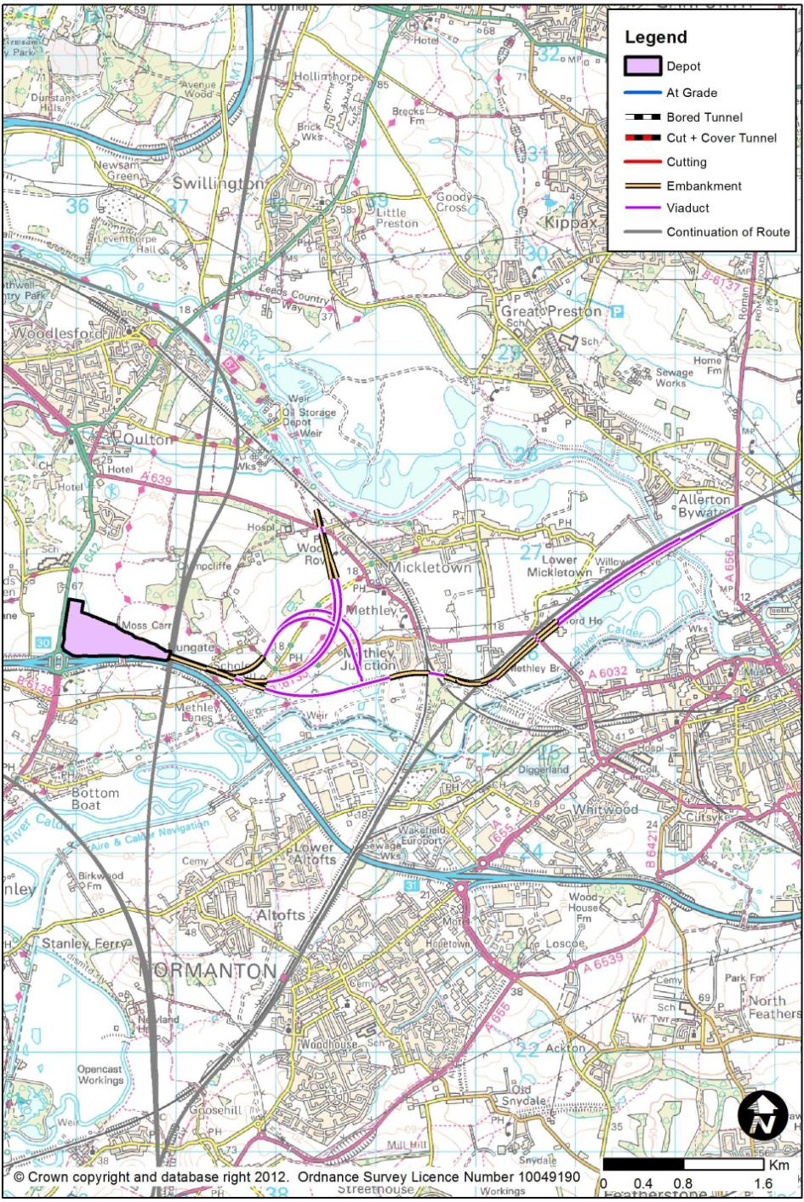

Methley
        - Methley depot would be located 800m south of Oulton and 11km south east of a proposed station in Leeds. The site would be located adjacent to the M62 at Junction 30. The placement of the site north of the junctions to Leeds and the East Coast Main Line would require three approach spurs to access Leeds, West Midlands and York.
        - The Depot would be single ended and approximately 29 hectares in size.
        - Rail access to the site would be complicated due to the site’s proximity to the main line and limited availability of horizontal straights on which to place turnouts. This would result in lower-speed grade-separated connections which cross each other to maximise their speed where possible. The need to serve York would mean a third connection that follows a former railway corridor south of Methley and spurs into the mainline near Allerton Bywater. The site’s location 25m above the flood plain would mean large approach embankments increasing the cost of constructing the depot.
        - Existing rail access to the site would be impractical but road access would be very good with the depot being situated adjacent to M62 Junction 30.
        - Due to space constraints for the approach connections and required vertical gradients, the carriage washer would be located on a dedicated siding parallel to the main stabling tracks. The washer location would complicate the operation of the depot, with trains needing to reverse out of the washer siding before heading back into the depot or stabling sidings.
        - Although this depot option would be the closest to Leeds, it would not serve both Leeds and York effectively. The complicated arrangement of the approaches to the depot adds to the cost of the option. This option was considered less-favourable compared with other options, and therefore parked.

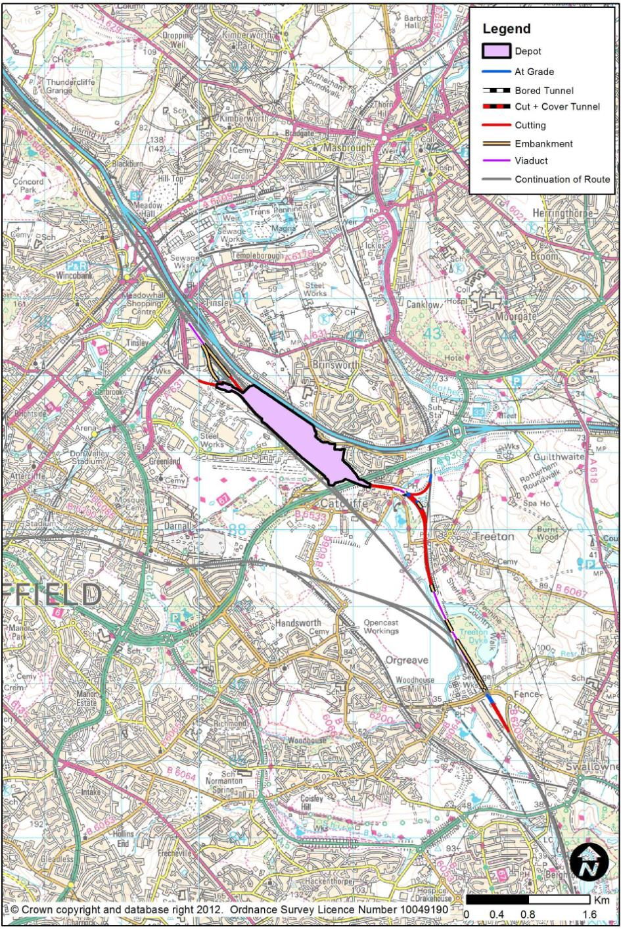

Rejected Combined IMD and RSD Sites
        - This section of the report describes the less-favoured combined site.

Tinsley
        - Tinsley depot would be located approximately two thirds of the way between Birmingham and Leeds approximately 2km south of Sheffield’s Meadowhall stopping centre, and 52km from a proposed station in Leeds. The brownfield site was formerly a railway marshalling yard created in the early 1960s to serve the South Yorkshire area. The yard closed to most rail use in the early 1990s, and parts of the site have been redeveloped. There are limited rail movements in this site due to the freight terminal (Sheffield International Rail Freight Terminal – SIRFT) at one end of the site.
        - The depot would consist of a double ended Infrastructure Maintenance Depot to the west, and single ended Rolling Stock Depot to the east. The depot would be approximately 45 hectares in size and the site would extend significantly beyond the available space within the former marshalling yard.
        - Access to both proposed and existing railways would be possible at both ends of the depot. To the south, the disused Catcliffe / Treeton chords would be reinstated to provide a spur to the Rotherham to Chesterfield line. The new route would run alongside this railway for 1.0km after leaving the main line near Swallownest via a grade-separated junction.
        - The northern connections would be via grade-separation with the main line with trains running through the platform face tracks at the proposed Meadowhall station. These spurs would require the widening of the proposed main line viaduct over Meadowhall. The northbound connection would pass under the main line in a box structure before rising at 1.8% vertical gradient to join the main line. The connection to the existing rail network would utilise the existing freight terminal tracks.
        - Road access would be off either a new Wood Lane diversion or off the Europa Link.
        - The layout would require the demolition of the Sheffield International Rail Terminal buildings, car showroom and adjacent hotel in order to accommodate the required depot footprint. Retaining walls would also be required around the site and adjacent to the M1 motorway to limit encroachment and excess spoil. The northern northbound connection would also cross over a complex area of transport infrastructure which includes Super Tram, an existing railway and road network, further complicating its construction. Operation of the depot would also be complicated by the conflicting movements of rail traffic using each depot.
        - The complicated railway accesses to the Depot and operation within it, coupled with actual site size constraints added to the cost of the option. This option therefore was considerably more expensive that alternative options and therefore parked.
- History of Options for Connection with the Existing National Railway Infrastructure
        - The remaining options for serving Nottingham and / or Sheffield in a ‘classic compatible’ (CC) manner were described in Chapter 5. As for the main route alignment options, consideration of CC options followed a sequential process. This section of the report summarise those studies. At the time of these studies, little work was done on actual locations for junctions etc, as the study was conceptual in nature, with generic solutions and generic costs.
  - East Midlands
        - Options were considered for serving Derby or Nottingham, with the route being:
- through Derby:
- through the Derby – Nottingham gap, or
- through Toton,

all with or without the capability of running trains to and from the south, as well as to and from the north.
- If the high speed main line were to run via Derby, CC options to Derby would clearly be unnecessary. CC connections to Nottingham for such a route would be tortuous and slow, with only modest advantages over current MML journey times. Only south-facing links would offer benefits, as northbound from Derby would be slower than via Chesterfield.
- If the high speed route went through the Derby / Nottingham gap, a south-facing CC Spur to Derby would be feasible. A south-facing CC spur to Nottingham would involve:
- A new grade-separated junction on the high speed main line
- a single new platform on the south side of Nottingham Midland Station, to accommodate 2 terminating services an hour.
- the reconstruction of Nottingham western approaches;
- grade-separation of Trent Junction in the east to west direction;
- resignalling between the new intersection junction and Trent Junction;
- North-facing and south-facing capability to Nottingham would involve:
- 2 grade-separated junctions on the main line;
- a minimum of 2 additional platforms at Nottingham to accommodate 7 additional trains;
- reconstruction of Nottingham station western approaches;
- 4 tracking west of Beeston Station;
- Grade-separation in both directions across the existing Trent Junction (from west of Sheet Stores Junction) and Attenborough Junction;
- Resignalling from the junction with the new high speed route as far as the reconstruction at Beeston;
- a significant risk that the twin track section between the new intersection junction and just west of Beeston may not be able to cater for the total traffic volume of passenger and freight services;
- a further risk that the rail junctions at Nottingham may need complete reconstruction.
- If the high speed main line were to go through Toton, with a station there, opportunities would arise for providing additional platforms to serve diverted national rail services, or an overlay of connecting services. These additional platforms adjacent to the high speed station would provide interchange options there. This option has already been described.
  - South Yorkshire
        - The options considered for South Yorkshire (at that stage of the work, comprising Sheffield Midland) were;
- CC Spur off a high speed route passing to the east of Rotherham, consisting of either a southern chord only, or both a southern and northern chord;
- CC Spur from the south only from an M1-based alignment for a high speed route; with a high speed station at Meadowhall.
        - In general, it was found that:
- options from the M18 route would be more expensive than from an M1 route;
- a Meadowhall-facing link would be unattractive for services from the south;
- a south-facing only link would be unattractive for services from the north;
- an east-facing approach from the Darnall direction might be practical for both north-facing and south-facing connections, as the Sheffield to Worksop route would appear to have spare capacity (and would not need widening in the manner that would be required for the larger high speed trains on this route);
- there could be capacity problems between Dore and Sheffield Midland, potentially solved by 4-tracking to Dore and re-instating the dive-under just south of Midland;
- there could be capacity problems between Sheffield Midland and Meadowhall, potentially solved by grade-separation in the Brightside or Wincobank areas, and by 4-tracking from Nunnery Main Line Junction into Sheffield station.
- At Sheffield Midland station, one or more new platforms would be required on the east side, depending on the train service frequency, with major works to create a new retaining wall to accommodate the new footprint, or by means of an extended re-spacing of tracks and station buildings / footbridges to contain the new platforms in the existing footprint;
- Dependent on frequency, options from the south may require works at Chesterfield Station, with a new platform on the Up Barrow Hill Line.
        - In view of these quite complex and inter-related issues, it was felt that the only practical potential for CC trains to serve Sheffield would be:
- a spur utilising the Darnall corridor carrying 1 or 2tph – this is the proposal which has already been described;
- a loop for only 1 or 2 tph via Chesterfield.

