
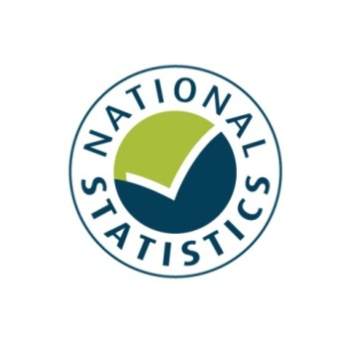

Taking Part 2012/13 Quarter 3
Statistical Release
March 2013






Taking Part is a National Statistic and has been produced to the standards set out in the Code of Practice for Official Statistics

The United Kingdom Statistics Authority has designated these statistics as National Statistics, in accordance with the Statistics and Registration Service Act 2007 and signifying compliance with the Code of Practice for Official Statistics.
Designation can be broadly interpreted to mean that the statistics:
• meet identified user needs;
• are well explained and readily accessible;
• are produced according to sound methods; and
• are managed impartially and objectively in the public interest.

Once statistics have been designated as National Statistics it is a statutory requirement that the Code of Practice shall continue to be observed. The UK Statistical Authority assessment is available at https://www.gov.uk/government/publications/uk-statistics-authority-assessment

Contents

Key findings 4
Introduction 9
Chapter 1: The 2012 Olympic and Paralympic Games 12
Chapter 2: Sport 16
Chapter 3: Heritage 23
Chapter 4: Museums and galleries 26
Chapter 5: Libraries 30
Chapter 6: Arts 33
Chapter 7: Archives 37
Chapter 8: Volunteering and charitable giving 39
Chapter 9: Equalities 43
Annex A: Background note 49
Annex B: Key terms and definitions 52
Annex C: Sector definitions 55

Key findings

Taking Part is a household survey in England, looking at participation in the cultural and sporting sectors. This report presents the latest headline estimates for the year up to and including December 2012. The survey has run for eight years and is used widely by policy officials, academics and charities to measure participation in the sport and cultural sectors. Please note the time period reported in this release now includes the period when the UK hosted the 2012 Olympic and Paralympic Games, which may have had an effect on participation in some of the sectors.

2012 Olympic and Paralympic Games
    - 88 per cent of adults intended to follow or followed the London 2012 Olympic or Paralympic Games, for example, by watching on television at home.

    - 24 per cent of adults actively got involved, or intended to actively get involved¹ in the Games, for example by attending a free Olympic event.
    - Over two thirds (69%) of adults were slightly or strongly supportive of London hosting the 2012 Olympic and Paralympic Games. Attitudes have fluctuated since 2005/06 (71% slightly or strongly supportive), with a low in 2007/08 of 60 per cent.
    - 16 per cent of adults reported that the UK winning the bid had motivated them to do more sport, 6 per cent reported that they were motivated to do more cultural activities and 8 per cent reported that they were motivated to do more voluntary work. Motivation to do more sport and cultural activities has significantly increased since 2010/11.

Sport (including recreational walking and cycling)
- 45 per cent of adults participated in at least one session of 30 minutes of moderate intensity sport in the week prior to being interviewed. This measure remained stable between 2005/06 and 2009/10, and first showed a significant increase in 2010/11 with further annual increases since then.

- Since 2005/06, participation of adults in at least one session of 30 minutes of moderate intensity sport in the last week has increased significantly overall and for the following specific age bands:

  - 25-44 year olds
  - 45-64 year olds
  - 65-74 year olds
  - Age 75+
There has been no change since 2005/06 using this measure of participation for 16-24 year olds, currently 59 per cent.

Culture
- Nearly three quarters (73%) of adults visited a heritage site in the last year. This represents an increase of 3 percentage points since the survey began in 2005/06 as well as an increase (3 percentage points) since 2010/11.

- The proportion of people who had visited a museum or gallery in the previous year has increased since 2005/06 (from 42% to 52%), a general upward trend since 2008/09.

- 37 per cent of adults had used a library in the 12 months prior to being interviewed, a significant decrease from 48 per cent in 2005/06, and a significant decrease from 40 per cent in 2010/11.

- 78 per cent of adults had attended or participated in the arts in the previous year, a significant increase reported since 2005/06 (76%) and 2010/11 (76%).

- Arts engagement increased to highest levels since the survey began in 2005/06 for people living in urban areas, reaching 78 per cent. This was a significant increase from 75 per cent in 2005/06. Those living in rural areas had a higher participation rate than those in urban areas (81% compared to 78%)

Volunteering and charitable giving
- The proportion of adults who had volunteered in the last 12 months was 26 per cent. 9 per cent of all adults had volunteered in a DCMS sector (Arts, Museums/Galleries, Heritage, Libraries, Archives, Sport.)

- There was a significant increase in the proportion of adults from the black and ethnic minority (BME) groups who had volunteered in the last 12 months compared to 2005/06 (up from 20% to 27%). This may be linked to the UK winning the bid to host the 2012 Olympic and Paralympic Games, since 23 per cent of black and minority ethnic volunteers said they were motivated to do more voluntary work as a result of the UK hosting the 2012 Olympics.

- There was also a significant increase in the proportion of adults aged 16-24 years (up from 25% to 34%) and women (25% to 28%) who had volunteered in the last 12 months compared to 2005/06.

- 90 per cent of adults had donated money (including donations into a collection box) in the last 12 months. 32 per cent of adults had donated to a DCMS sector, a similar level to those who had donated money to a DCMS sector in 2010/11.

Digital engagement
- 30 per cent of adults had visited a museum or gallery website, an increase from 16 per cent in 2005/06 and the highest reported level since data collection began in 2005/06.

- In this period, of those who had visited a museum or gallery website 60 per cent of adults had done so to find out about or order tickets for an exhibition or event, 45 per cent to find out about a particular subject, 21 per cent to look at items from a collection, 17 per cent of adults had taken a virtual tour of a museum or gallery and 14 per cent had viewed or downloaded an event or exhibition.

- 17 per cent of adults had visited a library website in the previous 12 months, a significant increase from 9 per cent in 2005/06.

Equalities
- Female participation of women doing at least one session of 30 minutes of moderate intensity sport per week has significantly increased since 2005/06 (36.6%), the first year data was collected, and since 2010/11 (37.1%). This equates to an additional 1.1 million women participating in at least one session of 30 minutes of moderate intensity sport per week since 2005/06.

- Since 2010/11, there has been an increase of 1.2 million adults doing at least one session of 30 minutes of moderate intensity sport per week, a large proportion of which was due to an increase of 700,000 women participating.

- Women had significantly lower levels of participation than men in most measures of active recreation, with only 40 per cent participating in 30 minutes of moderate intensity sport at least once a week (including recreational walking and cycling), compared with 50 per cent of men.

- The types of activities women participated in were considerably different to those that men participated in, with 13 per cent of women taking part in keep fit / aerobics / dance exercise compared with only 5 per cent of men, whilst 1 per cent of women played football outdoors compared with 13 per cent of men.

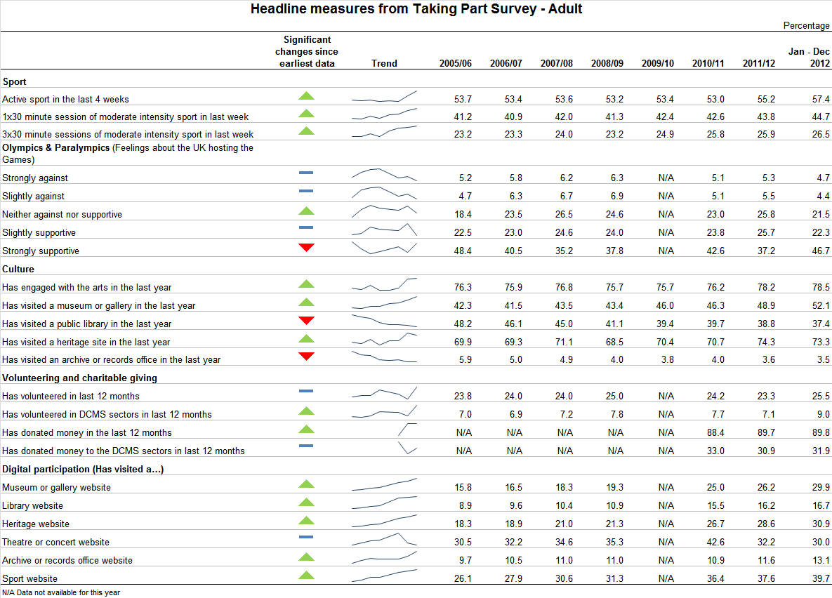
Introduction

This report
Taking Part is a household survey in England, looking at participation in the cultural and sporting sectors. This report presents the latest headline estimates for the year up to and including December 2012. The survey has run for eight years and was commissioned by the Department for Culture, Media and Sport (DCMS) in partnership with Arts Council England, English Heritage, and Sport England. The statistics are used widely by policy officials, academics, the private sector and charities to measure participation in the sport and cultural sectors.

Taking Part is the key evidence base for DCMS, providing reliable national estimates of participation and supporting the Department’s aim of improving the quality of life for everyone, by providing people with the chance to get involved in a variety of cultural and sport opportunities. The survey also aims to inform the DCMS Structural Reform Priorities and Business Plan through the provision of data for DCMS input and impact indicators. The latest DCMS indicators are available at: https://www.gov.uk/government/organisations/department-for-culture-media-sport/series/performance-indicators

The report presents headline findings for the main culture and sport estimates along with updates on data which are used to measure the influence of London hosting the 2012 Olympic and Paralympic Games and volunteering and charitable giving policy objectives. Where analysis has been extended to look at digital engagement within the DCMS sectors (heritage, museums and galleries, libraries and archives, arts, sport, volunteering and charitable giving), this is presented alongside the relevant sector figures. An additional chapter has been included in this release looking at women’s participation in sport.

Government policies which may have had an impact on participation figures have been outlined at the beginning of relevant chapters throughout the report. We are not, however, indicating that these policies have directly caused the change in participation, simply that they may be a factor. Where observations are made over time, the latest data are compared with the earliest available data (typically 2005/06). Key terms and definitions are provided in Annex B and C of this release.

The latest results presented in this report are based on interviews conducted between January 2012 and December 2012. The total sample size for this period is 9,427. statistical significance tests have been run on all estimates at the 95% level. All differences and changes reported are statistically significant at the 95% confidence level unless otherwise stated. This means the probability that any given difference happened by chance is low (1 in 20).

The accompanying spreadsheets to this release are available at: https://www.gov.uk/government/publications/taking-part-2012-13-quarter-3-statistical-release

Forthcoming releases and events
The next adult release, scheduled for June 2013, will present the quarter 4 estimates for year 8 (April 2012 – March 2013) for adults.

There will also be a child release presenting estimates for 2011/12 Q3 to 2012/13 Q2 in April 2013.

Future adult releases will follow a similar schedule, being released at the end of March, June, September and December ahead of quarterly reporting on the input and impact indicators that are produced by all Departments.

In addition, topic specific analysis will be published throughout the year, looking in depth at particular areas of the survey. Previous reports have covered Big Society (available at https://www.gov.uk/government/publications/encouraging-involvement-in-big-society-a-cultural-and-sporting-perspective-november-2011) and sport participation (published in the annex of the 2011/12 technical report, available at https://www.gov.uk/government/publications/technical-reports) The third and most recent report on the 2012 Olympic and Paralympic Games was published 13th December 2012 (available at https://www.gov.uk/government/publications/further-research).

The most recent Taking Part User Event was held on 28th November 2012. Details of this event and materials from previous events are available on our site at: https://www.gov.uk/government/publications/user-corner

If you would like further information on these releases or the Taking Part survey, please contact the Taking Part team on TakingPart@culture.gsi.gov.uk. Additional contact details are contained within Annex A.

Consultation
DCMS and Sport England consulted with users and other interested parties in summer 2012 on proposals to integrate the Taking Part and Active People surveys to change the way sport is measured. There was an excellent level of response from a wide selection of stakeholders. Overall we received considerable support for the proposals, alongside some areas for further consideration.
In summary, most respondents supported local and sport specific measurement, with a single result for sport, and data collected through a mixed mode. Consultees also expressed the importance of retaining consistency with previous results, which (alongside technical considerations) means that we need to implement any potential changes carefully through testing and with technical advice. A full consultation response is available at https://www.gov.uk/government/publications?departments%5B%5D=department-for-culture-media-sport&publication_filter_option=consultations.

We are therefore proposing to continue to ask sport participation questions in Taking Part Survey, but on behalf of Sport England. This means that sport participation data will not be analysed and reported on by DCMS or in the Taking Part publications. This approach allows for the inclusion of face-to-face data within Active People over time, so that Active People can become a fully mixed-mode survey. In the shorter term the data will be used to validate the landline estimates. This Taking Part publication will therefore be the final release to contain sport data and analysis. If you have any comments on this proposal then please email us at statsconsultation@culture.gsi.gov.uk by May 2nd 2013.

- The 2012 Olympic and Paralympic Games

This chapter explores a number of areas related to the UK hosting the 2012 Olympic and Paralympic Games, including the extent to which people in England supported hosting the Games, how people intended to get or got involved in the Games and whether the Games motivated people to participate in voluntary work, cultural activities or sport.

Survey results now include the period when the UK hosted the 2012 Olympic and Paralympic Games. Further analysis looking at participation rates during the quarter when the 2012 Games were held, will be carried out as part of the London 2012 Meta-evaluation (https://www.gov.uk/government/organisations/department-for-culture-media-sport/series/london-2012-meta-evaluation) and published in Summer 2013.

Government policy, which may have influenced the statistics presented, is described below:
The Government has a policy to make the most of the 2012 Olympic and Paralympic Games, to deliver a legacy over the next ten years, across the four themes of sport and healthy living, growth and the economy, communities and volunteering and the regeneration of East London, with the Paralympic legacy cutting across those four themes. This includes encouraging more people to take part in sport and volunteering. The Government intends to use the success of Games-related volunteering to increase the rate of volunteering, including through initiatives such as ‘Join in’, which is funded by the Office for Civil Society to promote sport related volunteering. It intends to promote cultural engagement following the Cultural Olympiad, which attracted around 20 million people to events across the UK.
Legacy planning was part of the planning for the Games from the bid stage onwards. The Government set out its legacy plans in a Written Ministerial Statement from the then Secretary of State for Culture, Media and Sport in December 2010. A meta-evaluation of the Games’ legacy benefits has been commissioned by the DCMS. An initial pre-Games report of legacy benefits was published in November 2012.

Key findings

    - 88 per cent of adults intended to follow or followed the London 2012 Olympic or Paralympic Games, for example, by watching on television at home.

    - 24 per cent of adults actively got involved, or intended to actively get involved¹ in the Games, for example by attending a free Olympic event.
    - Over two thirds (69%) of adults were slightly or strongly supportive of London hosting the 2012 Olympic and Paralympic Games. Attitudes have fluctuated since 2005/06 (71% slightly or strongly supportive), with a low in 2007/08 of 60 per cent.
    - 16 per cent of adults reported that the UK winning the bid had motivated them to do more sport, 6 per cent reported that they were motivated to do more cultural activities and 8 per cent reported that they were motivated to do more voluntary work. Motivation to do more sport and cultural activities has significantly increased since 2010/11.

The 2012 Olympic and Paralympic Games

Between January and December 2012 the Taking Part survey asked questions on adults’ intended or actual involvement in the Games. 88.2 per cent of adults intended to follow or followed the London 2012 Olympic or Paralympic Games, either by watching on TV at home (84.7%), reading a newspaper online or offline (36.2%), listening on the radio at home (15.7%), watching or listening on the internet at home (15.2%) or watching live events on a public big screen (11.3%).

Additionally, from July 2011 we asked adults whether they intended to or actually did actively follow or get involved in the London 2012 Olympic or Paralympic Games. 24.4 per cent of adults said they did, which included attending a free (7.0%) or ticketed (8.7%) Olympic or Paralympic event, taking part in a Games related community event or activity, e.g. street party or local Inspire Mark project (3.5%), or using a new or improved sports facility linked to the Games (1.0%). Other active involvements include gaining Games related employment or training (1.3%), taking part in a Games related cultural event or activity (1.4%) volunteering during the Games, e.g. as a Gamesmaker or London Ambassador (0.8%), or taking part in a Games related sport or physical activity (0.5%).

Support for the UK hosting the 2012 Olympic and Paralympic Games

Attitudes towards the UK hosting the Games have fluctuated over the period since 2005/06.
- During January to December 2012, the proportion of those who were strongly supportive fell by a small but significant amount from 48.4 per cent in 2005/06 to 46.7 per cent in the latest results. Strong support for hosting the Games is now at the highest level since winning the bid in 2005/06.
- The proportion who were neither against nor supportive of the Games has increased from 18.4 per cent to 21.5 per cent in January to December 2012, however this is the lowest level since winning the bid in 2005/06.
- The proportion of those who have been slightly against or strongly against and those slightly supportive of London hosting the 2012 Olympic and Paralympic Games has remained stable (Figure 1.1).

London won the bid to host the Olympic and Paralympic games on the 6th July 2005. The Games was staged in July, August and September 2012. These figures represent continuing strong support for the Games, however the fluctuations in the proportion of people strongly supportive of the Games since 2005/06 might be due to a number of factors including the stage in the cycle between the UK winning the bid and hosting the Games.

Figure 1.1: Adults’ opinions about the UK hosting the 2012 Olympic Games, 2005/06 to January – December 2012

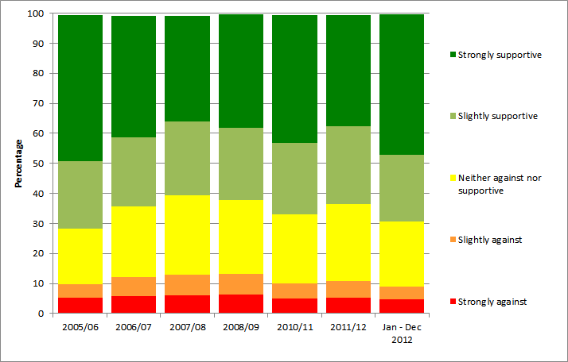
Notes
(1) Confidence intervals range between +/-0.4 and +/-1.3 from 2005/06 onwards.
(2) This question was not asked in 2009/10

- By ethnic origin

A higher proportion of adults from black and minority ethnic (BME) groups were supportive of the Games than those from the white group (78.3% and 68.2% respectively). The proportion of adults from the white group supportive of the Games significantly increased between 2010/11 and 2011/12. The corresponding proportion of adults from BME groups has remained relatively stable over this time period.

- By gender and age

Support for the UK hosting the Games was similar for men and women (69.3% and 69.4% respectively), although the support by men had remained stable since 2010/11 (69.9%), support by women had had increased significantly since 2010/11 (63.7%).

The younger age groups were more supportive of the Games (69.2% for 16-24 and 72.3% for 25-44 year olds), whilst those 65-74 and 75 years and older were the least supportive age groups (both currently at 65.8%). There has been a large increase in support since 2010/11 amongst the 75+ age group of 7.9 percentage points to 65.8%.

- By region

Support for the UK hosting the Games was similar across all English regions in the current period. There have been significant increases since 2010/11 for both the East Midlands and the West Midlands.

The levels of support within London, where the majority of the Games were held, varied. Between July 2005 and December 2012, 71.6 per cent of respondents in Waltham Forest (a host borough and the most supportive London borough) were supportive of the Games, compared to 56.4 per cent of respondents in Kingston upon Thames (the least supportive London borough) and 65.4 per cent for London as a whole and 69.0 per cent for England (Figure 1.2).

Figure 1.2: Proportion of adults who were slightly or strongly supportive of the UK hosting the 2012 Olympic Games, London, July 2005 to December 2012

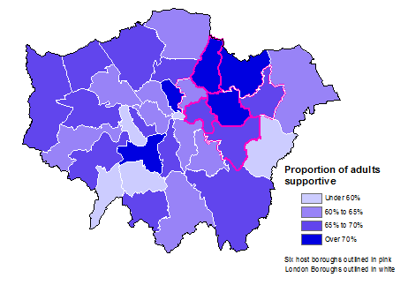
Notes
- Results for the City of London were indicative due to a small sample size.
- Sample sizes vary by London Borough (excluding City of London) from 198 to 777.
- The six host boroughs are Barking and Dagenham, Greenwich, Hackney, Newham, Tower Hamlets and Waltham Forest.

Further detail on this section can be found in the accompanying spreadsheets to this release available at: https://www.gov.uk/government/publications/taking-part-2012-13-quarter-3-statistical-release

- Sport

This chapter examines sport by a range of area-level and socio-demographic breakdowns. Although adults are asked about their participation in the four weeks before they were interviewed, the data are collected over a full year, so normal seasonal patterns are not an issue as they average out over the year. However, a particularly hot summer or cold winter could have an impact on participation across the whole year.

To note our headline Moderate intensity sport (MIS) includes any active sport that is continuous and raises a person’s heartbeat. This excludes utility walking or cycling, for example to work, but includes recreational walking and cycling. Exemptions are listed in Annex C.

The “sport in the last four weeks” measure includes recreational cycling but does not include recreational walking.

Key findings on swimming and cycling proficiency (the extent to which adults feel able to swim and cycle) are provided. Details on digital engagement as measured by visiting sports websites are also given.

Sport England commission a survey on sport participation called the Active People Survey. This provides statistics for sport participation at a local authority level, which the Taking Part survey is not designed to do. The latest Active People Survey results are available at http://www.sportengland.org/research/active_people_survey/active_people_survey_6.aspx. Please note that these statistics are not directly comparable to the Taking Part sport participation results. For further information on the differences between sources, see the background note at https://www.gov.uk/government/consultations/sport-participation-measurement-consultation-on-proposed-changes.

Government, policy which may have influenced these statistics is described below:
The Government has a current priority to deliver a year on year increase in the number of people doing a minimum of 30 minutes of moderate intensity sport at least once a week. There is a particular focus on getting young sports participants to develop a sporting habit for life. Details of the Youth Sport Strategy launched in January 2012 can be found at https://www.gov.uk/government/publications/creating-a-sporting-habit-for-life-a-new-youth-sport-strategy. Over £1billion will be invested to support this policy over the next 5 years, requiring National Governing Bodies of sport to focus some of that investment on 14-25 year olds, to raise participation in this age range and address key drop out points later in teenage years.

DCMS is also working with a range of key stakeholders on policy to increase the profile of women’s sport and to raise and maintain participation levels at all ages.

A major policy project is the delivery of a Sports Legacy to the Olympic and Paralympic Games. Sport is one of the deliverables in the overall legacy plans being co-ordinated by the Cabinet Office led by Lord Coe. There is a 10 point sports legacy plan to focus delivery which can be found at https://www.gov.uk/government/speeches/written-ministerial-statement-the-sporting-legacy-of-london-2012

Key findings

Latest results (January to December 2012) show:
- 45 per cent of adults participated in at least one session of 30 minutes of moderate intensity sport in the week prior to being interviewed. This measure remained stable between 2005/06 and 2009/10, and first showed a significant increase in 2010/11 with further annual increases since then.

- Since 2005/06, participation of adults in at least one session of 30 minutes of moderate intensity sport in the last week has increased significantly overall and for the following specific age bands:

  - 25-44 year olds
  - 45-64 year olds
  - 65-74 year olds
  - Age 75+
There has been no change since 2005/06 using this measure of participation for 16-24 year olds, currently 59 per cent.

- 57 per cent of adults participated in active sport at least once in the last 4 weeks. The trend has been fairly stable between 2005/06 and 2010/11. Data for 2011/12 and the latest data show a significant increase from 2005/06. Recent increases have been large enough to be significant over the shorter term since 2010/11.

- 26 per cent of adults participated in at least three sessions of 30 minutes of moderate intensity sport in the last week. This measure has increased gradually since 2005/06 with a significant increase first registering in 2009/10 and continuing to the present.

Participation in sport

In January to December 2012:
- 44.7 per cent of adults participated in at least one session of 30 minutes of moderate intensity sport in the last week, a significant increase from 2005/06 (41.2%). This measure is referred to as the 1x30 MIS measure.

- This measure remained stable between 2005/06 and 2009/10, and first showed a significant increase in 2010/11. A significant increase has also been evident over the shorter term, between 2010/11 and latest data.

- Participation was higher for men than women; 49.9 per cent of men and 39.8 per cent of women participated in sport using the 1x30 MIS measure. Sport participation rates for both men and women have increased significantly between 2005/06 and the latest data.

- 26.5 per cent of adults participated in at least three sessions of 30 minutes of moderate intensity sport in the last week, an increase from 2005/06 (23.2%).

- 57.4 per cent of adults participated in active sport at least once in the last 4 weeks. The trend had been fairly stable between 2005/06 and 2010/11. Data for 2011/12 and the latest data show a significant increase from 2005/06. Recent increases have been large enough to be significant over the shorter term since 2010/11.

Figure 2.1: Proportion of adults who had participated in sport, 2005/06 to January – December 2012

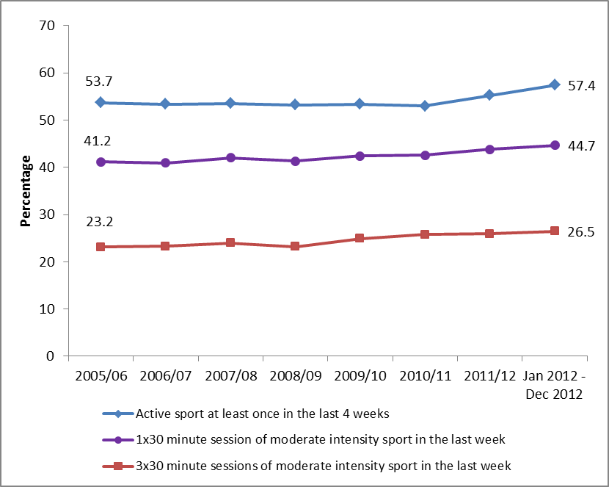
Notes
(1) Confidence intervals range between +/-0.6 and +/-1.9 from 2005/06 onwards

Frequency of participation in sessions of at least 30 minutes of moderate intensity sport in the last 4 weeks (including recreational walking and cycling):

When we examine the frequency of 30 minutes or more of moderate intensity sport undertaken in the last 4 weeks, between 2005/06 and January to December 2012:
- The percentage who did not participate at a moderate intensity level for at least 30 minutes in the last 4 weeks decreased from 49.0 per cent to 44.9 per cent.

At the other end of the activity spectrum:
- The percentage participating at least three times a week but not every day (between 12 and 27 days per month) increased from 14.3 per cent to 16.2 per cent.
- The percentage participating every day increased from 8.9 per cent to 10.2 per cent.

Active sport at least once in the last 4 weeks (includes recreational cycling but does not include recreational walking):

Using analysis by the ACORN classification, in general, people who live in less deprived neighbourhoods were more likely than those who live in more deprived neighbourhoods to participate in sport. This pattern has not changed since 2009/10.
There has been a signficant increase in participation by adults in the middle categories of “Urban Prosperity”, “Comfortably Off” and “Moderate Means” since 2005/06, but no significant change for the “Wealthy Acheivers” or “Hard Pressed” at the ends of the range.

Three regions have seen a significant increase since 2005/06, the North West, the East Midlands and the West Midlands.

For adults who did active sport at least once in the last 4 weeks:
- In the North West, an increase from 49.5 per cent to 55.2 per cent
- In the East Midlands an increase from 55.2 per cent to 61.4 per cent
- In the West Midlands an increase from 50.8 per cent to 55.6 per cent

Considering socio-demographic groups (apart from age and sex), since 2005/06 there have been changes in the rates of sport participation (active sport at least once in the last 4 weeks) for a number of categories. There have been large significant increases for:

- Those not working (from 38.6% to 44.2%)
- Adults in the lower socio-economic group (from 43.4% to 48.4%)
- Those living in social rented housing (from 38.9% to 43.9%)

At least one session of 30 minutes of moderate intensity sport in the last week (including recreational walking and cycling):

Since 2005/06, participation of adults in at least one session of 30 minutes of moderate intensity sport in the last week (1x30 MIS measure) has increased significantly for all adults and for the following age bands:

- 25-44 year olds (from 50.0% to 53.8%)
- 45-64 year olds (from 36.8% to 41.4%)
- 65-74 year olds (from 27.0% to 31.3%)
- Age 75+ (from 11.3% to 15.6%)
- All adults 16+ (from 41.2% to 44.7%)

However, for 16-24 year olds, on the 1x30 MIS measure (59.4%), there has been no change in participation since 2005/06. This pattern of no signficant change was also reflected in the “sport in the last 4 weeks” and the 3x30 measures for this age group. Older age groups had lower sport participation rates (Figure 2.2).

Figure 2.2: Proportion of adults who had participated in sport by age group, 2005/06 to January – December 2012 (at least one session of 30 minutes of moderate intensity sport in the last week including recreational walking and cycling).
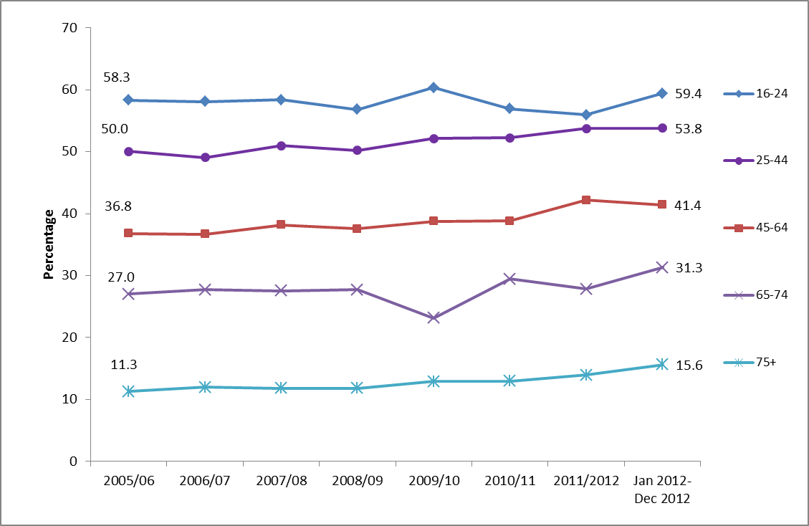
Notes
(1) Confidence intervals range between +/-1.2 and +/-5.7.

During January – December 2012 sport participation using the headline 1x30 MIS measure (including recreational walking and cycling) had been significantly:
- Higher for men than women: 49.9 per cent of men and 39.8 per cent of women participated in sport (see figure 2.3)
- Lower for respondents with a longstanding illness or disability compared to those without (29.3% compared with 51.4%)

There had been no significant difference in the percentage of respondents participating in sport between BME groups and the white group using this measure (Figure 2.4).

Since 2005/06 there has been a significant increase in sport participation rates for
- Both men and women
- Disabled as well as non-disabled people
- All age groups apart from 16-24 year olds
- Respondents from the white group

There had been no significant change in sport participation for 16-24 year olds, those in BME groups and those in the social or private rented sector.

Figure 2.3: Proportion of adults who had participated in sport by demographics, 2005/06 to January – December 2012 (at least one session of 30 minutes of moderate intensity sport in the last week including recreational walking and cycling).
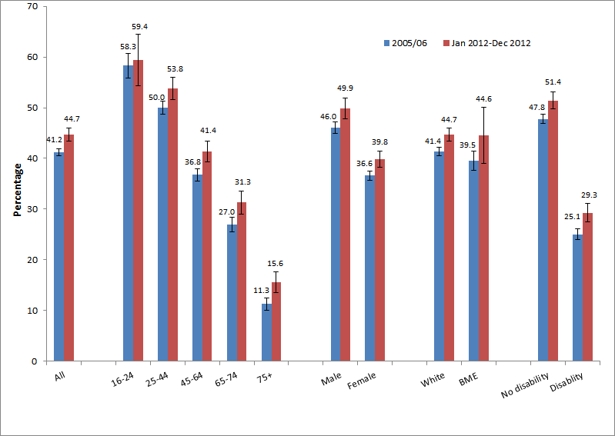
Notes
(1) Confidence intervals range between +/-0.7 and +/-5.2. Years where confidence intervals overlap cannot be reliably compared.

Digital engagement

39.7 per cent of adults had visited sports websites in the last 12 months, which was significantly higher than 26.1 per cent of adults in 2005/06. The proportion of adults visiting a sports website in January - December 2012 was the highest level reported since 2005/06.

Further detail on this section can be found in the accompanying spreadsheets to this release available at: https://www.gov.uk/government/publications/taking-part-2012-13-quarter-3-statistical-release

Cycling and swimming proficiency

Between January – December 2012
- 83.7 per cent of adults stated that they can swim and 87.1 per cent stated that they can cycle.

- Despite swimming being amongst the most popular sports for women, a higher proportion of men (87.2%) said that they can swim compared to women (80.5%). The proportion for women was significantly higher than in 2010/11 when the question was first asked (77.2%), whilst the level for men was at a similar level.

- A higher proportion of men than women can cycle (93.8% compared with 80.5%), the proportion for women has significantly increased from 2010/11 when the question was first asked, whilst the corresponding proportion for men has remained relatively stable.

- A higher proportion of people from a white background reported that they can swim than from BME groups (85.6% compared with 69.1%) and can cycle (88.3% compared with 77.6%).

- The proportion of people with a disability or long term illness that reported they can swim significantly increased from 70.0 per cent in 2010/11 to 73.2 per cent in January-December 2012. The corresponding proportion for people without a disability or long term illness was 88.0 per cent, significantly higher than in 2010/11 (85.6%).

- There was also a significant increase in the proportion of people with a disability or long term illness that reported they can cycle, from 70.4 per cent in 2010/11 to 73.6 per cent in January-December 2012. The corresponding proportion for people without a disability or long term illness was 92.4 per cent, significantly greater than in 2010/11 (91.0%).

- As is the case for overall sport participation, swimming proficiency was linked with the type of area people live in, with a higher proportion of people who live in the least deprived neighbourhoods who stated that they can swim.

- There was a significant increase in the proportion of people in the North West and South East able to swim, from 82.1 per cent in 2010/11 to 86.8 per cent in January-December 2012 for the North West and from 82.5 per cent in 2010/11 to 87.0 per cent in January-December 2012 for the South East.

- Cycling and swimming proficiency was also linked with age, with the percentage of adults who stated they can swim or cycle decreasing with age. The age group 45-64 years old had seen a significant increase in the proportion able to swim since 2010/11 when the question was first asked from 81.4 per cent to 86.1 per cent. All other age groups remained at similar proportions over this time period.

Further detail on this section can be found in the accompanying spreadsheets to this release available at: https://www.gov.uk/government/publications/taking-part-2012-13-quarter-3-statistical-release

- Heritage

The survey measures adult participation in heritage by attendance at a heritage site in the 12 months prior to interview, as well as the frequency with which adults attend these types of sites. Details on the ways that people digitally engage with heritage are also given. Digital engagement with the heritage sector includes visiting a heritage website to take a virtual tour of a historical site, learning about history or the historic environment, or discussing history or the historic environment on a forum.

English Heritage also published two reports in 2011 which build on the Taking Part survey to explore in more detail participation within the Heritage sector.
- The Visiting the Past report analyses the factors which affect people's likelihood of visiting three kinds of historic sites:
- Historic parks and gardens
- Historic places of worship
- Monuments, castles and ruins
It examines the effects of the demographic characteristics of visitors (eg age), other activities and social circumstances on the probability of visiting these sites. The findings are based on a statistical analysis of the visiting patterns of over 25,000 people surveyed in Taking Part.
- The Mapping Leisure report uses visualisation techniques to create a series of pictures of Taking Part data, allowing the landscape of cultural and sporting participation in England to be visually explored. The pictures visualise the participation levels, demographics, and connections, of over 100 cultural and sporting activities (including heritage). The report interprets the pictures and discusses the questions they raise.

Government policy, which may have influenced the statistics presented is described below:
DCMS is responsible for ensuring that the historic environment of England is properly protected and conserved, so that present and future generations can enjoy the benefits of engaging with heritage. Through the bodies it funds, DCMS seeks to promote understanding and access to the historic environment, allowing people to appreciate the heritage assets around them.

DCMS funds English Heritage, the Government’s statutory advisor on the historic environment, as well as funding and supporting a number of other bodies, including the National Heritage Memorial Fund and the Churches Conservation trust. Further details of work English heritage has been involved in are available on their website.

Key findings

- Nearly three quarters (73%) of adults visited a heritage site in the last year. This represents a significant increase of 3 percentage points since the survey began in 2005/06 as well as a significant increase (3 percentage points) since 2010/11, representing an upward trend since 2005/06.

- 31 per cent of adults reported visiting a heritage site at least three or four times a year, a significant increase since 2005/06, following a continuous upward trend from 2005/06 to the current period.

- There have been significant increases since 2005/06 in the proportion of people who had visited a heritage site over the previous year across almost all ages and socio-demographic groups (apart from the 16-24 and 25-44 year old age groups, those living in private sector rented housing and those who stated no religion).

Heritage attendance

The latest results show 73.3 per cent of adults reported visiting a heritage site in the last 12 months. This was a significant increase from 70.7 per cent in 2010/11 and from 69.9 per cent in 2005/06. The proportion of adults visiting a heritage site had been stable from 2005/06 to 2010/11, but has significantly increased since.

Looking at the frequency with which adults visit heritage sites, there was an increase in the rate of adults who visited a heritage site at least three or four times a year (30.8%, an increase of 4.3 percentage points from 2005/06). This represented a gradual upward trend since 2005/06 to the current period.

Socio-demographic groups which experienced large significant increases between 2005/06 and January to December 2012 were:
- Black or ethnic minority groups (an increase of 9.0 percentage points to 59.7%)
- 65-74 year olds (an increase of 8.6 percentage points to 78.5%)
- 75+ year olds (an increase of 7.4 percentage points to 59.6%)
- Other religion (an increase of 7.3 percentage points to 56.9%)

Those who had visited a heritage site in the 12 months prior to interview who lived in the “most deprived” index of deprivation group, underwent a significant increase of 17.2 percentage points to 56.9 per cent since 2009/10 when data using this classification were first collected.

There were significant increases amongst those who lived in the North East (6.3 percentage points to 75.4%), Yorkshire and the Humber (8.5 percentage points to 76.8%) and the West Midlands (4.7 percentage points to 70.5%) since 2005/06. The increases tend to have occurred since 2010/11. Prior to this, trends were relatively stable.

Digital engagement

Since 2005/06, the proportion of people visiting heritage websites has significantly increased from 18.3 per cent to 30.9 per cent, the highest level reported since data collection began. The proportion of adults visiting heritage websites had been stable from 2005/06 to 2008/09. Data were not collected in 2009/10, but since 2010/11 the proportion has increased.

The Taking Part survey added new questions on heritage websites from July 2011. From January 2012 to December 2012, of people who visited a heritage website:
- Three in five respondents used a heritage website to plan how to get to a historic site (60.0%).
- Half used a heritage website to learn about history or the historic environment (50.1%),
- Just under a quarter used a heritage website to buy tickets to visit a historic site (23.5%).
- 2.2 per cent of adults, who visited a heritage website, used it to discuss history or visits to the historic environment on a forum.
- 16.3 per cent of adults had visited a heritage website to take a virtual tour of a historical site.

Further detail on this section can be found in the accompanying spreadsheets to this release available at: https://www.gov.uk/government/publications/taking-part-2012-13-quarter-3-statistical-release

- Museums and galleries

This chapter examines museum and gallery attendance in the last 12 months, by a range of area-level and socio-demographic breakdowns. Details on the ways that people digitally engage with museums and galleries are also given. Digital engagement with museums and galleries is defined as using websites to look at items from a collection, finding out about a particular subject, taking a virtual tour of a museum or gallery or viewing or downloading an event or exhibition.

The Department also publishes monthly museum and gallery visits at https://www.gov.uk/government/statistical-data-sets/museums-and-galleries-monthly-visits. To note these figures are from the perspective of individual museum and galleries, therefore one person may visit a number of museum and galleries and be counted more than once by different institutions and data include overseas visitors. Whereas, Taking Part is a household survey in England and measures participation from the view point of the individual. Despite these differences the overall trend has been similar, showing an upward trend since 2005/06.

Until 2011/12, Arts Council England also published data on the number of museum visits from those sites participating in the Renaissance in the Regions programme. This was a quarterly return and data are available at http://www.artscouncil.org.uk/funding/apply-for-funding/renaissance/renaissance-museums-performance-indicators/. These figures are not entirely comparable with those published in the Taking Part survey, since one person may visit a number of these museums and be counted more than once by different institutions under the Renaissance in the Regions programme. The figures will also include overseas visitors, which the Taking Part survey does not. Despite these differences, a broadly similar trend is shown in these data as in the Taking Part survey.

Government policy, which may have influenced the statistics presented, is described below:
DCMS directly sponsors 20 museums and galleries, of which 13 were founded by Act of Parliament and are defined as “National Museums”. All DCMS sponsored institutions receive Grant-in-Aid funding from DCMS. Details of how much funding individual museums will receive are published in an annual report. Providing free admission (since 2001) to the permanent collections remains a condition of the national museums and galleries’ Grant-in-Aid funding.

The Department also:
- fund Renaissance in the Regions, a program to support England’s regional museums
- invest in museum and gallery education programmes
- co-fund and administer the DCMS/Wolfson Museums and Galleries Improvement Fund
DCMS’ stewardship of sponsored museums is at arm’s length. The Department does not intervene in their day-to-day business operations. Each sponsored museum is run by an independent Board of Trustees. The majority of these Trustees are appointed either by the Prime Minister or the Secretary of State for DCMS. The Boards of Trustees are responsible for:
- preserving and adding to the objects in their collections
- ensuring that the collections are exhibited to the public and available for study
- promoting the public’s enjoyment of science, history, art or design through their collections

Key findings

- The proportion of people who had visited a museum or gallery has significantly increased since 2005/06 (from 42% to 52%), a general upward trend since 2008/09.

- Attendance rates (52%) have been at their highest level since the Taking Part survey began in 2005/06. This is the first time the rate has been greater than 50 per cent, meaning the majority of adults had visited a museum or gallery in the 12 months prior to interview.

- 32 per cent of adults said they visited museums or galleries 1-2 times a year, 17 per cent did so 3-4 times a year, 3 per cent at least once a month and 1 per cent went at least once a week. There has been a significant decrease since 2005/06 in the proportion of adults who had not visited a museum in the last 12 months of 10 percentage points to 48 per cent.

- There has been a significant increase in the percentage of adults who had visited a museum or gallery in the last year amongst all age groups and all other socio-demographic groups compared to 2010/11.

Overall attendance at museums and galleries

In the period January to December 2012, 52.1 per cent of adults visited a museum or gallery, an increase in attendance from 2005/06 (42.3%). This was the highest proportion recorded since the survey began in 2005/06, as shown in Figure 4.1. The vast majority of visits were made in people’s own free time (97.7%), with a small percentage attending for paid work or for academic study (2.6% and 2.1% respectively).

Although people who live in rural areas were just as likely as people in urban areas to have visited a museum or gallery in the last year, there were variations by region.

In January 2012 to December 2012:
- Londoners (58.0%) had higher rates of attendance, compared to all other regions except the North East, Yorkshire and the Humber and the South East where the difference from London was not significant.
- Attendance in the West Midlands (47.2%) was lower than that of the North East (53.2%), Yorkshire and the Humber (54.1%), London (58.0%) and the South East (54.0%). The rate for the West Midlands was not significantly lower than the other regions of England.
- Since 2005/06, the proportion of people visiting museums or galleries increased significantly in all regions of England.

Figure 4.1: Proportion of adults who had visited a museum or gallery in the last year, 2005/06 to January 2012 – December 2012

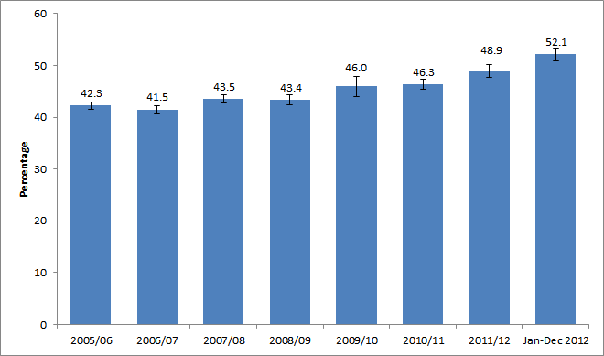
Notes
- Confidence intervals range between +/-0.7 and +/-1.9 from 2005/06 onwards. Years where confidence intervals overlap cannot be reliably compared.

People in higher ACORN groups had greater attendance rates of museums and galleries in the last year than those in lower groups, for example those categorised as Wealthy Achievers (58.7%) had significantly higher attendance rates than those categorised as moderate means (44.2%) or hard pressed (38.5%). Likewise those in the Urban Prosperity category (67.0%) also had significantly higher attendance rates than those of moderate means and the hard pressed. This is depicted in Figure 4.2. There has been a significant increase in attendance rates amongst all ACORN groups since 2005/06.

Over three in five adults (60.6%) in the upper socio-economic group visited a museum or gallery in the last year compared to 38.6 per cent in the lower group, and over half of working adults had attended (56.6%) compared to 45.6 per cent of adults not working.

Compared to 2010/11, in the year ending December 2012 those visiting a museum or gallery increased by between 4.0 and 8.8 percentage points, across all demographic groups.

Figure 4.2: Proportion of adults who had visited a museum or gallery in the last year, by ACORN group, January 2012 – December 2012.

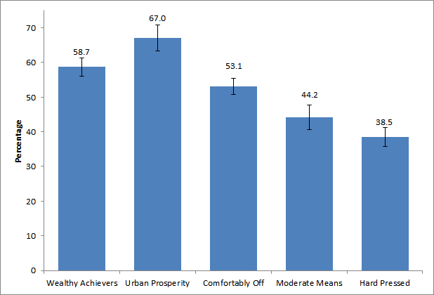
Notes
- Confidence intervals range between +/-2.3 and +/-3.8. Categories where confidence intervals overlap cannot be reliably compared.

Digital engagement

29.9 per cent of adults had visited a museum or gallery website, an increase from 15.8 per cent in 2005/06 and the highest reported level since data collection began in 2005/06. There has been an upward trend in digital engagement with museum and galleries since the data were first collected in 2005/06.

Between 2005/06 and January to December 2012, of those who had visited a museum or gallery website, there was
- An increase in the proportions of people visiting a museum or gallery website to find out about or order tickets for an exhibition or event (from 47.9% to 60.3%).
- A significant decrease in the proportion of adults who had visited a museum or gallery website to look at items from a collection (from 33.7% to 20.7%).

The Taking Part survey added new questions on museum or gallery websites from July 2011. In this period, of those who had visited a museum or gallery website, 45.5 per cent had done so to find out about a particular subject, 17.2 per cent of adults had taken a virtual tour of a museum or gallery and 13.9 per cent had viewed or downloaded an event or exhibition.

Further detail on this section can be found in the accompanying spreadsheets to this release available at: https://www.gov.uk/government/publications/taking-part-2012-13-quarter-3-statistical-release

- Libraries

This chapter examines library participation as measured by attendance in the last 12 months, by a range of area-level and socio-demographic breakdowns. Details on the ways that people digitally engage with library services are also given. Digital engagement with libraries is defined as completing a transaction (e.g. reserving or renewing items or paying a fine), searching and viewing online information or making an enquiry.

Government policy, which may have influenced the statistics presented, is described below:
Individual public library services are delivered by 151 library authorities in England, and they have a statutory duty under the Public Libraries & Museums Act 1964 to provide a comprehensive and efficient library service, set in the context of local need: that is, specifically of those who live, work and study in the local area. Central Government core funding for public libraries is paid through the local government settlement, administered by the Department for Communities and Local Government (CLG). Local authorities decide how to allocate funding to public libraries in the light of their statutory duties and local priorities, and in 2011-12 authorities in England invested £820m in their public library services.

The 1964 Act imposes a duty on the Secretary of State for Culture, Media and Sport to oversee and promote the public library service and to secure discharge of the statutory duties of local authorities as well as providing certain powers to take action where a local authority is in breach of its own duty.

The Government is responsible for national library policy and works closely with the development agency for libraries, Arts Council England. Further information about the Arts Council’s support for public libraries is available on their website.

Key findings

- 37 per cent of adults had used a library in the 12 months prior to being interviewed, a significant decrease from 48 per cent in 2005/06, and a significant decrease from 40 per cent in 2010/11.

- Since 2005/06, the proportion of people using a public library has declined in all regions.

Library attendance

In the period from January to December 2012, 37.4 per cent of adults reported using a library service in the last 12 months, a significant decrease from 48.2 per cent in 2005/06, and a significant decrease from 2010/11 (39.7%) (Figure 5.1).

As figure 5.1 shows, library usage has remained consistently higher amongst women than men, although usage has dropped significantly amongst both groups since 2005/06, from 52.3 per cent to 42.2 per cent for women, and 43.8 per cent to 32.4 per cent for men.

Between 2005/06 and the period from January to December 2012, the proportion of people using a public library declined in all regions. Looking at change in the shorter-term, the proportions were only significantly less than they were in 2010/11 for the North West and the South East.

Compared to 2005/06 there has been a decline in library usage amongst all age groups. Compared to 2010/11 there were significant decreases in the proportion of respondent who visited a library in the 12 months prior to interview amongst
- 45-64 and 65-74 year olds
- Both men and women
- The upper socio-economic group
- Those who were in work
- House owners,
- Those from white backgrounds
- Those who were non-religious
- Those who did not have a long standing illness or limiting disability

In the year ending December 2012, the following patterns of library attendance were observed:

- Women (42.2%) had a higher rate of library attendance than men (32.4%).
- Adults in upper socio-economic groups (40.4%) had a higher rate of library attendance than people in lower socio-economic groups (32.7%).
- Adults who are not working (40.6%) had higher rates of library attendance than those who are working (35.3%).
- Adults from black or minority ethnic (BME) groups (45.3%) had higher rates of library attendance then adults from the white group (36.4%).

Figure 5.1: Proportion of adults who had attended a library by sex, 2005/06 to January 2012 – December 2012

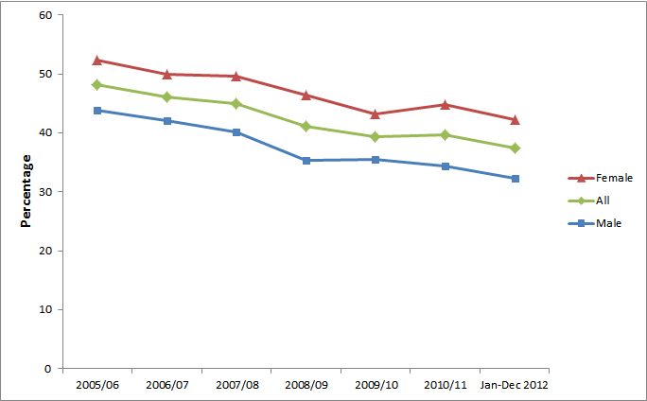
Notes
- Confidence intervals range between +/-0.7 and +/-2.5 from 2005/06 onwards.

Digital engagement

In the year ending December 2012, 16.7 per cent of adults had visited a library website in the previous 12 months, a significant increase from 8.9 per cent in 2005/06.

Of those who had visited a library website, 75.9 per cent had searched and viewed online information or made an enquiry. 39.8 per cent had completed a transaction, e.g. reserved or renewed items or paid a fine, a significant increase from 28.1 per cent in 2006/07.

Further detail on this section can be found in the accompanying spreadsheets to this release available at: https://www.gov.uk/government/publications/taking-part-2012-13-quarter-3-statistical-release
- Arts

Taking Part asks respondents whether they have attended or participated in a range of arts activities. These two forms of activity (attendance and participation) are combined to provide the overall measure of arts engagement. Examples of arts engagement include painting (participation) or attending a theatre. Details on the ways that people digitally engage with the arts are also given. Digital engagement with the arts is defined as viewing or downloading part or all of a performance or exhibition, discussing the arts or sharing art that others have created, uploading or sharing art that you have created yourself or finding out how to take part or improve your creative skills.

Government policy, which may have influenced the statistics presented, is described below:
It is a strategic Departmental objective to enhance access to the Arts, increasing both the numbers of those taking part in and attending arts events.

DCMS work with:
- Arts Council England on their objective to get more people attending and participating in the arts
- Voluntary Arts Network to make sure that the right pathways are available for anyone to participate in the arts
- Department for Business, Innovation and Skills to increase available opportunities in Informal Adult Learning: more information on the National Institute of Adult Continuing Education website
- National Association of Local Government Arts Officers to remove barriers to participation at a local level

DCMS funding for the arts is channelled through Arts Council England, which is the national development agency for the arts in England.

Key findings

- 78 per cent of adults had attended or participated in the arts in the previous year, a significant increase reported since 2005/06 (76%) and 2010/11 (76%). The upward trend has only been present recently. Prior to 2011/12, art engagement had been fairly stable and was 76 per cent when the data series began.

- Arts engagement increased to highest levels since the survey began in 2005/06 for people living in urban areas, reaching 78 per cent. This was a significant increase from 75 per cent in 2005/06. Those living in rural areas had a higher participation rate than those in urban areas (81% compared to 78%)

- Adults aged 65-74 and 75+ have seen a significant increase in engagement since 2005/06 (from 71% to 78% for 65-74 year olds and from 58% to 64% for aged 75 and over). However, adults aged 75 and over still had significantly lower arts engagement rates compared to other age groups.

Arts engagement

The latest results show 78.5 per cent of adults had engaged in the arts in the last year, a significant increase reported since 2005/06 (76.3%) and 2010/11 (76.2%).

Women (81.6%) had higher arts engagement rates than men (75.1%) between January and December 2012. There has been a significant increase in women’s engagement with the arts since 2005/06, but for men their level of engagement has remained similar over this period. Art engagement rates for both men and women were stable until 2010/11, the trend for women then increased.

Figure 6.1: Proportion of adults who had attended or participated in the arts, by sex, 2005/06 to January – December 2012

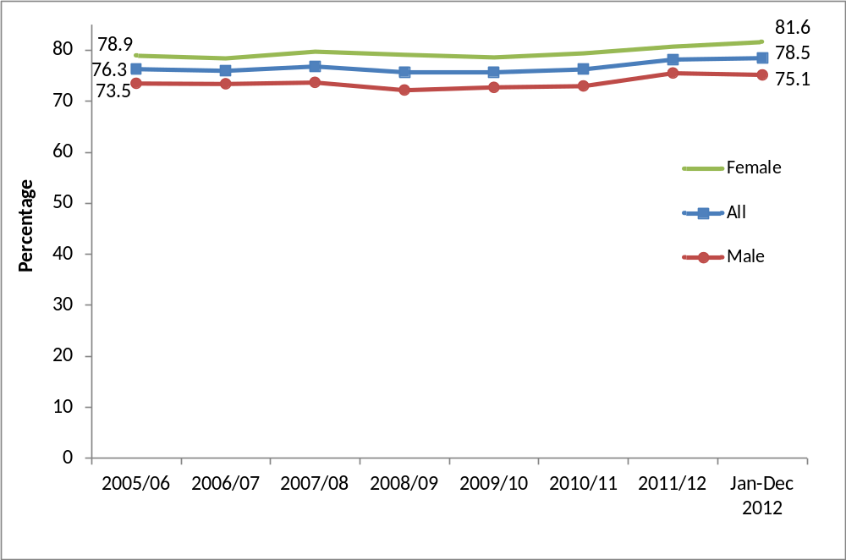
Notes
(1) Confidence intervals range between +/-0.9 and +/-3.1 from 2005/06 onwards.

In the year ending December 2012,
- 63.9 per cent of adults had engaged with the arts three or more times in the previous 12 months.
- 8.6 per cent of adults had engaged once only in the previous 12 months, a significant increase from 7.2 per cent in 2005/06.
- 21.6 per cent of adults had not engaged with the arts at all in the previous 12 months, a significant decrease from 23.8 per cent in 2005/06 and 23.9 per cent in 2010/11.

Figure 6.2 shows that the proportion of adults who had engaged with the arts once in the previous 12 months has had a large rate of overall increase, whilst the rate of those who had not engaged with the arts in the last 12 months has had a large decrease since 2005/06. There has been an upwards trend of those engaging at least once in the last 12 months, but there been no discernible trends for other frequencies of engagement over the time period.

There were significant increases in adults engaging in art in the North West (from 71.5% to 77.7%), in the East Midlands (from 75.8% to 80.0%) and in the East of England (from 79.7% to 83.9%) since 2005/06.

There were increases in arts engagement for adults living in urban areas (from 74.9% to 77.8%) during this period. Arts engagement also tended to be higher among people who live in less deprived neighbourhoods. Since 2009/10, levels of engagement have remained flat in each Index of Multiple Deprivation decile group.

Figure 6.2: Indexed arts engagement, by frequency of attendance, 2005/06 to January – December 2012
Indexed, 2005/06 = 100
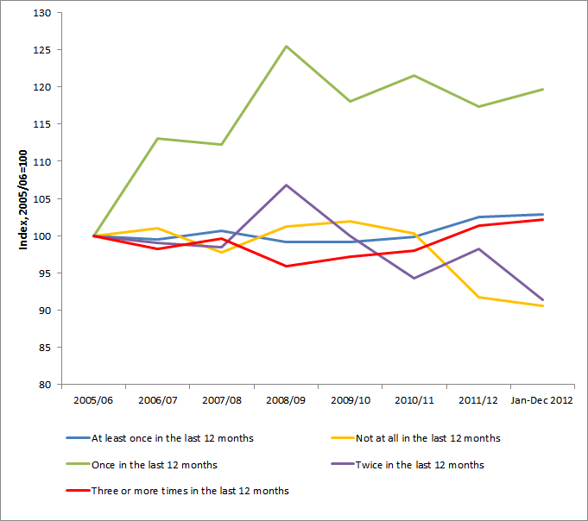

In the year to December 2012, the following patterns of arts engagement were observed:
- People aged 75 and over had lower arts engagement rates (63.6%) than the other age groups. Although the 65-74 and 75+ age groups have seen a significant increase in engagement since 2005/06 (from 70.7% to 78.4% for 65-74 year olds, from 57.7% to 63.6% for age 75 and over), engagement rates for the younger age groups have remained steady during that period.
- Arts engagement was higher amongst adults from the white group (79.4%) than adults from black and minority ethnic (BME) groups (70.7%).
- People with no long-standing illness or disability had a higher arts engagement rate (80.9%) than people with a long-standing illness or disability (72.6%). This could be due to barriers, for example lack of suitable transport to art facilities or a lack of hearing loops at the venue, enabling people with a long-standing illness or disability to engage. Both groups have seen a significant increase in the proportions since 2005/06.

These patterns were consistent with previous years.

Digital engagement

In the year ending December 2012, 30.0 per cent of adults had visited a theatre or concert website, no significant change from 2005/06 when the rate was 30.5 per cent but a significant decrease from 2010/11 (42.6%). However the wording of this question changed slightly in July 2011 which coincides with a decline in the proportion visiting these types of sites.

Of those who had visited a theatre or concert website, 47.3 per cent of people had bought tickets for an arts performance or exhibition, a significant increase from 43.2 per cent in 2006/07, but a significant decrease from 67.7 per cent in 2010/11.

The Taking Part survey added new questions about arts websites from July 2011. Between January and December 2012, for those who had visited an arts website, 71.5 per cent did so to find out more about an artist, performer or event, 22.5 per cent did so to view or download part or all of a performance or exhibition. 8.2 per cent of adults visited an arts website to find out how to take part or improve their creative skills.

Further detail on this section can be found in the accompanying spreadsheets to this release available at: https://www.gov.uk/government/publications/taking-part-2012-13-quarter-3-statistical-release

- Archives

This chapter examines attendance at archives in the 12 months prior to interview, by a range of area-level and socio-demographic breakdowns. Details on the ways that people digitally engage with archives are also given. Digital engagement with archives is defined as completing a transaction, viewing digitised documents online or searching a catalogue.

Key findings

- The proportion of adults who had visited an archive (in their own time or for voluntary work) was 3 per cent, a significant decrease from the 2005/06 level.

- Using the wider measure, which includes paid work visits and academic study visits, the proportion of adults who attended in the last year, has remained steady since 2008/09 when the data were first collected and was 4 per cent in the period from January to December 2012.

- In the same period, less than half of adults (48%) who visited an archive did so just once in the last 12 months.

- The 65-74 year old age band had the highest proportion of archive visits in the last 12 months (6% of people this age) whilst visits amongst 16 to 24 year olds (2% of people this age) were significantly lower than people aged 45-64 and 65-74

Overall participation in archives

In the latest period, 3.5 per cent of adults had visited an archive in the last year in their own time or as part of voluntary work. This was significantly lower than in 2005/06 (5.9%). Using the wider measure, including paid work visits and academic study visits, the proportion in the latest period increased to 4.4 per cent of all adults. The trend over time, shown in Figure 7.1 overleaf, was a downward one with a small peak in 2010/11.

Over three quarters of all archive visits (77.0%) were in the visitors own time, followed by 14.6 per cent visiting for paid work, and 8.6 per cent for academic study.

There have been significant decreases in archive attendance rates since 2005/06 in all regions apart from in the North East, Yorkshire and the Humber and the West Midlands where rates have remained steady.

There was little variation between different demographic groups (apart from age), although adults from upper socio-economic groups had a significantly higher attendance rate (4.1%) than those in lower socio-economic groups (2.9%).
The 65-74 year old age band had the significantly highest proportion of archive visits in the last 12 months (6.4 per cent of people this age) whilst visits amongst 16 to 24 year olds (1.9% of people this age) were significantly lower than people aged 45-64 and 65-74

Figure 7.1: Percentage of adults who had visited an archive or records office, 2005/06 to January – December 2012

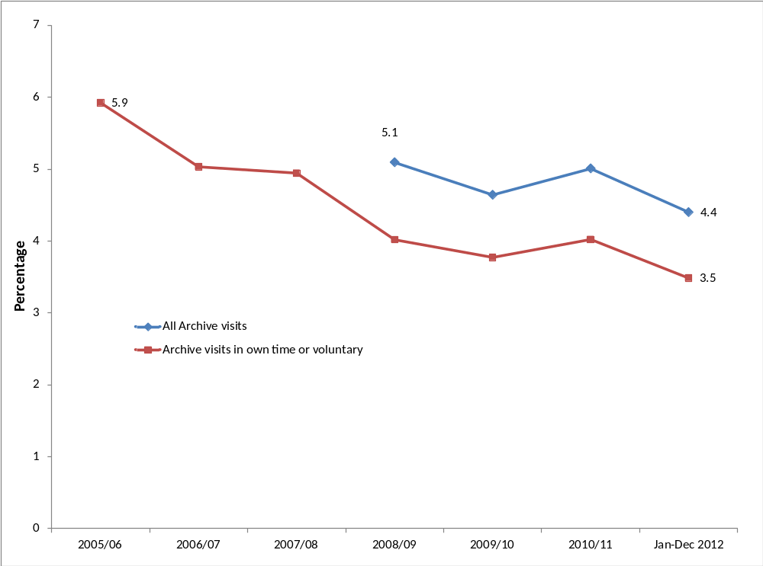
Notes
- Confidence intervals range between +/-0.3 and +/-0.8 from 2005/06 onwards.
- Some archive questions were not asked prior to the 2008/09 survey.

Digital engagement

A higher proportion of adults visited an archive or records office online than in person. In January – December 2012, 13.1 per cent of adults had visited an archive or records office website in the last 12 months, a significant increase from 9.7 per cent in 2005/06. Of those who had visited an archive or records office website, 63.3 per cent had done so to view digitised documents, 31.8 per cent of adults had searched a catalogue, over a fifth (22.9%) of adults had found information out about the archive (e.g. opening hours) and 18.9 per cent had completed a transaction, for example, to purchase records.

Further detail on this section can be found in the accompanying spreadsheets to this release available at: https://www.gov.uk/government/publications/taking-part-2012-13-quarter-3-statistical-release
- Volunteering and charitable giving
Taking Part asks whether respondents have participated in voluntary work in the last 12 months and whether this relates to any of the DCMS sectors. The survey also includes a range of questions on social capital and cohesion, as well as charitable donations and whether these relate to DCMS sectors.

Government policy, which may have influenced the statistics presented, is described below:
The Government has a policy to encourage charitable giving across society as a whole, to make it easier to give and provide better support to organisations that facilitate giving, whether through digital technology or simplification of the tax system.

For example, to encourage giving through the £100 million Catalyst match funding programme to help cultural organisations diversify their income streams, tax incentives aimed at boosting legacy giving to cultural bodies and other charities, and the first tax incentive policy to encourage lifetime giving of works of art to public collections through the Cultural Gifts Scheme.

Key findings

- The proportion of adults who had volunteered in the last 12 months was 26 per cent. 9 per cent of all adults had volunteered in a DCMS sector (Arts, Museums/Galleries, Heritage, Libraries, Archives, Sport.)

- There was a significant increase in the proportion of adults from the black and ethnic minority (BME) groups who had volunteered in the last 12 months compared to 2005/06 (up from 20% to 27%). This may be linked to the UK winning the bid to host the 2012 Olympic and Paralympic Games, since 23 per cent of black and minority ethnic volunteers said they were motivated to do more voluntary work as a result of the UK hosting the 2012 Olympics.

- There was also a significant increase in the proportion of adults aged 16-24 years (up from 25% to 34%) and women (25% to 28%) who had volunteered in the last 12 months compared to 2005/06.

- 90 per cent of adults had donated money (including donations into a collection box) in the last 12 months. 32 per cent of adults had donated to a DCMS sector, a similar level to those who had donated money to a DCMS sector in 2010/11.

Volunteering

A quarter of adults (25.5%) reported that they had taken part in voluntary activities in the last 12 months. This was the first year of data collection that this measure has been significantly higher than in 2005/06, when the figure was 23.8 per cent. The proportion of all adults that had volunteered in a DCMS sector was 9.0 per cent, a significant increase of 2 percentage points since 2005/06 when the rate was 7.0 per cent.

There was a significant increase in the proportion of adults from black and minority ethnic (BME) groups who had volunteered in the last 12 months compared to 2005/06 (up from 19.6% to 26.5%). The time series in Figure 8.1 shows a gradual increase in the proportion of BME adults who have volunteered since 2005/06, whilst the corresponding proportion of adults from the white group has remained stable since 2005/06. This may be linked to the UK winning the bid to host the 2012 Olympic and Paralympic Games, since 23.3 per cent of black and minority ethnic volunteers said they were motivated to do more voluntary work as a result of the UK winning the bid, compared to only 6.6 per cent of volunteers from the white group.

Figure 8.1: Proportion of adults who had volunteered by ethnicity, 2005/06 to January – December 2012

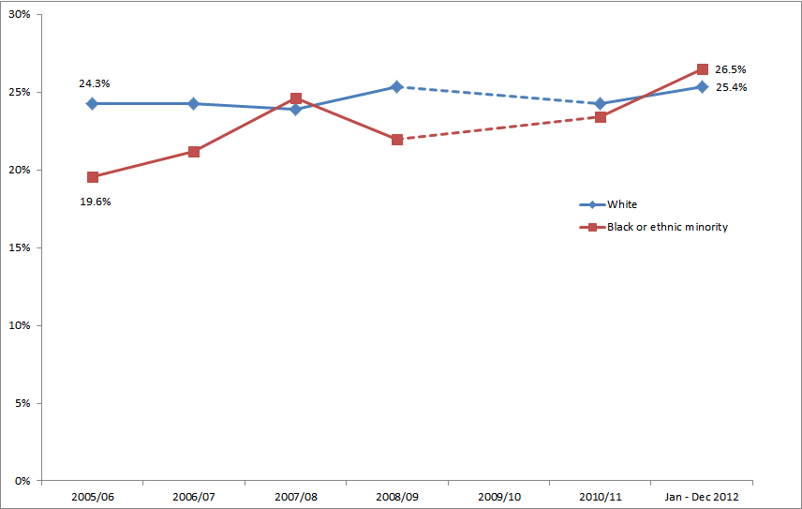
Notes
- Confidence intervals range between +/-0.7 and +/-4.6 from 2005/06 onwards
- Volunteering questions were not asked in 2009/10

In the 12 months to December 2012, there were significant differences in the proportion of males and females who volunteered in the sports sector. Nearly double the proportion of men volunteered in sport compared to females (28.6% compared to 14.7%). This has been the case since 2010/11.

There was also a significant increase in the proportion of adults aged 16-24 years who had volunteered in the last 12 months compared to 2005/06 (up from 24.7% to 34.4%). There was no significant change for other age groups over this time period.

Adults who had participated in a DCMS sector had higher volunteering rates within that sector than adults who had not participated, with the exception of the museum and galleries sector where the difference was not significant. For example, of adults who had participated in sport, 30.5 per cent of them had volunteered in sport, compared with just 9.1 per cent of those who did not play sport.

Respondents who volunteered in the museums sector, on average did so for 10 hours and 21 minutes during the four weeks prior to interview. For those who volunteered in the heritage sector, the average time spent doing so in this period was 9 hours, 55 minutes. The corresponding average volunteering times in the arts and sport sectors were 9 hours and 26 minutes and 8 hours and 20 minutes respectively in the four weeks prior to interview.

Charitable giving

Taking Part asks whether respondents had donated money in the last 12 months and whether this was to a DCMS sector.

In the year ending December 2012, 89.8 per cent of adults had donated money (including any donations into a collection box) in the last 12 months. 31.9 per cent of all adults had donated to at least one of the DCMS sectors. Within these sectors, 15.6 per cent of adults had donated to the museums and galleries sector in the last 12 months, 15.2 per cent to heritage, 7.4 per cent to sport, 6.4 per cent to the arts and 0.9 per cent to libraries. These are similar proportions to when the question was first asked in 2010/11.

35.2 per cent of adults donated money less often than once a month but at least 3 or 4 times a year. A further 36.0 per cent donated less often than once a week but at least once a month, a significant increase from 32.8 per cent in 2010/11. There was a significant decrease amongst those who gave only once in the last 12 months from 2005/06 (9.5%) to the year ending December 2012 (7.7%)

Charitable giving to the DCMS sectors significantly increased in the East Midlands and West Midlands between 2010/11 and January - December 2012 (from 28.2% to 36.0% in the East Midlands, and from 22.8% to 30.7% in the West Midlands). There was a significant decrease in charitable giving to the DCMS sectors in the North East over this period (from 35.0% to 23.2%).

Over four in five (83.3%) of respondents said they intended to give the same to DCMS sectors in the next 12 months, a significant increase from 2010/11 when the rate was 76.8 per cent. Of those who said they intended to give more to DCMS sectors in the next 12 months, 16.6 per cent gave the reason because “they need the money” and nearly a third (28.7%) said it was because “they have more money / I can afford to give more”. However of those who said they intended to give less to DCMS sectors in the next 12 months, 44.2 per cent said this was because they “have less money / can’t afford to give”.

Overall civic participation

Taking Part asks a series of questions on sport and cultural facilities in the respondent’s local area.

A quarter of adults (25.0%) had taken action to try to get something done about sport and cultural facilities in their area, or had no such problems affecting facilities in their local area. The most common action that had been taken was to contact the council, with 11.5 per cent of adults having done so. Also 5.7 per cent of adults had contacted their local councillor or MP.

41.4 per cent of adults had been involved in groups, clubs or organisations in the last 12 months. Of those adults, the most popular type of group was sport/exercise groups (48.1%) although this had significantly decreased from 2010/11 (52.2%), followed by hobbies/social clubs (36.8%), which had remained at a similar level to 2010/11.

Further detail on this section can be found in the accompanying spreadsheets to this release available at: https://www.gov.uk/government/publications/taking-part-2012-13-quarter-3-statistical-release

- Equalities

This chapter explores women’s participation in sport and active recreation in January – December 2012, covering levels of participation, the types of activities women participate in, proficiency in activities and enjoyment of sports. To note moderate intensity sport measures in this section include recreational walking and cycling.

Key findings

- Female participation of women doing at least one session of 30 minutes of moderate intensity sport per week has significantly increased since 2005/06 (36.6%), the first year data was collected, and since 2010/11 (37.1%). This equates to an additional 1.1 million women participating in at least one session of 30 minutes of moderate intensity sport per week since 2005/06.

- Since 2010/11, there has been an increase of 1.2 million adults doing at least one session of 30 minutes of moderate intensity sport per week, a large proportion of which was due to an increase of 700,000 women participating.

- Women had significantly lower levels of participation than men in most measures of active recreation, with only 40 per cent participating in 30 minutes of moderate intensity sport at least once a week (including recreational walking and cycling), compared with 50 per cent of men.

- The types of activities women participated in were considerably different to those that men participated in, with 13 per cent of women taking part in keep fit / aerobics / dance exercise compared with only 5 per cent of men, whilst 1 per cent of women played football outdoors compared with 13 per cent of men.

- Women also had lower levels of enjoyment in sport than men (81% of women rated their experiences positively compared with 85% of men).

- There were considerable differences in participation, proficiency and enjoyment between different groups of women, with for example, 83 per cent of women from white backgrounds able to swim compared with only 62 per cent of those from black and minority ethnic backgrounds.

Levels of participation

Only 39.8 per cent of women had participated in 30 minutes of moderate intensity sport at least once a week (this measure is referred to as the 1x30 MIS measure). This is much lower than the participation rate for men (49.9%).

Female participation for this measure has significantly increased since 2005/06 (36.6%), the first year data was collected, and 2010/11 (37.1%). This equates to an additional 1.1 million women participating in 1x30 MIS since 2005/06.

However, since 2006/07, the gap between male and female participation rates has stayed fairly stable, although there has been some narrowing of this gap since 2010/11 – further analysis of how this gap has changed is provided below.

Table 9.1 Gender gap between adults who had participated in 30 minutes of moderate intensity sport at least once a week 2005/06 to January-December 2012.
 | Male (number) | Male rate (%) | Female (number) | Female rate (%) | Gender gap (number) | Gender gap (%)
2005/06 | 9,100,000 | 46.0 | 7,700,000 | 36.6 | 1,400,000 | 9.4
2006/07 | 9,400,000 | 47.0 | 7,400,000 | 35.2 | 2,000,000 | 11.9
2007/08 | 9,700,000 | 48.1 | 7,700,000 | 36.2 | 2,000,000 | 11.9
2008/09 | 9,500,000 | 46.8 | 7,700,000 | 36.1 | 1,800,000 | 10.8
2009/10 | 9,800,000 | 47.8 | 8,000,000 | 37.3 | 1,800,000 | 10.5
2010/11 | 9,900,000 | 48.3 | 8,000,000 | 37.1 | 1,900,000 | 11.2
2012/13 Q3 | 10,400,000 | 49.9 | 8,700,000 | 39.8 | 1,700,000 | 10.1
Change since 2010/11 | 500,000 | 1.5 | 700,000 | 2.7
Change since 2005/06 | 1,300,000 | 3.8 | 1,100,000 | 3.1
Confidence intervals for the rates vary between +/- 0.9 and +/- 3.1

The gender gap in participation rates increased between 2005/06 (9.4%) and 2006/07 (11.9%), the reason for this widening of the gap is not known, but likely to be due to a number of factors. This gap persisted in the following year and was at its highest level in 2007/08 (see Table 9.1).

While the gender gap in participation has fluctuated somewhat over time, there has been some narrowing of the gap recently and is currently at its lowest level (10.1%) since 2005/06.

Since 2010/11, there has been an increase of 1.2 million adults doing at least one session of 30 minutes of moderate intensity sport per week, a large proportion of which was due to an increase of 700,000 women participating.

Figure 9.1: Proportion of adults who had participated in 30 minutes of moderate intensity sport at least once a week, by gender, 2005/06 to January-December 2012.
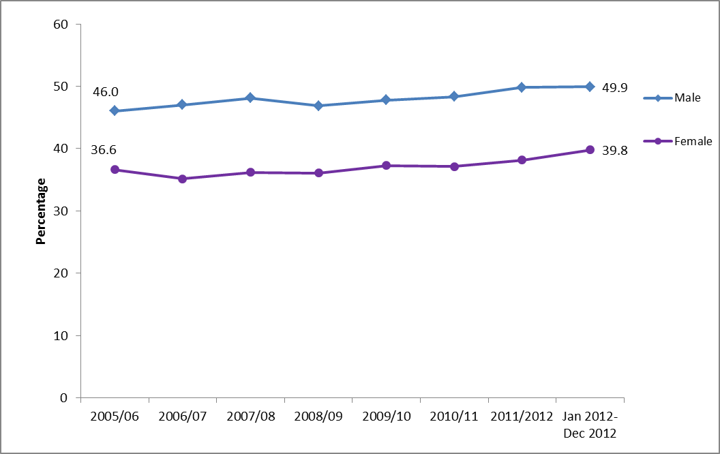
Note:
1. Confidence intervals range between +/- 0.9 and +/-3.1 from 2005/06 onwards

Female participation levels were lower than men’s for the other measures of participation, with:
- 50.9 per cent of women participating in any active sport in the last four weeks compared with 64.2 per cent of men
- 22.7 per cent of women participating in at least three sessions of 30 minutes of moderate intensity sport in the last week, compared with 30.5 per cent of men

Figure 9.2: Proportion of adults who had participated in sport, by gender, January-December 2012
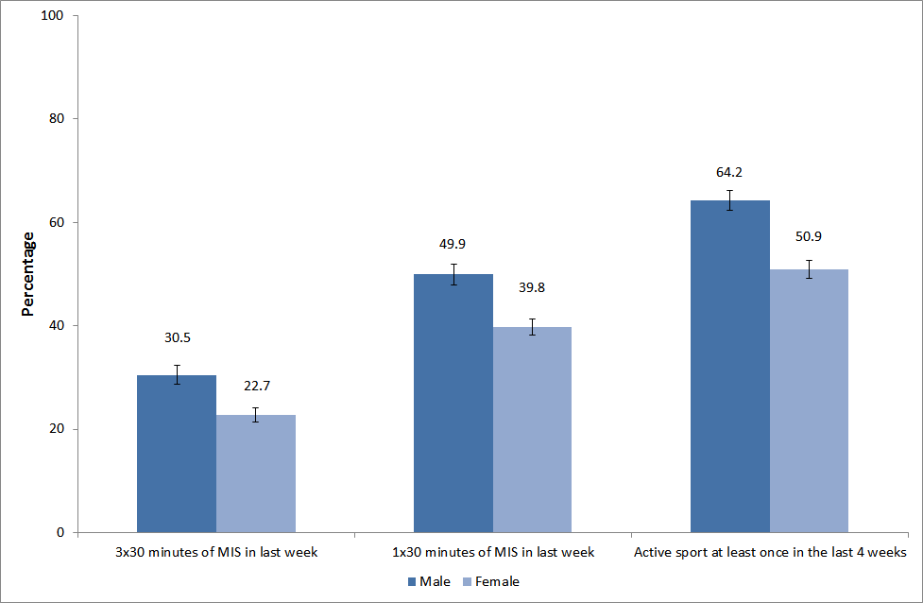
Note:
1. Confidence intervals range between +/- 1.4 and +/-2.0

Whilst previous analysis from the Taking Part Survey showed that the main barriers to participation (time, health and cost) did not vary by gender, other research has found psychosocial issues to be a particular barrier to participation for women and girls. These factors include: that sport is seen by some as unfeminine, girls’ earliest experiences of sport are off-putting, and many women are inhibited from exercising because of low body confidence.

Female participation was lowest in the oldest age group, with only 24.0 per cent of those aged 60 and above participating at the 1x30 MIS measure, compared with 49.4 per cent of 16 to 29 year olds and 44.8 per cent of 30 to 59 year olds. There were however similar variations between age groups in the participation levels of men.

Women from white backgrounds were more likely to have participated in 1x30 sport than those from black and minority ethnic (BME) backgrounds (40.5% compared with 34.6%). This pattern did not occur for men, where there was no significant difference between the participation of men from white backgrounds and men from BME backgrounds (49.2% compared with 55.5%).

Sports participated in

The most popular sporting activities for women were:
- Health and keepfit: 29.0 percent, of which
    - Health, fitness, gym activities: 15.8 per cent
    - Keepfit, aerobics, dance exercise: 13.2 per cent
- Indoors swimming or diving: 17.1 per cent
- Jogging, cross-country, road running: 7.0 per cent
- Cycling [health, recreation, training, competition]: 6.9 per cent

Women were more likely to participate in exercise type activities than the more competitive sports.

There were relatively few activities where women participated more than men, these included: indoors swimming or diving (17.1% compared with 12.9%), keepfit / aerobics / dance exercise (13.2% compared with 4.6%), yoga (4.5% compared with 0.7%) and tenpin bowling (3.8% compared with 2.7%).

Table 9.2: Selected sports participation, by gender, January-December 2012
 | Female | Male
Heath and keepfit of which: | 29.0% | 23.2%
Health, fitness, gym activities | 15.8% | 18.7%
Keepfit, aerobics, dance exercise | 13.2% | 4.6%
Swimming or diving [indoors] | 17.1% | 12.9%
Jogging, cross-country, road running | 7.0% | 9.6%
Cycling [health, recreation, training, competition] | 6.9% | 15.4%
Yoga | 4.5% | 0.7%
Tenpin bowling | 3.8% | 2.7%
Swimming or diving [outdoors] | 3.1% | 3.7%
Cycling [to get to places, i.e. work, shops] | 2.9% | 8.4%
Snooker, pool, billiards (excluding bar billiards) | 2.3% | 9.8%
Tennis | 2.1% | 2.7%
Badminton | 1.9% | 3.6%
Darts | 1.6% | 4.5%
Weight training (including body building) | 1.3% | 5.5%
Table tennis | 1.3% | 2.9%
Golf, pitch and putt, putting | 1.1% | 8.8%
Football (including 5-a-side and 6-a-side) [outdoors] | 1.1% | 12.7%
Note:
1. Confidence intervals range between +/- 0.3 and +/-1.6
2, Figures highlighted in bold are those where participation levels are significantly higher for that group

Proficiency

Whilst proficiency levels were high for women, they were still less likely to be able to swim than men (80.5% compared with 87.2%), or to be able to cycle (80.5% compared with 93.8 %). It is interesting that whilst women have similar proficiency levels in swimming and cycling, men are more likely to be able to cycle than to swim.

Whilst levels of female proficiency in cycling are similar to those in 2010/11 (78.5%), the proportion of women proficient in swimming has significantly increased since 2010/11 (77.2%).

Figure 9.3: Cycling and swimming proficiency, by gender, 2010/11 to January-December 2012
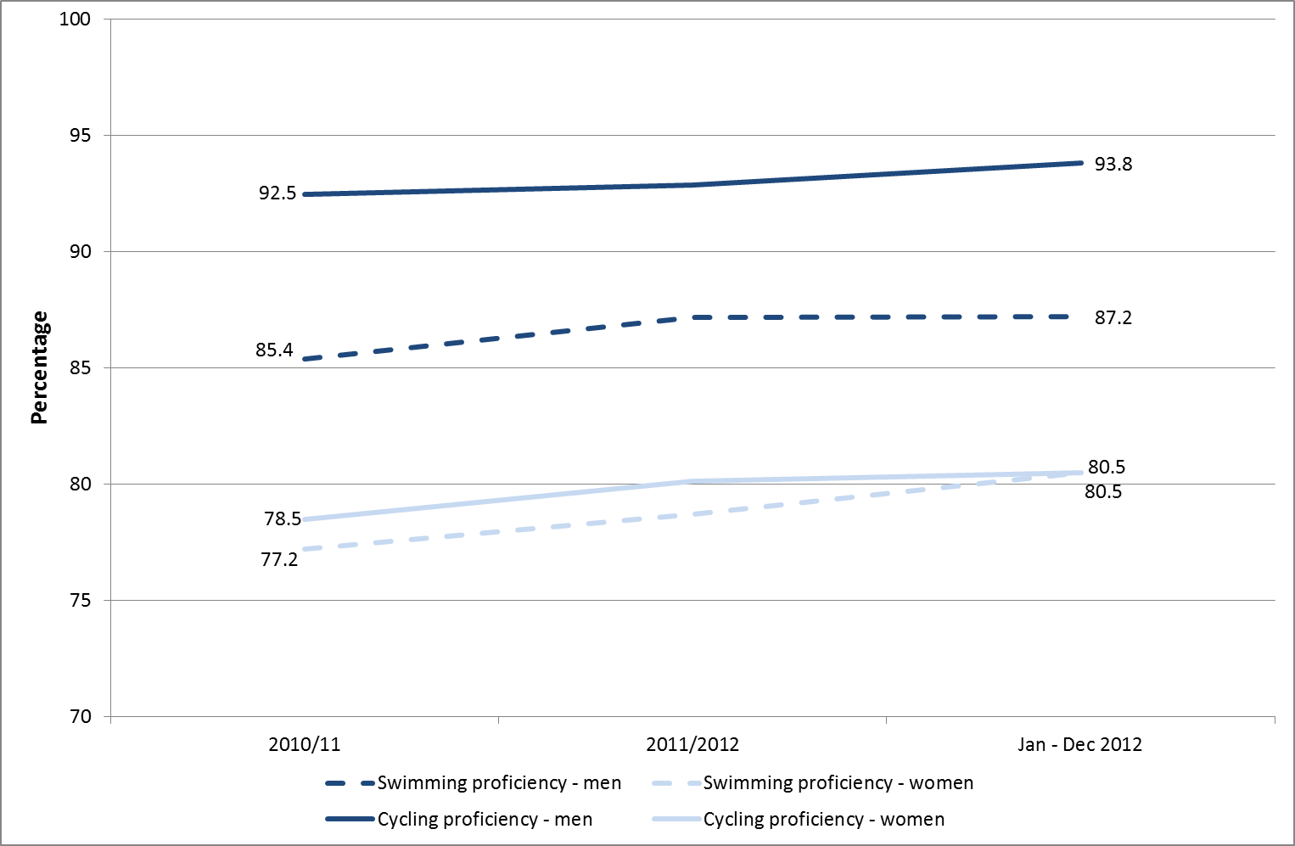
Note:
1. Confidence intervals range between +/- 0.8 and +/-1.7 from 2010/11 onwards

Proficiency was lowest in the oldest age group, with only 60.2 per cent of those aged 60 and over being able to swim (compared with 89.3% of those aged 16 to 29 and 88.6% of those aged 30 to 59) and 59.6 per cent able to cycle (compared with 93.9% of those aged 16 to 29 and 86.6% of those aged 30 to 59). There were similar variations between different age groups in the proficiency levels of men.

Women from white backgrounds were considerably more likely to be able to swim and cycle, with 82.9 per cent able to swim (compared with 61.7% of those from BME groups) and 82.9 per cent able to cycle (compared with 63.1% of those from BME groups). Whilst the gap in swimming proficiency was replicated for men (88.4% of white men could swim compared with 77.3% of men from BME groups), there were no differences in cycling proficiency.

Enjoyment in sport

Whilst there was a high level of enjoyment in sports for women (80.5% of those who took part rated their experience positively with a rating of at least 7 out of 10), this was lower than enjoyment levels for men (84.7% rated their experience positively). Such lower levels of enjoyment in sport by women may to some extent explain their overall lower levels of participation than men.

Older women (those aged 60 and above) were more likely to rate their experiences positively than the youngest age group (82.2% of those aged 60 and above compared with 75.9% of 16 to 29 year olds), although this may simply be a reflection of the lower levels of participation in older age groups. There was little difference in the level of enjoyment between white and BME women (80.7% compared with 79.1%).

Annex A: Background note

- The Taking Part survey is commissioned by the Department for Culture, Media and Sport (DCMS) and its partner arm’s length bodies (ALBs). For 2011 to 2015 these are Arts Council England, English Heritage and Sport England.

- Taking Part is a National Statistic and as such has been produced to the high professional standards set out in the Code of Practice for Official Statistics. National Statistics undergo regular quality assurance reviews to ensure they meet customer needs and are produced free from any political interference. For more information, see http://www.statisticsauthority.gov.uk/assessment/code-of-practice/code-of-practice-for-official-statistics.pdf.

The United Kingdom Statistics Authority has designated these statistics as National Statistics, in accordance with the Statistics and Registration Service Act 2007 and signifying compliance with the Code of Practice for Official Statistics.
Designation can be broadly interpreted to mean that the statistics:
• meet identified user needs;
• are well explained and readily accessible;
• are produced according to sound methods; and
• are managed impartially and objectively in the public interest.

Once statistics have been designated as National Statistics it is a statutory requirement that the Code of Practice shall continue to be observed. The UK Statistical Authority assessment is available at https://www.gov.uk/government/publications/uk-statistics-authority-assessment

- Stringent quality assurance procedures have been adopted for this statistical release. All data and analysis has been checked and verified by two different members of the team and TNS-BMRB to ensure the highest level of quality.

Guidance on the quality that is expected of Taking Part statistical releases is provided in a quality indicators document at https://www.gov.uk/government/publications/user-corner. These quality indicators outline how statistics from the Taking Part survey match up to the six dimensions of quality defined by the European Statistical System (ESS). These are: relevance, accuracy, timeliness, accessibility, comparability and coherence.

- The latest results presented here are based on interviews issued between January and December 2012. The total sample size for this period is 9,427.

- The survey measures participation by adults (aged 16 and over) and children (5-10 and 11-15) living in private households in England. No geographical restriction is placed on where the activity or event occurred. Further information on data for Scotland, Wales and Northern Ireland can be found in question 2 of the “Taking Part: Guidance Note” at https://www.gov.uk/government/publications/user-corner

- The median adult sample interview length for the 2011/12 survey was 40 minutes 31 seconds (mean 43 minutes 20 seconds). The median survey length for the 5-10 year old child interview was 12 minutes 46 seconds (mean 13 minutes 30 seconds) and for 11-15 year olds it was 22 minutes 12 seconds (mean 23 minutes 54 seconds).

- Participation in these activities must be for the purpose of recreation or leisure, including voluntary work. It excludes involvement in activities where the prime motivation is paid work or academic studies. The exceptions to this are attendance at historic environment sites which includes visits made for academic study, and sports participation which exclude volunteering, teaching, coaching and refereeing. Paid work visits and academic study visits are also included in one of the archive attendance measures.

- The range has been calculated using a 95% confidence interval. This means, had the sample been conducted 100 times, creating 100 confidence intervals, then 95 of these intervals would contain the true value. All estimates have been rounded to one decimal place. An overall design factor of 1.278 has been applied to the adult dataset for the period January to December 2012. Individual adult design factors have been calculated for each sector in this period, ranging from 0.856 to 1.665.

- Statistical significance tests have been run at the 95% level. A significant increase at the 95% level means that there is less than 5% (1 in 20) chance that the difference observed within the sampled respondents was not also observed in the English population as a whole.

- Some figures may have been revised from previous releases, in which case the figures in this release supersede those from previous statistical releases. For more detailed information on the DCMS revisions policy and how revisions are handled for the Taking Part Survey, please see the DCMS statement of compliance on our website, at https://www.gov.uk/government/organisations/department-for-culture-media-sport/about/statistics

- The data are weighted to ensure the representativeness of the Taking Part sample. There are two types of weighting: i) to compensate for unequal probabilities of selection; and ii) to adjust for differential non-response. Weighting is based on mid-2009 population estimates from the Office for National Statistics.

- For more information about the Taking Part Survey, including previous publications, see https://www.gov.uk/government/organisations/department-for-culture-media-sport/series/taking-part

Versions of the questionnaire from all years of the survey are available, see https://www.gov.uk/government/publications/questionnaires

- DCMS and Sport England consulted with users and other interested parties in summer 2012 on proposals to integrate the Taking Part and Active People surveys to change the way sport is measured. There was an excellent level of response from a wide selection of stakeholders. Overall we received considerable support for the proposals, alongside some areas for further consideration.
In summary, most respondents supported local and sport specific measurement, with a single result for sport, and data collected through a mixed mode. Consultees also expressed the importance of retaining consistency with previous results, which (alongside technical considerations) means that we need to implement any potential changes carefully through testing and with technical advice. A full consultation response is available at https://www.gov.uk/government/publications?departments%5B%5D=department-for-culture-media-sport&publication_filter_option=consultations.

We are therefore proposing to continue to ask sport participation questions in Taking Part Survey, but on behalf of Sport England. This means that sport participation data will not be analysed and reported on by DCMS or in the Taking Part publications. This approach allows for the inclusion of face-to-face data within Active People over time, so that Active People can become a fully mixed-mode survey. In the shorter term the data will be used to validate the landline estimates. This Taking Part publication will therefore be the final release to contain sport data and analysis. If you have any comments on this proposal then please email us at statsconsultation@culture.gsi.gov.uk by May 2nd 2013.

- The fieldwork for the survey is being conducted by TNS-BMRB. For more information, see http://www.tns-bmrb.co.uk

- We can also provide documents to meet the specific requirements of people with disabilities. Please call 020 7211 6000 or email takingpart@culture.gsi.gov.uk

- This report has been produced by Tom Knight, Sam Tuckett, Philippa Robinson and Penny Allen (DCMS). Acknowledgement goes to colleagues within the DCMS, partner ALBs and TNS-BMRB for their assistance with the production and quality assurance of this release.

- The responsible statistician for this release is Tom Knight. For enquiries on this release, please contact Tom Knight on 0207 211 6021 or Penny Allen on 0207 211 6106 or Sam Tuckett 0207 211 2382.

- For general enquiries telephone: 0207 211 6200
Department for Culture Media and Sport
2-4 Cockspur Street
London
SW1Y 5DH
enquiries@culture.gov.uk

Annex B: Key terms and definitions

Term | Definition
1 x 30 minute MIS | This refers to a person participating in moderate intensity sport for at least one 30 minute session in the last week.
2012/13 Q3 | This is the time period covering January-December 2012. It is also referred to as the 2012 calendar year.
3 x 30 minute MIS | This refers to a person participating in moderate intensity sport for at least three 30 minute sessions in the last week.
ACORN classification | A classification of residential neighbourhoods is a geo-demographic information system categorising some United Kingdom postcodes into various types based upon census data and other information such as lifestyle surveys.
Active Sport | Active sport excludes recreational walking and cycling, which are included in the ‘intensity’ measures. There are also minor differences in the sports and recreational activities within the active sport and ‘intensity’ measures. A list of active sports is available in Annex C: Sector definitions.
Active sport at least once in the last 4 weeks | The number of days in the last four weeks the respondent has done at least one of the active sports or activities for at least 30 minutes. This excludes any walking or cycling the respondent has done for health or recreation purposes only. Walking or cycling for sport training or competition is included.
Actively get involved in the Olympics | This covers  - Attending (Attended) a free Olympic or Paralympic event (e.g. marathon, cycling, road racing)  - Attending (Attended) a ticketed Olympic or Paralympic event  - Taking part (Took part) in a Games related sports or physical activity (e.g. AdiZone, Gold Challenge, Cadbury’s Spots V Stripes)  - Using (Used) a new or improved sports facility linked to the 2012 Games (e.g. Inspire-marked)  - Games related employment or training  - Taking part (Took part) in a Games related cultural event or activity (e.g. Cultural Olympiad, London 2012 Festival)  - Volunteering (Volunteered) during the Games (e.g. as a Gamesmaker, London Ambassador or for Cadbury’s Spots V Stripes)  - Taking part (Took part) in a Games related community event or activity (e.g. street party or local Inspire Mark project)
Archives | Archives are collections of documents that have been created by families, individuals, businesses or organisations and have been specially chosen to be kept permanently. Further information is available in Annex C.
Arts | A list of arts that the respondent may have participated or attended is available in Annex C: Sector definitions.

Term | Definition
Attendance | This refers to the respondent going to a place, for example, attending a library or a swimming pool.
Civic participation | Actions include, contact a local radio station, TV station or paper; talk to / written to a sporting or cultural facility, contact the council, contact a local councillor or MP, join a local group or attend a neighbourhood forum, attend a protest meeting or joined a campaign group, or help organise a petition.
Confidence interval | This provides a range in which there is a specific probability that the true value will lie within. For the Taking Part survey, 95% confidence intervals are used which means, had the sampling been conducted 100 times, creating 100 confidence intervals, then 95 of these intervals would contain the true value.
DCMS sectors | The DCMS sectors are the culture, arts, sport and volunteering and charitable giving sectors.
Digital participation | This refers to visiting websites for a number of reasons. These are outlined in Annex C: Sector definitions.
Digitally engage | This refers to the respondent engaging with the DCMS sectors via the internet.
Engagement | This refers to either attending and/or participating in the sport, culture or arts sector. For example, if the respondent attended an art gallery (attendance) or gave a dance performance (participation).
Following the Olympics | This covers watching the Olympics on TV at home, listening to the radio at home, watching or listening on the internet at home, reading the newspaper online or offline or watching live events on a public big screen.
Historic environment | A list of all historic environments is available in Annex C: Sector definitions.
Index of Multiple Deprivation (IMD) decile group | The Index of Multiple Deprivation is a composite index which measures neighbourhood deprivation across seven domains (for example housing and income deprivation). The IMD decile group splits neighbourhoods into ten groups according to the level of deprivation (eg 10% most deprived neighbourhoods).
Moderate intensity sport (MIS) | This is any active sport or recreational activity that is continuous and raises a person’s heartbeat. This excludes utility walking or cycling, for example to work, but does include recreational walking and cycling. Exemptions are listed in Annex C: Sector definitions.
Participation | This refers to the respondent actively taking part in the activity. For example sports participation could refer to playing football or tennis, whilst participating in the arts may refer to painting.
Public library service | A list of valid uses of a public library is available in Annex C: Sector definitions.
Significant increase/decrease | A significant increase/decrease at the 95% level means that there is less than a 5% (1 in 20) chance that the difference observed within the sampled respondents is representative of the English population as a whole.

Term | Definition
Socio-demographic groups | Categorising the respondents by different social classes such as age, gender, employment status, housing tenure, ethnicity, religion, disability/illness status and National Statistics Socio-Economic Classes (NS-SEC)
Taking Part Survey | A survey commissioned by the Department for Culture, Media and Sport (DCMS) in partnership with the Arts Council England, English Heritage and Sport England, looking at engagement and non-engagement in culture, leisure and sport. Further information is available at https://www.gov.uk/government/organisations/department-for-culture-media-sport/series/taking-part
Volunteering | Offering one’s time for free. This could be organising or helping to run an event, campaigning, conservation, raising money, providing transport or driving, taking part in a sponsored event, coaching, tuition or mentoring for no expense.

Annex C: Sector definitions

The following annex presents the various definitions for adult participation in DCMS sectors.

Libraries
The respondent is asked if they have used a public library service. If the respondent is unsure what is in scope, the interviewer has the following definition to refer to.
“Use of a public library can include:
- A visit to a public library building or mobile library to make use of library services (including to print/use electronic resources or to take part in an event such as a reading group or author visit)
- The use of on-line library resources or services remotely (i.e. used a computer outside the library to view the website, catalogue or databases)
- Access, and receipt, of the library service by email, telephone, fax or letter
- Receipt of an outreach service such as home delivery or library events outside a library building
Use of other libraries and archive services is excluded.”

Museum, gallery or archive
The respondent is asked if they have attended a museum, gallery or archive. If the respondent is unsure what is in scope, the interviewer has the following definition to refer to.
“Archives are documents that have been created by families, individuals, businesses or organisations and have been specially chosen to keep permanently. They can be written papers such as letters or diaries, maps, photographs or film or sound recordings. Archives are historical documents but do not have to be very old. Places that keep archives are usually called a record office or archive centre.
Registering a birth, death or marriage happens at a registry office, not at an archive centre/record office.”

Arts
The respondent is asked if they have participated in a given list of arts activities, or attended a given list of arts events. Eligible activities and events are as follows.
Participation:
- Dance – ballet or other dance (for fitness and not for fitness)
- Singing – live performance or rehearsal/practice (not karaoke)
- Musical instrument – live performance, rehearsal/practice or played for own pleasure
- Written music
- Theatre – live performance or rehearsal/practice (e.g. play or drama)
- Opera/musical theatre – live performance or rehearsal/practice
- Carnival (e.g. as a musician, dancer or costume maker)
- Street arts (art in everyday surroundings like parks, streets, shopping centre)
- Circus skills (not animals) – learnt or practised
- Visual art – (e.g. painting, drawing, printmaking or sculpture)
- Photography – (as an artistic activity, not family or holiday ‘snaps’)
- Film or video – making as an artistic activity (not family or holidays)
- Digital art – producing original digital artwork or animation with a computer
- Craft – any craft activity (e.g. textiles, wood, metal work, pottery, calligraphy etc)
- Creative writing – original literature (e.g. stories, poems or plays)
- Book club – being a member of one

Attendance:
- Visual art exhibition (e.g. paintings, photography or sculpture)
- Craft exhibition (not crafts market)
- Event which included video or digital art
- Event connected with books or writing
- Street arts (art in everyday surroundings like parks, streets or shopping centre)
- Public art display or installation (an art work such as sculpture that is outdoors or in a public place)
- Circus (not animals)
- Carnival
- Culturally specific festival (e.g. Mela, Baisakhi, Navratri)
- Theatre (e.g. play, drama, pantomime)
- Opera/musical theatre
- Live music performance (e.g. classical, jazz or other live music event but not karaoke)
- Live dance event (e.g. ballet, African People’s dance, South Asian, Chinese, contemporary or other live dance)

Historic environment
The respondent is asked if they have visited the following list of historic environment sites.

- A city or town with historic character
- A historic building open to the public
- A historic park, garden or landscape open to the public
- A place connected with industrial history or historic transport system
- A historic place of worship attended as a visitor
- A monument such as a castle, fort or ruin
- A site of archaeological interest
- A site connected with sports heritage

Active sport
The respondent is asked about their participation in active recreation and a range of sports. Eligible activities are as follows.

- Swimming or diving (indoors and outdoors)
- BMX, cyclo-cross, mountain biking
- Bowls (indoors and outdoor lawn bowls)
- Tenpin bowling
- Health, fitness, gym or conditioning activities
- Keepfit, aerobics, dance exercise (includes exercise bike)
- Judo
- Karate
- Taekwondo
- Other martial arts (includes self-defence, tai chi)
- Weight training (includes body building)
- Weightlifting
- Gymnastics
- Rugby League
- Rugby Union
- American football
- Football (includes 5-a-side and 6-a-side) [indoors and outdoors]
- Gaelic sport (e.g. camogie, Gaelic football, hurling, Irish handball and shinty)
- Cricket
- Hockey (excludes ice, roller and street hockey, but included in ‘other’)
- Baseball/softball
- Netball
- Tennis
- Badminton
- Squash
- Basketball
- Table tennis
- Track and field athletics
- Jogging, cross-country, road running
- Yachting or dingy sailing
- Canoeing
- Windsurfing or boardsailing
- Ice skating
- Curling
- Golf, pitch and putt, putting
- Skiing (on snow or on artificial surface; on slopes or grass)
- Horse riding
- Climbing/mountaineering (includes indoor climbing)
- Hill trekking or backpacking
- Motor sports
- Volleyball
- Orienteering
- Rounders
- Rowing
- Triathlon
- Boxing
- Waterskiing
- Lacrosse
- Fencing
- Other types of sport, e.g. rollerblading, street hockey, skateboarding, water polo, surfing, scuba diving, gliding, hang/paragliding, parachuting or parascending

Moderate intensity sport
To be counted as ‘moderate intensity’, the respondent must have participated in at least one 30-minute session (or alternatively three 30-minute sessions) in the past week of any of the sports (with the exception of bowls) listed above as well as recreational cycling or recreational walking. In addition, the effort put into the activity needs to be of moderate intensity, i.e. raises their breathing rate (or for walking it needs to be done at a brisk or fast pace).
The only exception to this is for those adults aged 65 and over, where some light activities are in also scope – indoor and outdoor bowls, yoga, Pilates, croquet and archery.

Digital Participation
Digital Participation includes visiting websites for at least one of the following reasons:

- Museum or gallery website – To look at items from a collection.
- Museum or gallery website – To find out about a particular subject.
- Museum or gallery website – To take a virtual tour of a museum or gallery
- Museum or gallery website – To view or download an event or exhibition
- Library website – To complete a transaction (e.g. reserve or renew items, pay a fine).
- Library website – To search and view online information or make an enquiry.
- Heritage website – To take a virtual tour of a historical site.
- Heritage website – To learn about history or the historic environment
- Heritage website – To discuss history or visits to the historic environment on a forum
- Arts Website – To view or download part or all of a performance or exhibition
- Arts Website – To discuss the arts or share art that others have created
- Arts Website – To upload or share art that you have created yourself
- Arts Website – To find out how to take part or improve your creative skills
- Archive or records office website – To complete a transaction.
- Archive or records office website – To view digitized documents online.
- Archive or records office website – To search a catalogue.

Volunteering
The respondent is asked about any voluntary work they have done, including:

- Raising or handling money / taking part in sponsored events
- Leading a group
- Being a member of a committee
- Organising or helping to run an activity or event
- Visiting people
- Befriending / mentoring people
- Coaching or tuition
- Giving advice/ information/ counselling
- Secretarial, administrative or clerical work
- Providing transport or driving
- Representing – e.g. addressing meetings, leading a delegation
- Campaigning – e.g. lobbying, canvassing, letter writing
- Conservation/restoration
- Officiating – e.g. judging, umpiring or refereeing
- Other practical help - e.g. helping out a school, religious group, with shopping/refreshments
- Work in a charity shop

The respondent is also asked whether this activity was connected to any of the following areas:

- Arts
- Museum or gallery
- Heritage
- Libraries
- Archives
- Sport
- Any other sector

2-4 Cockspur Street
London SW1Y 5DH
www.culture.gov.uk

Full definitions of terms are available in Annex B.
Moderate intensity sport is any active sport that is continuous and raises a person’s heartbeat. This excludes utility walking or cycling, for example to work, but our headline measure does include recreational walking and cycling. Exemptions are listed in Annex C.
A significant increase at the 95% level means that there is less than a 5% (1 in 20) chance that the difference observed within the sampled respondents is representative of the English population as a whole.
Statistical significance tests are applied to all estimates to determine the likelihood that any apparent differences are due to real change, and not due to chance. This is an inherent limitation to using surveys to represent a wider population, in this case all adults in England, compared to carrying out a census, i.e. interviewing all adults in England, which would be prohibitively resource intensive.
DCMS’ input and impact indicators provide information on the delivery and progress towards the Department’s stated outcomes. They reflect the quality and effectiveness of the programmes and priorities set out in our business planhttps://www.gov.uk/government/organisations/department-for-culture-media-sport/series/performance-indicators
Full definitions of terms are available in Annex B.
Inspire Mark projects are projects that have been inspired by the Games with the aim of doing something special in local communities and are part of the London 2012 Inspire programme of projects. Further information is available at http://www.london2012.com/about-us/inspire/
A significant decrease at the 95% level means that there is less than a 5% (1 in 20) chance that the difference observed within the sampled respondents is representative of the English population as a whole.
Moderate intensity sport is any active sport that is continuous and raises a person’s heartbeat. This excludes utility walking or cycling, for example to work, but our headline measure does include recreational walking and cycling. Exemptions are listed in Annex C.
A significant increase at the 95% level means that there is less than a 5% (1 in 20) chance that the difference observed within the sampled respondents is representative of the English population as a whole.
A range of sporting and recreational activities which are outlined in Annex C.
ACORN is an acronym for ‘A Classification Of Residential Neighbourhoods’. It is a system categorising postcodes into various types based upon census data of those who live there and other information such as lifestyle surveys.
What counts as a sport website is self-defined by the respondent, but is likely to include visiting sport fixture and results websites.
A significant increase at the 95% level means that there is less than a 5% (1 in 20) chance that the difference observed within the sampled respondents is representative of the English population as a whole.
In July 2011, this statement became part of a response list. From July 2005 - June 2011, it was asked as a single question. For this reason, this estimate cannot be compared with previous year’s estimates.
A significant increase at the 95% level means that there is less than a 5% (1 in 20) chance that the difference observed within the sampled respondents is representative of the English population as a whole.
Percentages will not total to 100% as some people may have visited a museum or gallery for more than one reason. Visits to museum and galleries for voluntary work have also not been included.
A significant decrease at the 95% level means that there is less than a 5% (1 in 20) chance that the difference observed within the sampled respondents is representative of the English population as a whole.
A significant increase at the 95% level means that there is less than a 5% (1 in 20) chance that the difference observed within the sampled respondents is representative of the English population as a whole.
An index measures change over time from a chosen starting point. It is expressed as a per cent of a base value, which always equals 100. In this example we are comparing each year’s figures with 2005/06. The values for 2005/06 equal 100 since this is the base year. An index of 110 in a subsequent year means that there has been a 10 per cent increase since 2005/06, whilst an index of 90 signifies a 10 per cent decrease since 2005/06.
Prior to July 2011 the question asked whether the respondent had visited “Theatre/ concert websites or other websites about art”. Since July 2011 the question was changed to ask whether they had visited “Arts websites (including music, theatre, dance, visual arts and literature)”.
A significant decrease at the 95% level means that there is less than a 5% (1 in 20) chance that the difference observed within the sampled respondents is representative of the English population as a whole.
Percentages will not total to 100% as some people may have visited an archive for more than one reason.
Our sectors cover sport, art, heritage, museums and galleries, libraries and archives.
A significant increase at the 95% level means that there is less than a 5% (1 in 20) chance that the difference observed within the sampled respondents is representative of the English population as a whole.
Actions include, contact a local radio station, TV station or paper; talk to / written to a sporting or cultural facility, contact the council, contact a local councillor or MP, join a local group or attend a neighbourhood forum, attend a protest meeting or joined a campaign group, or help organise a petition.
A significant increase at the 95% level means that there is less than a 5% (1 in 20) chance that the difference observed within the sampled respondents is representative of the English population as a whole.
http://webarchive.nationalarchives.gov.uk/20121204113822/http://www.culture.gov.uk/images/research/tp-adult-participation-sport-analysis.pdf
It’s time: Future forecasts for women’s participation in sport and exercise, WSFF, 2007 and others
Design factors are a calculated to correct for imperfect sample design. For example, Taking Part uses a clustered sample, rather than a random sample and this may affect the results for particular demographic groups – design factors are used to correct for this bias.

