

Activity DataBase v 2012

Installation and Configuration Notes

Introduction 2
Software requirements 2
Hardware requirements 2
Installation 2
Activity DataBase 20.3/20.4/2009/ 2009 SP1/ 2010/ 2010 SP1 and 2/2011 and version 2012 installation 2
Activity DataBase versions prior to 20.3 and version 2012 installation 2
Activity DataBase Topologies 3
Single Stand-Alone Computer 3
Multiple Stand-Alone Computers 4
Local Area Network (LAN) 5
Wide Area Networking (WAN) licencing with Local Area Network (LAN) projects – Enterprise version only 6
The Activity DataBase Configuration Tool 6
Run the Configuration Tool 7
Post-Installation 8
Select the Topology 8
Stand-Alone Computer 8
Wide Area Network (WAN) Configuration – Enterprise version only 10
Controller Configuration 12
Client Configuration 16
Activating the Activity DataBase software 19
Upgrading from Activity DatabBase 20.3/20.4/2009 to Activity DataBase 2012 21
Maintenance Operations 22
AutoCAD Configuration 23
Audit Configuration 24
Additional Configuring for AutoCAD for Automated View Generation 24
SQL Server Installation 25

Introduction

Activity DataBase 2012 is a major release of software.

Software requirements
Activity DataBase 2012:
- is designed to run on Windows XP SP2/3, Windows Vista and Windows 7 32 and 64 bit versions ;
- is available as a standalone or networked system.

Hardware requirements

The following are minimum requirements:
- Pentium IV microprocessor or direct equivalent
- 1 GB or more of available RAM
- 1 GB or more of free space on the hard disk for the application, plus space for data.

Installation

Place the CD in the CD drive and run setup.exe on the CD. This will install the prerequisite software:- .NET Framework 2 and Crystal Reports XI SP2. If you use the MS Installer ADBSetup.msi you will need to install the prerequisites manually which are on the CD. The ADB Crystal Reports activation key is B6W60-01CS200-00GPYB2-0GR1.

Windows Vista 32 bit and Windows 7 32 bit users will need to install Crystal XI SP4 (on the CD). The ADB Crystal Reports activation key is B6W60-01CS200-00GPYB2-0GR1.

Activity DataBase 20.3/20.4/2009/ 2009 SP1/ 2010/ 2010 SP1 and 2/2011 and version 2012 installation

For users who have already installed earlier versions of Activity DataBase you should uninstall them then install Activity DataBase 2012.

Activity DataBase versions prior to 20.3 and version 2012 installation

Please contact ADB Technical Support.

Software Installation/Configuration/Activation

The Activity DataBase 2012 installation is separated from configuration. Apart from specifying the installation folder the installation requires no input by the user.

Please note: all installations should be performed on the local workstations. There is no need to install Activity DataBase on the server; any files required on the server will be automatically copied by the Configuration Tool to the server.

Specifying the type of licensing, version of AutoCAD, activating audit is the function of the Activity DataBase Configuration Tool.

Activity DataBase 2012 uses software licensing.

It is recommended that you read the following, which has been reproduced from the Getting Started Guide - Section 2. Configuring your software.

Activity DataBase requires uses three XML configuration files, the:
- ADBConfiguration to:
- specify the location of the licence manager and the project controller;

- ADBLicenceManager to:
- validate that the installation is licensed;
- manage the number of concurrent connections to Activity DataBase;
- disable the software once the licence has expired;

- ADBController to:
- manage password-controlled access to Activity DataBase;
- maintain a central directory of the locations of registered projects.

The Activity DataBase installation program installs files as well as copying software to the target computer. Activity DataBase must be configured before can be used. This configuration is separate from the installation, and is performed by running the “ADB Configuration” program from the “Activity Database 2012” menu.

The location of these databases depends on the topology of installation. The topology describes the number and arrangement of computers that make up the installation.

Activity DataBase Topologies

Single Stand-Alone Computer

This is the simplest topology that Activity DataBase supports, in which Activity DataBase runs on a single computer, and both the Licence Manager and the Project Controller are held on the same computer. For sites with a single licence, this is by far the most common arrangement.

Although the computer may be physically connected to a network, and Activity DataBase projects may be stored anywhere on the network, the network is not involved in the configuration of Activity DataBase. The important consideration is that both licensing and user authentication are carried out locally.

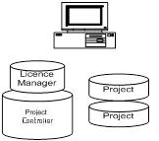
Single Stand-Alone Computer with Local Projects.

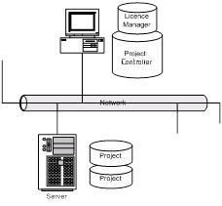
Single Stand-Alone Computer with Projects held on the Network.

Multiple Stand-Alone Computers

In this topology, Activity DataBase is installed on multiple computers, and the Licence Manager and the Project Controller are held on each computer individually. This approach may be adopted for sites with a small number of licences, where users need to run Activity DataBase when disconnected from the network.

There are advantages to this approach; principally the computer can be detached from the network (as long as projects databases are held locally) and Activity DataBase will still function.

Although this is a simple strategy, it has disadvantages:

- User authentication is performed locally, so usernames and passwords held on one computer would not be recognised on another;
- Project registration is local, so projects registered on one computer will not automatically be visible on another.

As in the previous example, these computers may or may not be physically connected to a network, and the Activity DataBase projects may be held either locally or anywhere on the network. Naturally, if the projects are stored on the network, they must be copied to the local computer before Activity DataBase can run detached from the network.

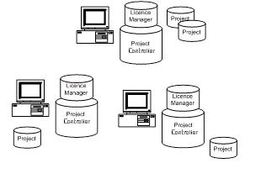
Multiple Stand-Alone Computers with Local Projects.

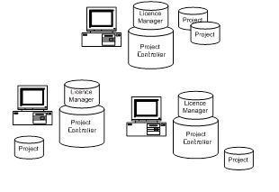
Multiple Stand-Alone Computers with Projects held on the Network.

Local Area Network (LAN)

This is the preferred strategy for single sites with multiple Activity DataBase licences. All authentication, licensing and project registration is done centrally.

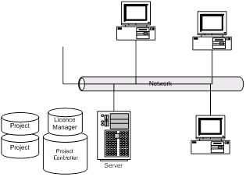
Activity DataBase in a LAN Environment

Although this schematic shows the project databases held on the server, they can be located anywhere on the network.

There are many advantages to this topology:
- Registering a project on one computer will make it immediately visible from any other computer.
- Users may be created and managed from any computer in the network.
- Activity DataBase can take advantage of concurrent licensing. If the installation has 5 licences, any 5 computers on the network can run Activity DataBase. If one of those computers closes its session, then another computer can make use of the licence.

The main disadvantage is that a computer must be connected to the network in order to run Activity DataBase.

Wide Area Networking (WAN) licencing with Local Area Network (LAN) projects – Enterprise version only

This strategy would be used where an organisation has a central licence server with multiple licences and multiple sites. All authentication is done centrally while project management is controlled for each site.

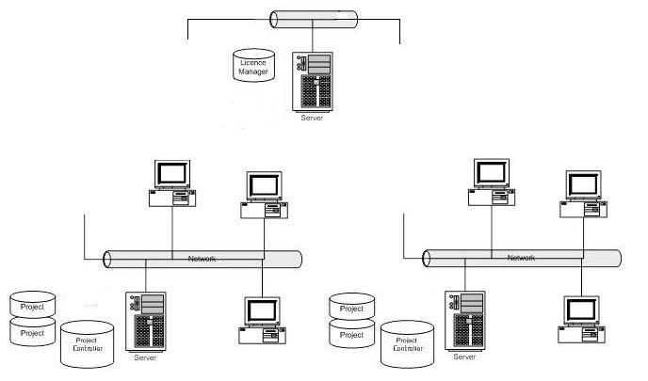

Activity DataBase in a WAN/LAN Networked Environment

There advantages of this topology:

- Licences can be used in a more flexible way.
- Projects can be still be controlled at site level.

The Activity DataBase Configuration Tool

Immediately after installation of Activity DataBase 2012 or installing Activity DataBase 2012 on a new machine, the configuration program must be run, to copy the Licence Manager and Master Database to appropriate locations. Activity DataBase will not run until it has been configured.

For Activity DataBase 2012 all users will need to activate/reactivate their ADB licence.

Users who are upgrading from Activity Database 20.3/20.4/2009/2009SP1/2010/2010 SP1 and 2 and 2011: Activity DataBase 2012 will automatically upgrade your projects if required.

Run the Configuration Tool

To run the configuration program, select “ADB Configuration” from the “Activity DataBase 2012” menu. These menu options are created by the Activity DataBase installation program.

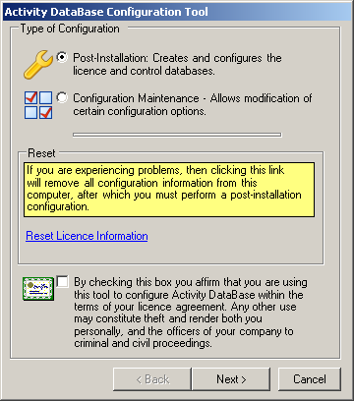
The Activity DataBase Configuration Tool

The configuration programme offers two choices:
- Post-installation – choose this option if Activity DataBase has just been installed;
- Maintenance – this option allows the user to configure various features, such as AutoCAD integration, data audit etc.

Before selecting Next you must acknowledge that you are using this tool within the terms of your licence agreement by checking the box at the bottom of the screen.

Post-Installation

Select the Topology

Choose whichever topology matches your installation. Note that the first option covers both single and multiple stand-alone computers.

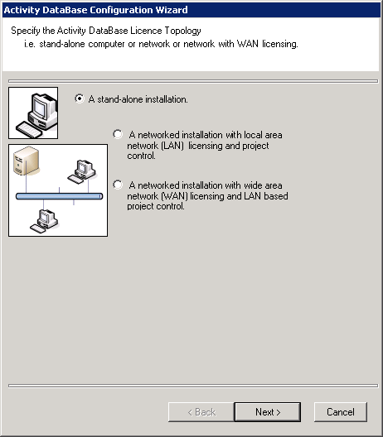

Stand-Alone Computer

The initial configuration for a stand-alone computer is very simple, and requires no further information from the user. Selecting Next will copy the configuration files to the local computer and configure them, ready for use.

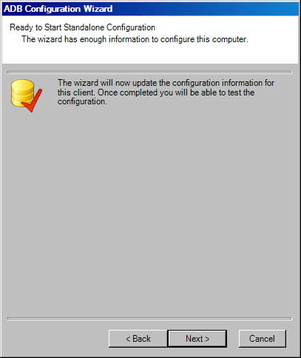

Once configuration has completed, it will be tested and the results of the connectivity tests will be displayed, as shown below. If any problems are encountered the information on this screen should be passed to your support organisation.

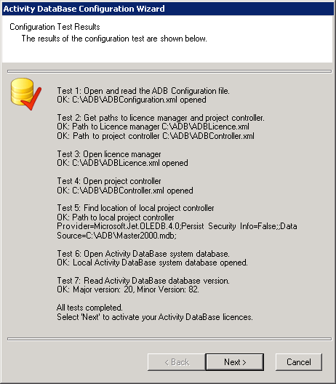

Post-installation configuration on a stand-alone computer requires that the Licence Server Manager is run to register Activity DataBase. If you wish to register Activity DataBase now, select Next to run the registration program automatically. If Cancel is selected, Activity DataBase will not be registered. Activity DataBase may be registered at any time by selecting “Licence Server Manager” from the “Activity DataBase 2012” menu.

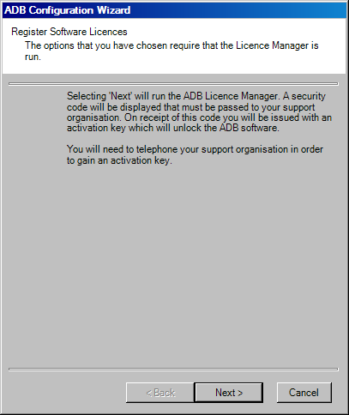

Local Area Network (LAN) Configuration

With a LAN topology, the location of the licence manager and project controller are the same. The network administrator must create a location on the network to which all Activity DataBase users have full access, and must expose that location as a network share.

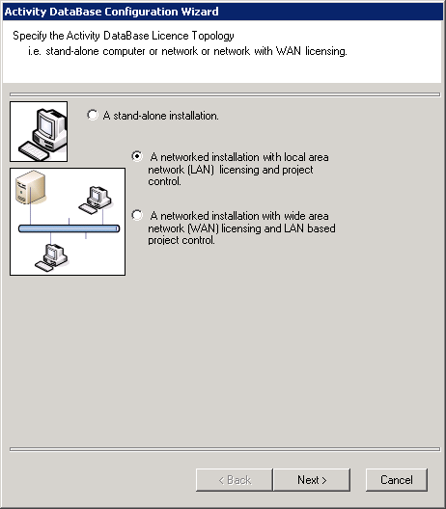

During the configuration process it is absolutely essential that you refer to the configuration controller location in a consistent way, which will be interpreted in the same way by all computers on the network.

It is recommended that UNC file naming conventions are used throughout the configuration process (e.g. “\\ComputerName\NetworkShare”).

Initially, indication must be given whether the controllers or a client are being configured on the network. The licence manager and project controller must be configured before any clients. This is all carried from one of the workstations and it is not required that ADB is installed on the server.

Controller Configuration

This procedure need only be performed once and can be undertaken from any ADB workstation.

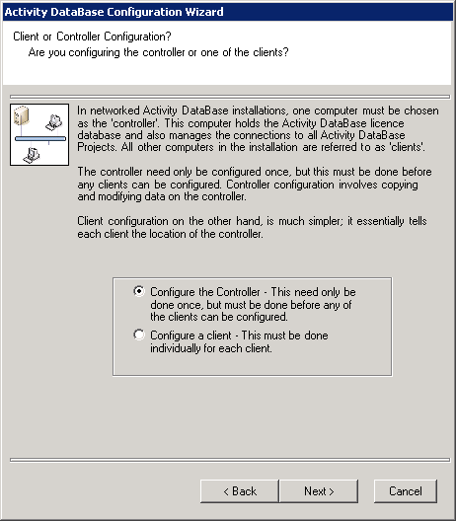

The location of the licence manager and project controller must now be specified. As mentioned previously, this must point to a location on the network to which all users have full access, preferably specified using UNC file naming.

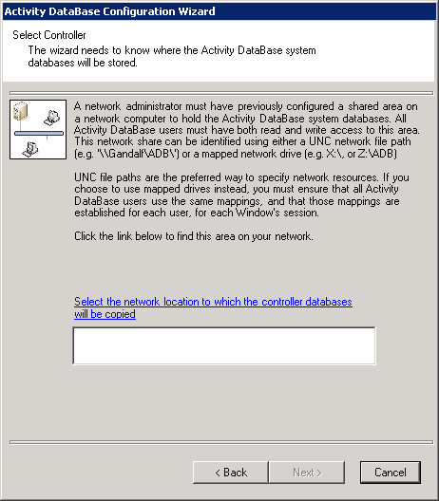

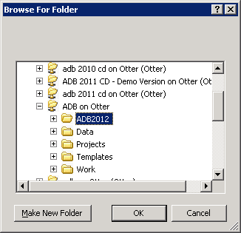
Specifying the location of the configuration licence manager and project controller.

Once the location of the licence manager and project controller is known, the configuration program has enough information to complete the process. Selecting Next will copy the configuration files to the licence manager and project controller.

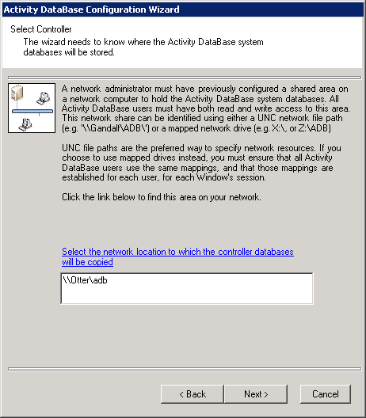

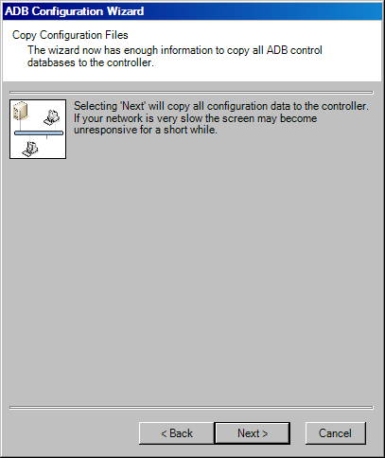

Select Next to copy the licence manager and project controller to the server.

Once completed, the configuration can be tested by selecting Next. The results of the connectivity tests will be displayed, as shown below. If any problems are encountered the information on this screen should be passed to your support organisation.

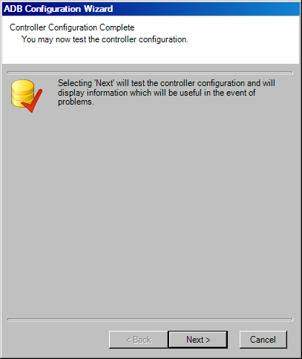

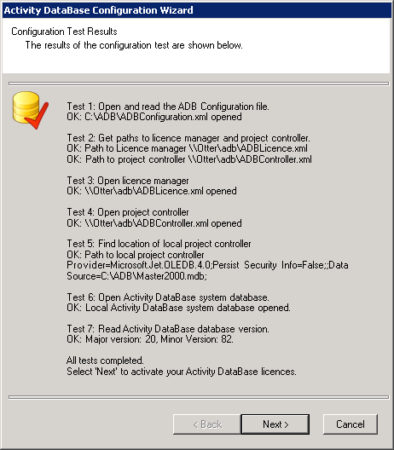

Post-installation controller configuration requires that the Licence Server Manager is run to register Activity DataBase. You will then be asked if you want to register the software now. If you select Next the registration programme will be run automatically. If Cancel is selected, Activity DataBase will not be registered. Activity DataBase may be registered at any time by selecting “Licence Server Manager” from the “Activity DataBase 2012” menu.

LAN Client Configuration

Client configuration can only be done once the controller has been configured. Each network client must be configured individually.

Controller configuration also results in configuration of the client from which the configuration programme is run, so there is no need to perform the client configuration process on that particular computer.

Client configuration is straightforward; the client simply needs to know the location of the controller databases. There is never any need to run the Licence Server Manager, as in this configuration, only the controller needs to be licensed.

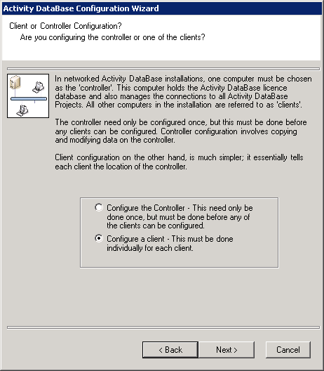

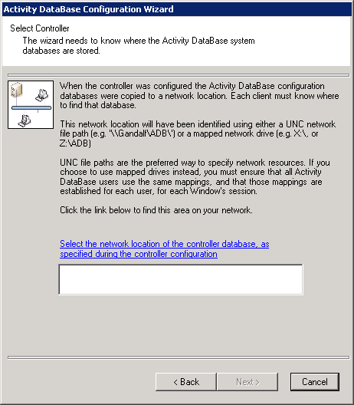

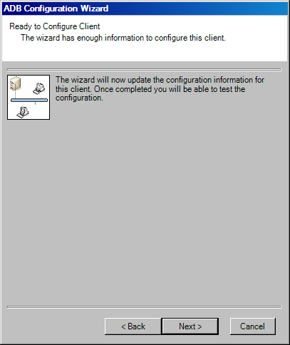

Once configuration has completed, it can be tested and the results of the connectivity tests will be displayed, as shown below. If any problems are encountered the information on this screen should be passed to your support organisation.

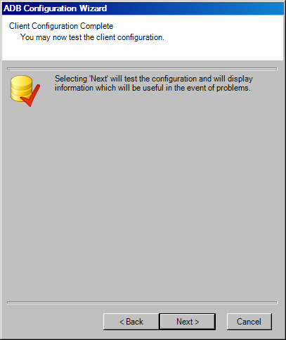

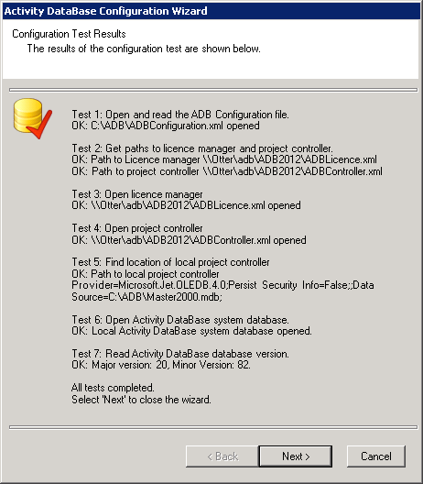

Wide Area Network (WAN) Configuration – Enterprise version only

With a WAN topology, the location of the licence manager and project controller are different, typically one central licence manager with project controllers on each LAN. The network administrator must create locations on the network to which all Activity DataBase users have full access, and must expose that location as a network share.

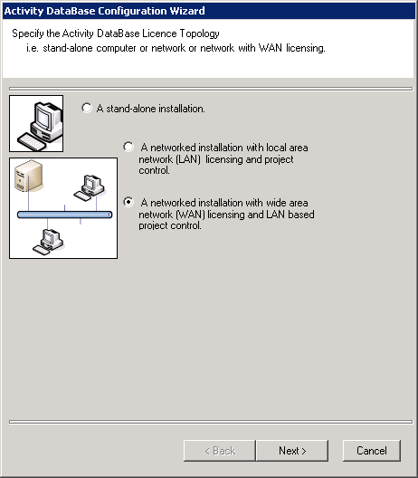

During the configuration process it is absolutely essential that you refer to the configuration controller location in a consistent way, which will be interpreted in the same way by all computers on the network.

It is recommended that UNC file naming conventions are used throughout the configuration process (e.g. “\\ComputerName\NetworkShare”).

Initially, indication must be given whether the controllers or a client are being configured on the network. The licence manager and project controllers must be configured before any clients. This is carried from one of the workstations; it is not required that ADB is installed on any of the servers. Configuring the licence manager needs only to be performed once; configuring the project controllers is required for each LAN.

Licence Manager Configuration

This will also configure the first project controller.

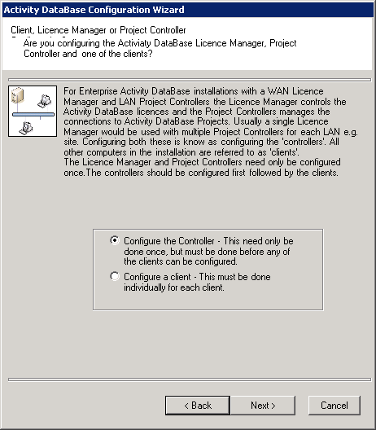

The location of the licence manager and first project controller must now be specified. As mentioned previously, this must point to a location on the network to which all users have full access, preferably specified using UNC file naming.

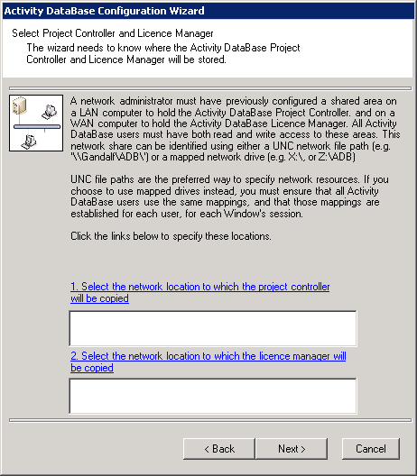

Specifying the location of the configuration licence manager and project controller.

Once the location of the licence manager and first project controller is known, the configuration program has enough information to complete the process. Selecting Next will copy the configuration files to the licence manager and project controller.

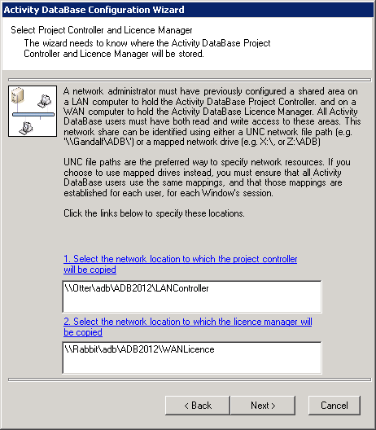

If you have already configured the licence manager you will receive the message below. Select ‘Yes’ to keep the existing licence manager configuration, otherwise select ‘No’ to reconfigure the licence manager.

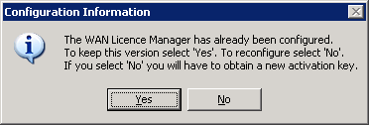

Once completed, the configuration can be tested by selecting Next. The results of the connectivity tests will be displayed, as shown below. If any problems are encountered the information on this screen should be passed to your support organisation.

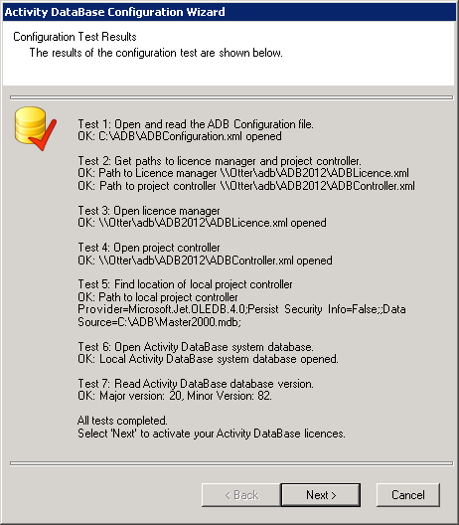

Post-installation licence manager configuration requires that the Licence Server Manager is run to register Activity DataBase. You will then be asked if you want to register the software now. If you select Next the registration programme will be run automatically. If Cancel is selected, Activity DataBase will not be registered. Activity DataBase may be registered at any time by selecting “Licence Server Manager” from the “Activity DataBase 2012” menu.

Project Controller Configuration

The location of the licence manager (already configured) and new project controller must now be specified. As mentioned previously, this must point to a location on the network to which all users have full access, preferably specified using UNC file naming.

Specifying the location of the configuration licence manager and project controller.

Once the location of the licence manager and the new project controller is known, the configuration programme has enough information to complete the process. Selecting Next will copy the configuration files to the project controller.

As you have already configured the licence manager and are just configuring a project controller, you will receive the message below. Select ‘Yes’ to keep the existing licence manager configuration.

Once completed, the configuration can be tested by selecting Next. The results of the connectivity tests will be displayed, as shown below. If any problems are encountered the information on this screen should be passed to your support organisation.

The Project Controller has now been configured. The above process should be performed for each required Project Controller. Note this will also configure this machine as a client.

WAN Client Configuration

Client configuration can only be done once the licence manager and project controller have been configured. Each network client must be configured individually.

Project controller configuration also results in configuration of the client from which the configuration programme is run, so there is no need to perform the client configuration process on that particular computer.

Client configuration is straightforward; the client simply needs to know the location of the licence manager and project controller.

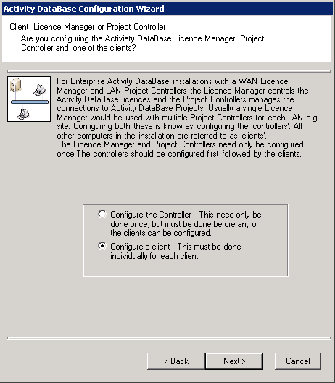

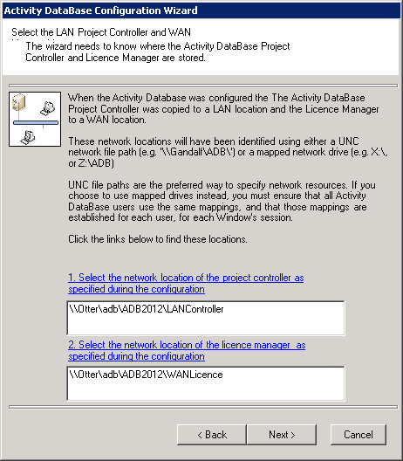

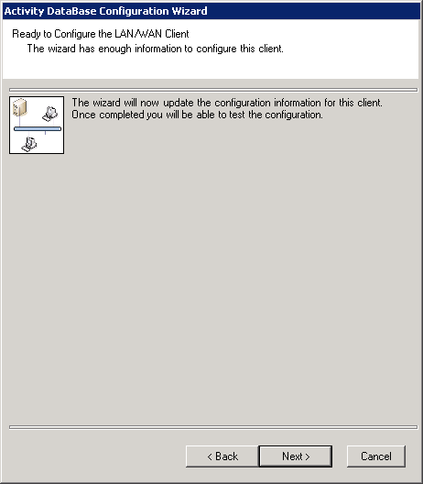
Once configuration has completed, it can be tested and the results of the connectivity tests will be displayed, as shown below. If any problems are encountered the information on this screen should be passed to your support organisation.

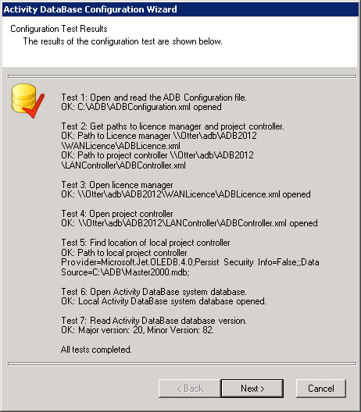

Activating the Activity DataBase software

When installing Activity DataBase and selecting the Post-Installation option, the last part of the configuration process is to run the “ADB Licence Server Manager”. (There is also a menu option to run this utility directly.) The form below is displayed:
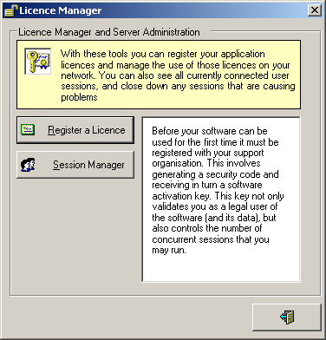

Select “Register a Licence” to display the next form (below). It is essential that the form displayed below remains open until this process is completed.

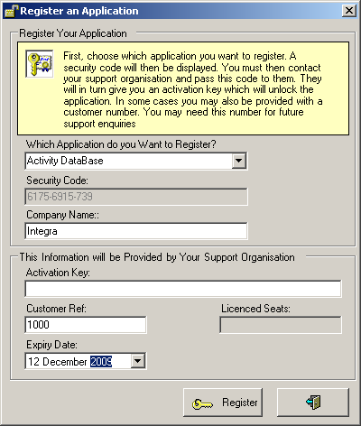

Select Activity DataBase, and read the security code displayed in the box below. Contact your ADB Support organisation stated in the Activity Database 2012 release notes with this code. A Customer Reference and activation key will be given which should be entered in the form; then select the “Register” button. Successful registration will be indicated and the number of seats licensed will be displayed.

Upgrading from Activity DatabBase 20.3/20.4/2009 to Activity DataBase 2012

Run the ADB Explorer under All Programs>Activity Database 2012>ADB Explorer. You will receive a message similar to below.

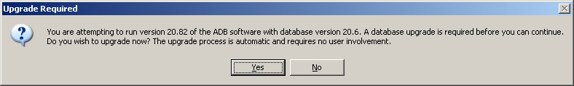

Note the internal software version of ADB 2012 is 20.82. This is required for backwards compatibility i.e. a project created in ADB 2012 can be used with ADB 2009 and 20.4.
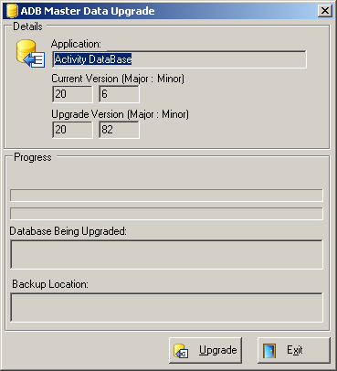

On logging on to ADB you will receive a message similar to that below for each project, informing you that it needs upgrading.

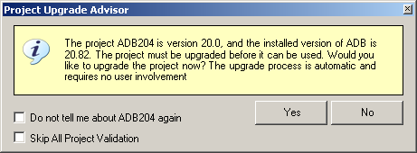

Click Yes to upgrade the project. It is recommended you upgrade all projects on the first log on. However, clicking No will allow ADB to be opened but without new functionality. The check boxes will stop the warning for a specific project or all projects.

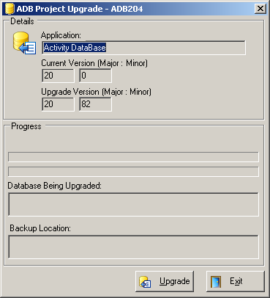

The upgrade process will happen when the first user logs on, and should be completed before other users connect to the system.

Upgrading from ADB 2010/11 to ADB 2012 will not require projects to be upgraded.

Maintenance Operations

The configuration maintenance can only be run after Activity DataBase has been initially configured and licensed. This option allows the following to be configured:

- AutoCAD version
- Audit support

Both of these configuration items function the same way, regardless of whether this is an installation or an upgrade. Administrator or Power User status is required to run this facility.

AutoCAD Configuration

In order to integrate with AutoCAD, some Activity DataBase files must be copied to the AutoCAD installation folder. Also, because Activity DataBase can run AutoCAD directly, it must know where the AutoCAD program is installed.

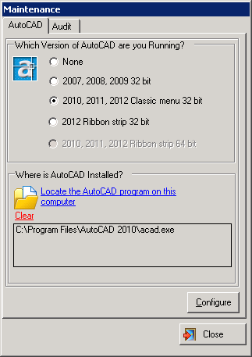

Enter the required information, and then select Configure. For Architectural Desktop select the equivalent AutoCAD version.

For AutoCAD 2010, 2011 and 2012 Classic menu the AutoCAD VBA Enabler will need to be installed for the specific version of AutoCAD. This can be downloaded from the Autodesk website www.Autodesk.com.

For 64 bit versions of AutoCAD, ADB must be configured for user with SQL Server.

Audit Configuration

If auditing is enabled (the default mode), then all structural changes to data are written to an audit log within the project database. Please note, before enabling Auditing, that this will increase the size of the project database, and may have a negative impact on performance.

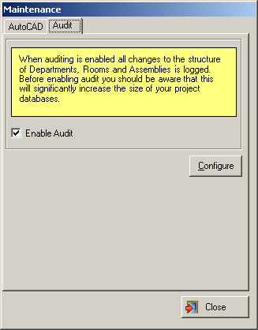

Before Activity DataBase software can be used for the first time, it must be configured and registered. This involves generating a security code and receiving in turn a software activation key. This key not only validates a legal user of the software and its data, but also controls the number of concurrent sessions that may be run.

Additional Configuring for AutoCAD for Automated View Generation

The Version of AutoCAD to be used with Activity DataBase should have already been specified using the Configuration Manager. To change the version of AutoCAD to be used with Activity DataBase, run the Configuration Manager again.

If AutoCAD is to be used to create component graphics from 3D surface models, an Activity DataBase DXB plotter will need to be defined as follows:

- Run AutoCAD
- From the File>Plotter Manager menu option select Add A Plotter Wizard
- Move to the Plotter Model screen accepting the defaults on the way and select AutoCAD DXB File
- Move to the Plotter Name screen and change the name to DXB i.e remove
“ File”. Note the space before File should also be removed.
- Move to the Finish screen and select Edit Plotter Configuration
- Select Custom Paper Sizes and Add
- Select Start from scratch and move to the next screen. Set Width to 8000 Length/Height to 8000 and leave the units as inches.
- Move to the Printable Area screen and set the Top, Bottom, Left, Right to 0.
- Move to the Paper Size Name screen and enter ADB.
- Move to the File Name and leave the file name as DXB and Finish.
- Select Media on the Device and Document tab and click on your newly created ADB paper size and select OK.
- To complete the DXB plotter setup select Finish on the Add Plotter – Finish screen.

SQL Server Installation

Activity DataBase can be used with SQL Server versions 2000, 2005 and 2008 including the express versions as well as MS Access databases. The user interface is virtually identical for both database types. SQL Server is required for 64 bit versions of AutoCAD.

ADB 2012 Projects are now created in batches by the system administrator, which has the following advantages:

- The server does not have to be configured to allow remote attachment of databases by users.
- The backup process is simplified for system administrators as database creation is under their control.
- For users the process of project creation appears very similar to MS Access; the only difference is that the database names are predefined while the user can assign any project code they wish.
- When all available projects have been assigned the user receives a message that they should ask the system administrator to create another batch of projects.

Two scripts in the SQL Scripts directory on the CD are provided for the purpose of initial system setup and batch database creation. The process is as follows:

- Copy the files from the SQL Scripts directory on the CD to a suitable folder on the Server where SQL Server is installed.
- Run the SQL Server Management Studio (SQL 2005/8) or Enterprise Manager SQL 2000. Open the script AttachControllerDatabase.sql and change the path to the location where you copied Master2000.MDF and run the script. You should then have a database MASTER2000 in the list of databases. This script only needs to be run once.

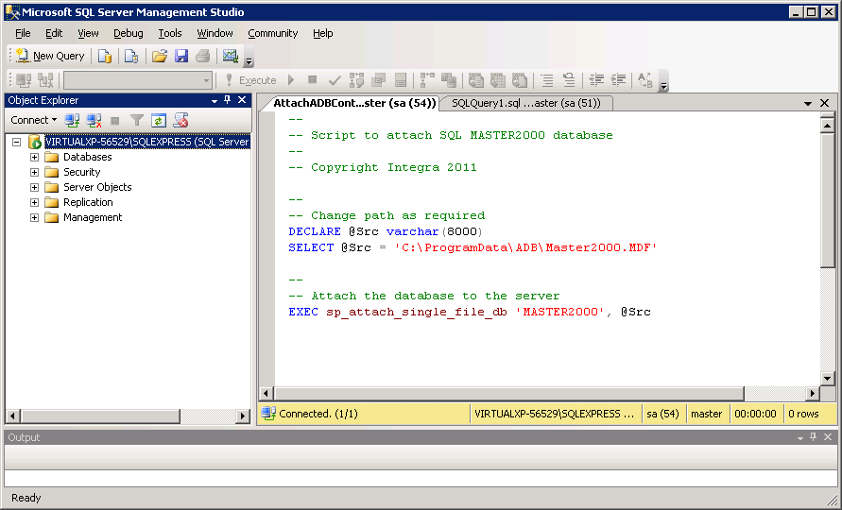

- Open the script CreateADBDatabases.sql. Edit the source path and change the path to the location where you copied ADBTemplate_20_82.MDF and change the target path to where you wish the ADB project databases to be created. By default the script creates 5 databases each time it is run. Change this as required. On running the script you should see new databases beginning with ADB added to the list.

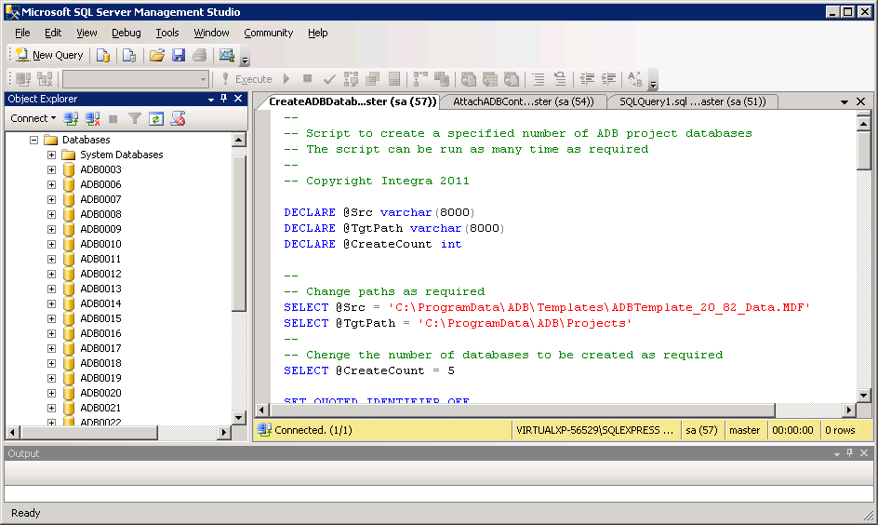

Having installed both SQL Server and Activity DataBase, select Modify an Option on the task bar.

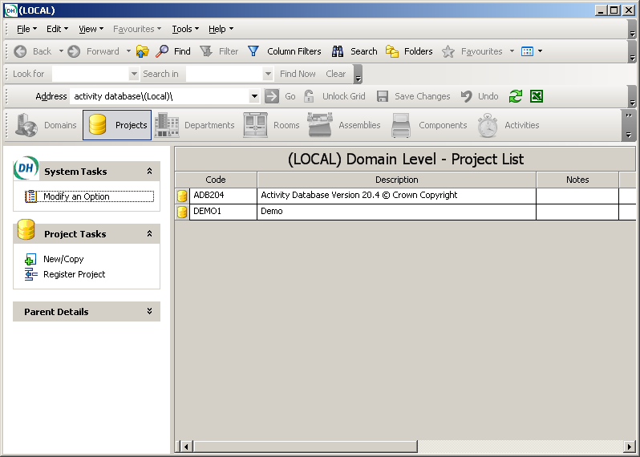

Complete the SQL-Server Authentication section by entering the name of the SQL Server, the SQL Server login name and password and where the Activity DataBase SQL Server databases are to be located.

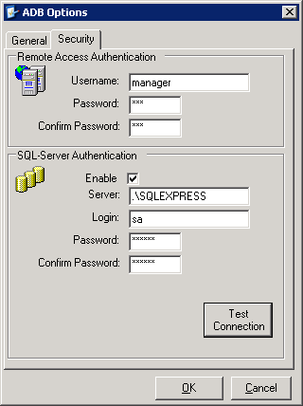

Having entered the server details, select Test Connection. This must display a message similar to that below.

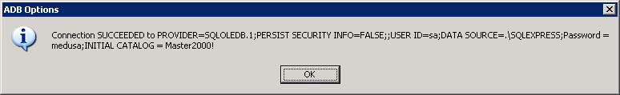

Creating a new SQL Server project is similar to creating a new MS Access project, except that SQL Server should be specified as the Project Type.

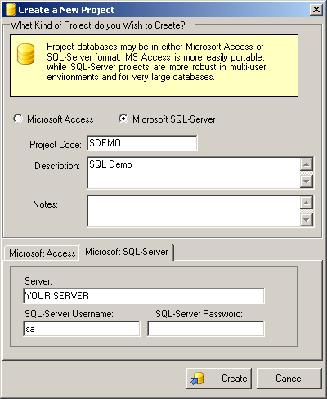

You should receive a message similar to that below.

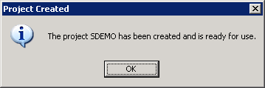

To register a SQL Server project created by another user, enter the Server name, Username and Password and click Fetch Database List. Select a database from the list and click Register.

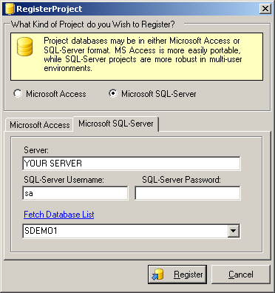

All other operations are identical to the MS Access version.

